List of Git commands are following :  
 a) git -v  
  
  
b)git status   
  
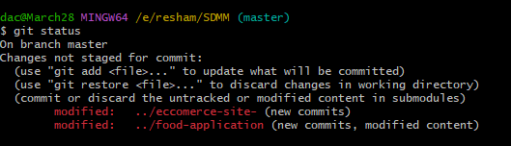  
c) git clone  
  
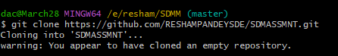

d) git add .  
  
  
e) git commit -m

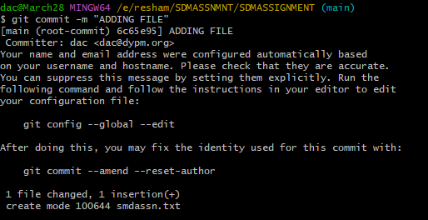

f) git push

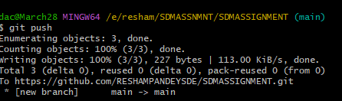

Q How to create branch ?

1)



2)

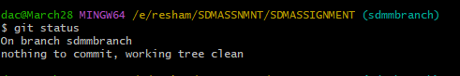

3)

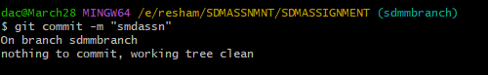

4

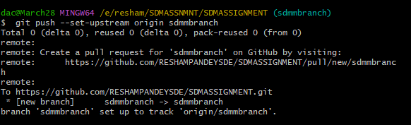

5.



Q. How to create project in JIRA ?

1. create scrum project   
2. Goto backlogs

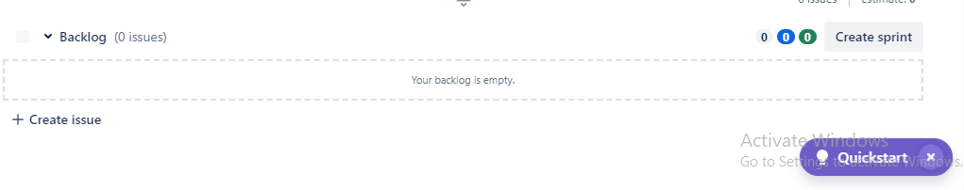

3.create userstories   
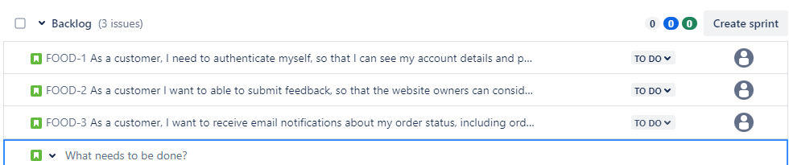

4.Now we are adding userstories to sprint .

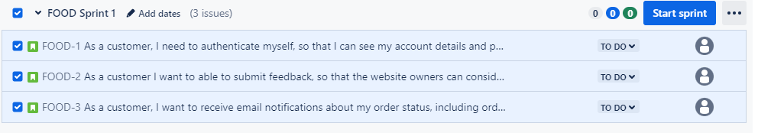

5.Now we are starting the sprint.  
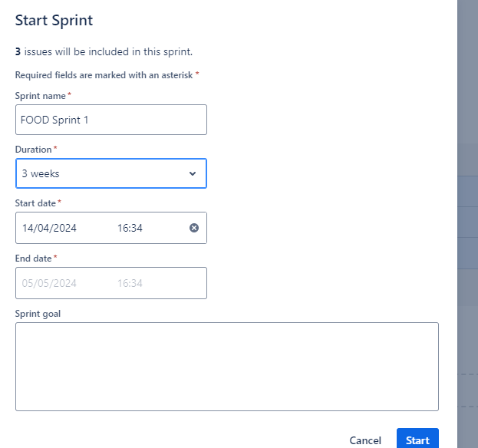

6.Now sprints are added into our To-do list   
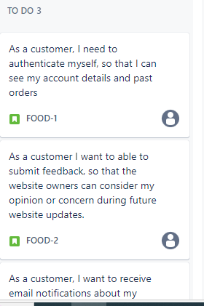

7.Now we will start working on sprint and after that it will go to progress

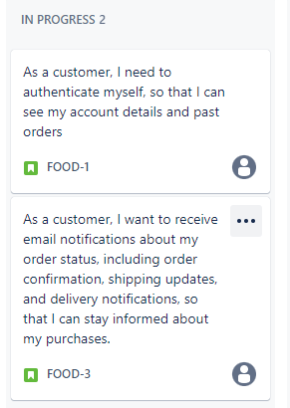

8. After resolving all the issues,the sprint goes to ‘Done’. 