TASK 1 :
from selenium import webdriver
from selenium.webdriver.common.by import By
from selenium.webdriver.common.keys import Keys
import time
driver = webdriver.Chrome()
driver.get("https://www.google.com")
time.sleep(60)
search_box = driver.find_element(By.NAME, "q")
search_box.click()
search_box.send_keys("Actor Suriya")
search_box.send_keys(Keys.ENTER)
time.sleep(60)

OUTPUT:
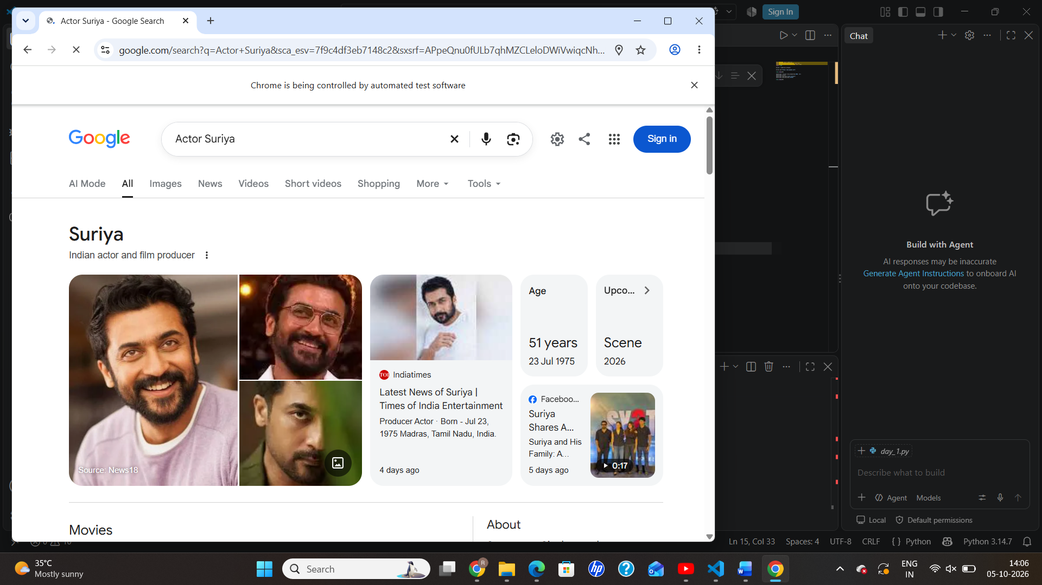

TASK 2:
from selenium import webdriver
from selenium.webdriver.common.by import By
driver = webdriver.Chrome()
driver.get("https://www.saucedemo.com/")
username = driver.find_element(By.ID, "user-name")
password = driver.find_element(By.NAME, "password")
login = driver.find_element(By.ID, "login-button")
username.send_keys("standard_user")
password.send_keys("secret_sauce")
login.click()
print("Login Successful!")
products = driver.find_elements(By.CLASS_NAME, "inventory_item")
print("Products:", len(products))
for product in products:
print(product.find_element(By.CLASS_NAME, "inventory_item_name").text)
print(product.find_element(By.CLASS_NAME, "inventory_item_price").text)
input()
driver.quit()

OUTPUT:
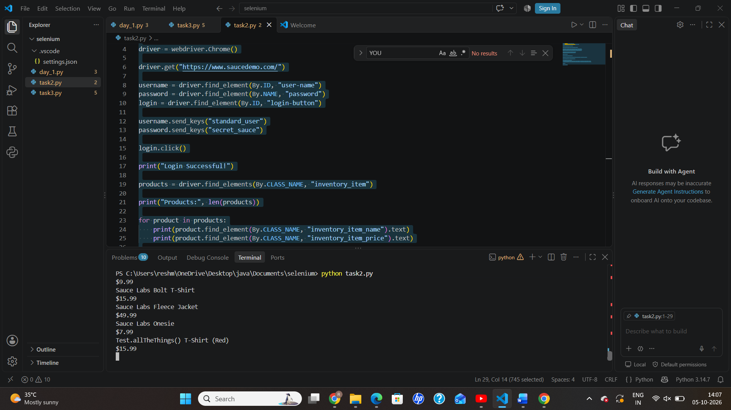
TASK 3:
from selenium import webdriver
from selenium.webdriver.common.by import By
from selenium.webdriver.support.ui import WebDriverWait
from selenium.webdriver.support import expected_conditions as EC
MOBILE = "8778095636"
options = webdriver.ChromeOptions()
options.page_load_strategy = "eager"
options.add_argument("--start-maximized")
driver = webdriver.Chrome(options=options)
wait = WebDriverWait(driver, 30)
driver.get("https://www.flipkart.com/login?ret=/")
mobile = wait.until(
EC.element_to_be_clickable((By.ID, "1"))
)
mobile.click()
mobile.send_keys(MOBILE)
continue_btn = wait.until(
EC.element_to_be_clickable(
(By.XPATH, "//button[normalize-space()='Continue']")
)
)
continue_btn.click()
otp_box = wait.until(
EC.element_to_be_clickable(
(By.XPATH, "//input[@type='number' and @autocomplete]")
)
)
otp = input("Enter OTP: ")
otp_box.send_keys(otp)
verify_button = wait.until(
EC.element_to_be_clickable(
(By.XPATH, "//button[normalize-space()='Verify']")
)
)
verify_button.click()
time.sleep(50)
print("Current URL:", driver.current_url)
input("Press Enter to close browser...")
driver.quit()

OUTPUT:
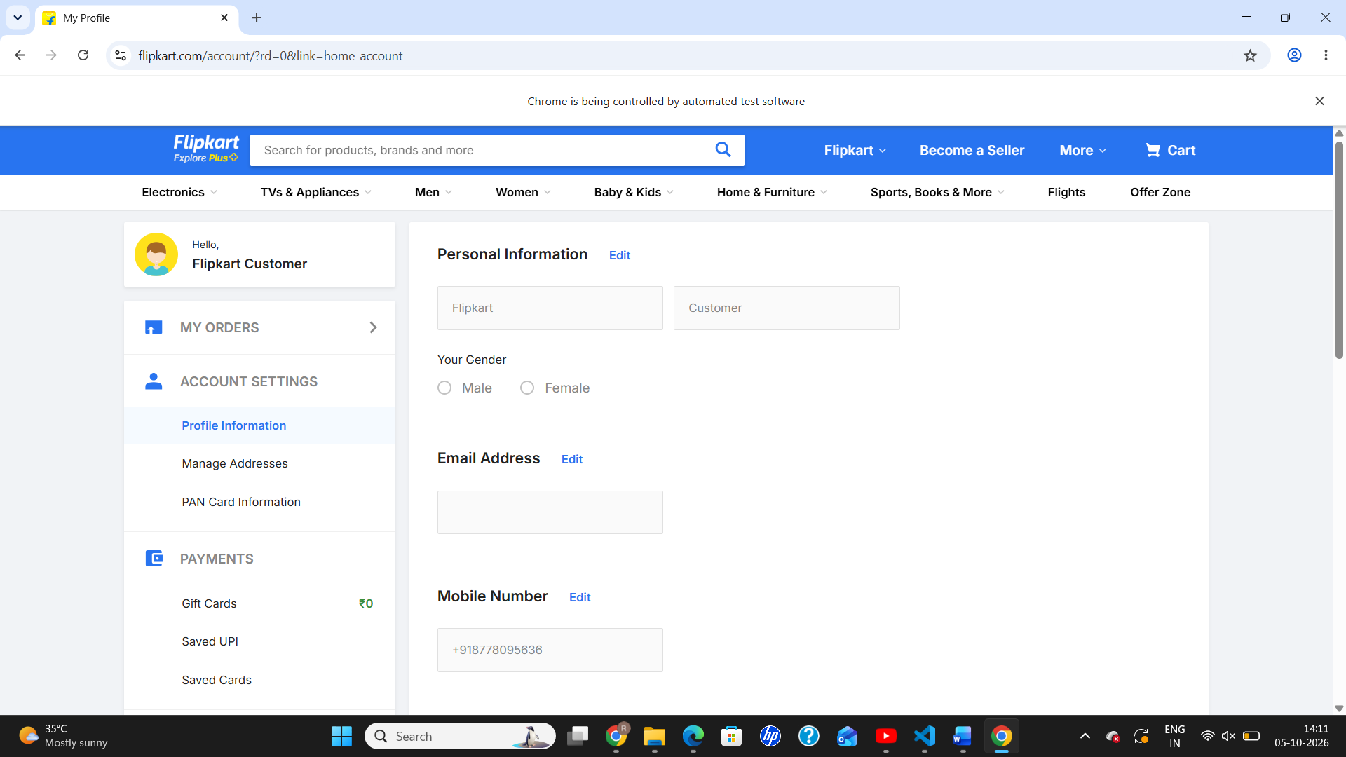
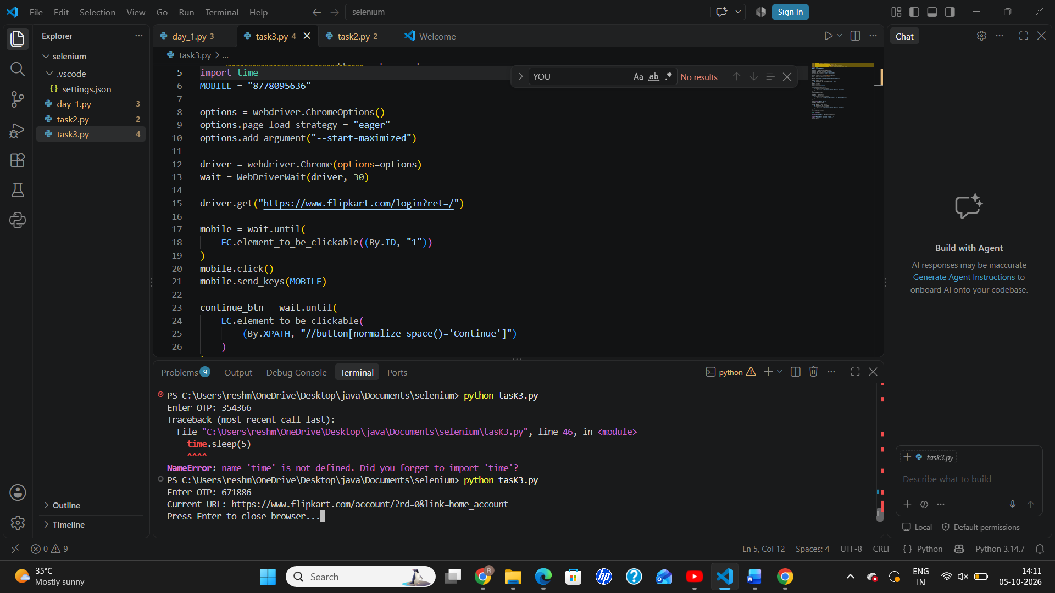S

