**Celsius to Fahrenheit Converter API**

Methods- GET

URL: <http://127.0.0.1:5000/convert>

Input: (Params)

{

“celcius” : 0

}

Output:

{

“fahrenheit”: 32.0

}

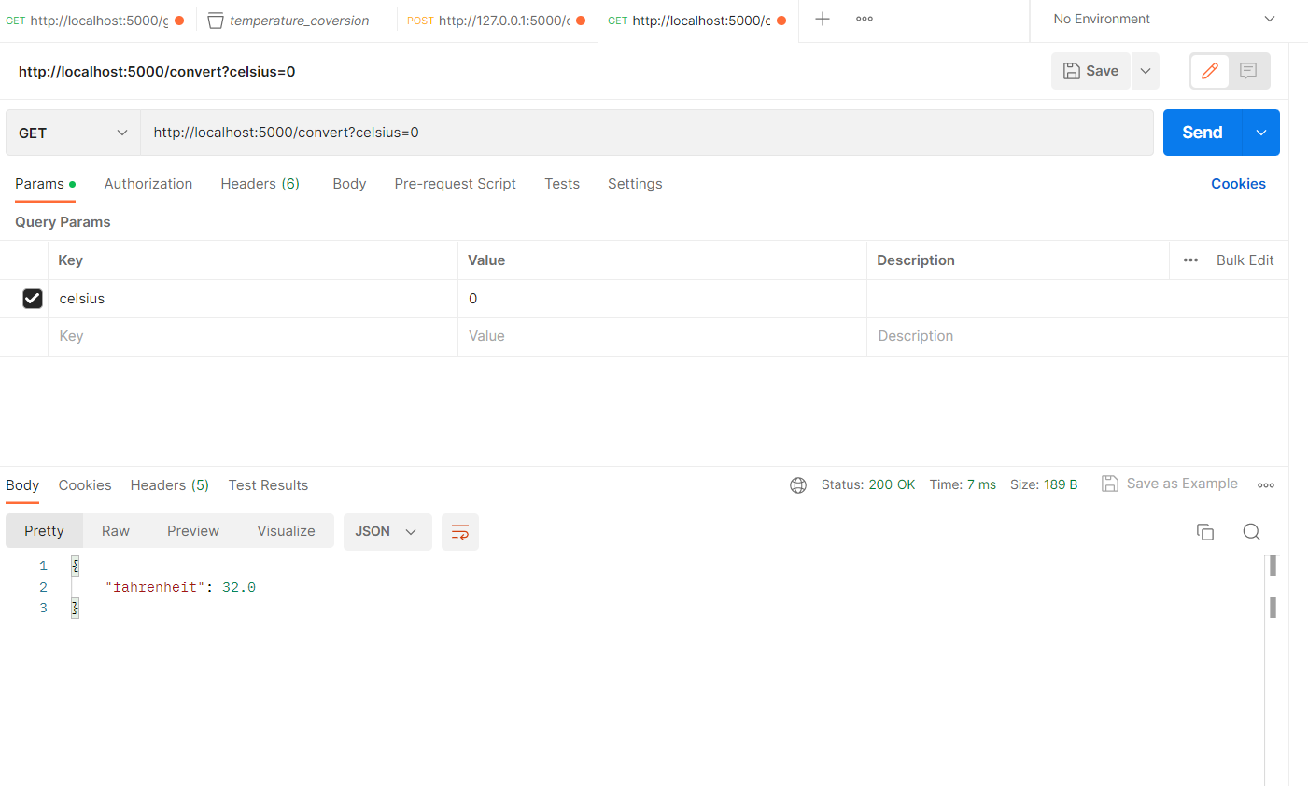

Methods- POST

URL: <http://127.0.0.1:5000/convert>

Input: (Body-raw)

{

“Celsius” : 0

}

Output:

{

“Fahrenheit”: 32.0

}

