README

**Data availability statement**

*The data for this project (Statistics Sweden, 2019) are confidential, but may be obtained from Statistics Sweden (SS) following a confidentiality assessment pursuant to the Public Access to Information and Secrecy Act. Researchers interested in access to the data may contact mikrodata@scb.se , also see*

[*https://www.scb.se/en/services/guidance-for-researchers-and-universities/*](https://www.scb.se/en/services/guidance-for-researchers-and-universities/)

*It takes between 1 to 6 months to from the time you are assigned a contact person to the delivery of your microdata. Most orders cost between SEK 30,000 and SEK 60,000.*

*All replications scripts, including detailed explanations of data construction, etc. are available at the following DOI: 10.5281/zenodo.4084626. https://doi.org/10.5281/zenodo.4084626*

**Registers used**

*Statistics Sweden. 2020. “Longitudinal integrated database for health insurance (LISA/Forvarvskalla), 1997-2011 [database]”, Microdata Online Access At Statistics Sweden (MONA), accessed (2020).*

*Statistics Sweden. 2020. “Wealth (Formogenhetsregistret)), 1999-2007 [database]”, Statistics Sweden Research Service, accessed (2020).*

*Statistics Sweden. 2020. “KURU, 1999-2011 [database]”, Microdata Online Access At Statistics Sweden (MONA), accessed (2020).*

*Statistics Sweden. 2020. “IoT, 1993-2011 [database]”, Microdata Online Access At Statistics Sweden (MONA), accessed (2020).*

*Statistics Sweden. 2020. “Vehicle Register (Fordonregistret), 1999-2007 [database]”, Microdata Online Access At Statistics Sweden (MONA), accessed (2020).*

*Statistics Sweden, Swedish Public Employment Service. 2020. “Handel (Unemployment Register), 1990-2015 [database]”, Microdata Online Access At Statistics Sweden (MONA), accessed (2020).*

*Statistics Sweden , Unemployment Insurance Administration. 2020. “ASTAT (Unemployment Register), 1999-2007 [database]”, Microdata Online Access At Statistics Sweden (MONA), accessed (2020).*

*Statistics Sweden. 2020. “Job (Employment Register), 1985-2011 [database]”, Microdata Online Access At Statistics Sweden (MONA), accessed (2020).*

*Statistics Sweden. 2020. “HUT (Household Budget Survey), 2003-2009 [database]”, Microdata Online Access At Statistics Sweden (MONA), accessed (2020).*

*Statistics Sweden. 2020. “Belinda (Inheritance Register), 2001-2009 [database]”, Microdata Online Access At Statistics Sweden (MONA), accessed (2020).*

*Statistics Sweden. 2020. “RAMS (Employer-Employee Register), 1985-2015 [database]”, Microdata Online Access At Statistics Sweden (MONA), accessed (2020).*

*Statistics Sweden. 2020. “Varsel (Lay-off Notification Register), 2002-2012 [database]”, Microdata Online Access At Statistics Sweden (MONA), accessed (2020).*

*Statistics Sweden. 2020. “HUS (Household Market and Nonmarket Activities Survey),* ***YEAR = ????*** *[database]”, Microdata Online Access At Statistics Sweden (MONA), accessed (2020).*

*Statistics Sweden. 2020. “Skatter (Tax Data), 1997-2011 [database]”, Microdata Online Access At Statistics Sweden (MONA), accessed (2020).*

*Statistics Sweden. 2020. “Akassa (UI Fund Information),* ***YEAR = ????*** *[database]”, Microdata Online Access At Statistics Sweden (MONA), accessed (2020).*

**Stata packages used**

spmap is used to create Figure2 and Figure2D in Figure2.do

* Installation:
  + ssc install spmap
  + ssc install shp2dta
  + ssc install mif2dta

binscatter is used to create Figure3 in Figure3.do

* Installation:
  + ssc install binscatter

outtable is used to create Table2 in Table2.do

* Installation
  + ssc install outtable

The Value of Unemployment Insurance

# Table Of Contents

Table Of Contents 1

Foreword 2

1 Figure 1: Estimated Consumption Dynamics around Start of Unemployment Spell 7

2 Figure 2: Identifying Variation in Local Transfers 8

2.1.1 Panel A,B, and C 8

2.1.2 Panel D 9

3 Table 2 & Figure 3 11

3.1 Table 2: Marginal Propensity to Consume Out of Local Welfare Transfers By Unemployment Status 11

3.2 Figure 3: Relationship Between First-Difference in Residual Local Transfers and First-Difference in Consumption by Employment Status 12

4 Figure 4: Regression kink design: Effect of UI benefits variation on consumption at unemployment 13

4.1 Panel A : A. UI Benefit Replacement Rate 13

4.2 Panel B: Consumption Drop at Unemployment 13

5 Figure 5: Non-parametric and Parametric RP Estimation 15

5.1 Panel A. Expected Price vs. Insurance Coverage 15

5.2 Panel B. Parametric Estimation of MRS Distribution 16

6 Figure 6: Comparison of MRS Estimates Across Different Approaches for the Baseline Sample 17

7 Table 1: Baseline Sample: Summary statistics 18

8 Table 2 19

9 Table 3: Insurance Choice Model Estimation & Implied MRS Distribution 21

### 

### Foreword

This documents aims at summarizing the different empirical exercises.

We first document the different data set used in our analyses and how they were constructed.

Then, for each Figure/Table of the paper, we document the following:

* code – original one and final one, i.e. cleaned and concise
* data set used
* sample
* method
* results

|  |  |
| --- | --- |
| **Main path** | |
| Main_path | \\micro.intra\projekt\P0568$\P0568_Gem\Data\Programs |
| **Adverse selection** | |
| data | $main_path\InsuranceValue\data |
| outputs | $main_path \InsuranceValue\outputs |
| **Other sources** | |
| dataUIVal | $main_path \AdverseSelection\data |
| dataConsumption | $main_path Consumption_eventstudies\Consumption measure |
| dataIntermediate | $main_path \InsuranceValue\data |
| tempfile | \\micro.intra\projekt\P0568$\P0568_Gem\Temp_files |
| lisa | \\micro.intra\projekt\P0568$\P0568_gem\Data\New_delivery_150525\LISA |

**Path.**

Note: sometimes the LISA data sets are called from the lisa folder and sometimes from the dataUIVal folder. The only difference between the two is that a duplicates drop LopNr_PersonNr command has been applied to the data set from the LISA folder, before saving it to UIVal.

**Data sets.**

Below a small description of the different data sets used in the empirical analysis, where they come from and what they contain. For some, the explanation is deffered to later in the document. When this is the case, it is possible to access the information by clicking on the name of the data set – this will lead you to the main description in the body of the document.

**December sample** – sample workers experiencing their first recorded unemployment spell between 2002 and 2007 and who are unemployed in December of the year in which they lose their job for the first time

|  |  |  |  |  |  |  |
| --- | --- | --- | --- | --- | --- | --- |
| **List of the different data sets** | Number of observations | Uniquely identified with | Inputs | Sample restrictions | | Key variables |
| Years |  |
| **Raw inputs** | | | | | | |
| PES_RKD_alex // 140_PES_RKD_Alex.dta  (same data set, stored in different folders) |  |  |  |  |  |  |
| 100_firstLayoffs | 1,221k | (LopNr_PersonNr, year_registry) (also year) | Pes_Lisa_Forvar_Union_RAW.dta | 2000-2010 | year = first layoff | LopNr_PersonNr  year, year_registry, startU, trueEnd, duration, UNION |
| Consumption_measure_YYYY_tiny | - | (LopNr_PersonNr, year) |  | 2000-2007 |  | Consumption variables |
| 002_ins0209.dta | 54, 870k | (LopNr_PersonNr, year) | AKAS, KASSA | 2002-2009 |  | L_UI, UI |
| 001_panel_lisa97_07.dta | 79,730k | (LopNr_PersonNr,year) | LISA, WealthR | 1997-2007 |  | Demographic & wealth variables |
| **Intermediate inputs** | | | | | | |
| 416_AllMonthsBarnAll | 4,781k | (LopNr_PersonNr,year) | LISA, 400_spell0007 | 2000-2007 |  | Barn* |
| 101_matchedCons_YYYY_bis.dta |  |  |  |  |  |  |
| **Final Samples** | | | | | | |
| 400_spell0007.dta |  |  |  |  |  |  |
| 400_spellDec0007.dta |  |  |  |  |  |  |
| 102_spellDec0007_bis.dta |  |  |  |  |  |  |
| 140_spell0007ins_Full.dta |  |  |  |  |  |  |
| **Derived samples** | | | | | | |
| 140_RKDgraph_diag.dta  (see Figure4.do for data construction) |  |  | PES_RKD_alex  100_firstLayoffs_bis  001_panel_lisa97_07.dta  Consumption_measure_YYYY_tiny, 2000-07  002_ins0209.dta | 2000-2007 |  |  |
| 305_structural_elig.dta |  |  |  |  |  |  |
| 306_structural_elig_cov.dta |  |  | 305_structural_elig.dta  001_panel_lisa97_07.dta  uival_142_cognitive.dta (cognitive variable) |  |  |  |

Note: _bis extension, when the sample has been created using firstLayoff_bis

**Main Sample of Analysis - 400_spell0007.dta / 400_spellDec0007.dta**

**400_spell0007.dta**

* 6,293k observations
* Years 2000-2007
* Age 18-62

**400_spellDec0007.dta**

* For each year in 2000-2007, start from the LISA panel 2000-2007 and merge it with the first layoff data. Defined treated individuals as individuals who become unemployed in year t. Keep individuals eligible to any UI coverage and are aged 25-55 at the time of layoff.
* Match treated individuals to their nearest neighbor in the sample (excluding individuals from the same household) – matching on age, gender, family composition, education, region, industry, lagged income (t-1 to t-3).
* Save an intermediary data set 100_matches_YYYY.dta where each line is identified by an idpair and a treatment status.
* …
* Then, restrict the sample to workers who are unemployed in December in the year of being laid off . Save the data set under 400_spellDec007.dta, 2,987k observations

Note: Consumption is at the household level, where we fix composition of the household as of event time -1, the year prior to being laid off. We exclude households where more than one member experiences an unemployment spell between 2002 and 2007.

**Layoff data – 003_Layoffs.dta / 003_firstLayoffs.dta / 003_firstLayoffs_bis.dta**

* Starting from Pes_Lisa_Forvar_Union_RAW.dta, drop all observations after 2012.
* Define key variables : unemployed, time_unemployed, layoff (see core of the paper for more details).
* Keep years 1999-2010. Define additional variables –layoff history (F1-L8), firm layoff risk history (t-t-3)
* Keep years 2000-2010. Save under **003_Layoffs.dta**, 86,892k observations.
* For each individual, retrieve year of the first layoff. Keep if year = year of first layoff. Save under **100_firstLayoffs.dta,** 1,221k observations.

**100_firstLayoffs_bis,** years 1996-2010, 1,377k observations. Same pattern without placing sample restrictions on years apart from the initial drop of observations after 2012. 003_Layoffs_bis.dta corresponds to Pes_Lisa_Forvar_Union_RAW.dta, dropping year > 2012, and creating new variables. Then, 100_deriving firstLayoffs_bis placing a restriction on year = year of first layoff.

**LISA panel - 001_panel_lisa97_07.dta / 001_panel_lisa00_07.dta**

* Load successively all LISA data sets for the years 1997-2007. Perform basic data manipulation – essentially variable creation.
* Merge with wealth data for the years 1999-2007. Again, basic variable creation– retrieving lagged variables, etc. Save under **001_panel_lisa97_07.dta.** 79,730k observations, years 1997-2007 (missing values for wealth variables at the beginning of the sample).
* Drop if year prior to 2000. Save the final data set under **001_panel_lisa00_07.dta.** 58,409k observations, years 2000-2007.

**Information on Family Composition - 416_AllMonthsBarnAll.dta**

* Starting from the main sample 400_spell0007.dta. For each year in 2000-2007, keep information on individuals present in the sample – i.e. LopNr_PersonNr, year. Save these temporary data sets under 416_AllMonthsIndexYYYY.dta.
* For each year, merge with LISA data set and retrieve information on the number of children Barn* variables. Save the temporary data sets under 416_AllMonthsBarnYYYY.dta.
* Concatenate all data sets and save under a unique data set **416_AllMonthsBarnAll.dta**. 4,781k observations, years 2000-2007.

Same for the December sample: starting from 400_spellDec007.dta and saving **416_DecSampleBarnAll.dta.**

**Data on Insurance Choice – 002_ins0209.dta**

* Starting from the raw KASSA data – UI fund information – for the years 2005-2009, retrieve history of UI contribution (L1 to L4). Save into a temporary data set called 002_kassa.dta.
* Starting from the raw AKAS data – union membership payment data for the years 2002-2006, retrieve history of UI contribution (L1 to L4). Merge with information from KASSE – 002_kassa.dta.
* Define UI = 0 if non-missing level of contribution (kassa or akas data). Replace UI = 1 if non-missing and non-zero level of contribution. Retrieve information on lagged UI – L_UI.
* Keep a single observation per (LopNr_PersonNr, year), and save final data set under **002_ins0209.dta**. The data contain 54, 870k observations and covers the years 2002-2009.

**Consumption measures.** We use the registry- based measure of annual household consumption expenditures for the universe of Swedish households created for all years 2000 to 2007 by Kolsrud et al. [2017] [1]

|  |  |  |  |
| --- | --- | --- | --- |
| **Do-files** | **Input** | **Intermediate output** | **Output** |
| **Figures** | | | |
| Figure 1.do | 101_matchedCons_YYYY_bis.dta, YYYY = 2000/2007  100_firstLayoffs_bis |  | Figure1.eps |
| Figure2.do | 400_spell0007.dta (main sample)  416_AllMonthsBarnAll.dta (info on family compo) |  | Figure2A.eps  Figure2B.eps  Figure2C.eps  Figure2D.eps |
| Figure 3.do | 400_spellDec0007.dta (main sample – December sample)  416_AllMonthsBarnAll.dta (info on family compo) |  | Figure3.eps |
| Figure4.do | 140_RKDgraph_diag  140_spell0007ins_Full.dta  140_PES_RKD_Alex.dta |  | Figure4_PanelA.eps  Figure4_PanelB.eps |
| Figure5.do | 102_SpellDec0007_bis.dta  305_structural_elig.dta |  | Figure5_PanelA_ins.eps ( Figure5.A in the paper)  Figure5_PanelA_unins.eps (FigureE2.A in the paper)  Figure5_PanelB.eps  FigureE2_PanelB.eps |
| Figure6.do |  |  |  |
| **Tables** | | | |
| Table1.do | 102_spellDec0007_bis.dta  305_structural_elig.dta |  | Table1.xlsx |
| Table2.do | 415_SocAid_varDecompDecOnlyBarn.dta |  | Table2.tex |
| Table3Table4.do | 306_structural_elig_cov.dta |  | Table3Table4.xlsx |

# Figure 1: Estimated Consumption Dynamics around Start of Unemployment Spell

**Code:** Figure1.do

**Data:**

* 101_matchedCons_YYYY_bis.dta, YYYY = 2000/2007
* 100_firstLayoffs_bis

**Sample:**

* Years 2000-2007
* Treated individuals & control group – nn matching on pre-event characteristics
* December sample
* Eligible to any form of UI - L_incUnemp > 50,000 SEK in t=0
* Age 25-55
* Unemployed in December of the year in which they lose their job for the first time

**Method:**

* *Parametric estimation.* 
  + FE regression of consumption – cons6 on time to event dummies, year FE, treatment dummy, dummies for month of the year at unemployment start, interaction term dummies: treatment status x month of unemployment start x time to event (all three and pairs of two)
  + Coefficients:
    - converting that estimate using 12*beta/ C_{-1} (“Drop in consumption at U”)
    - MRS : 1 + \gamma*(12*beta/ C_{-1})
* *Event Study graph.* FE regression of cons6 on time to event, year FE, interaction terms between treatment status and time to event. Retrieve coefficients from interaction terms, and normalize them by total household consumption as of event year -1.

**Output**:

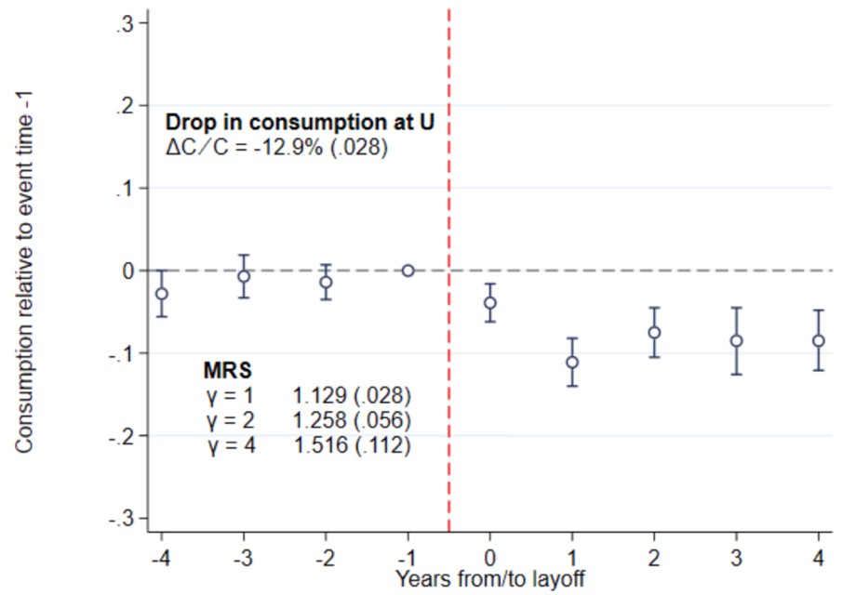

# Figure 2: Identifying Variation in Local Transfers

**Code**: Figure2.do

**Data:**

* 400_spell0007.dta
* 416_AllMonthsBarnAll.dta

**Sample:**

* Sample restrictions from 400_spellDec0007.dta:
  + Years 2000-2007
  + Eligible workers, no quits
  + Individuals aged 25-55 at the time of their first recorded unemployment spell
  + First spell between 2002-2007, only one spell per HH in this interval
  + Unemployed in December in the year of being laid off
* Additional sample restrictions
  + Remove pair of workers for whom we cannot retrieve lagged income on the year of the unemployment spell for the treated – i.e. missing L_incUnemp
  + Remove L_incUnemp =< 50,000 – keep only those eligible to basic UI
  + Treated workers i.e. unemployed workers

### Panel A,B, and C

**Sample:**

* current recipient – positive benefits in t
* at least one children – depchild_mod > 0

**Method:**

* Linear regression with group FE – *areg .. , absorb()*
* Outcome: benefits - SocBidrPersF
* Covariates:
  + Baseline : number of household members, age groups, year FE, dummies for number of children of certain ages, gender, marital status, family type, wealth decile
  + Panel A: income deciles, dummy for youngest children age
  + Panel B: income deciles, dummy for number of dependent children
  + Panel C: quintiles of income, dummy for youngest children age, dummy for number of dependent children

**Results:**

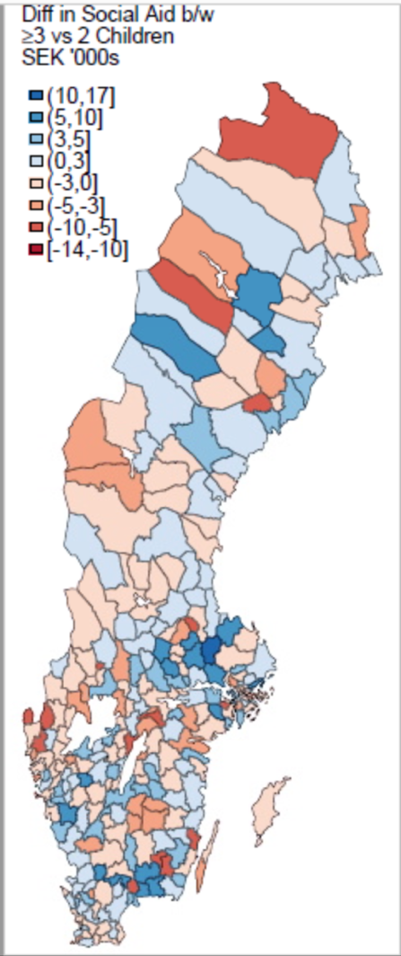

### Panel D

**Residualisation:**

* Sample: current recipient – positive benefits in t
* Linear regression of total benefits (SocBidr and BostBidr) on number of household members, age groups, year FE, dummies for number of children of certain ages, gender, marital status, family type, wealth decile, income decile

**Map**:

i) Defining the weights in the reference sample

* Take the population composition of Stockholm (Kommun = 180) in 2000 as a reference

Sample: 38,614 observations

* Split the following variables in 2 groups:
  + V1: Age, cut at 40 => above_40 (dummy)
  + V2: Family : married (FamType = {8,..12}) / single (FamType = {2,..,7}) => single_dummy
  + V3: Income (FovInk, as in the residualisation): cut at the median 242,058 SEK => above_med_ForvInk (dummy)
  + V4: Kids: no kids (FamType = {2,5,12}) / vs kids (FamType = {3,4,6,7,8,9,10,11}) => kids_dummy
* Compute the number of individuals in each cell V1 x V2 x V3 x V4 in 2000 in Stockholm and compute the share of each category in the total population

ii) Assigning weights to all other cities / years

* Starting from Starting from 413_Cleaned&Residualised_final.dta
* Drop missing values in FamType, Age, ForvInk (.08% of the sample) as it might have a residual effect on the counts. Drop FamType == 1 (contradictory family composition) (5 obs)
* Define the same set of dummy variables V1/V2/V3/V4
* Retrieve the initial number of individuals in each cell per (Kommun, year) as well as the total number of individuals per (Kommun,year)
* For each individual i, in a given cell jklm, define weights using the following formula:

iii) Map

* Collapse the data set by (Kommun,year) and retrieve average residualised benefits, using the weights defined above.

Note. I used analytical weights. Frequency weights do not allow for non-integer values.

* Retrieve change in (average) benefits between 2000 and 2007
* Set to missing when the average is computed over less than 4 individuals

**Results:**

# Table 2 & Figure 3

**Code:** Table2Figure3.do

**Data:**

* 400_spellDec0007.dta
* 416_AllMonthsBarnAll.dta

**Sample:**

* Sample restrictions from 400_spellDec0007.dta:
  + Years 2000-2007
  + Eligible workers, no quits
  + Individuals aged 25-55 at the time of their first recorded unemployment spell
  + First spell between 2002-2007, only one spell per HH in this interval
  + Unemployed in December in the year of being laid off
* Additional sample restrictions
  + Remove pair of workers for whom we cannot retrieve lagged income on the year of the unemployment spell for the treated – i.e. missing L_incUnemp
  + Remove L_incUnemp =< 50,000 – keep only those eligible to basic UI
  + Treated workers i.e. unemployed workers

N = 1,313,456 = 164,182 workers x 8 years

## Table 2: Marginal Propensity to Consume Out of Local Welfare Transfers By Unemployment Status

**Method:**

* Residualisation of social benefits
  + Residualisation
    - Linear regression
    - Outcome variable: SocBidrPersF - social benefits only
    - Covariates: household members, age group, year fixed effects, age of children and their age, number of children and their age, gender, marital status, family type, and decile for wealth and income
    - No Kommun Fe
  + Treatments applied to the residuals:
    - retrieve residuals ,
    - substract group average: =
    - take the first difference: d_
* MPC estimation
  + Trimming top/bottom 10% of d_cons6
  + Linear regression, standard errors clustered at the Kommun,year level
  + Outcome variable: d_cons6 (FD consumption 6)
  + Covariates: Residuals of social benefits interacted with unemployment duration – i.e. x, y, x#y. Duration of unemployment defined at the quarterly level

**Computation of standard errors**. and

## Figure 3: Relationship Between First-Difference in Residual Local Transfers and First-Difference in Consumption by Employment Status

**Method:**

* Linear regression of d_cons6 (FD consumption 6) on residuals of social benefits
* Trimming top/bottom 10% of d_cons6
* By sub-sample : before/after reemployment

# Figure 4: Regression kink design: Effect of UI benefits variation on consumption at unemployment

## Panel A : A. UI Benefit Replacement Rate

Data: 140_RKDgraph_diag.dta

Sample:

* Year 2002-2007
* Non-null (or missing values) in wages or benefits
* 350 bandwidth around the kink
* Lagged UI == 1

Method:

1. Collapse. Aggregate the outcome (benefits/wage) and explanatory variables at the wage bin level
2. RKD estimation. Regress linearly the he outcome on (wage – kink), (wage – kink)*(wage>kink) (by wage bin, using weights). Retrieve corresponding coefficients.

What is then plotted is:

* Blue dots : average value by wage bin – derived from the collapse
* Red curve: linear fit from RKD estimation – i.e. ratio on a + b*(wage – kink) + c*(wage – kink)*(wage>kink)

Results

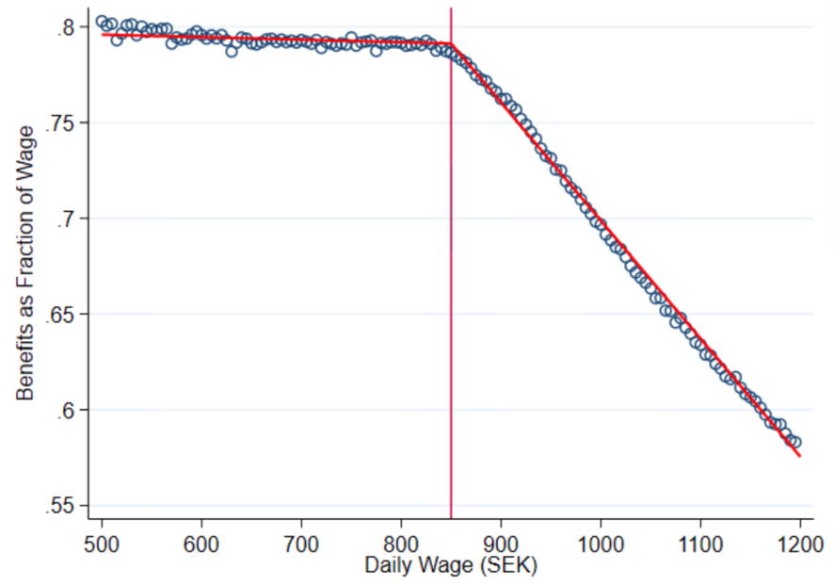

## Panel B: Consumption Drop at Unemployment

Data:

* 140_spell0007ins_Full.dta
* 140_PES_RKD_Alex.dta

Sample:

* Sample restrictions from data creation:
  + December sample – individuals whose first unemployment spell starts in December of year t
  + Keep unemployment spells that last at most 12 months
  + Keep year of unemployment
* Sample restrictions from RKD:
  + Year 2002-2007
  + Non-null (or missing values) in wages or benefits
  + 350 bandwidth around the kink
  + Lagged UI == 1
  + Trimming top/bottom 1% of consumption change
  + Keep age 25-55
  + Trimming

Method: MORE DETAILS TO BE ADDED

What is then plotted is:

* Blue dots : average value by wage bin – derived from the collapse
* Red curve: linear fit from RKD estimation – i.e. ratio on a + b*(wage – kink) + c*(wage – kink)*(wage>kink)

Results

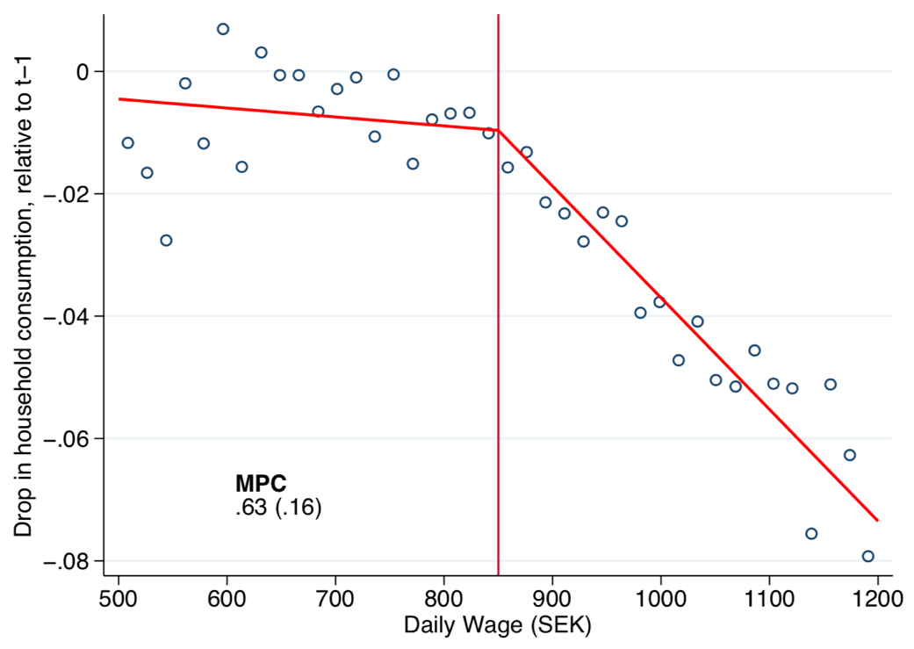

# Figure 5: Non-parametric and Parametric RP Estimation

**Code:** Figure5.do

## Panel A. Expected Price vs. Insurance Coverage

Initial codes:

* Uival_306_StructuralUMispLogit.dp
* Uival_311_nonParamCharts.do

**Data:** 305_structural_elig.dta

**Sample:** (check pre-existing sample restrictions etc)

**Method:**

* *Structural Estimation.* 
  + Starting from 305_structural_elig.dta. Create a measure of expected price at the individual level using predicted risk under comprehensive***.***
  + Run a logit regression of UI on expected price, log of lagged income (t-1 and t-2), year FE, age (quadratic form), gender, education level, family type. Random sub-sample : 5% of the initial sample.
  + Convert the prediction of the number of days spent unemployed in year t + 1 into a binary risk and obtain a measure of the expected price per unit of coverage.
* *Graph.* Plot average expected price per cell, for average expected price < 3. Draw mean, median and CI from structural estimation.

**Output**:

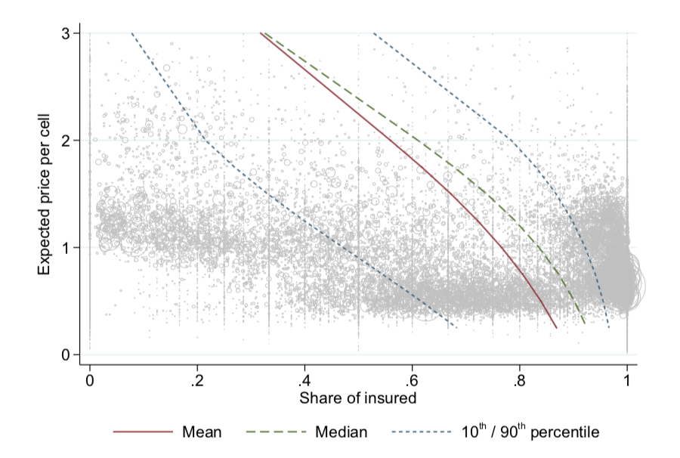

## Panel B. Parametric Estimation of MRS Distribution

Initial codes:

* uival_306_StructuralUnconstrainedLogit.do : baseline, insured / uninsured
* uival_333_MRS_DecSample_distributions : graph

Data :

* 305_structural_elig.dta for estimation
* 102_SpellDec0007_bis.dta

Sample:

* December sample
* Year prior to unemployment event (t = -1)

Method:

Result:

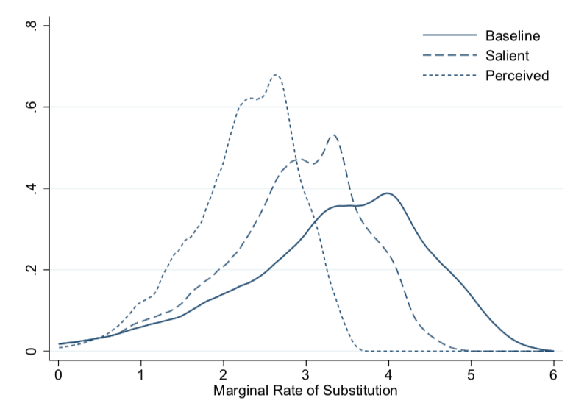

# Figure 6: Comparison of MRS Estimates Across Different Approaches for the Baseline Sample

MRS_CI_MH_MPC_SE_misperception_mean.pdf

# Table 1: Baseline Sample: Summary statistics

Code : Table1.dta

Data :

* 102_spellDec0007_bis.dta : December sample
* 305_structurel_elig.dta : estimation from predicted risk model

Sample :

* Implicit sample restrictions :
  + December sample
  + First unemployment spell – occurs over the years 2002-2007, when individual aged between 25-55
  + Exclude households where more than one member experiences an unemployment spell between 2002 and 2007.
  + Eligible workers, no quits,
* Explicit sample restrictions
  + Year prior to unemployment spell

Output: See excel file.

# Table 2

**Code:** Table2Figure4.do

Building from:

* 431_MPC_heterogeneity.do
* 413_MPC_SocialAid_descriptives_Unemp.do (using residualisation v4 of benefits)
* 415_SocAidvariatio_decomposition.do for the MPC analysis, as in equation (21) of the paper

**Data:** 400_spellDec0007.dta

**Sample:**

* Sample restrictions from 400_spellDec0007.dta:
  + Years 2000-2007
  + Eligible workers, no quits
  + Individuals aged 25-55 at the time of their first recorded unemployment spell
  + First spell between 2002-2007, only one spell per HH in this interval
  + Unemployed in December in the year of being laid off
* Additional sample restrictions
  + Remove pair of workers for whom we cannot retrieve lagged income on the year of the unemployment spell for the treated – i.e. missing L_incUnemp
  + Remove L_incUnemp =< 50,000 – keep only those eligible to basic UI
  + Treated workers i.e. unemployed workers

N = 1,313,456 = 164,182 workers x 8 years

**Method:**

* Residualisation of social benefits
  + Residualisation
    - Linear regression
    - Outcome variable: SocBidrPersF - social benefits only
    - Covariates: household members, age group, year fixed effects, age of children and their age, number of children and their age, gender, marital status, family type, and decile for wealth and income
    - No Kommun Fe
  + Treatments applied to the residuals:
    - retrieve residuals ,
    - substract Kommun average: =
    - take the first difference: d_
* MPC estimation
  + Trimming top 10% and bottom 10% of d_cons6
  + Restrict the sample to workers receiving welfare benefits in t-1, i.e. social benefits + housing benefits
  + Linear regression, standard errors clustered at the Kommun,year level
  + Outcome variable: d_cons6 (FD consumption 6)
  + Covariates: Residuals of social benefits interacted with unemployment duration – i.e. x, y, x#y. Duration of unemployment defined at the quarterly level

**Computation of standard errors**. and

**Results :**

~~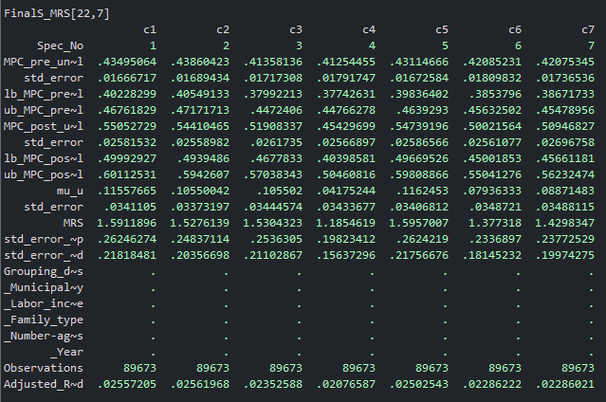~~

Corresponding Tex files in:

* […]\Empirical Analysis\6. MPC\Transfers\specification comparison spreadsheets\Social Aid only\Results with CI
* […]\Empirical Analysis\6. MPC\Transfers\specification comparison spreadsheets\Social Aid only\Results with nullity test

# Table 3: Insurance Choice Model Estimation & Implied MRS Distribution

Code : Table3Table4.do

Data: 306_structural_elig_cov.dta

Sample: Sample is the baseline sample of workers experiencing their first recorded unemployment spell between 2002 and 2007, as also used for the CB and MPC implementation.

Column 8 restricts the sample to individuals that experienced a change in job at some point in the 2002-2007 period. In column 9 the sample is further restricted to years in which a change in job took place.

Method:

1. Kolsrud, Jonas, Camille Landais, Peter Nilsson, and Johannes Spinnewijn, “The Optimal Timing of Unemploy- ment Benefits: Theory and Evidence from Sweden,” American Economic Review, April 2018, 108 (4-5), 985–1033.