JobMatch Cambodia — Database ERD
Production PostgreSQL Relational Schema & Foreign Key Architecture
Summary: 10 Production Tables · 93 Columns · 10 Foreign Key Relationships · 1 Soft Reference
1. Entity Relationship Diagram (Visual Schema)
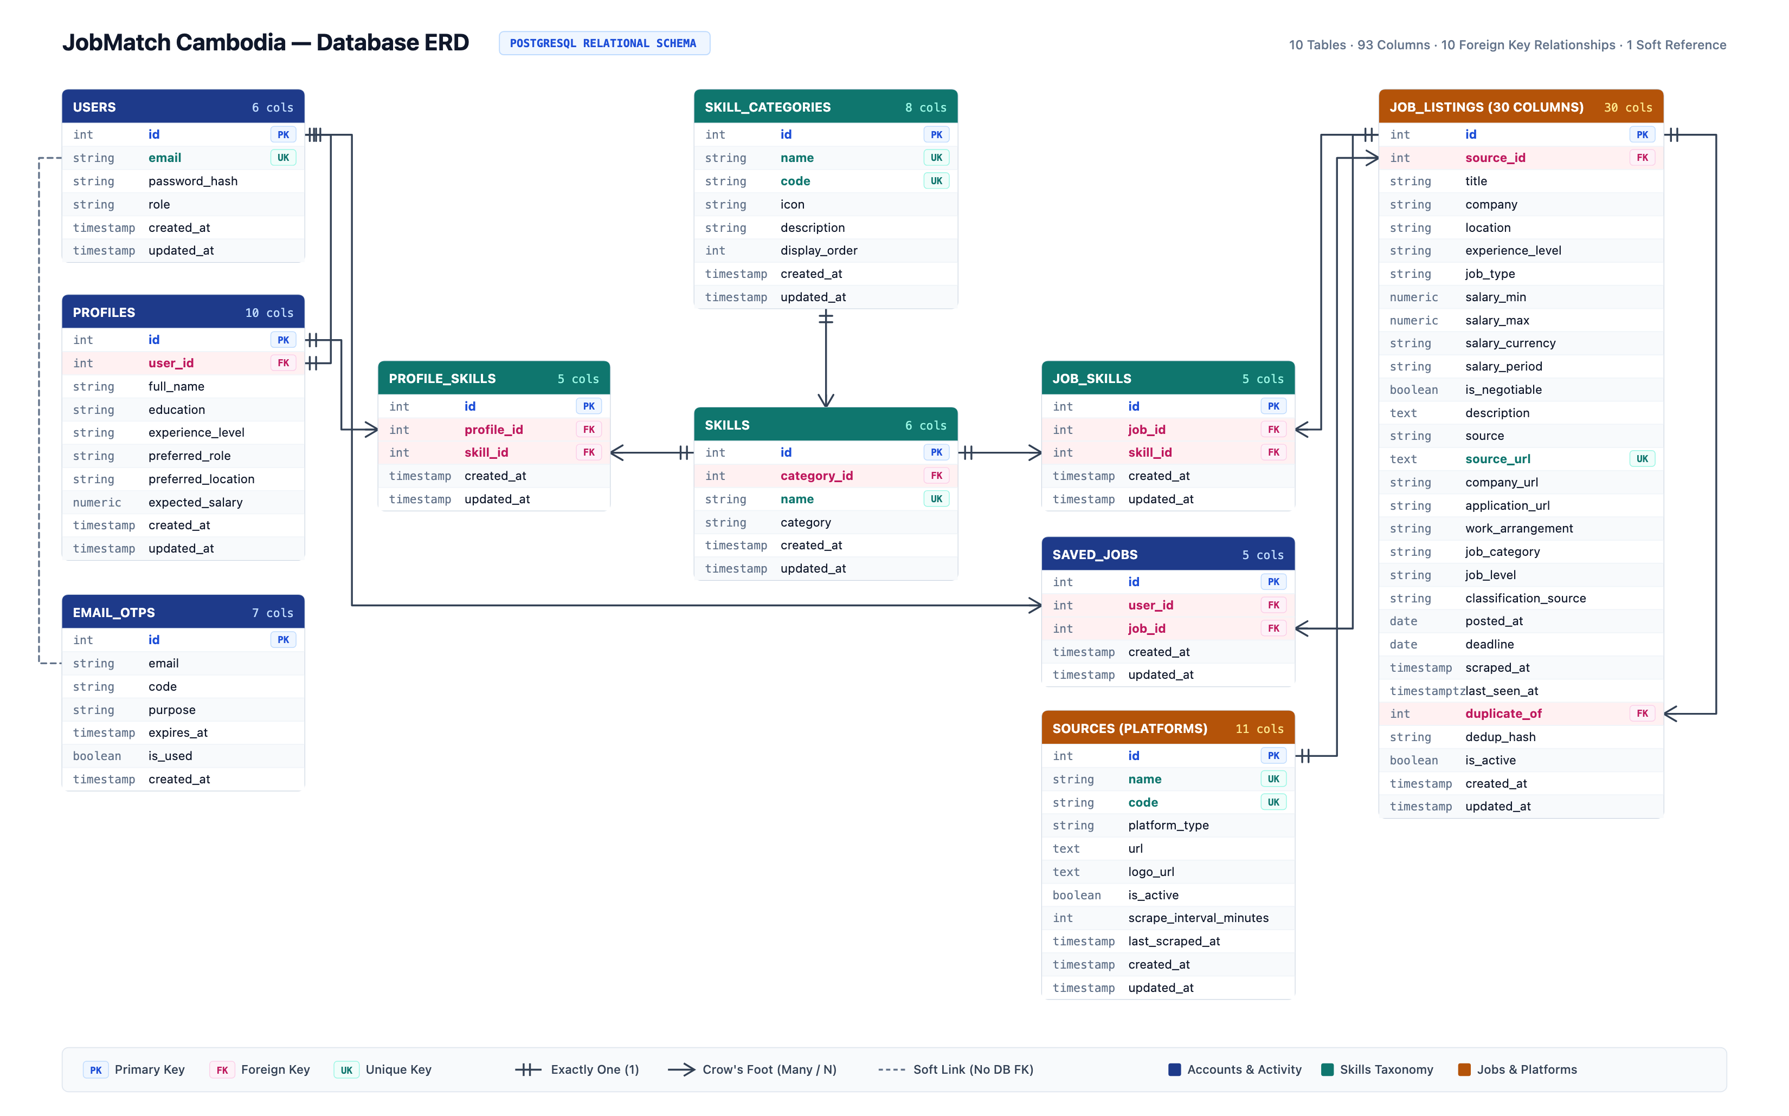
Figure 1: Full 10-Table Production Entity Relationship Diagram (Landscape View)
2. Foreign Key & Entity Relationships
From Table | To Table | Type | Foreign Key Column | Referential Action
users | profiles | 1 : 1 | profiles.user_id → users.id | ON DELETE CASCADE
users | saved_jobs | 1 : N | saved_jobs.user_id → users.id | ON DELETE CASCADE
profiles | profile_skills | 1 : N | profile_skills.profile_id → profiles.id | ON DELETE CASCADE
skill_categories | skills | 1 : N | skills.category_id → skill_categories.id | ON DELETE SET NULL
skills | profile_skills | 1 : N | profile_skills.skill_id → skills.id | ON DELETE CASCADE
skills | job_skills | 1 : N | job_skills.skill_id → skills.id | ON DELETE CASCADE
job_listings | job_skills | 1 : N | job_skills.job_id → job_listings.id | ON DELETE CASCADE
job_listings | saved_jobs | 1 : N | saved_jobs.job_id → job_listings.id | ON DELETE CASCADE
sources | job_listings | 1 : N | job_listings.source_id → sources.id | ON DELETE SET NULL
job_listings | job_listings | 1 : N | duplicate_of → job_listings.id | ON DELETE SET NULL (Self Ref)
users | email_otps | Soft Link | users.email ⤏ email_otps.email | Application Logic Verification
3. Data Dictionary & Detailed Table Schemas
Table: users
Stores candidate and administrator account credentials, authentication hashes, and system roles.
Column | Type | Key | Notes
id | integer | PK | Unique account identifier, auto-incrementing serial
email | varchar(255) | UK | User login email address, unique index
password_hash | varchar(255) | - | Bcrypt hashed credential string
role | varchar(20) | - | Authorization system role ('user', 'admin')
created_at | timestamp | - | Account registration timestamp (UTC)
updated_at | timestamp | - | Account modification timestamp
Table: profiles
Stores candidate professional details and matching preferences. Connected 1:1 with users.
Column | Type | Key | Notes
id | integer | PK | Unique profile identifier, serial
user_id | integer | FK | Associated user account (FK → users.id, UNIQUE, CASCADE)
full_name | varchar(150) | - | Candidate display name
education | varchar(150) | - | University degree, major, or academic institution
experience_level | varchar(50) | - | Seniority level ('entry', 'junior', 'mid', 'senior')
preferred_role | varchar(100) | - | Target job title (e.g. Flutter Developer)
preferred_location | varchar(100) | - | Preferred work city (e.g. Phnom Penh)
expected_salary | numeric(10,2) | - | Monthly expected compensation in USD (no float)
created_at | timestamp | - | Profile creation timestamp
updated_at | timestamp | - | Profile update timestamp
Table: email_otps
Stores temporary 6-digit cryptographic verification codes for registration and passwordless login.
Column | Type | Key | Notes
id | integer | PK | Unique OTP identifier, serial
email | varchar(255) | - | Target recipient email, indexed (soft link to users.email)
code | varchar(6) | - | 6-digit cryptographic verification code
purpose | varchar(50) | - | Purpose token ('register', 'login', 'reset')
expires_at | timestamp | - | Expiration timestamp (standard 10-minute window)
is_used | boolean | - | Redemption flag indicating whether code was consumed
created_at | timestamp | - | Code generation timestamp
Table: skill_categories
Master taxonomy grouping technical and soft competencies into domain clusters (3NF Normalization).
Column | Type | Key | Notes
id | integer | PK | Unique category identifier, serial
name | varchar(100) | UK | Human-readable category title ('Mobile Development', etc.)
code | varchar(50) | UK | Machine-readable slug ('mobile', 'backend', 'database')
icon | varchar(50) | - | Material/Cupertino icon identifier for Flutter UI chips
description | text | - | Scope of competencies and tools included in domain
display_order | integer | - | Visual ordering on mobile candidate profile chip screen
created_at | timestamp | - | Category creation timestamp
updated_at | timestamp | - | Category update timestamp
Table: skills
Master catalog of standardized technical skill tokens referenced across candidate profiles and job listings.
Column | Type | Key | Notes
id | integer | PK | Unique skill identifier, serial
category_id | integer | FK | Reference to master category (FK → skill_categories.id, SET NULL)
name | varchar(50) | UK | Normalized skill token (e.g. Flutter, FastAPI, PostgreSQL)
category | varchar(50) | - | Denormalized category string for backward compatibility
created_at | timestamp | - | Skill creation timestamp
updated_at | timestamp | - | Skill update timestamp
Table: profile_skills
Many-to-many junction table associating candidate profiles with acquired technical skills.
Column | Type | Key | Notes
id | integer | PK | Unique junction identifier, serial
profile_id | integer | FK | Candidate profile reference (FK → profiles.id, CASCADE)
skill_id | integer | FK | Standardized skill reference (FK → skills.id, CASCADE)
created_at | timestamp | - | Association creation timestamp
updated_at | timestamp | - | Association update timestamp
Table: job_skills
Many-to-many junction table associating job listings with required skills extracted via NLP.
Column | Type | Key | Notes
id | integer | PK | Unique junction identifier, serial
job_id | integer | FK | Job listing reference (FK → job_listings.id, CASCADE)
skill_id | integer | FK | Required skill reference (FK → skills.id, CASCADE)
created_at | timestamp | - | Association creation timestamp
updated_at | timestamp | - | Association update timestamp
Table: saved_jobs
Stores candidate bookmarks for vacancies saved to be reviewed or applied to later.
Column | Type | Key | Notes
id | integer | PK | Unique bookmark identifier, serial
user_id | integer | FK | Candidate account reference (FK → users.id, CASCADE)
job_id | integer | FK | Bookmarked vacancy reference (FK → job_listings.id, CASCADE)
created_at | timestamp | - | Bookmark creation timestamp
updated_at | timestamp | - | Bookmark update timestamp
Table: sources
Master registry of external recruitment sources and Telegram job aggregation channels.
Column | Type | Key | Notes
id | integer | PK | Unique source identifier, serial
name | varchar(100) | UK | Platform title (e.g. 'CamHR', 'BongThom', 'Telegram Jobs')
code | varchar(50) | UK | Machine-readable platform slug, indexed
platform_type | varchar(50) | - | Channel type ('telegram', 'web_portal', 'api')
url | text | - | Official platform root URL or public channel link
logo_url | text | - | CDN static image path for mobile source branding chip
is_active | boolean | - | Scraping enabled flag (default true)
scrape_interval_minutes | integer | - | Ingestion run frequency in minutes (default 60)
last_scraped_at | timestamp | - | Timestamp of most recent scraping pass
created_at | timestamp | - | Source record creation timestamp
updated_at | timestamp | - | Source record update timestamp
Table: job_listings
Primary vacancy repository storing 30 normalized columns aggregated from external recruitment channels.
Column | Type | Key | Notes
id | integer | PK | Unique job listing identifier, serial
source_id | integer | FK | Reference to recruitment source (FK → sources.id, SET NULL)
title | varchar(200) | - | Cleaned, standardized job title
company | varchar(150) | - | Verified hiring organization name
location | varchar(100) | - | Job location (e.g. Phnom Penh, Remote)
experience_level | varchar(50) | - | Required career seniority ('entry', 'junior', 'mid', 'senior')
job_type | varchar(50) | - | Employment arrangement ('full-time', 'part-time', 'internship')
salary_min | numeric(10,2) | - | Minimum monthly compensation in USD (no float)
salary_max | numeric(10,2) | - | Maximum monthly compensation in USD (no float)
salary_currency | varchar(10) | - | Currency denomination ('USD', 'KHR')
salary_period | varchar(20) | - | Pay cycle ('monthly', 'yearly', 'hourly')
is_negotiable | boolean | - | Flag indicating negotiable compensation
description | text | - | Full cleaned vacancy description text
source | varchar(50) | - | Origin platform identifier string
source_url | text | UK | Direct canonical URL to original post, unique index
company_url | string | - | Official hiring company homepage URL
application_url | string | - | Direct application link (Google Form, external ATS)
work_arrangement | string | - | Workplace setting ('on-site', 'hybrid', 'remote')
job_category | string | - | Primary technical domain classification
job_level | string | - | Standardized seniority classification
classification_source | string | - | Origin of classification model ('jev' or 'rule')
posted_at | date | - | Original publication date on source platform
deadline | date | - | Application closing deadline date
scraped_at | timestamp | - | Initial ingestion timestamp
last_seen_at | timestamptz | - | Timestamp when listing was confirmed active during scrape
duplicate_of | integer | FK | Canonical primary listing ID for deduplication (FK → job_listings.id)
dedup_hash | string | - | MD5 fingerprint hash for cross-source deduplication
is_active | boolean | - | Active visibility status flag for feed display
created_at | timestamp | - | Database ingestion timestamp
updated_at | timestamp | - | Record update timestamp
4. Suggested Schema Improvements (Architectural Recommendations)
Note: The following architectural enhancements represent production best practices for scalability, data integrity, and mobile feed performance. These are documented as suggestions and do not alter the base diagram.
• Composite Unique Keys on Junction Tables: Add composite UNIQUE(profile_id, skill_id) on profile_skills and UNIQUE(job_id, skill_id) on job_skills to prevent duplicate skill pairs at the database constraint layer.
• Strict 1:1 Enforcement on Profiles: Add UNIQUE(user_id) on the profiles table to guarantee at the database level that each candidate account can never instantiate multiple profiles.
• Formal Referential Action Rules (ON DELETE): Enforce ON DELETE CASCADE for candidate-owned entities (profiles, profile_skills, saved_jobs) for clean data deletion, and ON DELETE SET NULL for external sources and taxonomy nodes to preserve historical job postings.
• Taxonomy Normalization: Deprecate the redundant string columns skills.category and job_listings.source in favor of existing relational foreign keys skills.category_id and job_listings.source_id.
• Timestamptz Consistency: Standardize all timestamp columns across all tables to timestamptz (timezone-aware UTC) to eliminate clock drift discrepancies between local Cambodia time (UTC+7) and cloud infrastructure.
• Feed Pagination B-Tree Composite Indexes: Create composite B-Tree indexes on job_listings(is_active, posted_at DESC) and job_listings(job_category, posted_at DESC) for sub-50ms mobile feed queries.
• Transient OTP Retention Policy: Implement automated daily cleanup or PostgreSQL TTL partition drops for consumed or expired OTP records older than 24 hours to keep the security audit log clean.

