

**MILITARY COLLEGE OF SIGNALS**

**DEPARTMENT OF COMPUTER SOFTWARE ENGINEERING**

**OPEN ENED LAB - FOP**

|  |  |
| --- | --- |
| Submitted To | Mam Hafsa |
| Submitted By | Capt Mursaleen Ahmad |
| Hafiz Muhammad Tayyab Zia |
| Eesha Siddiqui |
| Abdullah Adil |
| Class | BESE 30-A |

Table of Contents ( Will be added at the end)

**Title of the Project**

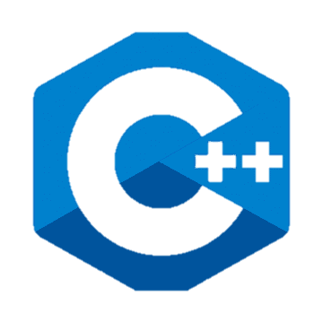**Student Grade Management System**

Student Grade Management System is a simple, interactive C++ program designed to help manage and analyze student grades efficiently. With features like marks input, validation, grade classification, average calculations, and the ability to update grades, it offers a streamlined and user-friendly solution for managing student performance data. By leveraging modular functions and a structured design, the program ensures clarity and functionality, making it an effective tool for academic grade tracking and management.

**Abstract**

The Student Grade Management System is a C++ program designed to facilitate the management of student grades for multiple subjects. The program allows users to input and validate student marks, classify grades based on a defined grading scale, calculate averages for individual students and subjects, and display results in a clear and structured format. Additionally, the system provides the functionality to update marks after the initial input, ensuring flexibility and accuracy. By employing modular functions and structured programming techniques, the system offers a user-friendly, efficient, and interactive approach to tracking and managing student performance. This tool is ideal for academic settings, enhancing the overall process of grade management.

**Objective**

The objective of the Student Grade Management System is to provide an efficient and user-friendly tool for managing and analyzing student performance. The system aims to streamline the process of inputting marks, validating data, classifying grades, calculating averages, and displaying results in a clear format. Additionally, it offers the flexibility to update marks as needed, ensuring accuracy and adaptability. The program is designed to enhance the management of academic records, making it a valuable resource for educators and administrators in maintaining organized and accurate student performance data.

**Scope**

It provides following functionalities:

• Manage grades for multiple students and subjects efficiently.

• Input, validate, and update student marks with ease.

• Classify grades based on a grading scale.

• Calculate and display averages for students and subjects.

• Provide a user-friendly interface for academic record management.