4.6 Prototype Interface Design
The prototype is delivered as a single-page React dashboard organised into five views, accessed through a persistent left sidebar. Each view exposes a distinct stage of the late-fusion monitoring pipeline — live observation, signal inspection, session review, decision explanation, and runtime configuration — while sharing one common RiskUpdate data contract. The interface is driven by a deterministic prepared-session replay loop that advances one inference window every Δt seconds, allowing the full risk-assessment behaviour to be demonstrated without a live model backend.

4.6.1 Live Monitor View
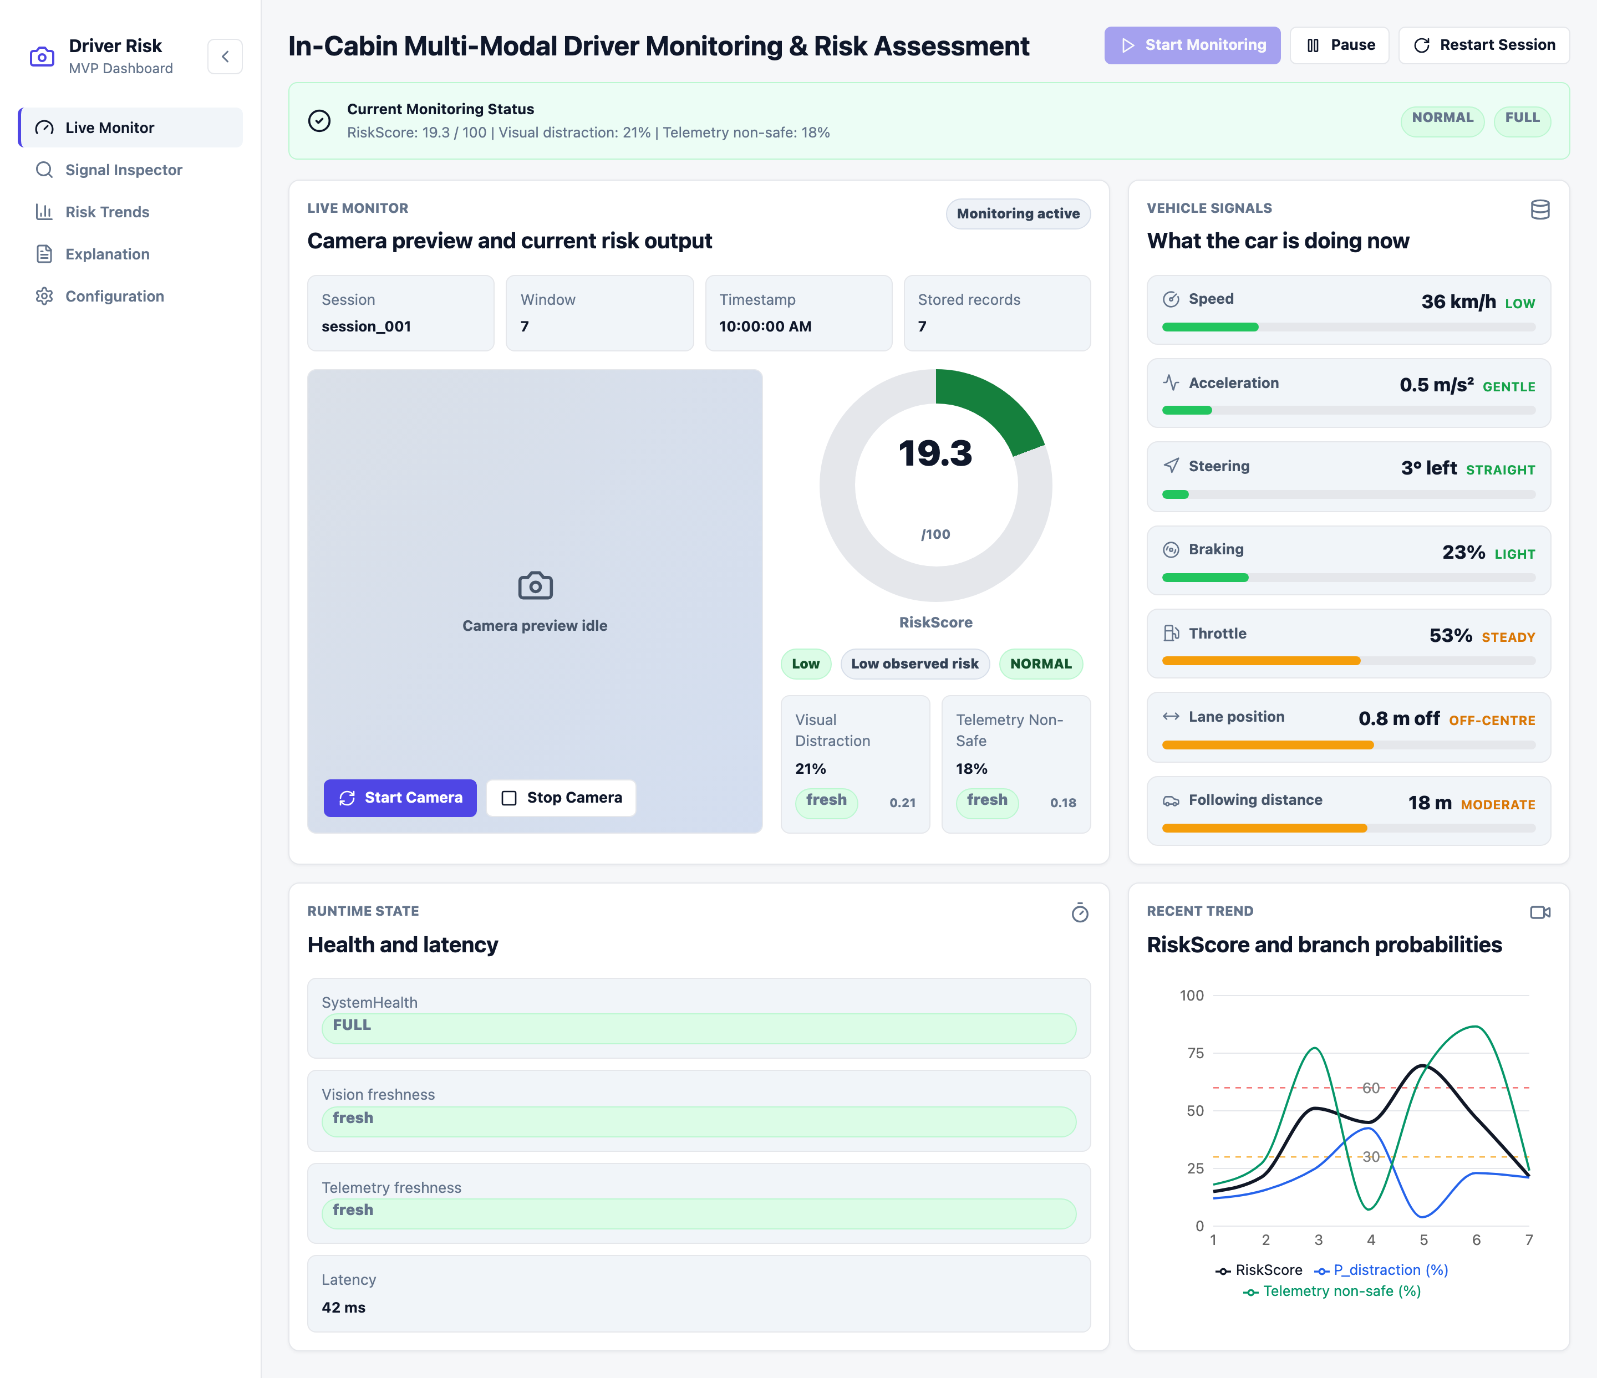
Figure 12: Prototype Interface — Live Monitor View
Figure 12 shows the primary real-time monitoring screen, presenting the current driver-risk output alongside the live camera and vehicle signals:
Camera Preview and Risk Summary
- Live webcam preview pane provides the visual input interface, with start/stop camera controls.
- Circular RiskScore gauge displays the fused 0–100 risk value, colour-graded by severity.
- Status pills summarise RiskLevel (Low/Medium/High), DominantEvidence, and AlertSeverity at a glance.
- Two modality cards report Visual Distraction and Telemetry Non-Safe probabilities with their freshness state.
Vehicle Signals Panel
- Eight vehicle-dynamics signals (speed, acceleration, steering, braking, throttle, lane position, following distance) shown with icons, plain-language values and units.
- Each signal has a colour-coded progress bar (green → amber → red) and a qualitative tag such as “low”, “gentle”, or “safe gap”, instead of raw model features.
Runtime State and Trend
- SystemHealth, vision/telemetry freshness, and end-to-end latency confirm the pipeline is operating within Δt.
- Recent-trend line chart overlays RiskScore against both branch probabilities across the latest windows.
Design Rationale: The view separates the human-readable monitoring summary (gauge, plain-language vehicle signals) from technical runtime evidence, so a non-specialist assessor can read the current risk state without inspecting model internals.

4.6.2 Signal Inspector View
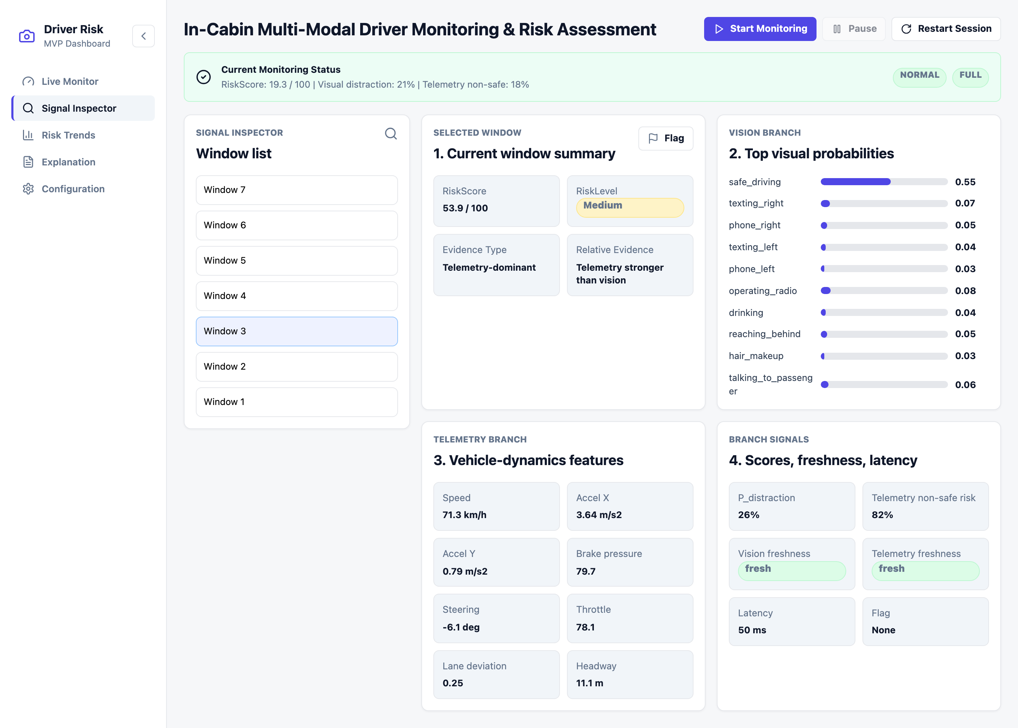
Figure 13: Prototype Interface — Signal Inspector View
Figure 13 presents the per-window inspection screen, used to examine the raw branch inputs and outputs for any selected inference window:
Window List and Summary
- Scrollable window list lets the assessor select any past inference window in the session.
- Selected-window summary shows RiskScore, RiskLevel, Evidence Type, and the relative modality split.
- A Flag control marks a window for later review, demonstrating update-style persistence.
Vision Branch — Top Visual Probabilities
- Horizontal bar list of the ten driver-state class probabilities produced by the vision branch (e.g. safe_driving, texting, phone, operating_radio).
Telemetry Branch and Branch Signals
- Vehicle-dynamics feature panel lists the eight structured telemetry inputs in their raw measured form.
- Branch-signals panel reports P_distraction, telemetry non-safe risk, per-modality freshness, latency, and flag state.
Design Rationale: This view exposes the full raw evidence behind every window, giving technical reviewers a transparent, drill-down counterpart to the summarised Live Monitor.

4.6.3 Risk Trends View
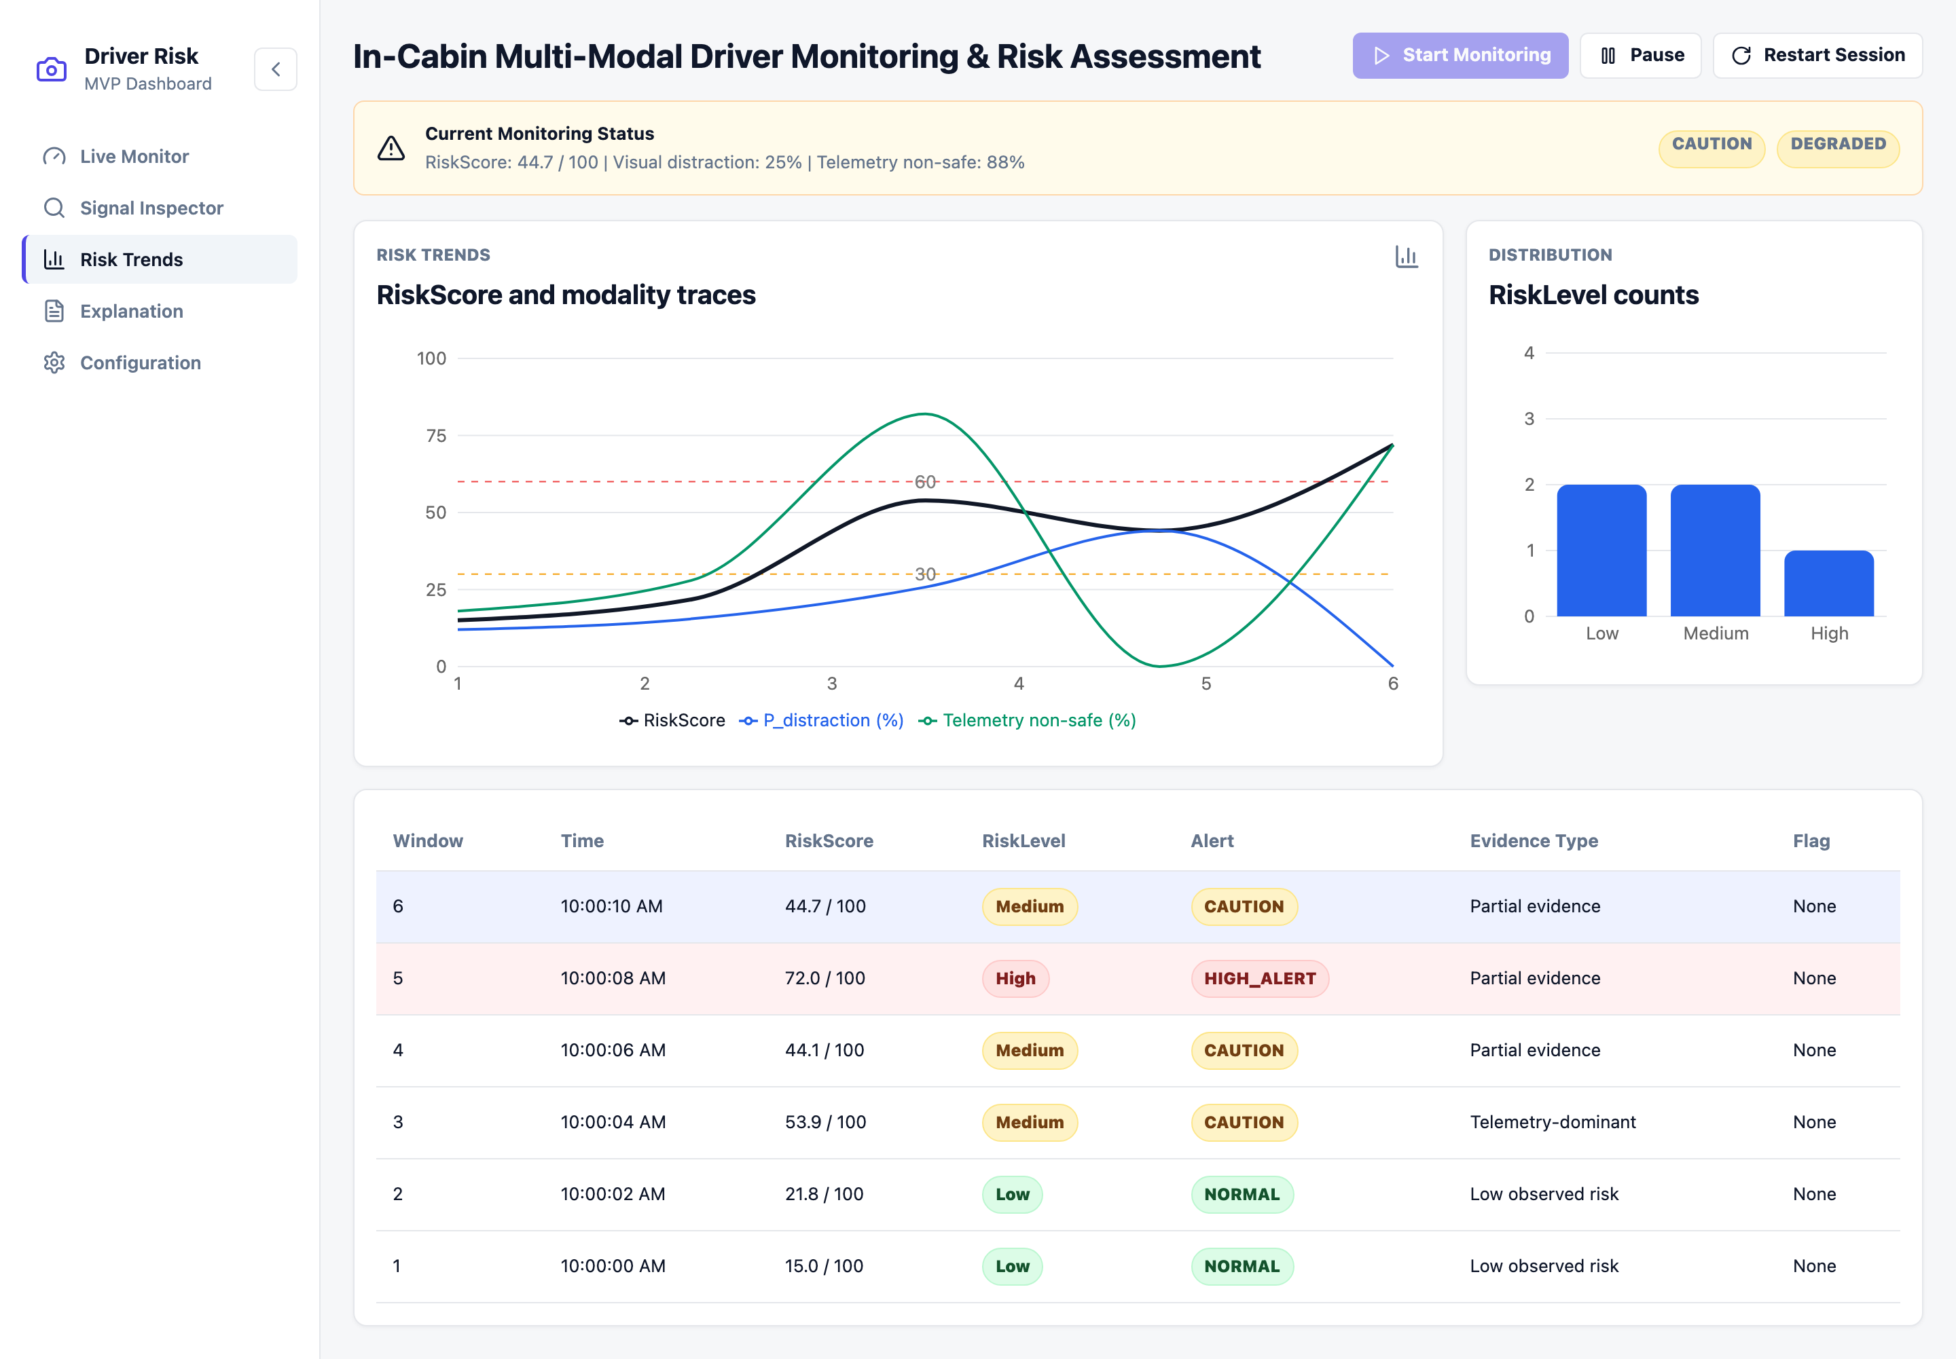
Figure 14: Prototype Interface — Risk Trends View
Figure 14 provides a session-level review of how risk evolved over the monitoring run:
RiskScore and Modality Traces
- Multi-line chart plots RiskScore against vision and telemetry probabilities across all windows.
- Threshold reference lines mark the Low/Medium and Medium/High boundaries.
Distribution and Event Log
- RiskLevel distribution bar chart counts how often each level occurred during the session.
- Tabular event log lists every window with timestamp, RiskScore, RiskLevel, Alert, Evidence Type, and flag — forming the exportable session record.
Design Rationale: The trend and log together evidence the pipeline’s session-level behaviour and provide the data later exported as JSON/CSV for evaluation.

4.6.4 Explanation View
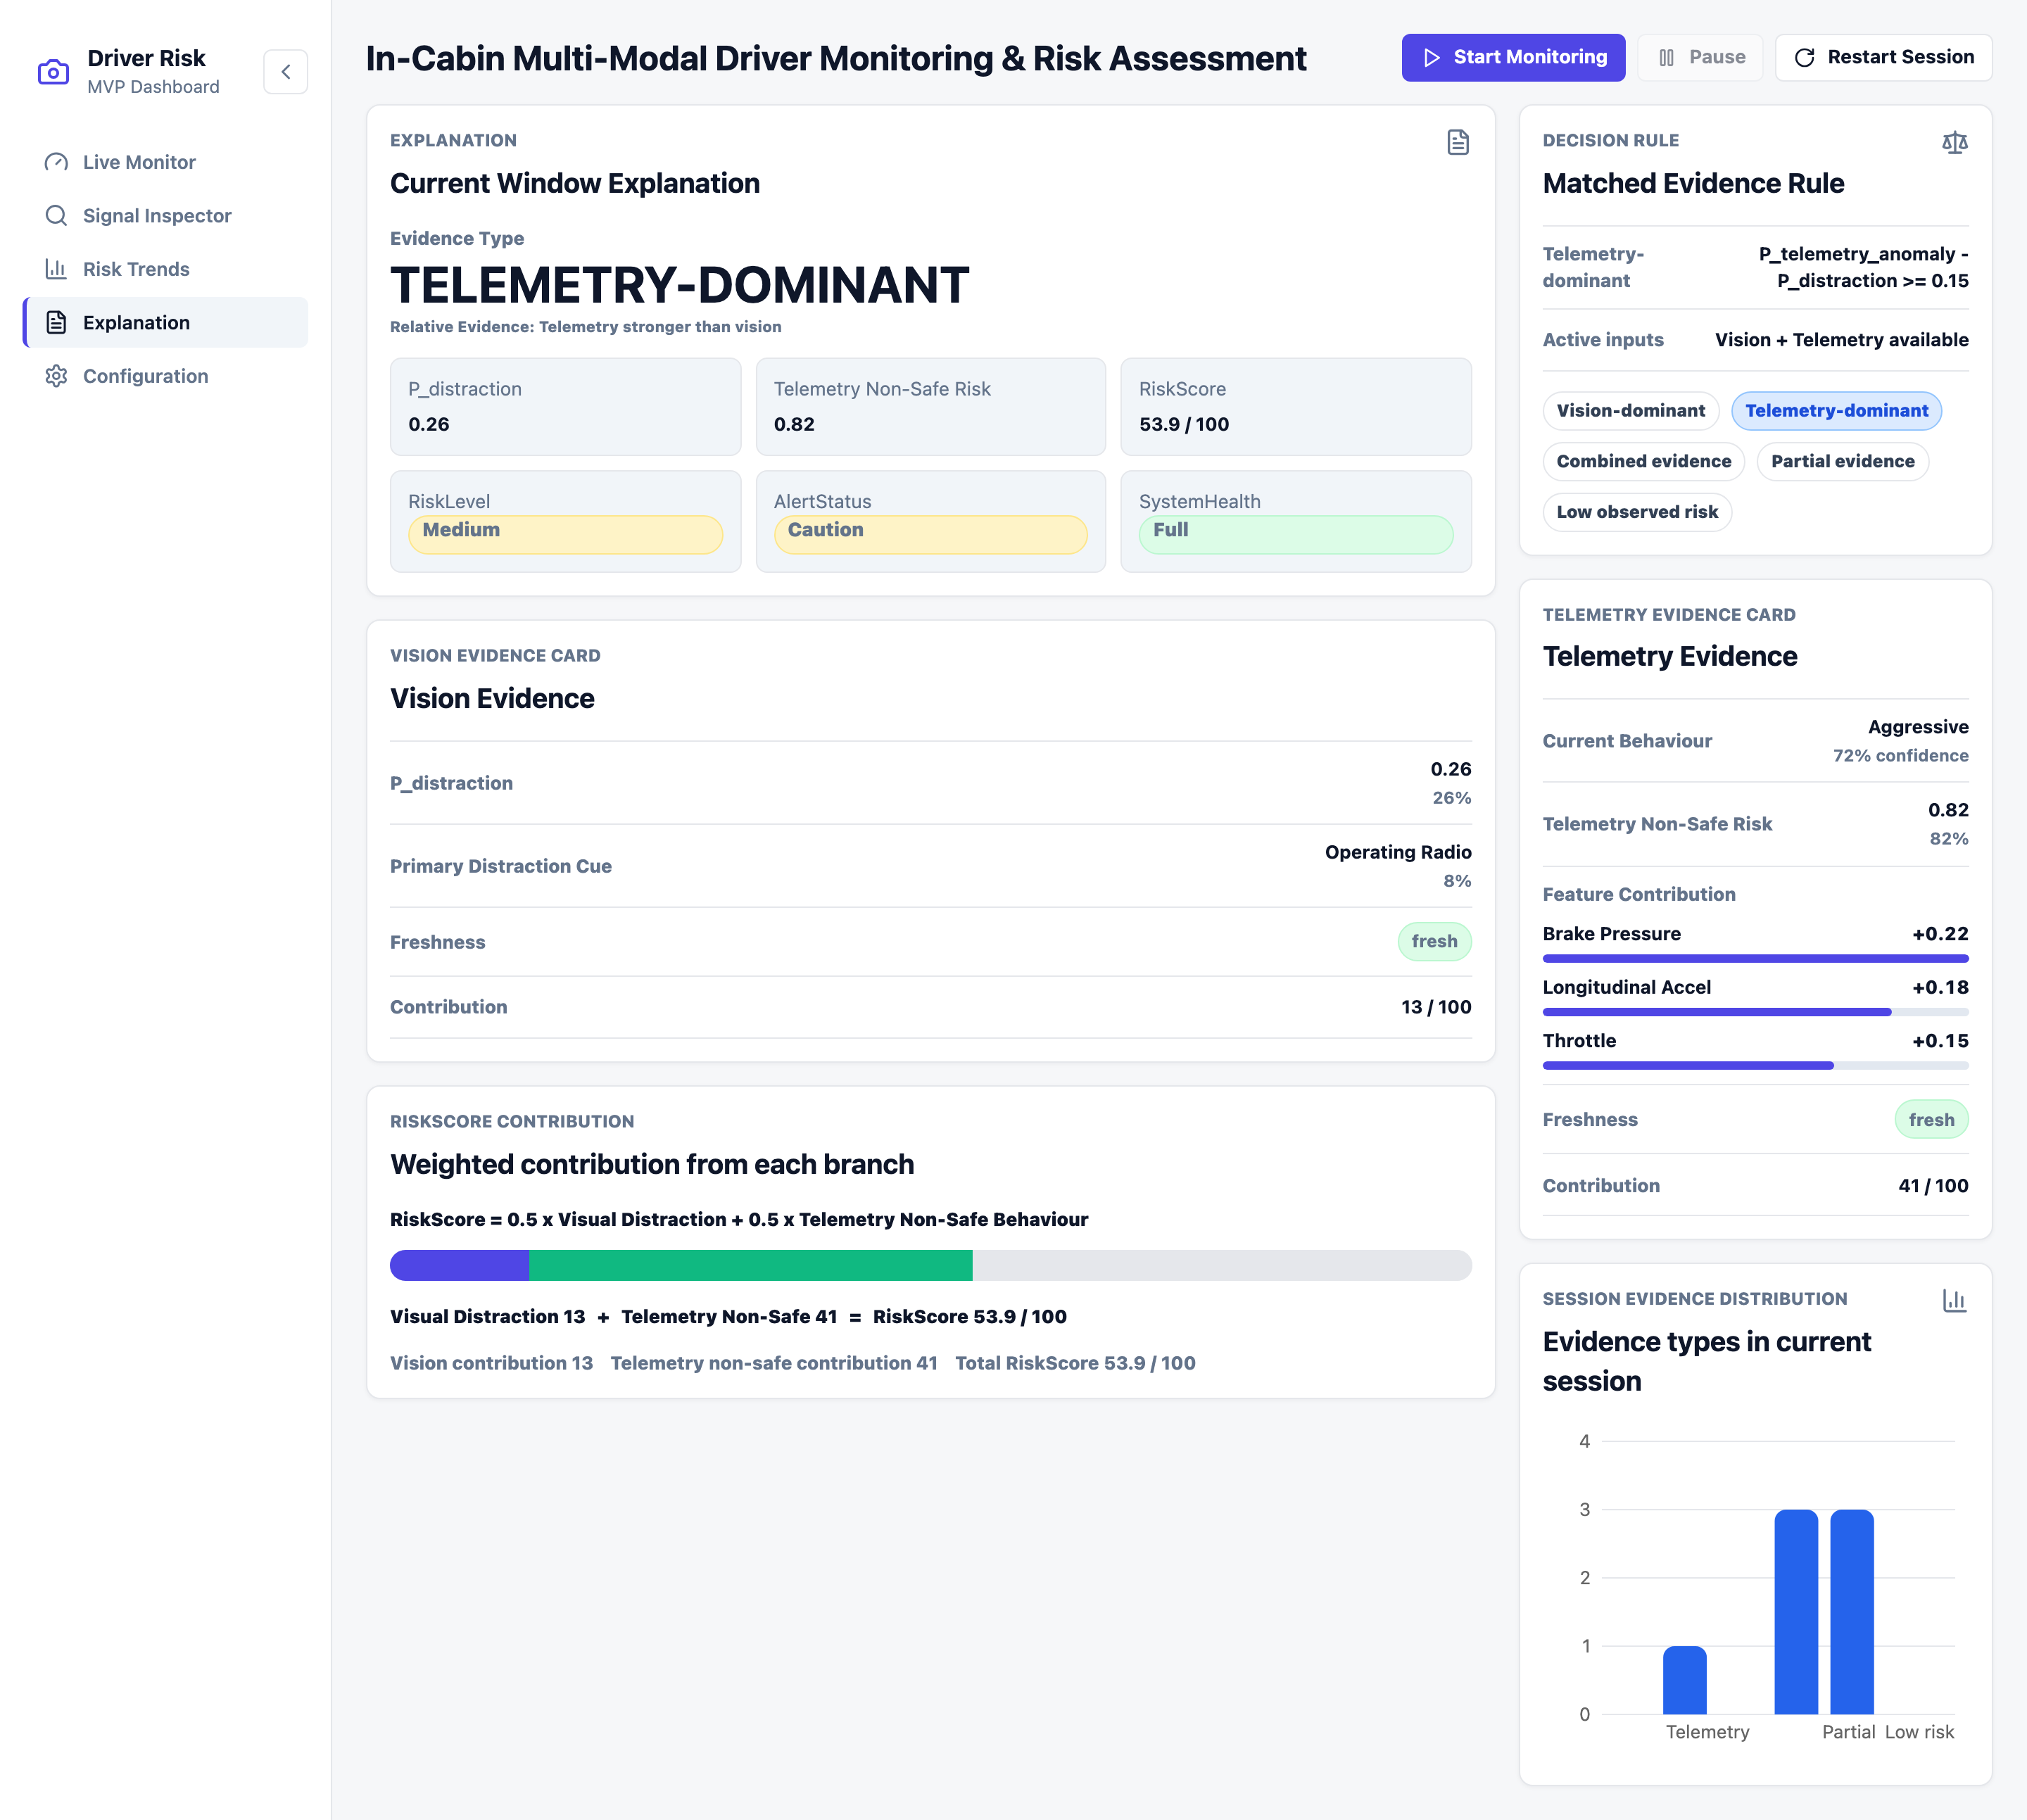
Figure 15: Prototype Interface — Explanation View
Figure 15 delivers the interpretability layer, explaining why the selected window received its risk output:
Current Window Explanation
- Headline Evidence Type (e.g. Telemetry-dominant) with the relative modality strength.
- Summary grid of P_distraction, telemetry non-safe risk, RiskScore, RiskLevel, AlertStatus, and SystemHealth.
Vision and Telemetry Evidence Cards
- Vision card reports the Primary Distraction Cue — the highest non-safe visual class — with its probability and freshness.
- Telemetry card reports the Current Behaviour with confidence and the top feature contributions driving the non-safe risk.
Decision Rule and RiskScore Contribution
- Matched Evidence Rule panel states the exact condition satisfied and highlights it among all five evidence types.
- Weighted-contribution bar decomposes the RiskScore into its vision and telemetry shares using the fusion weights.
- Session evidence-distribution chart shows how evidence types were distributed across the run.
Design Rationale: The view turns the late-fusion decision into a transparent, rule-based account, satisfying the explainability objective without exposing low-level model parameters.

4.6.5 Configuration View
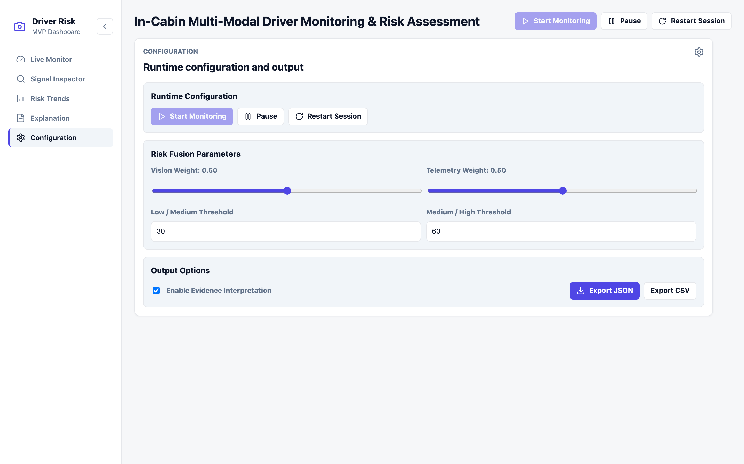
Figure 16: Prototype Interface — Configuration View
Figure 16 exposes the runtime controls and fusion parameters that govern the monitoring session:
Runtime Configuration
- Start, Pause, and Restart Session controls manage the replay-driven monitoring lifecycle.
Risk Fusion Parameters
- Vision Weight and Telemetry Weight sliders adjust the late-fusion contribution of each branch (default 0.50 / 0.50).
- Low/Medium and Medium/High threshold fields set the RiskScore-to-RiskLevel mapping boundaries (default 30 / 60).
Output Options
- Evidence-interpretation toggle enables the explanation output.
- Export JSON and Export CSV buttons download the full session record.
Design Rationale: Configuration deliberately surfaces only user-understandable controls — session control, transparent fusion weights, risk thresholds, and export — keeping internal runtime parameters out of the operator-facing interface.

