|  |  |  |  |
| --- | --- | --- | --- |
| **27.05.2019** |  |  | **Abteilung MN**  **Riccardo Feingold** |
|  |  |  |  |
|  |  |  |  |
|  |  |  |  |

3D Positioning

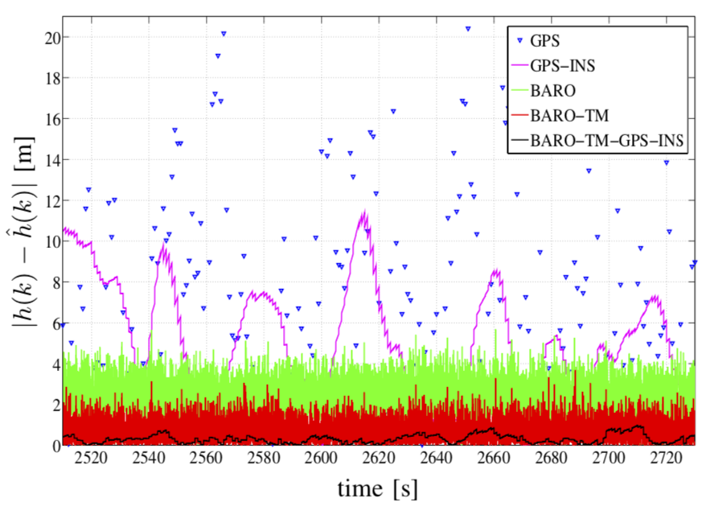Developing an Accurate Embedded-System for Estimating the 3D Position

Fig. 1Absolute height estimation error of GPS and barometric altimeter

Over the last years, vehicle positioning becomes more and more important, since many emerging implementations - such as car, train and plane traffic - rely on accurate vehicle location information (x,y and z coordinates), which are in reality not in all details correct, especially the vertical position.

The two most common ways of estimating or measuring the altitude are the GPS and the barometric altimeter, but the problem with those is, that they are not always giving accurate measurement results due to external influences. Such a disturbance for the GPS is for instance a dense infrastructure – everything, that is able to block, absorb or reflect the GPS signals. In the case of barometric altimeters, those disturbances could be e.g fast changing weather conditions [2].

To overcome those, an appropriate approach is “Sensor-Fusion[1]”. That means, it combines the advantages of all the used sensors with the idea of making it better than each sensor alone. Such a performance can be achieved by using certain methods, namely so called „filters“. The most known and used due to its good results is the Kalman-Filter, which is used for systems, that are showing fluctuations in their measurements - like in fig.1 (GPS or GPS-INS).

The Kalman-Filter takes in information about the state[2] dynamics which is known to have some error. Then by using this and the previous state, the filter predicts what the next state will be. In the update step, the predicted state will be adopted based on the measurements. The more accurate the measurements are the more emphasis is put on it and vice versa [3].

Then we also have the so-called Map-Matching algorithm. This is often used in GPS based applications like Google Maps. What it does, is improving the barometric height estimation by using topographic information. This information is stored in a dataset, which contains so called fixed-points, therefore, positions where the true height is known. Thus, if the current horizontal position corresponds to a location, for which height data is available, then calibration takes place [1].

Combining GPS, barometric altimeter and IMU[3] with those two methods, it is possible to receive not only accurate height estimates, but also accurate 2D position estimates. Therefore, the goal of this maturapaper is to develop such a system to prove the hypothesis.

**Vocabulary**:

|  |  |
| --- | --- |
| GPS | Global Positioning System |
| barometer | is a device for measuring the pressure |
| State dynamics | he state is defined by a model, which tries to constitute the reality mathematically (equation in article [3]) |
| IMU | Inertial Measurement Unit is basically a sensor containing an accelerometer, a gyro and a magnetometer |

Bibliography

[1]Bevermeier, Maik et al.: *Barometric Height Estimation Combined with Map-Matching in a Loosely-Coupled Kalman-Filter* (2010) <https://www.researchgate.net/publication/224199908_Barometric_height_estimation_combined_with_map-matching_in_a_loosely-coupled_Kalman-filter>

(fetched on the 25.03.19)

[2]Burgett, Scott et al.: *Method And Apparatus for Calculation Altitude Based on Barometric And GPS Measurement (2001)*<https://patentimages.storage.googleapis.com/b5/fa/3a/aebf34bdc779bc/US6735542.pdf> (fetched on the 27.03.19)

[3]Rhudy, Matthew et al.: *A Kalman Filtering Tutorial For Undergraduate Students* (2017) <http://aircconline.com/ijcses/V8N1/8117ijcses01.pdf> (fetched on the 06.05.19)

1. Techopedia: *Sensor Fusion* <http://bit.ly/SeNsOrFuSiOn> (fetched on the 19.05.19)
2.
3.