**What does this program do?**

This program extracts barcode and handwritten values from images.

**Template of Image files:**

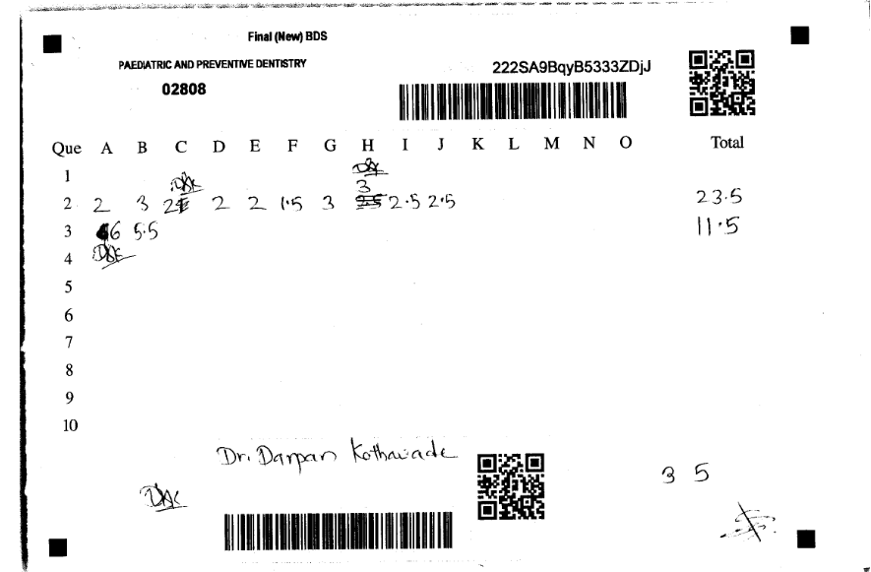

Fig.1 Template file for inputs of program

**Quality of files**

- Include skewed some images

- Lots of Noise in getting total value.

**What is important in this program?**

QRCODE (or Barcode) extraction and Total value extraction.

**What engine does this program use for Barcode recognition?**

This program uses Pyzbar

**What engine does this program use for extraction of total value?**

**- Opencv:**

This library take charge of image pre-processing for barcode extraction and total value extraction.

**- Yolo:**

Number detection & Recognition.

**- CNN:**

Accuracy of number detected by yolo is low, CNN is applied to the range of number image detected by yolo.

**How does this program work?**

**Algorithm of this program**

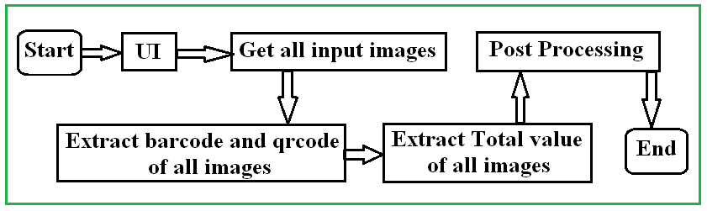

Fig. 2 Overall Algorithm

In code,

BARCODE.py: take charge of parts of program starting, UI and several pre-processing such as getting input images.

main_barcode.py: reflect logics of overall algorithm.

In below fig, red takes charge of “Extract barcode and qrcode of all images”, green for “Extract Total value of all images”, blue for “Post Processing”.

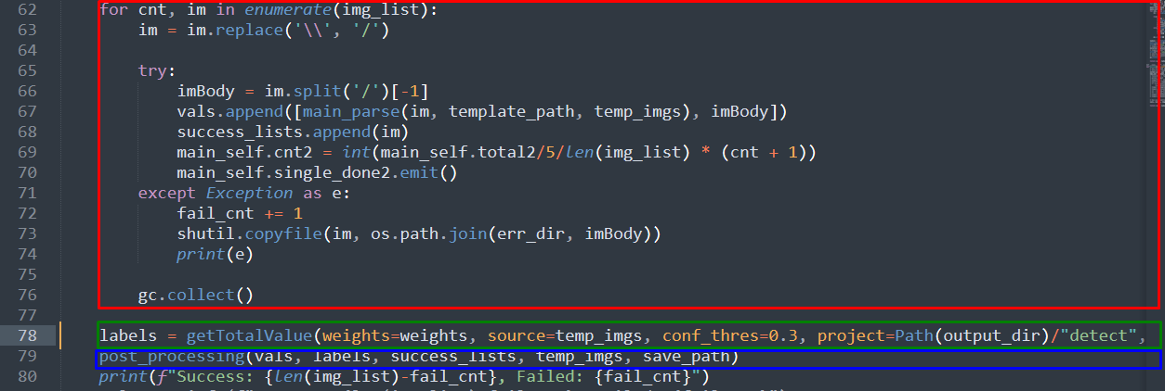

Fig 3. Algorithm (explanation in code)

**Extraction of QRCODE**

**Main function: main_parse(filename, template_path, temp_imgs)**

filename: image full name to be processed.

template_path: path of template.json file (stored total value image coordinates)

temp_imgs: path to save cropped images of total value

- By function extractBarcode(), extract barcode_data, qrcode_data, barcodeOri.

Here,

**barcode_data**: includes barcode informations [[*codename, code_value, coordinate*], ],

**qrcode_data**: qrcode informations, [[*codename, code_value, coordinate*], …],

**barcodeOri**: orientation of image (or barcode).

- By function barcode_ang() and codeLoc(), get exact barcode and qrcode, then image deskew.

Barcode_ang() rotates images in this right orientation and changes coordinates when orientation is “RIGHT”, “LEFT”, “DOWN” based on barcodeOri.

codeLoc()

**Save cropped images of total value**

- Principle to get total value image:

There are two qrcodes in every imge.

In this case of existing second qrcode (bottom and right) , total image coordinate is based on second qrcode coordinates.

If not existing second qrcode, to get total image coordinate program reads template.json file.

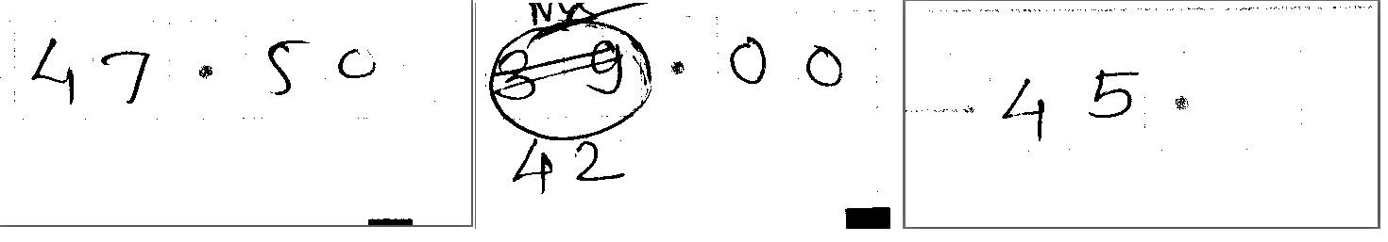

Fig 4. 3 Sample of image with total value

Let’s assume we have 100 input images.

First, program extracts 100 qrcodes and save 100 cropped total value images into certain path.

Then, the cropped images will be processed to extract total values.

**Extract Total value (see assist.py)**

**Detection & recognition all of total values using yolo**

There are lots of methods to extract handwritten digits including CNN, SVM, etc.

*Some issues to improve accuracy in our input images:*- We are dealing not single digit, but multi digits. So It is important to split total value images into single digit.

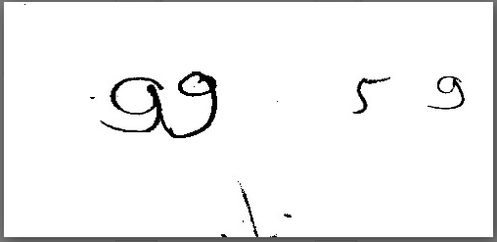

It is difficult to split above image into single digits by general method of opencv.

- Some images have lots of noises

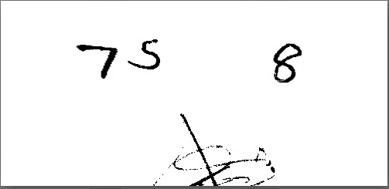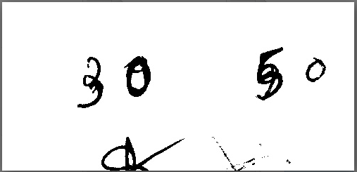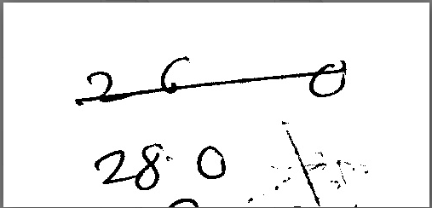

- This handwritten images has unique style.

***TO solve this issues, I have trained our dataset of total value images in yolo, so that I have detected and recognize handwritten digits in total value images.***

*Dataset preparation and train*

In 5000 input images, I got 5000 total value images with size 500X240.

By optimizing and improving dataset quality, I got about 3400 total value images.

I have trained the dataset in yolov 5, and got weight (epoch40.pt) file.

*Extraction of total value*

Using yolo framwork, we apply this weight file and input files.

For every input file(total value image), yolo detects signle digits and recognize the value, then get their accuracy.

(Detection accuracy is 100%, but recoginition may be wrong)

When the accuracy of recognition is low, program applies cnn in detected single digit region.

**Accuracy Improvement of total value recognition using CNN.**

I have trained online dataet in CNN, and got weight file (model.h5)

Applying this, program improved accuracy.

**Post-processing**

- This part makes xlsx file and json of output.