EECE 6370
Report #1: Nuclear Plants and Data Centers
Alexander Domijan

Topics:
Energy Systems modeling
Data Center Operation
Nuclear Grid Intergration



Grid Flexibility Optimization

By:
Roberto Avila

Date: 11/06/2025

Outline:

- Abstract
- Introductions:
  - Nuclear Power plants
  - Modern Grid Flexibility
  - Data Centers
- Nuclear energy & Data Centers
- Grid Flexibility Optimization
  - Introduction
  - Operational Flexibility Strategies
  - Quantifying Flexibility Capacity
  - Benefits
- Data Centers as flexible loads for nuclear powered grids
  - Optimization Model
  - Results
  - Code
- Conclusion
- References

Abstract:
The increasing electricity demand of modern data centers, driven by large-scale artificial intelligence and high-performance computing workloads, presents new challenges for power systems with limited operational flexibility. Nuclear generation, while clean and reliable, operates most efficiently at steady-state output and is therefore poorly suited for following the rapid load fluctuations characteristic of data center operation. This report investigates a nuclear-renewable grid architecture in which data centers serve as controllable demand-side resources to mitigate supply demand imbalances. Using hourly U.S. EIA generation and demand data, a flexibility model is formulated that constrains data center load within a ramp-limited, ±α deviation band while maintaining energy neutrality. Two control strategies a greedy real-time adjustment method and a model predictive control (MPC) approach with a 24-hour horizon are implemented to minimize generation demand mismatch. Simulation results show a reduction in root-mean-square error (RMSE) from 7194.1 MWh (no control) to 6455.8 MWh (greedy) and 5713.5 MWh (MPC). The findings demonstrate that data centers, leveraging existing UPS systems, thermal inertia, and workload-shifting mechanisms, can provide meaningful grid flexibility and enhance the operational feasibility of nuclear-dominated power systems.

Introduction:
Nuclear Power plants
Nuclear power plants are a type of thermal power station in which the source of heat is a nuclear reactor. The theory of operation is similar to other thermal power stations. Heat is used to generate steam, which drives a steam turbine connected to an electric generator. This electric generator uses the rotation of the steam turbine to create a rotating magnetic field. This rotating magnetic field induces current into its stator coils, which is used for powering the electric grid.
A nuclear reactor is a net positive power system used to sustain a controlled fission nuclear chain reaction. This device uses sustained nuclear fission to produce heat, that can be used in a nuclear power plant. Nuclear fission typically uses fissile nuclear materials, they are elements with excess neutrons that are subject to radioactive decay. Nuclear reactors regulate their thermal output by controlling the quantity of neutrons that are able to induce further fission events. That being said, nuclear reactors typically operate within a selected generation band where a reactor is most efficient. Thus, they tend to generate semi-constant power to maintain efficiency. This can be seen in data from the EIA, where typical generation lands between 70GW – 80GW [Fig 1].

Modern Grid Flexibility
Metrics from the EIA website show that the average daily range in energy demand in the united states is roughly 91,123 MWh [Fig 2]. This fluctuation illustrates the need for the electrical grid to adapt to changes, in particular due to increasing energy demands.

Data Centers
Large scale compute facilities (Data Centers), are one of the main sources for large scale fast growing power demand. These facilities consume vast amounts of energy to power and cool computing devices. Data centers represent a large flexible load (LFL) and are categorized as an “other” type of building under the EIA Commercial Buildings Energy Consumption Survey (CBECS). According to a 2018-2021 pilot study data centers are one of the most energy intensive building types using 10-40 times more energy per square foot than a typical office building.

Nuclear Energy & Data Centers
Recent data center growth due to the rise of generative AI has brought up concerns about the amount of power required to run these centers. In fact, an EIA Electricity analysis and forecast report found that as of February 2025 data centers account for roughly 4% of global electricity consumption. Due to the large scale and computational function of data centers, some large facilities consume enough power to rival a some metropolitan areas. This is why power stability is a main issue for many data centers. In fact, an entire economy has been born out of energy and hardware inadequacy within data centers aimed at operating AI and LLMs. This is why more data center operations are exploring alternative fuels, mainly nuclear energy. Nuclear energy provides, clean, reliable, and stable power. When delivered effectively, a nuclear power plant could support large scale data centers for their operational life. The idea is to streamline the means of production. In this case, energy isn't the product, but instead an ingredient, a fuel for large computation operations. Putting aside that even modern nuclear power plants were not designed for modular, repeatable, and accelerated deployments, the issue of grid flexibility is also pressing. By design, nuclear reactors are not meant to modulate their power output, this compromises the efficiency and efficacy of a nuclear power plant. As seen in Figure 1, when compared to solar and natural gas, nuclear energy barely fluctuates at all for any given month.
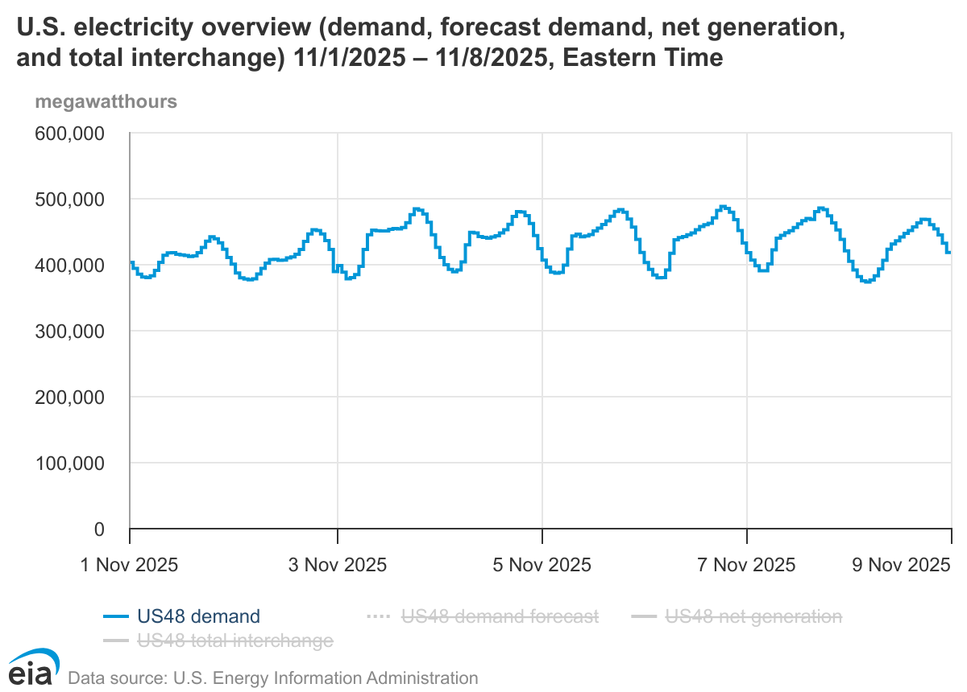Figure 1: U.S. electricity demand overview.
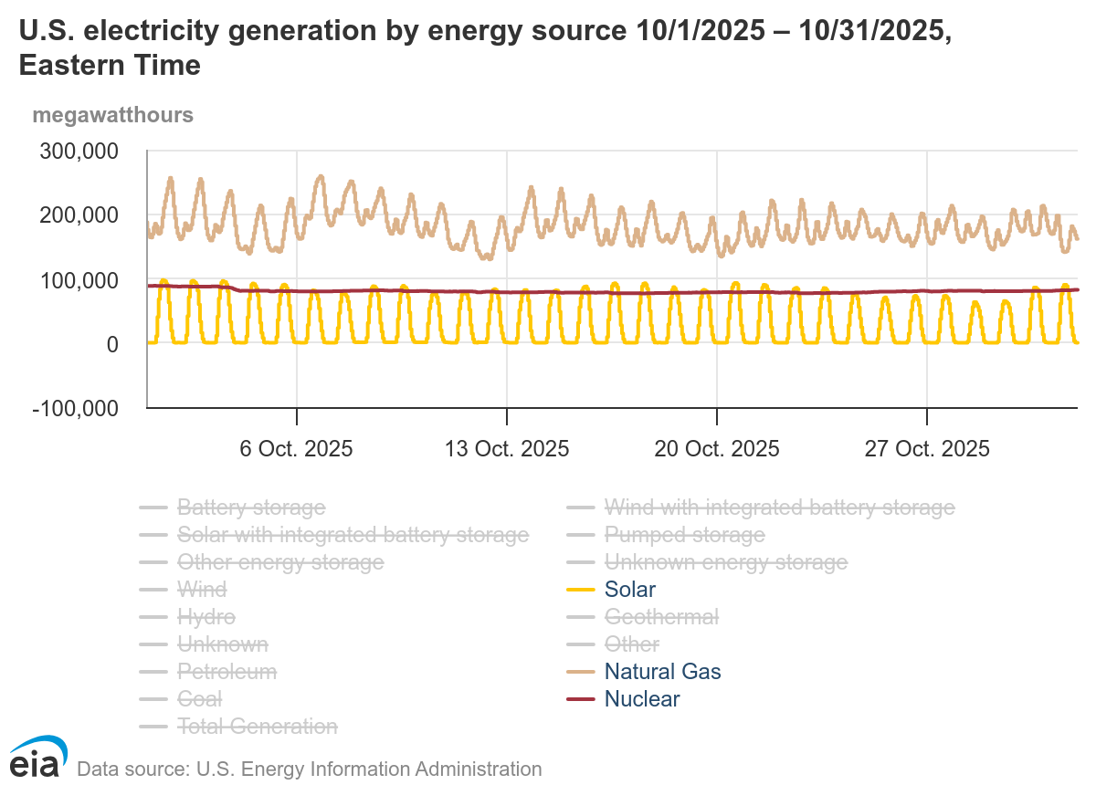Figure 2: U.S. Electricity demand by source 10/1-10/31
This fluctuation is even less significant on a daily basis. In contrast, data center power requirements typically vary widely for a given day. Often, they operate on a cyclical schedule, where more power is drawn during the day in times of high activity, and less activity at night. The conjunction of the infeasibility of modern, small, modular, and rapidly deployable nuclear power plants and the huge variable power demand of data centers make them an inefficient coupling of source and sink.

Grid Flexibility Optimization
Introduction
Grid Flexibility is the ability of a power system to balance supply and demand continuously across time and location. It is crucial to balance the demand and the supply of power for increased efficiency and grid longevity. Traditional flexibility sources like fossil fuels and other sources of energy are limited. Decentralized demand side resources could be the key to addressing power grid flexibility. In a 2025 paper “Data Centres as a Source of Flexibility for Power Systems”, data centers are explored as a form of demand side grid compensation using existing data center infrastructure. Due to their controllable loads, built in energy storage technology, and smart management systems, the paper posits that data centers could prove to be a source of flexibility. Existing flexibility sources include uninterruptible power supplies (UPS), backup generators, thermal energy storage, and IT servers [Table 1].
Table 1: Infrastructure type & flexibility
Infrastructure | Description | Flexibility Mechanism
UPS batteries | Store energy to provide backup power during outages | Can supply/absorb power from the grid in times of rapid fluctuation
Backup Generators | Typically efficient diesel generators, but have become increasingly renewable | Can reduce peak demand or serve as a source of reserve energy
Thermal Energy Storage | Cooling systems that build and remove thermal mass | Store/release heat
IT server operations | High Variability and under utilization | Can shift computing workloads in time or space to reduce or defer power demand

Operational Flexibility Strategies
Table 2: Flexibility Strategies Descriptions
Flexibility Strategy | Description
Load Shifting:  Demand response and load curve dampening. | - Delay tolerant IT loads are shifted to off peak hours  - Delay sensitive workloads remain fixed  - Cooling loads are also shifted
Virtual Energy Storage:  Grid services such as frequency regulation, peak shaving, and renewable balancing. | - Pre-cooling and controlled heating act as thermal batteries [Thermal Inertia]  - UPS batteries serve as frequency control loads  - Backup generators act as backup

Quantifying Flexibility capacity
Flexibility potential depends on UPS wattage, generator capacity, and the ratio of delay-tolerant workloads. Studies cited in the paper show that between 40%-90% of workloads are delay tolerant.
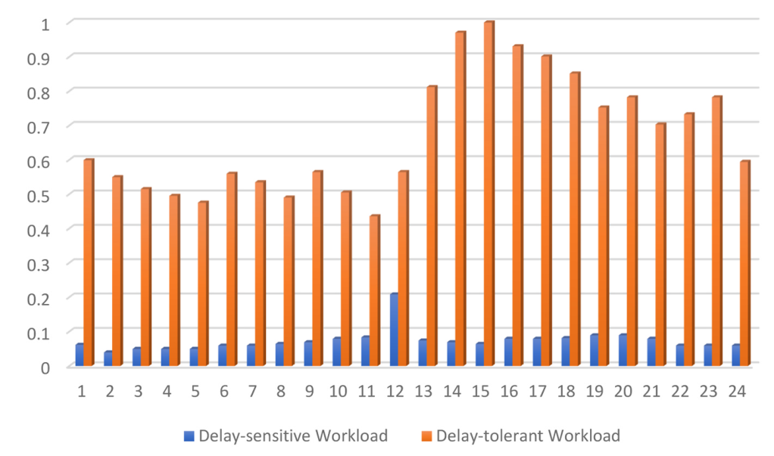Figure 3: Delay-Tolerant & Delay-Sensitive workloads as a fraction of total workload
Benefits
Table 3: Benefits of leveraging data center flexibility
Benefit type | Benefit Description
Grid Benefits | - Peak demand, congestion, and transmission loss reduction  - Improved energy integration  - enhances grid stability and resiliency
Enviromental Benefit | - Enables higher renewable and clean energy source integration  - reduces CO₂ emissions
Economic benefit | - Data center revenue increases due to energy company partnership  - reduction of operation costs in certain facilities  - avoided peak generation could save billions annually.

Data Centers as flexible loads for nuclear-dominated grids
Optimization Model
Given the modern infeasibility for nuclear reactors to solely power data centers, Nuclear reactors should instead be used as a baseline power provider and data centers should be used as an auxiliary form of load management. This system would optimize data center power draw and demand to minimize the mismatch between total generation and demand on an hour per hour basis. This system would supplement the constant power output of a nuclear dominated system with both renewable sources and data center sources. This behavior can be modeled with the following mathematical model [Table 4 & Table 5]:
Table 4: Model Parameters
Parameters | Description
L_{t} - [Decision variable] | Data-center power consumption at hour t (MWh  )
L₀ | Nominal data center load (MWh)
α | Maximum flexibility fraction (decimal)
G_{t}^{nuclear} | Nuclear power generation (MWh)
G_{t}^{renewable} | Renewable power generation (MWh)
D_{t}^{other} | Other demand sources (MWh)
R_{max} | Maximum energy ramp rate (MW/h)
P_{t} | Electricity price for cost based optimization ($/MWh)
Table 5: Model Constraints
Constraints
Load Limits | (1 - α)L₀ ≤ L_{t} ≤ (1 + α) L₀
Energy neutrality | ∑_{t}L_{t} = T x L₀
ramp-rate constraints | |L_{t} – L_{t -1} | ≤ R_{max}
Objectives
Grid Balancing | min∑|(G_{t}^{nuclear} + G_{t}^{renewable}) – (D_{t}^{other} + L_{t})|
Cost minimization | min∑P_{t}L_{t}
Table 6: Optimization algorithm methods
Method | Equation | Description
Greedy | Fig 4. | Adjusts data at each hour only using the current mismatch. Applying the largest permissible ramp
Model Predictive Control (MPC) | ∑_{k=t}^{t+H}(Tot_Gen(k) - Opt_Dem(k)))² | Adjusts data at each hour using a prediction horizon. Applying changes based on “predicted” data. Most likely what a more complex algorithm would look like.

Simulating this model with real world data is difficult, as it is hard to find a nuclear power dominated energy grid, However using EIA data, is easy to simulate a nuclear-renewable dominant grid with realistic demand and generation ratios.
Given the general guidelines of the model, 2 optimization methods were chosen to see the difference between a simple model (greedy model) and a complex model (Model Predictive Control) [Table 6].

Results
Results indicate that this data center, nuclear, and renewable optimization would be very effective and in line with the “Data Centres as a Source of Flexibility for Power Systems” paper mentioned before. Demand v. Generation error was compared using a root means square error (RMSE) metric, a common way to measure how far off prediction is from a real value. Each method was compared to an optimized demand curve [Table 7]. An RMSE methodology was chosen since it penalizes greater errors more than small errors. Comparing this way makes more sense than comparing average.
Table 7: RMSE per Optimization method
Method | RMSE (MWh)
None | 7194.1
Greedy | 6455.8
MPC | 5713.5

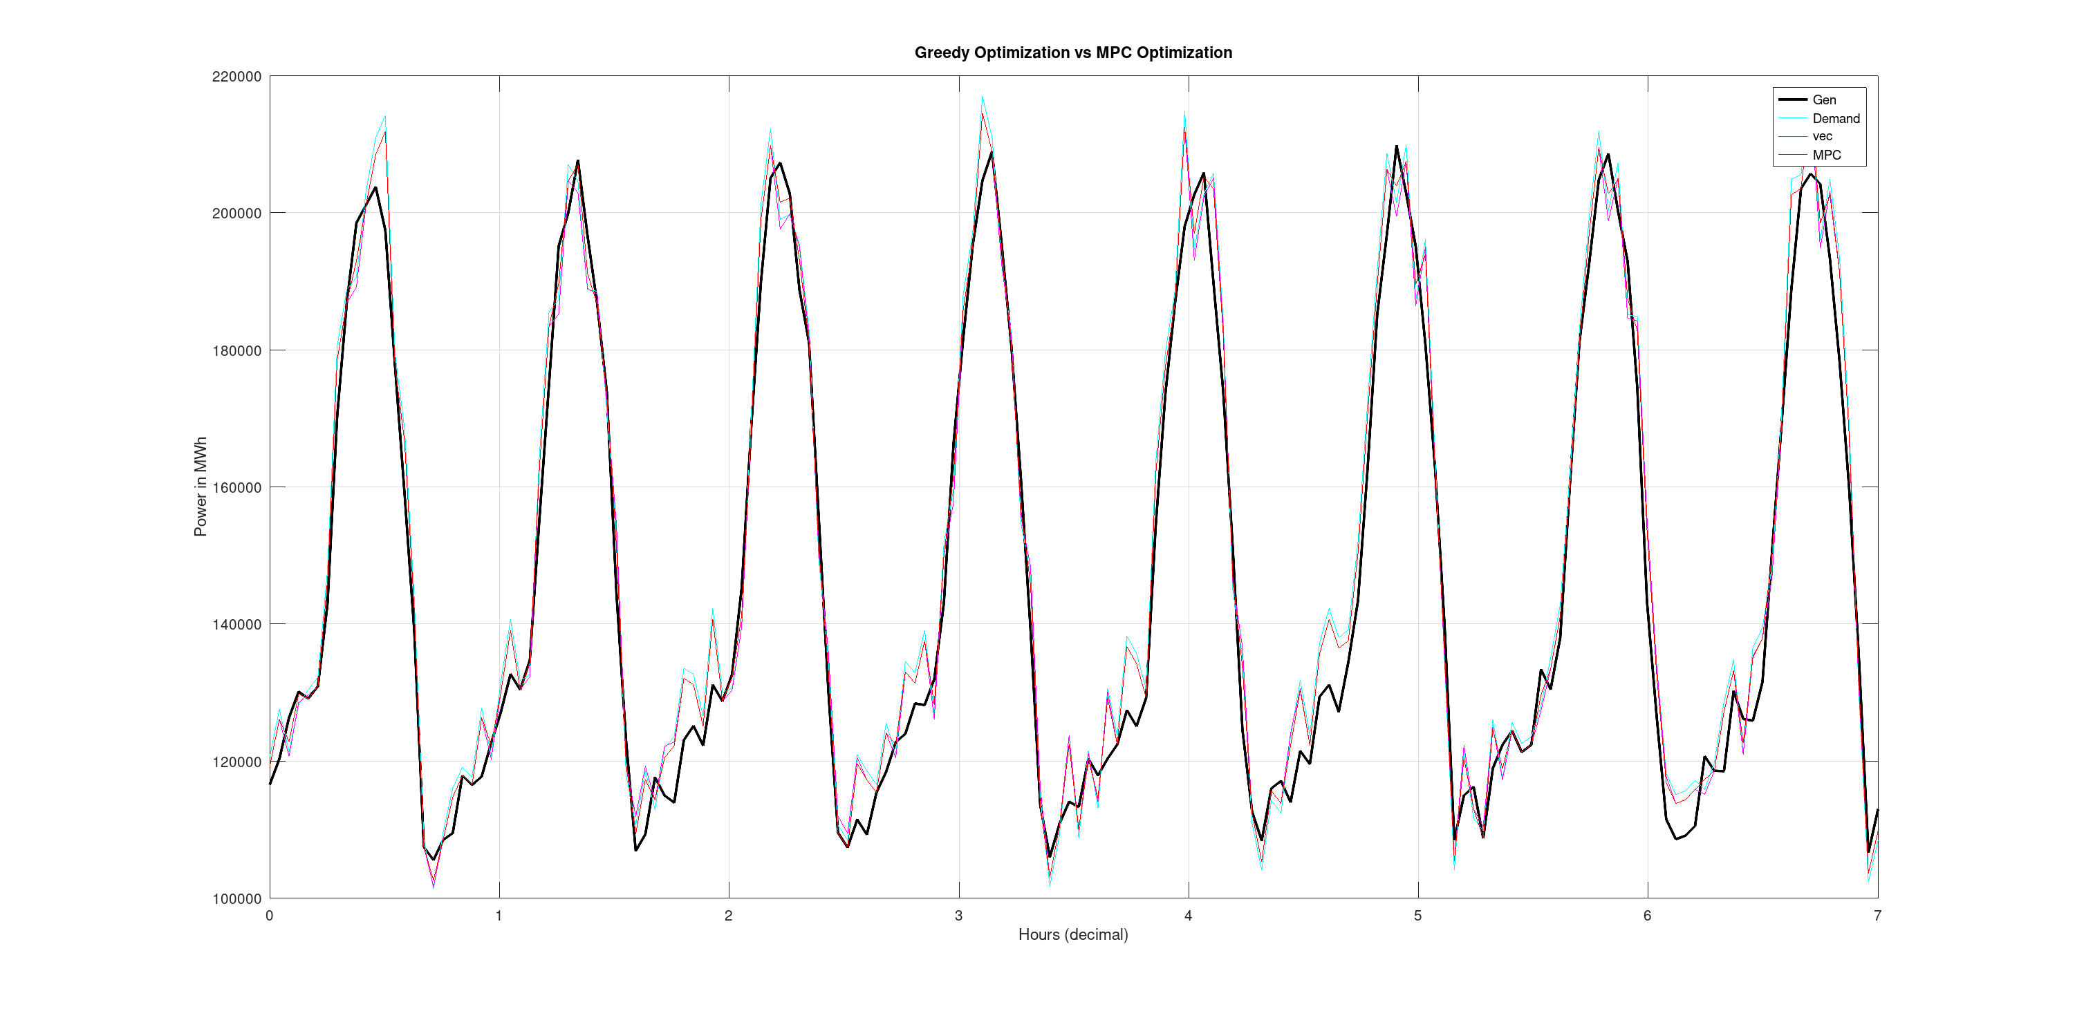Figure 4: RMSE per optimization method graph
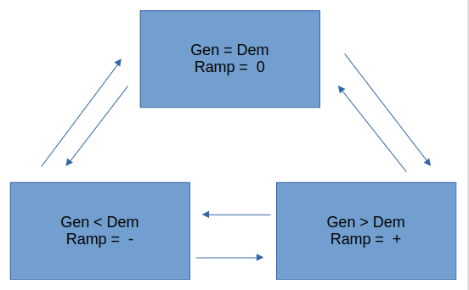Figure 5: Greedy method state machine

Code:
The following are code snippets illustrating the implementation of each method.
%% ================================================================
%% (1) Greedy optimizer
%% ================================================================
ideal_dc = Tot_Gen - Oth_Dem;
vec_dc = min(max(ideal_dc,Dat_Min),Dat_Max);

% forward ramp pass
for i = 2:N
diff = vec_dc(i) - vec_dc(i-1);
if diff > Dat_Rmp
vec_dc(i) = vec_dc(i-1) + Dat_Rmp;
elseif diff < -Dat_Rmp
vec_dc(i) = vec_dc(i-1) - Dat_Rmp;
end
end

% backward ramp smoothing
for i = N-1:-1:1
diff = vec_dc(i) - vec_dc(i+1);
if diff > Dat_Rmp
vec_dc(i) = vec_dc(i+1) + Dat_Rmp;
elseif diff < -Dat_Rmp
vec_dc(i) = vec_dc(i+1) - Dat_Rmp;
end
vec_dc(i) = min(max(vec_dc(i),Dat_Min(i)),Dat_Max(i));
end

Opt_Dat_Dem_vec = vec_dc;
Opt_Dem_vec = Oth_Dem + Opt_Dat_Dem_vec;

%% ================================================================
%% (2) MPC Rolling Horizon
%% * uses vectorized solver inside each horizon
%% ================================================================
H_mpc = 24;
Opt_Dat_Dem_mpc = Dat_Dem;

for t0 = 1:N
t_end = min(N, t0 + H_mpc - 1);

% Extract short horizon slice
sub_Tot = Tot_Gen(t0:t_end);
sub_Oth = Oth_Dem(t0:t_end);
sub_Min = Dat_Min(t0:t_end);
sub_Max = Dat_Max(t0:t_end);

ideal_sub = sub_Tot - sub_Oth;

% vectorized solver over short horizon
sub_dc = min(max(ideal_sub, sub_Min), sub_Max);

for i = 2:length(sub_dc)
diff = sub_dc(i) - sub_dc(i-1);
if diff > Dat_Rmp
sub_dc(i) = sub_dc(i-1) + Dat_Rmp;
elseif diff < -Dat_Rmp
sub_dc(i) = sub_dc(i-1) - Dat_Rmp;
end
end

Opt_Dat_Dem_mpc(t0) = sub_dc(1);
end

Opt_Dem_mpc = Oth_Dem + Opt_Dat_Dem_mpc;

Conclusion
Because nuclear power operates most efficiently at a steady, near-constant output, it is not well suited to serving as the sole power source for data centers, which exhibit significant variability in hourly demand. Instead, this report argues that data centers should be integrated into the grid as controllable, flexible loads supported by nuclear generation as a stable baseload and complemented by variable renewable sources. The optimization methods developed here both the greedy controller and the MPC-based approach demonstrate that adjusting data center demand within realistic flexibility limits can meaningfully reduce generation demand mismatches in nuclear dominated grids. These results highlight the potential for data centers to act as valuable grid-balancing assets, using existing infrastructure such as UPS systems, thermal inertia, and workload shifting to help stabilize systems where traditional generation cannot easily modulate output. As data center energy use continues to expand, leveraging their flexibility will be essential for improving grid efficiency and enabling greater adoption of clean, inflexible energy sources like nuclear power.

References:
[1]
M. T. Takci, M. Qadrdan, J. Summers, and J. Gustafsson, “Data centres as a source of flexibility for power systems,” Energy Reports, vol. 13, pp. 3661–3671, Mar. 2025, doi: https://doi.org/10.1016/j.egyr.2025.03.020.
‌[2]
J. L. Ruiz Duarte and N. Fan, “Operations of data centers with onsite renewables considering greenhouse gas emissions,” Sustainable Computing: Informatics and Systems, vol. 40, p. 100903, Dec. 2023, doi: https://doi.org/10.1016/j.suscom.2023.100903.
‌[3]
“U.S. Energy Information Administration - EIA - Independent Statistics and Analysis,” www.eia.gov. https://www.eia.gov/consumption/commercial/building-type-definitions.php
‌[4]
“U.S. Energy Information Administration - EIA - Independent Statistics and Analysis,” www.eia.gov. https://www.eia.gov/consumption/commercial/building-type-definitions.php
‌

