oxford_street_links_and_pattern_ids – all HERE navigable links which make up Oxford St between 51.513583,-0.157464 and 51.516395,-0.130432

F_WEEKDAY = SUN,MON,TUE,WED,THU,FRI,SAT

T_WEEKDAY = SUN,MON,TUE,WED,THU,FRI,SAT

LINK_ID|F_WEEKDAY|T_WEEKDAY

HERE_patterns - all HERE traffic patterns – an ID followed by average speeds in kph throughout 24 hours (96 values – 4 per hour)

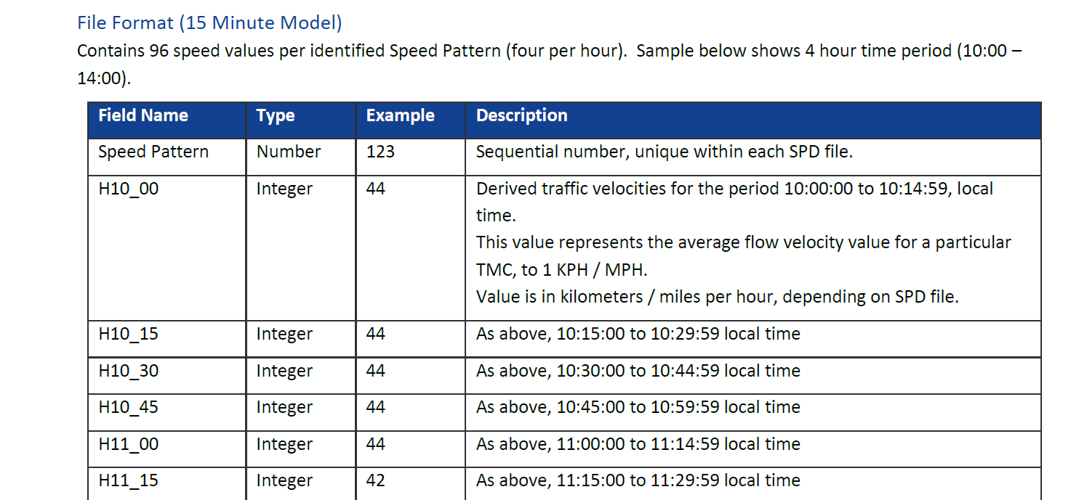

We talked about just selecting one link and assume it was representative….

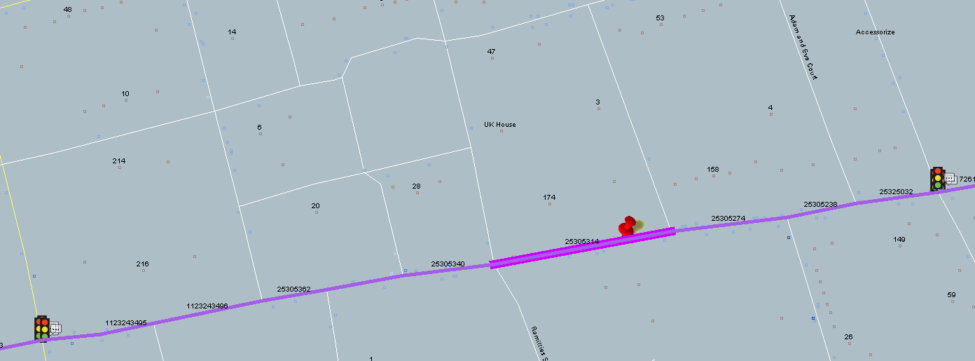

LinkID – 25305314

representative_link_and_pattern_ids – this link and it’s pattern ids

representative_link_patterns – the patterns that are applicable for this representative link