Overall Block Diagram

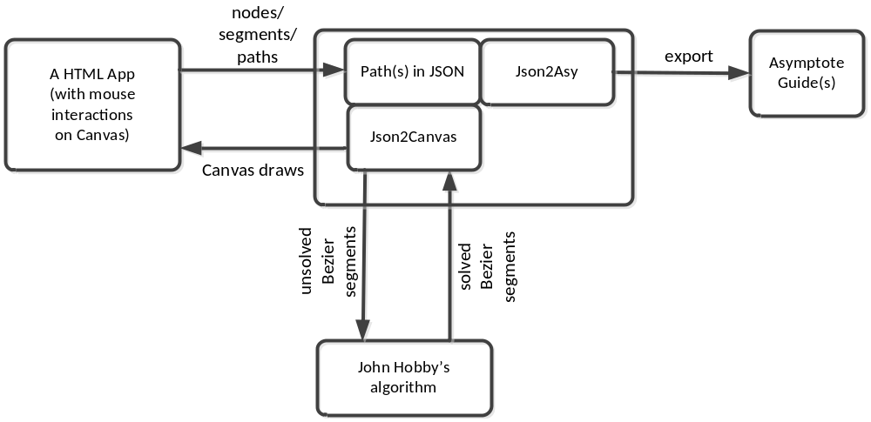

JSON format for path

Concepts & Terminology
A path is composed by segments, each of which is defined by its two end points (nodes), and the segment is either a straight line, or a cubic Bezier curve the two control points of which are automatically calculated by the algorithm in John Hobby’s 1986 paper (also in chapter 14 of “The METAFONT book”).

A continuous subset of a path is a subpath, which contains at least one segment.

A path can be either closed (or cyclic), or open (non-cyclic). Basically, the “closeness” of a path enables the rendering engines (Canvas/Asymptote/SVG/etc) to do two things:
- fill the interior region enclosed by the path;
- draw the closing point perfectly (with any pen shape).
A path (or subpath) has a direction, which goes from the 1st point to the last point; with the same order, each segment has its direction, which goes from the first node to the second node.

The type (or form) of a segment (straight line or Bezier curve) is determined by the connection property of its first node. For that purpose, the following two connection types are supported:
- straight line (denoted by “-- “)
- free curve (denoted by “..”)
The other three METAPOST connection types (i.e., bounded curve “…”, tense line “---”, and splice “&”) are not supported.

For a free curve segment, although its type (Bezier curve) is determined within the segment itself, the calculated control points for the Bezier curve may depend on its adjacent segments (unless both its pre- and post- segments are straight lines).

Note that a DEGRADED SEGMENT is a segment of zero length, i.e., its 1st and 2nd nodes coincide. The type of degraded segments is always treated as straight line, regardless, because it’s not very meaningful to calculate the control points if degraded segments are treated as Bezier curves.

Degraded segment is useful for connecting two free curve segments which need to be “non-smoothly” connected (i.e. with sharp corner). This is because, without the zero segment in between, the two adjacent free curves will be jointed smoothly as guaranteed by John Hobby’s algorithm. For example, there are two paths (go through the same set of nodes) in the diagram below:
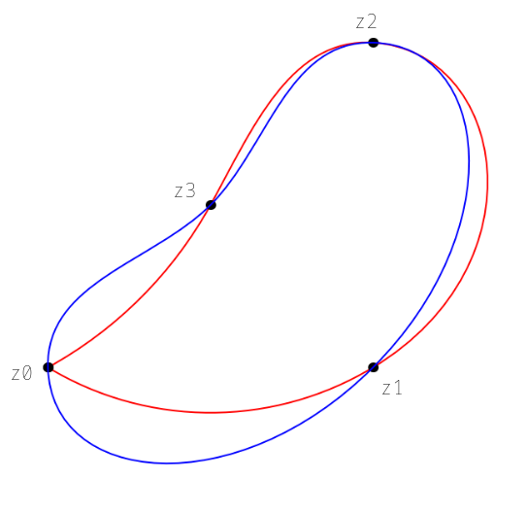
The blue path is “z0..z1..z2..z3..cycle”, in which segment “z0..z1” is connected with segment “z3..z0” smoothly at node “z0”;
On the contrary, the red path is “z0..z1..z2..z3..z0--cycle”, in which a degraded segment “z0--z0” connects the two free curve segment “z0..z1” and “z3..z0” non-smoothly.

The difference between the two paths also demonstrates the fact that the control points for a free curve segment depend on other free curve segments connected with it.

Data Structure
- Node

Nodes represent points on the HTML 2D-Canvas plane. Each node is a JSON object with the following properties:

“x”, “y”: coordinates in Canvas coordination (where the Y axis is pointing down)

samples

