http://colonelpanic.net/2009/05/building-a-firefox-plugin-part-two/

http://jldupont.blogspot.com/2009/11/notes-on-npapi-based-plugins.html

Wednesday, November 4, 2009

Notes on NPAPI based plugins
I am sharing the following diagram to (hopefully) lessen some pain from folks who intend to write NPAPI based plugins (Firefox, Chrome etc.).
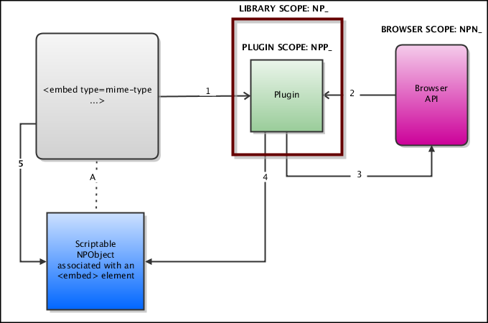
STEP 1: the host browser loads the library corresponding to the MIME type expressed in the embed element tag.
STEP 2: the host browser calls the NP_Initialize function of the library and passes a reference to the public API of the browser (i.e. the NPNetscapeFuncs starting with NPN_ in the Mozilla documentation). The host browser also calls the NPP_New function in order to instantiate a "plugin instance".
STEP 3: the host browser calls the NP_GetValue function (with the variable NPPVpluginScriptableNPObject ) of the library. See step 4.
STEP 4: the plugin calls the NPN_CreateObject (through the reference provided in step 2) to instantiate a "scriptable NPObject". This object serves as proxy to the embedobject declared on the source web page.
STEP 5: the web page can interact with the "scriptable object".

