- On windows7, enable remote access:
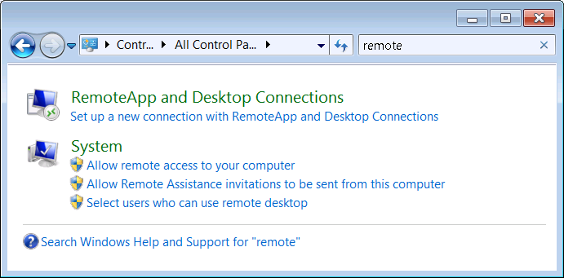

Click “Allow remote access to your computer”, with the following options:

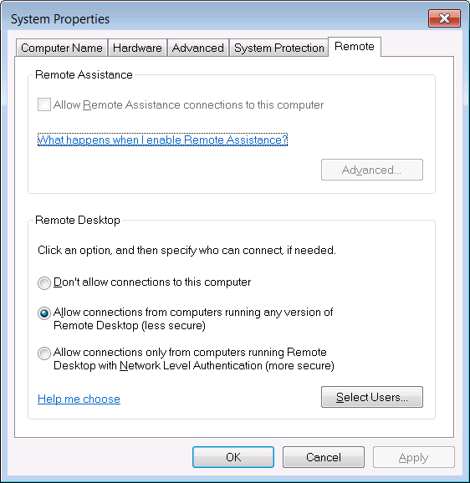

- On Linux:
yum install rdesktop
rdesktop –u ywxiong –d hq –p password –g 1920x1000 ip_of_win7

