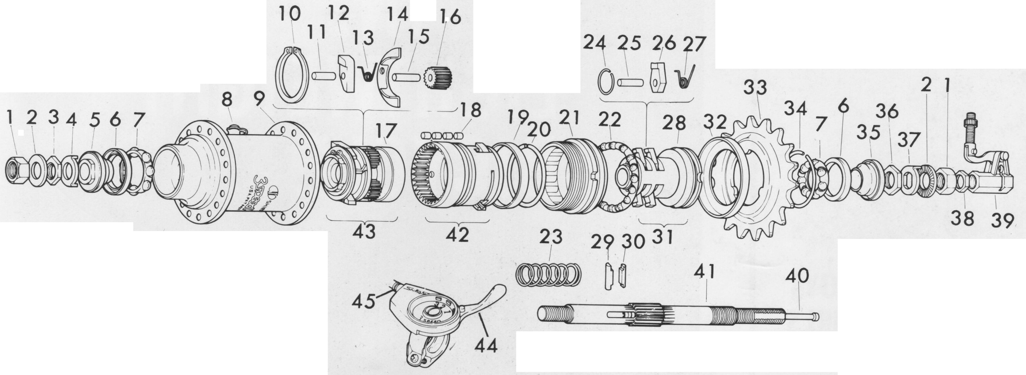

Key No. | Part No. | Description | 名称
1 | 300054 | Nut
2 | 300053 | R. Axle Washer
3 | 300052 | Lock Nut A
4 | 300051 | Cone Stay Washer
5 | 300050 | L.H. Cone w/Dust Cap B
6 | 300021 | Dust Cap A
7 | 300020 | Ball Retainer A
8 | 300000 | Lubricator
9 | 300001 | Hub Shell w/Left Cup 36 Holes
10 | 300384 | Snap Ring A
11 | 300032 | Pawl Pin C
13 | 300003 | Pawl Spring C
14 | 300035 | Pawl Plate
15 | 300033 | Pinion Pin B
16 | 300005 | Planet Pinion
17 | 300386 | Ratchet B-1
18 | 300038 | Roller
19 | 300039 | Roller Cover
20 | 300040 | Snap Ring D
21 | 300023 | Ball Cup
22 | 300019 | Ball Retainer B
23 | 300019 | Spring
24 | 300031 | Snap Ring B
25 | 300030 | Pawl Pin B
26 | 300141 | Pawl B
27 | 300028 | Pawl Spring B
29 | 300018 | Sliding Key B
30 | 300017 | Sliding Key A
32 | 300025 | Dust Cap
33 | 300422 | Sprocket 14T
33 | 300423 | Sprocket 15T
33 | 300424 | Sprocket 16T
33 | 300425 | Sprocket 28T
33 | 300426 | Sprocket 19T
33 | 300427 | Sprocket 20T
34 | 300027 | Snap Ring C
35 | 300056 | R.H. Cone w/ Dust Cap B
36 | 300057 | Lock Nut B
37 | 300058 | Non Turn Washer
38 | 300062 | Bell Crank Lock Nut
39 | 300700 | Complete Bell Crank
40 | 300059 | Push Rod
41 | 300049 | Axle
42 | 300472 | Complete Ratchet A-1
43 | 300386 | Complete Ratchet B-1
44 | 300361 | Trigger Shifter
45 | 308713 | 3 Speed Cable w/Casing
46 | 28417PA | 36 Hole Hub Ass'y.# Trigger Shifter

Description | Exploded diagram of internal 3 speed Shimano hub from a Sears bicycle
Date | 1 September 1977
Source | Scanned from a 1977 publication, published in the United States, with no copyright notice. (Owners manual for Sears bicycles 502.472684 (boys) and 502.472784 (girls), "Rev. 9-1-77")
Author | Sears Sports Center

Copyright expired

Source: http://en.wikipedia.org/wiki/File:Internal_hub_3_speed_Shimano.jpg

