Table of Content

Table of Content 1
1. Overview 1
2. Install jslint4java 2
3. Source Insight 4
4. Emacs 6
5. Sublime Text 7
Abstract: this article describes the ways to integrate “jslint4java” with several editors commonly in use.

1. Overview
Before sending source code to to JSLint, the first step is to make sure that the source files are "look good" cosmetically, namely:
- No tabs, only spaces
- No DOS/Mac new-line characters, only unix style
- No trailing spaces on each line
- Properly indented (there are a lot of tools for doing so. we can use "uglify-js" package from "node.js", as an example)
The processing steps above can be put into a small script (it depends on dos2unix/mac2unix/sed/nodejs/npm/uglify-js):
[bruin@fc13 bin]$ cat joli.sh
#!/bin/bash
dos2unix $1
mac2unix $1
sed -i "s/\t/ /g" $1
sed -i "s/[ \t]*$//g" $1
uglifyjs $1 -b --comments=all -o $1

Then it's about to send source code to jslint. There are several questions to be answered:
- What tool to use? There is a lot in the wild...online ones? tools based on java? tools based on V8/node.js? tools based on Rhino? It seems different tools have different behaviors even with the same options, and different versions of the same tool can also behave differently...so this question turns into two: which tool and which version of the tool.
- Which rules to follow? This is about the set of options to choose when we run jslint against our source files...and we know that engineers have different tastes... but for engineering practice, normally rules will be agreed upon and set once, and then everyone follows what’s agreed. Period!
The most up-to-date answers to these questions above are located here:

2. Install jslint4java
According to the link above, it was agreed to use “jslint4java” version 2.0.2… The repository of jslint4java: https://code.google.com/p/jslint4java/
This should work on both Windows and Linux, given that the JRE is installed.
Take Windows as an example:
- JRE: Download the latest JRE and install it. For example, simply run "jre-7-windows-x64.exe" downloaded from “oracle.com”. Verifying it after install by issuing a "java" command in DOS console, you should get something like this:
c:\>java -version
java version "1.7.0"
Java(TM) SE Runtime Environment (build 1.7.0-b147)
Java HotSpot(TM) 64-Bit Server VM (build 21.0-b17, mixed mode)

- Download the required release of jslint4java distribution: https://jslint4java.googlecode.com/files/jslint4java-2.0.2-dist.zip
Extract it into a local folder say "c:\jslint4java-2.0.2\". Verifying it from a dos console:
c:\>java -jar c:\jslint4java-2.0.2\jslint4java-2.0.2.jar
Usage: jslint4java [options] file.js ...
Options:
--anon If the space may be omitted in anonymous function
declarations
--bitwise If bitwise operators should be allowed
--browser If the standard browser globals should be predefined
--cap If upper case html should be allowed
--continue If the continuation statement should be tolerated
--css If css workarounds should be tolerated
--debug If debugger statements should be allowed
--devel If logging should be allowed (console, alert, etc.)
--encoding Specify the input encoding
--eqeq If == should be allowed
--es5 If es5 syntax should be allowed
--evil If eval should be allowed
--forin If for in statements need not filter
--fragment If html fragments should be allowed
--help Display usage information
Default: false
--indent The indentation factor
--jslint Specify an alternative version of jslint.js
--maxerr The maximum number of errors to allow
--maxlen The maximum length of a source line
--newcap If constructor names capitalization is ignored
--node If node.js globals should be predefined
--nomen If names may have dangling _
--on If html event handlers should be allowed
--passfail If the scan should stop on first error
--plusplus If increment/decrement should be allowed
--predef The names of predefined global variables
--properties If all property names must be declared with
/*properties*/
--regexp If the . should be allowed in regexp literals
--report Display report in different formats: plain, xml, junit,
checkstyle and report
--rhino If the rhino environment globals should be predefined
--sloppy If the 'use strict'; pragma is optional
--sub If all forms of subscript notation are tolerated
--timeout Maximum number of seconds JSLint can run for
Default: 0
--undef If variables can be declared out of order
--unparam If unused parameters should be tolerated
--vars If multiple var statements per function should be allowed
--version Show the version of JSLint in use.
Default: false
--white If sloppy whitespace is tolerated
--widget If the yahoo widgets globals should be predefined
--windows If ms windows-specific globals should be predefined

c:\>java -jar c:\jslint4java-2.0.2\jslint4java-2.0.2.jar
Usage: jslint4java [options] file.js ...
Options:
--anon If the space may be omitted in anonymous function
declarations
--bitwise If bitwise operators should be allowed
--browser If the standard browser globals should be predefined
--cap If upper case html should be allowed
--continue If the continuation statement should be tolerated
--css If css workarounds should be tolerated
--debug If debugger statements should be allowed
--devel If logging should be allowed (console, alert, etc.)
--encoding Specify the input encoding
--eqeq If == should be allowed
--es5 If es5 syntax should be allowed
--evil If eval should be allowed
--forin If for in statements need not filter
--fragment If html fragments should be allowed
--help Display usage information
Default: false
--indent The indentation factor
--jslint Specify an alternative version of jslint.js
--maxerr The maximum number of errors to allow
--maxlen The maximum length of a source line
--newcap If constructor names capitalization is ignored
--node If node.js globals should be predefined
--nomen If names may have dangling _
--on If html event handlers should be allowed
--passfail If the scan should stop on first error
--plusplus If increment/decrement should be allowed
--predef The names of predefined global variables
--properties If all property names must be declared with
/*properties*/
--regexp If the . should be allowed in regexp literals
--report Display report in different formats: plain, xml, junit,
checkstyle and report
--rhino If the rhino environment globals should be predefined
--sloppy If the 'use strict'; pragma is optional
--sub If all forms of subscript notation are tolerated
--timeout Maximum number of seconds JSLint can run for
Default: 0
--undef If variables can be declared out of order
--unparam If unused parameters should be tolerated
--vars If multiple var statements per function should be allowed
--version Show the version of JSLint in use.
Default: false
--white If sloppy whitespace is tolerated
--widget If the yahoo widgets globals should be predefined
--windows If ms windows-specific globals should be predefined

Notice that the output format of jslint4java, that for each error/warning, it's formatted as:
jslint:<filename>:<line_num>:<column_nr>:<err_message>

This format is important when integrating the errors/warnings messages with different editors.

3. Source Insight
Some of us are familiar with SourceInsight (SI 3.5) for C development, even though there are a bunch of other alternatives for JavaScript development…anyway, there is a way to integrate this jslint with Source Insight.
From an existing SI project, go to "Options->Custom Commands..." to bring up the dialog to define a customized command for jslint4java.
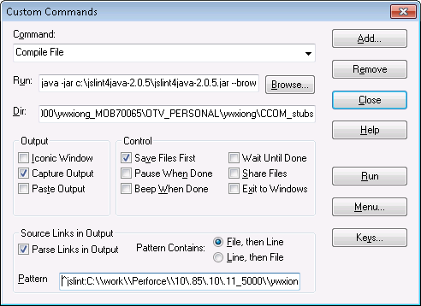
- The “Run” field (“%f” denoting the current file under edition):
java -jar c:\jslint4java-2.0.5\jslint4java-2.0.5.jar --browser --indent 4 --nomen --plusplus --sloppy %f

Note that the jslint4java command line option above is just a simple example.
- The “Dir” field is the path to the source files.
- The “Pattern” field is for matching the file-name and line-number of the jslint4java output:
^jslint:C:\\work\\Perforce\\10\.85\.10\.11_5000\\ywxiong_MOB70065\\OTV_PERSONAL\\ywxiong\\CCOM_stubs\\\([a-zA-z]+.js\):\([0-9]+\):[0-9]+:.*

Note that the directory path above is just a example, modify it to fit your setup.
From "View->Toolbars->Toggle Build Toolbar" to display the "Build toolbar" on screen, for easy access the "Compile" button, which is a shortcut to the command defined above. With a JS file opened in SI, click the "Compile" button, you should be able to get something like below, as what we would expected:
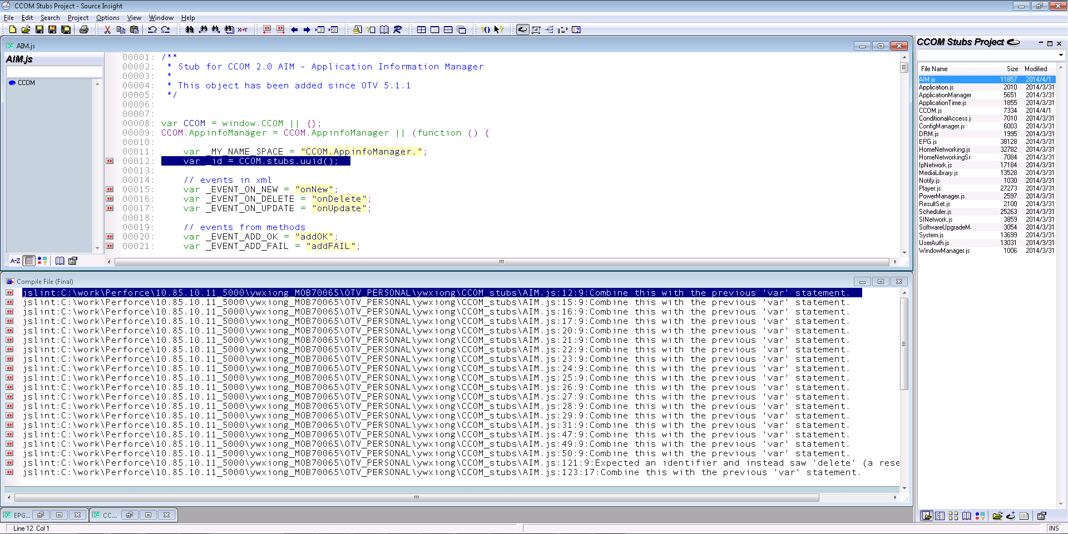

A note on the “Pattern” field:
SourceInsight uses RegExp groups to parse the "file name" and "line number", this means we need to define two groups in the RegExp, one for file-name, and the other for line-number. As the jslint4java output has "file-name" appears before the "line-number", we choose the "File, then Line" pattern.
For the "file-name" group, as we already specified the "Dir", we only need to let the group to match the file name only;
For the part before "file-name", escape the special characters such as "\" & "."
For the "line-number" group, it just follows the file name and a colon, and followed by another colon plus a column number and error message;
^jslint:C:\\work\\Perforce\\10\.85\.10\.11_5000\\ywxiong_MOB70065\\OTV_PERSONAL\\ywxiong\\CCOM_stubs\\\([a-zA-z]+.js\):\([0-9]+\):[0-9]+:.*

4. Emacs
Some prefer to use Emacs, although it’s a bit slower than the others. Anyway, we take Windows as an example below.
- Set PATH environment of Emacs for accessing “java.exe”, by adding the following into your emacs “init.el” file:
(setenv "PATH" (getenv "PATH"))

And then verify that by "M-x getenv RET PATH" from the mini-buffer.
- "Compile" the current file from the mini-buffer, by typing "M-x compile RET java -jar c:\jslint4java-2.0.5\jslint4java-2.0.5.jar --browser --indent 4 --nomen --plusplus --sloppy CCOM.js". We get something like this (notice that the error/warning are auto-linked with the lines in the source file):
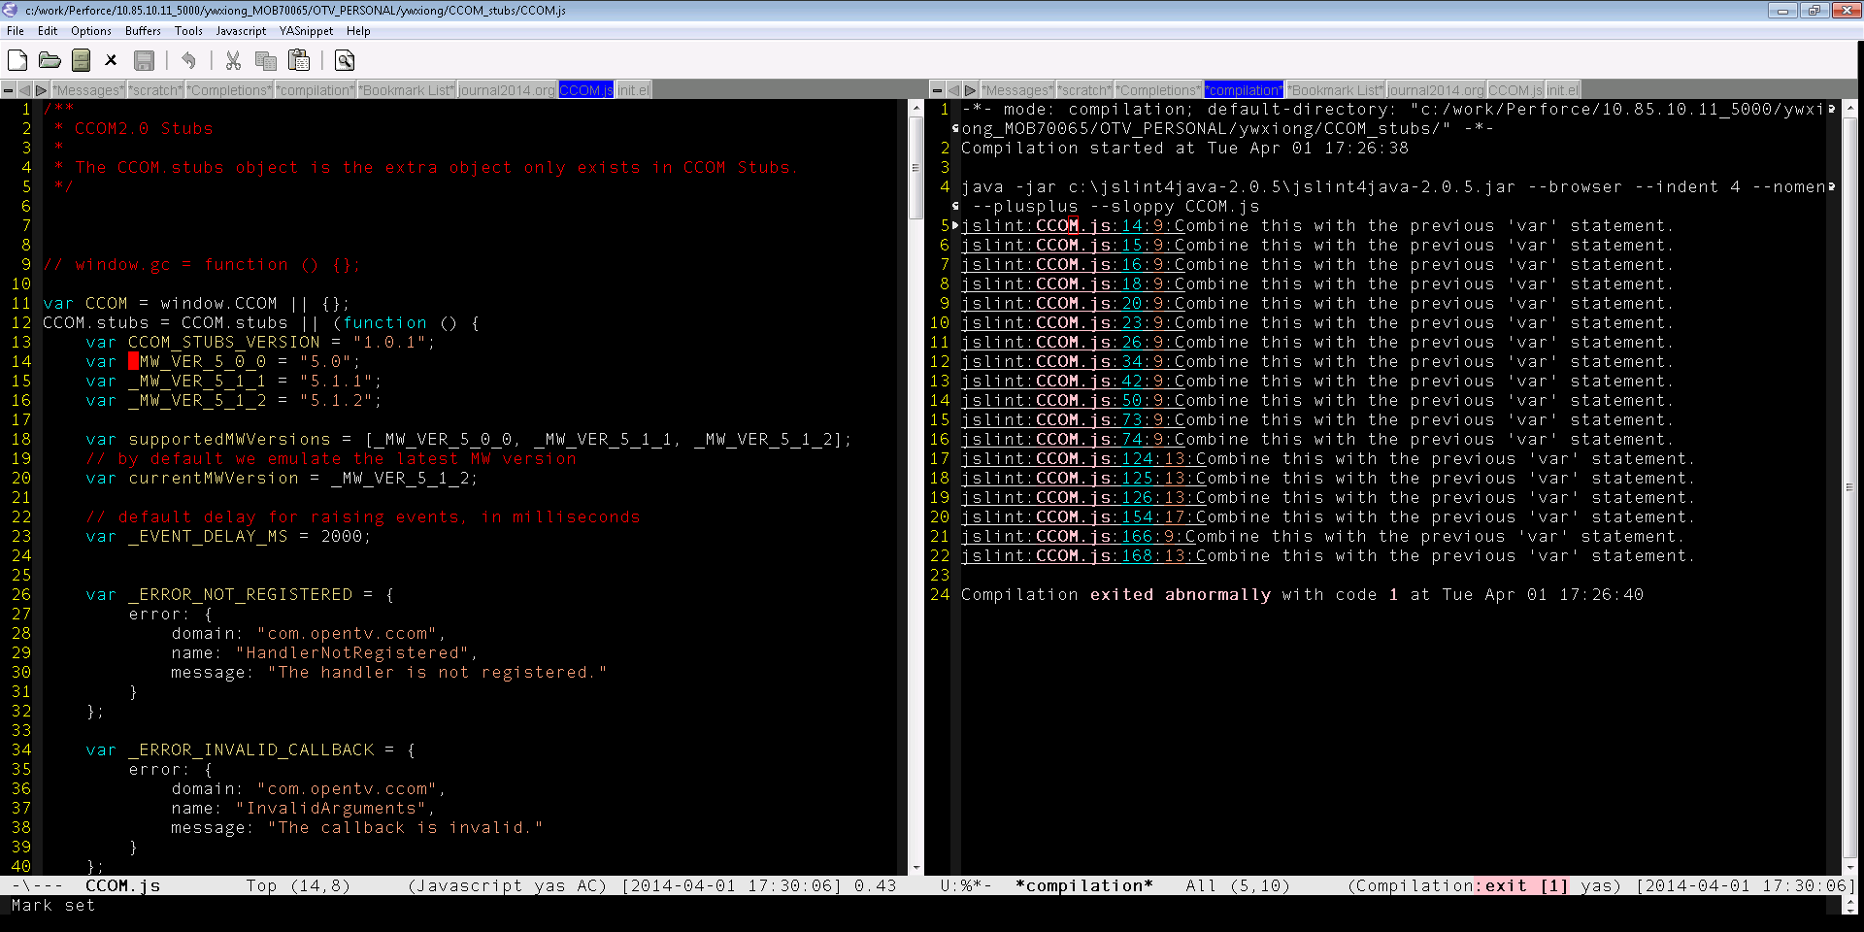
Note: this is the simplest way (i.e. less elegant but no Lisp programming required)...
For sophisticated integration, please check http://www.emacswiki.org/emacs/FlymakeJavaScript for a dedicated package for Emacs.

5. Sublime Text
Sublime Text is hot recently, even though it’s a closed-source project.
Below take ST3 Build 3059 (unregistered version) as an example.
- Navigate in the menu "Tools->Build System->New Build System..." to open a new tab for a new document for editing. Notice that the document name is by default "untitled.sublime-build", press Ctrl-S to save the file, then you have a chance to give it a meaningful name, say, "jslint.sublime-build".
Put the following JSON object into the document, save it:
{
"shell_cmd": "java -jar c:\\jslint4java-2.0.2\\jslint4java-2.0.2.jar --browser --indent 4 --nomen --plusplus --sloppy $file",
"file_regex": "^jslint:([A-Z].*.js):([0-9]+):([0-9]+):(.*)$"
}

Note that the syntax above is intended for Windows platform only. Minor adjustment is needed for Linux platforms. The "file_regex" property of the JSON object is for specifying the "file name", "line number", "column number", and "error msg" patterns in each error reported by the "build" tool (here it's jslint4java):
- The sequence of the 4 fields above are fixed (lucky enough that it's the same for jslint4java).
- The "file name" and "line number" fields are required/mandatory, while "column number" and "error msg" are optional. Here we have all 4 fields available.
- Each field is a group in RegExp, with Perl style.

- Make sure this "build system" is activated by checking the menu items:
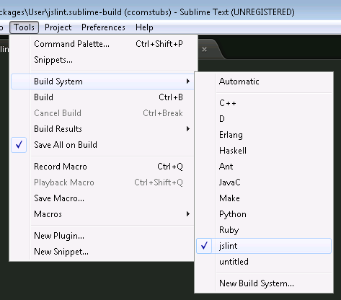
- Open a JavaScript file, and press "Ctrl+B" to invoke the build system against the file opened in the current focused tab. The “jslint4java” output message will be shown in a panel below the text window, and you can use F4 to navigate among the errors, if there is any. For backward navigate, using "Left-Shift+F4".
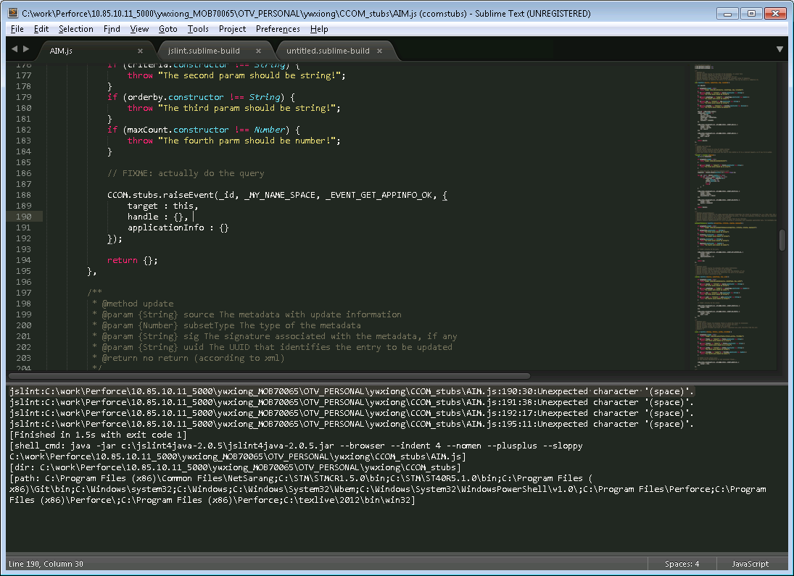

Btw, on Linux, I have the following JSON object for the new "build system":
{
"shell_cmd": "/usr/bin/java -jar /home/bruin/bin/jslint4java-2.0.2/jslint4java-2.0.2.jar --browser --indent 4 --nomen --plusplus --sloppy --predef \"$N,CCOM,CCOMX,OTV,window,document,navigator,setTimeout,setInterval,clearTimeout,clearInterval,fail,assertTrue,assertFalse,assertEquals,assertSame,assertNotSame,assertNull,assertNotNull,assertUndefined,assertNotUndefined,TestCase,Player,Source,System,Output,CA,CASystem,CAPIN,CADialogue,PID,AudioPID,Network,DVBNetwork,DVBCNetwork,DVBSNetwork,DVBTNetwork,EPGEvent,EPGService,Scheduler,ScheduleTask,ScheduleJob,DatabaseTable,DatabaseColumn,console,getURL,XMLHttpRequest,ActiveXObject,SVGPoint,AsyncTestCase,assertNotEquals,assertArray,assertObject,assertString,TestCase\" $file",
"file_regex": "^jslint:([A-Z\/].*.js):([0-9]+):([0-9]+):(.*)$"
}

