 | Top Half (ISR) |  | Bottom Half Mechanism
 | Protection | Stack | Interrupt Context | Thread Context
Linux | DP by default;  HP if SA_INTERRUPT flag is set. |  | SoftIRQ (scale to SMP) &Tasklet (not scale to SMP) without DP | Work Queue without DP
uRTOS | DP |  |  | SISR (Soft ISR), without DP.
eCos | DP and scheduler locked;  Full recursive is configurable. |  | DSR (Deferred Service Routine), with DP enabled.
Windows | DIRQL |  | DPC/APC at DISPATCH_LEVEL and APC_LEVEL | Work queues.  IoQueueWorkItem(IO_WORKITEM)
VxWorks | Configurable:  intIntRtnNonPreempt(),  intIntRtnPreempt(). | Dedicated |  | netJobAdd(), tNetTask
Solaris |  |  |  | Interrupt thread-pool for IPLs
uCOS-II | HP
MTOS
QNX
uCLinux

- Protection: what, why, how?

What/why: to prevent the execution of a task/isr from being un-recoverably-interrupted by other tasks or interrupts.

How:

- HP: hard protection: at CPU level, disable all interrupts, or all interrupts below certain priority levels.
- DP: device protection: disable a interrupt source (when servicing it).
- SP: software protection: semaphore/mutex/msgqueue/event/etc
- AP: auto-protection: 1:1 ring-buffer, instruction level…

SP/DP depends on HP, but the HP duration is under “control” of the careful implementation of DP/SP. So the rule of thumb:

- Avoid the abuse of HP/DP in drivers;
- Don’t expose HP/DP to apps.

- Interrupt Latency:

- From the point of the interrupt raised to the point the corresponding ISR starts executing.

- IRQL/IPL:

- Windows: IRQL, IRQ level
- Unix: Interrupt Priority Level

- System Responsiveness:

- Limit the usage of HP to a bare minimum.
- Consequences of HP: no further interrupts, including tick interrupt which means no further scheduling.

- Context & Stack:

- Interrupt context: no-blocking, no sleep
- Task context: may block/sleep
- Use the stack of hijacked task or use a system thread’s stack
- Use dedicated interrupt stack

- Top half and bottom half:
- TH: ISR, interrupt context, HP or DP; no blocking.
- BH: interrupt context (no blocking), or task context (may blocking)

- Why bottom-half helps (or when it does not help): a “buffering” mechanism for peak interrupt load. It’s assumed that the system is capable of executing each ISR at devices interrupt peak load, and leaving all the BH workload “buffered” in memory for later attention. This is a trade-off between time and space.
If device interrupts still get lost during execution of ISRs, BH mechanisms do not help, and this indicates a “system” architecture issue.

- Recursive interrupts (protection differences during execution of ISR):
- No recursive interrupts
- Partial recursive interrupts: 1. Priority level based, 2. Device based
- Full recursive interrupts

- Candidates for BH:

- Network
- SCSI
- Audio
- Video
- Demux
- OSD

References:

- Linux Kernel Development (3rd Ed). Robert Love. Addison-Wesley.2010.pp113-160
- uCOS ARM移植要点详解, 黄燕平,北航, 2005. pp15-50, pp120-140
- Embedded Software Development with eCos, Anthony J. Massa, Prentice Hall, 2003. pp40-51
- VxWorks下设备驱动程序及BSP开发指南.周启平,张杨.中国电力.2004. pp36-49,127
- VxWorks设备驱动开发详解.曹桂平.电子工业.2011.pp38-45
- Unix高级教程系统技术内幕.Uresh Vahalia. 清华大学. P27,59,449
- uC/OS-II源代码公开的实时嵌入式操作系统.Jean J. Labrosse.中国电力.2000
- Scheduling, Thread Context, and IRQL:
http://www.microsoft.com/taiwan/whdc/driver/kernel/IRQL.mspx
- 关于软中断: http://blog.csdn.net/dog250/article/details/5302742

Unix Signal

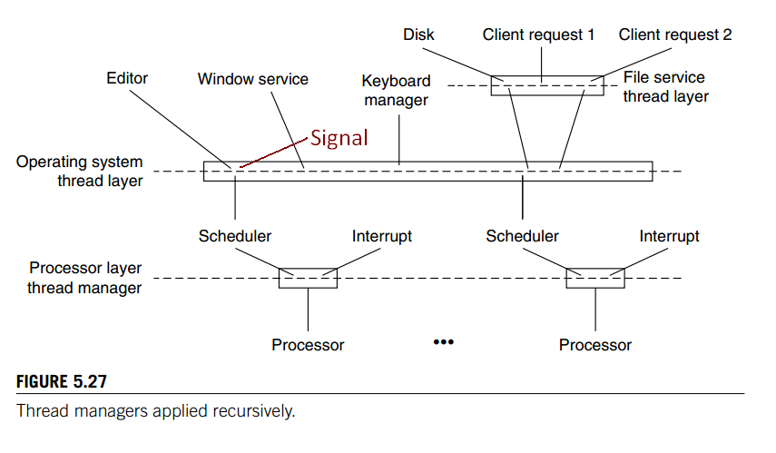
- Jerome: Layering Threads: To support interrupts, we can think of a processor as a hard-wired thread manager with two threads: (1) a processor thread (e.g., the thread that runs scheduler and (2) an interrupt thread that runs interrupt handlers in kernel mode… The operating system thread layer uses the processor threads of the processor layer to implement a second layer of threads and gives each application module one or more preemptively scheduled virtual processors. Me add: 1. in the OS thread layer, each thread is also support an “interrupt” thread based on signal mechanism provided by the OS. 2. Within each OS thread, it’s possible to implement a third layer of threads, usually in forms of cooperative fibers. The hierarchy could be recursively developed into many layers.

- APUE: Signals are software interrupts.

- 毛德超：信号（signal，亦称软中断）机制是在软件层次上对中断机制的一种模拟。。。二者之间的这种相似和类比不仅仅是概念上的，也体现在它们的实现上。

Reference:
- Principles of Computer System Design, Jerome H. Saltzer, M. Frans Kaashoek, 清华影印. p272 (Fig 5.27); Chapter 3 (naming & context); P206/259 (interrupt/exception/trap/faults/signal).
- Linux内核源代码情景分析（上），毛德超，胡希明。浙江大学。Pp716-756
- APUE (2nd), 人邮英文。Chapter 10 (Signal).
- 深入理解Linux内核，第三版，陈莉君等翻译。中国电力。第11章。
- http://www.alexonlinux.com/signal-handling-in-linux: the 3rd argument to signal handler “ucontext_t”: This type different from architecture to architecture. My advice to you is to ignore this pointer, unless you are writing a new debugger.

