Overall Block Diagram

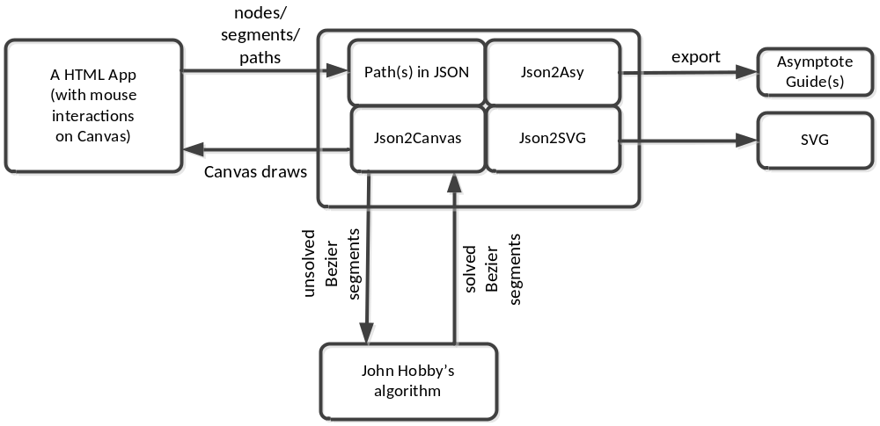

JSON format for path

Concepts & Terminology
A path is composed by segments, each of which is defined by its two end points (nodes), and the segment is either a straight line, or a cubic Bezier curve the two control points of which are automatically calculated by the algorithm in John Hobby’s 1986 paper (also in chapter 14 of “The METAFONT book”).

A continuous subset of a path is called a subpath of it. A subpath can contain no segment (i.e., an empty subpath), or all segments (i.e., the original path), or any number of segments in between (i.e., mimic the concept of set and subset, with the difference that segments in a subpath must be continuously connected).

An empty path (subpath) has no nodes (so no segement);
A degraded path (subpath) has only one node (also no segment);

A path can be either closed (cyclic), or open (non-cyclic). Basically, the “closeness” of a path enables the rendering engines (Canvas/Asymptote/SVG/etc) to do two things:
- fill the interior region enclosed by the path;
- draw the closing point perfectly (with any pen shape).
A path (or subpath) has a direction, which goes from the 1st point to the last point; with the same order, each segment has its direction, which goes from the first node to the second node.

The type (or form) of a segment (straight line or Bezier curve) is determined by the connection property of its first node. For that purpose, the following two connection types are supported:
- straight line (denoted by “-- “)
- free curve (denoted by “..”)
The other three METAPOST connection types (i.e., bounded curve “…”, tense line “---”, and splice “&”) are not supported.

For a free curve segment, although its type (Bezier curve) is determined within the segment itself, the calculated control points for the Bezier curve may depend on its adjacent segments (unless both its pre- and post- segments are straight lines).

Note that a degraded segment is a segment of zero length, i.e., its 1st and 2nd nodes coincide. The type of degraded segments is always treated as straight line, regardless, because it’s not very meaningful to calculate the control points if degraded segments are treated as Bezier curves.

Degraded segment is useful for connecting two free curve segments which need to be “non-smoothly” connected (i.e. with sharp corner). This is because, without the zero segment in between, the two adjacent free curves will be jointed smoothly as guaranteed by John Hobby’s algorithm. For example, there are two paths (go through the same set of nodes) in the diagram below:
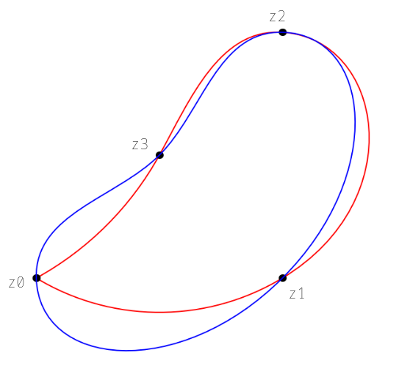
The blue path (as expressed in Asymptote) is “z0..z1..z2..z3..cycle”, in which the segment “z0..z1” is connected with segment “z3..z0” smoothly through node “z0”;
On the contrary, the red path is “z0..z1..z2..z3..z0--cycle”, in which a degraded segment “z0--z0” connects the two free curve segments (“z0..z1” and “z3..z0”) non-smoothly at node “z0”.

The difference between the two paths also demonstrates the fact that the control points for a free curve segment depend on other free curve segments connected with it.

Node

A node represents a point on the HTML 2D-Canvas plane. Each node is a JSON object with the following properties:
- “x” & “y”: coordinates in Canvas coordination (where the Y axis is pointing down)
- “conn”: the connection type between this node and its following node (if there is one), its value can be one of the following:
- “..”: free curve to the next node (similar to bezierCurveTo() in Canvas);
- “--“: straight line to the next node (similar to lineTo() in Canvas);
- null: no connection with the next node (similar to moveTo() in Canvas) .
- To be added (name, comments, dot or not, dot pen, dot color, etc)…

Path & Subpath
A path object mainly contains a node array property, together with some other optional properties. The data structure for subpaths is the same as for paths.
A path/subpath contains the following properties:
- “nodes”: its value is an array of nodes;
- To be added (name, comments, color, fill, style, etc)…
Note that as the path we defined is meant to be continuous, for each node in a path, the “conn” property value “null” can only be assigned to the last node of a path. All other nodes in a path must be connected to its next node in one of the two ways.

Specifically, for the “conn” property of the last node in a path:
- “null” value means the path is open (non-cyclic, non-closed);
- “..” value means the path is closed, the last node and the 1st node forms a free curve segment. In this case, the last node and 1st node of the curve must not coincide.
- “--” value means the path is closed, the last node and the 1st node forms a straight line segment. In this case, the last node and 1st node can either coincide or not.
Note that the closeness (cyclic or not) of the path (subpath) is determined by the “conn” property of its last node. The value also tells how the 1st node and last node in the path is connected: unless the value is one of “..” and “--”, the path is non-cyclic (not closed), otherwise it’s a closed path.

Sample paths in JSON
Take the previous diagram as example.

The blue path can be expressed in JSON as:

{"nodes":[
{"x":0,"y":0,"conn":".."}, // z0
{"x":100,"y":0,"conn":".."}, // z1
{"x":100,"y":100,"conn":".."}, // z2
{"x":50,"y":50,"conn":".."} // z3
]
}

The red path in JSON:

If starts at z0 (CCW):
{"nodes":[
{"x":0,"y":0,"conn":".."}, // z0
{"x":100,"y":0,"conn":".."}, // z1
{"x":100,"y":100,"conn":".."}, // z2
{"x":50,"y":50,"conn":".."}, // z3
{"x":0,"y":0,"conn":"--"} // z0
]
}

Or, if starts at z3 (CCW):

{"nodes":[
{"x":50,"y":50,"conn":".."}, // z3
{"x":0,"y":0,"conn":"--"}, // z0
{"x":0,"y":0,"conn":".."}, // z0
{"x":100,"y":0,"conn":".."}, // z1
{"x":100,"y":100,"conn":".."} // z2
]
}

References
- Donald E Knuth. The METAFONT book, Addison-Wesley, Reading, Massachusetts, 1986
- John D. Hobby: Smooth, easy to compute interpolating splines. Discrete Comput. Geom., 1:123－140,1986
- Asymptote User Manual (v2.23)
- Python version of the algo: http://tex.stackexchange.com/questions/54771/curve-through-a-sequence-of-points-with-metapost-and-tikz

