http://french.about.com/od/writing/ss/typeaccents_2.htm
- Typing French Accents - Windows: International Keyboard
For US English keyboard users, the international keyboard (which is not a physical keyboard, but rather a simple Control Panel setting) is the easiest and most convenient method for typing French accents because it maintains the QWERTY layout, with just a few changes and additions:
- To type accent grave (à, è, etc), type ` (to the left of 1) then the vowel. à
- Accent aigu (é), type ' (single quote) then e. é
- Cédille (U+00E7), type ' then c. ç
- Circonflexe (ê), type ^ (shift + 6) then e. ê
- Tréma (U+00F6), type " (shift + ') then o. ö
- To type French quotation marks U+00AB U+00BB use ctrl + alt + [ and ], respectively. «»
Note: The minor disadvantage of the international keyboard is that when you want to type the "helping" character (e.g., single or double quotes) by itself rather than above a vowel, you have to type the symbol then hit the space bar. For example, to type c'est, type c then ' then hit the spacebar then type e s t. It takes a little while to get used to typing that extra space when you just want to type ' or ".

- Win7 setup:
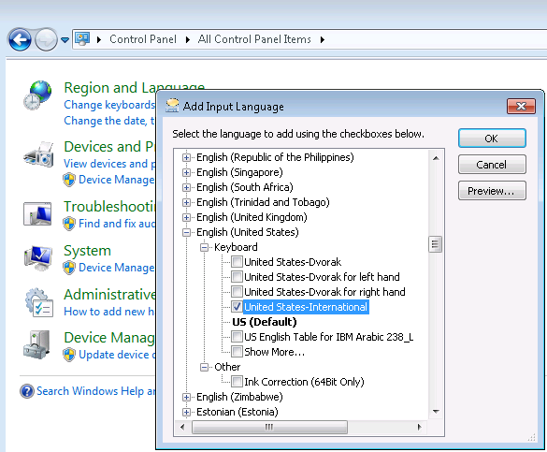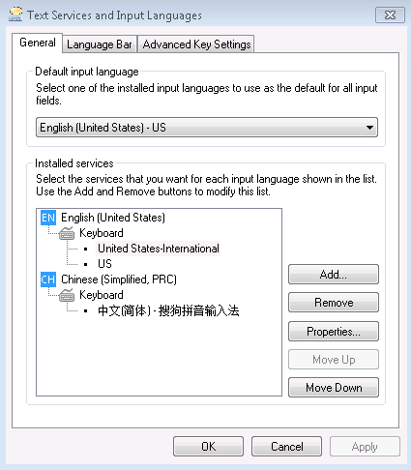
Fedora 19:
Menu->Settings->Keyboard:
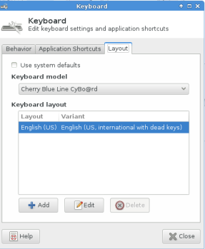
https://ask.fedoraproject.org/en/question/28468/problems-with-letter-c-in-us-international-keyboard-fedora-19/
For Cédille, press AltGr key (i.e., right ALT) together with “,”:
AltGr + , => ç
AltGr + SHIFT + , => Ç

