命令行解释：

-L: local port forwarding
localhost:8080:localhost:8123: 本地地址为127.0.0.1:8080，forward到的地址为sshd看到的localhost:8123
-i d:\aws.pem: public key
- ubuntu@aws: user@host，其中host是sshd运行的机器

也可以用MobaXterm图形化设置：

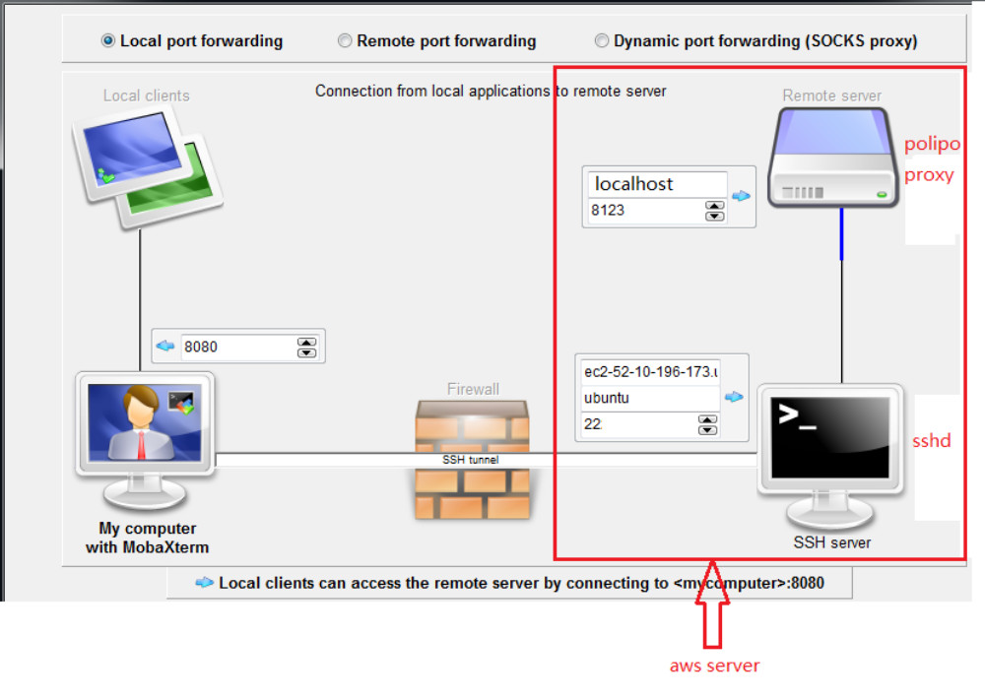
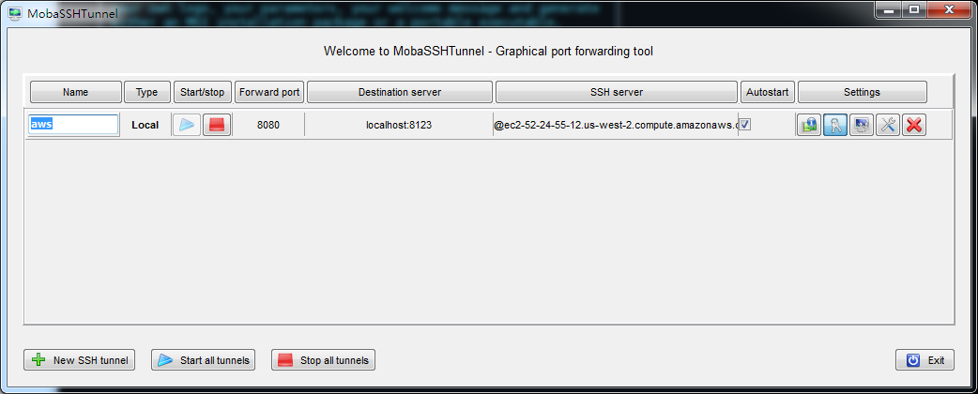

注意设置destination server 为localhost:8123，因为polipo被设置成监听loopback接口（见后）；

另外这里设置local network adapter 为 loopback 接口，这样本地监听地址为127.0.0.1:8080：
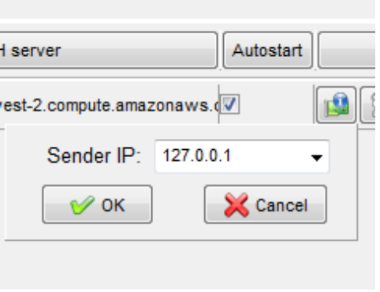

在mobaxterm中start以后：

客户端监听端口起来了：
bruin@WIN7 /d/xiongyw/doc/it/linux/bin (master)
$ netstat -an | grep 8080
TCP 127.0.0.1:8080 0.0.0.0:0 LISTENING

服务器端sshd的连接也建立了：
之前：
ubuntu@aws:~$ netstat -an|grep ":22 "
tcp 0 0 0.0.0.0:22 0.0.0.0:* LISTEN
tcp 0 36 172.31.9.247:22 123.114.36.184:1686 ESTABLISHED
tcp 0 0 172.31.9.247:22 123.114.36.184:1688 ESTABLISHED
tcp6 0 0 :::22 :::* LISTEN
之后：
ubuntu@aws:~$ netstat -an|grep ":22 "
tcp 0 0 0.0.0.0:22 0.0.0.0:* LISTEN
tcp 0 36 172.31.9.247:22 123.114.36.184:1686 ESTABLISHED
tcp 0 0 172.31.9.247:22 123.114.36.184:1688 ESTABLISHED
tcp 0 0 172.31.9.247:22 123.114.36.184:2280 ESTABLISHED
tcp6 0 0 :::22 :::* LISTEN

服务器端启动polipo proxy:

配置监听接口和端口：只在loopback接口上监听，更安全；端口缺省8123;

ubuntu@ip-172-31-9-247:/etc/polipo$ cat /etc/polipo/config
# This file only needs to list configuration variables that deviate
# from the default values. See /usr/share/doc/polipo/examples/config.sample
# and "polipo -v" for variables you can tweak and further information.

logSyslog = true
logFile = /var/log/polipo/polipo.log
proxyPort = 8123
#proxyAddress = "::0"
proxyAddress = "127.0.0.1"
proxyName = "bruin's polipo proxy"
chunkHighMark = 50331648
objectHighMark = 16384
localDocumentRoot = ""
dnsQueryIPv6 = no

启动：
ubuntu@ip-172-31-9-247:~$ sudo nohup polipo &
[1] 26569
ubuntu@ip-172-31-9-247:~$ nohup: ignoring input and appending output to ‘nohup.out’

检查启动结果：
ubuntu@ip-172-31-9-247:~$ ps -ef|grep polipo
root 26569 26126 0 00:43 pts/0 00:00:00 sudo nohup polipo
root 26570 26569 0 00:43 pts/0 00:00:00 polipo
ubuntu 26572 26126 0 00:44 pts/0 00:00:00 grep --color=auto polipo

ubuntu@ip-172-31-9-247:~$ netstat -an|grep tcp|grep 8123
tcp 0 0 127.0.0.1:8123 0.0.0.0:* LISTEN

客户端 chrome 网络配置：

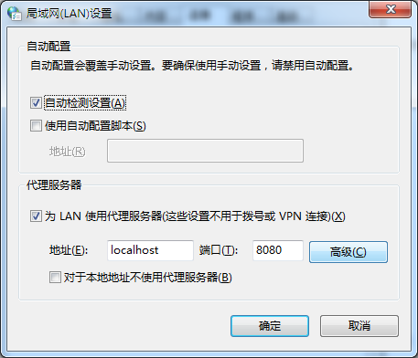

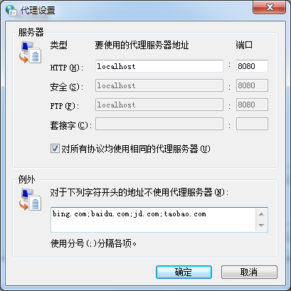

或者给chrome安装SwitchOmega插件并设置自动规则:

