Jonathan’s Website:

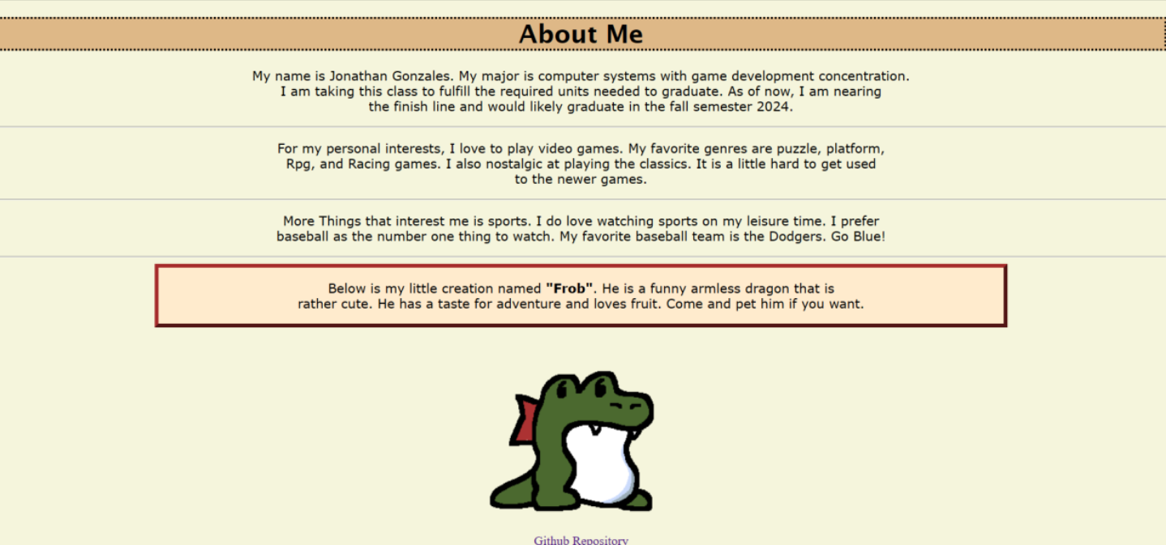

Pamala’s website:

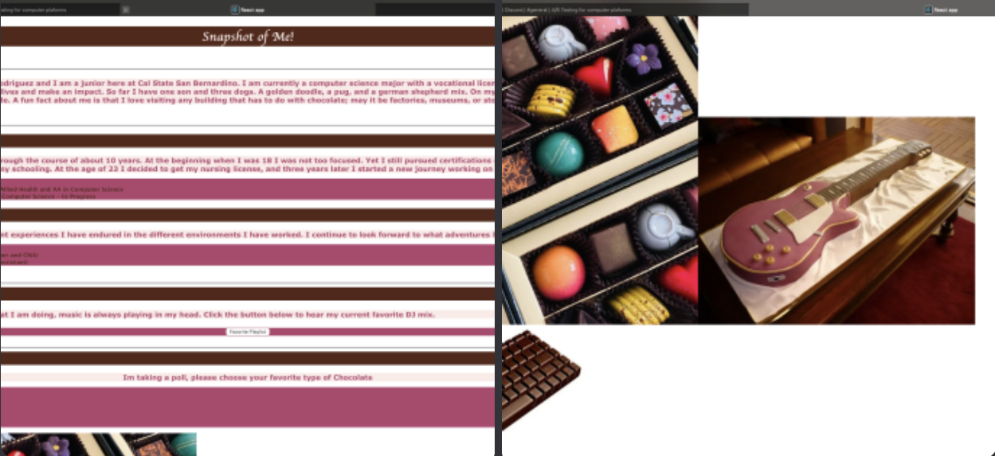

Roberto’s Website:

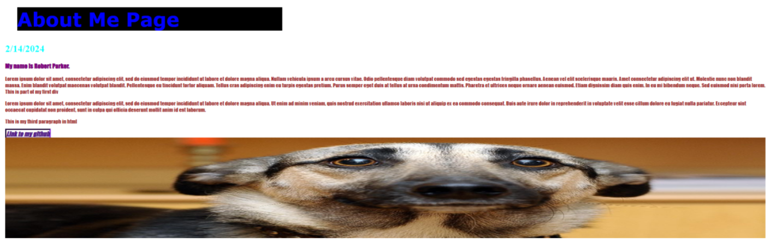

Ronald’s Website:

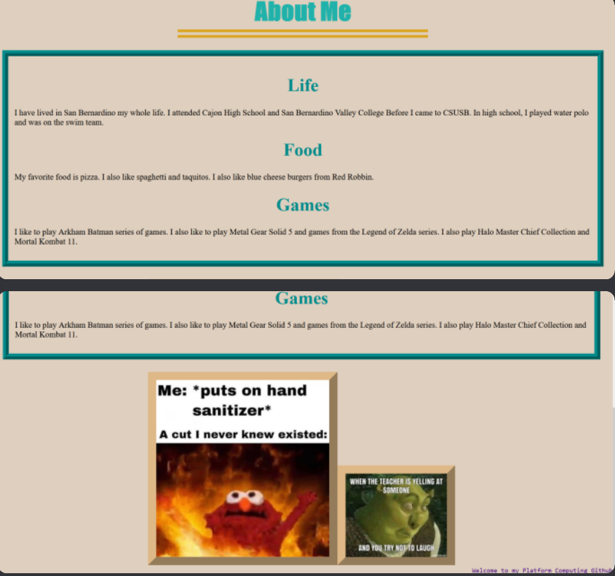

|  |  |  |  |  |  |
| --- | --- | --- | --- | --- | --- |
|  | Ronald unique user retention time (sec) | Pamela unique user retention time (sec) | Jonathan unique user retention time (sec) | Roberto unique user retention time  (sec) | Average Retention time (sec) |
| Ronald's website | 60 | 30 | 70 | 43 | 50.75 |
| Pamela's website | 40 | 40 | 70 | 41.229 | 47.80725 |
| Jonathan's website | 30 | 20 | 80 | 32.639 | 40.65975 |
| Roberto's website | 20 | 0 | 30 | 30 | 20 |

Ronald’s Website is the best performing Website because he has two images and used the work games.

Hypothesis: We can increase the retention time by adding more images and writing multiple paragraphs to increase probability of matching a user’s keyword and we will determine that this has increased the retention time based off the user average in seconds.

Github link: <https://github.com/RFIG99/Group_13_Final_Project/tree/main>