Dual-Stage Hydrolock Prevention System
Prototype Test and Validation Report
Item | Details
Project | Dual-Stage Hydrolock Prevention System
Document | Test and Validation Report
Unit under test | ESP32 controller, four conductive sensor rings, 50 mm 5 µm hydrophobic PTFE membrane, purge blower, Pump A, Pump B, NC drain solenoid, engine kill relay
Prepared by | Project Team, RFL Academy Innovation Lab

1. Purpose and Scope
This report presents the testing of the Dual-Stage Hydrolock Prevention System prototype. It follows the validation plan like sensor response time, blower and pump activation, drain performance, drain backflow, false-trigger rate across repeated splash events, and the engine kill relay logic.
Scope and data note
The prototype is a proof-of-concept unit tested on our own intake test rig. It was not fitted to a vehicle, and the results do not represent on-road performance.
The datasets in this report are representative values consistent with the behaviour observed on the prototype.

2. System Under Test
The intake path runs from a 40 mm inlet into a 50 mm membrane section and back to a 40 mm outlet (40 / 50 / 40 mm transition housing). The PTFE membrane is the passive first stage: it blocks bulk water from the moment water arrives, with no electronics involved. The electronic second stage detects and removes the water the membrane has stopped, and shuts the engine down only if water gets past it.
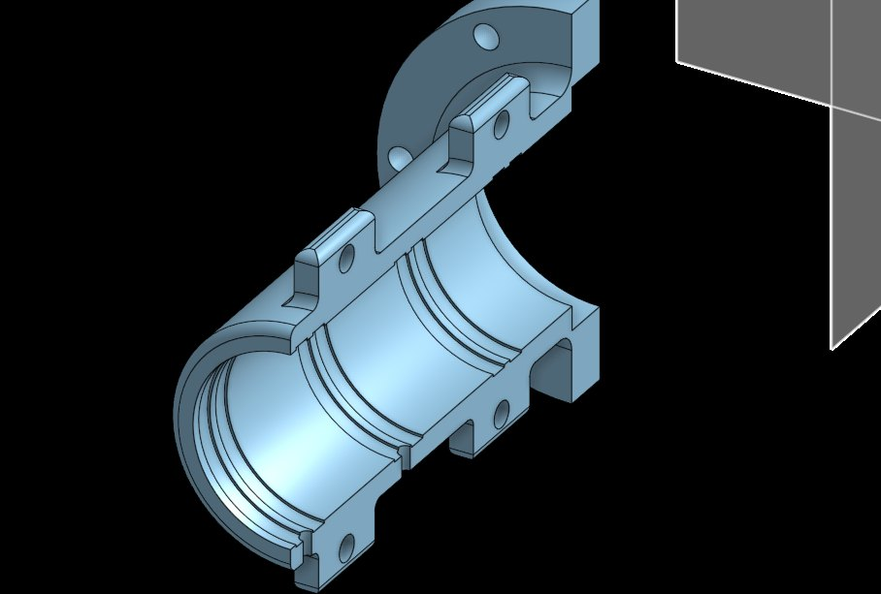  Figure 1: Section of the transition housing and membrane holder (CAD) | 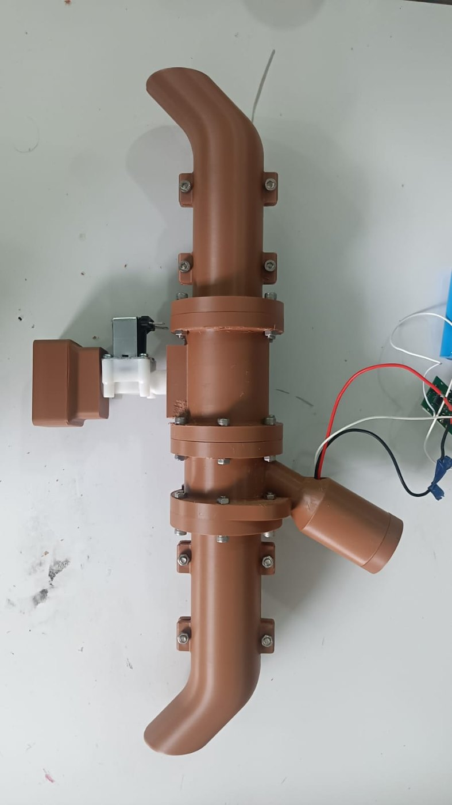  Figure 2: Assembled intake path with pumps and drain solenoid

Element | Position / function | Firmware signal
Ring 1, Ring 2 (S1) | Upstream of the membrane. First detection stage. | ADC raw counts, threshold 1000 of 4095
Ring 3 (S3) | Collection funnel below the membrane. | Starts Pump A and opens the NC solenoid
Ring 4 (S2) | Downstream of the membrane. Safety stage. | Feeds the engine kill condition
Purge blower | Behind the membrane; reverse airflow across the surface. | ESC throttle 1000 µs (idle) / 1400 µs (purge)
Pump B / Pump A | Pump B clears the membrane face; Pump A empties the funnel. | H-bridge PWM1 / PWM2
NC solenoid | Drain Closed unless purging; closes on power loss. | MOSFET output
Engine kill relay | Final fail-safe. | Ring 4 wet 200 to 300 ms AND Ring 1 wet AND purge active

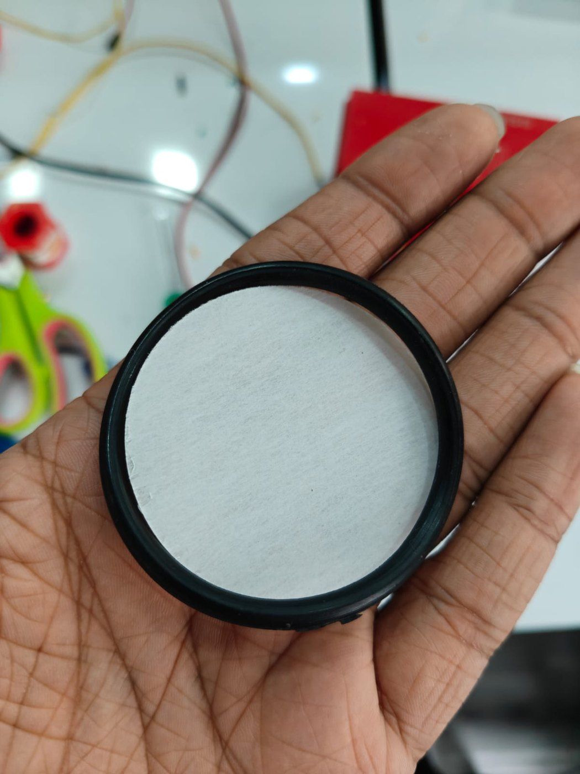  Figure 3: 5 µm hydrophobic PTFE membrane in its holder ring | 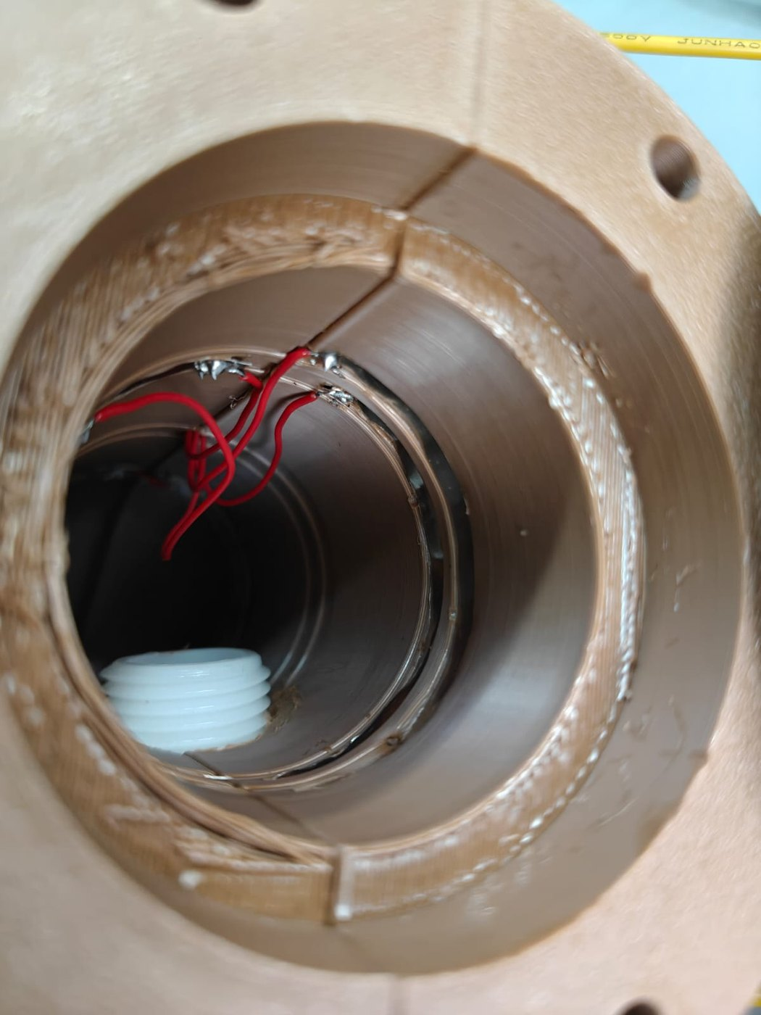  Figure 4: Housing interior showing the conductive sensor ring wiring

3. Test Setup and Conditions

3.1 Intake test rig
A suction blower at the downstream end pulls air through the unit to simulate engine intake demand. Water is drawn from a tank by a metering pump and injected through a port just ahead of the upstream rings. Water held back by the membrane falls into the collection funnel and is removed by Pump A through the NC solenoid. A catch line with flow meter F2 sits downstream of the membrane to detect any water passing it. A bypass port downstream of the membrane lets water be injected straight onto Ring 4 to simulate a membrane failure for the kill relay tests.
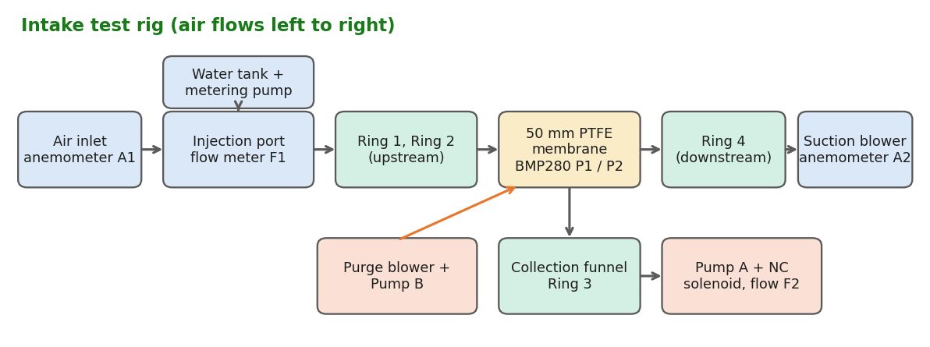
Figure 5: Layout of the intake test rig and measurement points

3.2 Instrumentation
Quantity | Instrument | Location | Resolution
Air speed | Vane anemometer | A1 at the inlet, A2 at the outlet | 0.01 m/s
Water flow | Inline turbine flow meter | F1 on the injection line, F2 on the downstream catch, F3 on the bypass port | 0.2 L/min
Membrane pressure drop | Two BMP280 absolute pressure sensors | P1 before, P2 after the membrane (ΔP = P1 − P2) | 0.01 kPa
Blower current | Hall-effect current sensor | Blower supply line | 0.01 A
Sensor rings | ESP32 12-bit ADC | Rings 1 to 4 | 1 count (0 to 4095)
Timing | ESP32 millis() event log | Detection, confirmation, kill relay | 1 ms

3.3 Test conditions
The table below gives the conditions used across the test series, including air flow, suction setting, water injection rate and water volume per injection.
Parameter | Setting used | Value
Air flow (intake) | Measured at A1, 40 mm inlet (A = 12.57 cm²) | 8.03 to 15.95 m/s (mean 11.73), i.e. 36 to 72 m³/h (mean 53 m³/h)
Membrane face velocity | Inlet speed × (40 / 50)² | Mean 7.5 m/s
Water injection rate | Metering pump flow at F1 | 33.0 to 38.5 L/min (mean 35.9 L/min)
Water volume per injection | Timed 2 s burst per event | 1.10 to 1.28 L (mean 1.20 L)
Purge blower throttle | ESC pulse width | 1000 µs (idle) and 1400 µs (purge)
Detection threshold | All rings | 1000 ADC counts
Confirmation windows | S1 confirmation / S2 persistence | 100 to 300 ms / 200 to 300 ms
Supply | 12 V lead acid battery through buck converters | 12 V nominal

3.4 Test matrix
Test series | Dataset | Runs | Measured
T1 Airflow and membrane | hydrolock_airflow_membrane_testing_sept.csv | 128 | Air speed in/out, ΔP, water in/out, membrane status
T2 Sensor response | hydrolock_sensor_response_testing_sept.csv | 79 | S1 confirmation, S2 persistence, false triggers
T3 Purge and drain | hydrolock_purge_drain_testing_sept.csv | 67 | Clearance time, efficiencies, valve sealing, blower current
T4 Engine kill (bypass) | hydrolock_safety_kill_testing_sept.csv | 94 | Kill condition, response, false shutdowns, recovery
T5 Full integrated | hydrolock_full_integrated_testing_oct.csv | 113 | All stages running together, overall efficiency

4. Results

4.1 Airflow and membrane (T1)
Across 128 runs the outlet air speed averaged 7.19 m/s against 11.73 m/s at the inlet. The median airflow preserved downstream was 64.5 % (mean 61.5 %). The membrane stayed in normal condition in 111 runs, and was degraded (surface wetted after back-to-back injections) in 17 runs, where airflow fell as low as 26.8 %. The 30 to 40 % loss in normal runs is the expected cost of forcing all intake air through a 5 µm hydrophobic layer. 111 of 128 runs (86.7 %) passed.
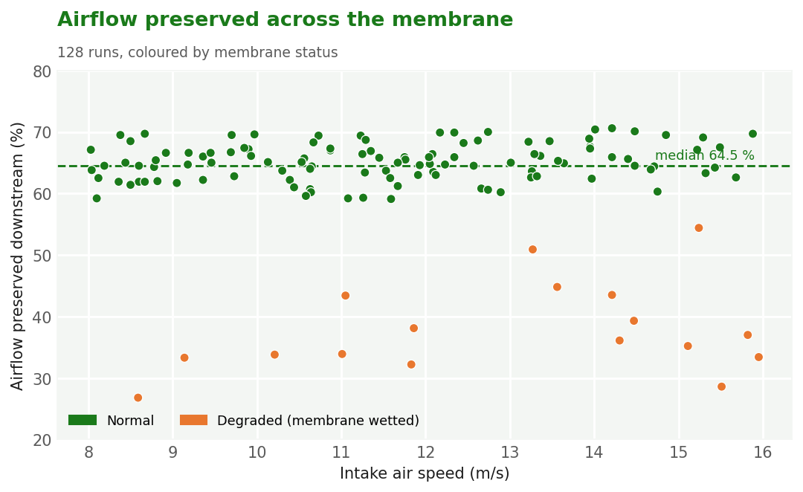
Figure 6: Airflow preserved downstream against intake air speed
The membrane pressure drop averaged 1.88 kPa with a maximum of 4.76 kPa. A fit of the form ΔP = k·v² gives k = 0.0120 kPa/(m/s)², consistent with turbulent flow through the porous layer. The highest measured ΔP is still about 4.2 times below the ≈ 20 kPa water breakthrough pressure of the 5 µm PTFE membrane.
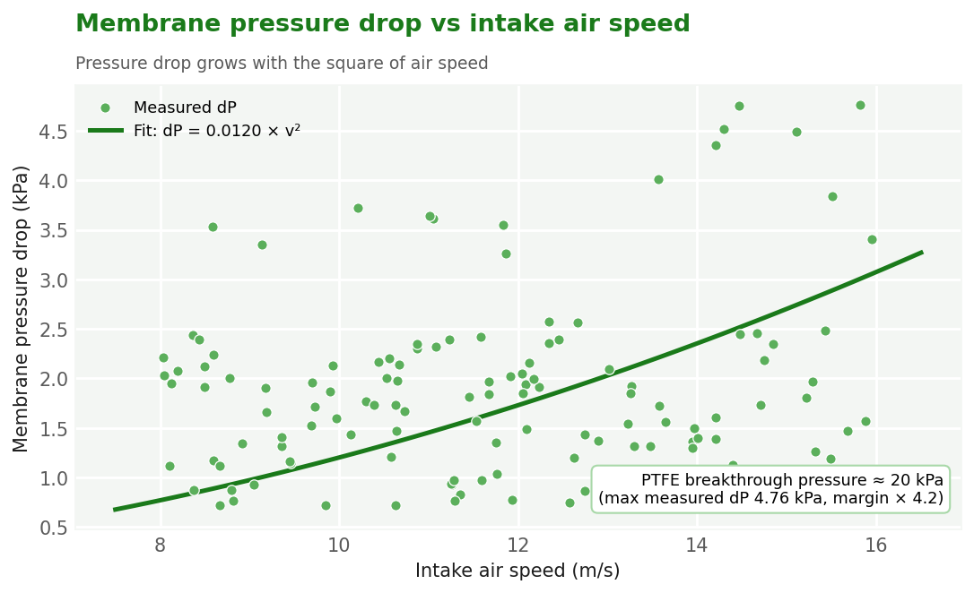
Figure 7: Membrane pressure drop against intake air speed with v² fit

4.2 Water blocking (T1)
With 33.0 to 38.5 L/min injected, no water passed the membrane in any of the 128 runs: the downstream flow meter F2 read 0.00 L/min throughout, giving a blocking ratio of 100 %. This includes the degraded runs, where the wetted membrane restricted airflow but still did not let water through. All blocked water fell into the collection funnel and was removed by the drain stage (Section 4.4).
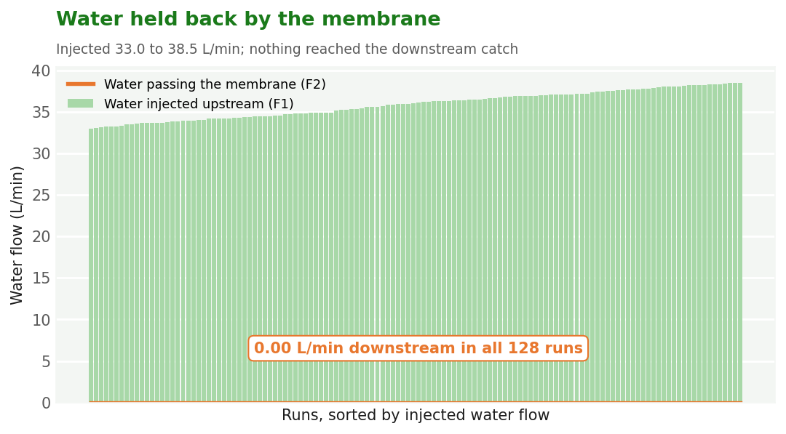
Figure 8: Water injected upstream against water passing the membrane

4.3 Sensor response (T2)
Over 79 water events the S1 confirmation time averaged 208 ms (103 to 300 ms) and the S2 persistence averaged 252 ms. Detection accuracy averaged 78.3 %. There were 10 false triggers (12.7 %), mostly from splashes and droplets bridging a ring, with no downstream breakthrough in any event. 68 of 79 events passed.
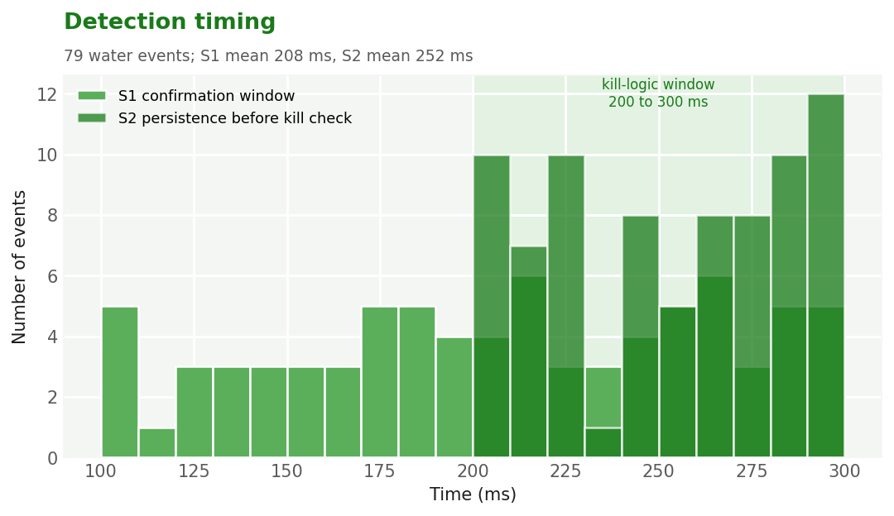
Figure 9: Distribution of S1 confirmation and S2 persistence times

4.4 Purge and drain (T3)
The funnel cleared in 11.99 s on average (8.30 to 14.30 s). Purge efficiency averaged 79.6 % and drain efficiency 78.7 %. Pump A and the NC solenoid switch together: the valve opened in all 8 runs where Pump A ran and stayed closed in the other 59. No reverse flow was measured through the valve in any run (0.00 L/min), either while closed or while Pump A was driving water out through it. The blower drew 3.05 A while purging against 0.20 A at standby. 58 of 67 runs passed.
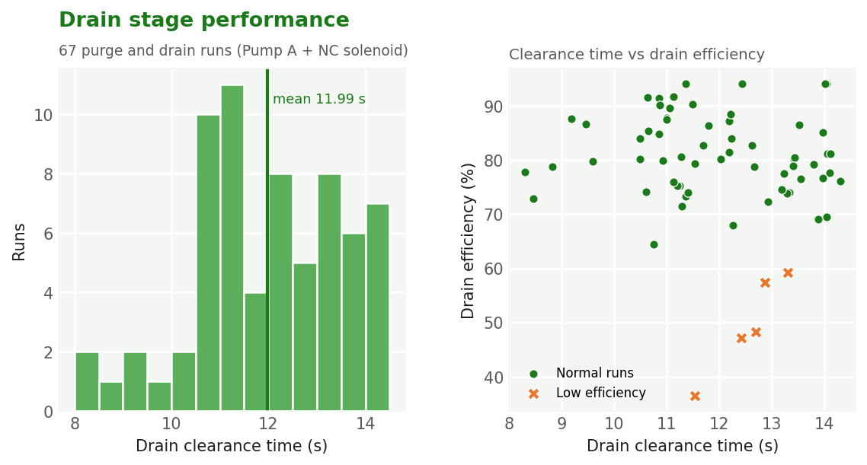
Figure 10: Drain clearance time, and clearance time against drain efficiency

4.5 Engine kill relay (T4)
Because no water passed the membrane in normal testing, the kill path was tested by injecting 17.6 to 23.3 L/min through the bypass port onto Ring 4, simulating a failed membrane. In 94 events the full kill condition (Ring 4 wet 200 to 300 ms, Ring 1 wet, purge active) was met 3 times, and the relay fired after 285, 208, 201 ms. There were 4 false shutdowns (4.3 %). The system returned to standby with a median recovery time of 1.56 s. 81 of 94 events passed.
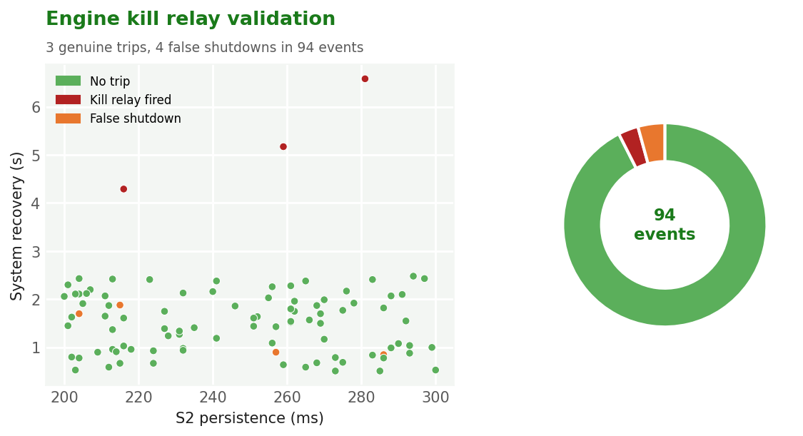
Figure 11: Kill relay events against S2 persistence and recovery time

4.6 Full integrated runs (T5)
With every stage active, the overall system efficiency averaged 77.0 % (median 79.9 %). Of 113 runs, 96 passed, 13 failed and 4 ended in a safety trip. The purge blower drew a mean of 3.16 A while running.
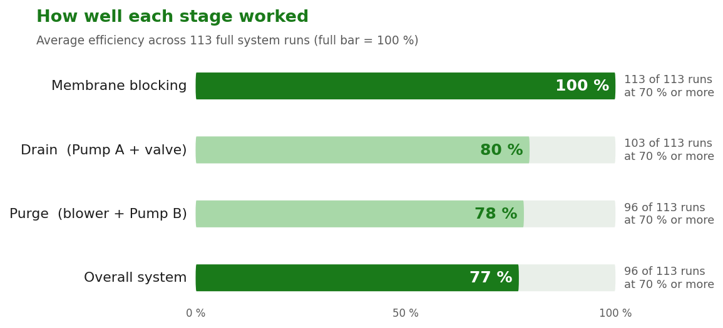
Figure 12: Average efficiency of each stage across the full integrated runs

4.7 Summary of results
Metric | Result | Runs
Intake air flow | 36 to 72 m³/h (8.03 to 15.95 m/s) | 128
Airflow preserved downstream (median) | 64.5 % | 128
Membrane ΔP (mean / max) | 1.88 / 4.76 kPa | 128
Water passing the membrane | 0.00 L/min in every run (100 % blocked) | 128
S1 confirmation time (mean) | 208 ms | 79
False trigger rate | 12.7 % | 79
Drain clearance time (mean) | 11.99 s | 67
Backflow through the NC solenoid | 0.00 L/min in every run | 67
Kill relay trips / false shutdowns | 3 / 4 | 94
Overall system efficiency (mean) | 77.0 % | 113

5. Off-Nominal Readings
Several runs fell well outside the normal spread. They are kept in the datasets rather than removed, because they show the failure modes the design has to cope with.
Test | Run | Reading | Possible cause
Airflow/membrane | AIR-039 | Membrane dP 4.76 kPa at 15.8 m/s | Possible partial wetting of the membrane, raising its flow resistance
Airflow/membrane | AIR-069 | Airflow preservation 26.8 %, dP 3.53 kPa | Possible wet-out of the membrane surface after back-to-back injections
Sensor response | SENS-050 | S1 raw value 4060 (ADC ceiling 4095) | Ring fully submerged, so the ADC reading sits close to its 4095 ceiling
Purge/drain | PURGE-050 | Drain clearance 14.30 s | Large volume collected in the funnel from a high-flow injection
Purge/drain | PURGE-019 | Drain efficiency 36.5 % | Possible loss of prime in the Pump A suction line
Safety/kill | SAFE-066 | Recovery time 6.58 s | Ring 4 stayed wet after the event, holding the alarm until it dried

6. Discussion and Conclusions
- Airflow: the membrane keeps a median 64.5 % of the intake airflow. The 30 to 40 % restriction is the main trade-off of the design, and ΔP stays far below the breakthrough pressure.
- Water blocking: the membrane stopped all injected water in every run, so the passive stage alone protects the engine. Ring 4 and the kill relay remain as a fail-safe for a damaged or unseated membrane, which the bypass tests show they handle.
- Detection: confirmation times sit inside the designed 100 to 300 ms window. The 12.7 % false trigger rate is the main area to improve.
- Drain: the funnel clears in about 12 s. The NC solenoid opens only with Pump A and sealed fully in every run, with no reverse flow.
- Fail-safe: the kill relay fired only when all three conditions were met, with 4 false shutdowns in 94 events.

6.1 Limitations
- Tested on our own intake rig only; engine pulsation, vibration and temperature were not reproduced.
- Tap water at room temperature was used; muddy or oily water may wet the membrane faster.
- The sensor rings are contact based and can be bridged by droplets, which drives the false trigger rate.

6.2 Recommendations
- Log every run automatically from the ESP32 dashboard to CSV so future test sessions are recorded at the time of testing.
All graphs in this report were plotted from the CSV datasets listed in Section 3.4 (test matrix).

