QSection .TPL

The .TPL file is a template control file used in the creation of design cross sections. The format of this file is as follows:

1. Station Control

The first variation is a station control file which will link multiple .TPL files over different ranges of chainages. The format is a comma delimited file as follows:

Column 1: STA

Column 2: Start station (do not include ‘+’)

Column 3: End station (do not include ‘+’)

Column 4: .TPL file for this station range.

Example:

STA,10087.078,10138.860,I:/Highway 97 Commotion Creek/RFL Control/BarrierRight.tpl

The BarrierRight.tpl will be used from station 100+87.078 to station 101+38.860

Note that I recommend to use ‘/’ for folder delimitation – this is a general thing when dealing with LISP.

1. Section Control
   1. Default Superelevation

When no superelevation is available for the given station the default will be utilized.

Column 1: S

Column 2: Left Super (%)

Column 3: Right Super (%)

Example:

S,-2,-2

This will set a normal crown of 2% down to the left and 2% down to the right.

* 1. Alignment Control

Column 1: AP

Column 2: Control number

Column 3: Layer for control

Example:

AP,1,C-ROAD-PVMT-EDGE

AP,2,C-ROAD-SHLD

AP,3,C-ROAD-BARR-CONC

Alignment 1 will be all the POLYLINES and LWPOLYLINES found on layer “C-ROAD-PVMT-EDGE”, 2 will be all found on “C-ROAD-SHLD”, and 3 will be all found on “C-ROAD-BARR-CONC”

* 1. Left/Right Offsets

Column 1: L or R

Column 2: See below

Column 3: See below

* + 1. Column 2: X
       1. Column 3: Y

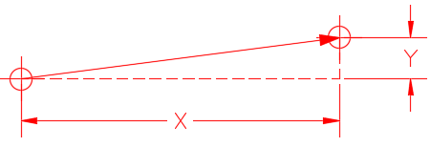

Example:

L,X0.0,Y0.0

L,X-3.5,Y-0.25

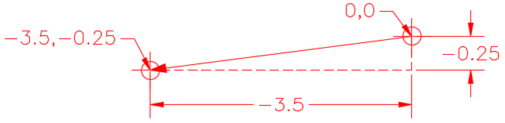

The first L defines the start left point and is at offset 0.0 from control line and at a depth of 0.0. The second lines moves the point the left section 3.5 units to the left of the previous point and 0.25 units down from the previous point.

* + - 1. Column 3: SPxxx

xxx (percent)

* + - 1. Column 3: SL / SR

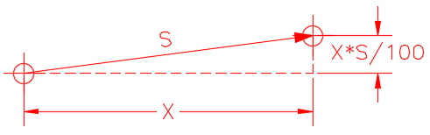

Example:

L,X-3.5,SL

Left Superelevation = -2.0

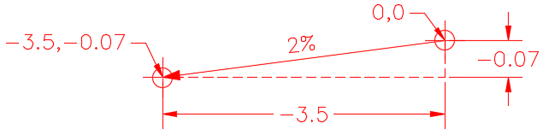

The left point will be moved 3.5 units left and down at 0.07.

* + - 1. Column 3: S-L / S-R

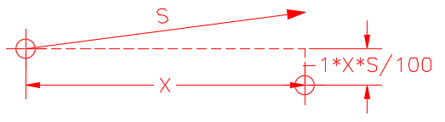

The use case for this is to move points on one side utilizing the superelevation on the other.

Example:

L,X-3.5,S-L

Left Superelevation = -2.0

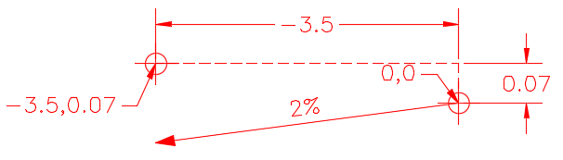

The left point will be moved 3.5 units left and up 0.07.

* + - 1. Column 3: DSL /DSR

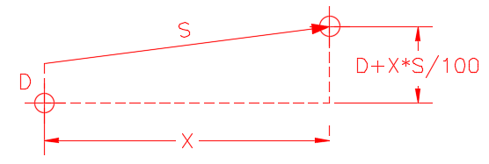

L,X-0.5,DSL-0.125

Left Superelevation = -2.0

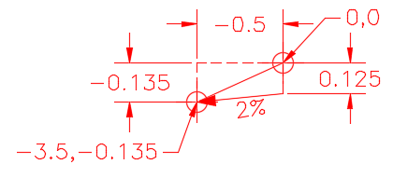

The use case for this is moving a point to the base of a material, such as a shoulder edge would be the bottom of the asphalt.

* + - 1. Column 3: DS-L / DS-R

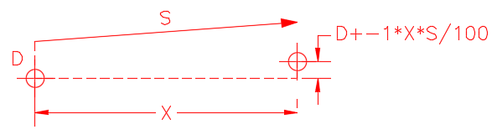

Column 3: OX

* + 1. Column 2: Ax

Calculate offset to intersection with Alignment Polyline number ‘x’

* + 1. Column 2: Y
       1. Column 3: OX

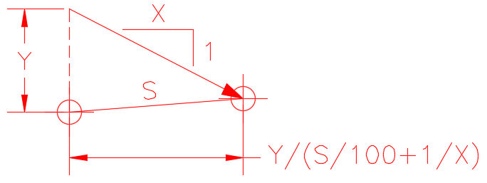

The use case for this is finding a point at the bottom of the subgrade travelling down a X:1 slope.

Example:

L,Y-0.9,OX2.5

Left Superelevation = -2.0

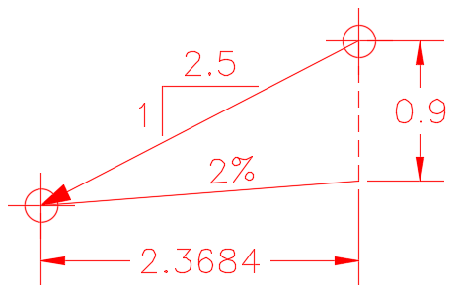

* 1. Column 1: CL / CR and FL / FR
     1. Column 2 / 3 : X / Y

Use case is for building ditching in cut and fill scenarios.

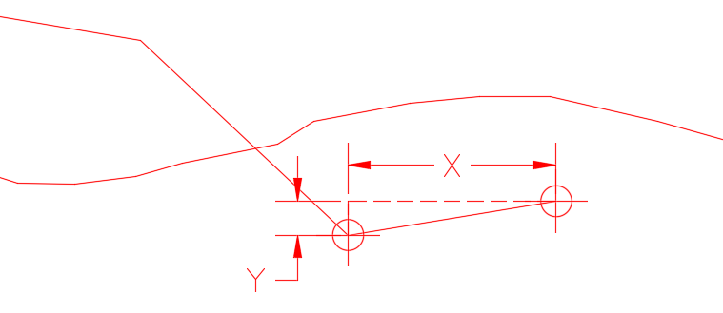

Example:

CL,X-1.0,Y-0.05

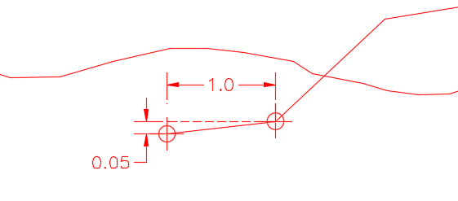

* + 1. Column 2 / 3 : xxx / yyy

‘xxx’ is the primary try, ‘yyy’ is the on fail try.

Primary:

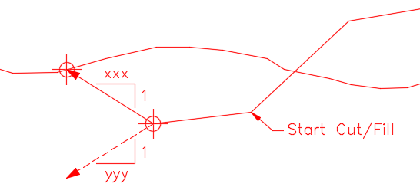

On Fail:

