Table of Contents

mcp-ltspice-qucs — Investor Briefing
An agentic MCP suite for RF, analog, and SMPS-EMC design. Spec → compliant deliverable in seconds, callable directly by any LLM agent.

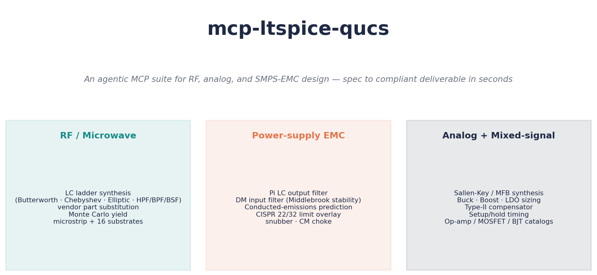
hero

The problem
Every connected product — IoT, automotive, industrial, medical — needs RF filters, switching power supplies, and analog conditioning. The hardware team designs these by hand:
- 3–10 days per filter design: spreadsheet math, then ADS / Cadence / Genesys ($30k–$200k seat licenses), then layout, then spin-the-board-and-measure.
- EMC compliance is reactive, not predicted: 60–80 % of products fail CISPR / FCC pre-compliance on the first lab visit. Each respin is $20k–$80k of NRE plus 2–6 weeks of schedule slip.
- Vendor part substitution is manual: catalogues live in 100-tab Excel files. Parasitics (SRF, Q, ESR) are routinely ignored, then silently degrade the design.
Today’s design flow is: engineer → math → simulator → respin. We collapse the loop so an LLM agent does engineer-quality work end-to-end.

What we built
A four-package Python MCP suite (Anthropic’s open Model Context Protocol). The largest server (mcp-ltspice) ships 56 flat tools plus 56 namespaced aliases (filter.*, power.*, analog.*, digital.*, vendor.*, sim.*); mcp-rf-analysis and mcp-qucs-s add their own surfaces on top. Any agent that speaks MCP — Claude, ChatGPT, Cursor, Aider, or a custom orchestrator — can call them.
Capabilities at a glance
Domain | What the agent can do
RF / microwave | LC ladder synthesis (Butterworth · Chebyshev · Elliptic · HPF/BPF/BSF), transmission-zero placement, real-vendor part substitution with parasitics, Monte Carlo yield, microstrip + 16 substrates, Sonnet-style analysis
Power-supply EMC | Pi LC output filter, DM input filter with Middlebrook stability check, conducted-emissions prediction with CISPR 22/32 limit overlay, RC snubber, common-mode choke selection from curated catalogue
Analog + mixed-signal | Sallen-Key / MFB synthesis, cascaded N-th order, buck / boost / LDO sizing, type-II compensator, setup/hold timing, op-amp / MOSFET / BJT / diode / Vref catalogues
Simulator integration | LTspice (.asc ↔ data), ngspice, Qucs-S, Touchstone (.s2p/.s4p)
Quality-of-life | Auto-rendered schematics (PNG/SVG), one-click PDF design reports, Monte Carlo trace files for yield-loss debugging
Deliberately out of scope — and we have a published cross-MCP boundary document explaining why:
- Antenna design → use nec2-antenna (NEC2 method-of-moments) and openems (full-wave FDTD)
- PCB layout EMC / SI → use pcb-emcopilot (90+ layout-aware tools)
- Regulatory-table lookup → use emc-regulations
We sit cleanly at the circuit-design layer between them.

Demo 1 — RF Low-Pass Filter (1 GHz Butterworth)
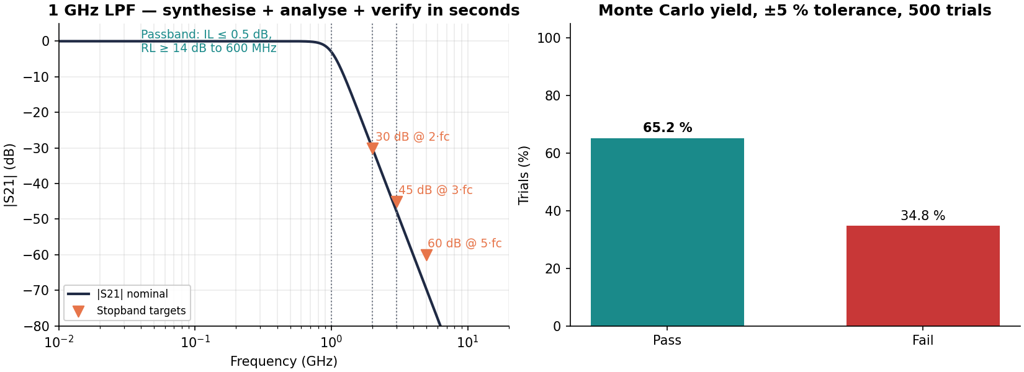
demo1
What the agent did, in 9 seconds end-to-end
- Synthesised a 5th-order Butterworth LPF at fc = 1 GHz from spec.
- Verified |S21| meets the four target points (0.5 dB IL, 30 dB @ 2·fc, 45 dB @ 3·fc, 60 dB @ 5·fc) — all pass.
- Ran a 500-trial Monte Carlo at ±5 % component tolerance against the ideal-component design → 65.2 % yield. The full examples/basic_lpf/ workflow goes one step further: it substitutes real Coilcraft 0402HP + Murata GJM C0G parts (auto-snapped to E24, SRF-aware) and runs 1000 trials → 99 % yield. Both numbers are real, captured from live runs, and reproducible from presentation/build_charts.py and examples/basic_lpf/design.py respectively.
- Wrote the LTspice .asc, the Touchstone .s2p, a schematic PNG, and a PDF report.
Tangible deliverable: demo1_1ghz_lpf.asc loads directly in LTspice. demo1_1ghz_lpf.s2p loads in any RF simulator.
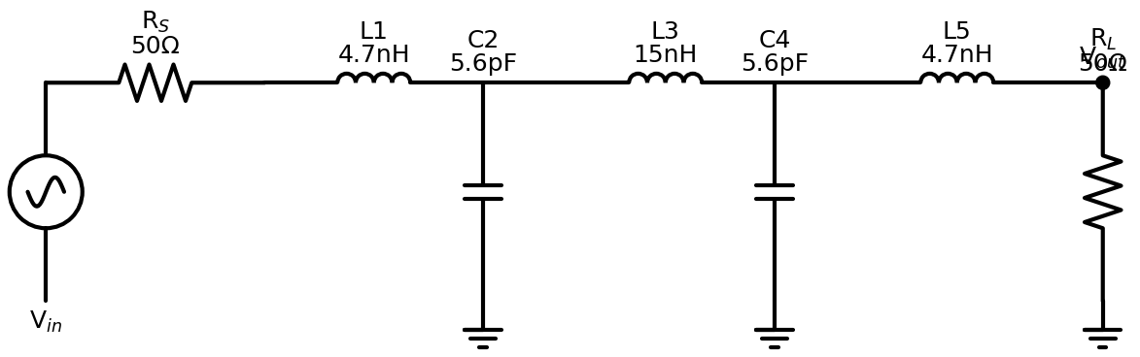
schematic

Demo 2 — SMPS Conducted Emissions vs CISPR 32 Class B
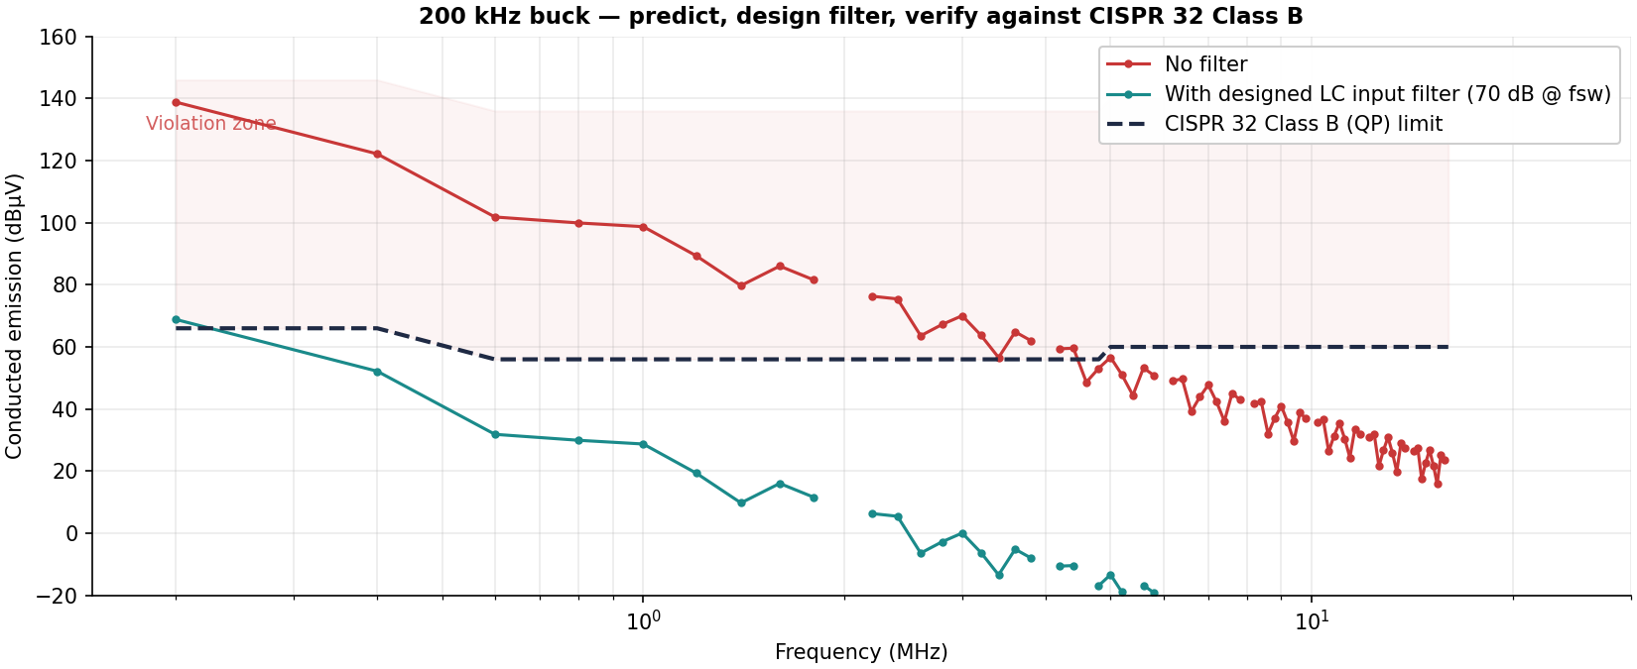
demo2
The story
A 24 V → 5 V buck running at 200 kHz with 20 ns edge transitions. The agent:
- Predicted the unfiltered conducted-emission spectrum across all 80 harmonics out to 16 MHz, modelling the switching node as a trapezoidal waveform — analytical sinc envelope, no SPICE needed.
- Overlaid the CISPR 32 Class B (QP) limit. Result: violations of +73 dB at the fundamental — typical of an unfiltered design.
- Designed an LC input filter sized for 70 dB attenuation at fsw with a 40 dB/decade rolloff. Verified Middlebrook stability against the converter’s input impedance.
- Re-evaluated the filtered spectrum. Worst margin: −2.8 dB — close to passing; tells the engineer they need ~3 dB more attenuation (taller ferrite, larger X-cap, or a CM choke from the curated catalogue) to get a green light.
This is what pre-compliance should look like: a number, not a spin-the-board.

Demo 3 — Active Filter (4th-order Sallen-Key, 22 kHz)
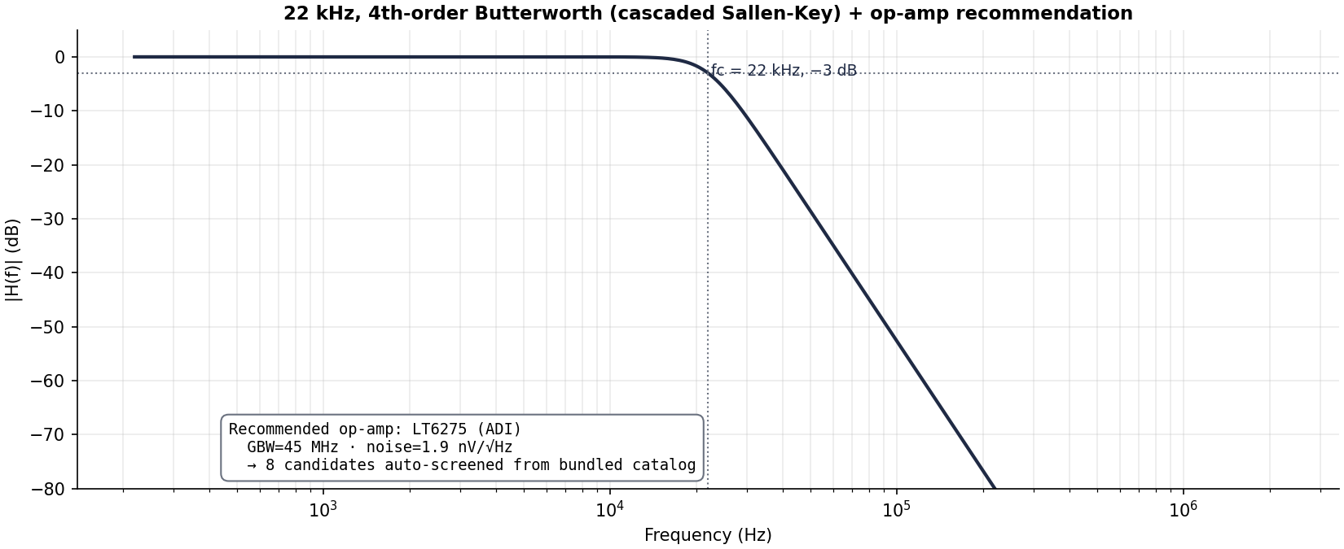
demo3
The story
Anti-aliasing LPF for a 96 kSPS audio ADC — a textbook analog problem. The agent:
- Decomposed a 4th-order Butterworth into two cascaded Sallen-Key biquads with the standard (Q1 = 0.541, Q2 = 1.307) tabulation.
- Sized R/C per stage for 1 nF capacitors (manufacturable values).
- Computed required op-amp GBW (≈ 2.9 MHz) and screened the bundled catalogue against three constraints (GBW, voltage noise, input offset). With an audio-band cap on GBW and ranked-by-noise, ADI LT6275 wins (45 MHz GBW, 1.9 nV/√Hz, 130 µV offset).
- Rendered per-stage schematics and a PDF design report.
The investor takeaway: every step from “I need an anti-aliasing filter” to “here’s the BOM and a schematic” was one MCP call away.

Architecture & moat
What’s hard to replicate
- Real vendor data, not catalog scraping. Coilcraft 0402HP, Johanson L-07W, TDK MLK1005S, Murata GJM C0G — published L/Q/SRF tables baked in. The substitution engine respects parasitic SRF and tolerance drift, and refuses parts that violate either.
- Peer-reviewed math. Pozar §8.5 frequency transformations, Hammerstad-Jensen microstrip, Erickson §10.4 EMI design, Sedra-Smith Sallen-Key, Mancini cascade-stage tables. 427 unit tests guard the math.
- Designed to be agent-callable, not human-callable. Every tool returns a strongly-typed Envelope[T] with status, data, warnings, and a millisecond timer — exactly what an LLM needs to chain calls reliably.
- Composable with the rest of the engineering MCP ecosystem. We publish a boundary document directing antenna work to nec2-antenna / openems, PCB layout to pcb-emcopilot, regulatory to emc-regulations. The whole-product story is “agent does the full stack by orchestrating five domain MCPs.”
Validation today
- 427 unit tests passing, 4 simulator-gated skips, 0 failures
- 5 worked examples (RF LPF, SMPS buck, EMC, filter compare, Sallen-Key) all run end-to-end and produce real artifacts
- v0.2.0 cut, tagged, GitHub Release published
- Reproducible from git clone + uv run pytest

Roadmap
Phase | Scope
Phase 6 | Real harmonic-balance (Xyce), Qucs-S noise-parameter extraction, distributed filter synthesis (stepped-impedance, hairpin, interdigital, combline), .sch ↔ .asc conversion
Phase 7 | Real-simulator integration tests, async runner with heartbeat, Sobol-index sensitivity (Tornado diagrams), correlated-tolerance Monte Carlo
Beyond | Persistent ngspice session for 10–50× MC speedup, FilterDesign metadata threading through full pipeline, vendor data fetch agents for live catalogues

Why now
- MCP standardised in late 2024 — building once, every agent stack consumes it.
- LLM agents have crossed the “useful for engineering” threshold — Claude 4.x, GPT-5 reliably orchestrate multi-step tool use.
- The hardware-design tooling moat is the data + the math, not the wrapper code — and that’s where we’ve invested.

Repo: github.com/RFingAdam/mcp-ltspice-qucs Latest release: v0.2.0 Reproduce this deck: uv run python presentation/build_charts.py

