MCP PCB EMCopilot Framework
Comprehensive PCB Design Review,
EMC Analysis & Signal Integrity Platform

____________________________________________________________

Version | v0.2.0 (Document Rev 1.0)
Date | 2026-03-12
Author | Adam Engelbrecht (RFingAdam)
License | Apache-2.0
Repository | github.com/RFingAdam/mcp-pcb-emcopilot

TABLE OF CONTENTS

Right-click and select 'Update Field' to populate Table of Contents

1. Framework Overview

1.1 What is MCP PCB EMCopilot
MCP PCB EMCopilot is a Model Context Protocol (MCP) server that provides 93 specialized tools for AI-assisted PCB design review, electromagnetic compatibility (EMC) analysis, signal integrity (SI) verification, and power integrity (PI) assessment. It enables AI assistants such as Claude Code and OpenAI Codex CLI to perform deep, physics-based analysis of printed circuit board designs.
The framework parses real PCB layout files from major EDA tools (KiCad, Altium, ODB++, Gerber, IPC-2581) and applies industry-standard formulas and heuristics to identify design issues before they reach the prototype stage. This "shift-left" approach to EMC and SI compliance can save weeks of redesign time and thousands of dollars in failed compliance testing.

1.2 Architecture Overview
The system follows a layered architecture with clean separation between protocol handling, data parsing, analysis computation, and output generation:
- MCP Protocol Layer: Exposes 93 tools via the Model Context Protocol standard, enabling any MCP-compatible AI client to invoke PCB analysis functions.
- Session Manager: Maintains parsed design state across multiple tool calls within a review session.
- Parser Layer: Supports 8 input formats including KiCad, ODB++, Gerber, IPC-2581, Altium, STEP, PDF schematics, and BOM files.
- Analyzer Layer: 8 analysis domains covering EMC/EMI, signal integrity, power integrity, thermal, DFM, RF/antenna, ESD, and high-speed digital interfaces.
- Report & Visualization Layer: Generates SVG board renders, PNG exports, and professional DOCX reports with embedded images and findings.

1.3 Key Value Proposition
MCP PCB EMCopilot provides automated, AI-orchestrated design review that catches EMC, signal integrity, and manufacturing issues before the first prototype is built. Key benefits include:
- Pre-compliance EMC checking: Predict radiated emissions and compare against FCC/CISPR limits before going to the test lab.
- Signal integrity verification: Validate impedance, crosstalk, timing, and eye diagrams for high-speed interfaces (DDR4/5, PCIe, USB, Ethernet).
- Power integrity analysis: Check PDN impedance, decoupling strategy, and VRM placement.
- Design for manufacturing: Verify solder paste ratios, component placement, assembly constraints, and tolerance stackups.
- Automated report generation: Professional DOCX reports with annotated board images, severity-ranked findings, and actionable recommendations.

2. Architecture Diagrams

2.1 System Architecture
The following diagram shows the end-to-end architecture of the MCP PCB EMCopilot framework, from MCP client interaction through parsing, analysis, and report generation.
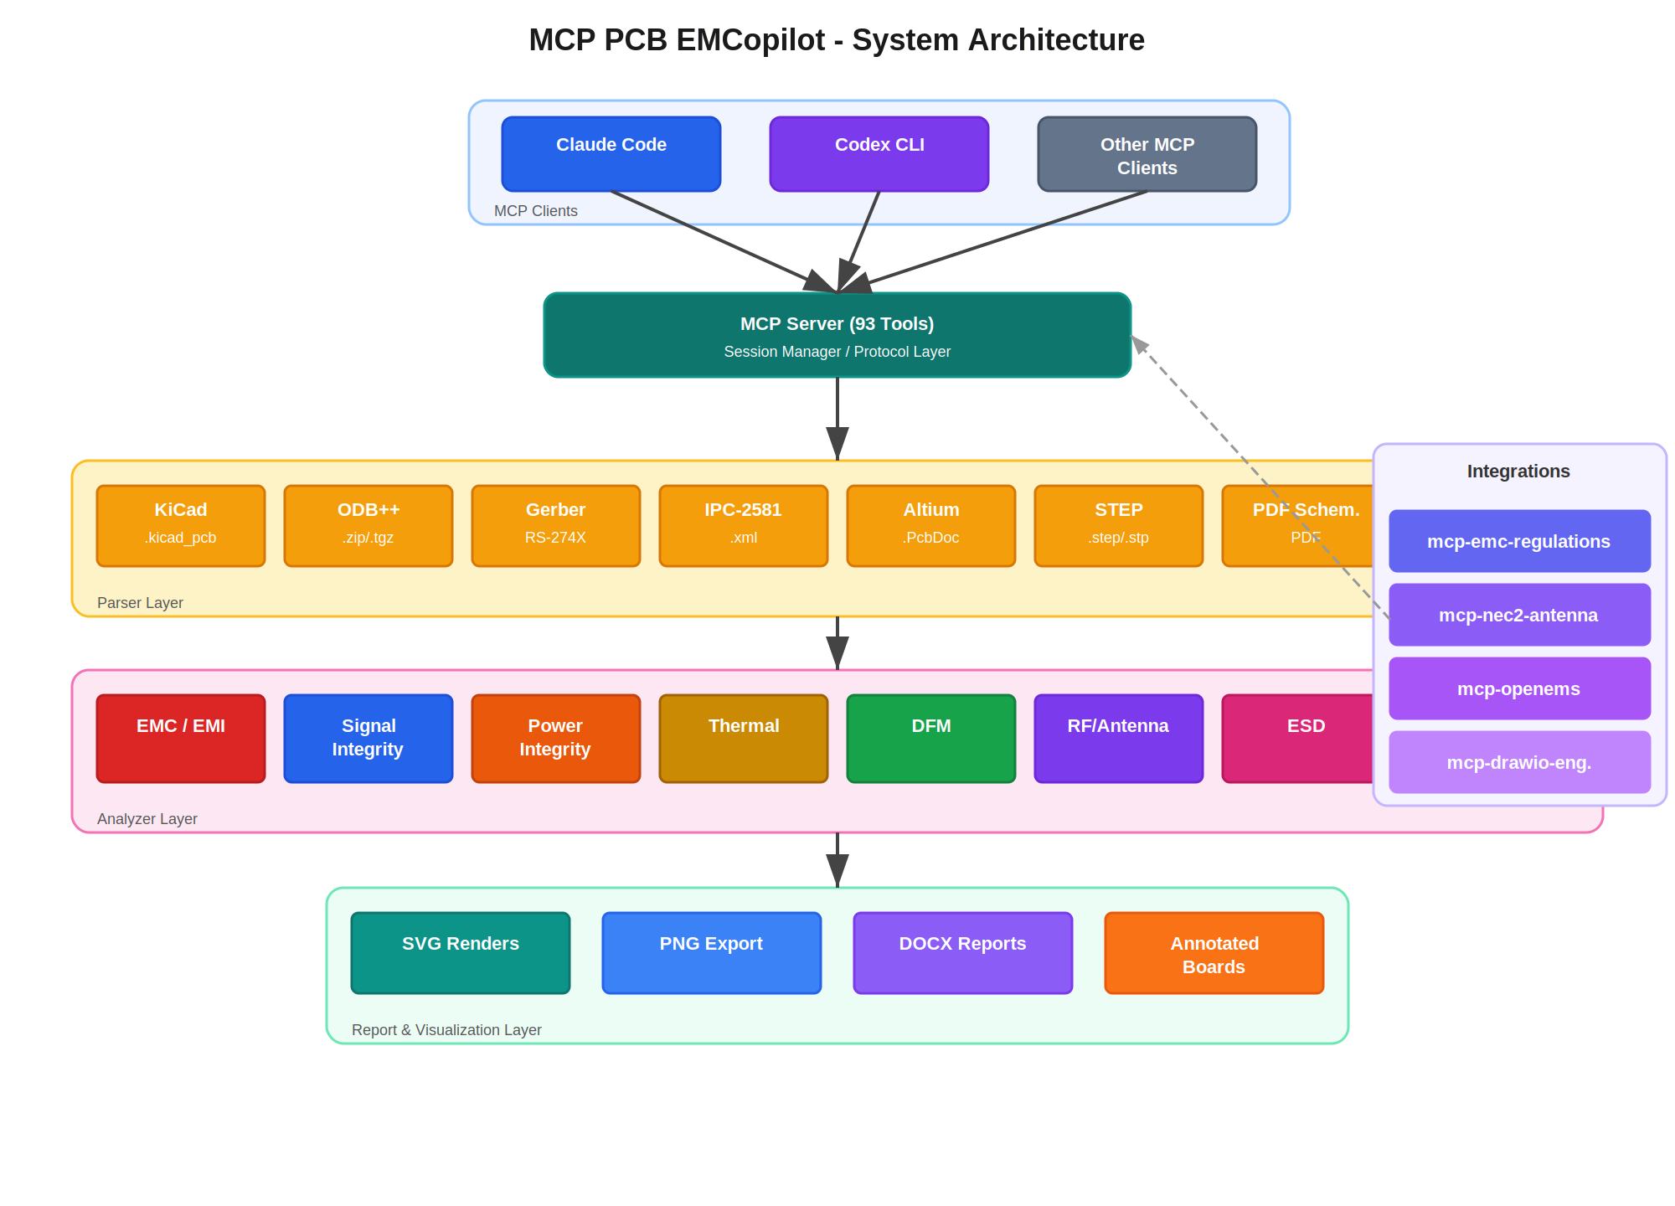
Figure 1: MCP PCB EMCopilot System Architecture

2.2 PCB Stackup Cross-Section
The framework includes stackup analysis capabilities. Below is a sample 6-layer stackup showing the layer arrangement, copper weights, and dielectric materials that the tool can parse and analyze from design files.
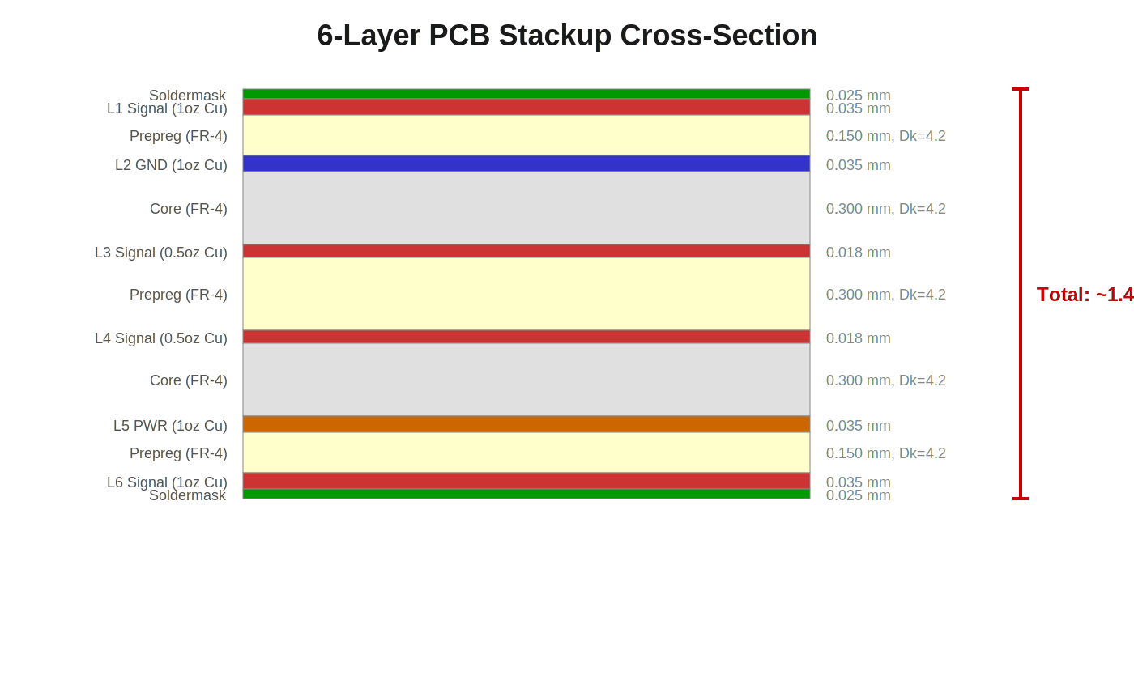
Figure 2: Sample 6-Layer PCB Stackup Cross-Section

2.3 EMI Analysis Flow
EMI analysis follows a signal-chain approach, modeling the path from clock/signal sources through PCB traces (acting as transmission lines) to unintentional antenna structures, predicting radiated emissions and comparing against regulatory limits.
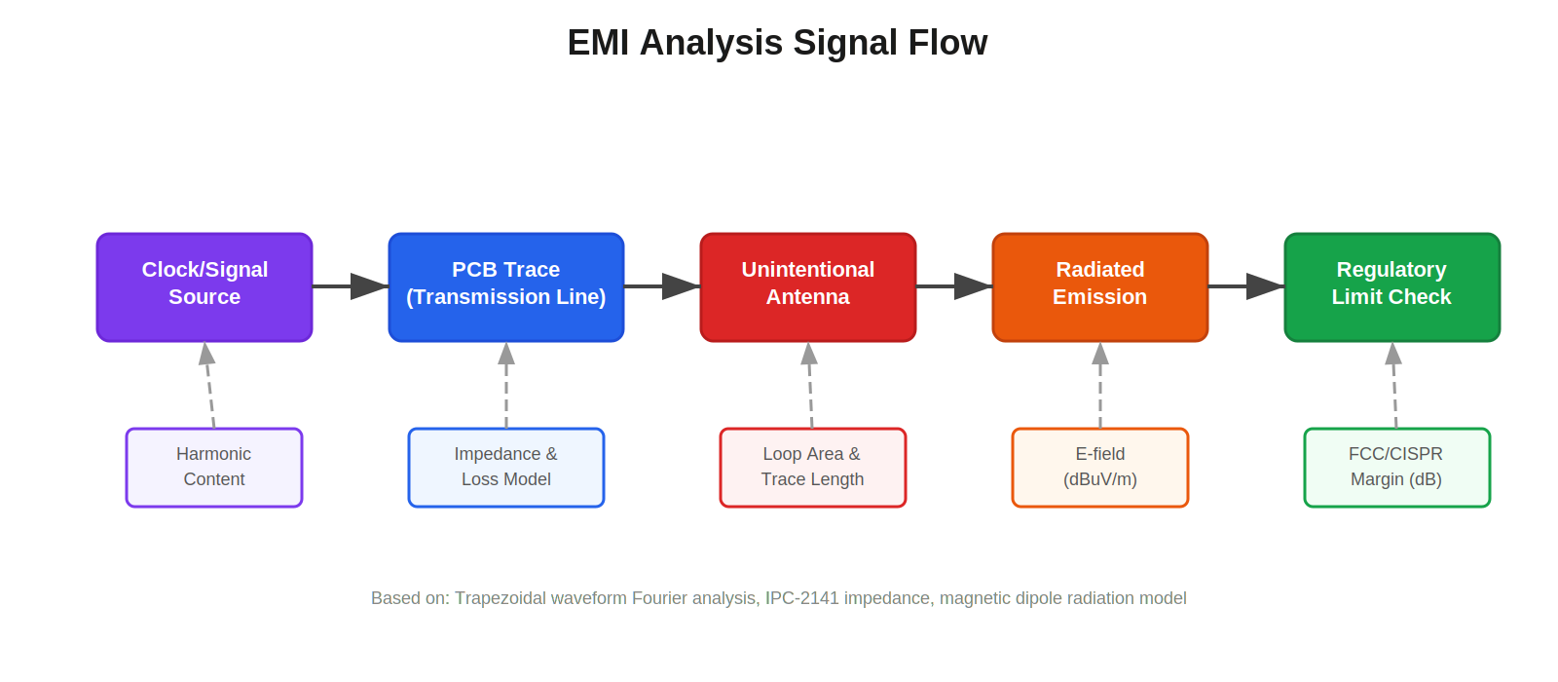
Figure 3: EMI Analysis Signal Flow

2.4 EMC Test Setup Reference
The compliance prediction tools model standard EMC test configurations. Below is a CISPR 25 radiated emissions test setup, which is the reference geometry used for automotive EMC predictions.
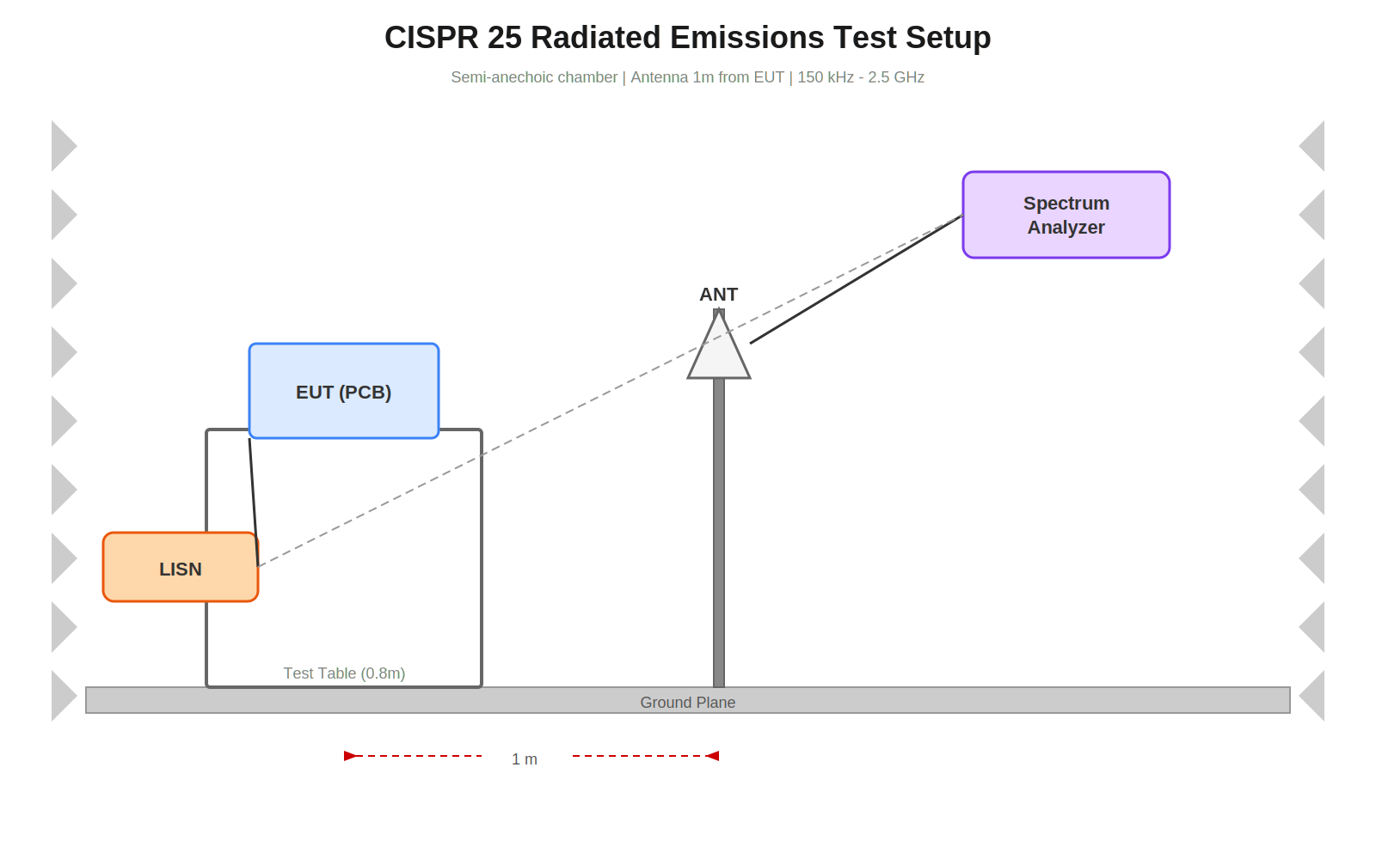
Figure 4: CISPR 25 Radiated Emissions Test Setup

3. Tool Categories (93 Tools)
The 93 MCP tools are organized into functional categories. Each tool accepts JSON parameters via the MCP protocol and returns structured JSON results.

3.1 Parsers & Session Management (14 tools)
These tools handle loading PCB design files and extracting structured data. The parse_layout tool returns a session_id that subsequent tools use to query the parsed design.
Tool Name | Description | Key Parameters
pcb_parse_layout | Parse PCB layout file (KiCad, ODB++, Gerber, IPC-2581, Altium) | file_path
pcb_parse_schematic_pdf | Parse PDF schematic for components and net labels | file_path, session_id
pcb_parse_step | Parse STEP file for 3D mechanical review | file_path
pcb_get_components | Get component list from parsed design | session_id, filter
pcb_get_nets | Get net list from parsed design | session_id, filter
pcb_get_traces | Get trace summary from parsed design | session_id, net_name, layer
pcb_get_vias | Get via list from parsed design | session_id
pcb_get_board_outline | Get board outline dimensions and area | session_id
pcb_get_stackup | Get layer stackup from parsed design | session_id
pcb_get_copper_pours | Get copper pour/zone data per layer | session_id
pcb_get_drill_table | Get drill table with sizes and counts | session_id
pcb_get_design_rules | Get extracted DRC constraints | session_id
pcb_list_sessions | List all active design sessions
pcb_close_session | Close a design session and free memory | session_id

3.2 Impedance Calculators (7 tools)
Physics-based impedance and transmission line calculators using IPC-2141 formulas (Hammerstad & Jensen for microstrip, Cohn for stripline).
Tool Name | Description | Key Parameters
pcb_calc_microstrip_impedance | Surface trace impedance (IPC-2141) | width, height, thickness, Er
pcb_calc_stripline_impedance | Buried trace impedance (Cohn) | width, height, thickness, Er
pcb_calc_differential_impedance | Differential pair impedance | width, spacing, height, type
pcb_calc_cpw_impedance | Coplanar waveguide impedance | width, gap, height, Er
pcb_calc_trace_width | Current capacity (IPC-2221) | current, temp_rise, copper_oz
pcb_calc_via_stitching | Via stitching density for EMI | frequency, Er
pcb_calc_pdn_impedance | PDN impedance frequency sweep | VRM, caps, planes, target_Z

3.3 Signal Integrity (14 tools)
Tools for analyzing signal quality, timing margins, crosstalk coupling, via transitions, and channel loss characteristics.
Tool Name | Description
pcb_analyze_timing | Analyze setup/hold margins
pcb_analyze_crosstalk | Estimate NEXT and FEXT between traces
pcb_analyze_via | Via inductance, capacitance, impedance
pcb_analyze_differential_pair | Differential pair routing quality
pcb_analyze_length_matching | Trace length matching for signal groups
pcb_analyze_mode_conversion | Differential mode conversion / SCD21
pcb_analyze_return_paths | Return path analysis for all HF nets
pcb_analyze_return_current | Return current density profile
pcb_analyze_return_current_density | Return current density on ref plane
pcb_calc_insertion_loss | Frequency-swept S21 and S11
pcb_calc_return_loss | Return loss, VSWR from mismatch
pcb_calc_skin_effect | Skin depth and AC resistance
pcb_calc_dielectric_loss | Dielectric loss (dB/inch)
pcb_calc_eye_diagram | Statistical eye diagram estimation

3.4 EMC / EMI Analysis (14 tools)
Electromagnetic compatibility and interference analysis tools for predicting emissions, analyzing shielding effectiveness, and checking compliance with regulatory standards.
Tool Name | Description
pcb_analyze_current_loop | Radiated emissions from current loops
pcb_analyze_clock_emi | Clock harmonic EMI envelope (trapezoidal)
pcb_analyze_smps_emi | SMPS switching harmonic EMI
pcb_analyze_emi_risk | Per-net EMI risk scoring
pcb_analyze_shielding | Enclosure shielding effectiveness
pcb_analyze_grounding | Grounding topology analysis
pcb_analyze_ground_stitch | Ground via stitching optimization
pcb_analyze_common_mode | Common-mode noise on diff pairs
pcb_analyze_cable_coupling | Cable-to-cable coupling for EMI
pcb_analyze_slot_antenna | Ground plane slot as antenna
pcb_analyze_trace_antenna | Trace as unintentional antenna
pcb_estimate_bandwidth | Signal BW and EMC from rise time
pcb_predict_emissions | Radiated emission spectrum vs limits
pcb_predict_compliance | EMC compliance prediction

3.5 Power Integrity (5 tools)
Power distribution network analysis including impedance profiling, decoupling capacitor placement, and VRM evaluation.
Tool Name | Description
pcb_analyze_pdn | PDN impedance analysis
pcb_analyze_decoupling | Decoupling capacitor placement
pcb_analyze_vrm | VRM placement and routing analysis
pcb_analyze_copper_spreading | Copper area heat spreading
pcb_calc_plane_resonance | Power/ground plane resonance

3.6 High-Speed Digital (8 tools)
Interface-specific analyzers for DDR memory, PCIe, USB, and Ethernet with protocol-aware timing and topology validation.
Tool Name | Description
pcb_analyze_ddr | DDR memory interface routing analysis
pcb_analyze_ddr_timing_budget | Per-lane DDR timing margin (JEDEC)
pcb_validate_ddr_topology | DDR topology auto-detect and validate
pcb_analyze_usb | USB routing analysis
pcb_analyze_ethernet | Ethernet PHY routing analysis
pcb_analyze_pcie | PCIe lane routing analysis
pcb_validate_pcie_lanes | PCIe lane skew validation
pcb_calc_pcie_link_budget | PCIe insertion loss budget

3.7 Thermal Analysis (2 tools)
Tool Name | Description
pcb_analyze_thermal | Component thermal dissipation analysis
pcb_analyze_thermal_via | Thermal via array analysis

3.8 DFM / Manufacturing (5 tools)
Tool Name | Description
pcb_analyze_placement | Component placement manufacturability
pcb_analyze_assembly | Board assembly process considerations
pcb_analyze_solder_paste | Solder paste stencil design analysis
pcb_analyze_tolerance | Manufacturing tolerance stackup
pcb_get_manufacturing_notes | Fab notes and material specs

3.9 ESD Protection (1 tool)
Tool Name | Description
pcb_analyze_esd | ESD protection circuit analysis

3.10 Classification & Detection (4 tools)
Automated classification of nets, interfaces, and overall design type to drive context-aware analysis selection.
Tool Name | Description
pcb_classify_design | Classify design type with complexity score
pcb_classify_nets | Classify all nets by function with confidence
pcb_detect_interfaces | Detect high-speed interfaces and pin counts
pcb_cross_reference_schematic | Cross-reference schematic vs layout

3.11 Visualization & Rendering (5 tools)
Tool Name | Description
pcb_render_board | SVG board view with components, traces, vias
pcb_render_net | SVG highlighting a specific net
pcb_render_stackup | SVG cross-section of layer stackup
pcb_annotate_board | SVG with annotation overlays
pcb_get_emi_hotspots | Identify high-EMI-risk board regions

3.12 Export & Reporting (6 tools)
Tool Name | Description
pcb_export_render_png | Export SVG render to PNG file
pcb_export_all_renders | Export all standard renders as PNGs
pcb_generate_report | Structured report from review results
pcb_generate_docx_report | Professional DOCX with embedded images
pcb_get_schematic_page | Get schematic page text and annotations
pcb_set_review_context | Set design review context and requirements

3.13 3D & Enclosure (3 tools)
Tool Name | Description
pcb_get_3d_clearances | Component-to-component 3D clearances
pcb_check_enclosure_fit | PCB assembly fits within enclosure
pcb_find_split_crossings | Signals crossing ground plane splits

3.14 Orchestration (2 tools)
High-level tools that coordinate multiple analyzers for comprehensive design review.
Tool Name | Description
pcb_run_design_review | Full automated multi-domain design review
pcb_optimize_ground_stitching | Optimize ground via stitching pattern

3.15 Reference Data & Utilities (3 tools)
Tool Name | Description
pcb_get_stackup_templates | Common PCB stackup configurations
pcb_get_material_properties | Dielectric properties for PCB materials
pcb_trace_return_path | Trace return current path for a specific net

4. Design Review Workflow
The automated design review process follows a structured pipeline that transforms raw PCB layout files into actionable engineering findings. The AI orchestrator (Claude Code or Codex CLI) drives this workflow by calling the appropriate MCP tools in sequence.
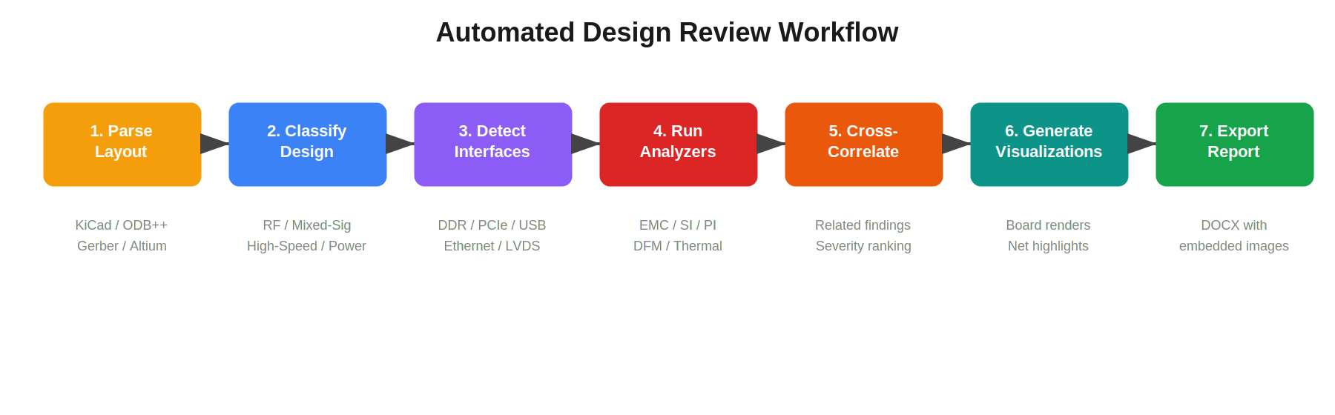
Figure 5: Automated Design Review Workflow

4.1 Step 1: Parse Layout
The review begins with pcb_parse_layout, which accepts KiCad (.kicad_pcb), ODB++ (.zip/.tgz), Gerber (RS-274X), IPC-2581 (.xml), or Altium files. The parser extracts components, nets, traces, vias, board outline, stackup, and copper pours into a unified data model. A session_id is returned for subsequent queries.

4.2 Step 2: Classify Design
pcb_classify_design analyzes the parsed data to determine the design type (RF, mixed-signal, high-speed digital, power, or simple digital) and assigns a complexity score from 1-10. This classification drives which analyzers are selected in Step 4.

4.3 Step 3: Detect Interfaces
pcb_detect_interfaces identifies high-speed interfaces present in the design (DDR, PCIe, USB, Ethernet, LVDS, RF) by analyzing net names, component packages, and pin counts. pcb_classify_nets categorizes every net by function (power, ground, clock, data, analog, etc.).

4.4 Step 4: Run Domain-Specific Analyzers
Based on the design classification and detected interfaces, the orchestrator selects the relevant analyzers. For a mixed-signal board with DDR4 and USB, this might include:
- EMC: clock EMI, current loop analysis, EMI risk scoring
- SI: DDR timing budget, USB differential pair, crosstalk, via analysis
- PI: PDN impedance, decoupling, VRM analysis
- DFM: placement, solder paste, assembly checks
- Thermal: power dissipation, thermal via analysis

4.5 Step 5: Generate Visualizations
The visualization layer produces SVG renders of the board layout, individual nets, stackup cross-sections, and annotated boards highlighting findings. These are exported as PNG images for embedding in reports.

4.6 Step 6: Export Report
pcb_generate_docx_report creates a professional Word document with embedded board renders, severity-ranked findings organized by domain, and actionable recommendations. The report follows a standard template with executive summary, detailed findings, and appendices.

5. Supported File Formats

5.1 Input Formats
Format | Extensions | Data Extracted
KiCad | .kicad_pcb | Full layout data: components, nets, traces, vias, zones, stackup, board outline
ODB++ | .zip / .tgz | Complete manufacturing data: all layers, drill data, netlist, components
Gerber | RS-274X | Layer-by-layer artwork: copper, mask, silk, drill (Excellon)
IPC-2581 | .xml | Industry standard data exchange format with full design intent
Altium | .PcbDoc | Altium Designer binary format (requires olefile)
STEP | .step / .stp | 3D mechanical model for clearance and enclosure analysis
PDF Schematic | .pdf | Schematic pages with text-layer extraction (requires pymupdf)
BOM | .csv / .xlsx | Bill of materials for component validation

5.2 Output Formats
Format | Usage
SVG | Board renders, net highlights, stackup cross-sections, annotated boards
PNG | Exported from SVG renders via cairosvg for embedding in documents
DOCX | Professional design review reports with embedded images and structured findings
JSON | Structured analysis results returned via MCP protocol

6. Simulation & Analysis Capabilities
The framework implements physics-based calculations grounded in industry standards and peer-reviewed electromagnetic theory. The following subsections detail the key computational methods.

6.1 Impedance Calculations (IPC-2141)
Microstrip impedance uses the Hammerstad & Jensen formulation with thickness correction. Stripline impedance uses the Cohn formula. Both account for effective dielectric constant and conductor thickness effects.
Trace Type | Formula Basis | Notes
Microstrip | Hammerstad & Jensen (IPC-2141) | Effective width correction for trace thickness
Stripline | Cohn (IPC-2141) | Symmetric or offset stripline between planes
Differential Pair | Coupled line theory | Coupling factor from trace spacing / height ratio
CPW / GCPW | Conformal mapping | Grounded and ungrounded coplanar waveguide

6.2 Current Capacity (IPC-2221)
Trace width calculations use the IPC-2221 current-temperature rise relationship with separate coefficients for internal and external layers. The formula accounts for copper weight, ambient temperature, and maximum allowable temperature rise.

6.3 EMI Prediction
Clock and signal EMI prediction uses trapezoidal waveform Fourier analysis to calculate harmonic content. The envelope of harmonics follows the well-known 0 dB/decade, -20 dB/decade, and -40 dB/decade slopes defined by the fundamental frequency, 1/(pi * tau_r) and 1/(pi * tau_f) corner frequencies. Emissions are calculated using the magnetic dipole antenna model for PCB current loops.

6.4 Eye Diagram Estimation
Statistical eye diagram calculation models the channel as a lossy transmission line with frequency-dependent conductor loss (skin effect + Hammerstad roughness correction) and dielectric loss. Eye height and width are estimated from the channel impulse response and compared against standard thresholds for the target data rate.

6.5 PDN Impedance
PDN impedance profiling models the VRM output impedance, bulk capacitors, MLCC decoupling capacitors, and plane capacitance as parallel RLC networks. The frequency sweep identifies anti-resonance peaks that exceed the target impedance Z_target = V * ripple% / I_max.

6.6 Thermal Analysis
Thermal resistance chain calculation models junction-to-ambient paths through the die, package, PCB copper, thermal vias, and convection. Thermal via arrays are analyzed for effective thermal conductivity enhancement.

6.7 Via Modeling
Via electrical models calculate parasitic inductance (from via barrel length and diameter), capacitance (from pad-to-antipad geometry), and characteristic impedance. These are used for signal integrity assessment of layer transitions.

6.8 Crosstalk Analysis
Near-end crosstalk (NEXT) and far-end crosstalk (FEXT) coupling coefficients are calculated from trace geometry (width, spacing, dielectric height) using coupled microstrip/stripline theory. The analysis accounts for coupling length, rise time, and termination conditions.

7. Integration with Other MCP Servers
MCP PCB EMCopilot is designed to work alongside other specialized MCP servers for a complete PCB engineering workflow. The AI orchestrator can invoke tools across multiple MCP servers in a single design review session.

mcp-emc-regulations
Capability: FCC Part 15, CISPR 11/22/25/32, IEC 61000-4-x
Provides regulatory emission limits and immunity test levels that EMCopilot's compliance prediction tools compare against. Enables automated pass/fail checking with exact limit values at each frequency.

mcp-nec2-antenna
Capability: NEC2 engine for dipole, yagi, loop, vertical
Simulates unintentional antenna structures identified by EMCopilot's trace and slot antenna analyzers. Provides radiation pattern and gain data for more accurate emission predictions.

mcp-openems
Capability: Full-wave EM simulation via openEMS
Validates EMCopilot's approximate calculations with full 3D electromagnetic simulation. Useful for complex structures like via transitions, plane resonances, and connector launches.

mcp-drawio-engineering
Capability: Engineering diagram generation
Generates PCB stackup diagrams, RF block diagrams, and EMC test setup illustrations. Used to create visual documentation for design review reports.

8. Getting Started

8.1 Installation
Clone the repository and install with uv:
git clone https://github.com/RFingAdam/mcp-pcb-emcopilot.git
cd mcp-pcb-emcopilot
uv pip install -e .
For full feature support, install optional dependencies:
uv pip install -e '.[all]'
This installs: olefile (Altium), openpyxl (Excel BOM), numpy (S-parameters), networkx (ground analysis), pymupdf (PDF schematics).

8.2 Configuration
Add to Claude Code:
claude mcp add pcb-emcopilot -- uv run --directory /path/to/mcp-pcb-emcopilot mcp-pcb-emcopilot
Add to Codex CLI:
codex mcp add pcb-emcopilot -- uv run --directory /path/to/mcp-pcb-emcopilot mcp-pcb-emcopilot
Or add to MCP client config file (JSON):
{
"command": "uv",
"args": ["run", "--directory", "/path/to/mcp-pcb-emcopilot", "mcp-pcb-emcopilot"]
}

8.3 Example Workflow
A typical design review session with Claude Code:
Step 1: Parse the PCB layout
User: "Parse my KiCad board at /designs/my_board.kicad_pcb and run a full design review."
Step 2: Claude Code calls the tools
# AI orchestrator calls these tools automatically:
pcb_parse_layout(file_path='/designs/my_board.kicad_pcb')
pcb_classify_design(session_id='abc123')
pcb_detect_interfaces(session_id='abc123')
pcb_run_design_review(session_id='abc123')
pcb_render_board(session_id='abc123')
pcb_export_all_renders(session_id='abc123')
pcb_generate_docx_report(session_id='abc123', output_path='review.docx')
Step 3: Review the output
# The AI returns a structured summary of findings:
# - 2 CRITICAL: DDR4 trace impedance mismatch, missing return via
# - 5 WARNING: Crosstalk on CLK net, via stub resonance, ...
# - 8 INFO: Copper pour coverage, stackup recommendations, ...
# Full report saved to review.docx

9. API Reference Summary
This section provides a condensed reference for all 93 tools organized alphabetically within each category. For complete parameter documentation, refer to the tool descriptions exposed via the MCP protocol (visible in your MCP client's tool listing).
Tool Name | Description | Key Parameters
pcb_parse_layout | Parse PCB layout file | file_path: str
pcb_parse_schematic_pdf | Parse PDF schematic | file_path: str, session_id?: str
pcb_parse_step | Parse STEP 3D file | file_path: str
pcb_get_board_outline | Board dimensions | session_id: str
pcb_get_components | Component list | session_id: str, filter?: str
pcb_get_copper_pours | Copper pour data | session_id: str
pcb_get_design_rules | DRC constraints | session_id: str
pcb_get_drill_table | Drill sizes/counts | session_id: str
pcb_get_manufacturing_notes | Fab notes | session_id: str
pcb_get_nets | Net list | session_id: str, filter?: str
pcb_get_stackup | Layer stackup | session_id: str
pcb_get_traces | Trace summary | session_id: str, net_name?: str
pcb_get_vias | Via list | session_id: str
pcb_list_sessions | Active sessions
pcb_close_session | Close session | session_id: str
pcb_calc_cpw_impedance | CPW impedance | width, gap, height, Er, thickness
pcb_calc_differential_impedance | Diff pair impedance | width, spacing, height, thickness, Er, type
pcb_calc_microstrip_impedance | Microstrip impedance | width, height, thickness, Er
pcb_calc_stripline_impedance | Stripline impedance | width, height, thickness, Er
pcb_calc_trace_width | Trace current capacity | current, temp_rise, copper_oz, layer
pcb_calc_via_stitching | Via stitch spacing | frequency, Er
pcb_calc_pdn_impedance | PDN impedance sweep | VRM, caps, planes, freq range
pcb_analyze_crosstalk | NEXT/FEXT coupling | width, spacing, height, length, rise_time
pcb_analyze_differential_pair | Diff pair quality | session_id, net_p, net_n
pcb_analyze_length_matching | Length matching | session_id, net_names, tolerance
pcb_analyze_mode_conversion | Mode conversion | Z_diff, Z_comm, length, freq
pcb_analyze_return_current | Return current profile | width, height, frequency
pcb_analyze_return_current_density | Return density map | session_id, net_name
pcb_analyze_return_paths | Return path analysis | session_id
pcb_analyze_timing | Timing margins | freq, length, setup, hold, rise_time

Tool Name | Description | Key Parameters
pcb_analyze_via | Via characteristics | drill, pad, antipad, length
pcb_calc_dielectric_loss | Dielectric loss | freq, Er, Df, length
pcb_calc_eye_diagram | Eye diagram | data_rate, length, Er, Df, width, height
pcb_calc_insertion_loss | Insertion loss S21 | freq, length, width, height, Er, Df
pcb_calc_return_loss | Return loss S11 | Z_line, Z_load
pcb_calc_skin_effect | Skin depth/loss | freq, conductivity, roughness
pcb_analyze_cable_coupling | Cable coupling | length, spacing, freq, type
pcb_analyze_clock_emi | Clock EMI harmonics | freq, amplitude, rise_time, loop_area
pcb_analyze_common_mode | Common-mode noise | Z_diff, skew, freq
pcb_analyze_current_loop | Loop radiation | freq, current, area
pcb_analyze_emi_risk | EMI risk scoring | session_id
pcb_analyze_grounding | Grounding topology | session_id
pcb_analyze_ground_stitch | Via stitch spacing | frequency, lambda_fraction
pcb_analyze_shielding | Shielding SE | material, thickness, freq, aperture
pcb_analyze_slot_antenna | Slot as antenna | length, width, freq
pcb_analyze_smps_emi | SMPS EMI | freq, duty, current, loop_area
pcb_analyze_trace_antenna | Trace as antenna | length, freq
pcb_estimate_bandwidth | BW from rise time | rise_time
pcb_predict_compliance | Compliance prediction | session_id, standard
pcb_predict_emissions | Emission spectrum | session_id, limit_standard
pcb_analyze_copper_spreading | Cu heat spreading | area, thickness, power
pcb_analyze_decoupling | Decap placement | session_id, ic_name
pcb_analyze_pdn | PDN impedance | session_id, rail_name
pcb_analyze_vrm | VRM analysis | session_id
pcb_calc_plane_resonance | Plane resonance | length, width, Er, height
pcb_analyze_ddr | DDR interface | session_id, ddr_type
pcb_analyze_ddr_timing_budget | DDR timing budget | session_id, ddr_type, data_rate
pcb_analyze_ethernet | Ethernet routing | session_id
pcb_analyze_pcie | PCIe lanes | session_id, gen
pcb_analyze_usb | USB routing | session_id, usb_version

Tool Name | Description | Key Parameters
pcb_calc_pcie_link_budget | PCIe link budget | gen, trace_len, via_count
pcb_validate_ddr_topology | DDR topology | session_id
pcb_validate_pcie_lanes | PCIe lane skew | session_id, gen
pcb_analyze_thermal | Thermal dissipation | power, theta_ja, T_ambient
pcb_analyze_thermal_via | Thermal via array | via_count, drill, length
pcb_analyze_assembly | Assembly check | session_id
pcb_analyze_placement | Placement check | session_id
pcb_analyze_solder_paste | Solder paste | session_id
pcb_analyze_tolerance | Tolerance stackup | dimensions, tolerances
pcb_analyze_esd | ESD protection | session_id, port_name
pcb_classify_design | Design classification | session_id
pcb_classify_nets | Net classification | session_id
pcb_cross_reference_schematic | Schem vs layout | session_id
pcb_detect_interfaces | Interface detection | session_id
pcb_annotate_board | Annotated board SVG | session_id, annotations
pcb_get_emi_hotspots | EMI hotspot regions | session_id
pcb_render_board | Board SVG render | session_id, layers, highlights
pcb_render_net | Net SVG render | session_id, net_name
pcb_render_stackup | Stackup SVG render | session_id
pcb_export_all_renders | Export all PNGs | session_id, output_dir
pcb_export_render_png | Export SVG to PNG | svg_content, output_path
pcb_generate_docx_report | DOCX report | session_id, output_path
pcb_generate_report | Structured report | session_id, format
pcb_get_schematic_page | Schematic page data | session_id, page_number
pcb_set_review_context | Set review context | session_id, requirements
pcb_check_enclosure_fit | Enclosure fit check | session_id, enclosure dims
pcb_find_split_crossings | Split plane crossings | session_id
pcb_get_3d_clearances | 3D clearances | session_id
pcb_optimize_ground_stitching | Optimize stitching | session_id, frequency
pcb_run_design_review | Full design review | session_id

Tool Name | Description | Key Parameters
pcb_get_material_properties | Material database
pcb_get_stackup_templates | Stackup templates
pcb_trace_return_path | Trace return path | session_id, net_name

10. Common Design Targets
The following tables provide quick-reference impedance targets and material properties commonly used with the framework's calculators.

10.1 Interface Impedance Targets
Interface | Single-Ended (Ohm) | Differential (Ohm)
General purpose | 50 | -
USB 2.0 | - | 90
USB 3.x | - | 85
HDMI | - | 100
DDR4 | 40 | 80
DDR5 | 40 | 80
PCIe Gen3/4 | - | 85
PCIe Gen5/6 | - | 85
Ethernet 100BASE-TX | - | 100
Ethernet 1000BASE-T | - | 100
LVDS | - | 100
SATA | - | 85

10.2 PCB Material Properties
Material | Dk (at 1 GHz) | Df (Loss Tan.) | Tg (C)
FR-4 Standard | 4.2-4.5 | 0.020 | 140-170
FR-4 High-Tg | 4.2-4.4 | 0.018 | 170-210
Rogers RO4003C | 3.38 | 0.0027 | 280
Rogers RO4350B | 3.48 | 0.0037 | 280
Isola I-Speed | 3.63 | 0.0082 | 200
Megtron 6 (R-5775) | 3.4 | 0.002 | 230
Polyimide (Flex) | 3.3-3.5 | 0.003 | 260+

