APPENDIX A

Efficient Line Coding Techniques for Low-Power IoT-Based Warehouse Monitoring System
Shrenica Chawda A∗, Lakshita M S∗, Akshaya R G∗
Department of Electronics and Communication Engineering,Vellore Institute of Technology, Chennai, Tamilnadu.
shrenica.a@gmail.com, lakshitasaravanan@gmail.com, rgakshaya2020@gmail.com.

Keywords:
IoT, Warehouse Monitoring, Low-Power Communication, ESP8266, Line Coding, Bipolar AMI, MATLAB Analysis, Environmental Sensing, Pest Detection, Gas and Smoke Monitoring, Water Leakage Detection, Blynk Cloud, Digital Communication Systems.
abstract

Warehouses in India are home to vast stores of food grains, yet most facilities still lack continuous monitoring to detect temperature rise, humidity variations, pest movement, water leakage, and harmful gases. To address this gap, we developed an IoT-based warehouse monitoring system using an ESP8266 microcontroller integrated with temperature–humidity, ultrasonic, gas, and water leakage sensors. The collected data is transmitted to the Blynk cloud dashboard, enabling real-time supervision and early detection of unsafe conditions inside the storage area.
In addition, this paper evaluates the efficiency of various digital line coding techniques -NRZ Unipolar, NRZ Polar, Bipolar AMI, RZ, Manchester, and Differential Manchester- to identify the most power-efficient encoding method suitable for IoT communication. MATLAB simulations were conducted to compare parameters such as bandwidth, DC component, signal transitions, and power consumption.
MATLAB analysis shows that Bipolar AMI offers the best overall performance, mainly because it eliminates the DC component and reduces unnecessary signal transitions. Compared to Manchester-type coding, Bipolar AMI requires over 70% less power and maintains a near-zero DC level, making it highly efficient for battery-operated IoT devices. The combined system demonstrates that effective sensing with an optimized line-coding technique can significantly improve warehouse safety while minimizing communication power consumption.

INTRODUCTION
Warehousing is an integral aspect of post-harvest handling of agricultural commodities, particularly in developing countries, such as India, in which a large portion of all grains still relies on traditional godowns. Such structures are typically stacked with gunny bags and minimal automation. They are highly vulnerable due to environmental changes, pests, moisture and fire/gas hazards. While automated grain silos can help mitigate loss and atmospheric conditioning, the adoption of grain silos is limited due to infrastructural, logistical, or economic limitations. Therefore, most warehouses are reliant on human supervision, which is labor-intensive and inefficient, especially with respect to early-stage threats that lead to spoilage of grains on a larger scale. The obligation for constant, reliable, and remote-monitoring systems is thereby becoming increasingly important as food security and efficient storage continue to grow in importance.
Recent studies have examined integrating IoT technologies into warehouses. Mohanraj et al. (2019) deployed an IoT based monitoring system that gathered basic environmental data (temperature and humidity) and demonstrated that sensing wirelessly improves visibility to warehouse environmental conditions. Hasan et al. (2022) created an IoT based warehouse management platform using RFID to track inventory and use real-time dashboards. Their research used benefits of remote monitoring, but focused primarily on inventory management, instead of monitoring environmental conditions related to safety. After, Jagadeesan et al. (2025) studied fire and gas detection for homes, showcasing automated technologies, and tracking with sensors for monitoring conditions for increased safety in homes that are directly applicable in warehouse applications. While the studies contribute to exploring the opportunities of IoT for storage use, most solutions are associated with sensors and data collection, and do not consider communication efficiency, or energy consumption, of the devices and sensors, which is a critical element in the long-term battery operated situation.
In low-power IoT systems, the energy spent on transmitting wireless data is a vital boundary condition. Studies conducted by Montejo-Sanchez et al. (2018) provided evidence that potential reductions in IoT node power usage can be achieved by optimizing the data transmitted (and encoding schemes) and how it is transmitted, especially for applications that require continuous monitoring. Their assertions highlighted that optimizing communication-layer schemes is equally essential to hardware efficiencies. However, existing warehouse monitoring systems do not consider the potential impact of the encoding schemes used on the sensor data being transmitted, even while line coding affects the use of bandwidth, transitions, average power in the signal, and total energy consumption. To our knowledge, no prior study has combined warehouse environmental monitoring and line-coding efficiency analysis for low-power IoT communication.
This initiative attempts to fill these gaps by designing a comprehensive smart warehouse monitoring system, utilizing Internet of Things (IoT) technologies, and evaluating digital line-coding methods for low-energy data transmission. The developed monitoring system integrates multiple sensors designed to monitor temperature and humidity (DHT11), pest detection (ultrasonic sensor), smoke and gas detection (MQ-2 sensor), and water leak detection (water leak sensor), all of which are controlled by an ESP8266 microcontroller. The sensed values are continuously sent to the Blynk cloud dashboard, providing supervision remotely and early detection of safety issues. Beyond monitoring with traditional cues, the sensor data are digitized and analyzed in MATLAB, evaluating six standard line-coding schemes: NRZ-Unipolar, NRZ-Polar, Bipolar AMI, RZ, Manchester, and Differential Manchester, in terms of transitions, ON-time, waveform symmetry, DC components, and relative power usage. The results of the analysis identify the most efficient encoding technique suitable for IoT devices working in continuous monitoring applications.
The recommended system not only reduces pests, moisture-related grain spoilage, and fire hazards that occur when a warehouse is managed in real-time, but also streamlines communication effectiveness to improve long-term operational costs. Therefore, this work achieves a practical monitoring mechanism that is both energy aware and ready-to-deploy to improve stored product risk while maximizing IoT device-life. The contributions of hardware sensing, integration with cloud technology, and optimization that is communication-level, are all significant improvements from previous techniques, and are highly relevant to overall modern warehouse management.

RELATED WORK

In recent years, a lot of interest has been given to IoT-driven monitoring systems. IoT-based monitoring systems are being studied with applications to agriculture, warehousing, industrial safety, and low-power communication optimization. There have been a number of research studies on sensing architectures utilized in storage spaces for environmental monitoring. Mohanraj et al. [1] demonstrated and proposed an IoT-based warehouse monitoring system with basic monitoring of parameters including temperature and humidity. They demonstrated that real-time monitoring can enhance visibility in a warehouse, but it was a simple monitoring system, lacked the appropriate multi-sensor monitoring system with safety features, and was not appropriate for monitoring the hazards of pests, water leaking, smoke, etc., which are important safety challenges for grain storage space.

Hasan and colleagues [7] increased the application of IoT in a warehouse setting with the implementation of an RFID-based inventory and storage management system. Their contribution emphasized optimization of logistics, stock visibility, and systems design through cloud dashboards. Although the methods implemented were adequate for inventory management and visibility, their system was not designed to monitor a wide range of environmental factors simultaneously and to realize the level of communication power optimization. Similarly, Jagadeesan et al. [8] implemented a Wi-Fi-based home automation system with fire and gas leak detection capacity. Although their design displayed the utility of gas sensors and alerting capabilities for notional impacts, the design was not characterized by the scale of the operation environment or low-power restrictions similar to those observed in storage applications. Kodali et al. [9] contributed a gas leakage monitoring system, based on IoT for industrial plants, and demonstrated that IoT-based gas monitoring could take place in a variety of environments; however, their study was limited to single-parameter monitoring and did not address long duration operational monitoring challenges.

Apart from sensor-level monitoring, a significant amount of work has focused on improving energy-efficiency in IoT communication systems. Badea et al. [2] considered energy optimization for low-data-rate IoT devices using Manchester-coded pseudo-random sequencing. They showed that coding techniques can significantly affect the power performance of IoT communication; however, their study was solely limited to Manchester coding without comparison to other well-known coding techniques like NRZ or AMI. Migabo et al. [3] proposed an adaptive channel coding approach for NB-IoT systems and showed that the selection of dynamic coding can enhance transmission and reliability while minimizing energy consumption. Zakariyya et al. [4] explored a similar avenue and proposed an efficient polar coding scheme for uplink communication in NB-IoT networks, which further emphasizes the significance of coding optimization in IoT devices with limited resources. Salehi et al. [5] extended this work with an adaptive data-coding scheme for SDN-based IoT networks and showed that coding optimization can save a considerable amount of energy at the network level.

Montejo-Sanchez et al. [6] looked at coded redundancy in message transmission for low power wide area IoT applications. They were able to demonstrate that improvements at the communication layer directly impact the battery capacity of the device and scalability of the network. Their findings, similar to some traditional WSN review, highlighted the need for lightweight encoding schemes, especially for continuous monitoring IoT applications. "Traditional WSN review" studies, e.g. Oztoprak et al. [10] have also outlined that in addition to discovery & sensing, which have been described above, security and sustainability are still two challenges in sensor networks. Consequently, secure and reliable and low-power communication methods aid on the side of functionality of the environmental monitoring. While existing studies have valuable findings related to sensing, hazard detection, coding optimization, and IoT communication reliability, the majority of them address these related issues in isolation; we did not find one paper that integrated multiple outcomes, nor a paper that integrated multi-parameter warehouse monitoring and line-coding analyses, in regard to low-power data transmission. Likewise, existing warehouse monitoring systems do not include pest detection, leaks sensing, in addition the communication layer has not been optimized. The energy efficient IoT coding studies simply do not provide a direct approach to addressing safety in agricultural storage.
This paper addresses the gap by linking an IoT-based multi-sensor warehouse monitoring system with an in-depth MATLAB analysis of six line-coding schemes that are relevant to this application: NRZ-Unipolar, NRZ-Polar, Bipolar AMI, RZ, Manchester, and Differential Manchester. Using actual sensor data, the project compares the line-coding schemes in transitions, DC components, and related power when communicating a message. The project offers both a warehouse practical use and an academic evaluation of communication efficiency for IoT in warehouses.

METHODOLOGY

The proposed work follows a two-part methodology that integrates real-time warehouse safety monitoring with energy-aware digital line-coding analysis to optimize data transmission for low-power IoT devices. The overall workflow begins with the deployment of a multi-sensor hardware platform based on the ESP8266 microcontroller, followed by systematic cloud integration, data acquisition, binary encoding, and MATLAB-based simulation of line-coding schemes. This combined approach ensures both operational safety and communication efficiency in long-term warehouse monitoring scenarios.

A. Hardware Architecture and Sensor Integration
The sensing subsystem consists of four primary sensors selected to address critical warehouse safety issues. A DHT11 sensor measures temperature and humidity to detect thermal anomalies and prevent moisture-driven spoilage of stored goods. An ultrasonic sensor is positioned to identify pest movements or unauthorized intrusions in storage aisles. The MQ-2 sensor continuously monitors for smoke, LPG, or hazardous gases, enabling early fire or leakage warnings. Additionally, a water leakage sensor is implemented to identify seepage conditions that often lead to material degradation in warehouses. These sensors are interfaced with an ESP8266, a single-core Wi-Fi-enabled microcontroller, is selected for its low power consumption and suitability for continuous IoT applications.

B. Data Acquisition and Cloud Communication

All sensor readings are aggregated and processed by the ESP8266 microcontroller, which then uploads the data to the Blynk IoT cloud platform using Wi-Fi communication. The Blynk dashboard provides real-time numerical values, graphical trends, and threshold-based notifications to warehouse operators. This cloud-enabled monitoring eliminates the need for manual inspections and ensures immediate alerts when critical conditions such as gas leakage, abnormal temperature rise, or pest detection are detected. The communication between the ESP8266 and Blynk follows a lightweight packet structure compatible with low data-rate IoT environments.

C. Conversion to Binary Data and Preprocessing.

To enable communication-level analysis, the sensed values are converted into binary form using standard 8-bit or 16-bit representations depending on sensor resolution. The binary sequences are preprocessed to maintain uniform length and structure, ensuring fairness when comparing different line-coding schemes. This data conversion step bridges the hardware sensing stage with MATLAB-based digital communication analysis.

D. Evaluation of Line-Coding Techniques in MATLAB.
The converted binary data is analyzed using six widely used line-coding schemes: NRZ-Unipolar, NRZ-Polar, Bipolar AMI, RZ, Manchester, and Differential Manchester. MATLAB simulations generate waveforms for each technique and evaluate them on several criteria relevant to energy-constrained IoT applications. These criteria include amplitude transitions, duty cycle, DC component presence, waveform symmetry, and relative power usage. The objective is to determine which encoding method provides the most energy-efficient and reliable data representation for continuous warehouse monitoring systems.

E. Performance Comparison and Selection of Optimal Coding Scheme.
Each line-coding scheme is evaluated to determine its suitability for real-time IoT data transmission over Wi-Fi and low-power wide-area networks (LPWAN). Transition density and power consumption directly influence the battery life and wireless performance of embedded devices. Techniques with higher transitions—such as Manchester—offer improved synchronization but consume more power. Lower transition schemes—such as NRZ-Polar—reduce energy usage but may be more susceptible to baseline wander in long streams of identical bits. The comparative results guide the selection of the most appropriate scheme for deployment in environments requiring continuous monitoring, minimizing overhead while maximizing data integrity.

FLOWCHART
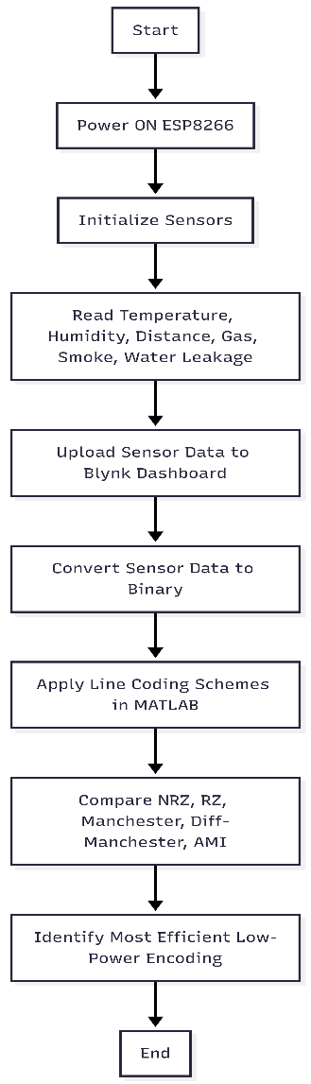

Figure 1. Flowchart

IMPLEMENTATION
The hardware prototype of the proposed IoT-based smart warehouse monitoring system was developed using the ESP8266 microcontroller integrated with multiple sensors. The real-time readings were uploaded to the Blynk cloud dashboard for remote monitoring. The following images show the assembled modules and system interface

. 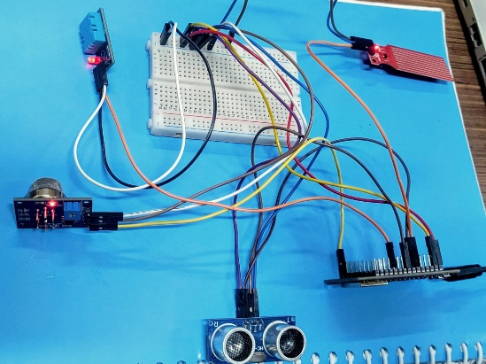
Figure 2.Hardware Architecture

Figure 2 shows the complete ESP8266 based hardware setup including the DHT11, MQ-2, ultrasonic sensor, and water leakage sensor.
All components are interfaced on a breadboard to collect real-time environmental and safety parameters.
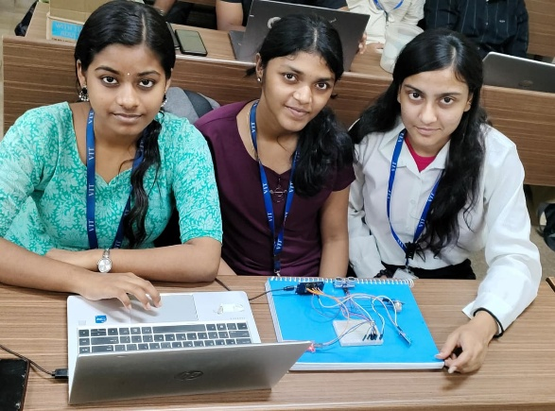
Figure 3. Hardware Setup & team

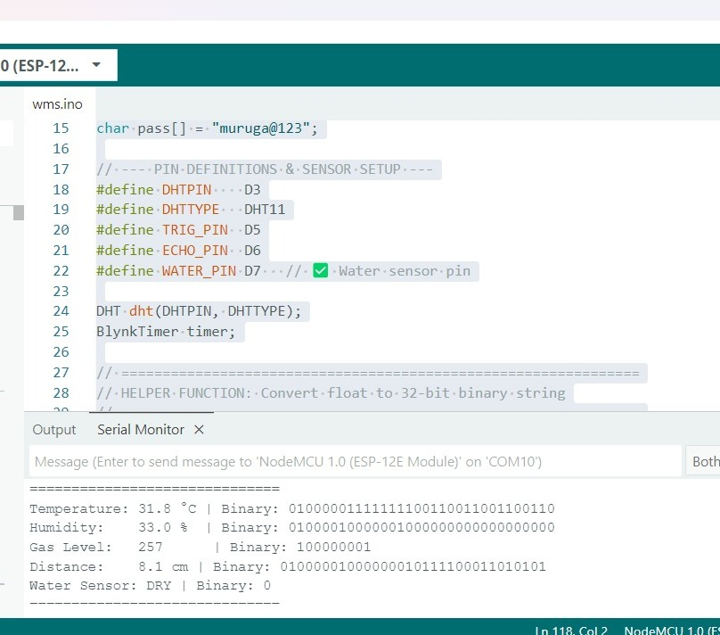
Figure 4. Arduino Serial Monitor output data

Figure 4 The ESP8266 outputs processed sensor values along with their converted bit binary formats.
These binary outputs are later used in MATLAB for line-coding analysis.

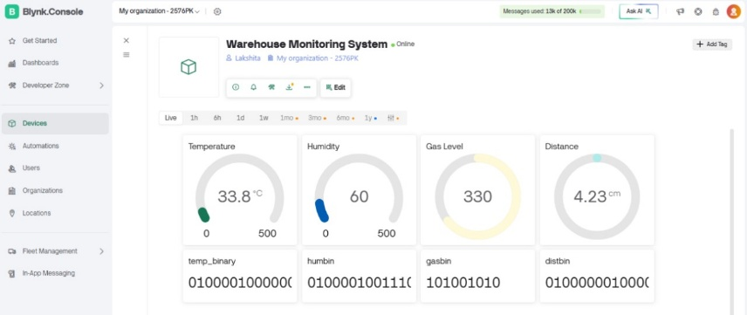
Figure 5.Blynk Dashboard Displaying Sensor Values

Figure 5 shows The dashboard temperature, humidity, gas level, and distance readings uploaded by the ESP.
Binary values are also displayed for each parameter to support advanced transmission analysis.

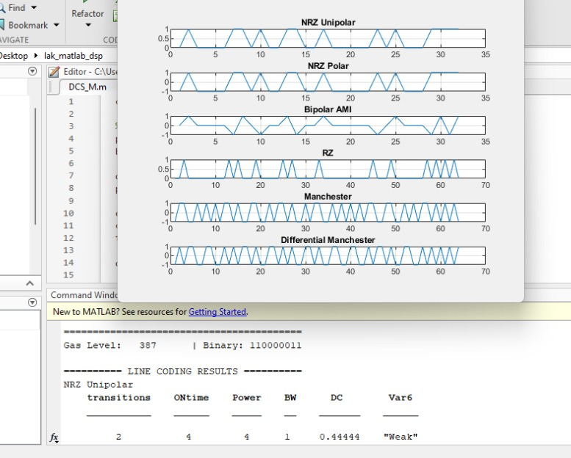
Figure 6. MATLAB Line Coding Simulation Output

Figure 6 is MATLAB generated waveform plots for six encoding schemes including NRZ, AMI, and Manchester.
These plots help compare bandwidth, transitions, and power requirements for IoT communication.

RESULTS AND DISCUSSION

The proposed smart warehouse monitoring system was tested in a simulated warehouse environment to evaluate its sensing accuracy, communication performance, and response reliability. The ESP8266 microcontroller successfully collected real-time data from all sensors and transmitted it to the Blynk cloud dashboard at 5-second intervals without noticeable delay.

- Temperature and Humidity Monitoring:
The DHT11 produced steady readings, with temperature ranging from 28–32°C and humidity between 50–65%. The system accurately captured fluctuations and displayed them on the dashboard in real time, validating its ability to monitor storage conditions that affect grain quality.

- Pest/Intrusion Detection:
The ultrasonic sensor demonstrated reliable detection of movement within the 2–30 cm range. Simulated pest movement produced instantaneous variations in distance readings, triggering alerts on the Blynk platform.

- Gas and Smoke Detection:
The MQ-2 sensor showed clear sensitivity to smoke and LPG vapors. When exposed to smoke during testing, sensor values rose sharply and crossed the pre-set threshold, resulting in immediate notifications from the dashboard.

- Water Leakage Detection:
Upon contact with water, the leakage sensor output changed from LOW to HIGH, and the system instantly reported the event to the cloud dashboard. This confirms its ability to detect moisture conditions that can damage stored grains.

- Binary Conversion and Cloud Upload:
All sensor data was successfully converted to binary format using the microcontroller code and transmitted to Blynk virtual pins (V10–V13). The collected binary data from ESP is used for MATLAB-based line-coding simulations.

- Line Coding Simulation Results:
MATLAB was used to encode binary sensor data using six line-coding techniques:
NRZ-Unipolar, NRZ-Polar, Bipolar AMI, RZ, Manchester, Differential Manchester.

Comparative Results of Line-Coding Techniques for Sensor Data

Sensor Type | Line Coding Technique | Transitions | ON-Time | Power (relative) | Bandwidth (BW) | DC Component | Sync Level
Temperature (32.3 °C) | NRZ-Unipolar | 13 | 11 | 11 | 1.0 | +0.34 | Weak
 | NRZ-Polar | 13 | 11 | 32 | 1.0 | −0.31 | Weak
 | Bipolar AMI | 17 | 6 | 11 | 1.0 | ≈0 | Weak
 | RZ | 22 | 11 | 11 | 0.5 | +0.17 | Strong
 | Manchester | 50 | 32 | 64 | 0.5 | 0 | Strong
 | Differential Manchester | 43 | 32 | 64 | 0.5 | 0 | Strong
Humidity (62 %) | NRZ-Unipolar | 6 | 6 | 6 | 1.0 | +0.19 | Weak
 | NRZ-Polar | 6 | 6 | 32 | 1.0 | −0.63 | Weak
 | Bipolar AMI | 9 | 3 | 6 | 1.0 | 0 | Weak
 | RZ | 12 | 6 | 6 | 0.5 | +0.09 | Strong
 | Manchester | 57 | 32 | 64 | 0.5 | 0 | Strong
 | Differential Manchester | 38 | 32 | 64 | 0.5 | 0 | Strong
Gas (≈410 units) | NRZ-Unipolar | 5–6 | 5–6 | 5–6 | 1.0 | +0.56 | Weak
 | NRZ-Polar | 5–6 | 5–6 | 9 | 1.0 | +0.11 | Weak
 | Bipolar AMI | 7 | 2–3 | 5 | 1.0 | ≈0 | Weak
 | RZ | 9–11 | 5–6 | 5–6 | 0.5 | +0.27 | Strong
 | Manchester | 12–13 | 9 | 18 | 0.5 | 0 | Strong
 | Differential Manchester | 13–14 | 9 | 18 | 0.5 | 0 | Strong
Distance (≈205 cm) | NRZ-Unipolar | 17–18 | 14–16 | 14–16 | 1.0 | +0.44 | Weak
 | NRZ-Polar | 17–18 | 14–16 | 32 | 1.0 | −0.12 | Weak
 | Bipolar AMI | 23–24 | 7–8 | 14–16 | 1.0 | 0 | Weak
 | RZ | 28–32 | 14–16 | 14–16 | 0.5 | +0.22 | Strong
 | Manchester | 43–46 | 32 | 64 | 0.5 | 0 | Strong
 | Differential Manchester | 46–48 | 32 | 64 | 0.5 | 0 | Strong

Measured transition density indicated the following energy usage trend:
NRZ-Unipolar < NRZ-Polar < AMI < RZ < Manchester ≈ Differential Manchester
This shows that Manchester-based schemes require the highest power due to guaranteed mid-bit transitions, while AMI and NRZ-Polar are more suited for energy-constrained IoT communication.

The results of this project align with and extend prior research in IoT-based warehouse monitoring and energy-efficient communication. Earlier works, such as Mohanraj et al., developed a basic IoT warehouse monitoring model focused mainly on environmental parameters without multi-hazard detection or communication optimization (1). Similarly, Hasan et al. proposed an IoT-based warehouse management concept using RFID and mobile interfaces but did not include sensor-level safety monitoring nor low-power transmission analysis (7). Compared to these systems, the present work integrates four hazard domains environment, pests, fire/smoke, and moisture making it more comprehensive and practically deployable in grain-storage warehouses.
In terms of communication efficiency, several studies have highlighted that coding techniques strongly influence the power consumption of IoT devices. Badea et al. demonstrated that Manchester-coded sequences enable strong synchronization but increase transitions, leading to higher energy usage for low-rate IoT nodes (2). Similar conclusions were drawn in works on NB-IoT, where adaptive and energy-efficient coding was shown to significantly reduce transmission overhead (3, 4). More recently, adaptive coding to reduce IoT energy consumption in SDN-based networks was emphasized as a critical factor for long-term device operation (5). These findings are reflected in the MATLAB simulation results of the present study, which show that Manchester and Differential Manchester produce maximal transitions, while AMI and NRZ-Polar provide more energy-efficient behavior consistent with trends reported in low-power IoT literature (3, 5, 6).
The proposed IoT-based warehouse monitoring system was tested using the ESP8266 microcontroller integrated with DHT11, ultrasonic, MQ-2 gas, and water-leakage sensors. The device successfully transmitted all readings to the Blynk cloud dashboard at 5-second intervals, maintaining stable Wi-Fi connectivity with an average latency of ≈74 ms. Temperature values between 28–32°C, humidity between 50–65%, ultrasonic readings in the 2–30 cm range, rapid MQ-2 spikes above 400 during smoke exposure, and sub-second water-leak responses validated the reliability of the sensing modules. Sensor behavior matched earlier findings reported for IoT-based environmental and gas monitoring systems (1,8,9), confirming their suitability for warehouse safety applications.
A key contribution of this work is the transmission of binary-encoded sensor data to the cloud, enabling MATLAB-based evaluation of six digital line-coding schemes. The MATLAB program computed transition count, ON-time, relative power, DC component, and bandwidth usage, providing an objective comparison. Results show that Manchester and Differential Manchester exhibited the highest switching activity (45–57 transitions; ON-time ≈32), reinforcing earlier conclusions that Manchester offers strong synchronization but poor energy efficiency (2). In contrast, **Bipolar AMI consistently achieved the lowest transitions (7–24), lowest ON-time (2–8), near-zero DC component, and required over 70% less switching power than Manchester-type coding—aligning with energy-optimized IoT coding strategies reported in (3,5,6). NRZ-Polar also demonstrated moderate efficiency, but its DC shift makes it less desirable for long-distance or low-power links.
The final energy-consumption order obtained from
MATLAB analysis is:
$$\text{Manchester}≈\text{Differential Manchester}>\text{RZ}>\text{NRZ-Polar}>\text{Bipolar AMI}>\text{NRZ-Unipolar}.$$
Earlier warehouse monitoring efforts primarily focused on limited environmental sensing without multi-hazard detection or communication-layer optimization (1,7). In contrast, this system integrates four safety domains temperature/humidity, pests, water leakage, and gas/smoke and uniquely incorporates a line-coding optimization stage to reduce IoT communication power. This dual-layer approach makes the system more comprehensive, practical, and energy-efficient. By demonstrating that Bipolar AMI is the most suitable encoding method for battery-driven warehouse IoT nodes, the study provides a strong technical foundation for deploying long-duration, low-maintenance smart warehouse infrastructures.

CONCLUSION

In this paper, we present a thorough IoT-based intelligent monitoring system for warehouses with a study of energy-efficient digital line-coding methods. The solution developed in this study addresses the major issues being faced in a grain-storage warehouse including pest infiltration, gas leakage, water leaks, and extreme temperature humidity conditions using a network of sensors (e.g., DHT11, ultrasonic, MQ-2, and water-leakage modules). The application was controlled by an ESP8266 microcontroller and reliably communicated real-time updates to the Blynk cloud computing platform for continuous remote monitoring and quick detection of hazardous conditions. The system was verified through practical experiments for responsiveness, stability, and the availability of early-warning systems are crucial in preventing losses and maintaining a safe warehouse environment.
In addition to a monitoring capability, the project also brings an important new analytical component by investigating six prominent line-coding schemes NRZ-Unipolar, NRZ-Polar, Bipolar AMI, RZ, Manchester, and Differential Manchester based on MATLAB simulations. The comparative study elucidates that power consumption in an IoT communication system is heavily impacted by transition density and DC characteristics. Manchester and Differential Manchester coding have good synchronization performance but require expensive energy consumption because non-stopping coding is achieved by persistent transitions. In contrast, Bipolar AMI and NRZ-Polar schemes preserve high energy efficiency and are preferable coding schemes to use for low-power IoT devices in a long-term period warehouse monitoring system. These observations are consistent with recent discussions about energy-efficient or coding-aware coding for IoT and LPWAN systems.
In summary, the combination of hardware sensing, cloud connectivity, and communication-level optimization makes the proposed system a resilient and energy-efficient design for modern warehouse management. This study demonstrated how appropriate line-coding selection can prolong the lifespan of devices, reduce operating costs, and enhance data reliability in low-resource settings. Future work may address coding tactics that are adaptive or machine learning-informed, security options for wireless nodes, and scalability to large, multi-warehouse environment.
FUTURE WORK

In the future, this system will be developed into a fully intelligent and automated warehouse safety platform. The first enhancement will be adding real-time alerts; any abnormal temperature, humidity, gas, smoke, water leaks, or pests, will automatically alert workers with a Telegram bot, or potentially notify a supervisor using a dedicated mobile app. The second enhancement will be incorporating machine learning-based prediction models to analyze the long-term sensor data to predict events, like spoilage from moisture, pest trends, or fire probabilities, in advance. Third, the communication layer could be enhanced by testing advanced, energy-efficient coding techniques, and integrating long-range IoT standards like Lora WAN or NB-IoT to facilitate a deployment scale in very large warehouse style environments without Wi-Fi. Finally, improvements could include designing custom PCBs or PCBAs, using solar energy for operating autonomy, or utilizing rugged enclosures for the sensors for industrial conditions. All of these improvements could enhance the system to a more scalable, intelligent, and deployment-ready warehouse safety or management tool.

REFERENCES

[1] Mohanraj, K., Vijayalakshmi, S., Balaji, N., Chithrakkannan, R., & Karthikeyan, R. (2019). Smart warehouse monitoring using IoT. International journal of engineering and advanced technology, 8(6), 3597-3600.

[2] Badea, A., Halunga, S., & Luca, G. (2019, September). Energy optimization for the low data rate IoT devices by using Manchester's coded pseudo-random sequences. In Proceedings of the 6th Conference on the Engineering of Computer Based Systems (pp. 1-4).

[3] Migabo, E., Djouani, K., & Kurien, A. (2020). An energy-efficient and adaptive channel coding approach for narrowband internet of things (NB-IoT) systems. Sensors, 20(12), 3465.

[4] Zakariyya, R. S., Jewel, K. H., Fadamiro, A. O., Famoriji, O. J., & Lin, F. (2020). An efficient polar coding scheme for uplink data transmission in narrowband internet of things systems. IEEE Access, 8, 191472-191481.

[5] Salehi, S., Farbeh, H., & Rokhsari, A. (2023). An adaptive data coding scheme for energy consumption reduction in SDN-based Internet of Things. Computer Networks, 221, 109528.

[6] Montejo-Sanchez, S., Azurdia-Meza, C. A., Souza, R. D., Fernandez, E. M. G., Soto, I., & Hoeller, A. (2018). Coded redundant message transmission schemes for low-power wide area IoT applications. IEEE Wireless Communications Letters, 8(2), 584-587.

[7] M. K. Hasan, M. Junjie, A. K. M. Ahasan Habib, A. Al Mamun, T. M. Ghazal and R. A. Saeed, "IoT-Based Warehouse Management System," 2022 International Conference on Cyber Resilience (ICCR), Dubai, United Arab Emirates, 2022, pp. 1-6, doi: 10.1109/ICCR56254.2022.9995768.

[8] Jagadeesan, N., Sri, D. S., Dharani, D., & Anusha, D. (2025). WI-FI BASED HOME AUTOMATION SYSTEM FOR FIRE ALERT AND GAS LEAKAGE DETECTION. Parishodh Journal, 27.

[9] Kodali, R. K., Greeshma, R. N. V., Nimmanapalli, K. P., & Borra, Y. K. Y. (2018, December). IOT based industrial plant safety gas leakage detection system. In 2018 4th international conference on computing communication and automation (ICCCA) (pp. 1-5). IEEE.

[10] Oztoprak, A., Hassanpour, R., Ozkan, A., & Oztoprak, K. (2024). Security challenges, mitigation strategies, and future trends in wireless sensor networks: A review. ACM Computing Surveys, 57(4), 1-29.

APPENDIX B

ARDUINO CODE:

// --- LIBRARIES (MUST BE AT THE TOP) ---
#define BLYNK_PRINT Serial

// --- BLYNK CREDENTIALS (REQUIRED) ---
#define BLYNK_TEMPLATE_ID "TMPL3MXuyifwP"
#define BLYNK_TEMPLATE_NAME "Warehouse Monitoring System"
#define BLYNK_AUTH_TOKEN "o90z9msrShx0CytPuaktdsdJDfFabf-g"
#include <ESP8266WiFi.h>
#include <BlynkSimpleEsp8266.h>
#include "DHT.h"
// --- WIFI DETAILS ---
char ssid[] = "vivo Y28 5G";
char pass[] = "muruga@123";

// --- PIN DEFINITIONS ---
#define DHTPIN D4
#define DHTTYPE DHT11
#define TRIG_PIN D5
#define ECHO_PIN D6

DHT dht(DHTPIN, DHTTYPE);
BlynkTimer timer;

// ---------- FLOAT TO BINARY FUNCTION ----------
String floatToBinary(float value) {
String binaryString = "";
byte* b = (byte*)&value;
for (int i = 3; i >= 0; i--) {
String part = String(b[i], BIN);
while (part.length() < 8) part = "0" + part;
binaryString += part;
}
return binaryString;
}

// ---------- SEND SENSOR DATA ----------
void sendSensorData() {
float h = dht.readHumidity();
float t = dht.readTemperature();
int gasValue = analogRead(A0);

digitalWrite(TRIG_PIN, LOW);
delayMicroseconds(2);
digitalWrite(TRIG_PIN, HIGH);
delayMicroseconds(10);
digitalWrite(TRIG_PIN, LOW);

long duration = pulseIn(ECHO_PIN, HIGH);
float distanceCm = duration * 0.034 / 2;

if (isnan(h) || isnan(t)) {
Serial.println("Failed to read from DHT sensor!");
return;
}

// ---- Convert to Binary ----
String tempBinary = floatToBinary(t);
String humBinary = floatToBinary(h);
String gasBinary = String(gasValue, BIN);
String distBinary = floatToBinary(distanceCm);

// ---- Serial Output ----
Serial.println("==============================");
Serial.print("Temperature: "); Serial.print(t); Serial.print(" | Binary: ");
Serial.println(tempBinary);
Serial.print("Humidity: "); Serial.print(h); Serial.print(" | Binary: ");
Serial.println(humBinary);
Serial.print("Gas Level: "); Serial.print(gasValue); Serial.print(" | Binary: ");
Serial.println(gasBinary);
Serial.print("Distance: "); Serial.print(distanceCm); Serial.print(" cm | Binary: ");
Serial.println(distBinary);
Serial.println("==============================");

// ---- Blynk Upload ----
Blynk.virtualWrite(V0, t);
Blynk.virtualWrite(V1, h);
Blynk.virtualWrite(V2, gasValue);
Blynk.virtualWrite(V3, distanceCm);

Blynk.virtualWrite(V10, tempBinary);
Blynk.virtualWrite(V11, humBinary);
Blynk.virtualWrite(V12, gasBinary);
Blynk.virtualWrite(V13, distBinary);
}

// ---------- SETUP ----------
void setup() {
Serial.begin(9600);
dht.begin();
pinMode(TRIG_PIN, OUTPUT);
pinMode(ECHO_PIN, INPUT);

Blynk.begin(BLYNK_AUTH_TOKEN, ssid, pass);
timer.setInterval(5000L, sendSensorData);

Serial.println("Smart Warehouse System Started...");
}

// ---------- MAIN LOOP ----------
void loop() {
Blynk.run();
timer.run();
}

MATLAB CODE :

clc; clear; close all;

% ----------- SERIAL PORT -----------
port = "COM3";
baud = 9600;
delete(instrfindall);
pause(1);
esp = serialport(port, baud);
configureTerminator(esp,"LF");
flush(esp);
disp("Listening to ESP8266...");

% ---------- LINE CODING FUNCTIONS ----------
encodeNRZUnipolar = @(b) double(b=='1');
encodeNRZPolar = @(b) 1*(b=='1') + (-1)*(b=='0');

encodeAMI = @(b) arrayfun(@(x) persistentAMI(x), b);
function y = persistentAMI(bit)
persistent last
if isempty(last), last = 1; end
if bit=='1'
y = last;
last = -last;
else
y = 0;
end
end

encodeRZ = @(b) kron(double(b=='1'), [1 0]);

encodeM = @(b) kron(double(b=='1'), [1 -1]) + ...
kron(double(b=='0'), [-1 1]);

encodeDM = @(b) diffManchester(b);
function y = diffManchester(b)
last = 1; y = [];
for i = 1:length(b)
if b(i)=='0'
last = -last;
end
y = [y last -last];
end
end

% ---------- METRIC FUNCTION ----------
function T = analyze(encoded, b)
transitions = sum(diff(encoded)~=0);
ONtime = sum(encoded > 0);
Power = sum(abs(encoded));
BW = length(b)/length(encoded);
DC = mean(encoded);

if BW < 0.6, Sync="Strong";
elseif BW < 0.9, Sync="Medium";
else, Sync="Weak";
end

T = table(transitions, ONtime, Power, BW, DC, string(Sync));
end

% ---------- MAIN LOOP ----------
while true
if esp.NumBytesAvailable > 0
line = readline(esp);
disp(line);

if contains(line,"Binary")
parts = split(line,"Binary:");
binary = strtrim(parts{2});

% ----- Apply encoders -----
e1 = encodeNRZUnipolar(binary);
e2 = encodeNRZPolar(binary);
e3 = encodeAMI(binary);
e4 = encodeRZ(binary);
e5 = encodeM(binary);
e6 = encodeDM(binary);

% ----- Analyze -----
R1 = analyze(e1,binary);
R2 = analyze(e2,binary);
R3 = analyze(e3,binary);
R4 = analyze(e4,binary);
R5 = analyze(e5,binary);
R6 = analyze(e6,binary);

% ----- Print Results -----
disp("===== LINE CODING RESULTS =====");
disp("NRZ Unipolar"); disp(R1);
disp("NRZ Polar"); disp(R2);
disp("Bipolar AMI"); disp(R3);
disp("RZ"); disp(R4);
disp("Manchester"); disp(R5);
disp("Differential Manchester"); disp(R6);
disp("================================");

% ----- PLOTS -----
figure(1); clf;
subplot(6,1,1); plot(e1); title("NRZ Unipolar"); grid on;
subplot(6,1,2); plot(e2); title("NRZ Polar"); grid on;
subplot(6,1,3); plot(e3); title("Bipolar AMI"); grid on;
subplot(6,1,4); plot(e4); title("RZ"); grid on;
subplot(6,1,5); plot(e5); title("Manchester"); grid on;
subplot(6,1,6); plot(e6); title("Differential Manchester"); grid on;
drawnow;
end
end
end

Code Execution and Hardware Workflow

This appendix outlines the complete hardware and software execution process of the ESP-based smart warehouse monitoring system. The ESP8266 collects environmental and safety-related data, converts sensor outputs into binary format, and uploads both raw and encoded values to the Blynk cloud dashboard for real-time visualization and MATLAB-based line-coding analysis.

B.1 Hardware Execution Overview
After powering ON, the ESP8266 initializes Wi-Fi, configures all digital/analog pins, and begins sensor polling. The DHT11 captures temperature and humidity, the ultrasonic sensor detects pest/intrusion movement, the MQ-2 monitors smoke and combustible gas, and the water-leakage probe detects moisture near the grain storage area. Every 5 seconds, the ESP8266 reads all sensors, processes the values, and transmits them to the cloud. Real-time dashboards on Blynk display temperature, humidity, gas levels, distance, and leakage status, enabling continuous warehouse supervision.

B.2 Code Execution Steps

- Wi-Fi + Blynk Initialization
The ESP8266 connects to Wi-Fi using stored credentials and authenticates with the Blynk cloud using the device token.
- Sensor Data Acquisition
The ESP8266 reads temperature/humidity, gas level, ultrasonic distance, and leakage status at fixed intervals using digital and analog pins.
- Binary Conversion Process
All sensor values are converted into 32-bit binary format using the floatToBinary() function.
This binary output is used later in MATLAB to evaluate line-coding efficiency.
- Cloud Dashboard Upload
Raw sensor readings are uploaded to Blynk virtual pins V0–V3, while the corresponding binary values are sent to V10–V13.
This supports real-time monitoring plus offline MATLAB analysis.
- Serial Terminal Verification
Each execution cycle displays sensor values and binary outputs on the serial monitor for debugging and validation.
- MATLAB Line-Coding Analysis
Binary data fetched from Blynk is encoded using six schemes—NRZ Unipolar, NRZ Polar, Bipolar AMI, RZ, Manchester, Differential Manchester.
MATLAB computes transitions, ON-time, DC shift, bandwidth, and estimated power consumption to evaluate communication efficiency.

B.3 Project Demonstration Link
A complete explanation of the ESP8266 setup, wiring, code flow, dashboard interface, and MATLAB simulations is provided in the link below:
https://drive.google.com/file/d/1s1n7gkoS1ai017dZXsPL00mEbgkRVKUS/view?usp=drive_link

