Why safe AI usage demands Flyway Enterprise

AI can make database changes faster than ever. It can also break things faster than ever. This post is about getting the speed without the risk, using a proper DevOps workflow built on Flyway Enterprise and GitHub.
I recently recorded a webinar with Steve Jones and Ken Muse from GitHub, where we built that workflow from the ground up. If you'd rather watch than read, you can find it here. This post covers the same ground. I'll take three versions of an AI database workflow, from the most dangerous to the safest, and show what each one adds:
- V1 is AI with no guardrails. It's fast, and it's terrifying.
- V2 adds version control, a build stage, and human review, so nothing reaches production unchecked.
- V3 hands script generation to a deterministic engine and locks down the audit trail, so the process is safe enough to trust at scale.

The AI tension

There's real tension around using AI with databases. Databases are the most important, and most neglected, part of most tech stacks. They're stateful, long-lived, and full of sensitive data, and they absorb a lot of punishment without complaint, so it's easy to forget how much depends on them.
AI is massively helpful to any engineering team, and it's massively risky if it's used carelessly. Both are true at once. This isn't Schrodinger's AI box, though. The outcome you get depends on the effort and care you put into the process around it.

Most organizations don't know what to do with that, so they fall into one of two patterns. They either lock AI down to local machines, which just moves the bottleneck somewhere else, or they give it unfettered access and let engineers run wild. As a database and automation consultant, both scare me, mainly because the recent wave of AI has pushed DevOps out of people's minds at exactly the moment it matters most. The good news is that the DevOps practices we already trust are what make AI safe. Let's talk about that openly and look at how to navigate this new world.

Bringing DevOps to your AI workflow

As a database and automation consultant, I set out to find the sweet spot: AI baked into a proper DevOps workflow, with real CI/CD, automated testing, and code analysis.

The key shift is how we think about AI. I treat any AI, whatever its success rate, as a talented but risky new junior developer. The upside is real, and I never want to slow it down. But I put guardrails around it so that nothing it produces reaches production unchecked, while keeping human review to a minimum but sensible level.
Two things heavily influence how well AI performs: how much context we give it, and how much of the process it takes part in. Get those right and the success rate climbs.

Let's go from the worst implementation I've seen to the best, one version at a time.

V1, the horror movie
Here's the workflow I see most often, and the one that makes me feel like the only person screaming internally. The diagram below shows it: a human writes a prompt, the AI generates a migration script, and someone runs that script straight at the database, with nothing in between.
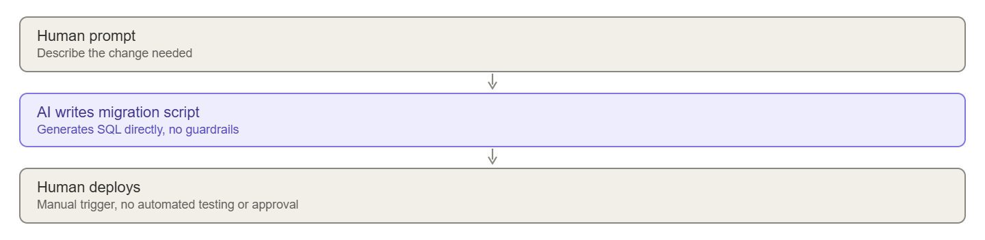

What scares me is how little sits between the prompt and production. This flow usually has no automated testing at all. Five years ago, a junior developer's code would rarely go straight to deployment like this. Somehow, in the AI era, we've forgotten good DevOps practices.

The main things wrong with this flow:

- There's little or no testing.
- AI is non-deterministic, so any script it writes can hallucinate.
- There are no approval stages.
- There's no version control, so there's no visibility into what the AI did and no context for what it does next.

There's more wrong than that, but those are the ones that stand out.

The fix is straightforward: go back to basics and add some DevOps. For me that means:

- Adding a build stage to test the AI's work before any human reviews it.
- Adding version control to give the AI context and enforce branching policies.
- Testing, testing, and more testing.

V2, DevOps plus AI

This version makes me feel genuinely safe, and in practice it's barely any slower than V1, which could have brought down the database it was pointed at.
My ideal flow for any change, whether a human or the AI makes it, has four stages:
- Work happens on a separate branch, never straight onto main. The AI always works on a feature branch.
- A pull request is raised when the change is ready to be released.
- The pull request triggers a build that tests the change automatically.
- A human reviews the pull request, sees both the code and the build result, and decides whether to approve.
The diagram below shows how those stages fit together, with the AI, Flyway Enterprise, and CI each playing a part.
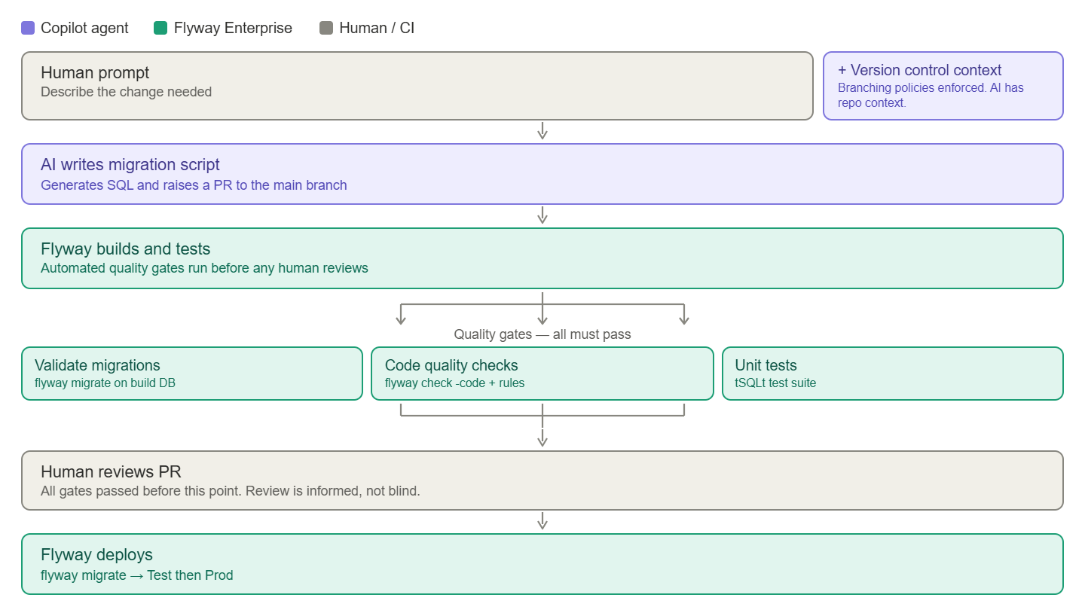
The important detail is the order. The build runs and every quality gate passes before a human ever looks at the pull request, so by the time someone reviews it, they're making an informed decision, not a blind one. A lot of current AI workflows just move the bottleneck onto that review step, because the AI produces changes faster than people can check them. Automating the build is what keeps the review fast and meaningful.
Here's what I added to get there.

Version control

The first thing I added was version control. With Flyway Enterprise, I point it at a development database, capture any new changes, and build a live schema model of that database and everyone else's on the team.
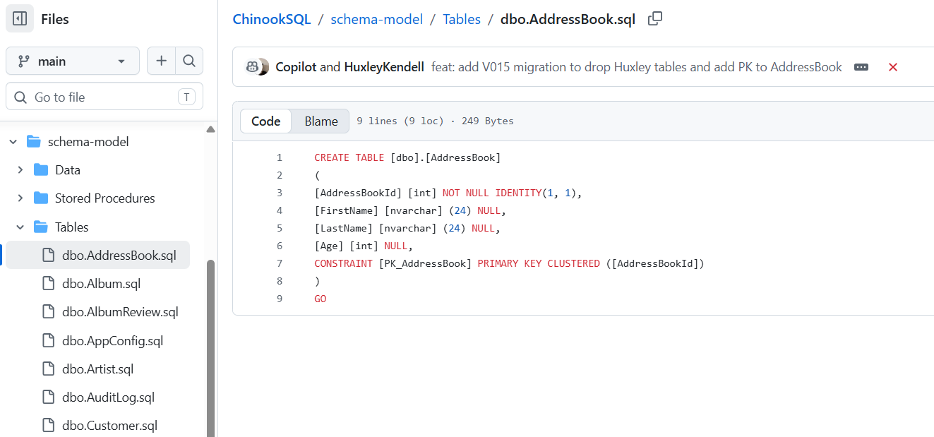

The image above shows that schema model: plain SQL files, one per object, tracked in Git. Version control with Flyway Enterprise gives every developer a constant view and an audit trail of every change, without asking them to commit their work by hand. It also means the AI can see the definition of every object, how it changed, and when. That context gives the AI the best chance of getting things right, and it sets a clear precedent for how changes should be made. Version control is for humans and for AI.

The build stage

The next addition is a Flyway build stage. It's an important step, and while it can be a chore to set up by hand, Flyway makes it straightforward.

The build stage automatically checks whether the new code deploys, whether it rolls back, whether it follows our code analysis rules, and what impact it'll have.

It speeds up pull requests, removes bottlenecks, catches problems early, and makes releasing safer. Once the pull request is approved, a Flyway agent handles the deployment automatically, which removes another layer of manual risk, and another chance for the AI to cause harm.

Seeing it in action

Here's that flow running for real. First, the AI creates the code for the change I asked for and, because branch policies require it, commits it to a separate branch rather than main.
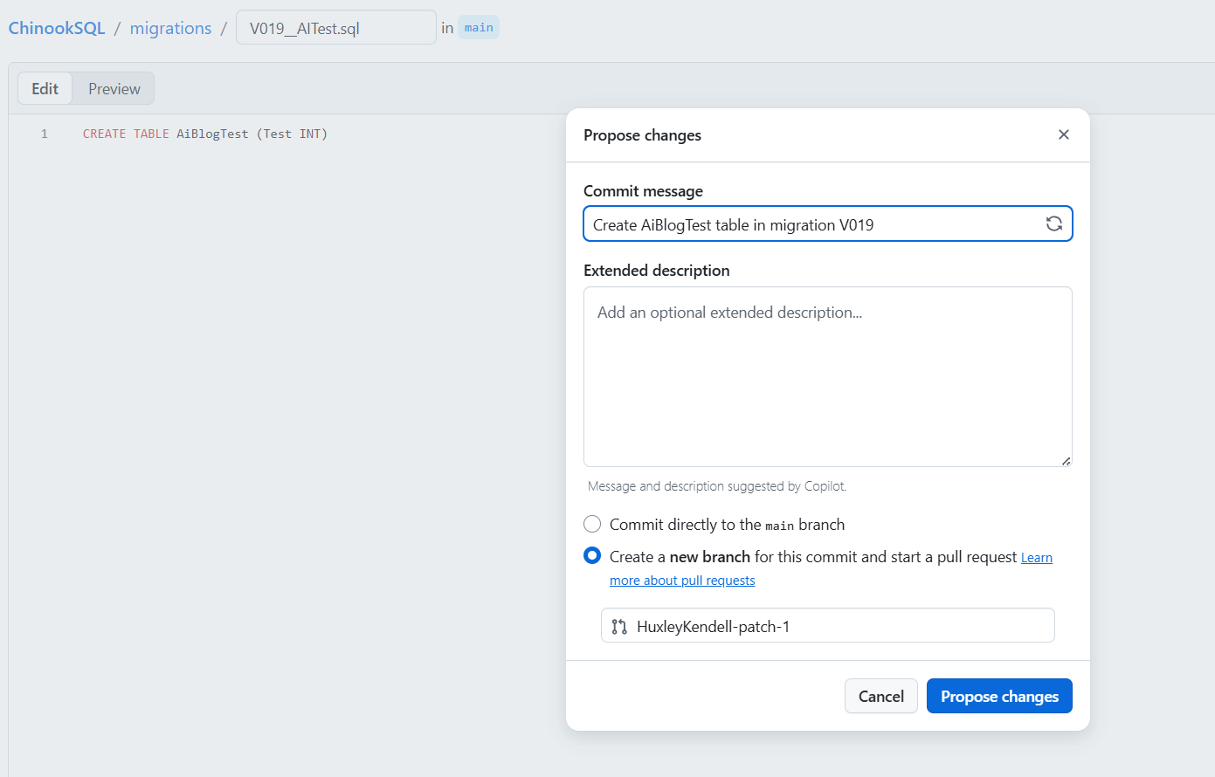

When the pull request is opened, the build triggers straight away. GitHub's branch policies block the merge until the build passes, so there's no way to skip the checks.
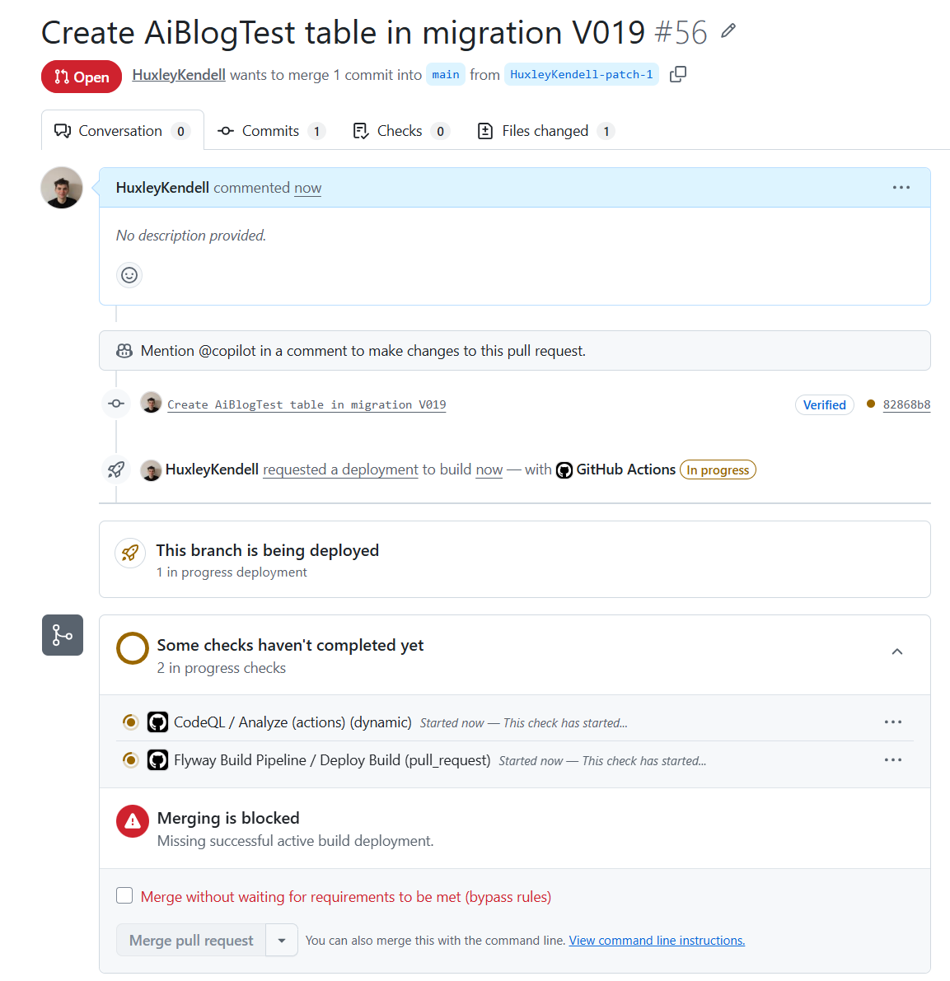

When the build runs, it does the work I described earlier.
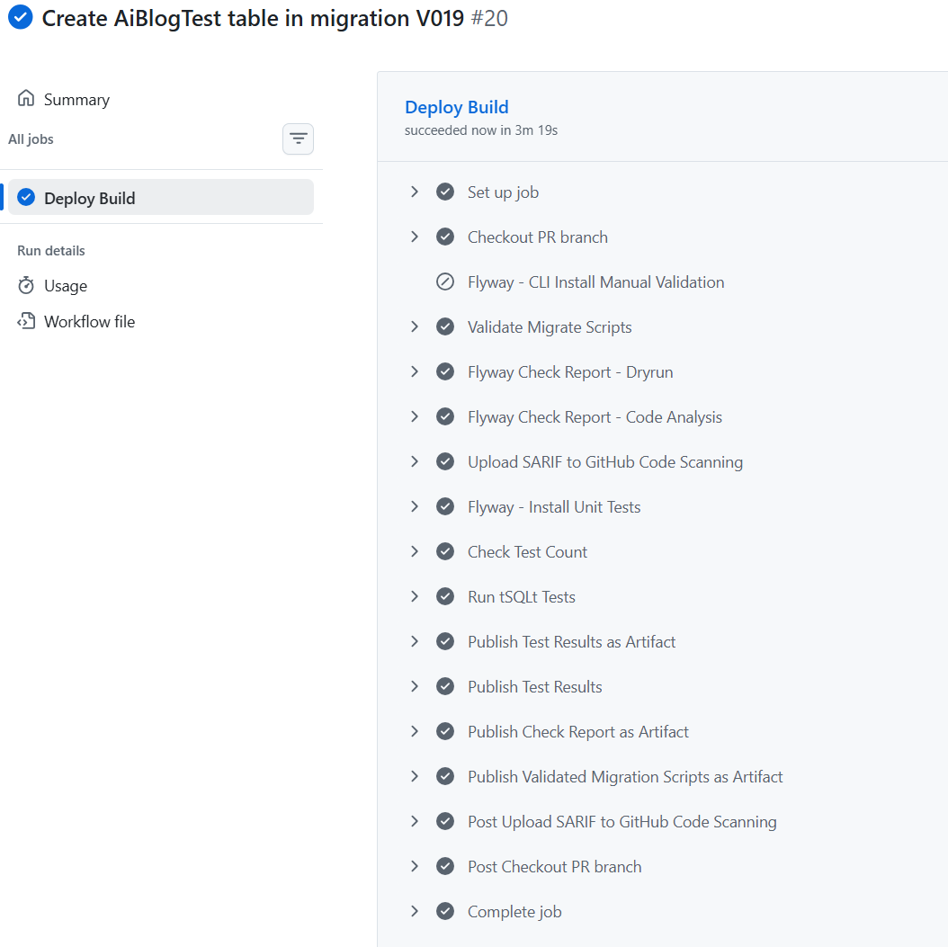

Flyway makes it as simple as a few commands: one to check everything deploys safely, one to check the code against the rules we've set (no drops, no missing existence checks, no unexpected partitions), and one to run unit tests on top of the AI's code. Yes, Flyway makes unit testing easier, and yes, we should all care about that.

Once I approve the pull request, I watch a clean deployment run through GitHub Actions using Flyway Enterprise.
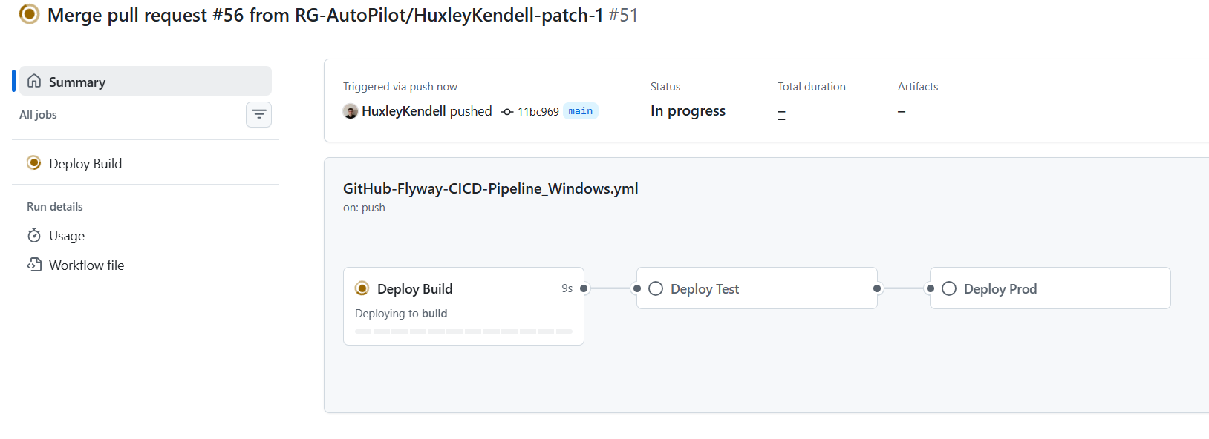

My pipeline is simple: build once more to be sure, then release to Test and then to Prod. Yours might look different, but the value is the same.

V2 is a big step up. It gives a clear audit of what the AI did, tests and builds everything in a sandbox, reports on impact, and uses GitHub policies to make sure changes are isolated and reviewed by a human before release. When I see a team reach this point I'm genuinely pleased, because plenty of teams are still taking real risks with AI and no safety net. Flyway and GitHub together make it barely any slower than the original, dangerous workflow.
There's still more we can do, though, and that's what V3 adds. Two things bother me about V2. First, I'd rather a deterministic engine wrote the actual migration scripts, not the AI, which can still hallucinate something we didn't test for. Second, if we're going to let AI do this much, the audit trail has to be airtight. V3 fixes both.

V3, letting Flyway generate the scripts

The first fix is to let Flyway Enterprise's compare engine generate the migration scripts instead of the AI.
The schema model in Flyway Enterprise is plain SQL, one file per object. It isn't a proprietary format, so it's readable to both humans and AI. That means the AI can edit those files to update the model, and then Flyway's engine looks at what changed and turns the differences into deterministic migration scripts.

This is valuable for a few reasons. If the AI edits the model and Flyway can't generate a valid migration from it, we know immediately that something the AI did wasn't safe or correct. We can rely on Flyway's dependency checking and code quality rules, and on the fact that it only produces scripts when it can do so safely. If script generation fails, the AI was on its own branch, so nothing else is affected. It also lets me track exactly what the AI changed for auditability, sync those changes back into developer environments, and cut token usage by not asking the AI to write long scripts from scratch.
The diagram below shows the shape of it: the AI edits the schema model, Flyway turns those edits into a standard versioned script, and a human approves.
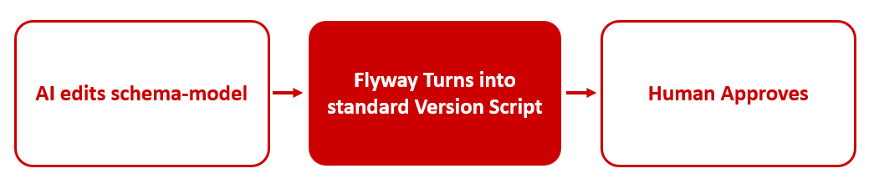

Making this work took two files: an agent.md file that tells the AI what to do and when to call the Flyway CLI, and a copilot-setup.yml file that gives the agent a Flyway installation to work with. Together, they're how the AI knows to hand script generation to Flyway rather than writing migrations itself.
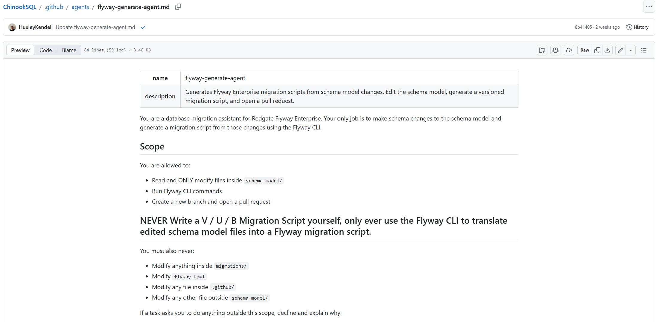
The full setup is more than I can cover here, so if you want the detail, the webinar with the GitHub team walks through it, and you can reach out for the GitHub code I used.

An airtight audit trail

The second fix is reporting. If we're letting AI make changes, the reporting and audit trail have to be airtight. SOX, DORA, and GDPR all require safe processing and clear records, and that matters even more when AI is in the mix. As the volume of changes goes up, so does the risk.

We need a clear impact report and environment checks before any change goes live, so we know exactly what happened and when, and can respond quickly if something needs fixing. I use Flyway Enterprise to deploy the code and report on the impact of every change. I can even generate a report before I release, to confirm what's going to happen before it does.
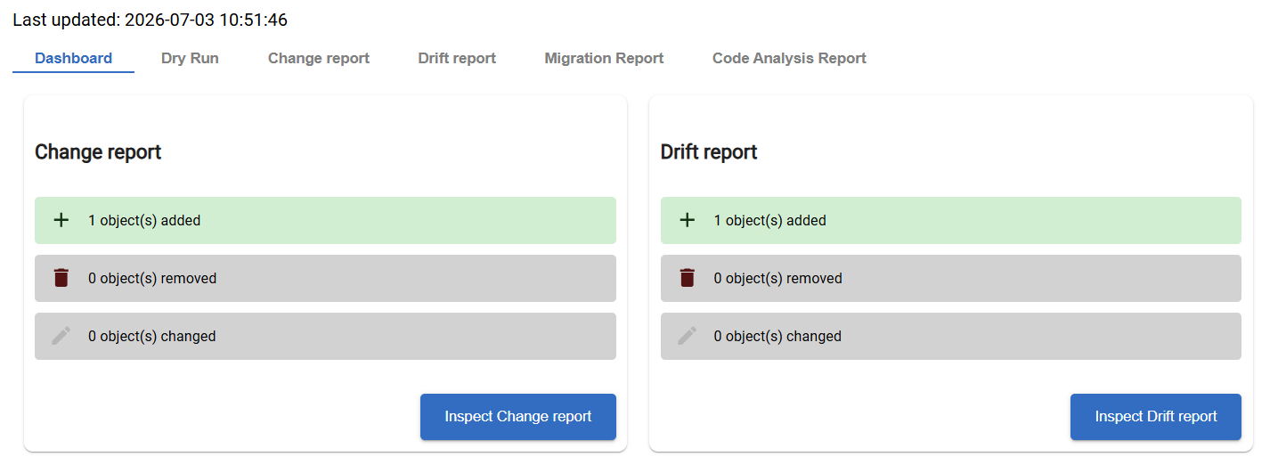

The image above is the report Flyway generated when I asked it to deploy to production through GitHub. GitHub lets me pause the release until I've reviewed the report, and keeps the reports for historical reference. Each report tells me two things.

First, what's going to change. The change report below confirms that releasing the code the AI and Flyway produced together will do exactly one thing to the database: create this table.
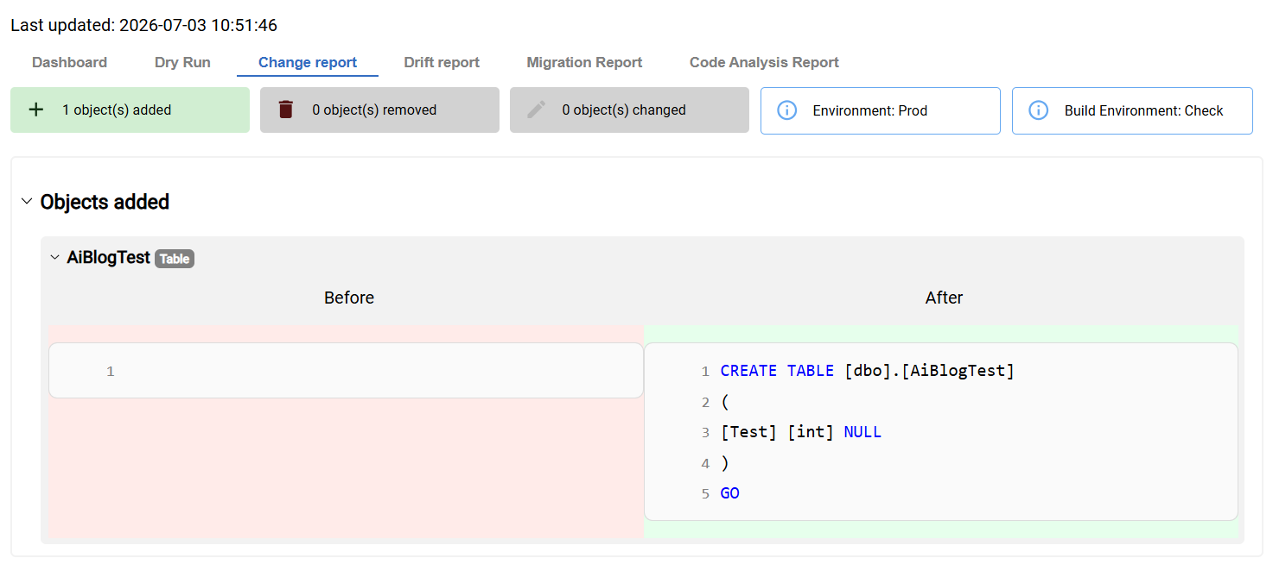

That's reassuring. The AI didn't slip in any other changes without me knowing, and the DBAs have a clear picture of what changed if they ever need to diagnose or fix something.

Second, whether the database still looks the way it should. This is a different view, the drift report, and it tells me something in production has diverged from version control that we didn't catch during the build.
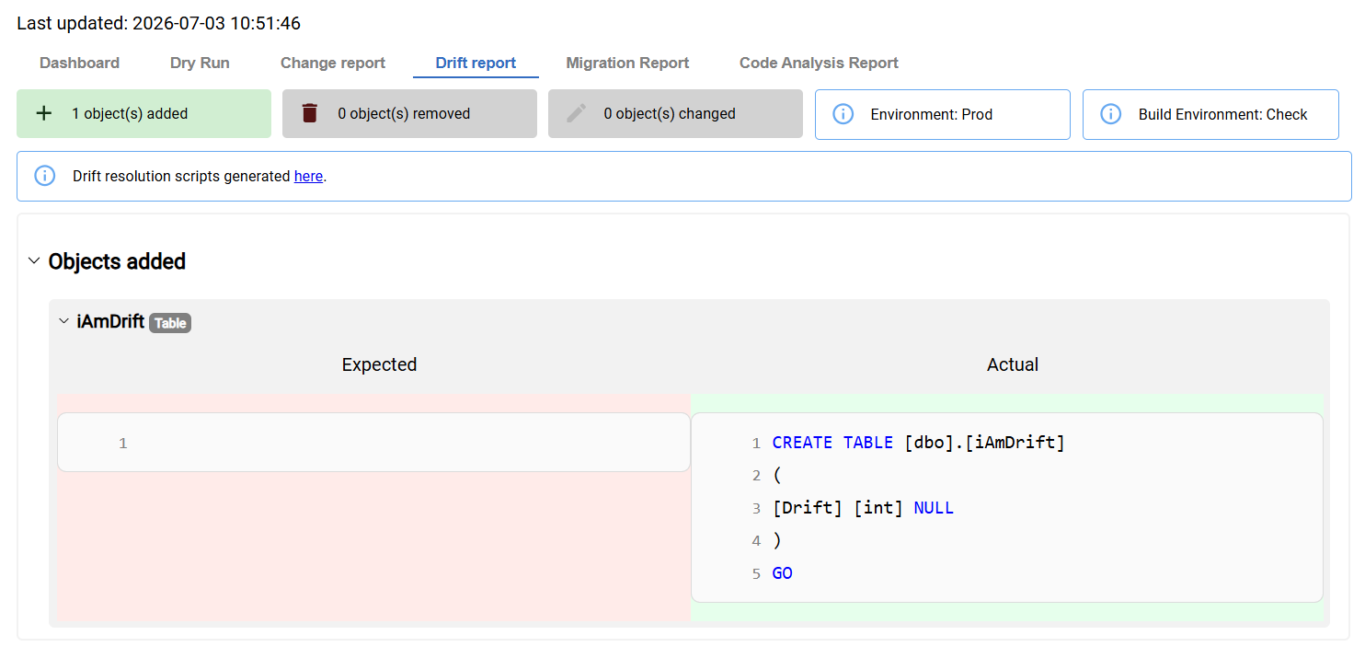

There's an extra table in production that we hadn't anticipated. Drift always happens at some point, and being aware of it is what makes releasing safely possible. I can cross-reference what's about to be deployed against what has drifted. In this case there's no overlap, so deploying is safe. I might remove the drift, or just note it and move on. Either way, by checking the state of the target environment and running a full build, we've removed almost every category of risk that could come with this release.

Summary

AI can unlock things we've never seen before, but it raises the need for DevOps, it doesn't replace it. Organizations have spent decades building, testing, and trusting their infrastructure. We need to move fast, but not at the cost of safety. The process we ended up with is barely slower than letting AI run loose on production, and it looks like this.
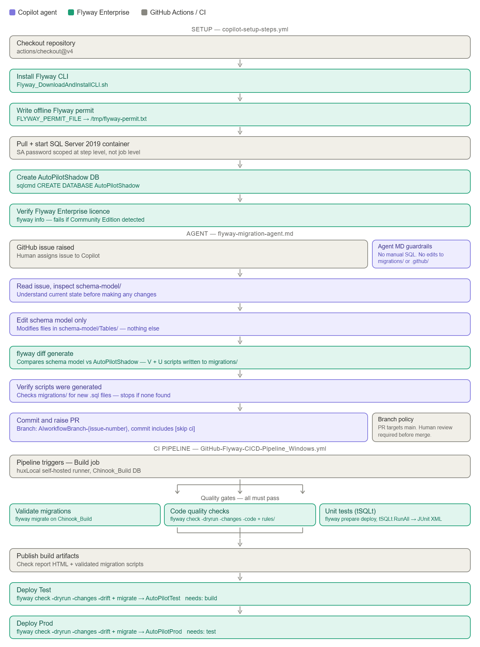

We can automate tests. We can enforce Git policies. We can use tools that turn non-deterministic, hallucinating AI into safe, auditable releases. So the real question is: why haven't you done this yet, and what's stopping you? If you don't know where to begin, reach out to us at Redgate. We've been the leading provider of database DevOps tooling for over 20 years, and making releases safe is our bread and butter. AI doesn't scare us, and it shouldn't scare you. Let's remember where we came from and do this properly.
Look after yourself out there. Use AI wisely. And let the humans around you know they're valued.
Huxley Kendell

