Assignment: Camera Calibration and Measurement Pipeline

Objective
Build a complete camera calibration pipeline using checkerboard images and evaluate measurement accuracy.

Requirements

Part 1 — Camera Calibration
Using OpenCV:
- Capture or use provided checkerboard images
- Compute:
  - camera matrix
  - distortion coefficients
- Save calibration results to YAML or JSON
- Compute reprojection error

Part 2 — Distortion Correction
- Undistort images
- Compare:
  - original
  - corrected images
- Explain visible differences

Part 3 — Real-World Measurement
- Apply perspective transformation if necessary
- Measure known object dimensions in mm
- Compare estimated vs actual measurements
- Compute measurement error

Part 4 — ROS2 Integration
Create ROS2 nodes:

calibration_node
Publishes:
- corrected image

measurement_node
Subscribes:
- corrected image
Publishes:
- measurement result

Introduction:
Camera-based vision systems are widely used in modern robotics, automation, industrial inspection, and measurement applications because they provide a flexible and low-cost method for capturing environmental information. In robotics, cameras are commonly used for object detection, navigation, localization, and real-world measurement tasks. However, raw images captured from real cameras are not geometrically perfect due to lens distortion and optical limitations. These distortions can affect object shape, straight-line consistency, and measurement accuracy, especially near the edges of the image.
To reduce these errors, camera calibration is performed. Camera calibration is the process of estimating the intrinsic parameters and distortion coefficients of a camera using a known geometric pattern such as a checkerboard. The intrinsic parameters describe the internal optical properties of the camera, including focal length and optical center, while distortion coefficients model lens distortion mathematically. In this assignment, OpenCV-based checkerboard calibration was used to compute the camera matrix and distortion parameters, which were then saved in YAML format for later use. Reprojection error was also calculated to evaluate the accuracy of the calibration process.
After calibration, distortion correction was applied to generate geometrically corrected images. The original and corrected images were visually compared to analyze distortion reduction and geometric improvement. Corrected images are important for reliable real-world measurement because inaccurate image geometry can produce incorrect object dimensions.
The project also includes a real-world measurement pipeline where object dimensions were estimated in millimeters using calibrated image information. Estimated measurements were compared with actual object dimensions to compute measurement error and evaluate system accuracy. Perspective transformation techniques were additionally considered to reduce viewpoint-related measurement inaccuracies.
Finally, the complete pipeline was integrated into a ROS2-based robotics framework. A calibration_node was developed to publish corrected images, while a measurement_node subscribed to the corrected image stream and published measurement results. This publish-subscribe architecture demonstrates how calibrated computer vision systems can be integrated into modern robotic applications for real-time image processing and measurement tasks.

Objective
The objective of this assignment is to develop a complete camera calibration and measurement pipeline using OpenCV and ROS2 for real-time computer vision applications. The project focuses on improving image accuracy, correcting lens distortion, and integrating calibrated image processing into a robotics communication framework.
The specific objectives are:
- Perform camera calibration using checkerboard images
- Compute intrinsic camera parameters and distortion coefficients
- Correct lens distortion using calibration results
- Measure real-world object dimensions from calibrated images
- Integrate the corrected image processing pipeline into ROS2 using publish-subscribe communication node

System Overview

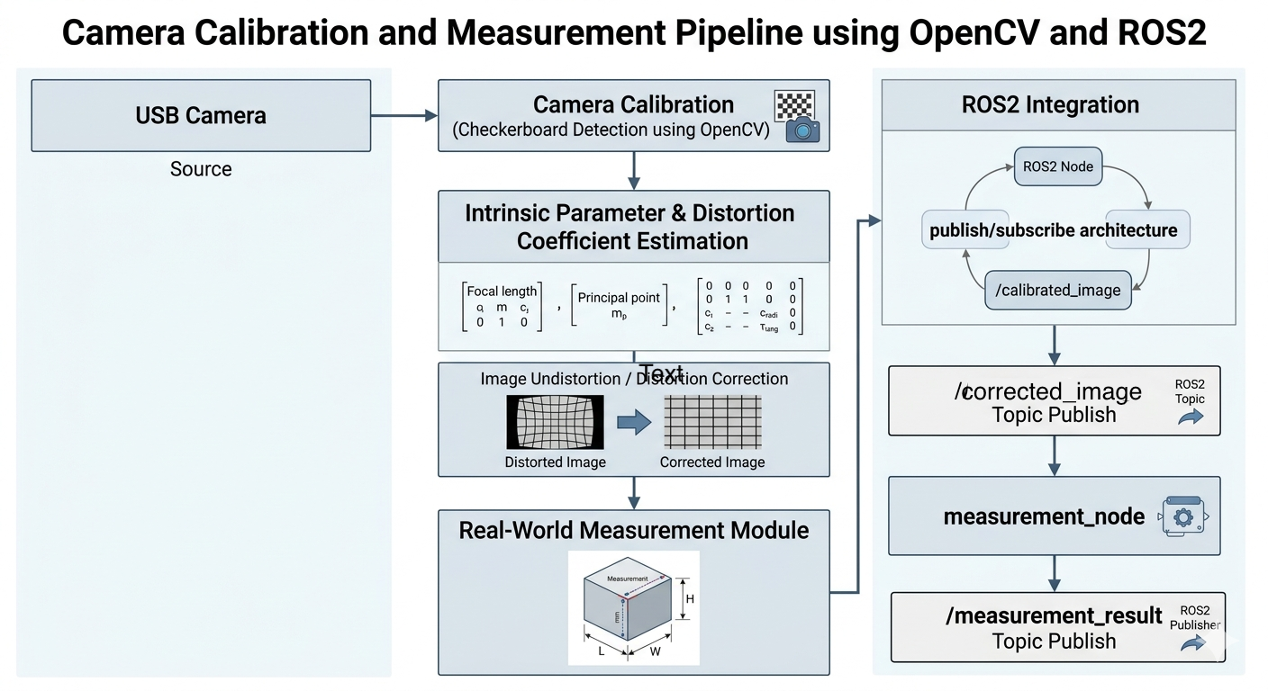

Part 1: Camera Calibration
Camera calibration is the process of estimating the intrinsic and extrinsic parameters of a camera in order to accurately model the image formation process. In computer vision and robotics applications, calibration is important because real camera images contain lens distortion and geometric inconsistencies that can reduce measurement accuracy.
In this project, OpenCV-based checkerboard calibration was used to estimate the camera matrix and distortion coefficients. Multiple checkerboard images were captured from different viewing angles to improve calibration robustness and corner detection quality.

4.1 Image Formation Geometry
A 3D world point is projected onto the 2D image plane using the camera projection model.
$$\left[\begin{matrix}u' \\ v' \\ w'\end{matrix}\right]=P\left[\begin{matrix}X_{w} \\ Y_{w} \\ Z_{w} \\ 1\end{matrix}\right]$$
Where:
- $\left(X_{w},Y_{w},Z_{w}\right)$ represents the world coordinates
- $\left(u,v\right)$ represents image coordinates
- $P$ is the projection matrix
The projection matrix is defined as:
$$P=K\left[R|t\right]$$
Where:
- $K$ = intrinsic matrix
- $\left[R|t\right]$ = extrinsic parameters

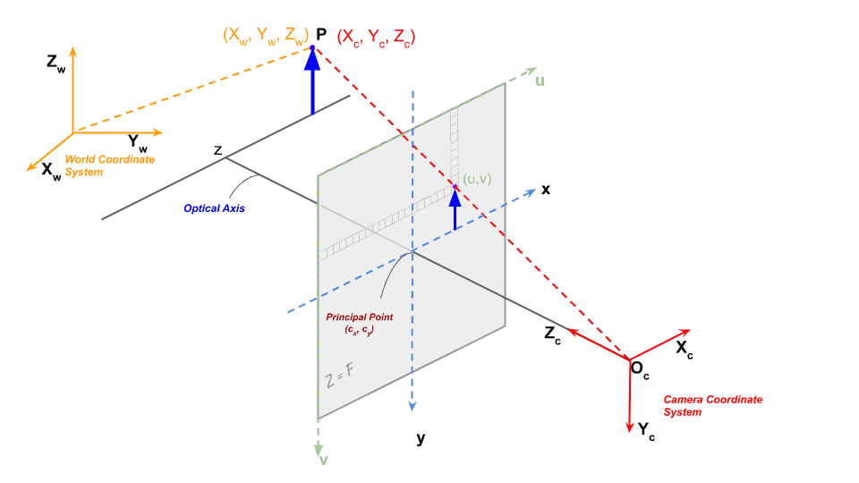
Geometry of Image Formation Diagram”
(3D world → camera → image plane projection figure)

4.2 Checkerboard Detection
A checkerboard pattern was used because its corners are easy to detect and provide stable geometric reference points. Multiple checkerboard images were captured from different orientations and distances.
OpenCV’s cv2.findChessboardCorners() function was used to detect checkerboard corners from the images.
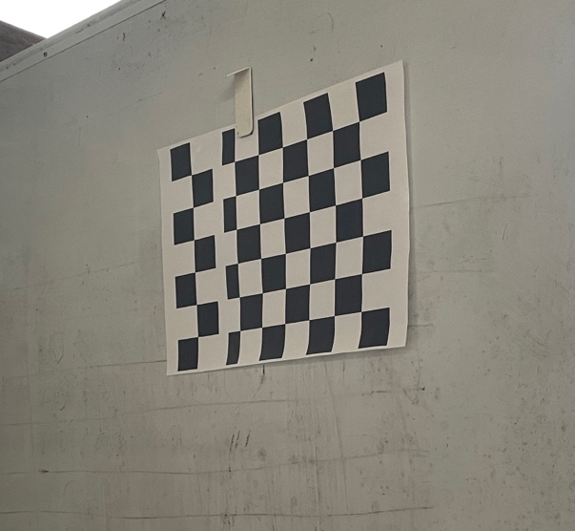 | 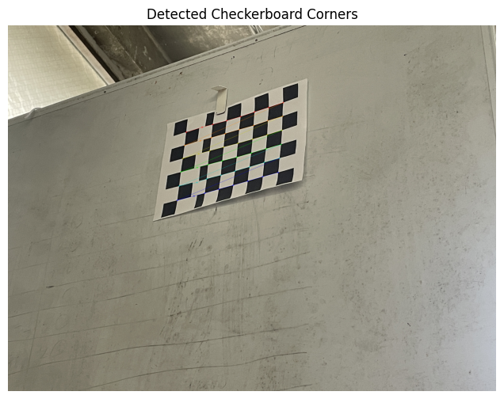
“Original Checkerboard Image”

4.3 Corner Extraction and Calibration
After corner detection, sub-pixel corner refinement was performed using cv2.cornerSubPix() to improve localization accuracy. These refined corner coordinates were then used for camera calibration using OpenCV’s cv2.calibrateCamera() function.
The calibration process computes:
- Camera intrinsic matrix
- Distortion coefficients
- Rotation vectors
- Translation vectors
The calibration results were saved in YAML format for later use.

4.4 Camera Matrix
The camera intrinsic matrix describes the internal optical properties of the camera.
$$K=\left[\begin{matrix}f_{x} & 0 & c_{x} \\ 0 & f_{y} & c_{y} \\ 0 & 0 & 1\end{matrix}\right]$$
Where:
- $f_{x},f_{y}$ = focal lengths
- $c_{x},c_{y}$ = optical center coordinates
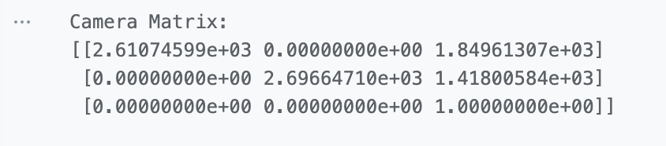
“Calibration Output Screenshot Showing Camera Matrix”

4.5 Distortion Coefficients
Lens distortion causes image deformation, especially near image boundaries. Distortion coefficients were estimated during calibration to model this distortion mathematically.
$$x_{distorted}=x\left(1+k_{1}r^{2}+k_{2}r^{4}+k_{3}r^{6}\right)$$
Where:
- $k_{1},k_{2},k_{3}$ are radial distortion coefficients
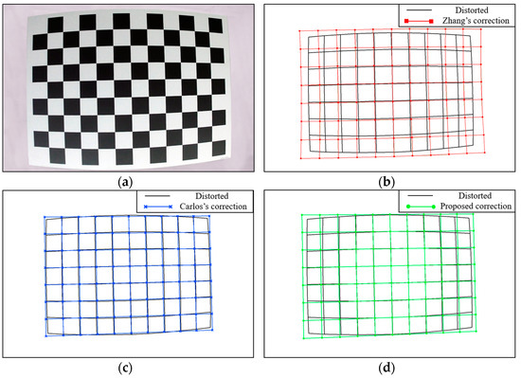
“Distorted vs Corrected Grid/Image Comparison”

4.6 Reprojection Error
Reprojection error was used to evaluate calibration accuracy by comparing detected checkerboard corners with projected corner positions generated by the calibration model.
$$e=\frac{1}{N}\sum_{i=1}^{N}{\left|p_{i}-{\hat{p}}_{i}\right|}$$
Lower reprojection error indicates better calibration quality and more accurate camera parameter estimation.
Mean Reprojection Error: 1.4692212318426745 pixels
“Reprojection Error Result Screenshot / Calibration Accuracy Output”

Part 2 — Distortion Correction

5. Distortion Correction
After camera calibration, distortion correction was applied using the estimated camera matrix and distortion coefficients. Real camera lenses introduce geometric distortion that causes straight lines to appear curved, especially near the image boundaries. This distortion can negatively affect object measurement and geometric consistency.
In this project, OpenCV’s cv2.undistort() function was used to generate corrected images from distorted input images.
The distortion correction process can be represented as:
$$I_{corrected}=Undistort\left(I_{distorted},K,D\right)$$
Where:
- $I_{distorted}$ = original distorted image
- $K$ = camera intrinsic matrix
- $D$ = distortion coefficients
The corrected images showed improved straight-line consistency and reduced geometric deformation compared to the original images.
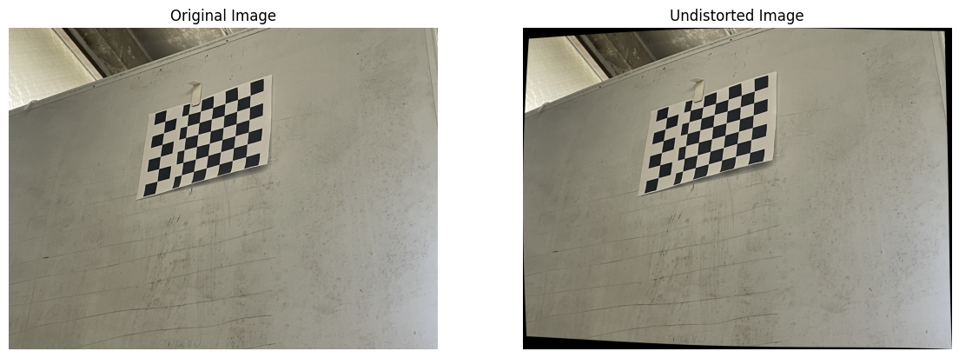

Part 3 — Real-World Measurement
After distortion correction, a real-world measurement pipeline was implemented to estimate object dimensions using calibrated images. The goal was to convert pixel measurements into real-world units such as millimeters.
Perspective transformation and pixel scaling techniques were used to improve measurement accuracy and reduce viewpoint-related distortion effects.
The pixel-to-real-world scaling relationship is defined as:
$$Scale=\frac{Real Width \left(mm\right)}{Pixel Width}$$
Using this scale factor, object dimensions were estimated as:
$$Measured Size=Pixel Size×Scale$$
Measurement error was calculated by comparing the estimated dimensions with the actual object dimensions.
$$Error=\left|Measured-Actual\right|$$
Lower measurement error indicates better calibration accuracy and improved geometric consistency.
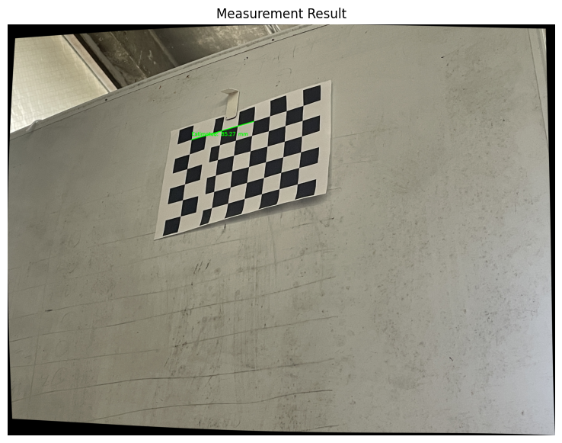
“Measurement Result Screenshot Showing Actual vs Estimated Size”

Part 4 — ROS2 Integration
After completing camera calibration and distortion correction, the image processing pipeline was integrated into a ROS2-based robotics framework for real-time communication and processing.
ROS2 uses a publish-subscribe communication architecture where nodes exchange data through topics. In this project, two ROS2 nodes were developed: calibration_node and measurement_node.

7.1 calibration_node
The calibration_node captures live camera frames using OpenCV, applies distortion correction using the calibration parameters, and publishes the corrected image to the /corrected_image ROS2 topic.

The processing flow is:
Camera Frame

Distortion Correction

Publish /corrected_image

The node continuously publishes corrected image frames for downstream processing.

7.2 measurement_node
The measurement_node subscribes to the /corrected_image topic and receives corrected image frames from the calibration node. The received images are then processed to extract measurement-related information such as image dimensions or object measurements.
The node publishes the processed measurement result to the /measurement_result ROS2 topic.
The processing flow is:
/corrected_image
↓
measurement_node
↓
Publish /measurement_result

7.3 ROS2 Publish-Subscribe Architecture
The complete ROS2 communication pipeline developed in this project is shown below:
USB Camera
↓
calibration_node
↓ publishes
/corrected_image
↓ subscribes
measurement_node
↓ publishes
/measurement_result
This architecture demonstrates how calibrated computer vision pipelines can be integrated into robotics systems using modular ROS2 communication nodes.

7.4 ROS2 Topic Verification
ROS2 command-line tools were used to verify topic communication and image publishing performance.
The following commands were used:
Bashros2 topic list
ros2 topic hz /corrected_image
ros2 topic echo /measurement_result
The /corrected_image topic successfully published corrected image frames, while the measurement_node successfully subscribed to the image stream and published measurement results.

