Please make a scientific contribution to the theory and application of groundwater application.

**Note:**

I want this work to meet a scientific level for a journal Q1 or Q2

Consider creating algorithms, models, methods and functions, theoretical contributions and practical applications.

* The paper must have a SCIENTIFIC contribution in theory.
* Create a fusion between different types of **machine learning with other layers**.
* Consider improving the existing model by **exploring other aggregation functions.**

**TO IMPROVE AND KNOW THE QUALITY OF YOUR DATASET, IT IS WISE TO**

* Consider using K-fold 5 or K-fold 10 for the cross-validation method for the datasets.
  + K-FOLD 10 is mainly accepted as a standard, but you can consider k-fold 5 with the Vietnam dataset.

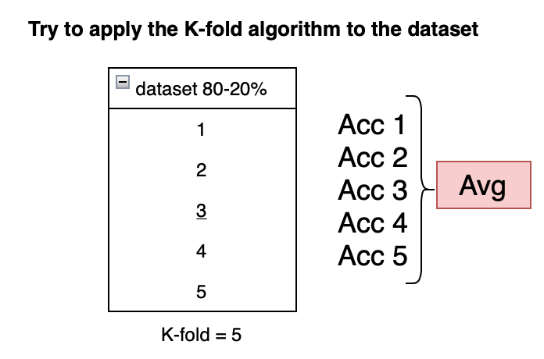

* Consider understanding the Vietnam dataset and its distribution and explain it in the paper.
* Consider improving the model by **merging two models, such as ensemble learning with machine learning and create a new contribution to the paper**.
* Answer the questions about why you have higher or lower results in the models.

You are to research Scie-papers Q1, Q2, and Q3. All your work this year must be a Scie paper.

**Note:**

You are expected to provide at least three science papers; your work quality does not meet any of the requirements for a science paper.

I will give you a guide to start considering the dissertation as well. However, I want you to follow a logical design. You are expected to have ten papers for your PhD defense. However, the first three scie papers Q1, Q2, and Q3, are the most important for your PhD defense.

