**JIRA**

**SOFTWARE SETUP**

|  |  |
| --- | --- |
| Date | 29 OCT 2022 |
| Team ID | PNT2022TMID38709 |
| Project name | Skill Job Recommder Application |

**Team Members**

1. **Ravi Ganesh . B(TL)**
2. **Parthiban . M**
3. **Dinesh Kumar . K**
4. **Srikanth . P**
5. **Vishwa.A**

# ROADMAP

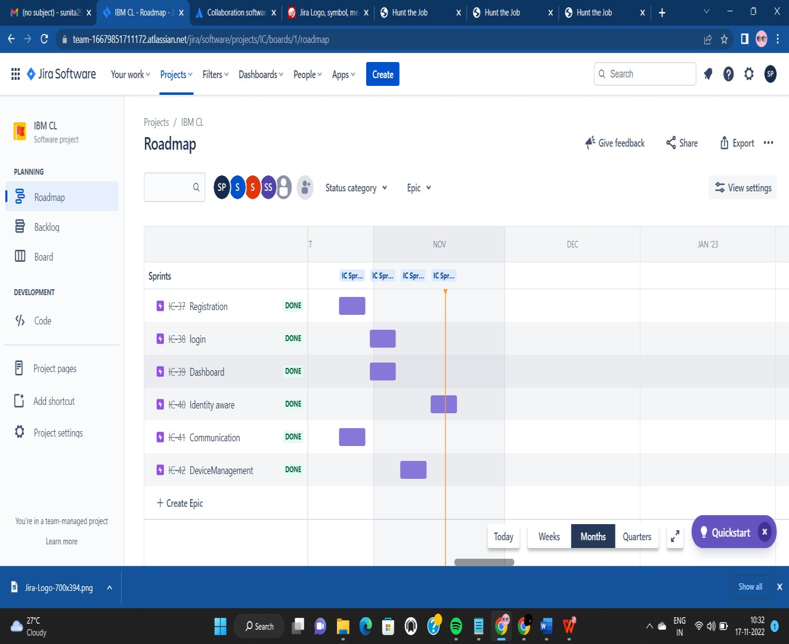

**BACKLOGS**

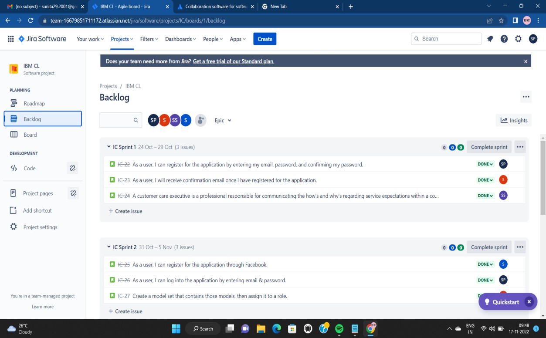

# JIRA-BOARD

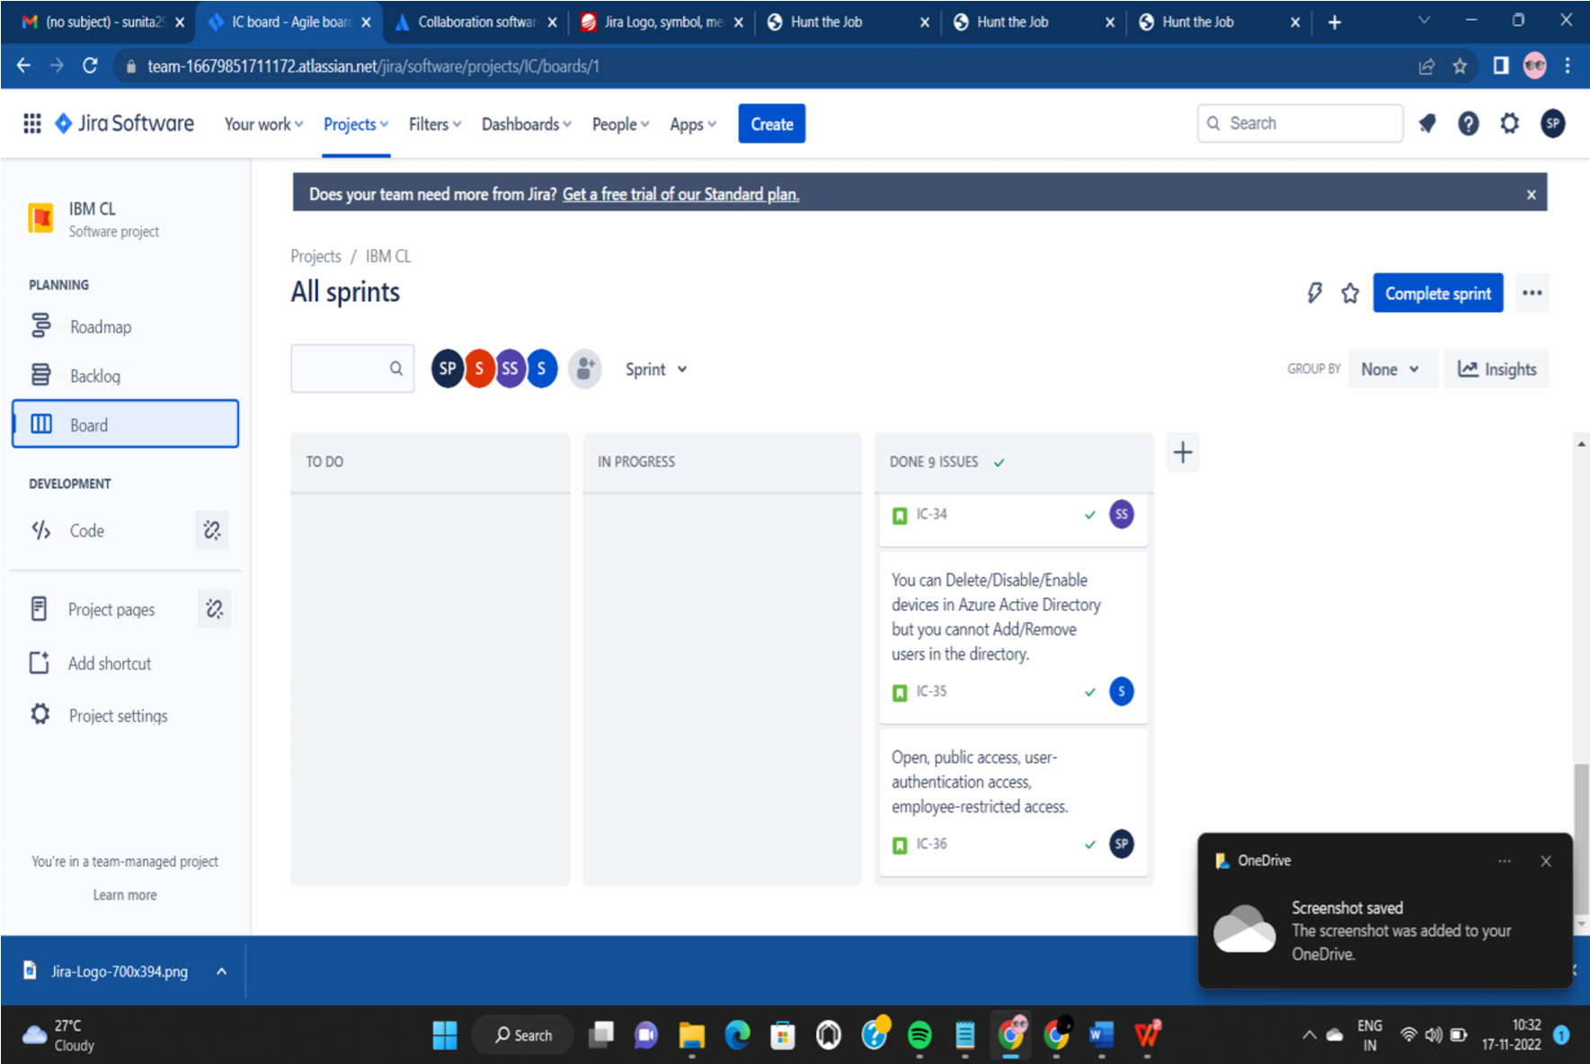

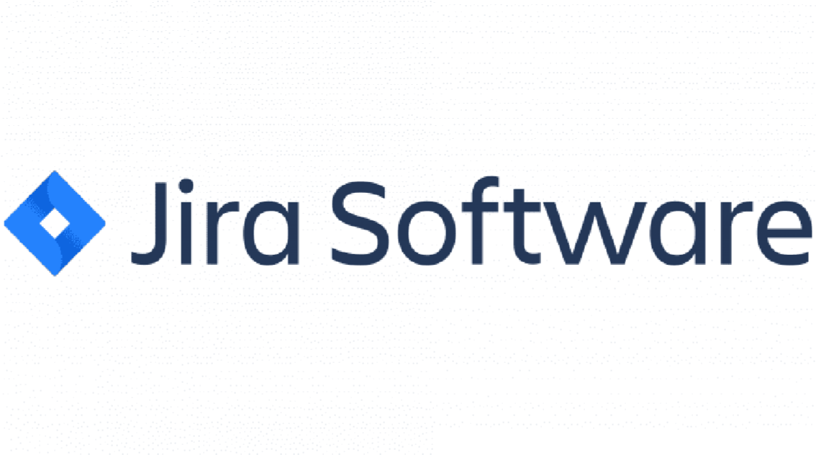

# JIRA SOFTWARE LINK

# https://team-

# 16679851711172 .atlassian.net/jira/software/projects/IC/boar ds/1/roadmap