**Artificial Intelligence**

**Group Members:** Ammar Khan, Abuzar Sultan, Swaiba Imtiaz

**Project:** Hand Digit Recognition using Artificial Neural Network

**Problem Statement**:

The problem that we are going to solve with Artificial Neural Network is of recognizing numeric digits that are hand written. The data set we chose to solve this problem is the **MNIST Handwritten-Digits** data set. The data set contains **60,000** training examples from **250** different writers. It contains 10,000 **test** examples for the model to evaluate it. An example from the data set is given below.

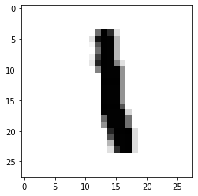

**Methodology**:

The framework used to train ANN is **Keras**. All of the pixels of all images were normalized between the range of 0 and 1. The 2-D image matrices were then transformed to 1-D linear vectors. The classes of 10 digits, i-e from 0-9, were encoded using One Hot Encoding. The model of ANN comprised of one Fully Connected Dense Layer of 10 Neurons with **sigmoid** as activation and one output layer with 10 Neurons with **softmax** as activation. The model was trained with the following hyper parameters:

**optimizer**: RMSprop

**loss function**: binary_crossentropy

**learning rate**= 2e-5

**epochs**: 30

**batch size**: 20

**validation set** : 20%

**Results**:

The model was neither over fitting, nor under fitting as shown in the figure below:

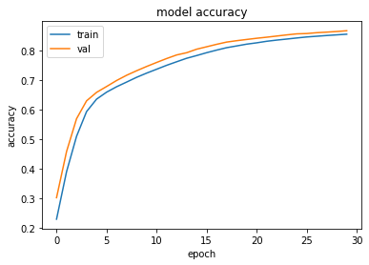

The accuracy of the model for test set was **85.83%,** which is sufficient for a shallow neural network. The snippet is shown below for testing:

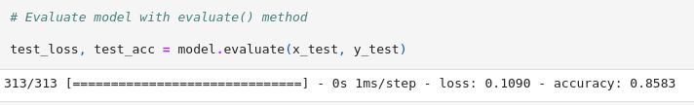

The confusion-matrix for all test set is shown below:

