Final Year Project Report
Project Name:
Cloud-based Recommendation System Based on Personality Identification



Project Advisor:
Ms. Shakra Mehak
shakra.mehak@skt.umt.edu.pk

Submitted By:
Ammar Khan 17010020010 BSCS-10
Mohammad Zafar Haider Butt 160090065003 BSSE-9

Session : Fall,2016 – Fall,2020

University of Management and Technology

Sialkot Pakistan

Dedication

This research is dedicated to my friends in good hope that they don’t have to waste hours and hours of time anymore before actually picking up a movie to watch.

Final Approval

Panel of Examiners

- Head of Department / Area Coordinator ______________________
Department of Computer Science
UMT Sialkot

- Committee Head (Final Year Projects) ______________________
Department of Computer Science
UMT Sialkot

- Supervisor ______________________
Department of Computer Science
UMT Sialkot

- Co-Supervisor ______________________
Department of Computer Science
UMT Sialkot

- UMT Librarian ______________________
Department of Computer Science
UMT Sialkot

Plagiarism Statement

Acknowledgements
We would like to acknowledge our supervisor, Ms. Shakra Mehak, for reducing highly abstract ideas to low-level technical representations, which helped us picture the project end-to-end.

Secondly, we would like to thanks our seniors who provided technical insights to add/remove features, trace bugs and provided highly credible advices.

Thirdly, we would like to thank AWS Ambassadors, from all around the globe, who helped us gather data by actively promoting it in their respective communities, and to all other individuals who participated in this long research.

Thesis Title: Cloud-based Recommendation System Based on Personality Identification

Objective: Provide quality movie recommendations w.r.t Personalities

Undertaken by

Supervised by
Starting Date

Completion Date

Abstract
Recommendation systems powered by massive amount of metadata collected from the items has allowed to categorize items and provide suggestion. However, massive growth of user-base has also created a problem in this regard. It is easy to collect metadata about user activity, but which metadata is suitable to categorize users still remains a problem in this area. Recommendation systems currently used targets features/hash-tags that users like to search about and provide recommendations based on it. The problem is when the dataset increases in size, the recommendations starts to become generalized and still it has no solution for the cold-start problem. This recommendation system categorizes users based on “Big Five Personality Model” and provides recommendation from within its own cluster group. User metadata collected based on these psychometric is backed by years of credible research in the area of Psychology and is effective in making clusters of users based on their own personality type. We collected dataset of 397 unique users along with 3710 ratings using our online portal. We took two approaches to evaluate our model. First technique employed a single ALS Supervised machine learning model that predicted ratings with RMSE of 1.922144121. The second approach employed a top layer with K-Means unsupervised ML algorithm to cluster users and 3 ALS models for each cluster group with RMSEs of 1.8136221989302894, 1.7896245995686275 and 1.7324192559667495. 10 recommendations were generated for each user and were shown on the online portal.
Portal link: https://dwaexczz5f.execute-api.us-east-1.amazonaws.com/production/
Keywords: ALS(Alternate Least Square), RMSE(Root Mean Square Error).

Contents
New paragraphs formatted as Heading 1, Heading 2, and Heading 3 will be added to the table automatically. To update this table of contents in Microsoft Word, put the cursor anywhere in the table and press F9. If you want the table to be easy to maintain, do not change it manually
.
Acknowledgements 4
Abstract 5
Contents 6
Definitions and Acronyms 8
List of Figures 9
- Fig.1 Collaborative filtering Models work flow
- Fig. 1.1 Results
- Fig.2 Work flow diagram of Twit Personality algorithm

List of Tables 10
1 Introduction 11
1.1 Problem Overview 11
1.2 Research Questions 11
1.3 Research Objectives 11
1.4 Scope 11
1.5 Methodology 11
1.6 Significance/ Potential Applications 11
2 Background 12
3 Literature review 13
3.1 Gap Analysis 13
4 Proposed Methodology 14
4.1 Suggested Approach 14
4.2 Workflow of the system 14
4.3 Algorithms/Architecture 14
5 Design and Implementation 15
5.1 System Design 15
5.2 System Implementation 15
5.3 Assumptions/Constraints (Optional) 15
6 Evaluation 16
6.1 Experimentation 16
6.1.1 Experimental Setup 16
6.1.2 Experiments Design/Details 16
6.2 Results 16
6.3 Discussion/Analysis 16
7 Conclusion and Future work 17
8 References/ Bibliography 18
9 Appendix 19
9.1 Glossary of terms 19
9.2 Pre-requisites 19
9.3 Reference/ Source Documents 19

Introduction
In the age of Big Data and Cloud-Computing, where the user base is keep growing and the classifiers to make the algorithms better are becoming more diverse than ever, recommendation systems developed by large stake holders like Amazon and Netflix Google etc. expected what was coming, but not like that. Traditional user-based and item-based algorithms solved these problems in the early age of the e-commerce boom, but one lacked item-similarity and scalability issues and the other lacked diversity issue and growth in one demotion only[1]. But, together both lacked sparsity issue. Item-Based collaborative, developed by Amazon, solved this issue by drawing item-item similarity on one level and then in another matrix kept the user-item interactions and drew recommendations based on similar purchase history[2]. With the advent of smart phones and huge number of people currently present and joining online e-commerce activity, the algorithm designed to processes user-item interactions based on nearest neighbors. The number of neighbors has been vastly increased and this led to another problem of generalized recommendations. The algorithms designed averaged out the results leading to non-personalized recommendations and inability to move to diversity in one’s liked trends, based on the personality of a target user. Keeping in mind that there are resource issues as well in hardware layer. Data has to be clustered in one way or another to reduce matrices so that it doesn’t have to compare results with the whole diverse range of users with no similarities.

Problem Overview:
The algorithms that are available in the market or proposed in research papers addresses similarities between items very well. The user-user are solely mapped based on their interaction with the items. The cold start problem has been solved up to an extent, but still in question, because the recommender systems are not aware of the user-user similarity and hence fail to solve cold start problems[3]. The Big Five personality model provides the most perfect psychometrics to analyze human nature, but none has been aggregated into any recommender system. Second problem is the clustering of the data. As your interaction increases with the recommendation system, the likelihood of the target-user getting non-personalized recommendation increases due to purchase of a lot of common products with the huge number of nearest neighbors. Thirdly, none of the recommendation system incorporates any methodology to identify trends of impulsive buying. Big five models also highlight users with the tendency of being impulsive buyers. Fourthly, you can fine tune algorithms, but in this era of massive requirement of compute power to train, test, deploy machine learning models it becomes harder to rely on old technologies/platforms. Machine Learning models needs to be moved to model-based in-memory machine learning frameworks like Apache Spark and databases needs to be moved to NoSQL solution to support horizontal scaling.
Relying on a single model for complex real-world problem doesn’t necessarily work in real life. This research paper proposes a methodology to group like-minded users into clusters and then generate models for each cluster.

Research Question:
The main focus of the project is to devise a system that can form user-item sub-matrices to introduce clustering which would facilitate scaling and cold start problem. Users will be classified based on Big Five personality traits[4] and will be put into separate clusters based on these classifiers namely;
- Openness
- Consciousness
- Extraversion
- Agreeableness
- Neuroticism
The system is then expected to draw recommendations based on nearest neighbors from within their category to reduce the negative effect of averaging out large sums of neighbors which kills personalization of the content recommended. Item-Item similarities remains the same as per other algorithms. The system is also expected to address diversity of the content, in terms of generalization of recommendation, but by comparing the items similar with other neighbors within their diversity group. This keeps personalization within their diversity group.
After segregating user-base, and then training models for each cluster, the intended ALS Supervised Models have to outperform the single model approach.

Research Objectives:
- Collecting psychometric data to populate Big Five model classifiers.
- Breakdown of user-item matrix based on classifiers from personality model using K-Means Clustering.
- User-Item Collaborative filtering recommendation system using ALS Matrix Factorization Supervised machine learning algorithm for each cluster
- Comparing RMSE for single model vs 3 clustered models.

Scope:
This study focuses on developing a modern day well-clustered hybrid recommendation system that involves machine learning, cloud-computing and psychological researches to provide scalable and personalized recommendation system to address the need to tailor content within the brackets of identified groups.

Methodology:
Datasets available online contains relationship between user-user or item-item or user-item based on purchased history. On the other hand, datasets available for Big Five mostly maps formations of clumps of similar people. To develop own dataset for this research, we will collect user-user psychometrics using questionnaires deigned to populate Big Five model, then clumps will be moved to separate groups. These groups will be asked to pick items from a dummy online store, so that we could map user-item matrices for each cluster. The similarities between products and users will be computed using item-based collaborative filtering as it is most effective to compute trends among users and compute similarities between items[5]. Item-item similarities will be computed offline since they are static in nature. But, the top most filter will remain user-user filtering to make clusters. Target user will then get recommendations based on its own cluster.
Top Layer, K-Means:
It is an Unsupervised Machine learning algorithm that partitions each user by calculating distance from mean of each cluster. The least distance to a cluster gets assigned to the user.
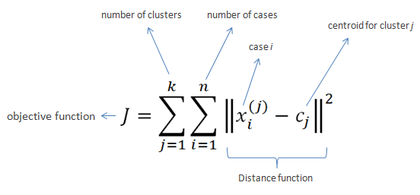

The distance function used in research is Euclidian distance.
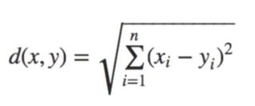
Three Bottom Layers, ALS Matrix Factorization Algorithm:
Alternating Least Square is a parallelized matrix factorization supervised machine learning algorithm that decomposes user-item matrix to users and features matrices. The decomposition of the rank of the matrices helps reduce the dimensionality problem. With the summation of matrices and U transpose F gives us the cost function and it is used to predict ratings of movies with original rating matrix. The errors are given when cost function is computed as RMSE, i.e. Root Mean Square Error, that is the sum of all squared errors. Apart from that, we have rank, iterations and regularization as Hyper-Parameters to tune the model.
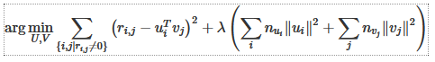

Significance/ Potential Applications:
This accommodates traditional roles of items-based CF and adjust the personalized recommendations to next level by taking human nature into account. Most of the IT firms like Google, Amazon, Netflix absorbs large sum of social media data to capture user interests by basing recommendations based on their posts, searched topics and their friend’s posts. Somehow, they are trying to encompass human nature into item-based CF to tailor content. But, to which extent boundaries needs to be drawn is still under question. This can help boost recommendation system’s ability to aggregate user’s own nature and item similarities to tailor content for movies recommendations.

Background
The domain of recommendation system was expecting a shift in its problem-solving techniques due to lack of knowledge in user profiling methodology. Previously know psychological models where mostly intuitive and lacked empirical data. Big five model provides an empirical way to analyze user and predicts patterns that matches what its traits suggest. Big Five model consists of five dimensions named
Openness:
As the name suggest, people who score high in this trait tend to seek new ideas. It constitutes of 6 sub-traits including active imagination, aesthetic sensitivity, attentiveness to inner feelings, preference to variety and intellectual curiosity. They tend to engage in deep and diverse ideas that are complex in nature. With much broader taste comes a lot of experience.
Conscientiousness:
People who score high in this trait are orderly, duty-full, efficient and aim for achievement. Two major categories for this trait is industriousness, which means being productive and dutifulness tends towards commitment and hard work. It generally predicts strong commitment to ideas that one believes in and structure life accordingly with dedication.
Extraversion:
People who tend to be talkative, outgoing, like being in groups score high in this trait. It detects one’s desire to look for gratification from the outside world. Meanwhile, the introverts tend to be more closed and seek gratification from inside world. Extraverts often describe their life in terms of relationship with other people. The human contact matters a lot and the external stimuli is the driving factor. So, popularity biases, peer suggestions mean a lot just to remain in touch with discussions in their circles.
Agreeableness:
People who are cooperative, kind, sympathetic considerate tend to score more in this trait. They are easy to convince. On the other hand, people who score low in this trait lack empathy, doesn’t agree to things easily and find hard to cooperate in groups. People who are more aggregable find hard to negotiate. On the other hand, people how are less aggregable are often termed as skeptic.
Neuroticism:
People who score high in this trait tend to be less emotionally stable, easily burdened by harsh conditions, moody, self-conscious, shy, frustrated, worried, feel anxiety a lot and are envious. Neuroticism is very controversial, as feelings towards negative emotions are generally much greater in magnitude than the positive emotions. So, its ability to flood the thought process is very likely.

In this project, the scale to measure these traits and sub-traits is International Personality Item Pool – Johnson. It is a shorter version of original 300 questions. This version compromises of 120 question which measures 10 items in each facet. The items in original version with lowest item-correlation were removed. Hence, it is flexible and less time consuming than the original one. The scale was tested using online sample from 21,588 adults and its correlation with the original scale was immensely relative. This scale is being widely used in research for measuring collaborative task performance, personnel selection and psychopathic personality traits. The methodologies regarding to recommendation systems have been discussed within the literature review of different techniques itself.

Literature review

Table: 1
Literature Review of Research Articles
Paper Title | Publishing Year | Methodology | Limitations
Twit Personality: Computing Personality Traits from Tweets using Word embeddings and Supervised Learning [link] | 2018 | Supervised learning model to extract public tweets from test users and trained model provides predictions which were tested against online Big Five personality test. | The model failed to map Neuroticism correctly against the original Big Five online test. Maybe people hide negative emotions from public spheres. Plus, tested dataset contained only 200 unique users.
THE 50/50 RECOMMENDER: A METHOD INCORPORATING PERSONALITY INTO MOVIE RECOMMENDER SYSTEMS [link] | 2018 | Provided a mechanism to adjust Big 5 scores in K-NN algorithm based on 50/50 criteria and compared with traditional K-NN | Assuming 50/50 criteria is good for experimenting but there is no empirical evidence for this ratio. Calculating Big 5 scores and delegating it to overall genre trail score is highly doubtful as it has never been recorded in any research paper. Differentiation based on Big 5 and genre hardly ever yields personalized recommendations. There is no mechanism to detect difference in movies within a genre.
Effects of Personality on Impulsive Buying Behavior: Evidence from a Developing Country [link] | 2018 | Using the original tested theories of Big Five and traits contributing positively and negatively to Impulsive buying was check in Pakistan. | The research doesn’t distinguish between intrinsic vs extrinsic factors to well establish relationship between Big Five traits for further elaboration.
Social Collaborative Filtering by Trust [link] | 2017 | Trustor-Trustee relation along with time decay to establish relationship between users in CF | Model tried to solve cold-start and sparsity problem by drawing continuous relation between user and its trusted group and its progression across time. But, sparsity degenerates into lower levels of Trust matrices which becomes even harder to remove.
The Big Five, Happiness, and Shopping [link] | 2016 | Establishes canonical relationship between Big Five and happiness, Happiness and Shopping and Big Five and Shopping. | Neuroticism was found related inversely to happiness and directly to Shopping may be due to human nature.
Hybrid User-Item Based Collaborative Filtering [link] | 2015 | Item-item CF to resolve items similarity. On top of that is the user-user SOM optimized with GA to classify users into clusters. Sparsity is solved using CBR and averaging filter. | CBR in collaboration with GA is designed to create clusters of equal size. But, human nature, based on Big Five, doesn’t suggests cluster-formation of equal demotions. Clusters should be scaled individually, rather than carving forced equal clusters.
Does Personality Affect Compulsive Buying? An Application of the Big Five Personality Model [link] | 2012 | Test model opted from Ridgway to test behavior of compulsive behavior and impulse-control with Big Five model. The relationship is then established between compulsive vs non-compulsive buyers | Study conducted was based on shopping experience. It didn’t include online shopping trends. It also didn’t focus on particular category or context of items.
Matrix factorization techniques for recommender systems [link] | 2009 | Introduced the world of CF to SVD technique to generated movie recommendations based on ratings. Introduced popularity decay factor, feedback mechanism (implicit and explicit). Categorized content by introducing feature dimensions. | Although being widely successful, the system does inherit the use of feedback mechanism to learn about the user, but providing an error correction function to adjust for biases and introducing averaging function for recommendation comparison with other users seems a bit of stretch to compensate for the unknown nature of users.
Amazon.com Recommendations: Item-to-Item Collaborative Filtering [link] | 2003 | Tested traditional recommendation systems against Amazon’s item-item purchase model of amazon’s recommendation system using different training/test sets ratios and neighbor inclusion variables. | Susceptible to cold-start problem and data sparsity. Users with long purchase history starts to get generalized recommendations. Doesn’t scales well with modern time needs.
Item-Based Collaborative Filtering Recommendation Algorithms [link] | 2001 | Item-based CF  User-based CF | User-based CF is becoming troublesome due to sparsity, and also gets affected with large number of neighbors. Item-based scales well still no resolution to sparsity and cold-start problem.

Item-Based Collaborative Filtering Recommendation Algorithms:
Collaborative filtering populates user-item matrix. It finds your potential neighbors and makes recommendations based on common factors[6]. It generally doesn't scale well with the increase in the number of nearest neighbors. Secondly, users with long history of usage with the system makes it difficult for the system to recommend particular items considering large sets of interests[3]. It is good to suggest diverse items, but the other drawback is that it mostly provides recommendations for “Hot Items” and new items gets ignored.
Content-Based Filtering finds similarities between items and then recommends items to users that are similar to their search. It scales well as the relation remains static between items across time, for most of the cases. Model does solve inclusiveness of the “New Items” into recommendations, but lacks identifying possible interests of a user beside its own previously known searched interests.
Clustering can solve this problem but, Content-Based Filtering finds no clusters(commonalities) among users to enhance vision of the system. Collaborative filtering finds clusters among users but the size of users among a cluster becomes so massive that it becomes harder to scale and reduces the speed and accuracy of the system.

Hybrid User-Item Based Collaborative Filtering:
This research paper proposed a model that accommodates the aspects of both user-user collaborative filtering and item-item collaborative filtering by proposing a hybrid model while keeping scalability and data sparsity in the model[7]. The model proposed was user-item based collaborative filtering. Data sparsity is held in check by using Case Based Reasoning (CBR) and average filling. Scalability is addressed using Self-Organizing Map (SOM) optimized with Genetic Algorithms (GA)[8]. The system checks for both user similarities and items similarities. The working is defined as
“At the time of recommendation, for a target user, the closest cluster is first identified for the user, then the traditional item-based CF is performed within the respective cluster.”
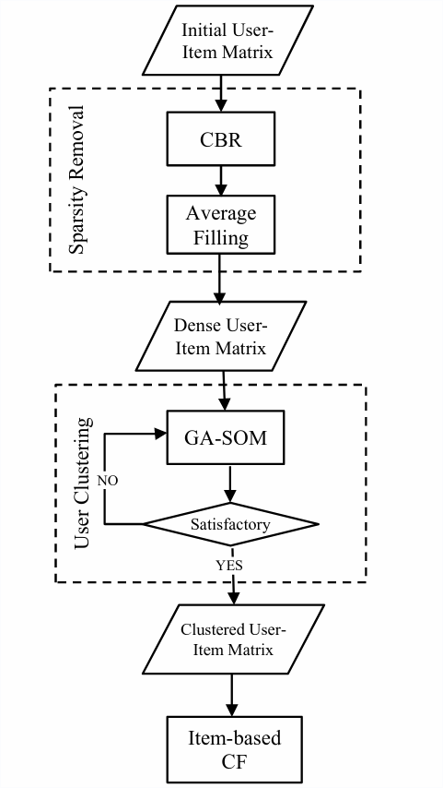
Fig.1 Collaborative filtering Models work flow
To address sparsity, CBR is first used and then average filling was introduced to deal with vacant cells based on the assumption that similar users have similar taste. Individual ratings are checked against users that rated similar to target user based on Euclidean distance. To generate recommendations on the fly, a sorted list of top K similar users is returned based on the similarity scores between K neighbors.

After removing null entries, similar users are separated based on user rating similarities and then grouped together using unsupervised neural network algorithm SOM. But, this research averted the formation of clusters by introducing GA-SOM which made results to be trustworthy until the cluster sizes were similar.
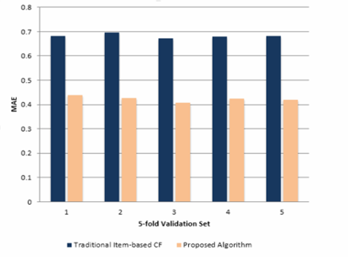
Fig. 1.1 Results

Does Personality Affect Compulsive Buying? An Application of the Big Five Personality Model:
This research papers gears towards solving the problem of the relationship between compulsive buying and the personality of an individual using the factors causing the compulsive buying vs the psychometrics collected through Big Five personality model[9]. This model was selected to map the relationship between the mood, social metrics, stimuli versus the psychometrics of the Big Five. The previous tests to check compulsive buying behavior were based on relationship of the items they need versus the income of the individual. The major flaw with this method was most of the impulsive buyers may not be flagged in this category due to their high income. The test model opted for this model was based on 6-item scale developed by Ridgway which measures the characteristics of obsessive-compulsive behavior and impulse-control. Test differentiates between compulsive buyers and non-compulsive buyers based on psychometrics.
Table.2 Results of impulsive buying according to big five personality traits
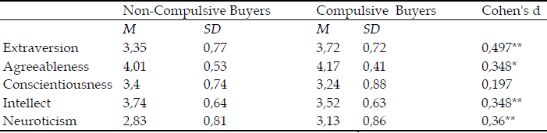
Out of 1522 test subjects, 93 of them were classified as compulsive buyers. The trend was more positive in young crowd. This study also suggests that most of the women rated higher in Neuroticism, hence more of them were classified as impulsive buyers. Hence, this study well establishes impulsive buying behavior using Big Five personality model.

Effects of Personality on Impulsive Buying Behavior: Evidence from a Developing Country:
Impulsive buying is categorized as buying that happened with little or no deep thinking. Impulsive buying is most likely to be the reaction of an external stimuli. Impulsive buying can also be triggered my certain moods and emotions and sometimes to coupe with negative emotions. Developing countries like Pakistan consists of 52% of Millennials as a part of their population. Millennials enjoy social networking more than other generations. This brings opportunities for businesses to provide means to enhance impulsive buying to attract more business. This is done via providing promotions, convincing by marketers and writing online blogs. Psychometrics provided by “Big Five” model suggests that people who score high in “Openness” are enjoys new ideas are of entrepreneurial type. Hence, they are more prone towards impulsive buying behavior. “Conscientiousness” refers to commitment to a structure and self-control. People who score high in this trait are less likely to engage in impulsive buying. “Extraversion” refers to one’s preference of formation of large social groups vs very few or none. Extraverts likes to socialize and engage in dialogues and are generally assertive in nature. The stimulus is mostly social. They have low self-control and tend to explore new things. So, those who score high in this trait have a positive effect on impulsive buying behavior. Neuroticism” refers to the negative emotions that one suffers and those who rank high in this trait are more likely to get offended really easily, and they are more self-conscious about themselves due to depression caused by negative emotions. So, impulsive buying acts as a temporary mechanism for them to relieve stress on short term basis, hence a positive coefficient for impulsive buying behavior. This study is based on responses from 400 people, out of which 381 responses were complete. 68% of the participants were female and 32% were males. In terms of age groups, 50% of individuals were between 20-25, 9% of the individuals were between 25-30 and 11% of the individuals were between 35%-40%. The result shows only 9.6% variance from the standard deviation. Hence, it confirms the original hypotheses except consciousness was rated positive for impulsive buying as per the results of the test.

Twit Personality: Computing Personality Traits from Tweets using Word embeddings and Supervised Learning:
The research paper proposed a model to extract Big Five personality traits from the public tweets from a dataset using a supervised machine learning model[10]. The outputs are checked against the trained model from Facebook Status Updates. The methodology proposed takes tweets into the account, generates tokens and forms word vectors using syntactical analysis and classifies the context. The classifiers then map the outcomes to Big five personality traits.
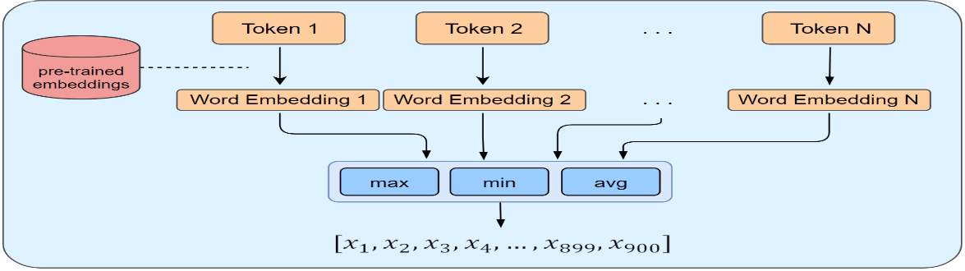
Fig.2 work flow diagram of Twit Personality algorithm
These obtained classifiers for Big Five model were then compared against the Big Five personality test questionnaire, that the user from the dataset were also asked to take. The mean deviation between 4 traits was 6.4%, but neuroticism couldn’t be mapped accurately between these two systems with a deviation of 33%.

Amazon.com Recommendations: Item-to-Item Collaborative Filtering:
According to Amazon’s Recommendation Model they have used some Models for recommendation system like: Clustering, Dimensional Reduction and Item-to-Item Collaborative Filtering Model[2]. They use recommendation algorithms to personalize the online store for each customer. The store radically changes based on customer interests, showing programming titles to a software engineer and baby toys to a new mother. The algorithm aggregates items from these similar customers, eliminates items the user has already purchased or rated, and recommends the remaining items to the user. Two popular versions of these algorithms are collaborative filtering and cluster models. Other algorithms including search-based methods and their own item-to-item collaborative filtering focus on finding similar items, not similar customers. For each of the user’s purchased and rated items, the algorithm attempts to find similar items. It then aggregates the similar items and recommends them.
In that item-to-item collaborative filtering provides Scalability that it creates the expensive similar items table offline, the algorithm is fast even for extremely large data sets because the algorithm recommends highly correlated similar items that’s why recommendation quality is excellent. As compared to collaborative filtering, because in collaborative filtering the algorithm perform well in limited user data to get high quality recommendations.
On the upper user-based level, the classification is done based on purchased history. This still remains a classification problem on how to group users. Amazon groups users based on similar purchase history. But, it doesn’t help solve sparsity and diversity problem as most of the items bought remains similar largely if the neighbors grouping data is huge and will provide non-personalized recommendations.
The downside to item-based collaborative filtering is that it cannot solve sparsity problem and doesn’t scales well with huge number of neighbors. This problem is currently prevailing in recommendation systems that are extremely popular.

Social Collaborative Filtering by Trust:
This research proposes a relationship between trustor and trustee in collaborative filtering which will help solve data sparsity problem by employing rating samples of similar users and building a social trust network as they propagate in time[5]. Users build trust nets based on the opinions of other users on a specific item. The item-specific matrix shows how the ratings of new users affect the weight of the matrix and then adjusts it balance towards social trust network. The proposed objective function minimizes the matrix by computing number of ratings given by users to an item and catches the number of users that built trust in similar items. This computation catches how the opinions of a user can affect the recommendations for another user in time. It will tailor recommendations for others as recommendations are being tailored for him across time. One important note, time is also used as a factor to build trustor-trustee to keep the recommendations up to date and tailored for users. The test results are better than tradition CF based algorithms, but it doesn’t work well with diversity issue as it tends to form n(item) x m(ratings) x a(relationships-time) matrices to define Trust Model[11], but vacant cells degenerates into relationship matrices which becomes more troublesome to deal in future.

The Big Five, Happiness, and Shopping:
This research points the impact of Big Five personality traits on shopping motivations and differences between sex based on shopping trends mapped under personality classification. The tests conducted employed canonical relationships between variable sets from each individual and map their clusters. 74-item questionnaire was made available to 575 people in Iran (keeping diversity in mind). The data was analyzed using SPSS version 21 to measure bivariate correlations, means, and standard deviations. The analyses concluded that higher extraversion, agreeableness, consciousness and openness with high utilitarian values, but neuroticism contributed inversely to utilitarian values but positively to compulsive and impulsive buying. Secondly, canonical relationship defined that higher extraversion and neuroticism contributes positively to hedonic values but it has an opposite effect as compared to openness. Thirdly, extraversion contributed negatively to compulsive buying and positively to impulsive buying. Utilitarian shopping values were confirmed from this test. Additionally, the provided insights on sex differences and indicated that males scored more on openness and consciousness and females scored more on neuroticism. It makes males geared more towards compulsive buying and females more towards impulsive buying.

THE 50/50 RECOMMENDER: A METHOD INCORPORATING PERSONALITY INTO MOVIE RECOMMENDER SYSTEMS:
The research paper presents an interesting way of adjusting personality scores into the recommendation system[12]. The users were asked to take the Big 5 personality test and the system calculates the scores[13]. The participants were also asked to rate the movies. The system plots a genre-trait table for each user. The difference in user score and each genre scores is calculated. The lower the value, the preferred the genre is. The predicted rating, based on traditional K-NN, and user calculated scores, based on big five, are then added before being divided by 2. A predicted rating table is then parsed by the system using this process. The lower the value, the higher the resemblance.

Matrix Factorization techniques for recommender systems:
The recommendation system algorithm developed by AT&T team is still the most widely discussed and appreciated system[14]. The algorithm beat the tradition CF based algorithms and provided new insights on how to categorize, adjust, error-correct, average user ratings and then plot them into user-item matrix. The system also profiles movies by extracting features and raking them against user dimensions. The dimensions maps which set of movie features maps for which users. The system relies on feedback that constantly checks for users’ preferences not only based on months, but on daily usage. It also introduced a feature to calculate how much the movie is relevant in present days, to adjust for the popularity spikes in term of an event. It is now known as time-decay feature. The SVD has two dimensions, user is one and the item interaction is other. The system plots, using the previous rating and correcting the user biases based on feedback loop, probabilistic ratings for the movies to be liked by the user. If the user rate the movie as it was generated previously by the movie, the loop doesn’t change anything. If the user rating varies from the system generated rating, the system has an error correction mechanism to accommodate and adjust other ratings.

Proposed Methodology

Suggested Approach:
Recommendation engines ingest data and provides meaningful insights on what a user might like, which is based on user’s history with it. Most of them are restricted to this approach. Amazon’s context-based collaborative filtering solved this to an extent by grouping people with similar history together. Netflix solved it by creating two sets of multi demotions between items, i-e movies, and user, but the projections made are solely based on similar rating from different users. How the users are grouped together is done by averaging and error correction functions to keep the ratings aligned and make grouped data less distorted for each other biases. On the contrary, human nature is a lot more complex. Further studies do provide some insights on how to structure the problem of two fields, at least in sense making.
Based on the ratings collected from our online portal, we clustered the users according to dimensions, EXT/AGG/NEU/OPN/CON and partitioned them to 3 clusters using k-means. ALS was trained on three different datasets and three models were trained.

Workflow of the system
To grip the problem at hand, a corelated data of user personality type is required and how it maps on the movie selection. Then we will be able to draw final conclusions. The system for this project is designed to test following hypotheses:
- Users with higher score in Openness should be interested in broader set of genres.
- Users with higher score in Conscientiousness should have a structured pattern of genre selection with near to constant time decay.
- Users with higher score in Extraversion should have lower value of time decay.
- Users with higher score in Agreeableness should have movies ranking higher than average users.
- Users with higher score in Neuroticism should have flexible time decay.
- Big 5 traits should work in conjunction, as it is already being researched in the field of Psychology.
- ALS models should be able to map movies based on users defined by their respective clusters.
Hybrid Content-Based CF algorithm will plot user-rating matrix. But, each cluster will be formed using K-means Clustering algorithm by calculating distance between psychometric scores of users. Each cluster shall reflect the pattern describe in the above hypotheses. This will reflect that we can use Big 5 model as a way to divide userbase psychologically.
The workflow for users to interact with system is as follow:

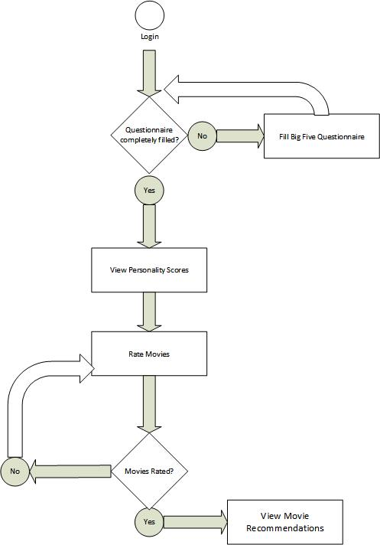
Fig. 3 User Work Flow

Algorithms/Architecture
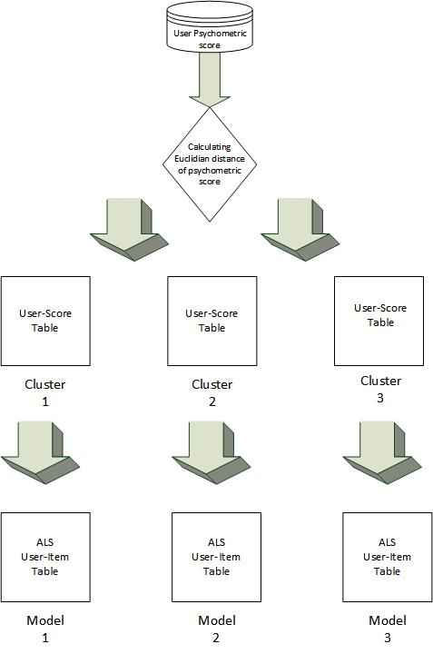
Fig.4 ML Models
After the completion of user process, the system will fetch user psychometric scores from the database and put them into appropriate clusters using K-Means. Each cluster will have a respective ALS Model trained on this group’s user-item data.

Design and Implementation

System Design
The system is designed with bleeding-edge toolchain for machine learning, infrastructure, software appliances, because you can have a lot of issues with the system even the tradeoffs in the algorithms are removed.

Performance:
The project is hosted on AWS. It employs Serverless modules that are by far the best solution for price/performance in the market with maximum uptime. The modules include AWS S3 in conjunction with AWS CloudFront to deliver static web content like HTML, CSS, JS and media content. The dynamic interaction with the system is made possible by JS embedded in the system that will call Flask API deployed on AWS API Gateway. The nature of pages is kept in a way to deliver it maximumly through CloudFront and only tasks are routed to API Gateway like login, signup, rating etc. AWS Lambda is used by API Gateway when an event is triggered like, validating user, registering user, fetching recommendations. The modular design enhances the performance of the system as each component is broken down to do its individual task only. The database used is AWS DynamoDB, which is by far the best NoSQL solution out in the market. Unlike SQL solutions, it maximizes on indexing attributes and distributing partitions physically to distribute workloads. Apache Spark is used to train/test model which is an in-memory clustering tool and MLlib provided K-means and ALS algorithm. The serverless model also provides avoidance of keeping sessions. Sessions are hard to keep track of in a distributed environment. So, Custom JWT serverless solution was used to validate requests. API Gateway with JWT generation/validation so that infrastructure, if scaled horizontally/vertically shall not have to worry about session tracking of a particular user. ALS is one of the fastest supervised ML algorithm due to its nature of decomposing large matrices to smaller ranked matrices.

Robustness:
Instead of deploying a monolith, serverless model is used so that each workload is broken down to its use case to enhance robustness of the system. Most of the tasks are performed by AWS Lambda. Each lambda function has a specific task defined that it gets from the API request. API Gateway, Spark, CloudFront and S3 itself are self-healing services. S3, DynamoDB keeps three copies of the data on physically separated locations. If an endpoint fails, the requests are routed to other endpoints. For Spark, if an underlying slave instance fails, that instance is dropped.

Interactivity:
The user to system interaction is kept simple by employing minimal front-end logic. Users are only required to sign up, login, fill the questionnaire, and rate movies. Once the model is generated, the new registered users will only have to register, login and fill questionnaire. Recommendations will be generated for them automatically.

Flexibility:
Each endpoint/service is accessed through an API. API makes it easy for users/systems to make requests to users in a defined pattern. If the underlying system goes in state/working change, the API should not undergo changes. This provides uniform access along with ability to change underlying services.

Portability and Re-usability:
The whole system is provided as IaC. IaC makes it easy to make the system programable. With programmability comes the ability to replicate. IaC will provision each resource from the source code for you. Hence, it can be replicated/modified as per code.

Security:
Static content like HTML, CSS, JS and media is kept private in the S3 bucket. The S3 bucket itself is private and the ACL keeps individual objects locked. Only root account can modify/delete/read/write directly from the bucket. Objects are readable from AWS CloudFront Distribution by an AWS service role, which allows S3 to be private and objects to be read from CloudFront only. API Gateway authorize users via AWS Cognito which generates JWT for the registered users requesting the service. The JWTs expires after a timeout. JWTs are embedded in cookies and if it changes, the AWS Cognito expires the JWT associated with user and makes the request nullified. DynamoDB itself can only be call via Lambda which requires a service role. Otherwise, database cannot be reached. To invoke a lambda function that calls DynamoDB, a service role for lambda and event trigger needs to be registered. To protect Spark EC2 instance, it is launched in a private subnet and given a service role to itself and other services to talk to each other. By not assigning a public IP, it cannot be accessed from outside world. Security groups and firewalls are also associated with the Spark and Ec2 instance to protect it from intrusions when it goes online for updates. Only Jupyter portal ports are exposed along with http protocol for ingress connections when going online. Only API Gateway and CloudFront are publicly accessible.

Interface Design:
Index Page
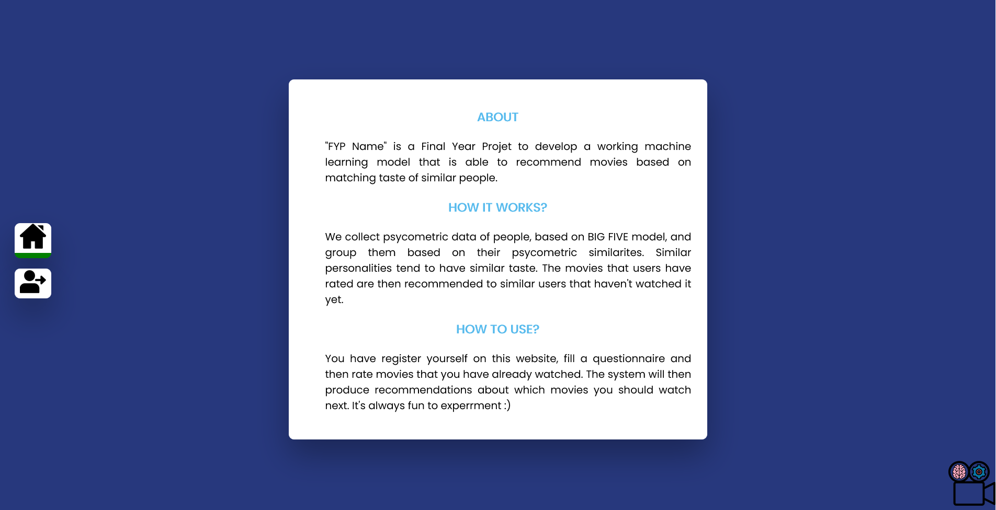
Signup Page
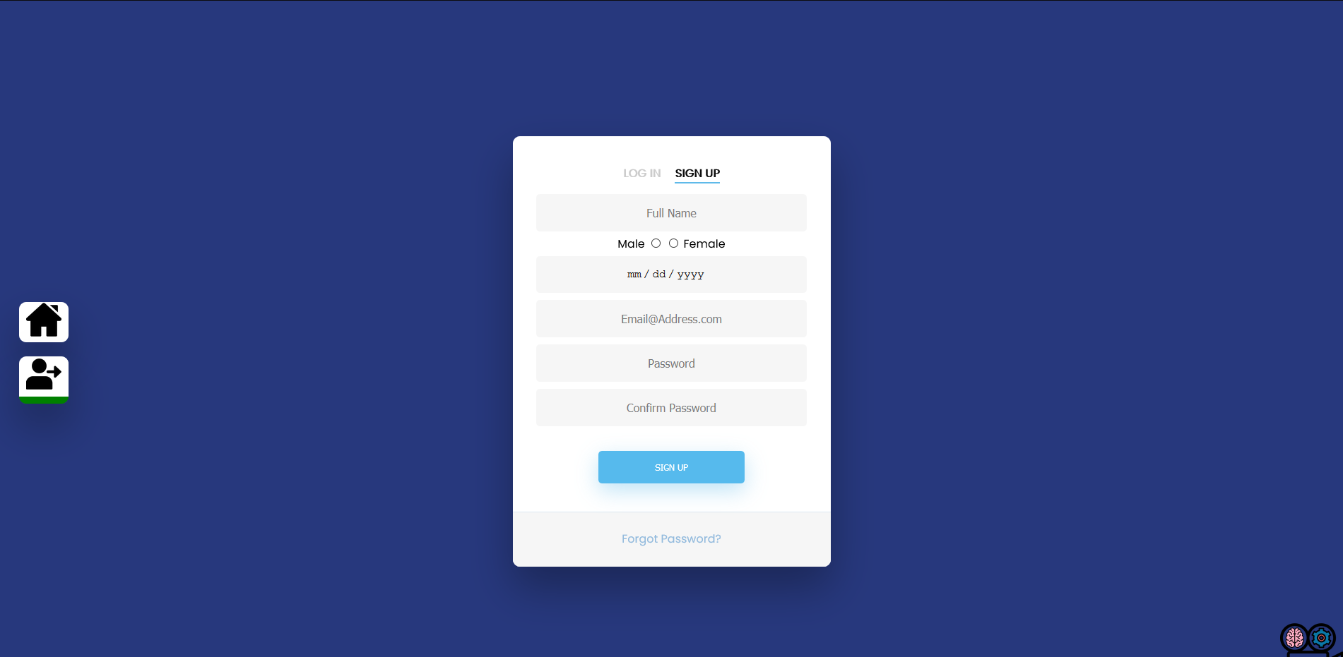
Login Page
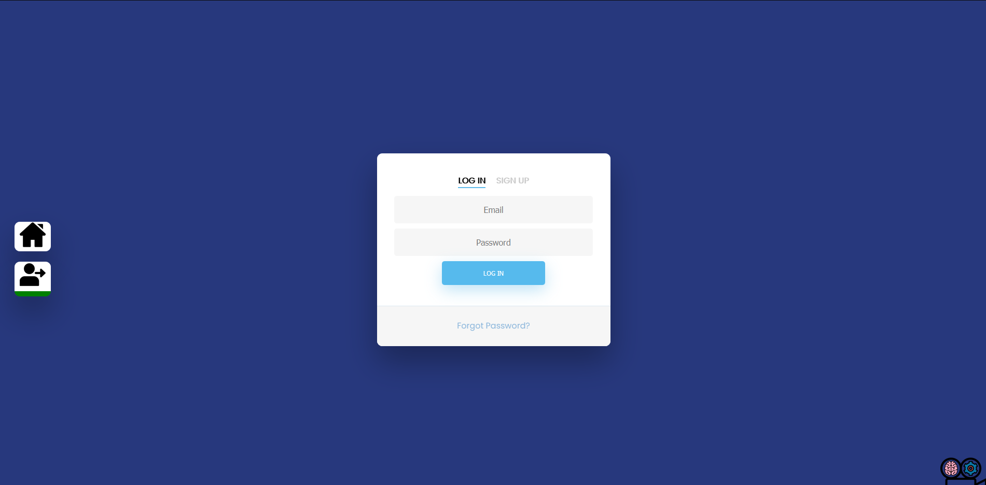
Questionnaire Page
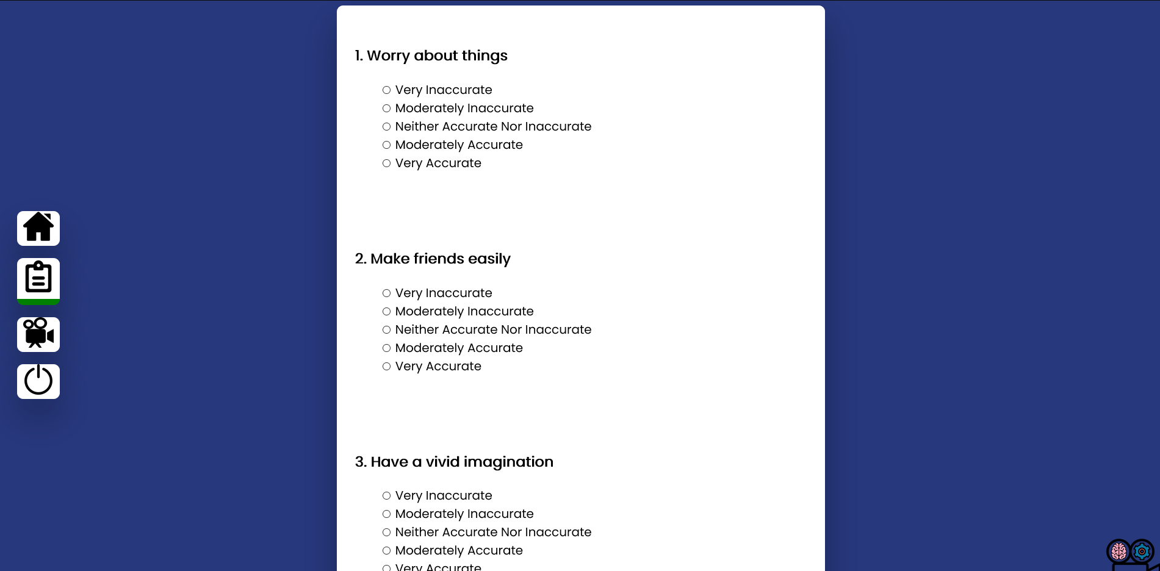

Movie Search Page
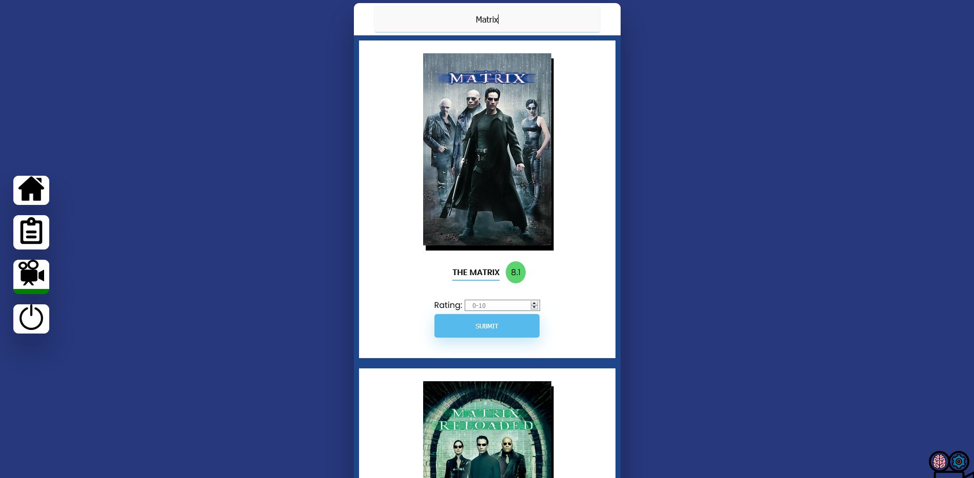

Recommendations Page (10)
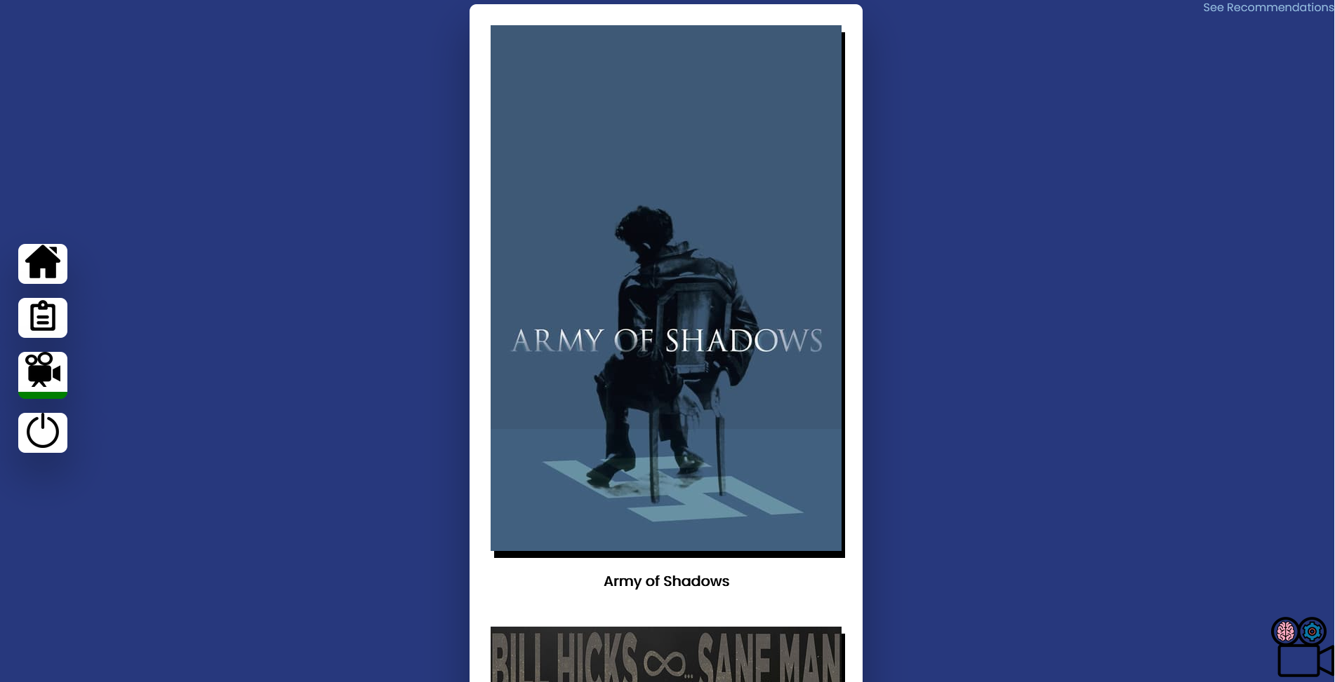

Logout Page
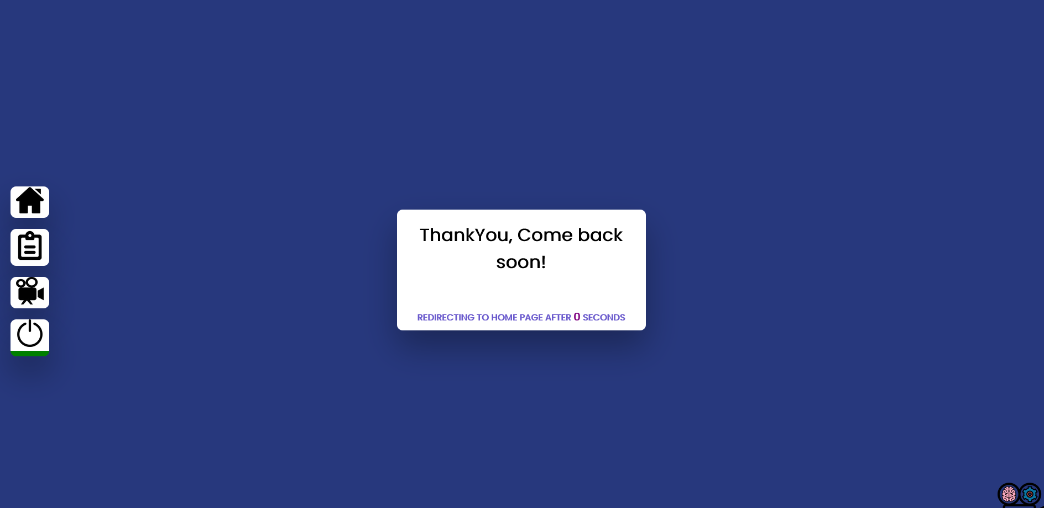

Architecture Design and UML:
As per diagram below, User will make request to CDN URL to fetch static content. JS makes the pages dynamic. HTML forms are used to login/register/fill questionnaires. Lambda functions are triggered to save these responses in DynamoDB. JS is used to call OMDB API to fetch movie search results. Movies rated are then submitted by JS API call method to API Gateway Endpoint. Request is validated and a Lambda function is triggered that puts the data in DynamoDB. Once the model is in training phase, Spark will fetch training data from DynamoDB and trained model is deployed in cluster mode. JS API Caller can then be able to call API Gateway which can then invoke Lambda function for Spark and get recommendations.
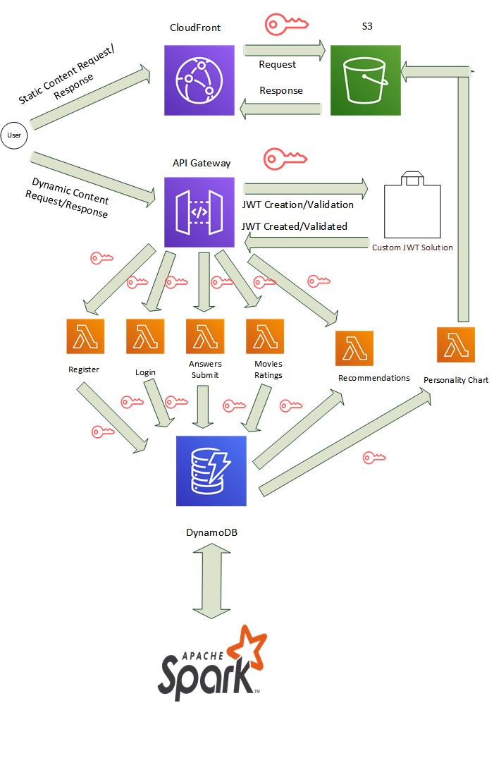Fig. 5 System Architecture

Dynamo DB Sample Design:
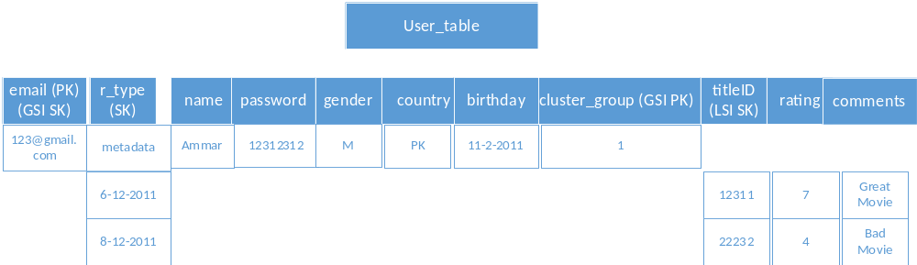

System Implementation
Following tools and technologies are used and their use case has been defined below in sequential access order:
AWS CloudFront:
Used to distribute S3 content. A URL is generated for each object. User can access website through index.html URL provided by CloudFront Distribution.
AWS S3:
Used to host static content for HTML, CSS, JS and media files.
AWS API Gateway:
Pip3 Flask environment deployed in API Gateway. It provides a front-end to use underlying services like DynamoDB, Spark. Users can access API to do following jobs:
- Register account
- Login
- Send filled questionnaire
- Search and rate movies
- Get recommendations

AWS Lambda:
Each API call triggers a Lambda function. Each lambda functions performs a specific job as listed in API access pattern.
AWS DynamoDB:
NoSQL JSON database that holds user metadata and movie data. Table contains:
- Email as Partition Key
- R_type as Sort Key
R_type can be metadata and date patterns. Metadata holds following attributes:
- Name
- Country
- Gender
- Password
- Birthday
- Cluster_group
Date pattern (eg,11-2-2011) holds the following attributes:
- titleID
- rating
- comments
Scores pattern holds the following attributes:
- EXT
- AGG
- NEU
- OPN
- CON
REC pattern holds the following attributes:
- 10_rec_list
Table also has LSI and GSI. LSI for table uses “email” as partition key and sort key is “titleID” and the projected attributes are “rating” and “comments”. For GSI table, “cluster_group” is used as partition key and “email” is used as sort key. Database access patterns are:
- Use email partition key only to get complete user record.
- Use email partition key and sort key to get user metadata or specific date record.
- Use email as partition key and titleID to get title and its rating and comments for specific user (LSI).
- Use cluster_group as partition key to get complete record of all users in a given cluster.
- Use cluster_group as partition key and email as sort key to get specific user from a cluster.
Apache Spark:
Spark is a massive parallel in-memory data processing engine which comes with enriched data frames features, an OLAP database, and a dense Machine Learning library to do lightening fast computations on datasets.

Assumptions/Constraints
The limit to this approach can be checked by training a single ALS model with complete dataset and then compare it with labeled 3 clustered datasets. One of the hurdles is ALS relies on ratings. The more the ratings, the better it will be able to recommend. But, it defaults to popularity if there are no or less ratings. Hopefully, clustering will solve this problem. Secondly, items that haven’t been rated enough or not rated completely would still never be recommended. This is a hard limit to this problem.

EVALUATION

Experimentation:
To evaluate the experiment, we collected our dataset for 397 unique users which provides users ratings response along with the psychometrics scores with the help of our online portal which allows the users to fill in the questionnaire and after that fill in the movie’s ratings that he/she has already watched. This experiment is going to be time consuming, so for the ease of the users, we have kept the design minimal and provided the fastest possible access patterns in terms of GUI design and backend access patterns. The user’s ratings collected were 3710. Null entries were never entered into the database from the beginning.

Experimental Setup:
We have kept the whole portal accessible via internet to maximize our reach. A web portal that will allow users to Signup -> Login -> Fill Questionnaire -> Rate Movies. With Spark, results were ingested into Data frames and transformed for K-Means, then labeled, and fed to its respective model.

Experiment Design/Details:

Signup Procedure:
Signup procedure is designed in a way to get all the required classifiers that are crucial for generating high quality clusters. Although fields like “Full Name” and “Password/Confirm Password” serve only the purpose of authentication/authorization, but fields like “Gender” and “Birthdate” defines a lot of segregation based on psychological factors. Most of the females are not interested in action movies and most of males are not interested in long format romantic movies. So, clusters need to be well aware of these differences. Moreover, likes/dislikes/interests are also based on the age of the users. From birthdate, we can calculate the age of the users and also keep it updating using current time to check the progress of interests and possible recommendations to new suspected interests based on age.

Questionnaire:
Questionnaire itself contains 120 items, taken from (John Johnson ,2014). Each question has 5 options to provide a specific response to the said statement. Each statement measures a score for a specific trait. Each trait has 24 questions. In order to eliminate biases for speedy filling, the questionnaire is built in such a way that all the questions are mixed up so that no trait gets consecutive statement representation. Moreover, each trait also has reverse polarity statements so that users could be checked for responses that doesn’t fall into bias and provide a different approach to a required trait scoring technique.

Movie Review:
Movie review page is linked with TMDB API to fetch search results for a specific string. The system presents match cases to users in a long tile format. We have avoided multiple small tiles and opted for large vertical tiles for two possible use cases. First one is to accommodate all the functionality in a good view space to users like movie title, community rating, your rating box and a submit button and secondly, movies that have sequels can be represented vertically and user can rate them in a single search procedure.

Recommendation System:
Once the dataset is collected from Dynamo DB, that records where transformed in the form that are understandable by K-Means. Example from dataset is given below.

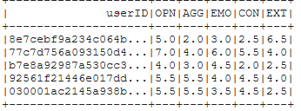
Fig.6 Data Set
After that, we calculated variance and mean of the dataset to check how much far apart the values are and what is the average value of the dataset.
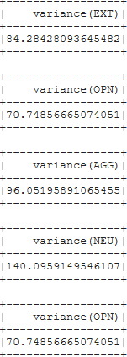
Variance Mean of Data Set
Fig.7 Variance Mean of Data Set

After that, we transformed dataset to get user-item combined matrix for ALS comparison model. The example is shown below.
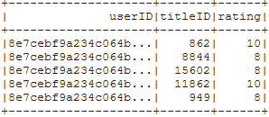
Fig. 8
The K-Means unsupervised model was checked from k = 2 to k = 6 and it yielded following results.

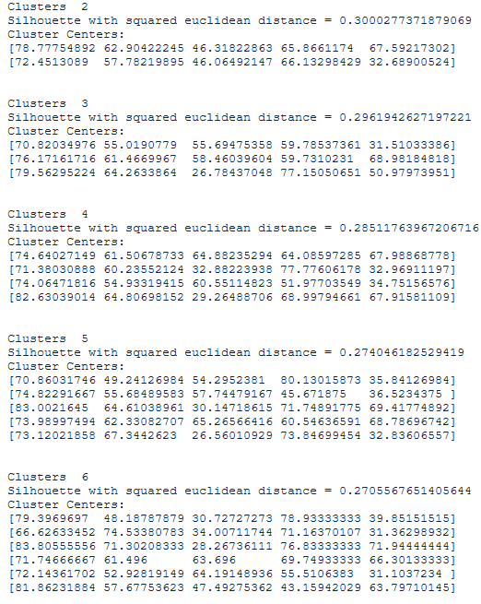
Fig. 9
The best case was k = 3 as it has good error rate and notice that it is providing segregation based on three traits. i-e OPN, NEU and CON. We could have gone for a bigger value of K but the it will shrink rating datasets for underlying ALS models as we have to increase number of models and split datasets according to cluster number.

For ALS, three datasets were prepared based on three different clusters just like ALS comparison model, but users are divided into 3 datasets based on cluster group label. ALS base model was trained on 5 different iterations. Each iteration containing different values of hyper-parameters. Lists shown below contains [rank, iterations, regularization constant]
We plotted the calculated RMSE for combined model for different values of hyper-parameters and plotted them.
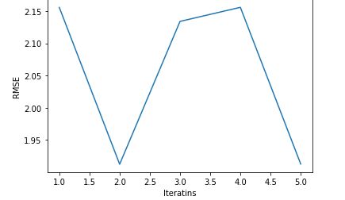
The lowest RMSE was 1.922144121 at [5,25,0.001] on combined model. Then we partitioned the datasets, per cluster base, and trained our 3 models using the same values of regularization, iteration, but we lowered value for the rank of the matrices to 5, to better fit our model.

Results
K-Means cluster was trained on k = 3 and the error was negligible, which means good segregation pointer. The centers and error are shown below
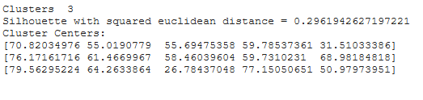
The 3 ALS models yielded the following RMSE
ALS MODEL for Cluster | RMSE
Model 1 | 1.8136221989302894
Model 2 | 1.7896245995686275
Model 3 | 1.7324192559667495

Each model has reduced error then the combined ALS model. Plus, if the model defaults to most popular items, cold-start problem, it will still be from their personality group.

Discussion/Analysis
The part with ALS training was the most difficult one. The RMSE was reduced by introducing clusters. The comparison of RMSE of all clusters is still lesser than the main model and it has reduced effect of popularity biases in term of generalization. The noticeable fact is the best segregation based on clustering we got was on Openness and Neuroticism. People high in openness watched Sci-Fi, Comedy, Documentary movies a lot and people high in Neuroticism watched Romance and Long Story movies a lot. So, even if you are in even one of these clusters and you have a little history with ALS, model’s popularity bias would still be closer to your choice. One problem still remains with these individual studies is that, we managed to get dataset of a fair number of users, but with large dataset, we can partition users into more clusters, based on scores, and we can further fine-tune our models and reduce RMSE. Extraversion still remains largely unpartitioned properly due to low amount of dataset required for large clusters. We might have to reduce number of questions for each category as it is troublesome to fill up 120 questions. This might increase the number of new users but the k-means datapoints might not be that much reliable. Each question has to be checked for items respective item scale for its reduction in dimensionality by checking its alpha value.

Conclusion and Future work
We finally managed to show that a single model approach is not adequate in real world. Users generates lot of data with their online activity. We can extract behavioral data with a more sophisticated approach explicitly also and then provide quality recommendations to users. Three models’ approach was better than single model approach in many useful ways. We, still plan on to carry this portal with us and collect more psychometric and rating data, and train our models using more qualifiers. You can try to cluster users in upper layer and train model based on genre weights in lower layers.

References/ Bibliography
[1] Y. Jiang, H. Zhan, and Q. Zhuang, “Application research on personalized recommendation in distance education,” ICCASM 2010 - 2010 Int. Conf. Comput. Appl. Syst. Model. Proc., vol. 13, no. Iccasm, pp. 357–360, 2010, doi: 10.1109/ICCASM.2010.5622798.
[2] G. Linden, B. Smith, and J. York, “Amazon.com recommendations: Item-to-item collaborative filtering,” IEEE Internet Comput., vol. 7, no. 1, pp. 76–80, 2003, doi: 10.1109/MIC.2003.1167344.
[3] S. Roy, M. Sharma, and S. K. Singh, “Movie Recommendation System Using Semi-Supervised Learning,” 2019 Glob. Conf. Adv. Technol. GCAT 2019, pp. 1–5, 2019, doi: 10.1109/GCAT47503.2019.8978353.
[4] K. Didericksen and D. Olson, “Five personality types based on big five 72,” vol. 22, no. 2, pp. 72–88.
[5] B. Yang, Y. Lei, D. Liu, and J. Liu, “Social collaborative filtering by trust,” IJCAI Int. Jt. Conf. Artif. Intell., pp. 2747–2753, 2013.
[6] B. Hu, Z. Li, and W. Chao, “Data sparsity: A key disadvantage of user-based collaborative filtering?,” Lect. Notes Comput. Sci. (including Subser. Lect. Notes Artif. Intell. Lect. Notes Bioinformatics), vol. 7235 LNCS, pp. 602–609, 2012, doi: 10.1007/978-3-642-29253-8_55.
[7] J. Beel, B. Gipp, S. Langer, and C. Breitinger, “Research-paper recommender systems: a literature survey,” Int. J. Digit. Libr., vol. 17, no. 4, pp. 305–338, 2016, doi: 10.1007/s00799-015-0156-0.
[8] K. jae Kim and H. Ahn, “A recommender system using GA K-means clustering in an online shopping market,” Expert Syst. Appl., vol. 34, no. 2, pp. 1200–1209, 2008, doi: 10.1016/j.eswa.2006.12.025.
[9] D. Shakaib Farid and M. Ali, “Effects of Personality on Impulsive Buying Behavior: Evidence from a Developing Country,” Mark. Brand. Res., vol. 5, no. 1, pp. 31–43, 2018, doi: 10.33844/mbr.2018.60197.
[10] G. Carducci, G. Rizzo, D. Monti, E. Palumbo, and M. Morisio, “TwitPersonality: Computing personality traits from tweets using word embeddings and supervised learning,” Inf., vol. 9, no. 5, pp. 1–20, 2018, doi: 10.3390/info9050127.
[11] D. R. Liu and Y. Y. Shih, “Hybrid approaches to product recommendation based on customer lifetime value and purchase preferences,” J. Syst. Softw., vol. 77, no. 2, pp. 181–191, 2005, doi: 10.1016/j.jss.2004.08.031.
[12] I. Cantador, I. Fernández-Tobías, and A. Bellogín, “Relating personality types with user preferences in multiple entertainment domains,” CEUR Workshop Proc., vol. 997, 2013.
[13] M. R. Mendonca, “Relating Big Five Factor Model to the Acceptance and Use of On-line Shopping,” Int. J. Mark. Stud., vol. 8, no. 3, p. 89, 2016, doi: 10.5539/ijms.v8n3p89.
[14] O. Chertov, A. Brun, A. Boyer, and M. Aleksandrova, “Comparative analysis of neighborhoodbased approache and matrix factorization in recommender systems,” Eastern-European J. Enterp. Technol., vol. 3, no. 4, pp. 4–9, 2015, doi: 10.15587/1729-4061.2015.43074.

Appendix

Glossary of terms

Pre-requisites

