# Sampling Design

### author: Derek Corcoran

#### Last update: 2015-04-27

First we load the spatial packages

library("raster", lib.loc="~/R/win-library/3.2")

## Loading required package: sp

library("rasterVis", lib.loc="~/R/win-library/3.2")

## Loading required package: lattice  
## Loading required package: latticeExtra  
## Loading required package: RColorBrewer

library("maps", lib.loc="~/R/win-library/3.2")  
library("maptools", lib.loc="~/R/win-library/3.2")

## Checking rgeos availability: FALSE  
## Note: when rgeos is not available, polygon geometry computations in maptools depend on gpclib,  
## which has a restricted licence. It is disabled by default;  
## to enable gpclib, type gpclibPermit()

library("rgdal", lib.loc="~/R/win-library/3.2")

## rgdal: version: 0.9-2, (SVN revision 526)  
## Geospatial Data Abstraction Library extensions to R successfully loaded  
## Loaded GDAL runtime: GDAL 1.11.2, released 2015/02/10  
## Path to GDAL shared files: C:/Users/usuario/Documents/R/win-library/3.2/rgdal/gdal  
## GDAL does not use iconv for recoding strings.  
## Loaded PROJ.4 runtime: Rel. 4.9.1, 04 March 2015, [PJ_VERSION: 491]  
## Path to PROJ.4 shared files: C:/Users/usuario/Documents/R/win-library/3.2/rgdal/proj

read rasters

bc <- readGDAL("C:/Users/usuario/Bats_California/layers/burn_canopy.asc")

## C:/Users/usuario/Bats_California/layers/burn_canopy.asc has GDAL driver AAIGrid   
## and has 250 rows and 322 columns

bc<-raster (bc)  
plot(bc)

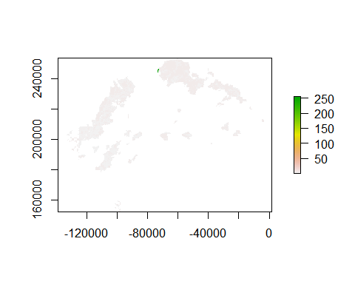

bb <- readGDAL("C:/Users/usuario/Bats_California/layers/burn_basal.asc")

## C:/Users/usuario/Bats_California/layers/burn_basal.asc has GDAL driver AAIGrid   
## and has 250 rows and 322 columns

bb<-raster (bb)  
plot(bb)

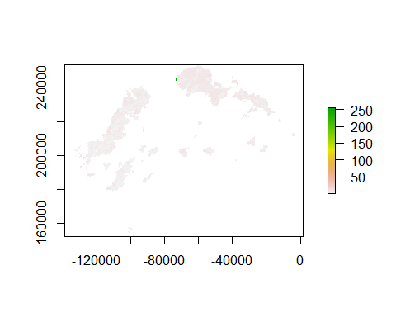

bs <- readGDAL("C:/Users/usuario/Bats_California/layers/burn_severity.asc")

## C:/Users/usuario/Bats_California/layers/burn_severity.asc has GDAL driver AAIGrid   
## and has 250 rows and 322 columns

bs<-raster (bs)  
plot(bs)

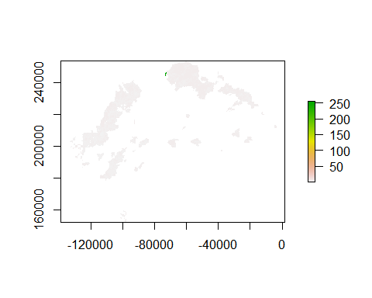

topo <- readGDAL("C:/Users/usuario/Bats_California/layers/plumastopo.asc")

## C:/Users/usuario/Bats_California/layers/plumastopo.asc has GDAL driver AAIGrid   
## and has 103 rows and 151 columns

topo<-raster (topo)  
plot(topo)

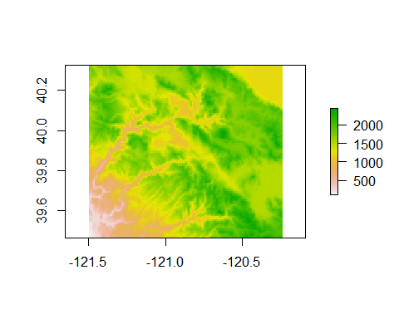

summary(bs)

## band1  
## Min. 1  
## 1st Qu. 2  
## Median 3  
## 3rd Qu. 4  
## Max. 255  
## NA's 72282

# Change outlayers and extract NAs

In order to classify the raster we will get rid of unnecesary outlayers, and change NAs to 0

df.bb <- data.frame(id=c(NA,1,2,3,4,5,6,7,255), v=c(0,1,2,3,4,5,6,7,8))  
bb <- subs(bb, df.bb,subswithNA=FALSE)  
df.bs <- data.frame(id=c(NA,1,2,3,4,255), v=c(0,1,2,3,4,5))  
bs <- subs(bs, df.bs,subswithNA=FALSE)  
df.bc <- data.frame(id=c(NA,1,2,3,4,5,255), v=c(0,1,2,3,4,5,6))  
bc <- subs(bc, df.bc,subswithNA=FALSE)

# Check for correlation between rasters

burn <-brick(bc, bs, bb)  
plot (burn)

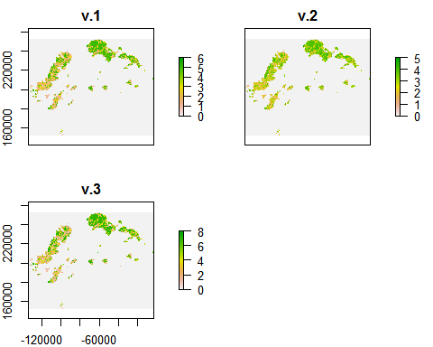

layerStats(burn, "pearson",na.rm=TRUE)

## $`pearson correlation coefficient`  
## v.1 v.2 v.3  
## v.1 1.0000000 0.9723716 0.9902661  
## v.2 0.9723716 1.0000000 0.9673089  
## v.3 0.9902661 0.9673089 1.0000000  
##   
## $mean  
## v.1 v.2 v.3   
## 0.3233540 0.2943354 0.4289565

# Clasification example

Even though we shouldn't classify using 3 layers of such high classification we will use the RasterBrick of the three burn classifications to exemplify how we will divide the area into areas of similar characteristics. Here we will ask R to use kmeans to sort the area into 3 types of habitat using the abovementioned rasterbrick:

## v.1 v.2 v.3  
## [1,] 0 0 0  
## [2,] 0 0 0  
## [3,] 0 0 0  
## [4,] 0 0 0  
## [5,] 0 0 0  
## [6,] 0 0 0

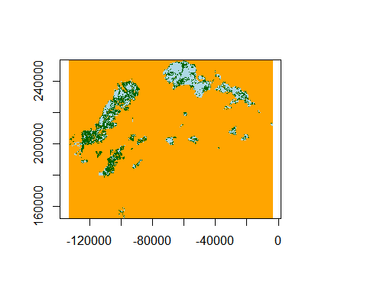

More info on how to do this clasification in [*https://geoscripting-wur.github.io/AdvancedRasterAnalysis/*](https://geoscripting-wur.github.io/AdvancedRasterAnalysis/)