**NumPy Assignment**

**Mishan Regmi**

**1841030**

**5 BCA ‘A’**

**Screen Shot**

1. Here I have imported NumPy and checked the version of NumPy and did some coding using NumPy.

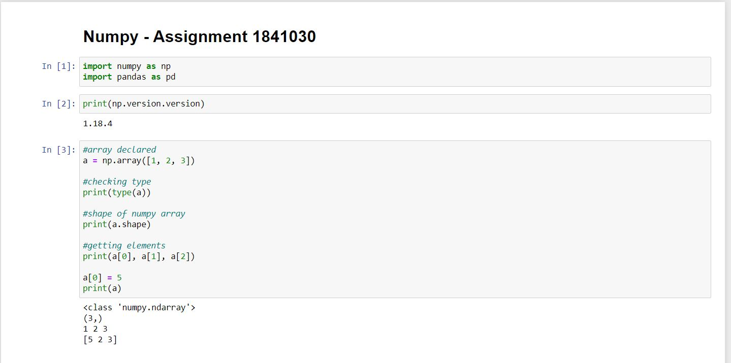

2. The difference in NumPy and List on basis of speed functionality is:

a. **Size** - NumPy data structures take up less space than Lists

b. **Performance** - NumPy have a need for speed and are faster than lists

c. **Functionality** - SciPy and NumPy have optimized functions such as linear algebra operations built in.

3. Differentiating both List and NumPy with Code

**a. Data Type**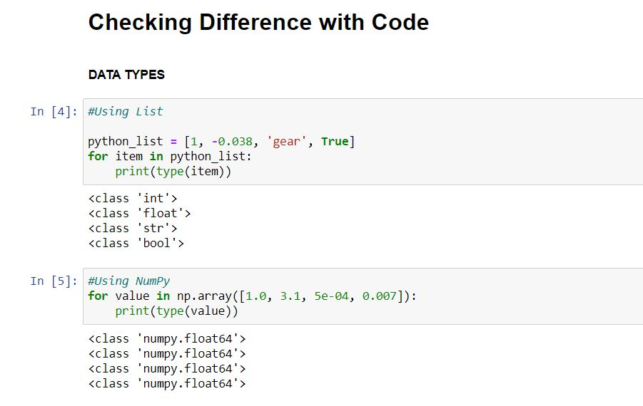

**b. Multiplication Operation on Both**

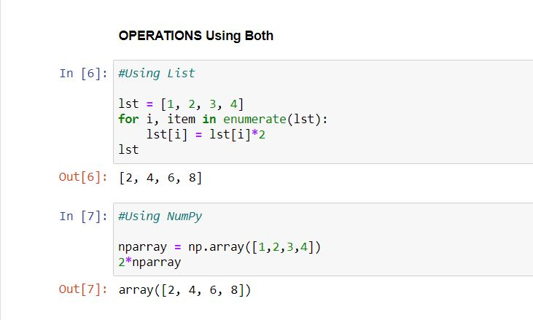

**c. Checking Running Time with Magic Function**

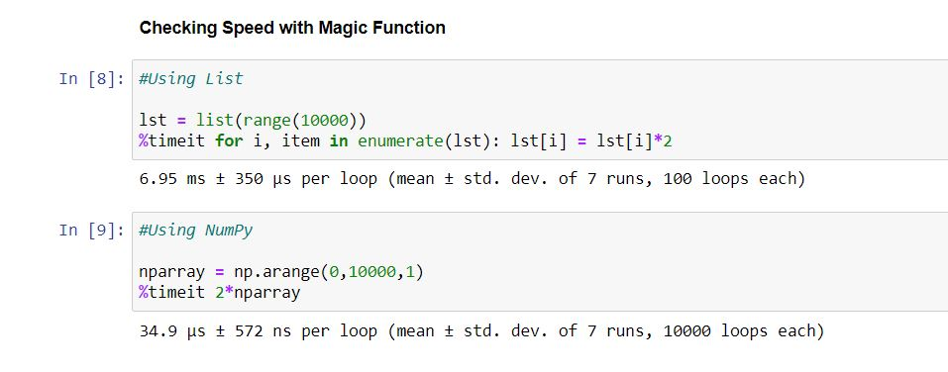

**THANK YOU**