MENTAL HEALTH ASSESSMENT AND TRACKING SYSTEM FOR CHILDREN

PROJECT REPORT

Submitted by

GOKUL KUMAR R (7376222AL131)

CHOLAATHIRAJ M S (7376222AL121)

HARIPRASATH S (7376222AL138)

In partial fulfilment for the award of the degree of

BACHELOR OF TECHNOLOGY

in

ARTIFICIAL INTELLIGENCE AND MACHINE LEARNING


BANNARI AMMAN INSTITUTE OF TECHNOLOGY
(An Autonomous Institution Affiliated to Anna University, Chennai)
SATHYAMANGALAM-638401

ANNA UNIVERSITY: CHENNAI 600 025

APRIL 2026

BONAFIDE CERTIFICATE

Certified that this project report “Mental Health Assessment and Tracking System for Children” is the Bonafide work of “GOKUL KUMAR R (7376222AL131), CHOLAATHIRAJ M S (7376222AL121) and HARIPRASATH S (7376222AL138)” who carried out the project work under my supervision.

Dr. Bharathi A Prof. SatheshKumar K
HEAD OF THE DEPARTMENT ASSISTANT PROFESSOR - II
Department of Artificial Intelligence Department of Artificial Intelligence
and Machine Learning and Machine Learning Bannari Amman Institute of Technology Bannari Amman Institute of Technology Sathyamangalam. Sathyamangalam.

Submitted for Project Viva Voice examination held on………………

DECLARATION

We affirm that the project work titled “Mental Health Assessment and Tracking System for Children” being submitted in partial fulfillment for the award of the degree of Bachelor of Technology in Artificial Intelligence and Machine Learning is the record of original work done by us under the guidance of Prof. SatheshKumar K, Assistant Professor - II, Department of Artificial Intelligence and Machine learning. It has not formed a part of any other project work(s) submitted for the award of any degree or diploma, either in this or any other University.

GOKUL KUMAR R CHOLAATHIRAJ M S HARIPRASATH S
(7376222AL131) (7376222AL121) (7376222AL138)

I certify that the declaration made above by the candidates is true.

ACKNOWLEDGEMENT

We would like to enunciate heartfelt thanks to our esteemed Chairman Dr. S.V. Balasubramaniam and the respected Principal Dr. C. Palanisamy for providing excellent facilities and support during the course of study in this institute.
We are grateful to Dr. Bharathi A, Head of the Department, Department of Artificial Intelligence and Machine Learning for her valuable suggestions to carry out the project work successfully.
We wish to express our sincere thanks to Faculty guide Prof. SatheshKumar K, Assistant Professor - II, Department of Artificial Intelligence and Machine Learning, for his constructive ideas, inspirations, encouragement, excellent guidance, and much needed technical support extended to complete our project work.
We would like to thank our friends, faculty and non-teaching staff who have directly and indirectly contributed to the success of this project.

GOKUL KUMAR R (7376222AL131)
CHOLAATHIRAJ M S (7376222AL121)
HARIPRASATH S (7376222AL138)

ABSTRACT

One of the most significant parts of a child's overall development is their mental health and emotional well-being. Parents and educators getting the chance to provide timely help would be greatly facilitated if emotional and behavioural concerns were identified at an early stage. But a reason why many existing mental health systems do not work for children is that they are either geared towards adults or are based on complicated diagnostic methods which are not suitable for children. In that case, Mindful Kids, Mental Health and Well-Being Surveillance, Assessment, and Tracking System for Children was created as a supportive and ethical digital platform for children's emotional wellness monitoring.
The system proposed offers a child-friendly, privacy-aware, and non-diagnostic environment where children can frequently record their emotional states via simple questionnaire-based check-ins and engaging wellness activities. It also offers role-based access control (RBAC), whereby children, parents, and administrators (or counsellors) are given different access rights to the system. Children may fill out wellness questionnaires, engage in mindfulness activities, and access their personal wellness dashboard. Parents can track their children's well-being trends, give their consent for participation, and receive early warning alerts if risk levels escalate. Administrators can use the aggregated and anonymized data to gain broader mental health insights without identifying individual children.
The system uses questionnaire data to do score-based risk assessment and divides results into low, moderate, or high risk categories. According to these levels, the platform suggests wellness activities such as mindfulness exercises, grounding techniques, or referrals to professional counselling. The app also gives parents an opportunity to track children's emotional well-being over time.

Keywords Mental Health Monitoring, Child Well-Being, Mental Health Surveillance, Wellness Tracking, Role-Based Access Control, Emotional Assessment, Mindfulness Activities, Early Risk Detection, Child-Friendly Digital Platform.

TABLE OF CONTENTS

CHAPTER  NO. | TITLE | PAGE  NO.
 | ACKNOWLEDGMENT  ABSTRACT | 1
 | TABLE OF CONTENTS | 2
 | LIST OF FIGURES | 4
1 | INTRODUCTION | 5
1.1 | BACKGROUND OF THE WORK | 6
1.2 | MOTIVATION | 8
2 | LITERATURE SURVEY | 10
2.1 | EXISTING WORKS | 11
2.2 | CONSTRUCTIVE CRITICISM AND GAP IDENTIFICATION | 12
2.3 | SUMMARY OF CHALLENGES AND PROPOSED SOLUTIONS | 13
3 | OBJECTIVES & METHODOLOGY | 15
3.1 | OBJECTIVES OF THE PROPOSED WORK | 15
3.2 | PROPOSED METHODOLOGY | 16
3.3 | WORKFLOW OF THE WEB APPLICATION | 20
3.4 | SYSTEM DESIGN | 23
3.5 | SYSTEM ARCHITECTURE | 27
3.6 | TECHNOLOGIES AND TOOLS USED | 29
4 | RESULT AND DISCUSSION | 34
4.1 | RESULTS | 34
4.2 | SIGNIFICANCE, STRENGTHS OF THE  PROPOSED WORK | 38
4.3 | LIMITATIONS OF THE PROJECT | 40
4.4 | COST-BENEFIT ANALYSIS | 41
5 | CONCLUSION AND FUTURE WORK | 43
5.1 | CONCLUSION | 43
5.2 | SUGGESTIONS FOR FUTURE WORK | 44
6 | REFERENCES | 46
7 | APPENDICES | 48
 | BILLS OF MATERIALS | 48
 | PUBLICATION CERTIFICATE | 48
 | PUBLICATION PROOF | 52
 | WORK CONTRIBUTION | 53
 | PLAGARISM REPORT | 56

LIST OF FIGURES

SI.NO | FIGURE NAME | PAGE  NO.
3.1 | Flowchart Of Methodology | 17
3.2 | Project Workflow | 20
4.1 | User Interface Of The Website | 35
4.2 | Parents Dashboard | 35
4.3 | Children Dashboard | 36

CHAPTER I

INTRODUCTION
Mental health and emotional well-being are basic needs of a child’s overall development. The childhood stage is a period when people undergo accelerated cognitive, emotional, and social development that influences the future personality, behavior, and learning abilities of the individual. Emotional well-being enables children to form positive relationships, develop self-confidence, and learn to deal with day-to-day challenges. Unfortunately, children today are exposed to various pressures like academic performance, social competition, family relationships, and increasing interaction with digital media. These factors can greatly impact their emotional condition and psychological well-being.
Children, in many instances, may not be able to articulate their emotions or convey their emotional problems to adults. Emotional stress, anxiety, or behavioral problems may go unnoticed until they lead to more serious issues concerning academic, social, or personal well-being. Identifying changes in emotional patterns at the early stages can enable parents, teachers, and caregivers to offer timely support and guidance. As the importance of child mental health becomes better understood, there is a rising need for solutions that can help with the monitoring of emotional well-being in a straightforward, convenient, and child-friendly way.
In most cases, conventional methods for mental health assessment involve clinical evaluations carried out by psychologists or counselors. Although such evaluations are important, they are normally carried out after a problem is noticed. In most cases, frequent clinical evaluations for assessment might not always be possible due to various factors such as unavailability of professionals, social factors such as stigma, or lack of awareness. Consequently, most children lack the support they need for their emotional development.
However, due to the evolution and advancement in digital technologies, web-based and mobile applications have been established as viable means for providing health monitoring and support. Such digital technologies have the ability to facilitate continuous observation of behavioral and emotional patterns. In the context of child mental health assessment, such applications must be designed in a manner that is engaging, accessible, and responsible.
The Mindful Kids – Mental Health and Well-Being Surveillance, Assessment, and Tracking System for Children is intended to meet this requirement by providing a technological platform that is centered on monitoring emotional well-being rather than making a diagnosis. The system enables children to monitor their emotions by completing simple questionnaires and emotional check-ins, as well as providing wellness activities that encourage positive mental practices. The system enables parents to monitor emotional trends and provides supportive insights that help parents comprehend their child’s emotional well-being. The system provides administrative analytics that enable the aggregation of insights regarding mental health trends without revealing the child’s information.
The system combines child-friendly design, role-based access control, and ethical data management practices to ensure the creation of a supportive environment that encourages emotional awareness and proactive care. The system encourages the early detection of potential emotional issues while ensuring that the system is non-diagnostic and centered on emotional well-being.

BACKGROUND OF THE WORK
Recently, mental health has emerged as one of the most critical issues in global health care. Several research studies have identified that emotional and mental issues often begin in childhood or during teenage. “If not handled properly, childhood emotional difficulties can have long-lasting effects on school performance, social relationships, and adult personality.” Hence, monitoring the mental health of children has become one of the most critical responsibilities for parents, educators, and mental health care providers.
Traditional approaches to monitoring mental health in children include observation, counseling, and clinical psychological evaluations. Although these approaches are critical in monitoring mental health in children, they have some limitations. For instance, adults may not be able to observe and identify the mental health of their children due to some limitations. Similarly, clinical evaluations may not identify mental health issues in children unless a critical issue arises.
Another issue is that children may not be able to express their emotions effectively. Young children may not have the words or the confidence to express emotions like anxiety, frustration, or sadness. This can lead to emotional issues being shown indirectly through changes in behavior, such as withdrawal, irritability, or loss of interest in activities. Without effective monitoring tools, it may be difficult to identify these changes.
Digital technology offers a chance to overcome these issues by allowing continuous and systematic monitoring of emotional well-being. Web-based applications and mobile platforms can offer simple solutions to record emotional experiences, monitor behavioral patterns, and offer wellness information. These platforms can also help children and parents communicate by offering information on emotional patterns over time.
However, it is important to note that developing digital mental health systems for kids entails addressing ethical and privacy issues. The information related to kids is very sensitive, and systems must ensure that the information related to kids’ personality is handled appropriately. Moreover, systems must not pose themselves as diagnostic tools if they are not clinically validated. Instead, the focus must be laid on developing systems that encourage kids to become emotionally aware, develop healthy coping mechanisms, and communicate effectively with kids.
The Mindful Kids system is developed considering the aforementioned facts. The system includes a structured questionnaire component that enables kids to respond to questions related to emotional, behavioral, cognitive, and social well-being domains. The response is obtained using simple Likert scales and emoji inputs to make it interesting for kids.
The system also uses role-based access control (RBAC), which enables different people to access different functionalities depending on their roles. Children can take assessments and engage in wellness activities, parents can view emotional trends and manage consent settings, and administrators can view anonymized aggregated data. This method ensures that personal data is not exposed while still allowing for the analysis of trends related to mental wellness.

MOTIVATION
The need for developing the Mindful Kids platform comes from the need for developing accessible and preventive mental health support systems for kids. The emotional struggles that kids undergo are often not recognized by parents and caregivers since they might not have the tools to effectively monitor their kids’ emotional well-being. Kids might not open up about their emotions due to fear, shame, or lack of awareness.
A digital tool that helps kids express their emotions regularly in an easy and fun way might fill the gap. It might assist parents in understanding their kids’ emotional state more clearly through visualizations, which might encourage parents to have healthy conversations, an essential tool for healthy emotional development.
The system that is proposed for development is based on supportive monitoring rather than medical diagnosis. Instead of diagnosing mental health conditions, the system uses a score-based risk assessment tool, which is based on the results obtained from the questionnaires. The emotional states are classified as low, moderate, or high risk levels, as determined by the average score obtained. The levels are used as indicators for parents to identify possible changes in emotional states.
Another reason for developing the system is the need for ethical and privacy-conscious monitoring of the information related to the children. The system has been designed to include parental consent, which ensures that the children can only participate in the system if given permission by the parents. The administrative users are restricted to viewing aggregated and anonymized information, while they are unable to access information related to specific children.
The scope of the project includes the development of a responsive web-based application that includes features such as emotional check-ins, questionnaires, and wellness activities for children, emotional trend monitoring, consent management, and early warning alerts for parents, and aggregated analytics to understand well-being patterns while maintaining privacy for administrators.

Another key feature that can be integrated into the system is the ability to track emotional trends over time. This can be done by providing parents the ability to view graphs that show weekly and monthly changes in their children’s moods or their levels of well-being. This will help parents to understand patterns and determine whether their children’s emotional state is improving, stable, or showing signs of concern.
The system also gives risk-based recommendations to guide parents on what they can do. For instance, if the emotional risk level of a child is low, the system advises the parents to have regular wellness check-ins and positive reinforcement. However, if the risk level increases to moderate, the system advises mindfulness exercises or grounding techniques. Additionally, if the risk level is high, the system advises seeking professional counseling assistance.

CHAPTER II

LITERATURE SURVEY
The rapid development of digital health technologies has greatly impacted the development of mental health monitoring and support systems. In recent years, researchers and developers have been increasingly interested in building digital systems that can be used to support the monitoring of emotional well-being, behavioral changes, and providing support to users. Such systems incorporate different technologies, including artificial intelligence, machine learning, data analysis, and user interface, to analyze behavioral changes and provide insights regarding mental well-being.
The development of mental health monitoring systems is of great importance, especially in the lives of children. This is due to the fact that early emotional experiences have been recognized as essential in influencing psychological development. Children experience different emotional issues, especially due to academic, social, and family factors. However, it is difficult to identify early signs of emotional distress in children, as they may not clearly communicate their feelings. Traditional approaches, including teacher observations, parental feedback, and clinical evaluations, can be used to identify emotional distress in children. However, they do not allow for continuous monitoring.
Digital platforms have the potential to bridge this information gap by providing regular emotional check-ins, assessments, and tracking of emotional trends over time. This can help parents and care-givers understand changes in their child's emotional state over time. Moreover, modern web technologies provide a range of tools that can be used to develop user-friendly applications that make mental health monitoring and tracking easy and interesting.
However, most existing systems either concentrate solely on providing tools for clinical diagnosis or provide basic monitoring tools such as surveys but fail to provide wellness activities that can help children get involved in their own emotional well-being. Moreover, issues of privacy, ethical data handling, and parental consent are not considered in most existing systems.

EXISTING WORKS

Smith et al. (2022) introduced a digital emotional monitoring system that employed machine learning algorithms to interpret behavioral patterns and mood indicators from user interactions. The system used emotional inputs from questionnaires and activity logs to forecast potential emotional changes. The study showed promising outcomes in identifying mood changes; however, the system mainly targeted data interpretation and did not include interactive wellness tasks that could assist users in regulating their emotional conditions.
Jones et al. (2021) designed a mental health monitoring system that employed physiological signals such as heart rate and stress indicators to interpret emotional conditions. The system employed deep learning models to interpret physiological data and generate mental health information. Although the system ensured accurate emotional detection, it relied on the use of specialized hardware devices, making it less feasible for use, especially among children and families who may lack access to such devices.
Lee et al. (2023) studied the application of sentiment analysis and text-based emotion detection to analyze the emotions of users in digital platforms. The proposed system analyzed the text inputs provided by the users and classified them into various emotional states. The findings revealed that natural language processing approaches could be used effectively to identify emotional expressions. Nevertheless, the proposed system was primarily designed for emotion detection and did not include parental monitoring capabilities or long-term emotional analysis.
Kumar et al. (2020) proposed a hybrid approach that integrated rule-based logic with machine learning models for monitoring emotional patterns. The proposed system collected user responses using well-structured questionnaires and employed classification models to predict emotional states. Although the proposed system offered better accuracy than the traditional rule-based approach, the study overlooked the significance of user-friendly interfaces for children and parental participation in monitoring emotional well-being.
Davis et al. (2019) created an interactive digital platform that facilitated mental health care, such as guided relaxation and mood tracking. The digital system was designed to help users engage in wellness activities and track their emotional trends. Although the digital system was successful in improving user engagement, it was not designed to address the issues and ethics of monitoring children's mental health.
Zhang et al. (2021) conducted a study on emotion recognition systems, which used facial and behavior-based recognition systems to recognize emotional cues in users. The study was successful in proving that emotion recognition systems could effectively recognize emotional cues in real-time. The study, however, raised ethical issues about the privacy and ethics of using facial recognition systems, especially in children.

CONSTRUCTIVE CRITICISM AND GAP IDENTIFICATION
Although some studies have been conducted to provide innovative solutions for emotion recognition and digital mental health monitoring, a careful analysis of the existing literature has identified some important gaps and limitations that should be addressed.
One of the most important gaps that have been identified in the literature is the lack of child-centered system design. For instance, the system developed by Davis et al. (2019) introduced an interactive platform for mood tracking and relaxation tasks. Although the system improved user engagement, it was primarily designed for adult users and did not take into account the specific usability requirements of children. Children need simpler interfaces, visual aids such as emojis, and interactive components that make it easier and more engaging to report their emotional state.
Another major shortcoming is the absence of effective and feasible methods for monitoring emotions. The system designed by Jones et al. (2021) was highly dependent on physiological signals like heart rate and skin conductance to identify emotional states. Although this method increased the accuracy of emotional state identification, it was dependent on hardware devices. This is a major drawback of the system, as it is not very user-friendly in real-world settings, especially for children and parents who do not possess such devices.
Another research gap is associated with the absence of comprehensive integration of parental engagement and monitoring mechanisms. The emotional state identification system designed by Lee et al. (2023) was highly dependent on text analysis to identify emotional states. Although this system proved the effectiveness of sentiment analysis in understanding user emotions, the system was not integrated with parental monitoring and consent management mechanisms. In the context of children’s emotional data, parental engagement and consent are highly necessary to ensure the ethical use of the system.
In addition, the lack of supportive intervention is also seen in various studies. Kumar et al. (2020) introduced a hybrid emotional analysis model that included rule-based systems and machine learning techniques for detecting emotional patterns. However, the system mainly focused on classifying and analyzing emotions instead of providing supportive activities for users in effectively managing their emotions.
Another significant gap in existing literature is privacy and ethical issues. Emotion recognition, as introduced by Zhang et al. (2021), included facial expression analysis and voice input for detecting emotions. Although this system showed promising results, there are certain privacy and ethical issues associated with using such systems. These issues are more critical in using such systems for children, for whom privacy is a significant concern.

SUMMARY OF CHALLENGES AND PROPOSED SOLUTIONS
From the literature review, some of the key challenges that have been identified in the development of digital mental health monitoring systems for children include the lack of adaptability to changing emotional states, the lack of child-friendly interfaces, the lack of parental involvement, the issue of privacy, and the lack of scalability of the current systems.
Another challenge that has been identified is the difficulty of tracking emotional patterns over time. Human emotions are dynamic and can change rapidly depending on a variety of environmental factors. Most current systems are designed to analyze emotional states at a particular point in time, rather than tracking long-term emotional patterns.
To overcome these challenges, the project proposes the development of the Mindful Kids – Mental Health and Well-Being Surveillance, Assessment, and Tracking System for Children.

The proposed system would utilize a score-based model of emotional assessment, in which questionnaires would be used to measure emotional, behavioral, cognitive, and social aspects of wellness. Instead of providing medical diagnoses, the proposed system would group emotional data into low, moderate, and high risk categories. This approach ensures that the proposed system remains supportive and not diagnostic in nature.
Another aspect that the proposed system would offer is role-based access control, in which different users can use the proposed system according to their roles. For instance, children can participate in emotional check-ins and wellness activities, parents can monitor emotional trends, and administrators can use the proposed system to conduct data analysis.
Another aspect that the proposed solution offers is the ability to track emotional changes, in which parents can track emotional changes over weekly and monthly periods. They can use visual graphs to identify possible changes in emotional wellness at an early stage.
In addition, the system also adheres to ethical data practices by ensuring that the child's engagement with the program requires parental consent, and administrative access to data is only provided in an anonymized aggregate format.

CHAPTER III OBJECTIVES AND METHODOLOGY
This chapter outlines the objectives and approach of the proposed Mindful Kids Mental Health and Well-Being Surveillance, Assessment, and Tracking System for Children. The objectives are designed in light of the research gaps that have been identified in the literature review, specifically the absence of child-friendly digital mental health surveillance systems that address privacy, parental participation, and ongoing emotional surveillance.
The proposed system is designed to offer a supportive digital environment where children can track their emotions, participate in wellness tasks, and facilitate parental surveillance of emotional patterns. The proposed system differs from conventional mental health assessment systems that are primarily designed for clinical assessment in that it is designed for emotional awareness, preventive surveillance, and supportive guidance.

OBJECTIVES OF THE PROPOSED WORK
Based on the analysis of existing mental health monitoring systems, the following objectives have been defined for the proposed project, as mentioned below:
- Objective 1: The first objective of the project is to develop a digital system that allows children to report their emotional status by providing structured questionnaires and regular wellness checks. The system uses a Likert scale with emoji-based answers to help children understand and interact with the system in a friendly and non-intimidating way.
- Objective 2: Another objective of the project is to ensure that parents are actively involved in monitoring their children’s emotional status and provide their consent for their children to participate in emotional monitoring. The system allows parents to view their children’s emotional trends and alerts parents in cases where their children’s emotional risk levels are high.
- Objective 3: The system aims to provide a score-based emotional risk assessment model using answers from questionnaires in the system. The emotional risk assessment model works by providing emotional, behavioral, cognitive, and social questions to the user and determining their emotional status using the average score from answers to these questions. The system categorizes emotional status into low risk, moderate risk, and high risk levels.
- Objective 4: In addition to the aforementioned features, the project aims to provide healthy emotional habits for kids through the addition of wellness activities within the system. Wellness activities include breathing exercises, mindfulness, and grounding techniques such as the 5-4-3-2-1 method. The features assist kids in developing healthy coping skills to deal with stress and emotional issues.
- Objective 5: Another objective for the project is to track the emotional changes over time using weekly and monthly trend analysis. The system enables the visualization of emotional trends using graphs and charts, enabling parents to understand the changes in their kids’ emotional states.
- Objective 6: The last objective for the project is to ensure that the system adheres to strict privacy and ethical standards for handling sensitive emotional information for kids. The system ensures the privacy and security of kids’ information, enabling administrators to conduct anonymous analytics.

PROPOSED METHODOLOGY
To achieve these objectives, we will use a formalized and structured approach, comprising several stages of development, implementation, and evaluation. The methodology encompasses the following major phases:

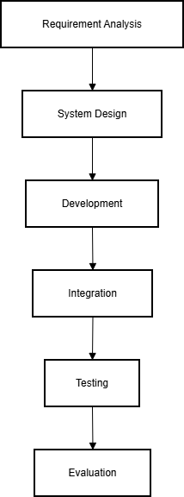
Figure 3.1 Flowchart of Methodology

Requirement Analysis

The first phase of the project is focused on identifying the functional and non-functional requirements of the system.
For conducting this phase of the project, relevant information was gathered through analyzing existing mental health systems, research papers, and interacting with potential users of the system, such as parents, students, and educators. Through such interactions and analysis, key requirements of the mental health system were identified.
These key requirements of the mental health system include:
- Child-friendly emotional assessment system
- Parent consent and monitoring features
- Emotional trend visualization
- Wellness activities for children
- Privacy and ethical data protection
This phase of the project was helpful in designing and developing the mental health system.

System Design and Architecture
Once the system requirements are identified, the next step is to design the system architecture.
To design the system, the role-based access control model (RBAC) is used, and there are three roles identified for the system:
- Child
- Parent
- Administrator/Counselor
Each role has different functionalities and permissions on the system.
To design the system architecture, different components are included, such as authentication, questionnaire, emotional risk analysis, wellness activity, reporting, and analytics.

Application Development
The application is built using modern web technologies for responsiveness and scalability.

Technologies used for the frontend of the system:
- React.js for dynamic frontend interfaces
- Tailwind CSS for responsive design
- Recharts for data visualization
- React Router for routing
Additionally, the system has an API that can be used for backend integration for data storage, authentication, and analytics processing.
In this stage, the major system modules such as user authentication, questionnaire processing, emotional risk analysis, wellness activities, and reporting are implemented.

Integration and Testing
Once individual modules are developed, they are integrated to form a complete system.
There are several tests carried out to ensure that a system is reliable and performs well.
- Unit Testing: Each module is individually tested to confirm whether it is working well.
- Integration Testing: The interaction of modules like sending questionnaires, calculating risks, and refreshing dashboards is tested.
- Performance Testing: The system is tested to confirm whether it is working well even with multiple users accessing it at a given time.
- Usability Testing: The user interface is tested to confirm whether it is easy for both kids and parents to use.

User Feedback and Iterative Improvement

After the implementation of the system, the process of usability evaluation follows. Feedback on the system is obtained from the target users, such as parents and students, regarding the usability and usefulness of the system. Based on the obtained feedback, the system can be improved to enhance the performance, design, and user experience of the system.

Final Evaluation and Documentation

The final stage of the project is to evaluate the system in accordance with the objectives that were established in the previous stages.

This stage is composed of the following processes:

Performance analysis of the emotional tracking features

Usability and responsiveness evaluation of the system

Development methodology and challenges documentation

Technical documentation and user manuals preparation

This stage is important to ensure that the system is ready to be used in a practical environment.

WORKFLOW OF THE WEB APPLICATION
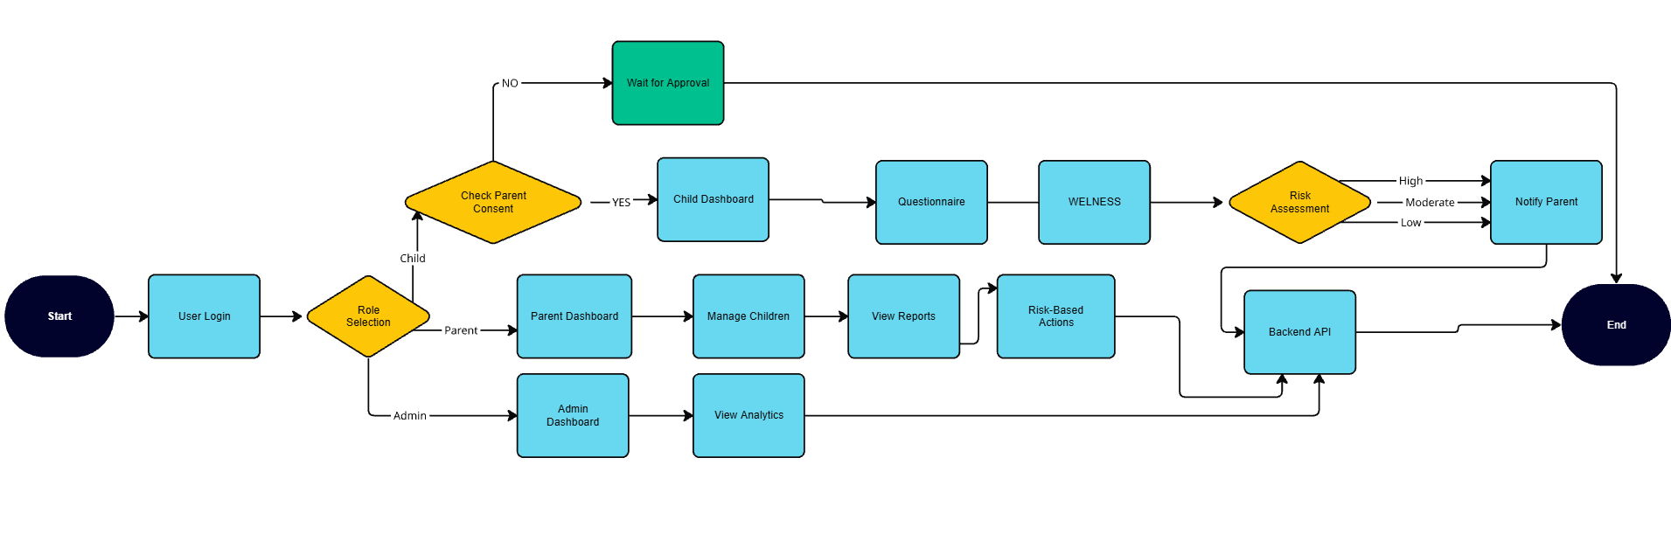
The following flowchart represents the workflow of the Mindful Kids – Mental Health and Well-Being Surveillance, Assessment, and Tracking System. This flowchart represents a series of operations that occur in a web application. The workflow is a representation of how a system processes a series of operations in order to produce a specific output. The workflow gives a comprehensive overview of a system’s processing of user input in order to produce a relevant output. The system’s output is related to a specific aspect of emotional well-being in children.

Figure 3.2 Project Workflow

Flowchart Explanation
- Start
This stage is where the user starts interacting with the system. The interaction is achieved by launching the Mindful Kids web application. The system will then load the application interface and initiate the login module. At this stage, the user is required to provide valid login credentials.
- User Login
At this stage, the user is required to provide valid credentials to access the system. The user will provide their login details, which include their email and password. The system will then verify the credentials using the authentication system. Once this stage is successful, the system will proceed to the next stage.
- Role Selection
At this stage, the system will determine the role of the user. The application has three types of users, which are child, parent, and administrator. The users have varying levels of privileges and functionality within the system.
- Parent Consent Verification (Child Role)
If a user logs in as a child, the first step is to verify whether there is parental consent to participate in emotional evaluations. Ethical usage of children's information and user privacy are ensured in this step.
If there is no parental consent to participate in the evaluations, it is placed in a waiting state. The child then waits until parental consent is granted to participate in the evaluations. Once parental consent is granted, the child is allowed to access the system.
- Child Dashboard Access
Once parental consent is granted, the child is directed to access the child dashboard. The child dashboard acts as a gateway to allow children to interact with the system. Children are allowed to access various emotional questionnaires and wellness activities that are beneficial to their emotional well-being through this interface.

- Questionnaire Module
The child then proceeds to answer a series of questions in the questionnaire module that are child-friendly and pertain to their emotional, behavioral, cognitive, and social well-being. The questions are in a simple rating scale format and are easily understandable and answerable for children.
The responses provided in this questionnaire are used to determine the emotional state of the child.
- Wellness Activities
After completing the questionnaire, the system offers access to the wellness activity section. Within this section, there are various activities that a child may engage in to improve his or her well-being. Such activities may include breathing exercises and mindfulness activities to improve a child’s ability to cope with situations.
- Risk Assessment
After the questionnaire results have been processed by the system, it proceeds to perform a risk assessment analysis. Within this section of the system, an emotional well-being score is calculated based on the results provided by the child who filled out the questionnaire. Once the score has been determined, it is categorized to fall within any of the following risk categories:
- Low Risk
- Moderate Risk
- High Risk
- Parent Notification
Depending on the level of risk established by the system, it generates an alert to notify parents of the results obtained from the questionnaire. If the level of risk is moderate or high with regard to the child’s emotional well-being, an alert is sent to parents through the parent dashboard section of the system.

- Parent Dashboard and Reports
Parents can use the parent dashboard to manage their children’s profiles and view their emotional reports. They can view emotional trends using graphical and statistical methods, allowing them to keep an eye on their children’s emotional state over time. Parents can then act upon the recommended steps based on the data provided by the system.
- Administrative Analytics
The system will then redirect the user to the admin dashboard if the user logs in as an administrator. Users can view aggregate analytics, providing them with an overview of emotional trends for all users. Individual data for children is not available to administrators, ensuring user privacy.
- Backend Processing
The backend API securely processes all data, including user questionnaires, risk assessments, and report data. This backend processing handles data communication between the user interface, database, and analytics.
- End
The workflow comes to an end once the system has processed the user’s session, providing them with the corresponding results such as the dashboard or report. The system then returns to its idle state, allowing users to continue monitoring their emotional state through further sessions if necessary.

SYSTEM DESIGN
The Mindful Kids – Mental Health and Well-Being Surveillance, Assessment, and Tracking System is a system that aims to create a safe, child-friendly, and interactive digital platform for monitoring and supporting a child’s emotional well-being. The system is focused on providing continuous emotional monitoring for a child by using questionnaires, wellness activities, and parental supervision under strict guidelines of privacy and ethics.

The system architecture is based on a role-based system, which allows different categories of users to interact with the system according to their specific role. This ensures that a child can easily participate in emotional monitoring, parents can easily monitor emotional trends and reports for their children, and system administrators can easily analyze system data without accessing individual child data.
The system is made up of several modules that are integrated into a single application to create a seamless workflow for emotional data collection, analysis, and reporting. The modules include user authentication, parental consent verification, emotional questionnaires, wellness activity modules, risk assessment, and reporting.
The frontend of this system has been developed using modern web development technologies, which provide an effective and user-friendly interface for users, including children and parents. The backend services have been designed to provide data processing, storage, and communication between application modules using secure APIs. The system has been designed with considerations for usability, response time, and scalability to allow multiple users to use this system efficiently.
Moreover, this system has paid special attention to data privacy and ethical data management, as it deals with sensitive data related to children’s emotional states. The system has ensured that there is parental consent required for child participation and that administrative analytics only show aggregated data. By implementing secure authentication mechanisms, data encryption practices, and access control, this system has ensured data privacy and security related to users’ data. The system design has ensured that it can provide a reliable and effective digital environment where children can safely express their emotions, parents can get meaningful insights into their child’s well-being, and administrators can see broader emotional trends.

FUNCTIONAL REQUIREMENT

Functional requirements are the operations and services that the system needs to provide to effectively satisfy the needs of the user. Following are the identified functional requirements for the Mindful Kids web application.

User Authentication and Role Management: The system needs to provide user authentication to access the system based on their roles. The web application needs to manage three roles for the users: child, parent, and administrator.

Parent-Child Linking and Consent Management: The system needs to provide the functionality for the parent to manage their children's profiles and obtain consent for their children to participate in emotional assessments. Only the children can use the questionnaire module of the system once their parents have given consent.

Emotional Assessment through Questionnaires: The web application needs to provide the functionality for the children to answer emotional, behavioral, cognitive, and social well-being-based questions in the form of questionnaires. The answers need to be obtained using rating scales in the form of emojis.

Risk-Level Assessment and Classification: The system needs to evaluate the answers to the questionnaire to obtain an emotional well-being score. On the basis of this score, the system needs to classify the emotional state of the user into risk level categories such as low, moderate, or high.

Wellness Activities Module: The system needs to incorporate interactive activities for the user to improve their well-being, such as breathing exercises, mindfulness activities, and grounding activities to help children manage their stress and maintain emotional equilibrium.

Emotional Trend Tracking and Reporting: The system needs to generate reports to display the emotional trends of the user. Parents need to be able to view graphical reports to view the emotional trends of their children.

Parent Notifications and Alerts: The system needs to send notifications to the parents of the user if the system detects moderate or high risk level emotional states.

Administrative Analytics Dashboard: The system needs to provide an analytics dashboard to administrators to view the emotional trends of the users, but this needs to be anonymous data to avoid violating user privacy.

NON-FUNCTIONAL REQUIREMENTS

Non-functional requirements describe the quality characteristics and performance criteria that ensure a system functions properly and efficiently.

Privacy and Data Security: Since the system processes confidential emotional information about children, it is important to implement robust privacy and security measures in the system. It is important that the system provides secure authentication and encrypted communication between various components of the system and limits access to user information on a need-to-know basis.

Performance Efficiency: The application should respond quickly to user interactions such as answering questionnaires, generating reports, and updating dashboards. Performance efficiency is required to prevent any delays in the operation of the system.

User-Friendly Interface: The system should provide a user-friendly interface that is not only aesthetically pleasing but also easy to understand and navigate. The interface should be simple and intuitive enough to allow children and parents to easily understand and interact with the system, regardless of their technical expertise level.

Reliability and Availability: The system should function properly without any interruptions or errors. It is important that error handling is properly implemented in the system to ensure that it runs smoothly and efficiently.

Scalability and Future Expansion of the System: The architecture of the system should allow future extensions such as adding more wellness programs, integration with mobile applications, or increasing its usage to accommodate a larger number of users. At the same time, it should also allow easy integration with cloud-based infrastructures if needed in the future.

Maintainability of the System: The system should be built in a modular fashion so that any component of the system can be modified or enhanced without affecting the rest of the system.

SYSTEM ARCHITECTURE

This subsection presents an overview of the architecture of the Mindful Kids – Mental Health and Well-Being Surveillance, Assessment, and Tracking System for Children. The architecture of this system is composed of various software components that work together to provide a secure, responsive, and user-friendly interface to facilitate children's emotional well-being. Moreover, this system is intended to accommodate various user groups, such as children and parents, while protecting their privacy and handling their emotional information in an ethical manner.

The architecture of this system is multi-layered, and each layer is responsible for performing various functions in this system. These layers include the web interface, application logic, data management, and analytics layers. With these layers, it is possible to perform various functions in this system, such as collecting children's emotional assessment information and analyzing it to provide a report and recommendations.

Web Application Layer: This layer represents the user interface through which children, parents, and administrators interact with the system. It includes various components such as dashboard, questionnaire form, wellness activity components, and reporting components. For creating this web interface, we have utilized a JavaScript library called React.js and a CSS framework called Tailwind CSS. It is very responsive and visually appealing. With this interface, children can fill out emotional check-ins and wellness activities, and parents can view reports and manage consent settings.

Application Logic Layer: The application logic layer is responsible for handling all the functionality of the system. It handles questionnaire response data from children and calculates their emotional well-being scores. It classifies the level of risk based on the response provided by the child. It checks whether the emotional state of the child is of low risk, moderate risk, or high risk. It also handles access control so that each user is restricted to only a specific set of components based on their role.

Backend API Layer: The backend API is the connection point for the frontend interface and the system database. It is responsible for managing all the requests sent to the API, such as saving questionnaire results, retrieving emotional trends, managing user authentication, and sending notifications to parents when needed. This API ensures the safe passage of data and the performance of the system by handling requests efficiently.

Data Management Layer: This is the core part of the system responsible for managing all the data used by the system. This ranges from user accounts, questionnaire results, emotional scores, and historical trends. The database is designed to store all the data securely and efficiently. User data is also protected from unauthorized use through proper storage mechanisms.

Analytics and Reporting Module: This is the part of the system responsible for analyzing the data collected and providing insights for better decision-making. The emotional trends are presented through visual aids such as graphs and charts to help parents understand the emotional status of their children over time. The administrator also has the ability to view analytics and understand the trends for all the users on the system without accessing individual user accounts.

Notification and Alert System: This section of the application tracks emotional risk levels and sends notifications if required. When the application identifies moderate and high levels of emotional risk in emotional assessments, it sends automatic notifications to the parent dashboard. These notifications are designed to be helpful and not alarming in nature and motivate parents to look at the reports and take necessary actions.

Error Handling and System Feedback: This application provides error-handling capabilities and offers feedback to users in case of errors. For example, if there is no loading of data, if there is an error in user authentication, or if there is a problem with the network, it provides error messages to help users solve the issue.

TECHNOLOGIES AND TOOLS USED
The Mindful Kids – Mental Health and Well-Being Surveillance, Assessment, and Tracking System for Children is built using modern web technology that supports scalability and provides an interactive user interface. The choice of technology is based on the requirements of creating a secure and interactive platform that allows children to participate in emotional assessments while enabling parents to track emotional well-being trends. The application uses various tools and technologies that support the front-end of the application, the back-end of the application, and the visualization of emotional analytics.
The technology stack has been chosen to allow smooth communication between the various modules of the application and to enable the processing of the questionnaire responses while maintaining the security of the user data. The tools and technology used in the development of the application are discussed in the following subsections.

Emotional Assessment and Risk Evaluation
The mechanism for emotional assessment is developed by asking child-friendly questions related to various aspects of emotions. These questions are divided into four categories:
- Emotional well-being
- Behavioral patterns
- Cognitive responses
- Social interaction patterns
The children respond to these questions by using a Likert scale and emoji inputs. This is helpful for children to easily respond to these questions based on their emotions without having to explain them. These responses are converted into a numerical form, showing the emotional state of the child.

Risk Evaluation Process
The emotional score collected from the questionnaire is passed through a simple evaluation algorithm that determines an average score, which reflects the emotional state of the child.
The system will then determine the emotional state of the child and place it in any of the following categories:
- Low Risk
- Moderate Risk
- High Risk
Each category reflects a varying state of emotional well-being, and by identifying it, parents are able to understand the changes that may occur in their child’s emotional state and take appropriate action by engaging in wellness activities or consulting a counselor.

Recommendation Generation

Based on the risk level calculated, the system provides supportive recommendations for both children and parents.

For example:

Low risk levels may prompt users to continue healthy emotional habits and check-ins.

Moderate risk levels may prompt users to engage in wellness activities such as breathing and mindfulness prompts.

High risk levels may prompt parents to pay attention and possibly consult a mental health professional.

The system, in this way, continues to be supportive and non-diagnostic, promoting emotional awareness rather than medical diagnosis.

Programming Languages

The main programming languages required for the development of the project are JavaScript and HTML/CSS.

JavaScript is a key technology in the development of the user interface. JavaScript allows the user interface and the backend services to interact in real-time. HTML is responsible for the layout of the web application. On the other hand, the application of CSS is crucial in the development of the user interface. It helps in the development of a responsive and visually appealing interface.

Development Environment
The development of the system was done using Visual Studio Code (VS Code) as the development environment. Visual Studio Code is a powerful platform used in web development with various useful features.
The main advantages of using Visual Studio Code are as follows:
- Advanced code editing
- Advanced syntax highlighting
- Debugging
- Support for multiple programming languages
- Terminal
- Framework and library support through extensions
These features of Visual Studio Code have made it an efficient environment in handling complex projects and organizing the source code accordingly.

Front-End Technologies
The frontend of the Mindful Kids application is intended to offer a user-friendly interface. The major frontend technology used in the development of the application includes:

- React.js: React.js is used in the development of dynamic user interface applications. It helps in the creation of reusable user interface components such as a dashboard, form, and visualization.
- Tailwind CSS: Tailwind CSS is used in the development of responsive user interface applications. It helps in the creation of visually appealing user interface applications.
- React Router: React Router helps in routing different pages of the application, including the login page, dashboard, questionnaire, and report.
- Recharts: Recharts helps in the creation of visualization graphs and charts used in displaying emotional trends and analytics.

Backend and API Integration

The application includes a backend API layer that facilitates communication between the user interface and the database. The backend services include data storage, user authentication, and processing of the responses from the questionnaire.

The backend services are created using Node.js and Express.js. These services are efficient in handling the API request and processing the data. The system uses a lightweight database like SQLite for storing the user data, emotional assessment results, and the historical trend data.

The backend services facilitate the exchange of data securely. It helps the system scale up as more users are able to access the system.

Version Control
Git is version control. That is to say that it helps collaborate smoothly and manage code. Now, let's see how Git contributes to our project:
- Track changes: Git records every code update, letting you revert to previous versions and track changes each member of the team makes.
- Lesser conflict: We could make one branch for one feature, thereby having lesser conflict in the merging of code.
- Collaboration: Git allows for effective collaboration among developers. Many developers can work on the same project in parallel without overwriting each other's code. We ensure an organized and collaborative development process because our team uses Git.
- Backup and Security: Git is a very good backup system. Repositories are stored both locally and on remote servers such as GitHub or GitLab. So, if the local systems fail, then code will be safe.
- Code Review and Feedback: It makes possible peer code review through the usage of pull requests, enabling team members to review and suggest improvements in the changes before merging.
- Continuous Integration Support: Git integrates well with CI/CD pipelines, enabling automated testing, deployment, and monitoring of changes, enhancing the overall development workflow.

CHAPTER IV RESULTS AND DISCUSSION
This chapter will present the results of the development and implementation of the Mindful Kids – Mental Health and Well-Being Surveillance, Assessment, and Tracking System for Children. It will include a discussion on the performance of the system in terms of functionality and effectiveness in the surveillance and monitoring of the emotional well-being of children. It will include the evaluation of the performance of the system in terms of the different modules that are incorporated in the system. In addition to the presentation of the results of the testing of the system, the chapter will include an analysis on the effectiveness of the proposed system in terms of the objectives that were earlier proposed. It will include a discussion on the benefits of the system. It will include a discussion on the importance of the system in terms of the early awareness of the emotional well-being of children.

RESULTS
The following is a figure representing the user interface of the Mindful Kids – Mental Health and Well Being Surveillance, Assessment, and Tracking System. The user interface is intended to be simple, interactive, and child-friendly to allow children to participate in emotional check-ins while providing parents with an intuitive user interface to track emotional trends. The user interface has been built to be responsive to allow users to access the system on various devices such as computers, tablets, and phones. The user interface is structured to ensure efficient navigation through various features such as emotional questionnaires, wellness activities, reports, and notifications for parents and children.
The user interface incorporates various features such as login authentication, role-based user interfaces, emotional questionnaires, wellness activities, and graphical reports from various modules such as emotional assessment forms, wellness activities, and reports. The user interface is intuitive and user-friendly to ensure that children can interact with the system without any difficulties while parents can efficiently use the system to track reports.

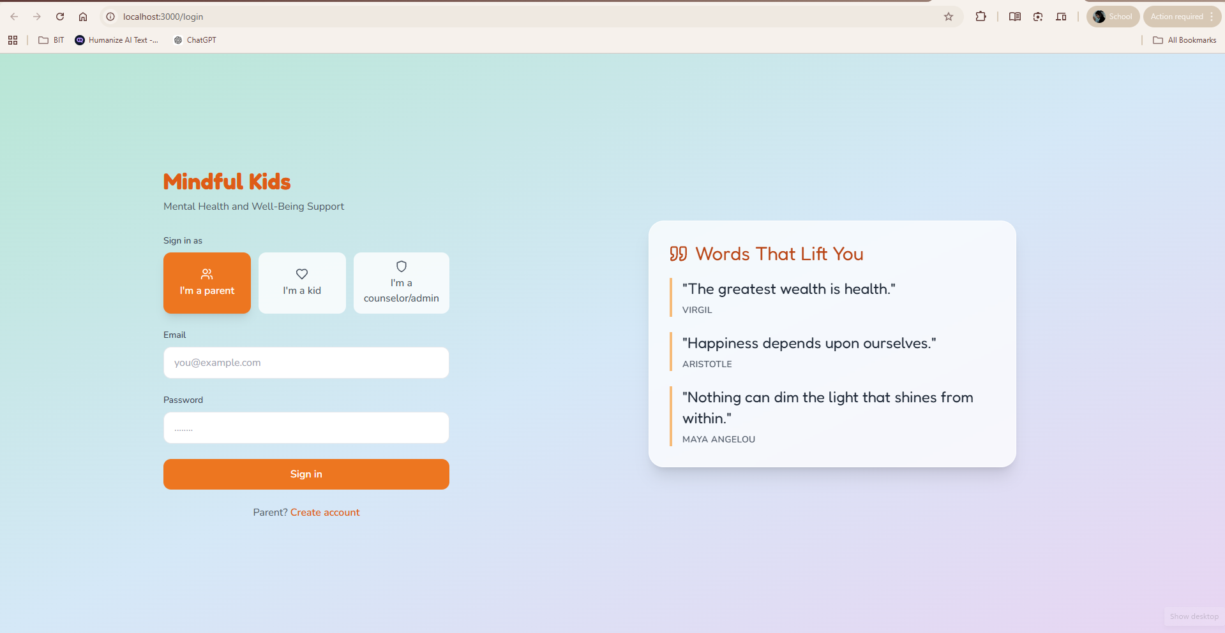
Figure 4.1 User Interface of the Website

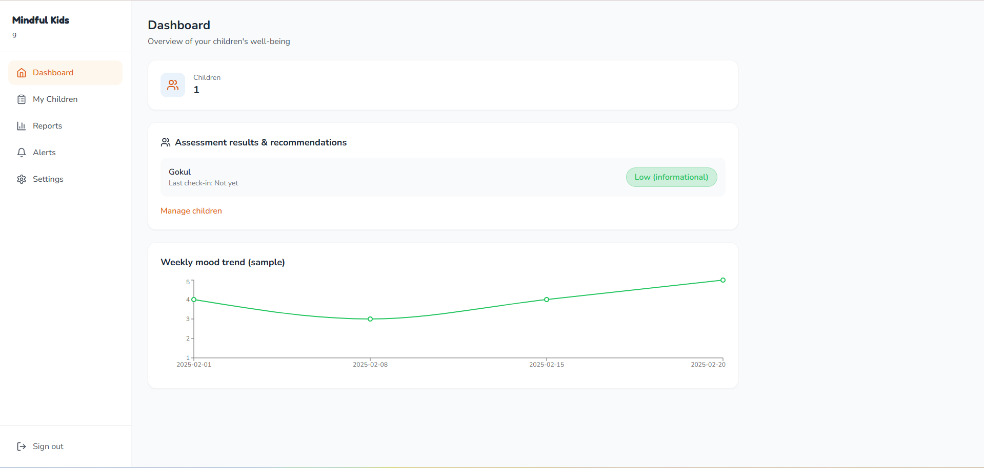 Figure 4.2 Parents Dashboard

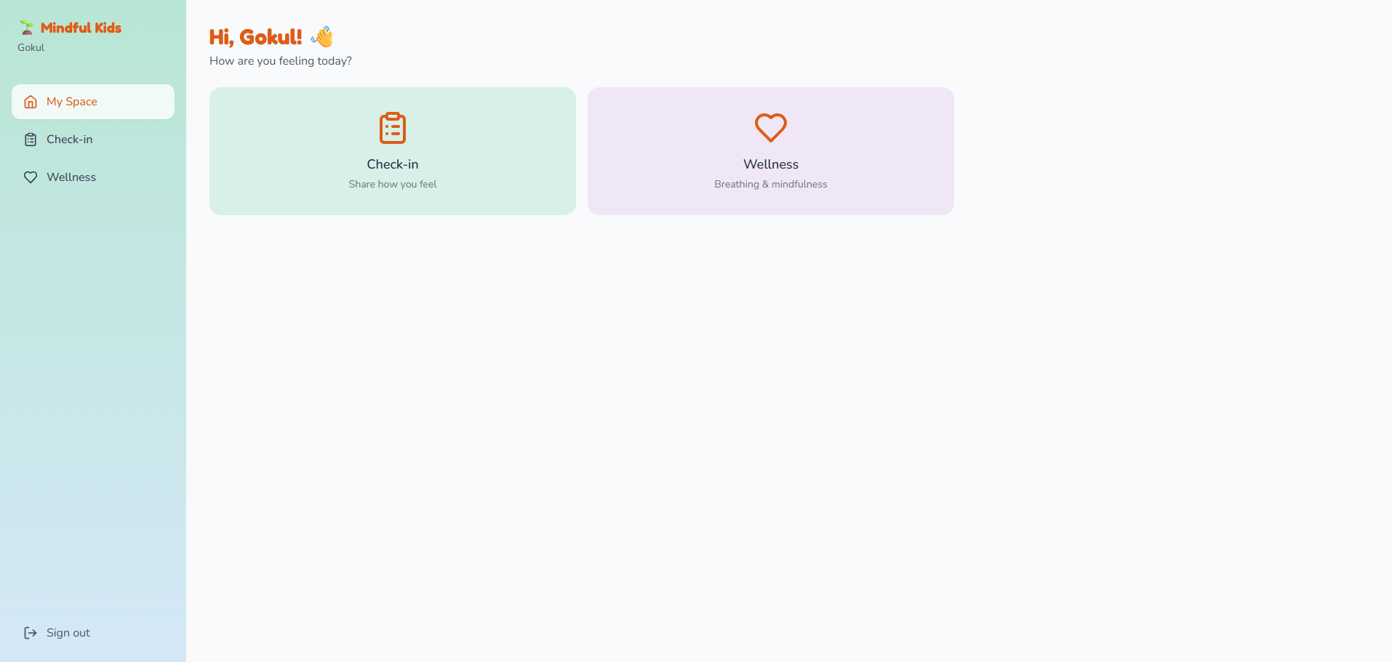Figure 4.3 Children Dashboard

Emotional Assessment and System Response Time
The performance of the emotional assessment module was evaluated based on the time taken by the system to process the responses to the questionnaires and generate the emotional risk classifications. The system uses a score-based evaluation model that analyzes the responses provided by the children through the structured questionnaires. The system was able to process the data from the questionnaires and generate the risk levels for the children within a few seconds. When the children submit the questionnaires, the system calculates the average score and determines the emotional risk level by classifying it into one of the three levels: low risk, moderate risk, and high risk. The system then updates the dashboard and provides the necessary recommendations according to the risk levels. In most cases, the entire process was completed by the system within a couple of seconds.
The response time is very important for a seamless user experience, especially considering that both children and parents will be using the system frequently. From the results of the testing, it is evident that the system is able to give quick responses and update emotional trend reports without any delays.

User Data Privacy and System Security
The privacy and security of children's emotional data were a critical requirement during the development of the system. Since the system deals with critical information about children's emotional well-being, security measures were put in place to prevent unauthorized access and maintain the security of the data.
The system provides a secure way of authenticating users and controlling access to the system. Children are allowed to participate in emotional assessments, parents are allowed to view emotional reports about their children, and the administrator is allowed to view aggregated analytics without access to individual users' data.
The system also provides a way of obtaining parents' consent before children are allowed to participate in emotional assessments. Emotional assessment data is stored securely in the database and retrieved through authorized API calls.
Security testing proved that the platform provides adequate security for the data of the users from unauthorized access. The implementation of the authentication mechanism provides adequate security for the emotional data of the users.

User Accessibility and Feedback
Usability testing was also carried out to test the usability of the web application. A group of users was chosen to test the usability of the system. The users were composed of children and parents. The usability test was conducted to check if the users could easily use the system. The test was conducted to check if the system was user-friendly and if children could easily fill out emotional questionnaires. The test also showed that children could easily express their emotions using the use of emojis. The parents also found the use of the dashboard and the graphical reports to be quite simple and informative.
The parents also mentioned that the wellness activities provided within the system were quite useful. The activities were quite helpful in improving the emotional well-being of the children. The navigation of the system was also quite simple. The usability test showed that the system was quite user-friendly and could be used by both technical and non-technical users.

Comparative Analysis with Traditional Monitoring Approaches
In order to assess the efficacy of the proposed system, the features proposed in the system have been compared with traditional methods that are used in monitoring the emotional well-being of children. Traditional methods, like manual observation and counseling, are not always effective, as they involve intermittent evaluation.
When comparing the proposed system with traditional methods, it can be said that there are several benefits. For instance, in traditional methods, manual observation and counseling involve intermittent evaluation, whereas in the proposed system, emotional state evaluation is made through digital means, thus making it continuous. Emotional state trend visualization provides parents with an opportunity to observe emotional state trends.
Furthermore, the integration of wellness activities within the platform ensures that there is proactive support that promotes healthy emotional habits in children. It is worth noting that traditional monitoring methods have always focused on identifying problems, not preventive emotional wellness habits.
The comparative analysis has shown that the Mindful Kids system offers an extensive and interactive approach in emotional monitoring. This is due to the integration of emotional monitoring, parental supervision, wellness activities, and visual reports.

SIGNIFICANCE, STRENGTHS OF THE PROPOSED WORK
The proposed Mindful Kids – Mental Health and Well-Being Surveillance, Assessment, and Tracking System for Children is a meaningful contribution to the field of digital mental health monitoring. The system is intended to provide early awareness of emotional health by incorporating emotional assessment tools, well-being activities, and parental surveillance into a single platform. The proposed system addresses various challenges associated with traditional emotional monitoring tools by presenting a constant means of tracking emotional patterns while ensuring ethical and privacy guidelines are observed.
One of the most significant advantages of the proposed system is that it focuses on early emotional awareness. Unlike traditional mental health monitoring tools that only concentrate on emotional diagnosis after symptoms are apparent, this system focuses on emotional check-ins. The system enables children to regularly report their emotional states by responding to a series of questionnaires. By regularly checking their emotional states, parents are able to become aware of potential emotional changes at an early stage. The early awareness is likely to prevent emotional changes from becoming severe over time.
Another strength of this system is that parents are able to be involved through supervision. The system is able to ensure that children are only able to participate in emotional assessment after obtaining permission from parents. This is a strength in that parents are able to be actively involved in ensuring that data is handled well. Parents are able to access information on emotional trends through graphs and risk levels through the parents’ dashboard.
Parents are able to understand more about children’s emotional development through recommendations provided by the system. The system is able to ensure that children are able to participate in activities that promote positive mental health through interactive wellness activities. The activities are able to promote positive mental health through breathing exercises and mindfulness activities. This is a strength in that children are able to be encouraged to participate in activities that promote positive mental health.
Another strength associated with the proposed system is its user-friendly interface. The interface has been made such that children and parents can easily use it. For instance, the use of emoji-based response systems has been incorporated to ensure that children are able to participate in emotional assessments without any confusion. Additionally, parents are able to easily understand emotional trends through graphical visualization techniques such as charts. The simplicity associated with the interface ensures that users are able to interact with the system comfortably, irrespective of whether they are technically inclined or not.
Another strength associated with the proposed system is its scalability. The system has been made modular such that different components such as questionnaires, reporting systems, wellness activities, and analytics are able to function independently while being integrated into the system. This means that in future, additional features such as mobile applications and integration with health monitoring systems can be added to the system.
Another notable advantage is that the system is privacy-aware. This is because the system deals with emotional information concerning children. As such, there are adequate security features in place to ensure that user privacy is well catered for. For instance, access control is role-based to ensure that users only access information related to their role. Additionally, administrative users are only allowed to view aggregate and anonymized information. This is to ensure that user privacy is well maintained while still being able to analyze trends concerning emotional well-being.

Moreover, the system shows efficiency and responsiveness. For example, the system is able to process question responses quickly and update emotional reports in real time. This shows that users are able to interact with the system smoothly without any delays.

LIMITATIONS OF THE PROJECT
Although there are some benefits in using the Mindful Kids – Mental Health and Well-Being Surveillance, Assessment, and Tracking System for Children, there are also some limitations that have to be taken into account. Knowing these limitations is significant in understanding the current state of the project and how it can be improved in the future.
The first limitation that can be pointed out in the system is that, in assessing the emotional state of the child, it is based on how they respond to the questionnaire. Since the emotional state is based on how the child answers the questions, there is a possibility that the results might not be entirely true depending on how honestly they answer. Younger kids might not totally comprehend some of the questions, and they might only answer based on how they feel at that moment, not on how they truly feel.
Another limitation is that the system is based on supportive monitoring and not on professional psychological diagnosis. The risk levels on the system are based on simple calculations using scores from the questionnaire. Although these risk levels may help in detecting potential emotional issues, they cannot be used as a replacement for professional diagnosis by psychologists. Therefore, the system is best used as a supportive monitoring system, promoting awareness.
Another limitation is based on the use and participation of the children. For the system to be effective, the children must be consistent in their use and must take emotional checks regularly. If a child is not consistent in taking the questionnaires, the system may not be effective in analyzing the emotional trends.
The second limitation is related to the interpretation of the data. The emotional state of the children may be influenced by various factors. For instance, the school environment and the conditions of the children’s homes could be among the factors. Additionally, the emotional state of the children could be influenced by their social interactions and their personal experiences. The system is based on the children’s responses to the questionnaires and does not consider the various factors that might influence the emotional state of the children.
The platform is based on the web application. Therefore, the accessibility of the platform is based on the availability of the internet. There might be challenges related to the efficiency of the system in regions where the internet access is low.
Furthermore, the system presently supports basic emotional assessment criteria based on pre-defined questionnaires. Though the method ensures simplicity and ease of use, it may not be able to cover the full range of complexities of human emotions and the various psychological changes that might develop over time.
Lastly, the matter of data privacy and security is an ongoing concern for digital systems that carry sensitive user data. Though the system provides mechanisms for authentication, access control, and parental consent, it is important to constantly monitor and upgrade the system to keep it secure against various cybersecurity threats.

COST-BENEFIT ANALYSIS
The cost-benefit analysis assesses the overall feasibility of the Mindful Kids – Mental Health and Well-Being Surveillance, Assessment, and Tracking System for Children in terms of its value. It compares the development cost of the system with the overall benefit derived from using the system in terms of emotional surveillance, awareness among parents, and prevention of mental health issues among children. It helps evaluate whether the development of the system was justified in terms of the overall benefit it provides.
The development of the proposed system utilized open-source technology and development tools, which helped reduce the overall development cost of the project. Technologies used in the development of the web interface of the proposed system include React, Node.js, Tailwind CSS, and Recharts. Since these are open-source technologies, there were no additional costs associated with using these tools and technologies in software development.
Most of the resources that were used in the project were related to research, system design, development, and testing. These resources were necessary for designing emotional assessment questionnaires, system architecture, role-based access mechanisms, and data handling. Considering that most mental health monitoring systems need expensive software and specialized tools for monitoring, the cost of developing the system is still very low.
Another significant aspect that contributes to the reduction of the overall cost is that the system does not need any specialized hardware and computational resources for running. The system is a web application that can be run on any device, such as a laptop, a tablet, or even a smartphone, as long as it is connected to the internet.
From a benefits point of view, there are various benefits associated with this system that make its cost of development justified. The first and foremost benefit is its ability to facilitate continuous emotional well-being monitoring for children in a simple manner. By helping children participate in emotional well-being regularly through this system, parents are able to become aware of any changes in children's emotional well-being and take steps to address these changes in a timely manner.
Another important benefit associated with this system is its ability to improve communication between children and parents regarding emotional well-being. By providing parents with reports on children's emotional well-being through this system, parents are able to take steps to address any issues related to children's emotional well-being in a timely manner. This is particularly useful in ensuring that children's emotional well-being is not compromised unknowingly.
The inclusion of various wellness activities such as breathing exercises is useful in providing additional benefits to children by encouraging them to follow healthy emotional well-being habits. By including these activities within the system, it is no longer simply a monitoring system but a digital environment that promotes healthy emotional well-being habits.
The platform is also created with scalability and flexibility in mind. This is because the system uses a modular architecture and web technologies. This means that the system can be expanded in the future to include other features such as a mobile app, analytics, the educational system, and mental health professionals. This increases the utility of the platform over time.
In terms of cost-effectiveness, the system provides a solution for families, educational institutions, and wellness programs that need a cheap solution for emotional well-being monitoring. This is because the system is cheap to deploy due to the fact that it uses a minimal infrastructure and open-source technology. The system is also improved over time through the use of version control.

CHAPTER V
CONCLUSION AND FUTURE WORKS
The Mindful Kids – Mental Health and Well-Being Surveillance, Assessment, and Tracking System for Children has been created to respond to the ever-increasing demand for digital tools that can help track the emotional health of young children at an early stage. The system has incorporated emotional assessment, parental supervision, emotional well-being activities, and visualization into a secure web application that is child-friendly. The system has been designed to allow young children to express their emotional states regularly and for parents to track emotional patterns. The system has been created to raise emotional awareness among young children and encourage supportive action when necessary.
The project has shown that it is possible to use web technologies and emotional assessment tools to provide a system that can be used to track the emotional health of young children. The system has been developed to ensure that data is handled responsibly by incorporating ethical considerations into its implementation. The system has been designed to provide a solution that can be used to track emotional patterns among young children.

CONCLUSION
The results achieved from the development and testing of the proposed Mindful Kids system indicate that it successfully accomplishes its purpose of creating a supportive digital environment that monitors the emotional well-being of children. The system allows children to participate in a structured emotional check-in process by simply answering questionnaires while at the same time offering parents significant insights into their child's emotional well-being through visualizations.
The results from testing the system indicate that it is able to process answers from questionnaires and produce emotional risk classifications within a short time. The inclusion of emotional trend visualization enables parents to track changes in their child's emotional state over time, which could help identify potential emotional concerns at an early stage. The system's parent dashboard also enables consent management and monitoring features that ensure ethical participation of children.
The feedback collected from users during the usability test showed that the system interface is easy to comprehend. The emotional assessment was conducted by the children without facing any difficulties due to the use of a simple rating system and visual aids like emojis. The feedback from parents showed that the graphical reports helped them gain better insights into their child’s emotional state. The results show that the system is user-friendly for both technical and non-technical users.
The addition of activities like breathing exercises and mindfulness is a great addition to the system as it helps the child learn healthy habits. The system is not only limited to emotional assessment but also helps provide emotional support to the child.
However, despite its effective functionality within its current limits, some drawbacks are present. The emotional assessment is dependent upon self-reported feedback, which may have some implications for accuracy. The system is also designed to give supportive insights rather than a professional psychological assessment. Despite this, it is clear that the proposed system has great potential as a preventative mental health monitoring system that could be of great use to parents who want to better understand their child's emotional development.
In conclusion, it is evident that the Mindful Kids platform is a viable solution for emotional well-being among children. The system's inclusion of emotional assessment, parental supervision, and wellness activities makes it a valuable contribution to digital mental health support technologies.

SUGGESTIONS FOR FUTURE WORK

Advanced Emotional Assessment Techniques
The future versions of the system may also employ advanced techniques in assessing emotions. For instance, additional behavioral factors may be taken into consideration in assessing emotions. These may include activity patterns or levels of engagement.

Mobile Application Development
The current implementation of the system is a web-based application. It may be beneficial to develop a mobile application. A mobile application may greatly benefit the users of the system. It may enable parents and children to have an easier time accessing the application.

Integration with Educational and Counseling System
The future versions of the system may be able to integrate with educational systems or counseling services. Such integration may enable educators or counselors to have a better understanding of the emotional status of the children.

Enhanced Data Analytics and Predictive Insights
The system could be further developed to include advanced data analysis techniques that will allow the analysis of emotional trends more accurately. Machine learning could be employed to analyze emotional data and offer predictive insights that will aid parents and caregivers in the identification of potential emotional issues at an early stage.

Expansion of Wellness and Support Modules
The system could be further enhanced to include more wellness features that will offer more support to children. This could be achieved by adding more features to the wellness modules, including meditation sessions and emotional learning modules.

REFERENCES

- J. M. Fernández-Batanero, M. Montenegro-Rueda, J. Fernández-Cerero, and I. García-Martínez, “Effectiveness of digital mental health interventions for children and adolescents: A systematic review,” Children, vol. 12, no. 3, pp. 1–18, 2025.
- S. Liverpool, C. McDonagh, J. Feather, C. Uzondu, M. Howarth, and C. Foster, “Digital mental health interventions for children and young people: Systematic overview of reviews,” European Child & Adolescent Psychiatry, vol. 34, pp. 1–14, 2025.
- T. Chen, Y. Zhang, and H. Liu, “Promoting mental health in children and adolescents through digital technology: A systematic review,” Frontiers in Psychology, vol. 15, pp. 1–12, 2024.
- E. T. Welsh, A. R. McCaffrey, and M. Johnson, “Design considerations for digital mental health platforms for families and young people,” Journal of Medical Internet Research, vol. 26, pp. 1–15, 2024.
- S. Boege, M. Schaub, and A. Wenger, “Mood-monitoring applications for youth mental health: Protocol for a systematic review,” JMIR Research Protocols, vol. 13, pp. 1–10, 2024.
- A. O’Leary, M. Walsh, and J. Browne, “Using wearable digital devices to screen children for mental health conditions: Opportunities and ethical challenges,” Sensors, vol. 24, no. 10, pp. 1–18, 2024.
- O. A. Stein and L. Patel, “Societal implications of digital mental health technologies,” Digital Health and Society, vol. 2, no. 1, pp. 45–59, 2024.
- K. Di Pierdomenico et al., “Universal digital mental health interventions for children and adolescents: Evidence and future perspectives,” Child and Adolescent Psychiatry and Mental Health, vol. 19, pp. 1–14, 2025.
- B. M. White, R. Prasad, N. Ammar, and A. Shaban-Nejad, “Digital health innovations for screening mental health impacts of adverse childhood experiences,” Journal of Digital Health Research, vol. 3, no. 2, pp. 50–62, 2025.M. Asif, S. Mishra, A. Sonker, S. Gupta, and S. Maurya, “Proactive emotion tracker: AI-driven continuous mood monitoring,” arXiv preprint arXiv:2401.13722, 2024.
- D. B. Olawade, O. Z. Wada, A. C. David-Olawade, and A. O. Ige, “Artificial intelligence in mental healthcare: Current trends and future directions,” Frontiers in Digital Health, vol. 6, pp. 1–14, 2024
- S. Torous and J. Wisniewski, “Digital mental health and artificial intelligence: The future of mental healthcare,” The Lancet Digital Health, vol. 4, no. 6, pp. e395–e396, 2022.
- P. Lattie, A. Stiles-Shields, and D. Graham, “An overview of and recommendations for more accessible digital mental health services,” Nature Digital Medicine, vol. 5, pp. 1–7, 2022.
- R. Hollis et al., “Technological innovations in mental healthcare: Harnessing digital tools for youth mental health,” The Lancet Psychiatry, vol. 8, no. 8, pp. 698–709, 2021.
- L. Torous, J. Bucci, and I. Bell, “The growing field of digital psychiatry: Current evidence and future directions,” World Psychiatry, vol. 20, no. 3, pp. 318–335, 2021.
- S. Wasil, S. Gillespie, and J. Patel, “Harnessing digital technology to improve mental health services for youth,” Annual Review of Clinical Psychology, vol. 18, pp. 1–24, 2022.
- K. Mohr, M. Riper, and M. Schueller, “A solution-focused research approach to achieve an implementable revolution in digital mental health,” JAMA Psychiatry, vol. 79, no. 2, pp. 1–3, 2022.

APPENDICES
I. BILLS OF MATERIALS
Due to the fact that only coding is used, there is no expense. Only the service cost, which would be the absolute least, is taken into account because my project doesn't include any components. Because of this, I declare it to be free.
II. PUBLICATION CERTIFICATE
GOKUL KUMAR R




CHOLAATHIRAJ M S




HARI PRASATH S



III. PUBLICATION PROOF
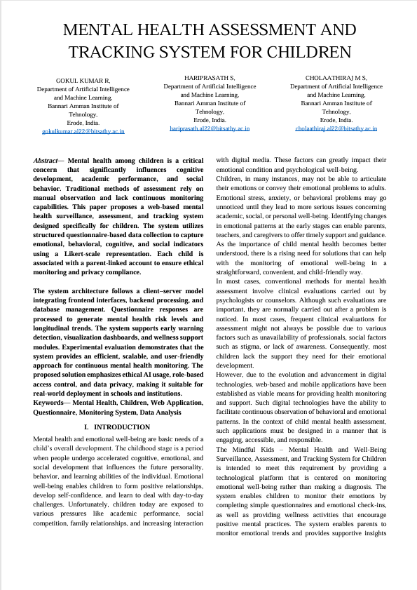

IV. WORK CONTRIBUTION
MEMBER 1: GOKUL KUMAR R
Responsibility: Backend Developer – Developed the backend services and implemented the emotional assessment logic. Handled the database and API integrations for the system.
- Week 1: Examine the existing digital mental health monitoring systems. Different ways of collecting emotional well-being data from children were also explored. Backend requirements for the system were also examined.
- Week 2: Designed the backend architecture of the system. Planned the APIs that will be integrated into the system. APIs include user authentication, questionnaire submission, emotional risk calculation, and report generation.
- Week 4: Implemented the backend modules for the system. Implemented the user authentication and role-based access control (child, parent, admin). Designed the database models for the system.
- Week 5: Implemented the emotional risk calculation module. Implemented the APIs for processing emotional data. APIs were integrated for the backend of the system.
- Week 6: Optimized the performance of the backend. Optimized the database queries and APIs. Implemented the validation mechanisms for the system.
- Week 7: Tested the backend modules. Tested the APIs using different input scenarios. Tested the smooth communication between the front and backend.
- Week 9: Backend integration with the frontend system was done. Logging mechanisms were put in place. Error handling was improved to ensure the system operates properly.
- Week 10: Debugging was done. Issues that were present with regard to API communication were addressed.
- Week 11: Helped with the testing of the system. Documentation of the backend system, including the API and explanation of the system architecture, was done.
- Week 12: Helped with the demonstration of the project. The backend system functionalities were explained during the final presentation.
MEMBER 2: CHOLAATHIRAJ M S
Responsibility: Frontend Developer – Created the user interface, dashboard, questionnaire modules, and graphical reports for the application.
- Week 1: Conducted research on user interface design guidelines for children-based applications and analyzed existing mental health monitoring application interfaces to obtain inspiration for our application's interface.
- Week 2: Created wireframes and layouts for the system's user interface, including login interfaces, dashboards, questionnaire modules, and reports.
- Week 4: Created the user interface for the application using React.js and Tailwind CSS. Created a responsive user interface to accommodate various screen sizes.
- Week 5: Created a user interface for the application's questionnaires using an emoji-based Likert scale to enable children to easily select emotional reports.
- Week 6: Created a graphical user interface to display charts and trend graphs to present emotional reports to parents.
- Week 7: Enhanced user interaction with the application by improving navigation and page transitions to ensure a seamless user experience.
- Week 9: Integrated various frontend components with backend APIs to allow for real-time processing of emotional assessments and updates to reports.
- Week 10: Undertook interface testing to ensure that both children and parents could use the interface as desired.
- Week 11: Improved the interface design after interface usability feedback and enhanced accessibility features.
- Week 12: Helped prepare the final project presentation and presented the user interface as well as the system interaction workflow.
MEMBER 3: HARI PRASATH S
Responsibility: System Integration and Testing – Responsible for integrating system modules, conducting system testing, and ensuring overall system performance and reliability.
- Week 1: Learnt about various approaches to system integration and testing strategies that can be applied to web-based systems.
- Week 2: Prepared a testing plan and identified various key system performance indicators such as system usability, response time, and system reliability.
- Week 4: Assisted in integrating frontend and backend system modules to ensure efficient data communication between system modules.
- Week 5: Conducted functional testing on various features of the system such as login authentication, submission of questionnaires, and generation of reports.
- Week 6: Conducted performance testing to assess system response time and dashboard update speed.
- Week 7: Conducted testing on notification and alert systems to ensure parents are notified when emotional risk levels are high.
- Week 9: Completed user testing with sample users to test the accessibility and usability of the system.
- Week 10: Identified bugs in the system and helped in fixing integration bugs related to data flow and navigation.
- Week 11: Completed reports on testing and provided a summary on the evaluation of the system.
- Week 12: Assisted in conducting final testing on the system, documentation, and demonstration.

V. PLAGRASIM REPORT:
