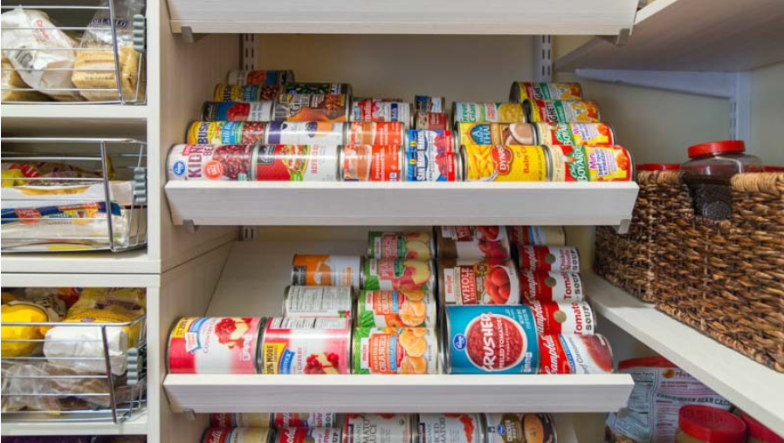

|  |
| --- |
| ABC Pantry |
| Business requirement Document |

Simplilearn BA Capstone Project:

*Submitted by*

*Ravutla Goutham Ravi Kumar*

|  |
| --- |
| Table Of Contents |
| 1. Project Tasks |
| 2. Project Overview |
| 3. Requirements Classification schema |
| 4. Knowledge Area Implementation |
| 5. Techniques |
| 1. Process maps |
| * Current State As-Is process |
| * Future State process |
| 1. Process Modelling |
| * Use Case Diagram |
| * Context Diagram |
| 1. Scope Modelling |
| * Product In-scope and Out of scope |
| 1. Data Modeling |
| * ER Diagram |
| 1. Activity Diagram |
| 1. Swim Lanes |
| 1. Mock Screens for proposed feature |
| 6. Product Backlog |
| 7. Tableau Workbook with Dashboard |
| 8. Excel Workbook |

## 1. Project Tasks:

|  |  |  |
| --- | --- | --- |
| S.No | Tasks | References |
| 1 | Identifying stakeholders – Create a list of stakeholders (as taught in Business Analysis Planning and Monitoring Knowledge Area) | * Figure 1: Stakeholder Map via Stakeholder Matrix. * Figure 2: Onion Peel Diagram * Table 3: Applied BA Knowledge Areas |
| 2. | New feature implementation & Enhancements to be made in this application | * Table 1: BACCM |
| 3. | Identify objectives of the new feature. | * Table 1: BACCM |
| 4. | Create as-is and future process map (using flowcharts) | * Figure 4: Current State Process * Figure 5: Future State Process |
| 5. | As a Business Analyst working on this project, find out the scope of the feature .To find the scope you can use the case diagram (UML) or context diagram for the same. | * Figure 6: Process Modelling using Use case Diagram (UML) |
| 6. | Write down the main feature components that need to be developed. | * Table 4: High-level Components that needs to be built |
| 7. | Write the in-scope and out-of-scope items for this software. | * Table 5: Product In-scope & Out of Scope |
| 8. | Draw an activity diagram for the system. | * Figure 9: Activity Diagram for Waiters/Managers |
| 9. | Draw an ER diagram of the system. | * Figure 8: Data Modelling using ER Diagram |
| 10. | Write out the business requirements, both the functional and nonfunctional requirements. | * Table 2: Requirement Classification Schema |
| 11. | Draw wireframes or mock screens for any two of the features namely Menu Creation and any other feature as deemed fit by the student. | * Figure 10: Waiter order creation Mock screens * Figure 11: Menu Creation Mock screens |

## 2. Project Overview

* Introduction:

ABC Company is the world’s leading online e-commerce company. They started by selling books and now have a presence across the world selling more than 6 million items globally.

Most of the products that dominate ABC Company’s sales are non-essential products like fashion products, electronic gadgets, mobile phones, beauty products, books and home furnishings. ABC Company has realized that every household will need daily essential products like cereals, snacks, beverages, cleaning products, grooming products and so on.

* BACCM Model

Captured the overview of project based on Conceptual framework of **Business Analysis Core Concept Model** (BACCM)

|  |  |
| --- | --- |
| Business Need | ABC Company is seeing a huge market globally in Daily Essential Products and wants to venture into this side of business.  ABC Company decided to create a new feature known as ABC Pantry which would sell daily essential products. This would be an additional enhancement in the current website/app. This would be ABC Company’s foray into daily essential products which are regular consumption products and would lead to repeat sales every month.  Needs identified in introducing pantry services feature into ABC company’s app.   * Enhancement of company’s app by introducing pantry feature. * Pantry feature should serve regular customers as well as acquire new ones. * Huge global market in Daily essential products. * Online purchasing among customers have been growing in groceries segment. * Currently no leading e-commerce company is in Daily essentials market. * New enhancement should make customer make repeat sales across month. |
| Change | * Existing system should have a new feature called ABC Pantry * This feature should be at a prominent visible area of existing app. * Categories of products are grouped together to search. * Logical grouping of products for customers to search and buy * ABC Pantry should be able to show advertisements. * Pantry should have feature to show offers. * Daily reports at the end of the day. |
| Solution | ABC pantry feature should be added as the enhancement to existing mobile application of ABC company. It allows customers to place orders of daily essential items along with non-essential items. It helps customers to place their groceries at the comfort of their home and get them delivered to their home directly. It also facilitates users to use offers they get to save part of their expenses. |
| Stakeholders | Figure-1: Stakeholder map via stakeholder matrix |
| Value/Objectives | * ABC Pantry feature in existing mobile application may act as a foray into daily essential goods market. * With regular consumption of essential goods, customers would lead to repeat sales every month. * Easy searching of products in mobile app due to logical grouping of products according to categories. * Generating advertising revenues by showing poster advertisements of the stores integrated in the pantry feature itself. * Customers can add to cart & purchase any item from either non-essential items or daily essential products or both at the same time in one complete order. * Management can target the sales to specific set of cities based on data from zonal division of cities according to highest sales done. * Many reports can be generated as required by management based on the orders made on daily essential products from different cities in categories accordingly. |
| Context | This is for a world’s biggest leading e-commerce platform company which stared of by selling books and now has global presence selling more than 6 million items globally. Most of the products that are sold in this e-commerce platform are non-essential products. But there are whole other essential products for household that the company is looking to foray into because household items market is a huge market. So ABC is decided to create a market place for daily essential goods by creating a feature into its existing e-commerce application which helps customer to place the essential items order in itself. |

## 3. Requirements Classification Schema:

*Table:2 Requirements Classification*

|  |  |
| --- | --- |
| Business Requirements  Why did company want it? | Stakeholder Requirements  What are the needs? |
| * ABC Company is the world’s leading online e-commerce company. They started by selling books and now have a presence across the world selling more than 6 million items globally which are only non-essential products. Non-essential products include fashion products, gadgets, cosmetics, books, home furnishings etc. * But it has seen huge upside in market potential of online purchasing for essential goods that every household will need, which are regular consumption products globally. * Now ABC decided into to currently, majority of market is occupied by big players like big basket, Jio Mart, Grofers and rest is of small scale players like Best Price, Spencer’s. * Now ABC pantry is looking to digitalize the purchases of essential goods along with non-essential items in one place which could lead to customers making repeat sales every month. * They realized this new venture would be an additional enhancement of their global mobile application. Along with it, management can target the sales to specific set of cities based on data from zonal division of cities according to highest sales done. * Many reports can be generated as required by management based on the orders made on daily essential products from different cities in categories accordingly. * Feedback from customers reviewing the service provided by this new venture can be identified from reports. | For new feature enhancement, company should maintain these below:   * Separate pantry section at the sellers for essential products at different geographical locations which covers the delivery services for whole city. * Create a norm to update the inventory frequently at the backend to maintain the status of availability of the essential goods in the platform for customers. * Delivery team should differentiate separate only essential goods order and deliver them as per the specified date and time without any delays. * All the packaged essential items are revised in frequent intervals about the expiry dates,   remove from pantry if found any and update the stock availability in platform.   * Management reports for the end of each day   Like sales of each day.   * Report of sales in each product category, Total sales across all cities and across USA and weekly numbers. * Sales report according to each zone that city falls into. * Sales of whole US is categorized into 4 zones in which cities with highest sales falls under zone1. Management should get interim repost of cities falls under which zones. * Reports of best & worst selling categories.   For feature enhancement, platform should maintain:   * Clear description of data of the essential goods including expiry date and delivery date and time along with customer availability at the given location. * Each bill generated should have clear separation of essential goods and non-essential goods * Logical grouping of all products for customers for daily essential items wish to buy. |
| Solution Requirements  What does company want ? | Transition Requirements  What are the conditions? |
| Functional Requirements:   * New feature ABC Pantry is the solution enhancement to the existing mobile application. * It should be placed at a prominent position in the app so that customers can easily notice. * On clicking the Pantry Icon in the app, a pantry home page should appear which displays the logical grouping of products according to categories. * Each group should contain wide varieties of products from preferred brands. * Categories of products include 1. Flour and rice, 2. Sugar, Salt and Spices, 3. Pulses, 4. Personal care, 5. Snacks, 6. Hand wash and Sanitizers, 7. Household cleaning essentials, 8. Breakfast food items, 9. Tea and Coffee, 10. Baby care, 11. Female Hygiene, 12. Tissues and fresheners. * Pantry home page should show five label advertisements which displays on screen for 3 seconds or can be swiped to view them. * Below the advertisements section in homepage, there should be current offers like seller offers, payment offer & discounts, cashback offers, product discounted offers, delivery offers etc. section where list of the offers that are going on different categories of products. * Customer should be able to add both non-essential items along with essential items into the cart and place them as well simultaneously in a single order. * Panty feature should not allow users to place order below 30$ value of essential products which means the proceeding to payment only done when essential goods order value exceed 30$. * Cart should allow individual items below 30 $ to add to it without any issues. * Delivery section determines the order is qualified for free delivery. If order value is less than 50 $ and above 30$ then order is not qualified for free delivery. * Only orders above 50$ value are qualified for free delivery. * Management should get detailed reports of following: * Total orders and product sales for each day. * Total sales for each product category. * Total sales across USA. * Total sales for each city. * Total sales for each zone that city falls into (that is, zone 1, 2, 3, and 4) * Using above details analysis should be done to identify best-selling and worst-selling categories. * Total sales of each week city wise * Identification of which day of the week shows highest booking by customers by using sales and orders done on each day of the week. * Recommendations and suggestions based on past orders.   Non Functional Requirements   * **Usability**: Screens should be easily understood by customers and have to be self-explanatory. * **Scalability & Performance:** Pantry feature should be scalable to handle multiple orders at a time due to frequent order placements could be done by customers. * **Availability:** New functionality should be available at all times with updated information of products in real time. * **Security:** Customers data should be secured as the purchasing behavior of essential goods of customers should be protected at all times. | * There is no separate cart to be maintained for the essential goods. All categories of products should be ordered from same cart at one go. * Essential goods should be valued minimum 30$ in an order. * Categories of products are grouped together to search. * Logical grouping of products for customers to search and buy * ABC Pantry should be able to show advertisements. * Pantry should have feature to show offers. * Daily reports at the end of the day to assess the orders trend across cities, zones, country level. |

## 4. Knowledge Area Implementation:

*Table:3 Applied BA Knowledge Areas*

|  |  |  |  |
| --- | --- | --- | --- |
| **Business Analysis Planning & Monitoring** | | | |
| **KA Tasks** | | **Task Details** | |
| **BA Approach** | | Adaptive |  |
| **Formality and Level of Detail of Business Analysis Deliverables** | Solution Definition | Defined in iterations to arrive at best solution or improve an existing solution |  |
| Level of Formality | Informal—information is gathered through team interaction and feedback. |  |
| Activities | * Activities will be divided into iterations with deliverables first and then the associated tasks are identified. * The work in each Iterations will be prioritized & planned based on the agreed Product roadmap. * The Product Roadmap will be reviewed quarterly to capture any changes in priorities. |  |
| Timing | Tasks are performed iteratively |  |
| **BA Activities** | | * Analyze business needs * Define a business case * Elicit information from stakeholders * Collaborate with the Stakeholders * Prioritize the Requirements * Define Future State * Model requirements * Validate solutions * Project management * Project development * Quality testing | |
| **Timing of Business Analysis Work** | | BA tasks will be performed iteratively over the course of the initiative. | |
| **Complexity and Risk** | | * Computer operating skills & training for the backend maintenance of the inventory. * Changes in Requirements & Scope in the middle of Iterations (i.e. Scope creep) * Delay in updating the feature functionalities and QA.. | |
| **Acceptance** | | Business Acceptance Testing for each Planned Release will be used as the Stakeholder signoff. | |
| **Identify Stakeholders** | | **Product Stakeholders:**  **External**   * Customer * Sellers * Suppliers * Delivery fleet * Inventory manager   **Business Analyst**  **Internal**   * ABC management * Project Sponsor * Employees * HR * Domain and Implementation Subject Matter Expert * Project Manager * Developer * Tester * Operation Support | |
| **Stakeholder Engagement & Collaboration** | | **Sprint/Iteration Review Meetings** – At the end of each Sprint Stakeholders closer to the Solution delivery will meet to discuss what was done as part of the Sprint. What work was completed and what was not completed and was carried over to the next Iteration.  **Weekly / Bi- weekly connects -** With the Business & Technology to clarify any doubts and/or solicit feedback on the work developed thus far.  **Sprint/Iteration Planning Meetings –** Discuss & Decide what work or tasks will be taken up by the Technology team for the upcoming sprint/iteration.  **Backlog Grooming Sessions –** To Prioritize the Product Backlog and ensure that the necessary work required for the Product development is captured  **Quarterly Planning Sessions** – With the Stakeholders to discuss overall progress of the Product, resolve any Stake holders concerns or conflicts, Evaluate & adjust the product delivery timeline in case of any risks or delays identified. Discuss any next steps to resolve any immediate conflicts & concerns, Readjust the Product Roadmap if required, Discuss Business & Stakeholder requirement priorities. | |
| **Elicitation & Collaboration** | | | |
| **KA Tasks** | | **Task Details** | |
| **Requirements Elicitation** | | Weekly Meetings with Stakeholders to:   * Generate Ideas and discuss the Requirements. * Reiterate on Requirements understanding. * Review the High-level or detailed documented Requirements * Review the Modeled Requirements and solicit feedback * Prepare & Review Dummy mockups for the system * Discuss any complexities or risks   These meetings should align with each Iteration and should focus on feature capabilities being developed in the upcoming Iterations. | |
| **Communication Plan** | | Monthly Reports (Velocity Charts, Defect Reports, Scope Change metrics, Burndown Charts etc.)  Agile Dashboard reports  Project Status meetings  Release Plans. | |
| **Strategy Analysis** | | | |
| **KA Tasks** | | **Task Details** | |
| **Current State Analysis** | | * Since this is a new system there will not be any Current State Analysis of an existing system. * However, the current state analysis could be performed for the similar systems existing in the Organization for analyzing the Security Implementation Processes, Technological & Infrastructure Implementation, Architectural Vision. * External Stakeholder Analysis (e.g. Vendors, Suppliers) to understand if there are any Gaps in their cost model, processes, Manpower (skill level) & feedback. | |
| **Future State Analysis** | | * Define the Organization Structure for the Program * Define the Roles & Responsibilities in the Organization Structure * Define the High-Level Scope of the Program * Define the Product Delivery Timeline * Define the Product Roadmap for the Year * Define the Success Criteria at the Program level & Delivery level * Define the High-level Architecture of the Product. * Define the Business Architecture & Vendor Management Plan | |
| **Assess Risks** | | * Training the Staff in the correct usage of the system * Ensuring all the Orders Are packed & Delivered in time. * Order Delays due to large order volumes or incorrect or incomplete Customer information or Navigation error by the Deliverer etc. * Web Application availability or Application downtime. | |
| **Change Strategy** | | * Analyze if there are any Gaps with the current Suppliers, Vendors & Delivery fleet. * Identify how these gaps can be bridged. * What will be the cost on onboarding a Vendor or Supplier? * Identify if there are additional stakeholder groups that will need to involve like Enterprise data management group, Payroll, HR etc. | |
| **Requirement Analysis & Design** | | | |
| **KA Tasks** | | **Task Details** | |
| **Model Requirements** | | * Define the **System Level** Requirements:   **ABC Pantry:**   * + Users should be able to view ABC Pantry feature in Application home page.   + Pantry should be in a visible position when app is launched.   + When user clicks on pantry it should be redirected to Pantry home page.   + Users should be able to view and differentiate app home page from pantry home page.   + Pantry home should consist of advertisements pane above with 5 rolling labeled advertisements with a time limit of 3 seconds for every advertisement to display on screen.   + There should be a current offers feature inside the pantry below the advertisements pane.   + Logical grouping of categories of products as mentioned above should be displayed in home page below offers pane.   + Each product should contain detailed information including dimensions of packing, date of manufacturing, date of expiry, weight, price, MRP, offer price etc.   + Users should be able to add both essential and non-essential items to cart and place them in one order.   + Delivery details should be mentioned before proceeding to payments. * Define the **Subsystem Level** Requirements: * **Report generation:**   + Report of sales and orders done on each day should be generated and trigger email to concerned stakeholders.   + Entire sales reports of each of product categories for each day, week and month level should be generated.   + Creating automated visualizations of sales reports according to city level, zones level and country wide for future predictions.   + Based on the data obtained, reports should generate best-selling and worst-selling product categories and which day of the week shows highest bookings. * **Conditions in new System**   + Value of order of essential goods should be more than 30$ Inorder to proceed for payments. App won’t allow to place the order if it is below 30$.   + Free delivery should be mentioned in delivery details section only if the order value is greater than or equal to 50$. Only then order is qualified for free delivery.   + Orders value falls below 50$ and above 30$ should be having free delivery and should display delivery charge in delivery details section.   + Product stock should be updated in real time basis and displays the availability to users before placing them.   + Managers can enter customer feedback form information into the system. * **Admin System**   + Management should be able to extract sales reports.   + Sellers should be able to view their product sales in frequent intervals.   + Sellers should be able to view the availability of product in inventory to maintain the stock at all times. * Define the **Component Level** Requirements:   + User Login   + User Account Information   + Pantry feature integrated in app   + Advertisement pane   + Offers feature   + Categorization   + Delivery address information   + My Cart   + Order Processing – Delivery information, Update order status   + Reporting     - Identifying BI Tool   + Technology Stack:     - Application Authentication     - Application & Database Architecture     - Data Modelling     - Application framework     - API Contracts     - User Interface Design     - Application Monitoring     - Disaster Recovery Plan | |
| **Verify & Validate the Requirements** | | * Ensure Verification & Validation Plan is in place. * Verification & Validation of Requirements can be done at each of the Component Level, Sub-System Level & System Level. * Verify that the developed product aligns with the Specified Requirements (as specified in the Acceptance criteria). * Validate that the assembled sub-system or the solution meets the Business & Stakeholder requirements by doing the User Acceptance testing on the assembled product. * We should be able to trace the Component Level Design back to the System Level requirements supplied by the Stakeholder by the Verification Plan. * This way we can ascertain that the system is completely covered with respect to the Verification & Validation. | |
| **Define Design Options** | | * In house development(Build) vs contract it out to vendors.     Based on Cost, Security, Maintenance, Integration Complexities, Operational Support etc. | |
| **Analyze Potential Value & Recommend Solution** | | * **Build Pros**:   + Data Security   + Inhouse Maintenance   + Cost of Building   + Can Monitor the system runtime   + Quick resolution in the event of System downtime.   + Align with Organization Standards & Policies * **Build Cons:**   + More time to put into production   + Higher cost of Development & Maintenance * **Buy Pros:**   + Lesser time to put into production i.e. Plug and Use solution   + Minimum Maintenance liability   + Lesser Maintenance cost * **Buy Cons:**   + Less visibility into System Monitoring & Downtime.   + Higher turnaround time in an event of system downtime or failure.   + May not satisfy Organization Standards & Policies.   + Data Exchange.   + External & Internal System Integration   + Cost of Buying | |
| **Requirements Life cycle management** | | | |
| **KA Tasks** | | **Task Details** | |
| **Trace Requirements** | | * The Requirements level of abstraction can be broken down into Business Requirements, Stakeholder Requirements, Solution Requirements & Transition Requirements with each level providing more detailed view of the Requirements. This is achieved by the Requirement Classification Schema noted in the earlier section of the Document. * Additionally, the System can be divided at different levels to make sure that all the requirement specifications are covered, and the requirements can be traced to the most granular level. This can be done by breaking down the System into System Level Requirements which is a higher-level requirement provided by the Users, then the Sub-System Level & then the Component Level requirements. | |
| **Maintain Requirements** | | * Each Business & Stakeholder Requirement will go through the following phases:   Detailed Analysis, Design, Development, Functional testing, User Acceptance Testing, Performance Testing.   * Each Requirement in the backlog should have an Acceptance Criteria in consensus from the Stakeholders before moving to any active Sprint/Iteration. * The Sub-System level & Component level requirements should be defined such that each requirement can be tested mutually exclusive to the other Requirements and when integrated works in harmony with the other requirements * Ensure that the Requirement definition remains consistent throughout its lifecycle by keeping the User stories & documents updated. | |
| **Prioritize the Requirements** | | * Any changes to the Requirements will be logged as a new Requirement in the Agile dashboard and will have to go through Backlog grooming and Prioritization. * Priority of the Requirement should be defined by the Business Criticality and the Value it will impart to Business or stakeholders, any dependencies on the other processes. | |
| **Assess Changes to the Requirement** | | * Any changes to the Requirements will be logged as a new Requirement in the Agile dashboard and will have to go through Backlog grooming and Prioritization. * The changes to the requirement are updated in the User story documents. * Any known dependencies should be linked to the Requirement in the Agile Dashboard. * Any changes to the requirement should be traceable from the Original Requirement to the last change made to the Requirement. * Assess the Impact of the change to the Product or Solution delivery timeline, cost, synergy with the other associated components. | |
| **Solution Evaluation** | | | |
| **KA Tasks** | | **Task Details** | |
| **Measure Solution Performance** | | * + **Scalability and performance**:   This new feature is required to support customers of 12 cities across USA who are likely to repeat multiple orders in a month. | |
| **Analyze Performance Measures** | | Once the Solution or part of the assembled solution is made available in Production, we should be continuously monitoring for the following against the defines Performance measures above:   * Sales of essential goods done across cities. * Left over products for a long time which adding up to inventory costs. * Efficient usage of inventory by not making them stagnant. * Cart additions are working as per the above prescribed conditions or not? * Incoming Load or traffic i.e. Number of Orders per unit of time. * Application Run time & Downtime if any. * Total time taken to fulfill the Order. * How is delivery team coping up with multiple orders? * How is the Risk Mitigation plan working? * User Feedback | |
| **Assess Solution Limitation** | | Any underperforming Performance Measures noted above. | |
| **Enterprise Limitation** | | * + Ability to provide Prepaid & Postpaid Accounting for the Orders.   + The Solution supports Prepaid accounting by allowing the customers to pay using Credit Cards, online banking, UPI, COD and other existing payment methods | |

## 5. Techniques Used During the BA Approach:

#### a) Process Maps:

*Figure4: Current state As-Is Process:*

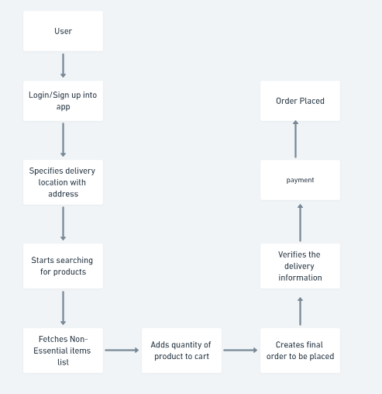

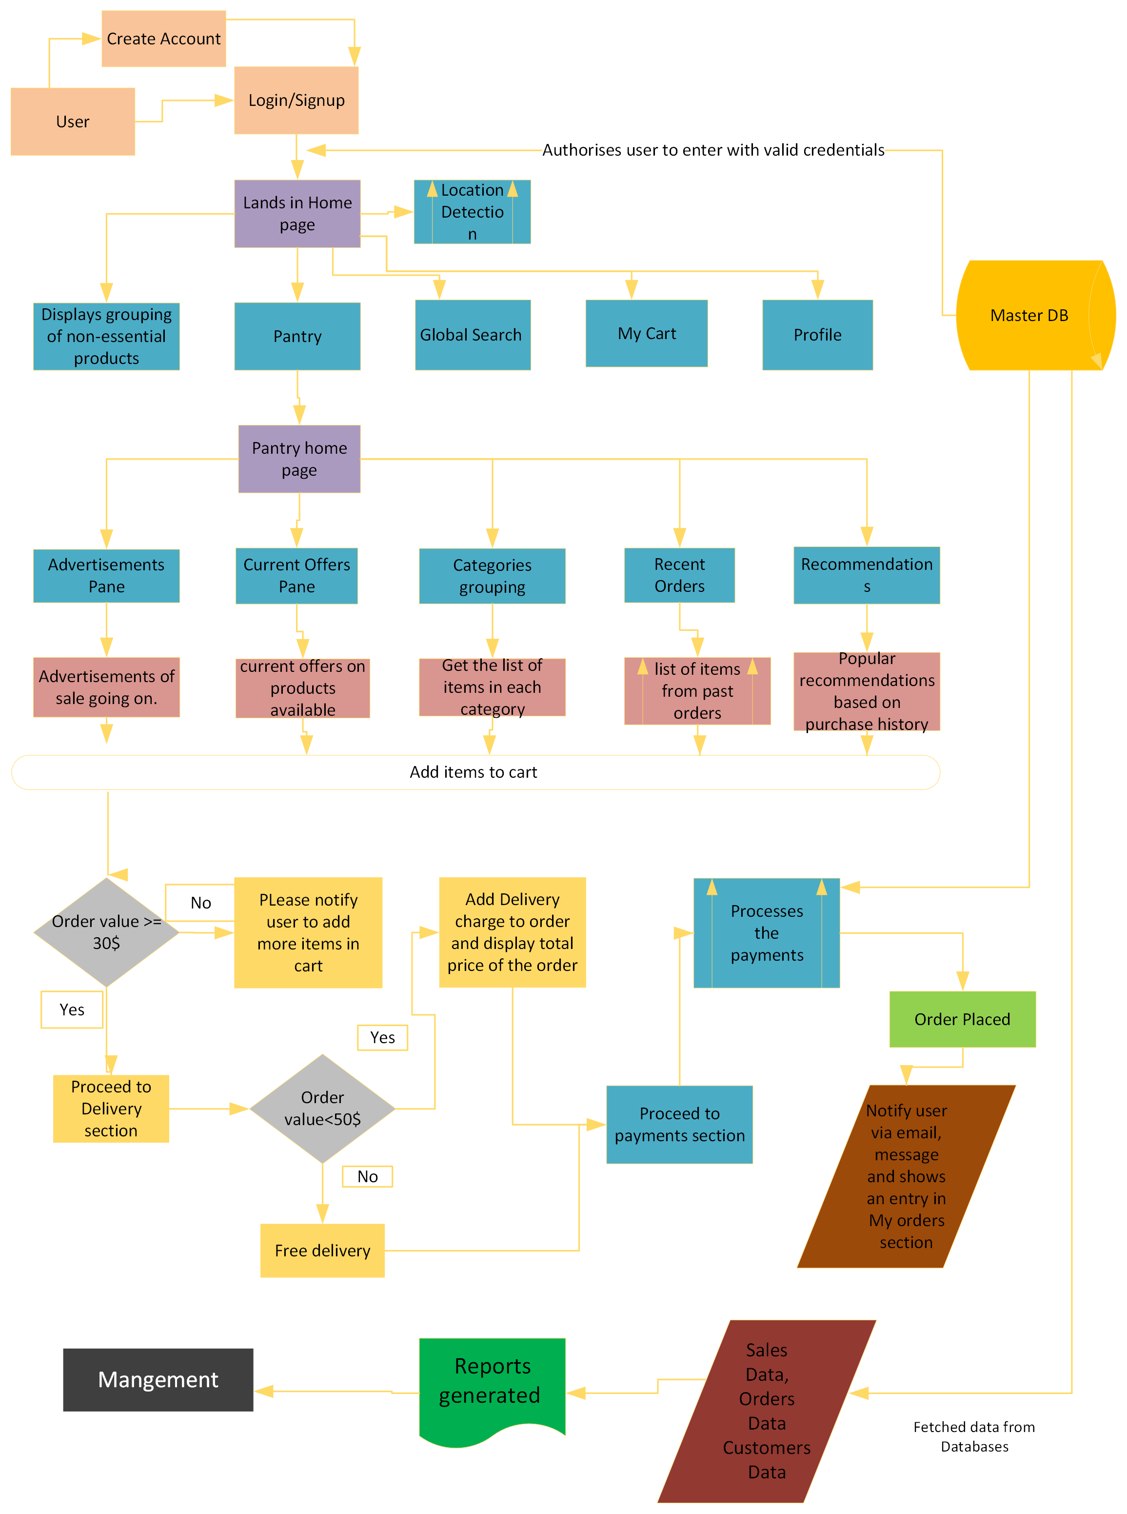

*Figure5: Future process Map*

#### b) Process Modelling

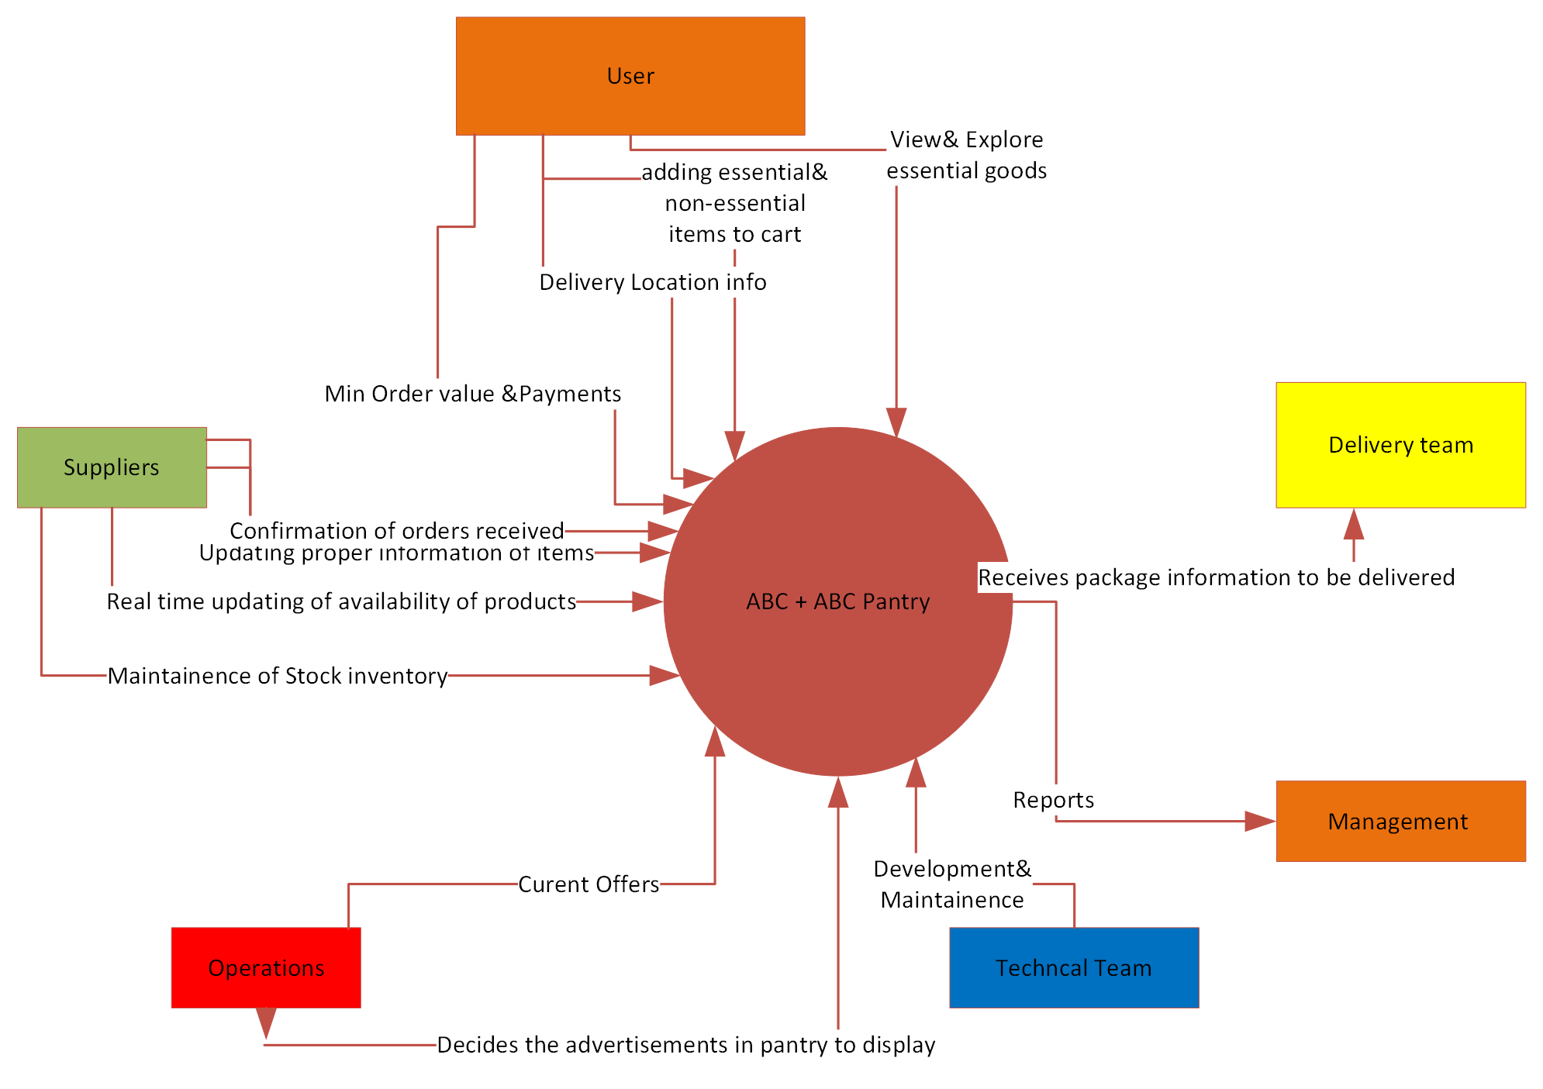

*Figure6: Depicts the context diagram which shows the interaction of different stakeholders with the New system*

------------------------------------------------------------------------------------------------------------------------------------------

System-Level Development

Check against system-level verification requirements

Sub-system Level Development

Validation against assigned requirements

Deliver Products

Check against sub-system level verification requirements

Component Level Development

Deliver Products

Validation against assigned requirements

Check against component level verification requirements

*Figure 7: Product Verification & Validation Model*

#### c) Scope Modelling

*Figure8: Product In-Scope and Out of-Scope for ABC Pantry*

|  |  |
| --- | --- |
| In-Scope | Out of Scope |
| Pantry icon position in home page | Separate platform for suppliers |
| Search bar for pantry |  |
| Advertisement pane | Payment to supplier without fulfilment of order |
| Offers pane |  |
| Recommendations pane |  |
| Categories section |  |
| Delivery information details |  |
| Order details |  |
| Product details |  |
| Cart merging |  |
| Order value details |  |
| Customer complaints & feedback |  |
| Inventory maintenance |  |
| Flexible payment options |  |

#### d) Data Modeling:

*Figure7: Entity Relationship diagram for new system*

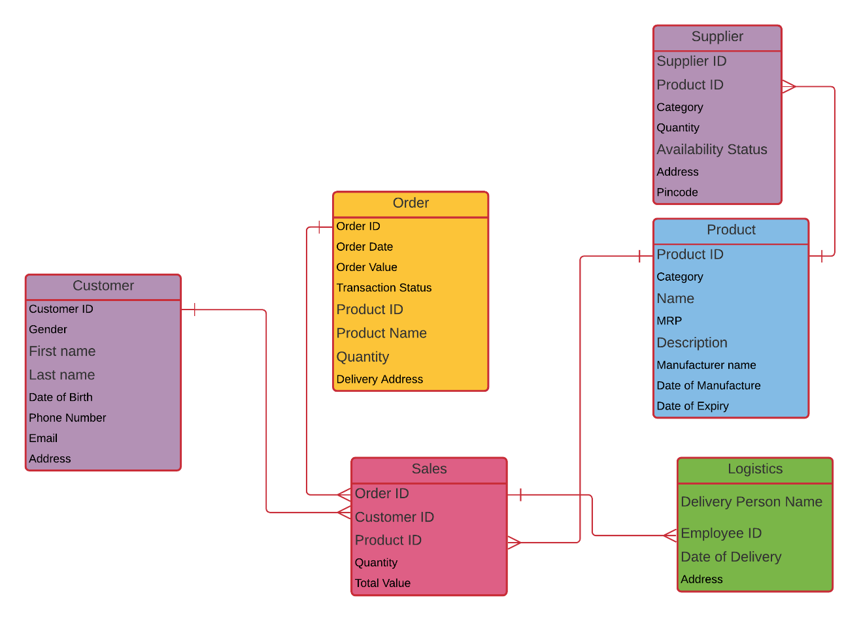

#### e) Activity Diagram:

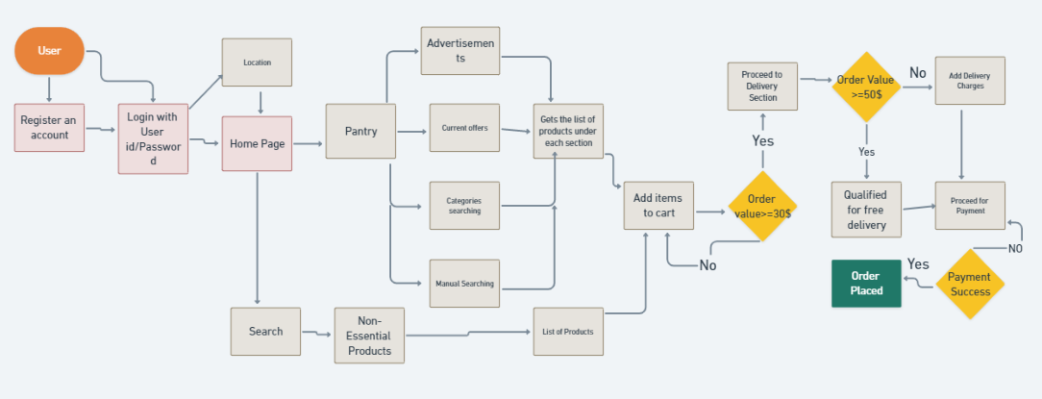

#### *f) Swimlane Activity Diagram:*

The Diagram employs the swim lanes to show the responsibility or synchronization bar to represent the parallel processes in multiple areas.

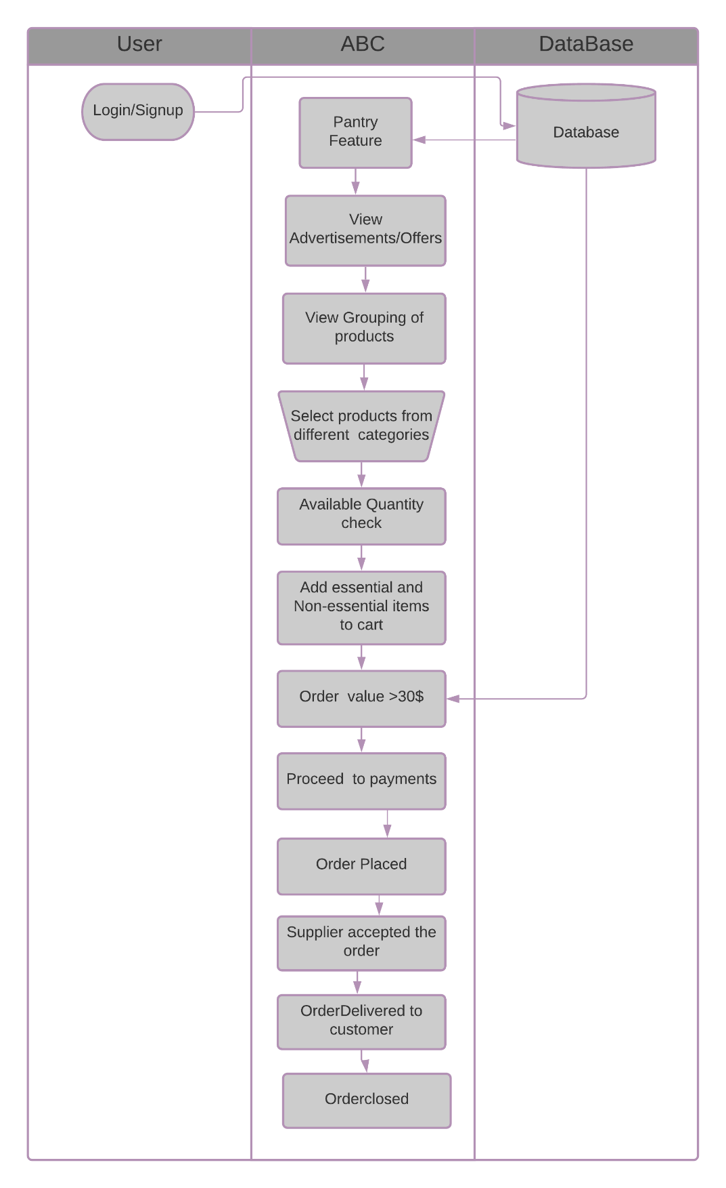

#### g) Mock Screens for the New feature ABC Pantry:

|  |  |
| --- | --- |
| ABC Home Page | Pantry Home |

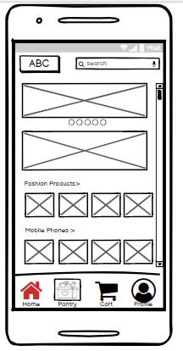 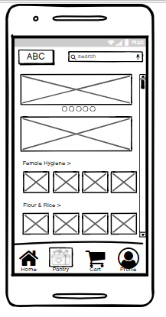

|  |  |
| --- | --- |
| Female Hygiene Category List | Product Description |

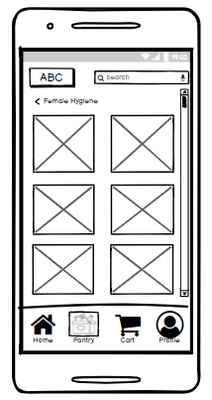 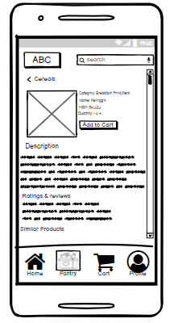

#### Conclusion:

New Feature integration into existing ABC app achieves its business objective on release.

Business Objectives:

1. 1.ABC pantry feature in mobile app.
2. clicking up opens new range and categories of products
3. Logical grouping of categories of products.
4. Pantry should be able to show advertisements
5. pantry should have a feature to show current offers.
6. Should be able to add these products to main cart along with non-essential items.
7. Total min order should be 30$, on the other hand individual items could be less than 30$.
8. 8.Free delivery on orders more than 50$
9. ABC categorized cities into 4 zones based on highest sales.
10. Management should get reports at end of the day.

## 6.Product Backlog:

|  |  |  |  |  |  |
| --- | --- | --- | --- | --- | --- |
| User Stories | State | Backlog Priority | Story Points | Acceptance Criteria | Iteration Path |
| As a user I want to have pantry right beside Home button so that it is easily visible. | Approved | 9 | 4 | 1. User should be able to view pantry icon beside Home button.  2. User should be able to identify pantry icon with pantry name below.  3. User should be able to differentiate that pantry icon should be highlighted when clicked. | Release 1  Sprint 1 |
| As a user I want to see pantry home page with details related essential product so that I can focus on purchasing essential goods. | Approved | 9 | 3 | 1. User should be able to view only essential products information on pantry’s home page.  2. User should see only images and details of essential goods on pantry home page. | Release 1  Sprint 1 |
| As a user I want to see current offers going on pantry right on its pantry’s home page so that I can get information related to offers on products I’m going to order. | Approved | 7 | 2 | 1. User should be able to identify & view offers section on pantry home page itself.  2. User should be able to recognize the on-going offers on products specified.  3.User when clicked should get all the information on conditions applied. | Release 1  Sprint 1 |
| As a user, I want to view promoted products in advertisements section provided in app’s pantry home page so that I can buy products. | Approved | 5 | 1 | 1. User should be able to see advertisements pane in pantry’s home page.  2. User should be able to swipe to view the next advertisement. | Release 1  Sprint 1 |
| As a user I would like to see advertisements move on periodic intervals so that I can view all of them without wasting time. | Approved | 5 | 3 | 1. User should be able to see that advertisement swiped automatically in seconds interval. | Release 1  Sprint 2 |
| As a user I want to see products categorized on pantry home page so that I can search easily for necessary related items. | Approved | 9 | 5 | 1. User should be able to see products grouped categorically on home page.  2. User should be able to find products according to categories.  3. User should be able to view all categories grouped when scrolled down the pantry page. | Release 1  Sprint 2 |
| As a user I want to add essential and non-essential items to one cart simultaneously so that I can place order at once. | Approved | 9 | 4 | 1. User should be able to add both non-essential and pantry items to cart.  2. User should be able to proceed to delivery section when cart contain both pantry items and non-essential goods. | Release 1  Sprint 2 |
| As a user I need to see list of all related products in a specific category so that I can make a purchase with full information. | Approved | 7 | 2 | 1. User should be able to view different brands related to specific product category in category page.  2. User should be able to see products list in a category. | Release 1  Sprint 2 |
| As a user I have to add minimum order value of 30$ so that It can proceed with further steps in-order to place it. | Approved | 9 | 5 | 1. User should not be able to proceed to further steps to payment and delivery section if order value is less than 30$.  2. User should be able to view the proceed button is disabled if order value is less than 30$.  3. User should be able to see proceed button is enabled if order value is equal to or greater than 30$. | Release 1  Sprint 3 |
| As a user I want to see delivery options like date and time, charges of delivery so that I can view my total order value including delivery charges. | Approved | 7 | 5 | 1. User should be able to get free delivery if the total order value exceeds 50$.  2. User should be able to see that their order is qualified for free delivery at the delivery section.  3. User should get the total order value including delivery charges in delivery section if order value is less than 50$ and greater than 30$. | Release 1  Sprint 3 |
| As a supplier I want to update the stock quantity status so that my customer could know the availability of products in my inventory. | New | 6 | 2 | 1. Supplier should be able to update the available quantity of products in his inventory.  2. Supplier should be able to see the quantity that is displayed in the product description. | Release 1  Sprint 3 |
| As a supplier I want to add more products to my inventory so that my customer are more aware of the products available. | New | 4 | 3 | 1. Supplier should be able to add more products to his online inventory.  2. Supplier should be able to update all the relevant details regarding a new product.  3. Supplier should be able to see list of products available in his inventory with quantity details. | Release 1  Sprint 4 |
| As a supplier I want to add Name, category, price, quantity, description, date of manufacture, date of expiry, nutritional values of a product so that customer can view detailed information needed to make a purchase. | New | 6 | 4 | 1. While updating the existing products, these fields should be updated mandatorily.  2. Mandatory fields while adding a new product should be updated to get it added to inventory. | Release 1  Sprint 4 |
| As a manager I want to get reports on sales trend on each day so that appropriate decisions can be made. | New | 3 | 8 | The management should be able to generate reports showing sales trends. | Release 1  Sprint 4 |

## 7. Tableau Workbook with Dashboard

1. Create a dashboard for senior management for Chicago to view sales of personal care products for the last 6 months. Make assumptions as appropriate and create the dashboard using your own mock data. For any missing data make your assumptions to create mock data. Write down the assumptions as well.
2. Create a dashboard to show Senior Management for Chicago to view sales of breakfast products for the last six months. Make assumptions as appropriate and create the dashboard using your own mock data. For any missing data make your assumptions to create mock data. Write down the assumptions as well.

Dashboard for both Personal care and Breakfast food items:

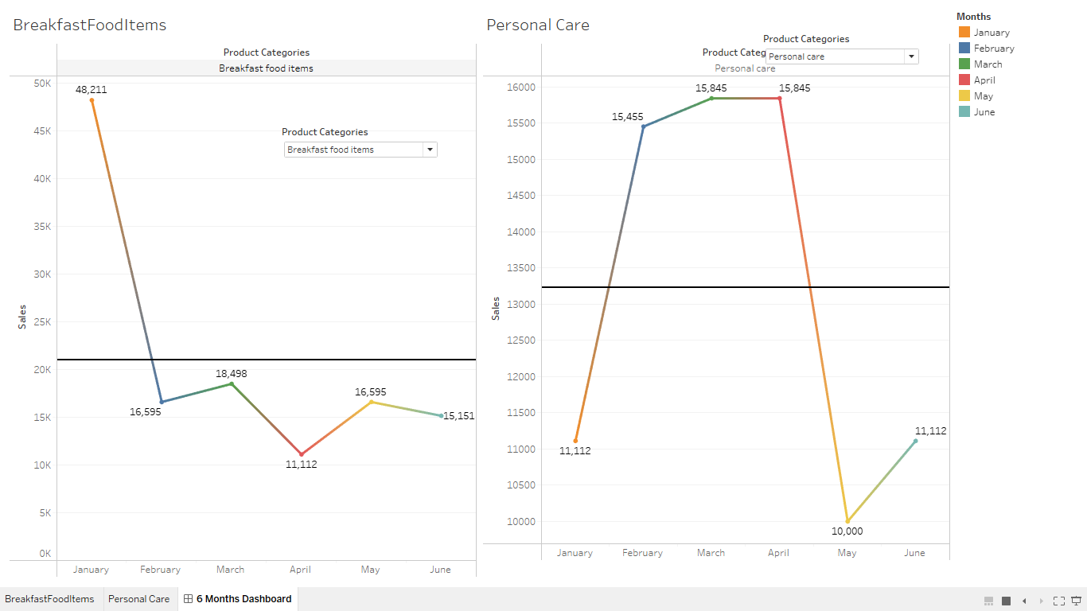

Tableau workbook Attachment:



## 8. Excel Workbook

Please find the solutions for the 3 questions mentioned in Project 1 in below excel dataset.

