

LIBRARY MANAGEMENT SYSTEM

Business Requirements Document

Simplilearn Project-2

By

R. Goutham Ravi Kumar

Glossary

1. Introduction
2. Problem Statement Overview.

a. Solution Overview

1. Business objectives of Library Management System (LMS)
2. Stakeholders

a. Stakeholder Matrix

1. Process Maps

1. Current system process map

2. Proposed system process map

1. Scope of New System
2. Context diagram for Proposed LMS.
3. In-Scope and Out-of-Scope Requirements
4. Business Requirements

a. Functional Requirements

b. Non-Functional Requirements

1. Activity Diagram for the system
2. ER diagram for the System
3. Environment
4. Mock Screens for the features.

1. Introduction

Stanford University is a private research university in California. The university was founded in 1885 and as of today, 83 Nobel laureates, 28 Turing Award laureates, and 8 Fields Medalists have been affiliated with Stanford as students, alumni, faculty, or staff.

For the benefits of the students Stanford started its own library in 1885. The library at Stanford was housed in one large room capable of accommodating 100 readers. As the university grew to enroll more than 20,000+ students in a given year the library grew as well. Today the library boasts of having more than 4 million books in it.

2. Problem Statement Overview.

The paper based maintaining, organizing, and handling of countless books in the library becomes a nightmare.

**Problems with manual library:**

* A lot of time is wasted managing the manual library.
* The number of employees needed to manage the library is high.
* Fine calculation is a tedious and time-consuming affair.
* No reports could be generated on books issued due to the manual system.
* It is difficult to manage 4 million books present in the library.
* Students could deposit the books only in the library timings.

**a. Solution Overview**

The university wanted a Library Management Software to automate their library’s activities. Using the software:

* One can find books with a click,
* Issue/reissue books quickly, and
* It will manage all the data efficiently using this system.

It also provides immediate and accurate information regarding any type of book, magazine, or research paper, thereby saving a lot of time and efforts.

**3. Business objectives of LMS**

Advantages of Library Management System:

* Reduce overheads and increase productivity of library staff.
* Cost reduction.
* Up-to-date records of all books, research papers, magazines, and other materials available in the library.
* Improve student engagement in the library.
* It will generate dynamic reports for better decision-making.

**4. Stakeholders**

|  |  |  |  |
| --- | --- | --- | --- |
| Keep satisfied | Manage closely | Monitor | Keep Informed |
| University Management | Business Analyst | Library Staff | Technical team |
|  | Library Manager | Students | Inventory Suppliers |
|  | Project Manager | Faculty |  |
|  |  |  |  |

**4.1 Stakeholder Matrix**

Power/Influence

Keep Satisfied

High

|  |  |
| --- | --- |
| Faculty  Stanford Management | Manage Closely  Library manager  Business Analyst  Project Manager |
| Admins  Monitor | Technical Team  Students  Library Staff  Informed |

Impact/Interest

High

Low

**5.1. Current system process map**

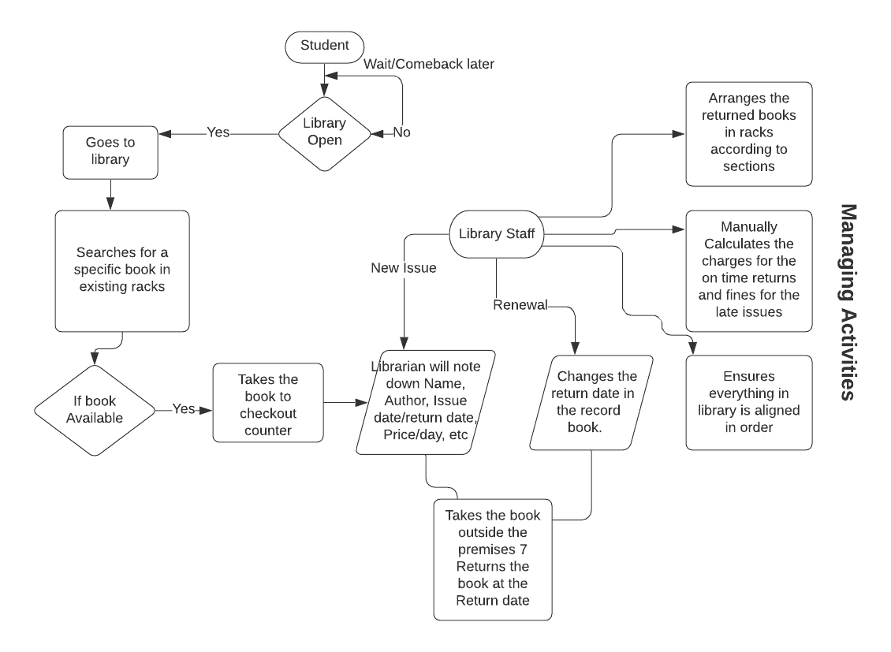

*Figure1: Represents the current system of functioning of Library at Stanford University.*

**5.2 Future State Process Map**

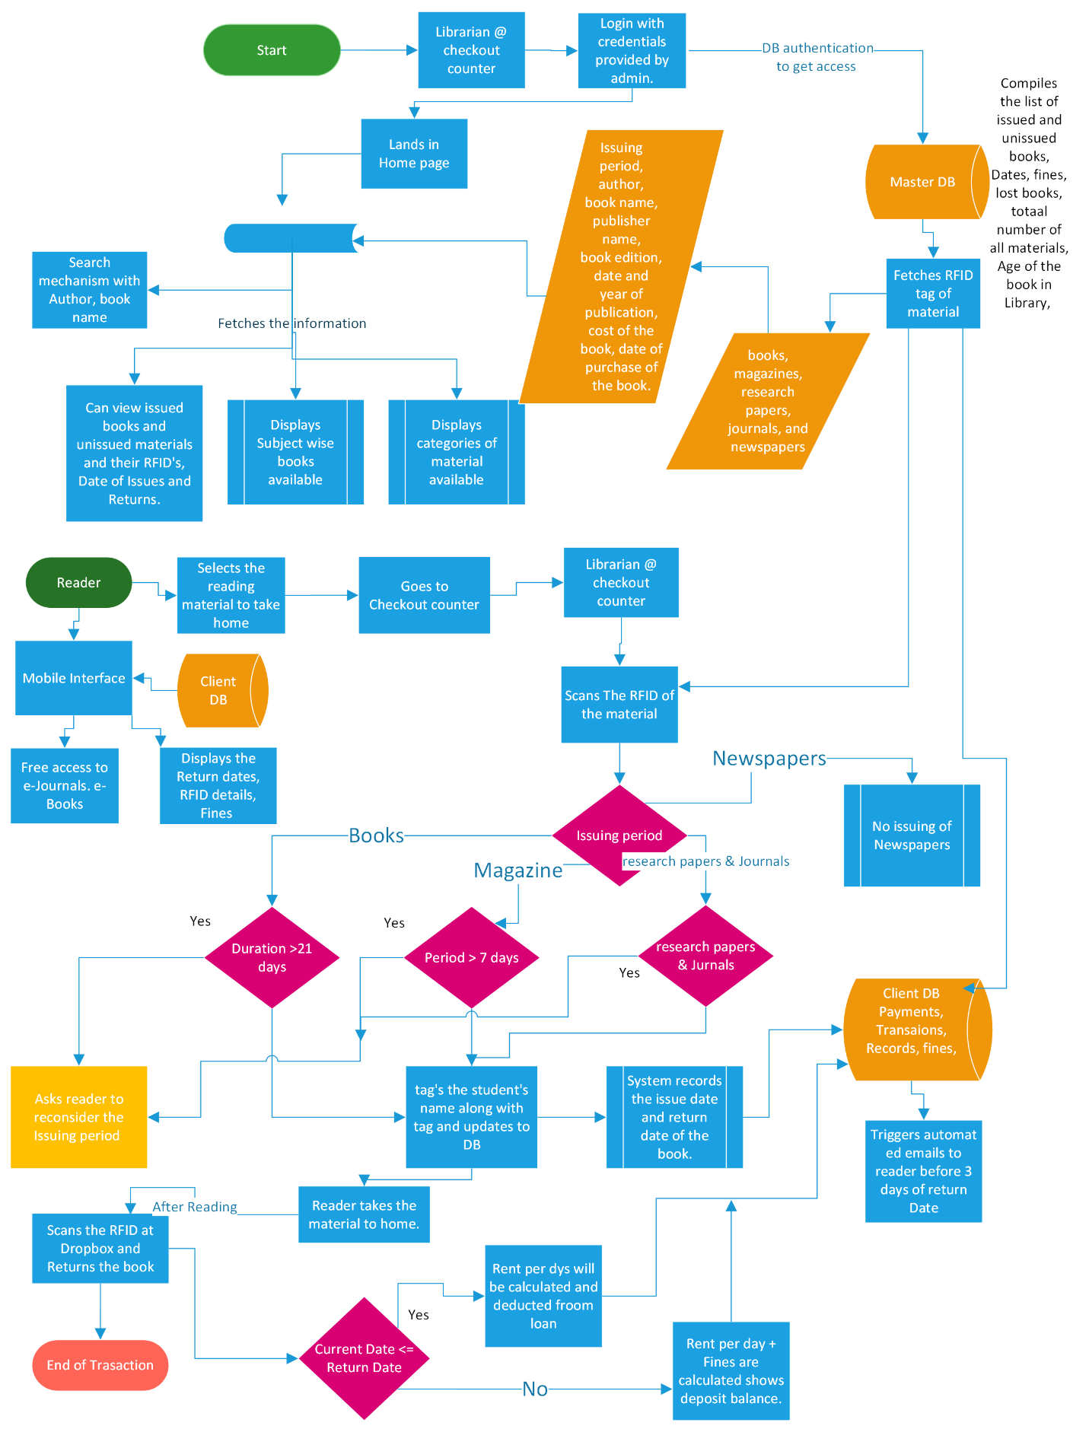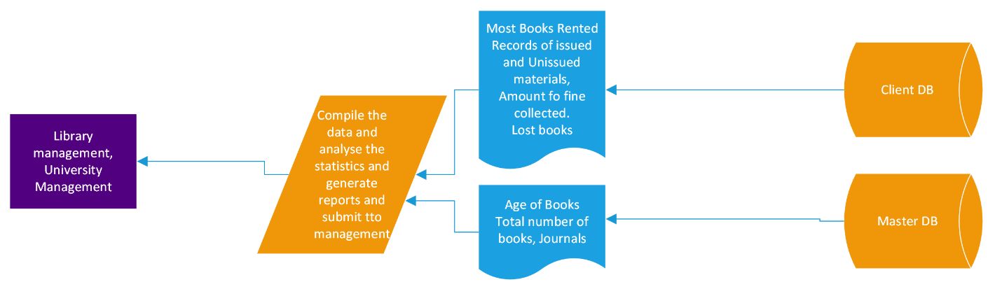

*Figure2: Represents the future system process map of Library at Stanford University.*

**6. Scope of New System**

**6.a Context diagram for Proposed LMS.**

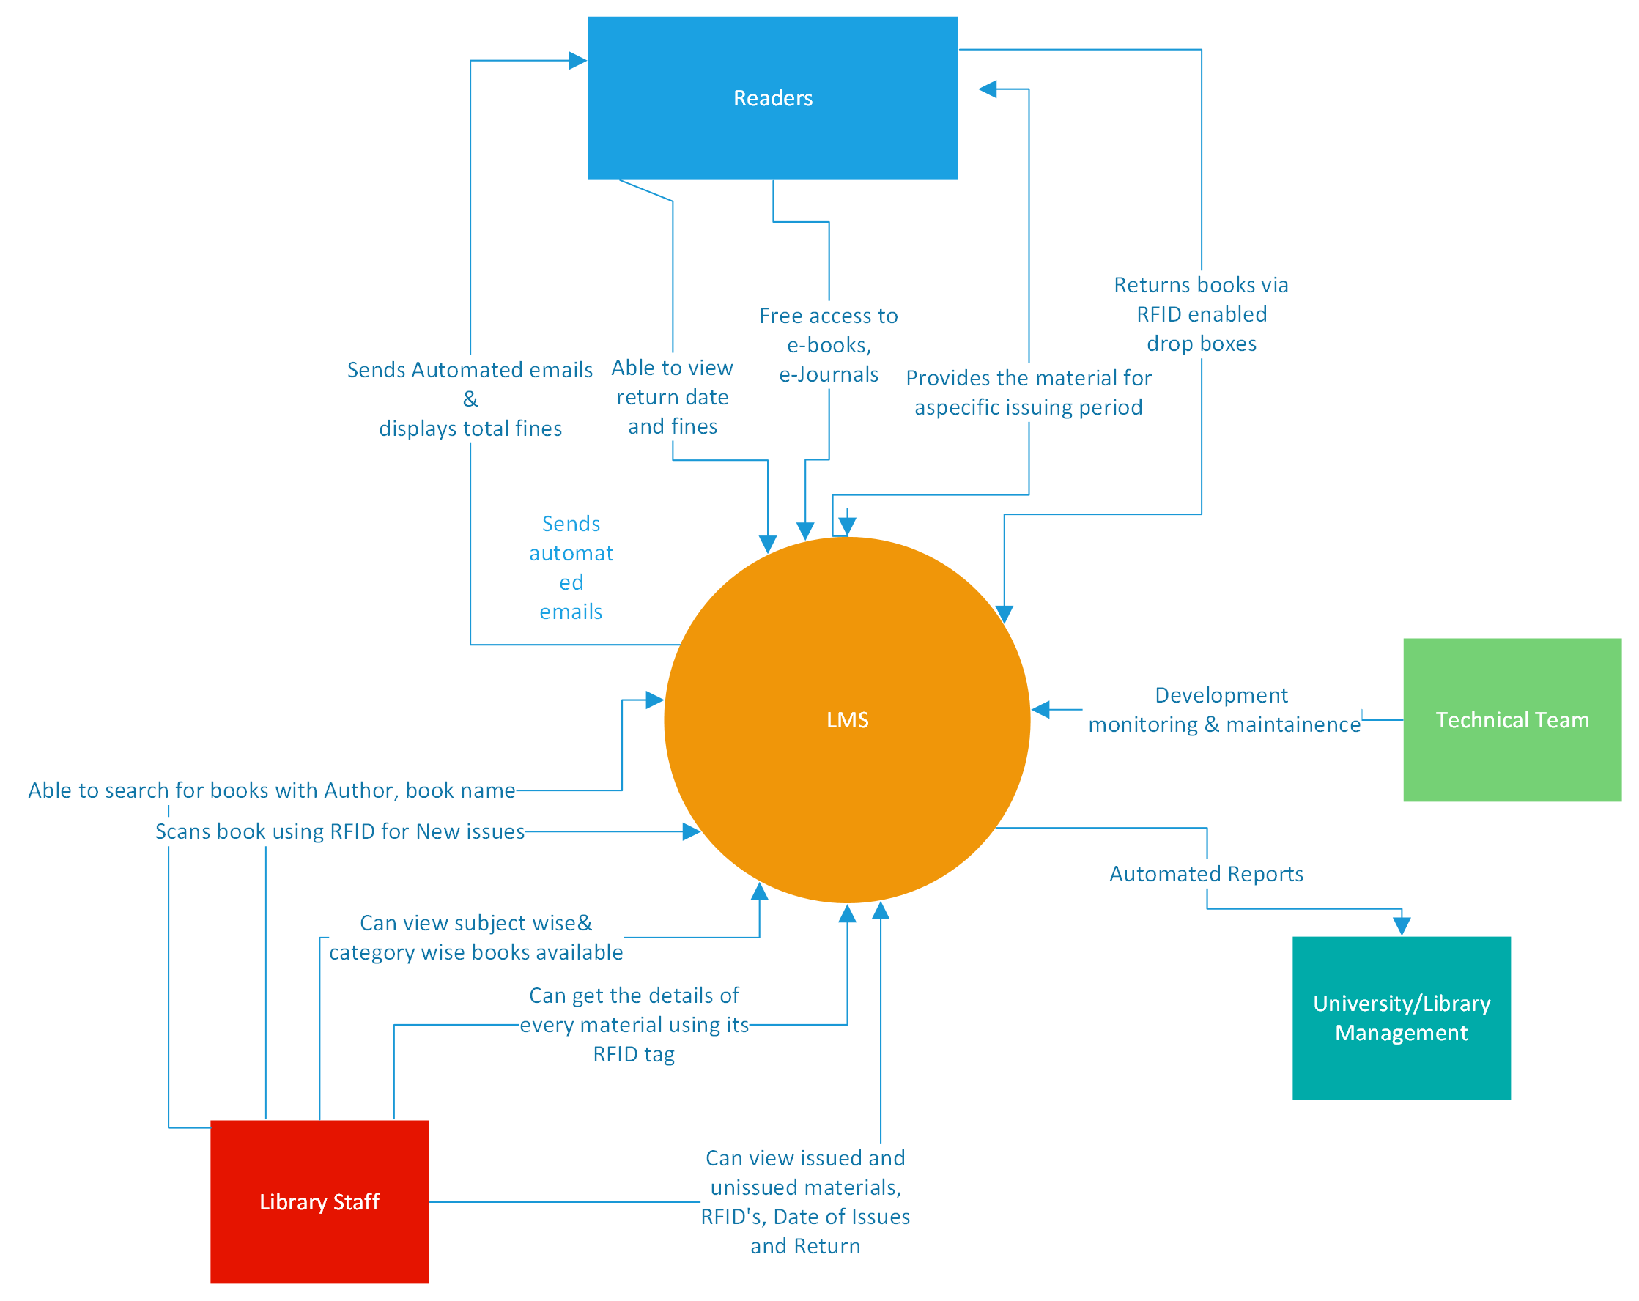

*Figure3: Depicts the context diagram which shows the interaction of different stakeholders with the New system.*

7. In-Scope and Out-of-Scope Requirements

7.1 In-Scope Requirements:

|  |
| --- |
| Database requirements |
| 1. Should be able to keep records of books, magazines, journals, newspapers. |
| 2. Subject wise books should be classified in the system. |
| 3. The record of every RFID tagged material should be stored in database. |
| 4. Detailed information of every reading material must be stored. |
|  |
|  |
| Operational Requirements |
| 1. Every reading material shall have RFID tag on it. |
| 2. RFID readers are placed at the exit gate of library for Anti-theft detection. |
| 3. RFID enabled drop box station should be installed outside of library. |
| 4. Issuing periods should be different for different categories of materials. |
|  |

7.2 Out-Of-Scope requirements

|  |
| --- |
| 1. Newspapers shall not be allowed to be issued. |

8 Business Requirements

|  |
| --- |
| Functional Requirements |
| Home page requirements |
| 1. Library staff should be able to search for book on LMS using book or Author name. |
| 2. Staff should be able to use RFID tag to capture details of the book for new issues. |
| 3. Records of all types of materials should be categorized accordingly. |
| 4. Books should be classified subject wise. |
| 5. Should get the report of age of the books more than 20 years old. |
|  |
| Issues requirements |
| 1. Should be able to do the task new issue of book. |
| 2. Library staff should be able to use a RFID reader to capture details of the book. |
| 3. Renewal of book should be done with just RFID tag. |
| 4. Should be get the data of unissued books or available books in library. |
|  |
| New Record creation |
| 1. Should have the RFID tag attached to the material. |
| 2. Staff should be able to scan or enter the tag ID to get the details of the book |
| 3. System shall record the issue date and return date of the book mandatorily. |
|  |
| Mobile Interface requirements |
| 1. Students should be able to login using their college ID and mobile number or else register using them. |
| 1. Students should be able to access the library system online to know the return date. |
| 2. They shall receive automated emails 3 days before return date. |
| 3. Access to e-books, e-journals shall be given to students. |
|  |

|  |
| --- |
| Non-Functional Requirements |
| System requirements |
| 1. LMS can be used on any Windows and Mac OS run computers |
| 2. Users will need an active internet connection. |
| 3. It will be RFID ready (NCIP 2.0 HTTP server available) |
| 4. Auto scheduled tasks like emails and database maintenance |
| 5. Data should be stored in cloud |
| 6. Highly secure, scalable, and reliable |
|  |
| Usability Requirements |
| 1. The screens should be self-explanatory and very user friendly. |
|  |
| Environment Requirements |
| 1. Program development and maintenance in Java. |
|  |

**9. Activity Diagram for the system**

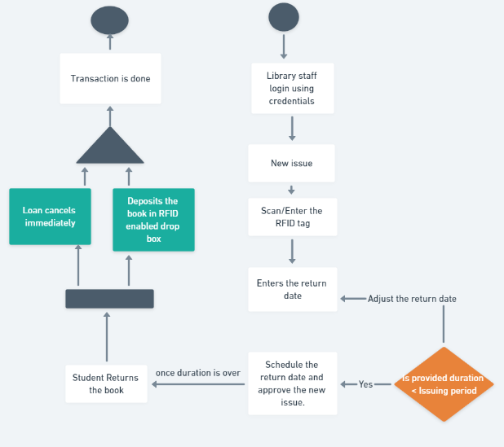

*Figure4: Shows the Activity diagram where control flow is drawn from one operation to another.*

**10. ER diagram for the System**

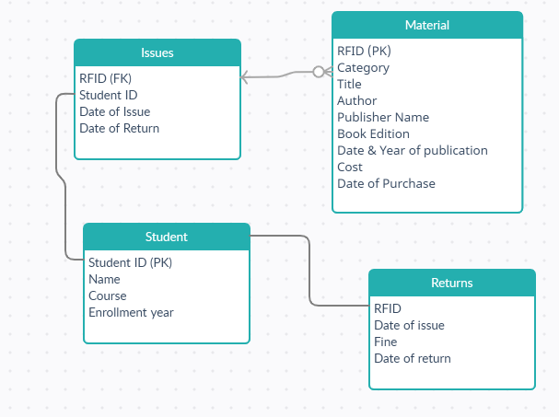

*Figure5. Entity Relationship diagram displays the relationship of entity sets stored in database.*

**11. Environment**

|  |
| --- |
| Program should be created and maintained in Java. |

**12.Mock Screens for the features.**

**12.1: HomePage**

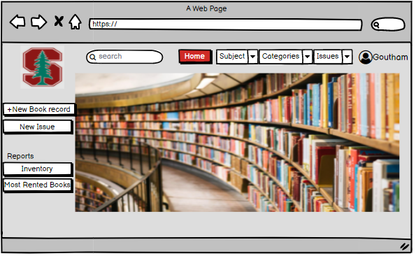

**12.2: New Record creation page**

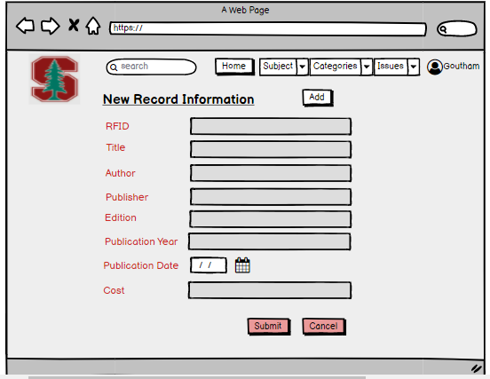

**12.3: New Issue Page**

