**Shahid’s Persona Research Details**

**------------------------------------------------------------------------------------------------------------------------------------------**

**Persona-1: Tarun**

**Bio**

Interested to collect paperback books and see them in shelf & like to enjoy reading with the touch of pages.

**Likes& Dislikes**

Don’t like to read on screen at any cost.

Likes to collect Romance/Love/Thriller fiction genre and Academic

Likes to use Technology-Online Purchasing

Purchase decisions based on suggestions & Recommendations

**Motivations:**

Once started to read, have to complete any cost asap depends on book.

**Pain**

Not interested to pay hefty price.

**Expectations:**

Storage space-No Rereading—Likely to buy another rack extra

Not interested to lend to others only just for money

**Libraries:**

Pain-Not knowing actual timings

Interested to borrow from library but on door step.

**Expenditure**

Yearly spending: 3000

Avg price

Max rice of a book purchased

**Assumption Validation**

Interested to **exchange** book directly to other user rather than dropping off **provided** the user must be behaving like a professional.

Prefers dropping in stall/vendor/third-party only when faced any kind of odd behavior before from the other user.

**Persona-2 --- Roshan**

**Bio**

Interested to read in hardcopies and enjoys friction while turning pages.

**Likes & Dislikes**

Likes to purchase paperback on online/Offline.

Prefers eBooks for academic/Office purpose as they are portable.

Purchase decisions based on reviews & recommendations from friends.

**Motivation**

Purchasing based on Author’s previous work and type of genre.

In some case reads first chapter and decides to buy.

Likely to complete a book in 2days if no external disturbances involved.

**Pains**

Waiting for book when it isn’t available anywhere.

Shifting a whole rack of books while relocating.

**Libraries**

Likes to read in library for the ambiance.

Interested to borrow book at door step only as a last priority.

**Expenditure**

Yearly spending: 1500

Max price book: 800

Avg price of a book: 300-350

**Assumption Validation**

Unlike to lend his books to others.

If he lends, expects to receive book in same condition as given (as it is).

Prefers to borrow only for hours, if he liked it then purchase a new copy of it.

**Persona-3: Shubam Sahu**

**Bio**

Interested to read e-books in beaches or while travelling. Habit of highlight in e-books for future reference.

**Likes & Dislikes**

Likes to mark, copy and save it in digital document in e-books and easy usage of dictionary in kindle.

Interested to purchase 1-2 books paperback copies in a month.

Preferred to buy Hardcopies if E-books & hardcopies are available at same cost.

Preferred to read Fiction/Thrillers for stories.

Dislikes love/romance

Likely to access a pdf version of a book within few google searches and highly unlikely to purchase it with high prices (>70).

**Pains**

Pileup of paperbacks purchased and takes time to obtain interest to read them.

Eyestrain while reading for longtime on screen but adjusted because of modes given reading mode, night mode in gadgets.

Wait till prices come down for a specific book if hefty prices.

Takes more time to read in home because of many distractions.

**Advantages on e-reading**

Downloadable, easily available, portable, sync across multiple devices, dictionary

**Expenditure**

Avg spending Per year: 5000-6000Rs/- (Foreign authors) – E-books+Paperback+AudioBooks

**Motivations**

Re-reading- Likes to refer some highlighted or paragraph or side headings for remembering.

Personal Development books are mostly interested for self-improvement.

**Libraries**

Ambiance, Silence keeps you focused on reading a book.

Interested to utilize doorstep books from library.

**Assumption Validation**

Hardcopies are for reading and showoff in your collection in home if taken above scenario into consideration.

Likely to lend books to people in neighborhood.

Expected to receive book in same condition without any folding, highlights.

Interested to give book by himself provided he/she must around his community, Office etc.. and the receiver should be known.

**Mohan’s Persona Details Docx**

## Name: Vasudev moorthy

## Age: 50+

## Occupation: Management consulting and professor in couple of schools

## Status: Married

## Place: Pune

## Bio:

## Vasudev moorthy is a management consulting and professor for past 20years. He’s self disciplined and family person. He loves to read many books and in fact he has a passion towards writing books. He published around 10 books which is quite popular.

## Motivations / Goals

Share kind of knowledge while writing books. 2 or 3 are called non-fiction books (Based on specific skills or knowledge). He wrote friction books also which doesn’t have facts.

## How to write a proposal, organizational theory.

## When you feel u have lot of experience and there is a gap, that’s the motivation to write books

## Reading books is not consistent, when we are busy or not in a mood to write books we won’t read books. You may look certain kind of books or variety of books. He will find particular author and read only his books because he likes the language and likes the thought process. Some of the time you will not feel reading at all. If you have time to read also it won’t motivates to read books because of many reasons.

People won’t have a habit of reading a complete book at one stretch.

1St preference is hardcopy rather than E-book. Because as writer he loves to read books by hardcopy as the quality of hardcopy books a higher. Even bad books can be easily published in E-books so it has no quality.

He’s happy to spend RS.300 per book.

As a writer he has the community of people who would suggest him to read some specific book. And then he will go and buy books and read. He read many books depend on the mood, likes and suggest from his friend.

If the money is high around 500, he little bit hesitate to buy books

He also red very bad books and he literally through away. He has many books in his shelf which is not even opened and red and that’s a waste inventory.

He does sometimes read the same books again.

Waste books remain in his shelf for a long time and even rats will eat the books.

He will sell those books to 2nd hand book seller guys.

He used to visit British library a lot.

The people are still reading and preferred to read books in this digital age.

E-book cannot replace the touch and feel for a hardcopy book.

## Name: Kishan malur

## Age: 35

## Occupation: Product manager in Technology Company and professor in couple of schools

## Status: Married

## Place: Pune

## Bio:

He’s an occasional reader; it means he reads books when someone recommends him (He needs some recommendation before he buys).

If he wants to read a book which is urgent, he goes for E-books like kindle. Or else he will go and buy it in Amazon. But he likes hardcopy

Cost matters - If the cost is less in kindle (199/-) than Amazon (600/-), the price is high and he would probably go with kindle.

If the book is so good to read, he will buy the book rather than kindle. (These are important book which he doesn’t want to lend anybody)

He like Autobiography, history, Politics, Current affairs, business books (start with why, so good they cannot ignore you)

He don’t like reading fiction and novels (He don’t enjoy reading these books)

He can spend Rs.3000 to 4000/- for a book. If it is a carrier related books.

His goal is to spend at least 30mins every day on reading books.

If he wants to read book he read and it depends on his work pressure but his habit is to read books before going to his bed.

If the book cost is high he tries to borrow the book from his friend or try to buy some 2nd hand books.

Because the books that are filling up on his shelf he gave away all the books to paper wale guy. Before that he asked to his friends and family to get the book and after they refuse to buy he sold it to paper wale guy.

He receives book by gifts, he buy books, he borrow books – These are the three ways where he get books.

He buys the book as that book is important but after some years he don’t want that books as it is outdated. Such kind of books he really wants to give away even if it’s free.

Some category of books which is special to him, and he don’t want to share with anyone even with friends.

Some other category of the books which he is ready to lend and share with friends but doesn’t want to give away to paper wale guy.

He doesn’t have any problem in reading E-books. But that doesn’t mean he’s ignoring hardcopy books.

Small incident: - His daughter wants to read Harry potter books but he doesn’t encourage his daughter to read from kindle. He needs hardcopy book but the book costs high and he doesn’t know where his daughter will like the book or not after reading chapter 1. So in this situation he definitely wants to borrow or rent a book, and somehow he got the book from his neighbor friends. (The pain point here is, he struggled to get the book for rent and he doesn’t know which neighbor has the book)

He’s ok to read 2nd hand books but the book should be clean and he’s happy to lend books if the book is returning back safe.

He’s not happy to give his book to some X person, if the person has some social identity then its ok to lend his books to him.

**Zaki’s Persona Research details**

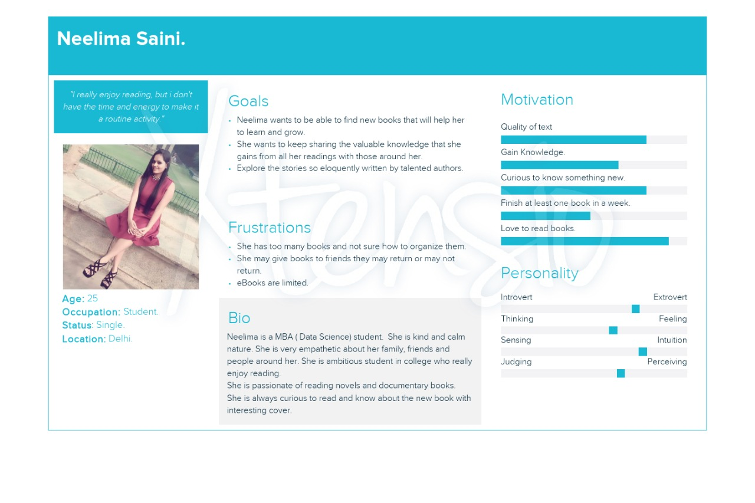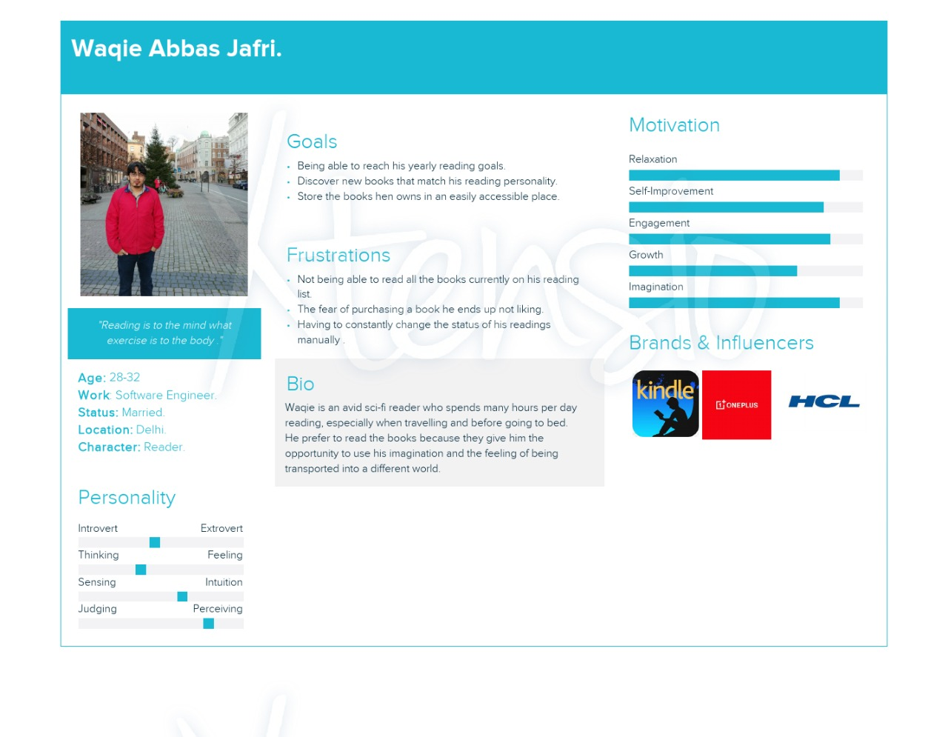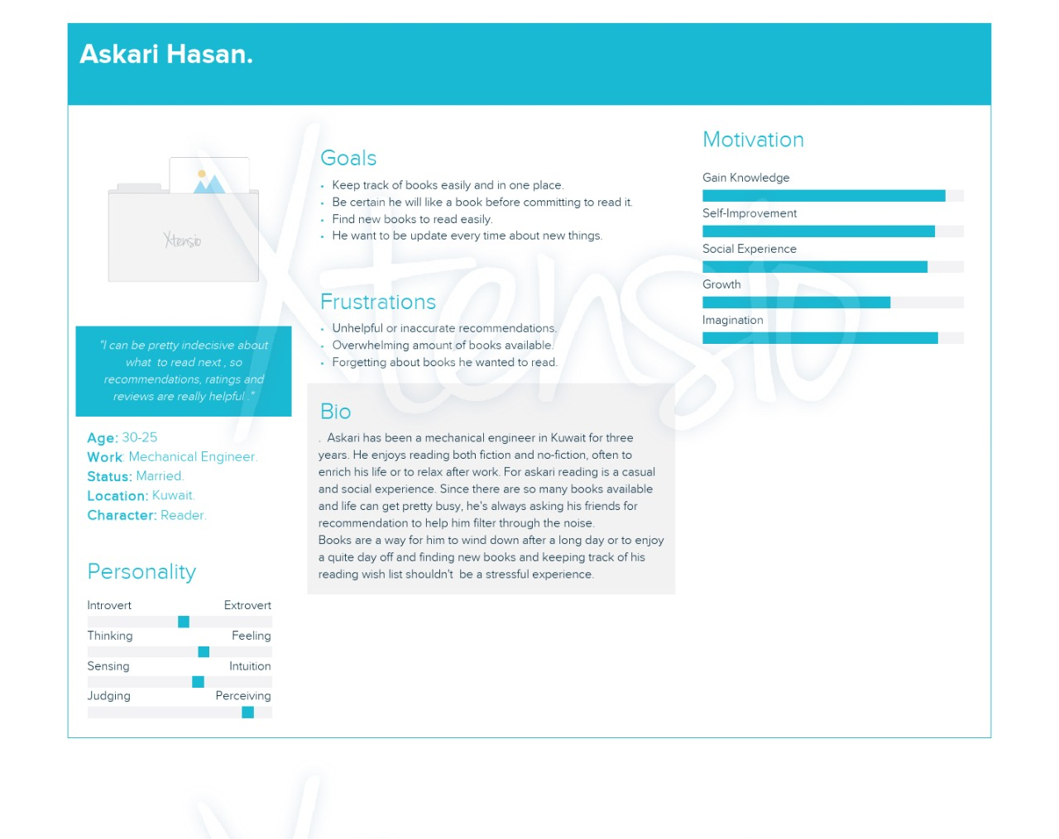

**Generalized Assumptions**

**Children College MNC Employees Middle Aged**

Graphical books Fiction Tech Literature

Short Stories Love Stories Business/Management Books Auto-Biographies

Comics Motivation/Life teachings Ancient History

Fantasy Series (HP) Personal Development

Sacred books

Foreign Authors

**E-Book**:

Pros:

Cost effective

Portability

Marking/copypaste

Cons:

Eye Strain

**Hardcopy**:

Pros:

Interested for borrowing.

Cons

Piling up

**Libraries**:

If New collection

Ease of availability

Ambiance- Silence/Focused Reading

**Rentor-Rentee**

Details & Profile Required

**Observations**

1. Pages, Images, fonts