LOAN MANAGEMENT SYSTEM (LMS)
System Architecture & Functional Specification
For NBFC Lending & Accounting Operations — SaaS Web Platform
Covers: Multi-product lending • Embedded accounting/GL • RBI regulatory reporting • Credit Information Company (CIC) reporting • Borrower onboarding forms • Product application forms
Prepared for: LawDocs
Date: July 2, 2026 — Version 5.0

Volume 2 of 3 — Engineering Standards & Calculation Engine (Sections 24–45)
Cross-references to Sections 1–23 resolve to Volume 1; Sections 46–98 to Volume 3. The master document remains LMS_Architecture_Specification_v8.docx.

24. Interest & Charges Calculation Engine
Note — retained for context and worked examples. The consolidated, authoritative calculation reference is Section 45; see the Single-Source-of-Truth map.
This section gives the exact formulae behind every interest/charge computation referenced elsewhere in this document (Sections 3, 6, 8), plus a worked numeric example for each — so the calculation engine can be unit-tested against a known-correct answer before it is wired into the servicing module.

24.1 Day-Count Conventions
The day-count convention must be set once per product in the Product Master (Section 3) and used consistently by every formula below. Mixing conventions between origination and servicing is the most common source of EMI-schedule discrepancies in loan systems.
Table 24.1 — Day-Count Convention Options
Convention | Usage / Notes
Actual/365 (Fixed) | Daily rate = Annual Rate ÷ 365, regardless of leap year. Recommended default for LAS, Smart Credit Line, Gold Loan, and daily-reducing LAP/Business Loans.
Actual/Actual | Daily rate = Annual Rate ÷ (365 or 366, per the actual calendar year). Used where the loan agreement explicitly references the actual year length.
30/360 | Every month treated as exactly 30 days, year as 360 days. Used for monthly-rest EMI loans where the schedule is calendar-month based rather than day-based (e.g., standard Personal/Vehicle Loan EMI schedules).
Recommendation: use 30/360 for standard monthly-rest EMI products (Section 24.2) and Actual/365 (Fixed) for daily-interest products (Sections 24.3, 24.6, 24.9, 24.11). Whichever convention is chosen must be stated in the Key Fact Statement (Section 17.1) and the Loan Agreement, since it changes the exact rupee amount charged.

24.2 EMI — Reducing Balance, Monthly Rest
Used for standard amortizing products: Personal/Business Loan, Vehicle Loan, and LAP/Gold Loan where the borrower opts for EMI rather than bullet repayment.
EMI = P × r × (1 + r)^n / ((1 + r)^n − 1)

where:
P = principal (sanctioned/disbursed amount)
r = monthly interest rate = (Annual Rate ÷ 12) ÷ 100
n = tenure in months

For each installment i (i = 1 … n), starting from outstanding balance B₀ = P:
Interest_i = B_(i-1) × r
Principal_i = EMI − Interest_i
B_i = B_(i-1) − Principal_i

Worked Example A — Personal Loan: P = ₹5,00,000, Rate = 14% p.a., Tenure = 36 months
r (monthly rate) | 14 ÷ 12 ÷ 100 = 0.011667
EMI | ₹17,088.81
Month 1 | Interest = ₹5,833.33 · Principal = ₹11,255.48 · Closing Balance = ₹4,88,744.52
Month 2 | Interest = ₹5,702.02 · Principal = ₹11,386.80 · Closing Balance = ₹4,77,357.72
Outstanding after 12 EMIs | ₹3,55,921.50 (used in Worked Examples E & F below)

24.3 Daily Reducing Balance (Broken-Period Interest)
Where the product's policy is 'daily reducing balance' (common for LAP and Business Loans), interest for any period — especially the first, broken period between disbursement and the first EMI date — is computed on actual elapsed days rather than assuming a uniform 30-day month:
Period_Interest = Outstanding_Principal × (Annual Rate ÷ 100 ÷ 365) × Actual_Days_Elapsed

The EMI amount itself is still computed once at sanction using the Section 24.2 formula; daily reducing balance only changes how the interest component of a given installment is derived when the period between two payment dates is not exactly one calendar month.
Worked Example B — LAP: P = ₹20,00,000, Rate = 11% p.a., Tenure = 180 months, disbursed with a 28-day first period
Standard EMI (30/360, 180 months) | ₹22,731.94
First-period interest (actual 28 days, Actual/365) | ₹20,00,000 × (11 ÷ 100 ÷ 365) × 28 = ₹16,876.71
First-period principal component | ₹22,731.94 − ₹16,876.71 = ₹5,855.23

24.4 Flat Rate Interest Method
Used only where the product is explicitly marketed/sanctioned on a flat-rate basis (some Gold Loan and legacy schemes). Flat rate produces a materially higher effective rate than the same nominal rate under reducing balance — this must be disclosed as the APR in the Key Fact Statement (Section 17.1), not the flat rate itself.
Total_Interest = P × Annual_Flat_Rate ÷ 100 × Tenure_Years
EMI = (P + Total_Interest) ÷ Number_of_Installments

24.5 Bullet / Interest-Only Repayment (Simple Interest)
Used for Gold Loan bullet schemes and LAS/Smart Credit Line overdraft balances that are not converted to EMI.
Interest = Outstanding_Principal × (Annual_Rate ÷ 100 ÷ 365) × Days_Held

Worked Example D — Gold Loan: P = ₹1,00,000, Rate = 12% p.a., held 180 days, redeemed in full
Interest | ₹1,00,000 × (12 ÷ 100 ÷ 365) × 180 = ₹5,917.81
Total amount payable at redemption | ₹1,00,000 + ₹5,917.81 = ₹1,05,917.81

24.6 LAS / Smart Credit Line — Daily Interest on Utilized Balance
Interest accrues only on the amount actually drawn, recalculated every day the utilized balance changes, and totalled over the billing cycle for the monthly statement (Section 3.1, 3.2).
Daily_Interest = Utilized_Balance_on_that_day × (Annual_Rate ÷ 100 ÷ 365)
Cycle_Interest = Σ (Daily_Interest) for every day in the billing cycle

Worked Example C — LAS: ₹2,00,000 utilized for 15 days, then ₹1,50,000 for the next 15 days, at 10.5% p.a.
Days 1–15 interest | ₹2,00,000 × (10.5 ÷ 100 ÷ 365) × 15 = ₹863.01
Days 16–30 interest | ₹1,50,000 × (10.5 ÷ 100 ÷ 365) × 15 = ₹647.26
Total cycle interest | ₹863.01 + ₹647.26 = ₹1,510.27

24.7 Penal Charges (Not Penal Interest)
Per RBI's Fair Lending Practice directions on penal charges, these must be levied as a flat fee or a fixed percentage of the overdue amount only (not the entire outstanding), must not be compounded, and must not be structured as an additional component of the interest rate.
Penal_Charge = Overdue_Installment_Amount × Penal_Rate_% (one-time, non-compounding)
— or a flat fee per overdue occurrence, whichever the Board-approved policy specifies —

The Penal Charge ledger (Section 8.2) must post this as a separate fee-income line, never blended into the Interest Income ledger, so that regulatory disclosures correctly separate interest from penal charges.

24.8 Part-Payment / Prepayment Recalculation
Two configurable options, selectable by the borrower at the time of part-payment (Section 6):

Option A — Reduce Tenure (EMI unchanged)
n_new = ln( EMI ÷ (EMI − r × P_new) ) ÷ ln(1 + r) [round up to the next whole installment]

Option B — Reduce EMI (remaining tenure unchanged)
EMI_new = P_new × r × (1 + r)^n_remaining ÷ ((1 + r)^n_remaining − 1)

Worked Example F — continuing Example A: part-payment of ₹1,00,000 at the end of month 12 (outstanding ₹3,55,921.50)
Principal after part-payment (P_new) | ₹3,55,921.50 − ₹1,00,000 = ₹2,55,921.45
Option A — new tenure (EMI stays ₹17,088.81) | 16.56 → 17 remaining months (down from 24)
Option B — new EMI (tenure stays 24 remaining months) | ₹12,287.53 (down from ₹17,088.81)

24.9 Foreclosure Payoff Amount
Foreclosure_Amount = Outstanding_Principal
+ Accrued_Interest_Since_Last_Installment
+ Foreclosure/Prepayment_Charge (% of Outstanding_Principal, per product policy)
+ Any_Unpaid_Penal_Charges

Worked Example E — continuing Example A: foreclosure immediately after the 12th EMI, charge = 4% of outstanding
Outstanding principal | ₹3,55,921.50
Accrued interest since last EMI | ₹0 (foreclosed exactly on the due date, for simplicity)
Foreclosure charge (4%) | ₹3,55,921.50 × 4% = ₹14,236.86
Total foreclosure payoff | ₹3,55,921.50 + ₹14,236.86 = ₹3,70,158.31

24.10 Effective Interest Rate (EIR) for Ind AS 109 Amortized Cost
Required for the accounting entries in Section 8.2 (fee income recognition) — the EIR is the discount rate that equates the loan's estimated future cash flows to its gross carrying amount at initial recognition, and has no closed-form solution; it must be solved iteratively (Newton-Raphson or bisection).
Gross_Carrying_Amount = Σ (t = 1 to n) CF_t ÷ (1 + EIR)^t

where CF_0 = Net amount disbursed (Disbursed Amount − directly attributable transaction costs
+ upfront fee income received), and CF_1..n = contractual principal + interest
cash flows (i.e., the EMI schedule from Section 24.2).

This is mathematically the same problem as computing a bond's yield-to-maturity or a cash-flow stream's IRR/XIRR; most languages have a library function (e.g., Excel/Sheets XIRR, numpy-financial irr, or a custom Newton-Raphson solver) that can be reused directly.

24.11 Interest Recomputation on Partial Redemption (Gold Loan)
When a borrower redeems part of the pledged ornaments (Section 3.4) and proportionately repays part of the principal, interest on the remaining principal is recomputed from the redemption date using the Section 24.5 simple-interest formula, applied to the reduced principal for the remaining holding period.

24.12 Standard Asset & NPA Provisioning — Worked Example
Applying the classification and rates configured in Section 9.4 to a sample ₹50,00,000 portfolio:
Table 24.2 — Illustrative Provisioning Computation
Standard assets: ₹42,00,000 outstanding | Provision @ 0.40% (Middle Layer overlay) = ₹16,800
Sub-standard assets: ₹5,00,000 outstanding | Provision @ 10% = ₹50,000
Doubtful (D1) assets: ₹2,00,000 outstanding, secured | Provision @ 20% of secured portion = ₹40,000
Loss assets: ₹1,00,000 outstanding | Provision @ 100% = ₹1,00,000
Total provisioning requirement | ₹16,800 + ₹50,000 + ₹40,000 + ₹1,00,000 = ₹2,06,800
Rates shown are illustrative per Section 9.4's configurable table; Compliance must confirm the exact rates in force under the extant RBI Prudential Norms Directions before this is used for actual provisioning.

25. Field-Level Developer Specifications
Consolidated validation patterns and state-machine enumerations referenced (but not spelled out) by the forms in Sections 2–3 and the workflow in Section 4 — provided here once, centrally, for reuse across every form and API.

25.1 Regex / Format Validation for Regulated Fields
Table 25.1 — Validation Patterns
Field | Pattern (regex) | Notes
PAN | ^[A-Z]{5}[0-9]{4}[A-Z]{1}$ | 10 chars, e.g. ABCDE1234F
Aadhaar Number | ^[2-9]{1}[0-9]{11}$ | 12 digits, does not start with 0 or 1; store masked/hashed, never in plaintext
GSTIN | ^[0-9]{2}[A-Z]{5}[0-9]{4}[A-Z]{1}[1-9A-Z]{1}Z[0-9A-Z]{1}$ | 15 chars
CIN | ^[LU]{1}[0-9]{5}[A-Z]{2}[0-9]{4}[A-Z]{3}[0-9]{6}$ | 21 chars
LLPIN | ^[A-Z]{3}-[0-9]{4}$ | 7 chars, e.g. AAA-1234
IFSC Code | ^[A-Z]{4}0[A-Z0-9]{6}$ | 11 chars, 5th character is always 0
Mobile Number (India) | ^[6-9][0-9]{9}$ | 10 digits, starts 6–9
Email | ^[^\s@]+@[^\s@]+\.[^\s@]+$ | Standard email format check
PIN Code (India) | ^[1-9][0-9]{5}$ | 6 digits, does not start with 0
Voter ID (EPIC) | ^[A-Z]{3}[0-9]{7}$ | 10 chars
Driving Licence | ^[A-Z]{2}[0-9]{2}\s?[0-9]{11}$ | State-code-prefixed; format varies slightly by issuing state, validate length 15–16
Vehicle Registration Number | ^[A-Z]{2}[0-9]{1,2}[A-Z]{0,3}[0-9]{4}$ | e.g. MH12AB1234
Udyam Registration Number | ^UDYAM-[A-Z]{2}-[0-9]{2}-[0-9]{7}$ | —
IRN (GST e-Invoice) | ^[a-f0-9]{64}$ | 64-character hash, used in Section 3.7
LEI (Legal Entity Identifier) | ^[A-Z0-9]{18}[0-9]{2}$ | 20 chars (ISO 17442). Mandatory for non-individual borrowers with aggregate exposure ≥ ₹5 crore, per RBI; validate via an accredited LEI issuer (LEIL/CCIL).
DIN (Director Identification No.) | ^[0-9]{8}$ | 8 digits; for company directors / LLP designated partners — verify via MCA21.
CKYC Identifier | ^[0-9]{14}$ | 14-digit CKYC number from CERSAI CKYCR; carried on every applicant record.
Bank Account Number | ^[0-9]{9,18}$ | 9–18 digits; format check only — always confirm via penny-drop + account-name-match.
Patterns above are practical validation baselines; always cross-verify via the respective issuing authority's API (NSDL for PAN, UIDAI/CKYC for Aadhaar, GSTN for GSTIN, MCA21 for CIN, Vahan for vehicle registration — see Section 12) rather than relying on format-validation alone.

25.2 Entity Status Enumerations (State Machines)
Table 25.2 — Application Status
Enum values (ordered) | DRAFT → SUBMITTED → DOCS_PENDING → UNDER_APPRAISAL → APPROVED → SANCTIONED → AGREEMENT_PENDING → DISBURSED
Terminal/exception states | REJECTED, WITHDRAWN, CANCELLED (reachable from any pre-DISBURSED state)
Table 25.3 — Loan Account Status
Enum values | ACTIVE, OVERDUE_BUCKET_1 (1–30 DPD), OVERDUE_BUCKET_2 (31–60 DPD), OVERDUE_BUCKET_3 (61–90 DPD), NPA_SUBSTANDARD, NPA_DOUBTFUL, NPA_LOSS, RESTRUCTURED, WRITTEN_OFF, SETTLED, FORECLOSED, CLOSED
Transition source | Driven automatically by the DPD-to-classification mapping in Section 9.4; manual override requires maker-checker (Section 14)
Table 25.4 — Collateral Status (generic, applies across Section 3 collateral types)
Enum values | PENDING_VERIFICATION, VERIFIED, PLEDGED/REGISTERED, ACTIVE, PARTIALLY_RELEASED, RELEASED, INVOKED, AUCTIONED, REPOSSESSED
Table 25.5 — Document Status
Enum values | PENDING_UPLOAD, UPLOADED, UNDER_REVIEW, VERIFIED, REJECTED, EXPIRED
Table 25.6 — Bureau Submission Status (Section 13)
Enum values | QUEUED, GENERATED, SENT, ACKNOWLEDGED, PARTIALLY_REJECTED, REJECTED, RESUBMITTED
Table 25.7 — Regulatory Return Status (Section 9)
Enum values | DATA_AGGREGATING, GENERATED, VALIDATION_FAILED, PENDING_APPROVAL, APPROVED, SUBMITTED, ACKNOWLEDGED

25.3 Product-Wise Business Rule Limits (Consolidated)
Pulls the min/max fields scattered across each product's configuration table in Section 3 into one reference for form-level validation.
Table 25.8 — Cross-Product Limits Reference
Product | Loan Amount Band | Tenure Band | Applicant Age | LTV
Loan Against Securities | Configurable by security category | 12 months (renewable) | 18–70 | Per Section 3.1 LTV table
Smart Credit Line | Configurable by risk grade | Revolving, annual review | 21–60 | N/A (unsecured)
Loan Against Property | Configurable, typically ₹5L–₹5Cr | Up to 180 months | 21–65 (at maturity) | Per Section 3.3 LTV table
Gold Loan | Per gram-rate table | Up to 12 months | 18–70 | Capped per RBI ceiling (Section 3.4)
Unsecured Personal/Business Loan | Configurable, typically ₹50K–₹25L | 12–60 months | 21–60 | N/A (unsecured)
Vehicle/Two-Wheeler Loan | Up to on-road price less down payment | 12–84 months | 21–65 (at maturity) | Per Section 3.6 LTV table
Supply Chain Finance/Invoice Discounting | Configurable per Anchor program | Invoice tenor (typically 30–180 days) | N/A (entity) | N/A
Microfinance (JLG/SHG) | Per RBI qualifying-asset cap | 12–36 months | 18–60 | N/A (unsecured, group-guaranteed)

26. API Request/Response Payload Samples
Note — happy-path samples only. Production semantics (idempotency, errors, versioning, async) are authoritative in Section 40; the full contract is Section 63.
Illustrative JSON payloads for the endpoints listed in Section 22, to anchor the request/response contract shape. Field names and structure should be finalised during technical design, but the shape below reflects the data model in Section 11.

26.1 POST /applications

Request
{
"partyId": "PTY-00019284",
"productCode": "LAP",
"requestedAmount": 2000000,
"requestedTenureMonths": 180,
"purpose": "BUSINESS_EXPANSION",
"coApplicantPartyIds": ["PTY-00019285"],
"collateral": {
"type": "PROPERTY",
"propertyType": "RESIDENTIAL",
"address": { "line1": "...", "city": "Pune", "state": "MH", "pincode": "411001" }
}
}

Response
{
"applicationId": "APP-2026-000481",
"status": "SUBMITTED",
"createdAt": "2026-07-01T10:15:00+05:30",
"nextStage": "DOCS_PENDING",
"documentChecklist": ["PAN", "PROPERTY_TITLE_DEED", "BANK_STATEMENT_12M"]
}

26.2 POST /applications/{id}/bureau-pull

Request
{
"consentReference": "CNS-88213",
"bureau": "CIBIL",
"pullType": "HARD"
}

Response
{
"bureauReportId": "BUR-77213",
"score": 742,
"reportDate": "2026-07-01",
"existingObligationsMonthly": 18500,
"flags": { "suitFiled": false, "writtenOff": false }
}

26.3 POST /loan-accounts/{id}/disburse

Request
{
"disbursementAmount": 2000000,
"disbursementMode": "FULL",
"beneficiaryAccount": { "accountNumber": "XXXXXXXXXX1234", "ifsc": "HDFC0001234" },
"valueDate": "2026-07-05"
}

Response
{
"loanAccountId": "LN-2026-004417",
"status": "ACTIVE",
"emiAmount": 22731.94,
"firstEmiDate": "2026-08-05",
"glPostingReference": "JV-2026-091823"
}

26.4 POST /loan-accounts/{id}/repayments

Request
{
"amount": 22731.94,
"mode": "NACH",
"valueDate": "2026-08-05",
"referenceNumber": "NACH-88213-08"
}

Response
{
"transactionId": "TXN-2026-119284",
"principalComponent": 5855.23,
"interestComponent": 16876.71,
"outstandingBalance": 1994144.77,
"status": "POSTED"
}

26.5 GET /loan-accounts/{id}/schedule

Response (excerpt)
{
"loanAccountId": "LN-2026-004417",
"schedule": [
{ "installmentNo": 1, "dueDate": "2026-08-05", "emi": 22731.94,
"principal": 5855.23, "interest": 16876.71, "balance": 1994144.77 },
{ "installmentNo": 2, "dueDate": "2026-09-05", "emi": 22731.94,
"principal": 5910.44, "interest": 16821.50, "balance": 1988234.33 }
]
}

26.6 POST /collections/{loanId}/ptp

Request
{
"promisedAmount": 22731.94,
"promisedDate": "2026-09-10",
"channel": "TELE_CALLING",
"remarks": "Borrower confirmed salary credit on 8th"
}

Response
{
"ptpId": "PTP-2026-002917",
"status": "OPEN",
"loanAccountId": "LN-2026-004417"
}

Sections 27–44 below extend Version 1.0 with the additional depth and compliance detail identified in architecture review. Each new section is cross-referenced to the base section(s) it augments. Regulatory names, thresholds, and formats cited here are per the extant RBI Master Directions/statutes as of this revision and must be re-validated by Compliance before go-live, consistent with the convention used throughout Version 1.0.

27. Reference Technology Architecture & Decision Criteria
Version 1.0 deliberately kept the stack technology-agnostic (Section 1.2). This section adds a recommended reference architecture and the decision criteria behind it, so the IT team has a concrete, defensible starting point rather than an open field. The reference choices are illustrative; any equivalent that meets the criteria in Table 27.2 and the data-residency/security requirements of Sections 14, 34–35 is acceptable.

27.1 Reference Stack
Layer | Reference Choice | Rationale | Viable Alternatives
Language / runtime | JVM (Java 21 / Kotlin) or .NET 8 | Mature decimal & date libraries, strong concurrency, deep hiring pool in India, first-class RBI-audit tooling | Go, Node.js (TypeScript)
Service style | Modular monolith at launch; carve out Servicing, Reporting, Collections as services later | Avoids premature distributed-systems complexity while preserving Section 15 API-first boundaries | Full microservices from day one (only if team is experienced)
Sync API | REST + JSON (OpenAPI 3.1) external; gRPC internal | Ubiquity, tooling, contract testing; gRPC for low-latency internal calls | GraphQL gateway for the borrower portal
Primary datastore | PostgreSQL 16 (partitioned, logical replication) | ACID, native DECIMAL, table partitioning, row-level security for tenant isolation, mature India-region managed offerings | Oracle, SQL Server, YugabyteDB
Event backbone | Apache Kafka | Durable event log for accrual, disbursement, reporting; supports outbox/exactly-once (Section 38) | RabbitMQ, cloud-native queues
Cache / session | Redis | Rate-limiting, DP/limit hot-state, idempotency-key store (Section 40) | Memcached, Valkey
Search | OpenSearch | Fast borrower/loan lookup, audit-log search | Elasticsearch, Typesense
Object store | S3-compatible with Object-Lock (WORM) | Scanned KYC/agreements with immutable retention (Sections 35, 42) | Azure Blob (immutability), MinIO on-prem
Reporting mart | Columnar store (ClickHouse or Postgres+Citus) | Heavy regulatory/MIS queries isolated from OLTP (Section 9.3) | Managed warehouse in an India region
Runtime platform | Kubernetes + Terraform (IaC) | Blue-green/canary (Section 1.1), reproducible per-tenant infra | VM + Ansible for smaller deployments
Secrets / keys | HSM-backed KMS + Vault | FIPS-grade key management for PII/field encryption (Sections 34) | Cloud KMS with dedicated HSM
Observability | OpenTelemetry + Prometheus/Grafana + centralised logs | Traces, RED/USE metrics, SLA/TAT dashboards (Section 42) | Managed APM suites

27.2 Decision Criteria
Criterion | Weight | What to check
Data residency (India) | Must-have | All storage/processing in an India region per RBI localisation (Sections 14–15)
Money correctness | Must-have | Native fixed-precision DECIMAL; no float in money paths (Section 28)
ACID & auditability | Must-have | Strong consistency for GL; immutable audit trail (Sections 8, 34)
Horizontal scalability | High | Stateless services + read-replicas + partitioning to hit Section 29 targets
Talent availability | High | In-house/market skills to own the stack long-term
Managed-service maturity in India region | Medium | Reduces ops burden while keeping localisation
Total cost of ownership | Medium | Licensing + infra + ops modelled per Section 42.3
Vendor lock-in | Medium | Prefer open standards/portable data formats

Guidance: begin as a modular monolith with clean domain boundaries and an event backbone; promote the highest-load domains (Servicing, Reporting, Collections) to independently deployable services once traffic and team maturity justify it. This satisfies the API-first and independent-deployability goals of Section 15 without paying full microservices cost on day one.

28. Money Precision, Rounding & Ledger Integrity Standard
This standard closes the single most common source of loan-system defects — money represented as floating point, and undocumented rounding. It is binding on every calculation in Section 24 and every posting in Section 8. The illustrative JSON in Section 26 shows decimal-looking numbers for readability only; on the wire and at rest, money must follow 28.1.

28.1 Money Representation
- Store and compute money as fixed-precision DECIMAL(18,4) or as integer paise — never as binary floating point (float/double), which cannot represent values like 0.10 exactly and silently drifts across accrual cycles.
- INR minor unit is the paisa (2 decimal places for presentation/posting); internal interim computation retains 4–6 decimal places and rounds only at defined boundaries (28.2).
- Currency and precision are attributes of the amount; all APIs express money as a string or integer-minor-units, with an explicit currency code, to avoid client-side float parsing.

28.2 Rounding Policy
- Rounding mode: commercial round-half-up (0.5 rounds away from zero) applied consistently; the chosen mode is stated in the Key Fact Statement (Section 17.1) since it changes the exact rupee amount.
- Round only at boundaries: (a) EMI amount at sanction, (b) each posted installment split, (c) each GL posting. Carry full precision between boundaries; never round mid-formula.
- Last-installment adjustment: because per-installment rounding accumulates a residual, the final installment is set to fully retire the outstanding balance (final EMI = prior closing balance + final interest). This balloon/residual adjustment guarantees the schedule closes to exactly zero.
- Sub-paise residuals from daily-interest and provisioning runs are swept to a designated Rounding/Adjustment GL (28.3) so the trial balance always ties.
Computation | Precision carried | Round at | Rounding target
EMI (Section 24.2) | 6 dp internal | Sanction | Nearest ₹0.01 (or ₹1 per product config)
Installment interest/principal split | 6 dp | Each installment | ₹0.01; residual to final EMI
Daily interest (LAS/Gold, 24.5–24.6) | 6 dp | Cycle close | ₹0.01; sub-paise to Rounding GL
EIR / ECL discounting (24.10, 30) | 10 dp | Reporting only | ₹0.01 at disclosure
Provisioning (24.12, 9.4) | 4 dp | Month-end | ₹1 or ₹0.01 per policy; residual to Rounding GL

28.3 Ledger Integrity Invariants
- Append-only ledger: a posted journal entry is never updated or deleted; corrections are made by a dated reversal/contra entry that references the original. This preserves an immutable audit trail (Section 14).
- Balanced-posting invariant: every journal voucher is validated at commit so that Σ debits = Σ credits (to the paisa); an unbalanced JV cannot persist.
- Continuous trial balance: the sum of all GL balances nets to zero at all times; an automated tie-out runs at day-end and blocks close on any break (Section 41.3).
- Value-date vs posting-date are stored separately; back-dated entries beyond a configurable window require maker-checker (Section 14) and are flagged for audit.

28.4 Concurrency & Financial Consistency
- Revolving products (LAS Section 3.1, Smart Credit Line 3.2): drawdown, repayment, and daily drawing-power revaluation race on the same limit. Use row-level locking or optimistic concurrency (row_version) on the limit/utilisation record so a drawdown cannot exceed available drawing power under concurrent updates.
- Postings are idempotent, keyed by business-event id, so a retried disbursement/repayment event (Section 40) posts exactly once.
- Interest accrual and provisioning batch jobs are re-runnable (idempotent) and checkpointed, so a mid-run failure can resume without double-posting.

29. Quantified Non-Functional Requirements & SLAs
This section replaces the qualitative targets in Section 15 with testable numbers. Values are recommended defaults for a mid-sized NBFC and must be ratified against the NBFC’s own volume forecast during technical design; each is an acceptance threshold for the performance and resilience tests in Section 41.4.

29.1 Service-Level Targets
Dimension | Target | Notes / measurement
Production availability | 99.9% monthly (≤ 43.8 min/month downtime) | Excludes pre-notified maintenance; measured at the API gateway
Core transactional API latency | p95 ≤ 300 ms, p99 ≤ 800 ms | Read/write on loan, schedule, repayment endpoints under peak load
Borrower portal page load | ≤ 2.0 s p95 | First contentful interaction on 4G/broadband
Disbursement end-to-end | ≤ 5 s (excl. payment-rail settlement) | Request → GL posting → response (Section 26.3, D4)
Bureau pull round-trip | ≤ 8 s p95 or async (Section 40.4) | Bounded by the CIC API; degrade to async on breach
Sustained throughput | ≥ 500 TPS sustained, 2,000 TPS peak | Mixed read/write; horizontally scalable to 2× via replicas
Concurrent users | 3,000 internal + 50,000 borrower sessions | Stateless services behind load balancer
DR — RPO / RTO | RPO ≤ 15 min, RTO ≤ 2 h | Async replication to DR region; validated by half-yearly drills
Data-quality SLA (bureau file) | ≥ 99.5% first-pass acceptance | Rejected-record ratio per CIC cycle (Section 10.5)
Notification delivery | ≥ 99% within 60 s (SMS/WhatsApp) | Statutory notices tracked to delivery receipt

29.2 Batch Windows
Batch job | Window / SLA | Upstream dependency
Day-end (EOD) interest accrual | Start 22:00, complete ≤ 02:00 | All value-dated transactions posted
DPD / asset-classification run | ≤ 03:00 (post-accrual) | EOD accrual complete (Section 9.4)
Daily drawing-power revaluation (LAS/WHR) | ≤ 07:00 (before market open) | Price/NAV feed received (D7)
Month-end provisioning & ECL | ≤ D+1 18:00 | Month-end classification frozen (Sections 9.4, 30)
CIC monthly file generation | ≤ 5th of month; submit by 10th | Prior-month servicing frozen (Section 10.5)
Regulatory return generation | ≤ return due date − 3 working days | Reporting mart refreshed (Section 9.3)
Bank reconciliation (BRS) | Daily by 11:00 | Bank statement feed ingested (Section 8.3)

29.3 Capacity Assumptions (baseline model)
- Portfolio: up to 2 million live loan accounts; 8 million parties; growth 30% YoY for 3 years — sizing must hold p95 latency at 3-year volume.
- Transaction volume: ~60 million posted ledger entries/year; peak collection day ~250,000 repayments (month-start EMI clustering).
- Document storage: ~15 KB–2 MB per document, ~20 documents/loan → model 8–12 TB at year 3, on WORM object storage with lifecycle tiering (Section 42.3).
- Reporting mart refresh: nightly full + near-real-time CRILC delta; replicas sized so MIS/regulatory queries never touch the OLTP primary.

30. Ind AS 109 Expected Credit Loss (ECL) Model
Sections 8.2 and 9.4 reference Ind AS 109 ECL but do not specify it. This section adds the staging model, the significant-increase-in-credit-risk (SICR) triggers, the PD × LGD × EAD computation, and the reconciliation to RBI’s IRAC prudential floor. It applies to Ind AS-compliant NBFCs; the engine is configurable so parameters can be recalibrated without code change.

30.1 Three-Stage Staging
Stage | Definition | ECL basis | Interest recognition
Stage 1 | Performing; no significant increase in credit risk since origination | 12-month ECL | On gross carrying amount (EIR)
Stage 2 | Significant increase in credit risk but not credit-impaired | Lifetime ECL | On gross carrying amount (EIR)
Stage 3 | Credit-impaired (NPA) | Lifetime ECL | On net carrying amount; realisation basis (Section 33)

30.2 SICR Triggers (Stage 1 → Stage 2)
- Backstop: 30+ days past due (rebuttable presumption of SICR per Ind AS 109).
- Watchlist/EWS flag raised (Section 37), covenant breach, or internal risk-grade downgrade beyond a configured notch threshold.
- Restructuring/forbearance (Section 32.2), or a material fall in bureau score / cash-flow indicators (AA, GST, UPI analytics — Section 3.33).
- Move to Stage 3 on the NPA definition in Section 9.4 (90+ DPD or qualitative impairment); upgrade only after a cooling/cure period per policy.

30.3 ECL Computation
ECL = Σ ( PD_t × LGD_t × EAD_t × DF_t )
PD = probability of default (12-month for Stage 1, lifetime for Stage 2/3)
LGD = loss given default = 1 − recovery rate (collateral, cures, cost of recovery)
EAD = exposure at default (outstanding + expected drawdown for revolving lines)
DF = discount factor at the original Effective Interest Rate (Section 24.10)

- Retail pools are modelled by homogeneous segment (product × bucket × vintage) using a provision-matrix / roll-rate approach; wholesale/large exposures may be assessed individually.
- Forward-looking overlay: PDs are adjusted for macro scenarios (base/upside/downside, probability-weighted) with a documented management overlay and governance sign-off.

30.4 Worked Example & IRAC Reconciliation
Applying illustrative parameters to the same ₹50,00,000 sample used in Section 24.12:
Segment | EAD | PD | LGD | ECL
Stage 1 (standard) | ₹42,00,000 | 1.5% (12-mo) | 35% | ₹22,050
Stage 2 (SMA/underperforming) | ₹5,00,000 | 12% (lifetime) | 40% | ₹24,000
Stage 3 (NPA) | ₹3,00,000 | 100% | 60% | ₹1,80,000
Total ECL | ₹50,00,000 | — | — | ₹2,26,050

IRAC provisioning on the same pool (Section 24.12) is ₹2,06,800. RBI requires the higher of IRAC and ECL: here ECL (₹2,26,050) exceeds IRAC, so ECL is booked and no additional Impairment Reserve is needed. Where IRAC exceeds ECL, the shortfall is appropriated to a non-distributable Impairment Reserve. Both figures are disclosed per RBI’s prudential-floor requirement.

31. Taxation Sub-Module — GST & TDS
Section 8.2 posts TDS and GST at a high level. This sub-module specifies the treatment so tax ledgers, invoices, and statutory returns are generated correctly. Rates cited are indicative and configurable.

31.1 GST
Charge / item | GST treatment | Notes
Interest on loan | Exempt | Interest/EMI interest is outside GST; keep segregated from fee ledgers
Processing / login / documentation fee | Taxable (18%) | Tax invoice generated; place of supply = borrower’s state (CGST+SGST or IGST)
Foreclosure / prepayment charge | Taxable (18%) | Treated as a service fee
Penal charges (Section 24.7) | Taxable per policy/opinion | Confirm current position; post to a separate fee-tax ledger, never blended with interest
Cheque-bounce / other recoveries | Taxable (18%) | —
Advocate, recovery-agent, GTA services procured | RCM — NBFC pays GST | Reverse-charge input; eligible for ITC subject to Sec.17(4) 50% restriction for NBFCs
Input Tax Credit | 50% restriction (Sec.17(4)) | NBFCs may opt for the 50% ITC rule; configure ITC eligibility per invoice
Returns | GSTR-1, GSTR-3B | Auto-compiled from the fee/tax ledgers; reconcile ITC against GSTR-2B

31.2 TDS / TCS
Section | Applies to | Handling
194A | Interest paid by the NBFC on borrowings/deposits (Section 8.2 liability side) | Deduct, deposit monthly, file 26Q; issue Form 16A
194Q / 206C(1H) | Purchase/sale of goods above threshold (vendor spend) | Applied in Accounts Payable (Section 8.4)
194N | Cash withdrawals above threshold | Monitored on cash-heavy products (Gold Loan)
195 | Payments to non-residents (overseas education tie-ups, foreign vendors) | With DTAA/LDC handling; file 27Q
TDS on interest income | Where a customer deducts TDS on interest paid to the NBFC | Track TDS receivable; reconcile to Form 26AS

All tax computations post to dedicated payable/receivable ledgers (Section 8.1), feed a monthly tax-liability workflow with maker-checker, and are reconciled to the statutory returns before filing.

32. Interest Calculation Engine — Moratorium, Restructuring & Top-Up
Extends Section 24 with the three schedule-changing events it did not cover. Figures below are computed from first principles and double as golden test vectors (Section 41.2).

32.1 Moratorium & Interest Capitalisation (Education / EMI-Holiday)
Moratorium_Interest = P × (Annual_Rate/100) × (Moratorium_Months/12) [simple interest]
Capitalised_Principal = P + Moratorium_Interest (if interest not serviced during moratorium)
EMI_post = Capitalised_Principal × r(1+r)^n / ((1+r)^n − 1)

Worked Example G — Education Loan | Value
Principal (P), Rate | ₹8,00,000 at 11% p.a.
Moratorium (course + grace) | 24 months, interest not serviced
Moratorium simple interest | ₹8,00,000 × 11% × 2 = ₹176,000
Capitalised principal at repayment start | ₹976,000
EMI over 84 months post-moratorium | ₹16,711.50

If the borrower opts to service simple interest during the moratorium (Section 3.21), there is no capitalisation and the EMI is computed on the original ₹8,00,000.

32.2 Restructuring — Schedule Regeneration & Modification Gain/Loss
On restructure, a new schedule is generated and, under Ind AS 109, the gross carrying amount is recomputed by discounting the modified cash flows at the original EIR; the difference is a modification gain/loss (posted per Section 8.2, added row). A restructured account also attracts the higher provisioning and reporting flag of Section 9.4.
Worked Example H — Restructure of the Example A loan | Value
Outstanding after 12 EMIs (from 24.2) | ₹355,921.45
Restructure terms | Rate cut to 10% p.a., tenure extended to 48 months
New EMI | ₹9,027.09
PV of new cash flows at original EIR (14%) | ₹330,342.16
Modification loss (carrying − PV) | ₹25,579.28

32.3 Top-Up Loan
Combined_Principal = Existing_Outstanding + New_Tranche
EMI_topup = Combined_Principal × r(1+r)^n / ((1+r)^n − 1) at the blended/re-priced rate

Worked Example I — Top-up on the Example A loan | Value
Existing outstanding | ₹355,921.45
New tranche | ₹2,00,000
Combined principal | ₹555,921.45
Re-priced rate / tenure | 13% p.a. / 48 months
Blended EMI | ₹14,913.98

Rate resets on floating-rate loans (Section 6) regenerate the schedule the same way — recompute the outstanding at the reset date and re-solve EMI (or tenure, per borrower election, Section 24.8).

33. NPA Income Recognition & Reversal Accounting
RBI IRAC norms require that interest on NPAs is recognised on realisation, not accrual. This section specifies the entries that Section 8.2 must fire on classification and cure — the mechanism referenced by the new journal rows added to Table 8.2.

33.1 On Downgrade to NPA
- Reverse unrealised interest already credited to income in the current/prior period: Dr. Interest Income / Cr. Interest Receivable.
- Continue to compute contractual interest for MIS, but book it to a memorandum Interest Suspense account rather than P&L: Dr. Interest Receivable / Cr. Interest Suspense.
- Unamortised fee income and accrued penal charges on the account are similarly de-recognised from income where not realised.

33.2 On Recovery from an NPA Account
- Actual receipts are appropriated per Board policy (typically charges → interest → principal, or as the sanction specifies): Dr. Bank / Cr. Interest Suspense → Interest Income for the interest portion realised.
- Only the realised portion hits P&L; the balance remains in suspense.

33.3 On Upgrade / Cure
- When the account is upgraded to standard after the prescribed cure (Section 9.4), accrual-basis recognition resumes prospectively; suspense is unwound to the extent realised.
This treatment ensures the P&L never carries unrealised NPA interest, aligning the GL (Section 8), the NPA engine (Section 9.4), and the ECL model (Section 30).

34. Security, IT Governance & Cyber Resilience (RBI Framework Mapping)
Section 14 lists good security practices but does not map them to the frameworks an RBI inspection will test against. This section aligns the platform with the RBI (Information Technology Governance, Risk, Controls and Assurance Practices) Directions, 2023 — in force from 1 April 2024 — and with CERT-In incident-reporting rules, and specifies the controls Version 1.0 left implicit.

34.1 Control-Domain Mapping
RBI IT-framework domain | Requirement | Where implemented
IT governance | Board-level oversight, IT Strategy Committee, documented roles | Governance model + Section 1.4 roles
IT & information-security risk management | Risk register, periodic IT risk assessment | Risk function; Section 37 links credit-fraud EWS
Information & cyber security policy | InfoSec policy, cyber-security policy, hardening baselines | Security standard (this section) + Section 14
Access control | Least-privilege RBAC at module/screen/field, SoD, PAM for admins | Section 1.4, 14 + privileged-access management
Cryptography & key management | TLS in transit; AES-256 at rest; field tokenisation for PAN/Aadhaar; HSM/KMS | 34.2
Application security (SDLC) | Secure SDLC, SAST/DAST, dependency/SBOM scanning, code review | Section 41.4
Change & configuration management | Maker-checker changes, IaC, segregated environments | Section 42.1
BCP / DR | RPO/RTO, DR drills, Cyber Crisis Management Plan (CCMP) | Section 29.1 + drills
IS audit & assurance | VAPT before go-live and at least annually / on major change | Section 41.4
Third-party / outsourcing risk | Vendor due diligence, right-to-audit, LSP governance | Sections 17.2, 21, 36.2
Audit trail & log retention | Immutable logs; CERT-In: retain logs 180 days in India | 34.3 + Section 14

34.2 Key Management & API Security
- Keys and secrets are held in an HSM-backed KMS/Vault; no secret in source, config files, or images; automatic rotation and per-tenant key separation.
- PII (PAN, Aadhaar, account numbers) is encrypted and tokenised at the field level; only masked values are shown in the UI and logs (Section 14).
- Server-to-server APIs use OAuth2 client-credentials plus mutual TLS; user sessions use OIDC with MFA; webhooks are signed and verified (Section 40.4).

34.3 Incident Response & Breach Reporting
- Detect → contain → eradicate → recover, with a documented CCMP and an on-call security function.
- Report cyber incidents to CERT-In within 6 hours of noticing (per the 2022 Directions); maintain synchronised (NTP) logs for at least 180 days within India.
- Where a personal-data breach occurs, notify the Data Protection Board and affected data principals as required under the DPDP Act (Section 35), and preserve forensic evidence with a root-cause analysis.

35. Data Privacy (DPDP) — Consent Model & Retention Schedule
Section 14 names the DPDP Act, 2023 but does not model consent or retention. This section makes consent a first-class, versioned artifact and defines a data-class retention schedule, including the rule for the conflict between the right to erasure and statutory retention.

35.1 Consent as a First-Class Entity
Attribute | Notes
consent_id (PK) | Unique per consent grant
party_id (FK) | Data principal
purpose | Specific purpose (underwriting, servicing, marketing, bureau pull, LSP sharing) — no bundling
data_categories | Categories covered by this consent
artifact_ref | AA/DEPA consent-artifact handle or e-consent record
channel & timestamp | How and when consent was captured
version & language | Notice version and the vernacular language shown to the principal
expiry / validity | Time-bound where applicable (e.g., AA consent window)
status | ACTIVE / EXPIRED / REVOKED — revocation is honoured and logged
linkage | Application / Loan Account / bureau pull the consent authorises

- Every downstream data pull (bureau, AA, GSTN, DigiLocker) and every share (LSP/co-lender) checks for a valid, unexpired consent of matching purpose before proceeding.
- Data-principal rights — access, correction, nomination, grievance, and erasure — are exposed as workflows with defined turnaround and audit logging; notices are provided in the borrower’s chosen language.

35.2 Retention Schedule
Data class | Minimum retention | Basis
KYC records & documents | 5 years after account closure / relationship end | PMLA Rules (Section 16.3)
Transaction & loan-account ledger | 8 years | Companies Act books + audit
CIC submission records | As per CICRA / bureau agreement | Section 10
AML case records (STR/CTR) | 5 years from transaction/closure | PMLA
Call recordings (collections) | Per policy (e.g., 6–12 months) | Section 36
Video-KYC recordings | As per RBI KYC Master Direction | Section 2
Security & audit logs | ≥ 180 days online (CERT-In); archive longer | Section 34.3
Consent artifacts | Life of relationship + statutory tail | DPDP + sectoral law

- Erasure vs. retention: where a data principal requests erasure but the data is under a statutory retention obligation, retention prevails for the mandated period; the record is restricted/anonymised for all non-statutory uses and purged when the obligation lapses.
- All storage and processing remain within India (Section 15); processors operate under data-processing agreements with purpose limitation.

36. Collections Conduct & Recovery-Agent Governance
Section 7 covers collections mechanics but not the conduct guardrails RBI enforces. These rules are built into the collections and field-app workflows, not left to agent discretion.

36.1 Conduct Rules (system-enforced)
Rule | Enforcement
Permitted contact window 08:00–19:00 | Dialer/field-app blocks calls/visits outside the window and on borrower-set DND
No harassment / coercion | Scripted, recorded interactions; complaint linkage; supervisor review of escalations
Call recording & retention | All tele-calling recorded and retained per Section 35.2 for dispute handling
Language & identification | Agent identifies self/agency; communicates in the borrower’s language
Privacy in recovery | No disclosure of the debt to third parties/relatives beyond permitted contacts
Digital lending | No coercive recovery; recovery only via the regulated entity/authorised LSP
No unsolicited limit increase | Revolving-limit increases (Section 3.2/3.33) require explicit borrower consent

36.2 Recovery-Agent / Agency Governance
- Agents and agencies are empanelled through the Vendor Master (Section 21) with a signed Code of Conduct, mandatory training/certification, and coverage mapping.
- Performance and complaint history feed the vendor performance score; breaches trigger warning/suspension workflows and are reportable to the Board.
- Outsourcing follows RBI’s outsourcing directions — the NBFC remains responsible for agent conduct; right-to-audit is retained.

37. Fraud Risk — Early Warning Signals, RFA, FMR & Wilful/Large Defaulters
Version 1.0 covers AML (Section 16) but not credit-fraud risk management, which RBI mandates separately. This module adds Early Warning Signals (EWS), the Red-Flagged Account (RFA) workflow, Fraud Monitoring Return (FMR) reporting, and the wilful/large-defaulter process.

37.1 Early Warning Signals (EWS)
- Indicators (configurable, scored): first-payment / early default, cheque/mandate bounces, sudden turnover or settlement drop (GST/AA/UPI analytics), fund diversion or unexplained related-party flows, over-invoicing in SCF/factoring, multiple AA/KYC rejections, device/velocity/identity-fraud signals at digital origination.
- EWS alerts route to a review queue; a triggered account can be tagged for enhanced monitoring or escalated to RFA.

37.2 Red-Flagged Account (RFA) & Fraud Workflow
Stage | Action
EWS trigger | Alert raised; analyst review within SLA
RFA classification | Account red-flagged; forensic/stock audit commissioned where warranted
Fraud determination | Fraud committee decision within the RBI-prescribed timeline from RFA
Reporting | Fraud Monitoring Return (FMR) to RBI; borrower flagged in CIC (Section 10) and CRILC (Section 9.2)
Recovery / legal | Parallel legal action (Section 7.2); provisioning per norms

37.3 Wilful & Large Defaulters
- Identification committee and review committee process per RBI’s Master Direction on Treatment of Wilful Defaulters and Large Defaulters, with borrower representation before final classification.
- Confirmed wilful/large defaulters and non-cooperative borrowers (Section 7) are reported to all CICs and in CRILC; consequences (no further credit) are enforced at origination (Section 5).

38. Integration Resilience Patterns & Per-Integration SLAs
Section 12 lists external integrations but not how the platform behaves when they are slow or down — critical when a UIDAI, bureau, GSTN, or payment-rail outage must not corrupt money or block the whole pipeline.

38.1 Standard Patterns
- Every outbound call has a timeout budget, retry with exponential backoff + jitter, and a circuit breaker that fails fast when a dependency is unhealthy; bulkheads isolate one slow dependency from the rest.
- State-changing calls carry an idempotency key (Section 40) and use the transactional outbox pattern so an event is delivered exactly once even across retries and restarts; unprocessable messages go to a dead-letter queue with alerting.
- Inbound webhooks/callbacks (payment status, TReDS settlement, bureau async) are signature-verified, idempotent, and reconciled against a daily settlement/status file.
- Graceful degradation: queue KYC when UIDAI/CKYC is down; reuse a cached bureau report within its validity; allow a maker-checker manual override where a non-critical dependency is unavailable — never silently skip a mandatory control.

38.2 Per-Integration Profile
Integration | Mode | Timeout / retry | Fallback | Reconciliation
Credit bureaus | Sync + async | 8s / 2 retries | Cached report within validity; async on breach | Pull log vs. billing
UIDAI / CKYC | Sync | 5s / 1 retry | Queue & resume; offline XML | Daily verify count
GSTN / Account Aggregator | Async (consent) | Per API / backoff | Retry within consent window | Consent-artifact ledger
Payment rails (NACH/UPI/RTGS) | Async | Rail SLA | Retry; move to manual | T+1 settlement & return-code recon (38.3)
CERSAI / Depository (NSDL/CDSL) | Sync/async | 10s / 2 retries | Retry queue | Charge/pledge register tie-out
RBI CIMS | Batch | Portal SLA | Re-submit | Acknowledgement archive (Section 9.3)
e-Sign / e-Stamp | Sync | 15s | Retry; fall back to alternate vendor | Executed-doc register

38.3 Payment-Rail Reconciliation
- NACH/e-NACH returns are mapped from standard return-reason codes to system actions (bounce → penal charge → DPD roll, Section 24.7 / D5); UPI Autopay reversals and RTGS/NEFT returns are handled symmetrically.
- A daily settlement reconciliation matches instructed vs. settled vs. returned amounts to the GL (Section 8.3), with an exception queue for breaks; disbursements and collections are idempotent so a re-presented instruction cannot double-post.

39. Data Dictionary, Temporal Design & Indexing
Section 11 lists key entities and PK/FKs. This section adds the column-level conventions, the temporal (effective-dated) design that lets a loan retain the exact configuration it was booked under, and the indexing/partitioning strategy needed to hit Section 29 targets.

39.1 Standard Columns (every table)
Column | Type | Purpose
id | UUID/BIGINT (PK) | Surrogate key
tenant_id | UUID | Row-level tenant isolation (Section 15)
created_at / created_by | TIMESTAMPTZ / user | Audit
updated_at / updated_by | TIMESTAMPTZ / user | Audit
row_version | INT | Optimistic concurrency (Section 28.4)
is_deleted / deleted_at | BOOL / TS | Soft delete; hard-delete only per retention (Section 35)
source | ENUM | Channel/system of record

39.2 Temporal / Effective-Dating
- Configuration entities — Product Master, interest rate grid (Section 5.4), LTV/haircut tables, COA-to-Schedule-III mapping, regulatory-returns catalogue — are versioned with valid_from / valid_to (business time) plus system-time audit.
- A Loan Account stores the config_version it was booked under, so servicing, disclosures, and disputes always reflect the terms in force at origination even after the product is re-configured — a bi-temporal design.
- Rate-change grandfathering (Section 5.4) is expressed as effective-dated rate rows, not in-place edits.

39.3 Types, Money & PII
- All money columns are DECIMAL(18,4) (Section 28.1); enumerations use the state values in Section 25.2; PII columns are encrypted/tokenised (Section 34.2).

39.4 Indexing & Partitioning
- Partition Loan Account and Transaction/Ledger by tenant_id and time (monthly) to keep hot data small; archive closed-loan partitions.
- Indexes on every FK, on (status, dpd_bucket) for collections/NPA queries, on party natural keys (PAN, Aadhaar-hash) for de-dupe, and covering indexes for the heaviest MIS queries — served from read-replicas (Section 15).
Table | Sample columns | Keys/Index
loan_account | loan_account_id, party_id, product_code, config_version, sanctioned_amt DECIMAL(18,4), roi DECIMAL(9,6), status, dpd_bucket, valid_from | PK loan_account_id; FKs; idx(status,dpd_bucket); partition(tenant_id, opened_month)
txn_ledger | txn_id, loan_account_id, debit_gl, credit_gl, amount DECIMAL(18,4), value_date, posting_date, event_id | PK txn_id; uniq(event_id) idempotency; partition(tenant_id, posting_month)

40. API Engineering Standard — Idempotency, Errors, Versioning & Async
Section 26 shows happy-path payloads. This section adds the production contract: idempotency (so a retried disbursement cannot pay twice), a uniform error envelope, versioning, pagination, auth, and the async pattern for long-running calls.

40.1 Idempotency
- Every state-changing POST accepts an Idempotency-Key header; the server stores key → response for 24 hours and replays the stored result on any retry, so disbursements/repayments execute exactly once (Sections 26.3–26.4, D4/D5).
POST /loan-accounts/{id}/disburse
Idempotency-Key: 5f3a...c91
Authorization: Bearer <token> # OAuth2 client-credentials + mTLS
{ "disbursementAmount": 2000000, "disbursementMode": "FULL",
"beneficiaryAccount": { "accountNumber": "XXXXXXXXXX1234", "ifsc": "HDFC0001234" },
"valueDate": "2026-07-05" }

40.2 Error Envelope & Status Codes
HTTP/1.1 422 Unprocessable Entity
{ "error": {
"code": "SANCTION_CONDITION_PENDING",
"message": "Disbursement blocked: 1 pending sanction condition.",
"traceId": "b7e2-4a10-9c33",
"fields": [ { "field": "conditionId", "issue": "CON-118 not cleared" } ] } }

HTTP | Meaning | Example
400 / 422 | Malformed / business-rule validation | Invalid PAN; pending sanction condition
401 / 403 | Unauthenticated / unauthorised | Missing token; role lacks approve rights
404 | Resource not found | Unknown loanAccountId
409 | Conflict / duplicate | Idempotency-Key reused with different body
429 | Rate-limited | Retry-After header returned
500 / 503 | Server / dependency error | Bureau circuit open (Section 38)

40.3 Versioning, Pagination & Auth
- URI versioning (/v1) with a published deprecation policy; only backward-compatible changes within a version.
- List endpoints use cursor pagination (limit + nextCursor), documented filtering/sorting, and standard rate-limit headers (X-RateLimit-*).
- User calls: OIDC + MFA (Section 34.2); server-to-server: OAuth2 client-credentials + mTLS; webhooks are HMAC-signed and verified.

40.4 Async / Long-Running Operations
- Bureau pulls, regulatory-return generation, bulk disbursement, and file generation return 202 Accepted with a job resource; the client polls the job or receives a signed webhook on completion (avoids gateway timeouts, Section 29.1).
POST /applications/{id}/bureau-pull → 202 Accepted
{ "jobId": "JOB-77213", "status": "PROCESSING", "poll": "/jobs/JOB-77213" }
GET /jobs/JOB-77213 → 200 OK
{ "jobId": "JOB-77213", "status": "COMPLETED", "result": { "bureauReportId": "BUR-77213", "score": 742 } }

41. Test Strategy & Golden Test Vectors
Section 23 covers UAT at a high level. This section adds the engineering test strategy, formalises the Section 24/32 worked examples as a regression suite, and defines the reconciliation harness that protects financial integrity.

41.1 Test Pyramid & Coverage
- Unit tests ≥ 80% on the calculation and GL engines (the financial core); contract tests for every external integration (Section 12/38); end-to-end tests covering each product (Section 3) and borrower type (Section 2) at least once.
- Negative and boundary tests: zero/one-month tenure, leap-year day-count (Section 24.1), part-payment on the final installment, rounding edges (Section 28.2), NPA classification exactly at 90 DPD, concurrent drawdown on a revolving limit.

41.2 Golden Test Vectors (calculation engine)
These fixed input→output cases are the canonical regression suite; the engine must reproduce each to the paisa before release.
Case | Inputs | Expected output
EMI (24.2) | ₹5,00,000 · 14% · 36m | EMI ₹17,088.81
LAP broken-period (24.3) | ₹20,00,000 · 11% · 28-day first period | First-period interest ₹16,876.71
LAS daily (24.6) | ₹2,00,000→₹1,50,000 · 10.5% · 15+15d | Cycle interest ₹1,510.27
Gold bullet (24.5) | ₹1,00,000 · 12% · 180d | Interest ₹5,917.81
Foreclosure (24.9) | Outstanding ₹3,55,921.50 · 4% | Payoff ₹3,70,158.31
Moratorium (32.1) | ₹8,00,000 · 11% · 24m | Capitalised ₹976,000; EMI ₹16,711.50
Top-up (32.3) | ₹355,921 + ₹2,00,000 · 13% · 48m | EMI ₹14,913.98

41.3 Reconciliation Harness
- Automated trial-balance tie-out (Σ GL = 0), loan sub-ledger-to-GL reconciliation (Section 8.3), and bureau-file data-quality validation (Section 10.5) run in CI against seeded data and at day-end in production.
- Regulatory-return totals are cross-checked to the GL before a return is marked ready (Section 9.3); any break blocks submission.

41.4 Performance, Resilience & Security Testing
- Load and soak tests to the Section 29 thresholds; chaos/failover tests validating RPO/RTO and circuit-breaker behaviour (Section 38).
- SAST/DAST, dependency & SBOM scanning in the pipeline; independent VAPT before go-live and at least annually or on major change (Section 34); a dedicated regulatory-reporting UAT pass generating a full cycle of RBI returns and bureau files against sample data.

42. DevOps, Observability, Capacity & Cost Model
Extends the SaaS/operational notes in Section 15 with concrete delivery, monitoring, and sizing practices.

42.1 CI/CD & Environments
Aspect | Practice
Pipeline | Build → test → SAST/DAST → artifact sign → deploy; no manual production edits
Infrastructure | Terraform IaC; immutable images; per-tenant config as code
Releases | Blue-green / canary (Section 1.1); feature flags for staged rollout
DB migrations | Expand-contract (backward-compatible) migrations; no destructive change without a reversible plan
Environments | Dev → QA/UAT → Staging → Prod + DR (Section 1.1), with production-like data masking
Secrets | KMS/Vault only (Section 34.2); rotation automated

42.2 Observability
- OpenTelemetry traces with a correlation id propagated across services and into logs; RED metrics (rate/errors/duration) per endpoint and USE metrics per resource.
- SLA/TAT dashboards for both business (loan TAT, collection efficiency) and regulatory-submission timelines; alert thresholds tied to Section 29 targets (e.g., page when p99 > 800 ms for 5 min, or EOD accrual risks the 02:00 window).
- Audit and security logs ship to a WORM store (Section 34.3) separate from application logs.

42.3 Capacity & Cost Model
- Capacity is modelled from the Section 29.3 volume assumptions: compute sized for 2,000 TPS peak with headroom, DB IOPS for the collection-day spike, and 8–12 TB of tiered document storage at year 3.
- A per-tenant cost model attributes compute, storage, bureau/API call, and communication costs to each tenant/product for FinOps and pricing; unit economics are tracked against the product-profitability MIS (Section 13).

43. Cross-Cutting Field Standards & New Product Variants
Addresses the form/field gaps in Sections 2–3: a reusable consent block, mandatory field additions applied across all applicant types, a machine-evaluable convention for conditional fields, and two common product variants that were missing.

43.1 Standard Consent Block (reusable on every application)
Field | Data Type | Mandatory | Notes / Validation
Bureau-Pull Consent | e-consent + ref | Yes | Purpose-tagged; links to Section 35 consent entity
Account Aggregator Consent Handle | Reference | Conditional | For AA-based cash-flow underwriting (Section 3.33)
GSTN Data-Pull Consent | e-consent | Conditional | For GST-based products (Section 3.26)
DPDP Processing Consent | e-consent | Yes | Purpose limitation; revocable and logged
LSP / Data-Sharing Consent | e-consent | Conditional | Where sourced via an LSP (Section 17.2)
e-Sign / e-Stamp Consent | Digital signature | Yes | Aadhaar e-Sign or DSC (Section 4)

43.2 Mandatory Field Additions (all applicant types)
Field | Applies to | Notes / Validation
CKYC Identifier | Every applicant | 14-digit CKYC number carried on the record (Section 25.1)
LEI | Entity borrowers ≥ ₹5 cr aggregate exposure | ISO 17442; per RBI phased mandate (Section 25.1)
Account-Name-Match Score | Every bank account | Result of penny-drop + name match, not just format check
Nominee Details | FD/insurance/deposit-linked & as policy | Name, relationship, share
UBO / Controlling Persons | Partnership, LLP, Trust, HUF | Beneficial owners ≥ 10%/controllers per PMLA — parity with the company UBO grid (Section 2.6)
PEP-by-Association | Every applicant | Relative/close associate of a PEP (Section 2.11)
DIN | Company directors / LLP designated partners | 8 digits; verify via MCA21
KFS Language Preference | Every borrower | Vernacular language for KFS/agreement (Sections 17.1, 35)

43.3 Conditional-Field Rule Convention
Every field marked "Conditional" in Sections 2–3 must carry a machine-evaluable trigger so the form engine can render/require it deterministically, rather than relying on prose. The trigger is stored with the field schema:
condition: { field: "<other_field>", operator: "==|!=|>|>=|in|isTrue", value: <x> }
examples:
GSTIN.required when { field:"annualTurnover", operator:">=", value: <GST_threshold> }
Collateral.required when { field:"loanAmount", operator:">", value: <EDU_security_threshold> }
LEI.required when { field:"aggregateExposure", operator:">=", value: 50000000 }

43.4 New Product Variant — 3.34 Top-Up Loan
Field | Data Type | Mandatory | Notes / Validation
Parent Loan Reference | Reference | Yes | Existing loan being topped up; must be standard/performing
Existing Outstanding (auto) | Currency | Yes | Pulled from servicing (Section 6)
Additional Amount Requested | Currency | Yes | Within combined-LTV / eligibility caps
Combined FOIR / Eligibility | System-computed | Yes | Re-underwritten on combined obligations (Section 5)
Blended Rate & New Schedule | System-computed | Yes | Per Section 32.3

43.5 New Product Variant — 3.35 Balance Transfer / Takeover
Field | Data Type | Mandatory | Notes / Validation
Prior Lender & Loan Details | Text/Reference | Yes | Existing lender, account no., outstanding, rate
Foreclosure / Closure Quote | Document | Yes | Foreclosure statement from the prior lender
List of Documents (LOD) | Checklist | Yes | Documents to be released by the prior lender on takeover
Direct-Payoff to Prior Lender | Workflow | Yes | Disbursement paid to the prior lender; balance (if any) to borrower
Top-Up-on-BT Option | Boolean/Currency | Conditional | Additional amount over the transferred balance (uses 3.34)

44. Architecture & Flow Diagrams
Version 1.0 was entirely narrative/tabular. The diagrams below make the architecture and the risk-bearing flows explicit. They are the visual companion to Sections 1, 4, 8, 10, 11 and 25.

44.1 System Context
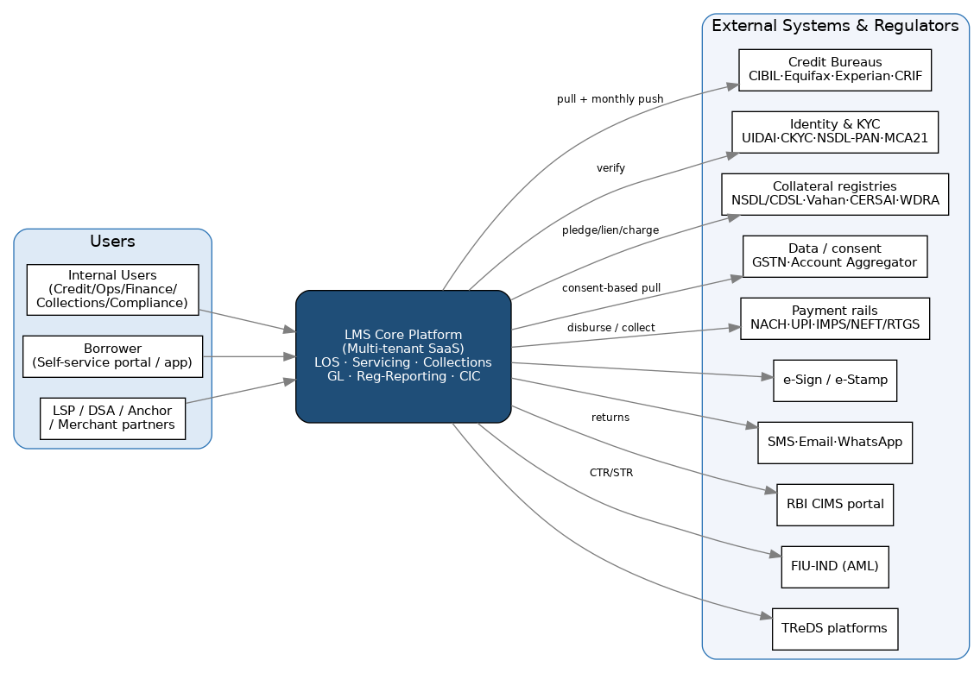
Figure 44.1 — System context: the LMS core, its users, and the external systems/regulators it integrates with (Section 12).

44.2 Deployment & Disaster-Recovery Topology
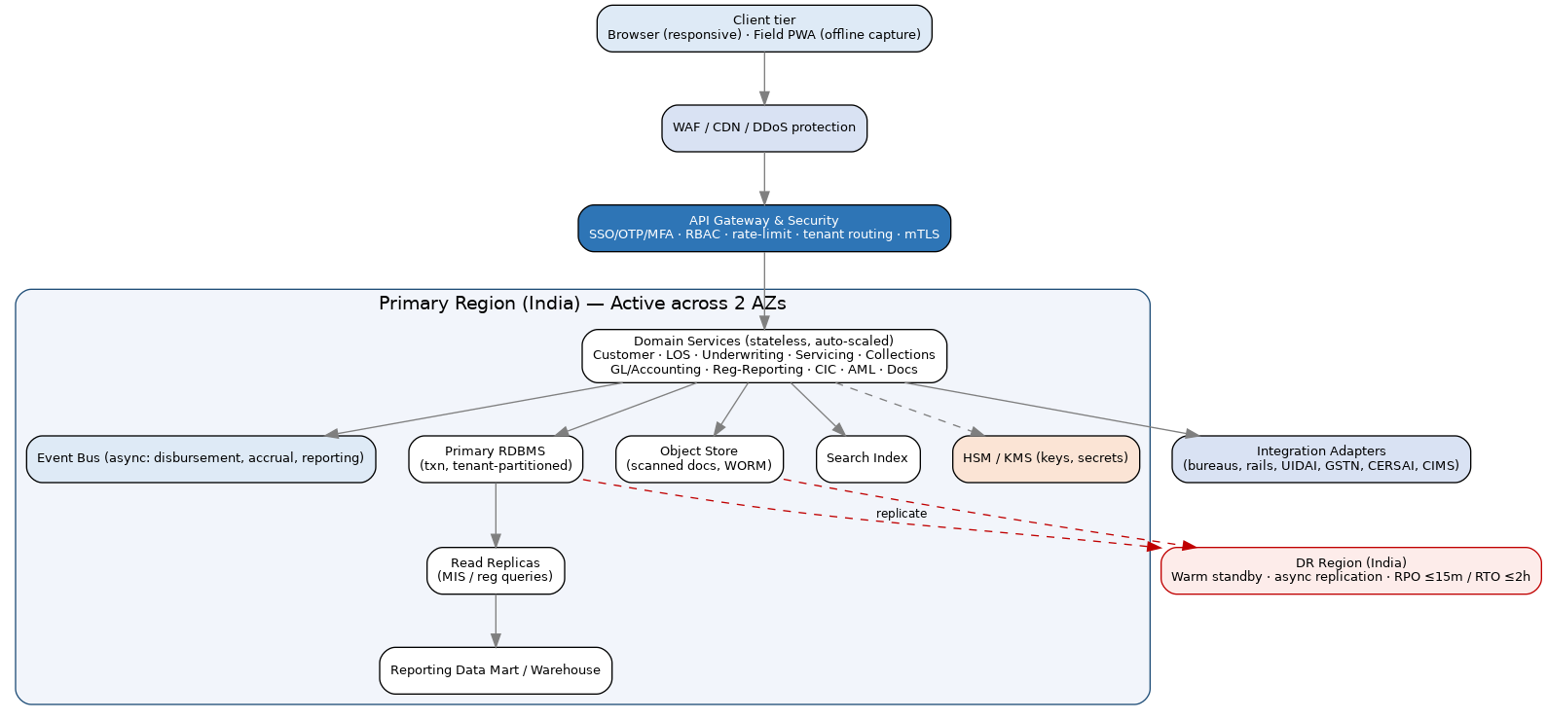
Figure 44.2 — Layered deployment across two AZs with a warm DR region (Sections 1.1, 15, 29.1).

44.3 Core Data Model (Entity–Relationship)
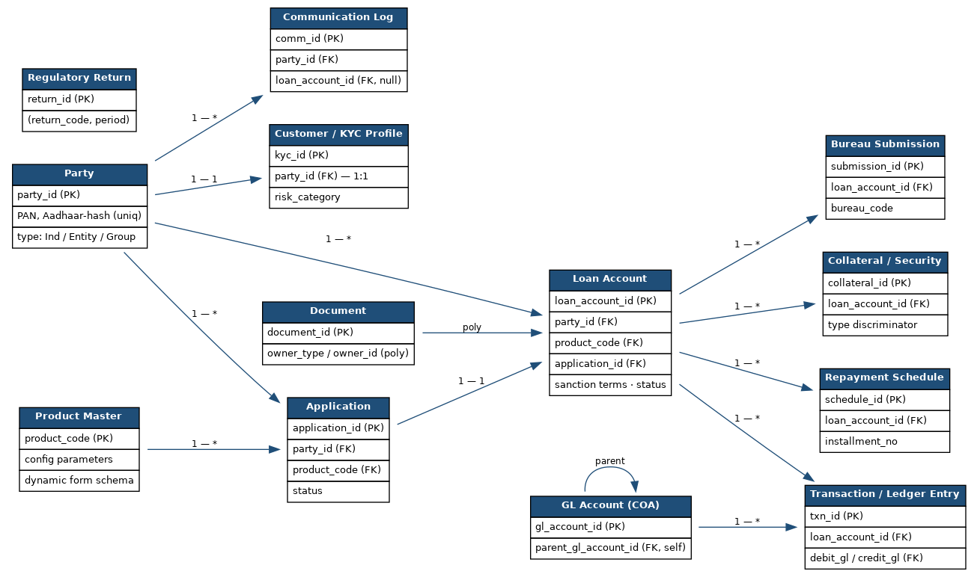
Figure 44.3 — Core entities and relationships (Section 11), with PK/FK and cardinalities.

44.4 Sequence — Disbursement → GL Posting
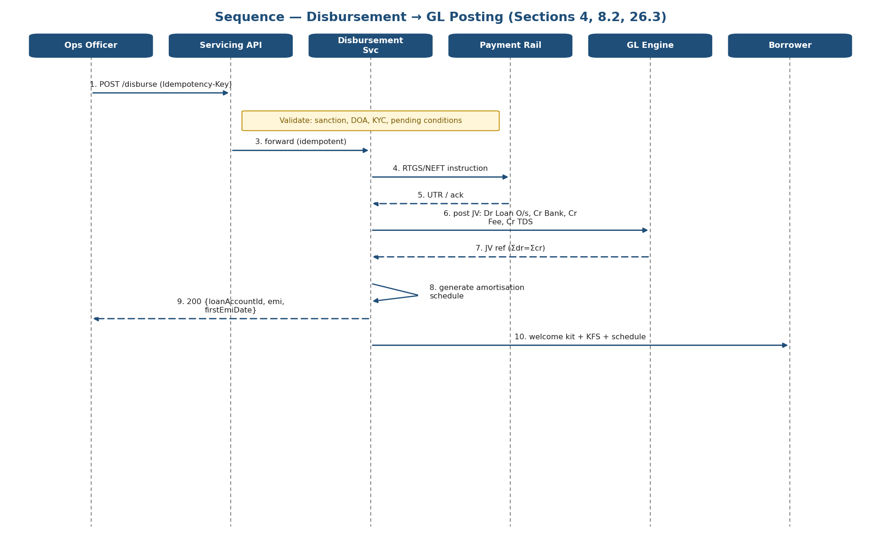
Figure 44.4 — Disbursement flow with idempotency and balanced GL posting (Sections 4, 8.2, 26.3).

44.5 Sequence — EMI / NACH Collection & Failure
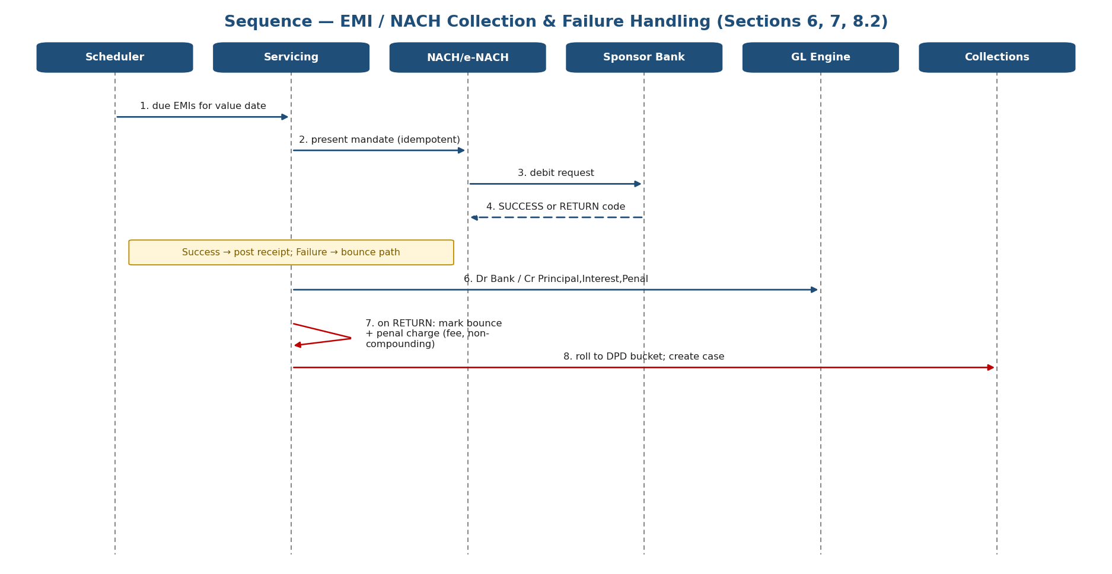
Figure 44.5 — Collection with success and bounce/return paths (Sections 6, 7, 24.7).

44.6 Sequence — Monthly CIC (Bureau) Reporting
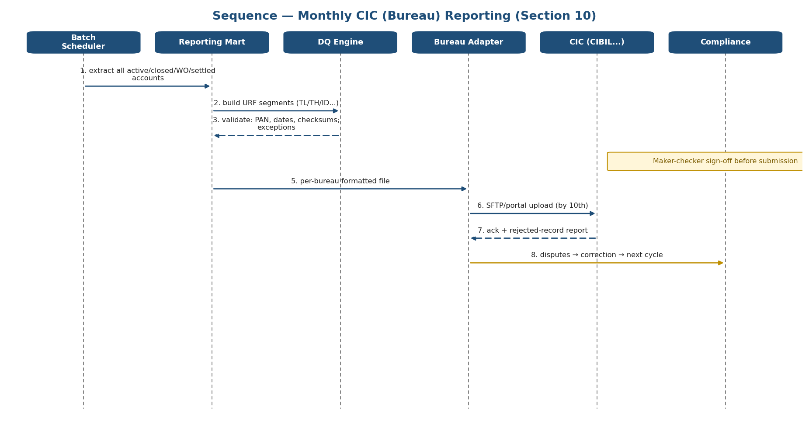
Figure 44.6 — Monthly bureau file generation, DQ, maker-checker, submission and disputes (Section 10).

44.7 Sequence — LAS Drawing-Power Revaluation & Margin Call
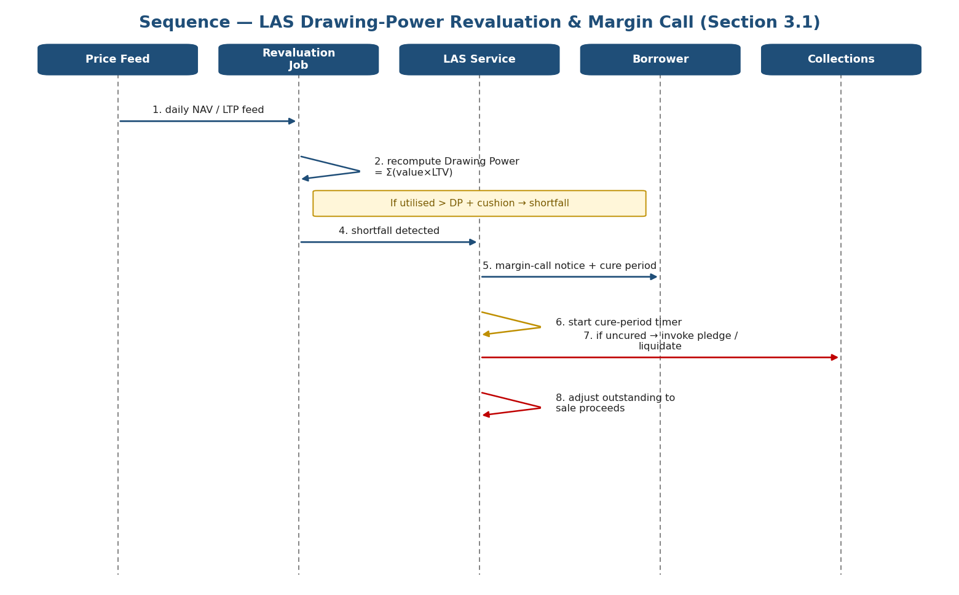
Figure 44.7 — Daily revaluation, margin call, cure period and invocation (Section 3.1).

44.8 State Machine — Loan Account
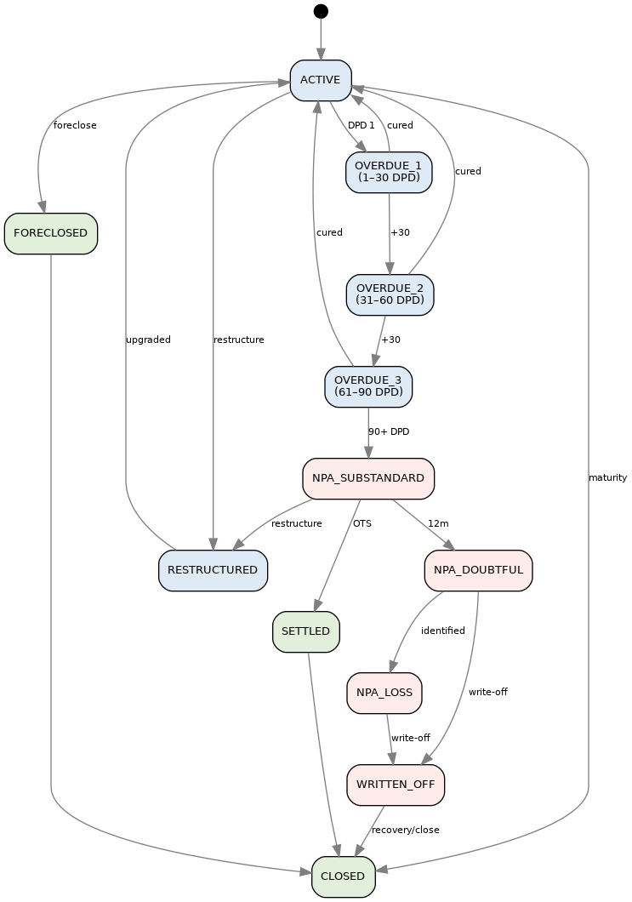
Figure 44.8 — Loan Account lifecycle and NPA transitions (Section 25.2, 9.4).

44.9 State Machine — Application
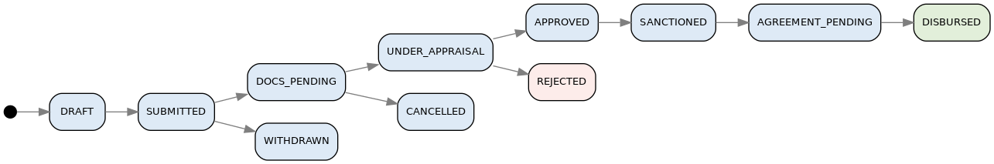
Figure 44.9 — Application lifecycle to disbursement, with terminal states (Section 25.2).

Sections 45–68 (Version 3.0) add the comprehensive calculation engine and the assurance, delivery and governance layers expected of a top-tier advisory deliverable. Section 45 consolidates and extends the calculation logic of Sections 24 and 32; every formula is paired with a worked, numerically-verified example so a developer can implement and unit-test it directly.

45. Comprehensive Calculation Engine — Interest, Charges, Fees & Penalties
This is the single reference for every monetary computation in the platform. It consolidates Sections 24 and 32 but consolidates them and adds the additional methods that different loan products require. Each product in Section 3 is wired (via the Product Master) to one interest method, a fee schedule, and a penalty method; Section 45.4 gives the product-to-method matrix. All computations obey the money-precision and rounding standard in Section 28.

45.1 Calculation-Method Taxonomy
Family | Methods available | Typical products
Interest | Simple · Flat/Add-on · Reducing balance (annual/quarterly/monthly/daily rest) · Compound · Amortised EMI · Front-end discount · Rule-of-78 · Step-up/Step-down · Balloon/Bullet · Floating/Reset · Advance vs Arrears · Per-diem | All products
Charges & fees | Processing · Login · Documentation/legal/valuation · Foreclosure/prepayment · Part-payment · Renewal/AMC · Conversion · CERSAI/stamp · Statement/NOC | All products
Penalties | Penal charge on overdue installment/amount · Bounce/mandate-failure · Covenant/non-compliance (insurance lapse, stock statement) | All products
Yield/subsidy | APR · EIR · Interest subvention · No-cost-EMI subvention · Prepayment rebate | As applicable

45.2 Day-Count Conventions
The convention is set once per product in the Product Master and used consistently by every formula below (see Section 24.1). Mixing conventions is the most common cause of schedule discrepancies.
Convention | Daily rate basis | Where used
Actual/365 (Fixed) | Annual ÷ 365 (ignores leap year) | LAS, Gold, Smart Credit Line, daily-reducing loans
Actual/Actual | Annual ÷ 365 or 366 per actual year | Where the agreement references actual year length
Actual/360 | Annual ÷ 360 | Some money-market / discounting facilities
30/360 | Each month = 30 days, year = 360 | Standard monthly-rest EMI products
30E/360 (European) | 30/360 with end-of-month rule | Certain structured facilities

Per-diem interest = Outstanding × (Annual_Rate/100 / Day_Count_Basis) × Actual_Days

45.3 Interest Methods (with worked examples)

45.3.1 Simple Interest
Interest = P × (Annual_Rate/100) × (Days / Basis)

Example: P = ₹1,00,000 · 12% · 90 days (Actual/365) → Interest = ₹2,958.90; amount due = ₹102,958.90. Used for Gold bullet, LAS, bridge facilities.

45.3.2 Flat Rate / Add-On Interest
Total_Interest = P × (Flat_Rate/100) × Tenure_Years
EMI = (P + Total_Interest) / Number_of_Installments

Example: P = ₹2,00,000 · 10% flat · 3 yrs → Total interest ₹60,000; EMI ₹7,222.22. Crucially, the true reducing-balance equivalent (APR) is ≈ 19.5% — materially higher than the 10% headline, which is why the flat rate must never be shown as the APR in the KFS (Section 17.1).

45.3.3 Reducing Balance — Rest Frequency Matters
Rest = the frequency at which interest is recomputed on the reducing principal
Annual rest : interest charged on the opening balance for the whole year
Quarterly : recomputed every quarter
Monthly rest : recomputed every month (standard EMI)
Daily rest : recomputed every day on the actual outstanding

Example (₹1,00,000 · 12% · 2 yrs, principal in 2 equal annual parts): annual-rest interest = ₹12,000 + ₹6,000 = ₹18,000; the same loan on a 24-month monthly-rest EMI (₹4,707.35) charges total interest ₹12,976. Annual rest costs the borrower more — the rest frequency must be disclosed.

45.3.4 Compound Interest
A = P × (1 + (Annual_Rate/100)/f)^(f × Years) where f = compounding frequency/year

Example: ₹1,00,000 · 10% · 2 yrs → quarterly compounding A = ₹121,840.29 (interest ₹21,840.29) vs annual compounding ₹121,000. Note: RBI restricts compounding of penal charges (Section 24.7).

45.3.5 Amortised EMI (Reducing, Monthly Rest)
EMI = P × r(1+r)^n / ((1+r)^n − 1), r = (Annual/12)/100 [see Section 24.2]

The default for Personal/Business, Vehicle, LAP and EMI-based Gold loans. Golden vector: ₹5,00,000 · 14% · 36m → EMI ₹17,088.81 (Section 24.2).

45.3.6 Front-End Discount (Bills / Invoices / Factoring)
Discount = Face_Value × (Rate/100) × (Days/Basis)
Advance = Face_Value − Discount (interest deducted up-front)

Example: ₹1,00,000 invoice · 12% · 90 days → discount ₹2,958.90; advance ₹97,041.10. Because interest is deducted up-front, the effective yield ≈ 12.37% > 12%. Used for Bill/Cheque Discounting (3.12), TReDS (3.11), Factoring (3.10).

45.3.7 Rule of 78 (Prepayment Rebate on Flat Loans)
Unearned_Interest = Total_Interest × (Σ remaining-month digits / Σ all-month digits)

Example: flat loan with ₹60,000 total interest over 36 months, prepaid after 12 → unearned (rebate) = 60,000 × 300/666 = ₹27,027.03; interest earned ₹32,972.97. The actuarial method (45.8) is fairer to the borrower and is the preferred approach.

45.3.8 Step-Up / Step-Down EMI
Step-up : EMI grows by g% each period (lower early EMIs) — used for young/edu borrowers
Step-down: EMI reduces over time — used where income tapers
Solve so that Σ PV(EMI_t at r) = Principal

Example: a ₹10,00,000 · 10% · 120m loan with 5% annual step-up starts materially below the level EMI and rises yearly; the engine sizes the first-year EMI so discounted cash flows equal principal. Used in Education (3.21) and Affordable Housing (3.18).

45.3.9 Balloon / Bullet
Amortise (P − Balloon) as EMI; Balloon amount due as a lump sum at maturity

Example: ₹10,00,000 · 12% · 60m with a 30% balloon → EMI on the amortising 70% ≈ ₹15,571.11 plus a ₹300,000 bullet at maturity. Common in CV/CE (3.16) and Equipment (3.14).

45.3.10 Advance vs Arrears EMI
Arrears (default): first EMI one period after disbursement
Advance (annuity-due): EMI_advance = EMI_arrears / (1 + r) [first EMI at disbursement]

Example: the ₹5,00,000·14%·36m loan has an arrears EMI of ₹17,088.81; the advance-EMI equivalent is ₹16,891.74. Advance EMIs are common in Vehicle/CE financing.

45.3.11 Floating / Reset
On a benchmark reset (Section 5.4/6), recompute the outstanding at the reset date and re-solve either the EMI (tenure fixed) or the tenure (EMI fixed) per borrower election (Section 24.8). Every reset is effective-dated (Section 39.2) so the schedule history is auditable.

45.4 Product ↔ Calculation-Method Matrix
Product (Section 3) | Interest method | Charges | Penalty
LAP / Housing / Affordable | Reducing balance, monthly rest (EMI) | Processing, foreclosure, legal/valuation, CERSAI | Penal charge on overdue EMI
Personal / Business (unsecured) | Amortised EMI | Processing, foreclosure | Penal on overdue EMI + bounce
Gold Loan | Bullet simple interest / monthly-servicing / EMI | Processing, valuation, auction | Penal on overdue; auction
LAS / Smart Credit Line | Daily reducing on utilised balance | Renewal/AMC, processing | Penal on overshoot; margin call
Vehicle / CV-CE / Tractor / EV | Amortised EMI (often advance EMI) | Processing, RTO/hypothecation | Penal on overdue EMI + bounce
Bill/Cheque Discounting · TReDS · Factoring | Front-end discount | Discount/factoring charge | Sec.138 workflow on dishonour
Supply Chain Finance | Discount / reducing on drawn | Program/processing | Penal on overdue invoice
Microfinance (JLG/SHG) | Reducing balance (weekly/fortnightly rest) | Processing (capped) | Per RBI MFI norms
Education | Step-up EMI, moratorium + capitalisation | Processing | Penal post-moratorium
Working Capital / CC / OD | Daily reducing on utilised (Drawing Power) | Renewal, processing | Penal on overdrawn
Consumer Durable / BNPL / POS | Amortised EMI / no-cost-EMI subvention | Processing/late fee | Late fee per Section 24.7
MCA / RBF | Fixed multiple via holdback % | Processing | Minimum-payment fallback

45.5 Fees & Charges Methods
Charge | Method | Worked example
Processing fee | % of sanctioned amount (or flat), + GST 18% | ₹5,00,000 × 1% = ₹5,000 + ₹900 GST = ₹5,900
Foreclosure / prepayment | % of outstanding principal | Outstanding ₹3,55,921.50 × 4% = ₹14,236.86 (Section 24.9)
Part-payment charge | % of amount prepaid (often nil for floating-rate individuals) | ₹1,00,000 × 2% = ₹2,000
Bounce / mandate failure | Flat per instance + GST | ₹500 + ₹90 GST = ₹590
Documentation / legal / valuation | At actuals or slab | As per empanelled vendor (Section 21)
Renewal / AMC (revolving) | Flat or % of limit, annual | ₹10,00,000 limit × 0.5% = ₹5,000 p.a.
Rate-conversion / switch fee | % of outstanding | On fixed↔floating switch
CERSAI / stamp / registration | Statutory, at actuals | Per state stamp duty
Statement / duplicate NOC | Flat | ₹200 + GST

Interest is GST-exempt; all fees above are taxable and post to a separate fee-income + GST-output ledger (Sections 31, 8.2).

45.6 Penal-Charge Methods (RBI-Compliant)
Per RBI’s penal-charges framework, penalties are levied as a flat fee or a fixed percentage of the overdue amount only, are not compounded, and are never an add-on to the interest rate (Section 24.7).
Penalty type | Method | Worked example
Overdue installment | % of overdue EMI (one-time, non-compounding) | ₹17,088.81 × 2% = ₹341.78
Overdue amount (revolving/OD) | % of the overdrawn/overdue amount | On the shortfall only, not the whole limit
Bounce / auto-debit failure | Flat per failed presentation | ₹590 incl. GST
Covenant / non-compliance | Flat per breach (insurance lapse, stock statement not filed) | Per sanction terms; posted as fee income
Cheque dishonour | Charge + Sec.138 NI Act workflow | Section 7.2 legal workflow

45.7 Subvention & No-Cost-EMI Mechanics
No-cost EMI: borrower pays 0% headline; the interest the lender would have earned is
funded by the merchant as a subvention.
Merchant_Subvention = Financed_Amount − PV(borrower instalments at the lender yield)

Example: ₹30,000 item · 6-month no-cost EMI · lender yield 18% (1.5%/mo). Borrower pays 6 × ₹5,000 = ₹30,000. PV of those instalments at 1.5%/mo = ₹28,485.94, so the merchant subvention = ₹1,514.06, booked as income and reconciled separately (Section 3.22). The borrower-facing rate remains 0%.
Government interest subvention example: ₹3,00,000 · 1 yr with a 3% subvention → ₹9,000 claimed from the nodal agency (Section 3.9); the borrower services the net rate and the subsidy is tracked to claim status.

45.8 Prepayment Rebate — Rule-of-78 vs Actuarial
- Rule-of-78 (sum-of-digits): front-loads interest; gives a smaller rebate on early prepayment (45.3.7). Legacy method, less borrower-favourable.
- Actuarial method: rebate = total interest − interest actually accrued on the reducing balance to the prepayment date. This is the fair, recommended method and aligns with reducing-balance economics.

45.9 APR & EIR
APR / EIR = the rate that makes Σ EMI_t/(1+r)^t = Net_amount_disbursed
Net_amount_disbursed = Principal − up-front fees + up-front income; solved iteratively (IRR)

Example: ₹5,00,000 · 14% · 36m with a 1% processing fee (₹5,000). Net disbursed ₹4,95,000; EMI ₹17,088.81 → APR ≈ 15.74% (above the 14% note rate because of the fee). The APR is the all-in figure disclosed in the KFS (Section 17.1); the EIR (Section 24.10) drives Ind AS 109 amortised-cost accounting.

45.10 Consolidated Calculation Test Vectors
Fixed input→output cases across all methods; the engine must reproduce each to the paisa (extends Section 41.2).
Method | Inputs | Expected output
Simple interest | ₹1,00,000 · 12% · 90d | ₹2,958.90
Flat → APR | ₹2,00,000 · 10% flat · 3y | EMI ₹7,222.22; APR ≈ 19.5%
Compound (quarterly) | ₹1,00,000 · 10% · 2y | A ₹121,840.29
Front-end discount | ₹1,00,000 · 12% · 90d | Advance ₹97,041.10; yield 12.37%
Rule-of-78 rebate | ₹60,000 int · 36m · prepaid m12 | Rebate ₹27,027.03
No-cost-EMI subvention | ₹30,000 · 6m · 18% yield | Subvention ₹1,514.06
Advance EMI | ₹5,00,000 · 14% · 36m | ₹16,891.74
Penal charge | ₹17,088.81 overdue · 2% | ₹341.78
APR with fee | ₹5,00,000 · 14% · 36m · 1% fee | APR ≈ 15.74%

