LOAN MANAGEMENT SYSTEM (LMS)
System Architecture & Functional Specification
For NBFC Lending & Accounting Operations — SaaS Web Platform
Covers: Multi-product lending • Embedded accounting/GL • RBI regulatory reporting • Credit Information Company (CIC) reporting • Borrower onboarding forms • Product application forms
Prepared for: LawDocs
Date: July 2, 2026 — Version 5.0

Volume 3 of 3 — Governance, Delivery & Developer Reference (Sections 46–98)
Cross-references to Sections 1–23 resolve to Volume 1; Sections 24–45 to Volume 2. The master document remains LMS_Architecture_Specification_v8.docx.

46. Reference-Model & Standards Alignment
A top-tier architecture anchors itself to recognised industry frameworks rather than an invented structure. This section maps the platform to banking, IT-governance and India-specific standards, giving auditors and the Board a familiar frame of reference.

46.1 Framework Mapping
Framework | Purpose | How the design aligns
BIAN (Banking Industry Architecture Network) | Service-domain reference model | Modules in Section 1.3 map to BIAN service domains — e.g., Party Reference Data Mgmt, Product Directory, Consumer/Corporate Loan, Collections, Credit Management, Financial Accounting, Regulatory Reporting
TOGAF | Enterprise-architecture method & views | Sections 1, 11, 12, 44 provide Business, Data, Application and Technology views; Section 47 adds baseline/target/transition
COBIT 2019 | IT governance & management objectives | Section 34 maps to governance/risk/assurance objectives (aligned to RBI IT Directions)
ITIL 4 | IT service management | Sections 42 (observability, change) and 58 (go-live, hypercare) reflect ITIL practices
COSO / COSO-ERM | Internal control & enterprise risk | Sections 8, 14, 33, 37, 55 map to control activities and risk response
ISO/IEC 27001 & NIST CSF | Information-security control frameworks | Section 50 control matrix maps each control to these frameworks and the RBI IT Directions

46.2 India Stack, Digital Rails & Messaging Standards
The platform is designed to consume India’s public digital infrastructure natively rather than through bespoke point integrations.
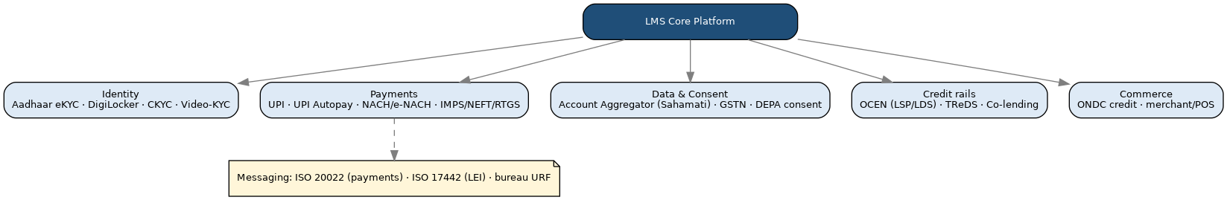
Figure 46.1 — Alignment to India Stack layers and digital-lending rails (Sections 12, 38).
Layer / standard | Component | Where used
Identity | Aadhaar eKYC, DigiLocker, CKYC, Video-KYC | Onboarding (Section 2, 12)
Payments | UPI, UPI Autopay, NACH/e-NACH, IMPS/NEFT/RTGS | Disbursement & collection (Sections 6, 38)
Data & consent | Account Aggregator (Sahamati), GSTN, DEPA | Cash-flow underwriting (Sections 3.33, 35, 43)
Credit rails | OCEN (LSP/LDS roles), TReDS, Co-lending | Digital lending & partnerships (Sections 17, 18)
Commerce | ONDC credit, merchant/POS | Embedded/BNPL/POS (Sections 3.22–3.23)
Messaging | ISO 20022 (payments), ISO 17442 (LEI), bureau URF | Integration & reporting (Sections 10, 12, 40)

47. Current-State Assessment, Maturity & Transition Architecture
Sections 1–44 describe the target state. A Big-4-grade deliverable also documents where the organisation is today, the gap, and the path across — so the programme is a managed transition, not a single leap.

47.1 Indicative As-Is Pain Points
- Product changes require code releases; new products take weeks to launch.
- Fragmented systems — origination, servicing, accounting and collections in separate tools with manual reconciliation.
- Regulatory returns and bureau files assembled semi-manually, with rework and late-submission risk.
- Limited straight-through digital origination; heavy branch dependency; thin analytics/EWS.
- Provisioning and Ind AS 109 ECL computed offline in spreadsheets.

47.2 Capability Maturity — Current vs Target
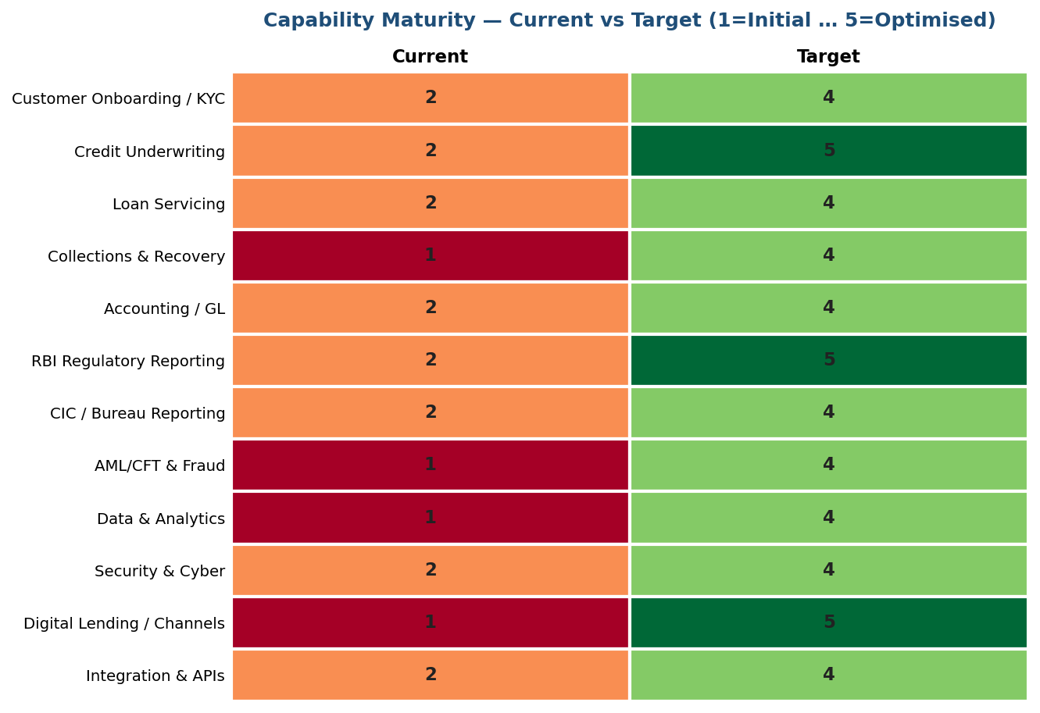
Figure 47.1 — Capability maturity heatmap (1 = Initial … 5 = Optimised). Illustrative baseline; confirm in current-state workshops.

47.3 Gap Analysis (illustrative)
Capability | Gap | Priority
Product configuration | Code-driven → parameterised engine (Section 3) | High
Digital origination | Manual → straight-through with AA/eKYC (Sections 2, 3.33) | High
Accounting/GL & provisioning | Offline → embedded GL + ECL engine (Sections 8, 30) | High
Regulatory reporting | Semi-manual → configurable engine + DQ (Section 9) | High
Collections & EWS | Reactive → bucketed queues + early-warning (Sections 7, 37) | Medium
Analytics & MIS | Static → self-service mart + dashboards (Section 13) | Medium

47.4 Transition Architecture — Migration Waves
A phased transition (not big-bang) reduces risk and lets the NBFC realise value early. Each wave is independently shippable behind the API gateway (Section 15).
Wave | Scope | Outcome
Wave 0 — Foundation | Core data model, Party/KYC, Product Config engine, GL | Platform backbone live
Wave 1 — Origination | LOS, underwriting, bureau, KFS, e-sign | Digital origination for 2–3 flagship products
Wave 2 — Servicing & Accounting | Calc engine, servicing, embedded GL, provisioning | Books and schedules on-platform
Wave 3 — Collections & Reporting | Collections, RBI returns, CIC reporting | Compliance fully automated
Wave 4 — Advanced | Co-lending, digital/BNPL, AA/alt-data, EWS | Growth & efficiency features

47.5 Architecture Decision Records (ADRs) — sample
ADR | Decision | Rationale / alternatives
ADR-01 | Modular monolith at launch, service extraction later | Balances speed and future scale (Section 27); alt: full microservices — rejected as premature
ADR-02 | PostgreSQL as primary datastore | ACID, native DECIMAL, partitioning, India-region managed options; alt: Oracle — higher licence cost
ADR-03 | Parameterised Product Config engine | New products without code release (Section 3); alt: per-product code — rejected
ADR-04 | Embedded GL rather than external accounting package | Real-time loan-to-GL integrity (Section 8); alt: bolt-on GL — reconciliation risk
ADR-05 | Configurable returns engine, not hard-coded returns | RBI formats change over time (Section 9); alt: hard-coded — high change cost
ADR-06 | DECIMAL money + append-only ledger | Financial correctness (Section 28); alt: float — rejected outright

48. Requirements Traceability Matrix (RTM)
The RTM links every material requirement to the design section that satisfies it and the test that verifies it — the backbone of audit and UAT traceability. An extract is shown; the full RTM is maintained as a living artifact and each requirement carries a stable ID.
Req ID | Requirement | Design ref | Verification
FR-01 | Configure a new product without a code release | §3, §39.2 | Config-only product added in UAT
FR-02 | Dynamic onboarding forms by applicant type | §2 | E2E per applicant type
FR-03 | Bureau pull with consent at underwriting | §5.1, §35 | Contract test vs each CIC
FR-04 | Generate amortisation schedule at disbursement | §24, §45 | Golden vectors (§45.10)
FR-05 | Auto double-entry posting for every event | §8.2 | GL tie-out (§41.3)
FR-06 | Monthly CIC file in URF per bureau | §10 | DQ + acceptance-rate test
FR-07 | Configurable RBI returns by SBR layer | §9 | Regulatory UAT pass
FR-08 | NPA classification & provisioning + ECL | §9.4, §30 | Worked-example reconciliation
FR-09 | Collections buckets, PTP, field app | §7 | E2E collections
FR-10 | KFS with APR and cooling-off | §17, §45.9 | KFS generation test
NFR-01 | API p95 ≤ 300 ms at peak | §29.1 | Load test
NFR-02 | RPO ≤ 15 min / RTO ≤ 2 h | §29.1 | DR drill
NFR-03 | Money as DECIMAL; balanced postings | §28 | Unit + property tests
SEC-01 | Field-level encryption/tokenisation of PII | §14, §34.2 | Security test / VAPT
REG-01 | Report cyber incident within 6 h | §34.3 | Tabletop exercise
REG-02 | LEI for entity exposure ≥ ₹5 cr | §25.1, §43.2 | Validation rule test

49. Regulatory Obligations Register
Each obligation is mapped to where it is addressed, the accountable control owner, and the evidence produced. This single register is what a regulator or auditor typically asks for first; thresholds/formats are per the extant Master Directions and are re-validated by Compliance.
Regulation / basis | Key obligation | Design ref | Owner / evidence
RBI Scale-Based Regulation | Layer-appropriate prudential norms & returns | §9.1–9.2 | Compliance / return archive
RBI KYC Master Direction | CDD, risk categorisation, periodic re-KYC, CKYC | §2.11, §16 | Compliance / KYC audit log
RBI Digital Lending Directions | KFS, APR, cooling-off, LSP/FLDG, no unsolicited limit | §17, §36 | Compliance / KFS + consent logs
RBI penal-charges framework | Penalty as fee, non-compounding, not penal interest | §24.7, §45.6 | Finance / penal-charge ledger
RBI IT Governance Directions 2023 | IT governance, infosec, BCP/DR, IS audit | §34 | CISO / policy + VAPT reports
CERT-In Directions 2022 | 6-hour incident reporting; 180-day logs | §34.3 | CISO / incident register
PMLA & Rules | CTR/STR/NTR/CCR to FIU-IND; 5-yr records | §16 | Principal Officer / FIU filings
DPDP Act 2023 | Consent, purpose limitation, rights, breach notice | §35 | DPO / consent + retention logs
CICRA & RBI CIC directions | Monthly CIC reporting; disputes | §10 | Compliance / submission logs
Ind AS 109 | ECL, EIR, staging, prudential floor | §30, §24.10 | Finance / ECL model docs
RBI LEI directions | LEI for entity exposure ≥ ₹5 cr | §25.1, §43.2 | Credit / LEI capture
RBI Microfinance MD | Household income & indebtedness caps, pricing | §3.8 | Credit / MFI checks
RBI Co-lending / Securitisation | MRR, true-sale, disclosures | §18 | Treasury / deal records
RBI Outsourcing / Recovery-agent | Agent conduct, code, contact-window | §36, §21 | Ops / agent governance
RBI Wilful/Large Defaulter MD | Identification committees, CIC reporting | §37.3 | Credit / committee minutes
Fair Practices Code | Pricing rationale, grievance, Ombudsman | §5.4, §9.5 | Compliance / grievance MIS
Factoring Regulation Act | CERSAI assignment filing timelines | §3.10 | Ops / CERSAI filings
RBI data localisation | Storage & processing within India | §15 | IT / hosting evidence

50. NFR Catalogue & Security Control Matrix

50.1 NFR Catalogue (extract, with IDs)
NFR ID | Category | Target | Verification
NFR-01 | Performance | Core API p95 ≤ 300 ms, p99 ≤ 800 ms | Load test (§29.1)
NFR-02 | Availability | 99.9% monthly | Uptime monitoring
NFR-03 | Resilience | RPO ≤ 15 min, RTO ≤ 2 h | DR drill
NFR-04 | Scalability | ≥ 500 TPS sustained, 2,000 peak | Soak/scale test
NFR-05 | Batch | EOD accrual complete by 02:00 | Batch SLA monitor
NFR-06 | Security | PII encrypted/tokenised; MFA | VAPT
NFR-07 | Auditability | Immutable audit trail | Audit review
NFR-08 | Data residency | All data within India | Hosting evidence
NFR-09 | Accessibility | Borrower portal WCAG 2.1 AA | Accessibility audit (§60)

50.2 Security Control Matrix (framework mapping)
Control | NIST CSF | ISO 27001 (Annex A) | RBI IT Directions
Access control / least privilege / PAM | PR.AC | A.5.15–A.5.18 | Access control
Cryptography & key management (HSM/KMS) | PR.DS | A.8.24 | Cryptographic controls
Secure SDLC / SAST-DAST / SBOM | PR.IP | A.8.25–A.8.28 | Application security
Logging, monitoring & SIEM | DE.CM | A.8.15–A.8.16 | Audit trail / monitoring
Incident response (6-hr CERT-In) | RS.RP | A.5.24–A.5.28 | Incident management
BCP / DR & drills | RC.RP | A.5.29–A.5.30 | Business continuity
Third-party / outsourcing risk | ID.SC | A.5.19–A.5.23 | Outsourcing risk
Data classification & DLP | PR.DS | A.5.12–A.5.13 | Data leak prevention

51. Business Case, TCO & Financial Model
All figures in this section are illustrative planning assumptions to demonstrate the model structure — they are placeholders for the NBFC’s own validated numbers, not a costing. They should be refined in a costing workshop.

51.1 Value Drivers
- Revenue growth: faster product launch and straight-through digital origination increase throughput.
- Cost reduction: lower cost-to-originate and cost-to-serve through automation and self-service.
- Credit-loss reduction: earlier warning signals, better collections, lower GNPA/PAR.
- Regulatory efficiency & confidence: automated, accurate returns reduce rework and penalty risk.

51.2 Five-Year Financial Model (illustrative, ₹ crore)
Line | Y0 | Y1 | Y2 | Y3 | Y4 | Y5
Investment (build) | 6 | 6 | 0 | 0 | 0 | 0
Run / opex | 0 | 3 | 3 | 3 | 3 | 3
Gross benefits | 0 | 4 | 9 | 14 | 16 | 18
Net cash flow | -6 | -5 | 6 | 11 | 13 | 15

At a 12% discount rate the illustrative NPV is ≈ ₹19 crore with payback around Year 3. Sensitivity: if benefits land 20% lower, NPV ≈ ₹11 cr; 20% higher, ≈ ₹27 cr. TCO comprises build, run/opex, integration/bureau/API call costs, and communication costs, attributed per tenant/product for FinOps (Section 42.3).

52. Build vs. Buy & COTS Vendor Evaluation
A structured build-vs-buy decision with a weighted scorecard. Scores below are an illustrative framework, to be completed with the NBFC’s own weighting and a formal RFP.
Criterion | Weight | Build (custom) | Buy (COTS LMS)
Fit to multi-product / config engine | 20% | High (tailored) | Medium–High
Time-to-market | 15% | Slower | Faster
RBI/CIC reporting coverage out-of-box | 15% | Build required | Often included
Total cost of ownership (5-yr) | 15% | Higher build, lower licence | Licence + customisation
Flexibility / control / IP ownership | 15% | High | Vendor-dependent
Vendor risk / lock-in | 10% | None | Present (mitigate via escrow, §61)
Talent & maintainability | 10% | In-house skill needed | Vendor + partner ecosystem

Representative COTS options for an Indian NBFC include Nucleus FinnOne Neo, TCS BaNCS, Oracle FLEXCUBE, and newer platforms such as Lentra, Jocata and Finflux. A hybrid path — COTS core with custom digital-origination and analytics layers — is common. The recommendation should follow a scored RFP against these criteria.

53. Target Operating Model (TOM)
Technology is only one dimension; the TOM defines the people and process changes needed to run the platform.
Dimension | Target state
Process | L0–L3 process taxonomy for origination, servicing, collections, close, reporting; documented SOPs and RACI
Organisation | Clear ownership: Product Config (Ops), Credit, Servicing, Collections, Finance/GL, Compliance, IT/CISO, Data
Governance | Three lines of defence; model governance (§66); change advisory board (§42)
Technology | Platform per Sections 1, 15, 27
Data | Data ownership/stewardship, golden customer record, DQ framework (§67)
Sourcing | LSP/DSA, recovery agencies, valuers/advocates governed via Vendor Master (§21, §61)

54. Implementation Roadmap, WBS & Programme Governance
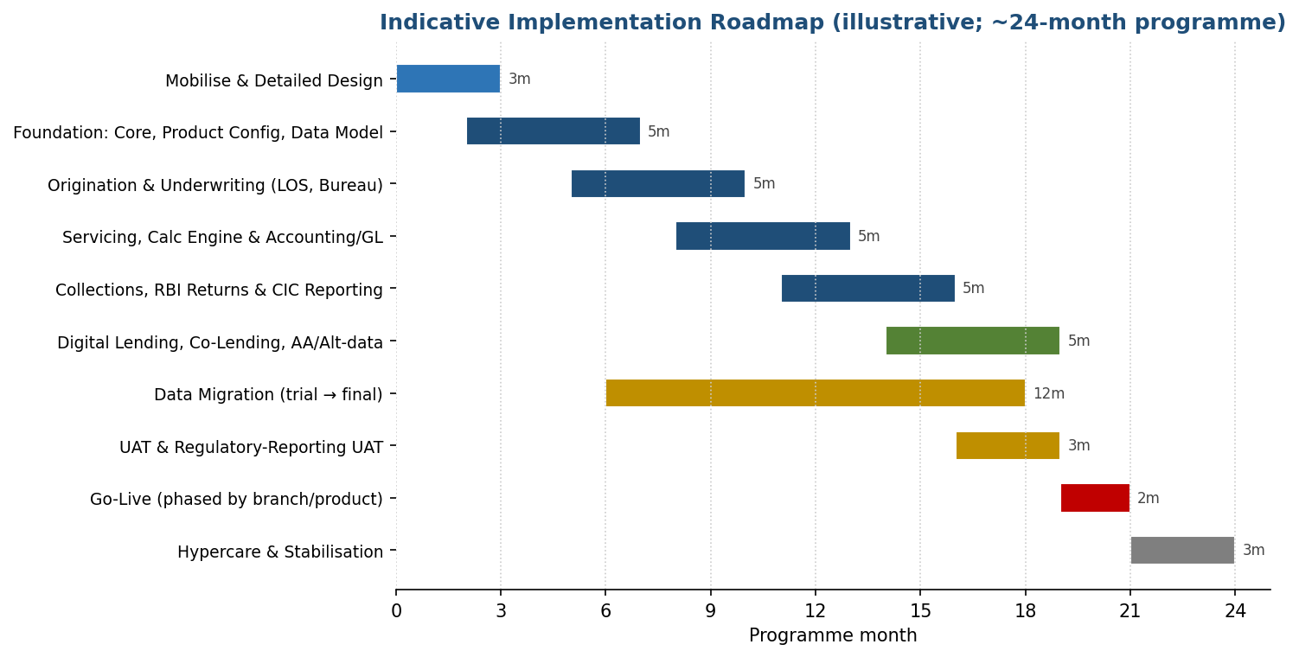
Figure 54.1 — Indicative phased roadmap (illustrative ~24-month programme; confirm in planning).

54.1 Work Breakdown (phase level)
Phase | Key work packages | Exit criteria
Mobilise & design | Detailed design, environments, IaC, data-model sign-off | Design baselined
Foundation | Core, Party/KYC, Product Config, GL | Backbone in QA
Origination | LOS, underwriting, bureau, KFS, e-sign | Flagship products live in UAT
Servicing & accounting | Calc engine, servicing, GL, provisioning | Golden vectors pass; GL ties
Collections & reporting | Collections, RBI returns, CIC | Regulatory UAT pass
Advanced & go-live | Co-lending, digital, migration, cutover | Go-live readiness met (§58)

54.2 Programme Governance
- Steering Committee (Board/CXO sponsor) for decisions and funding; monthly.
- Programme Management Office (PMO) for plan, RAID (§55), status (programme status reporting), and change control.
- Workstream leads (Product/Credit, Servicing/Finance, Collections/Compliance, Platform/IT, Data/Reporting, Change).
- Design Authority / Architecture Review Board owning ADRs (§47.5) and non-functional compliance.

55. RAID Log — Risks, Assumptions, Issues, Dependencies
Type | Item | Impact | Response / owner
Risk | Regulatory formats change mid-build | Rework of returns | Configurable engine (§9); Compliance watch
Risk | Data-migration quality from legacy | Wrong balances at cutover | Two trial runs + reconciliation (§23.1); parallel run
Risk | Integration dependency downtime (UIDAI/bureau) | Origination stalls | Resilience patterns + fallback (§38)
Risk | Scope creep across 30+ products | Timeline slip | Phased waves (§47.4); change control
Assumption | India-region cloud & data localisation available | Enables §15 | Validate with hosting
Assumption | Bureau/AA/GSTN API access granted | Enables underwriting | Confirm memberships
Issue | Legacy data gaps (missing PAN/UBO) | Bureau rejections | DQ remediation (§67)
Dependency | Board-approved pricing & DOA policy | Blocks sanction config | Obtain before Wave 1 (§5.4)
Dependency | LEI for large-exposure borrowers | Blocks disbursal | Capture at onboarding (§43.2)

56. Organizational Change Management & Adoption
A platform of this scope changes how Credit, Ops, Collections, Finance and Compliance work daily. Adoption is a managed workstream, not an afterthought.
Lever | Approach
Stakeholder analysis | Map impact and influence across roles (Section 1.4); tailored engagement plans
Impact assessment | Role-by-role “day in the life” before/after; identify process and skill changes
Training | Role-based training, sandbox practice, quick-reference guides, train-the-trainer
Communications | Cadence of updates, FAQs, floor-walkers at go-live
Adoption tracking | Usage metrics, help-desk themes, feedback loops; reinforcement post go-live
Resistance management | Early involvement of super-users; visible sponsor support

57. Operational Resilience
Beyond disaster recovery (Section 29.1), operational resilience — increasingly an RBI supervisory expectation — asks the NBFC to keep critical services within tolerable disruption limits under severe-but-plausible scenarios.
Element | Detail
Critical business services | Disbursement, EMI collection, regulatory reporting, borrower servicing, bureau reporting
Impact tolerances | Maximum tolerable disruption per service (e.g., collections outage ≤ 4 h; reporting ≤ due-date − 1 day)
Scenario testing | Cyber attack, cloud-region loss, key-vendor (bureau/rail) outage, data-corruption — tabletop + technical
Dependency mapping | People, process, technology and third-party dependencies per critical service (§38)
Response & recovery | Runbooks (operational runbooks), CCMP (§34), and DR (§29.1) with defined RPO/RTO
Board reporting | Resilience posture, incidents, and test outcomes reported to the Board

58. Go-Live Readiness, Cutover & Hypercare

58.1 Go-Live Readiness Assessment (GLRA)
Gate | Go / no-go criterion
Functional | All P1/P2 UAT defects closed; golden vectors pass (§45.10)
Regulatory | One full cycle of RBI returns & CIC files generated and validated (§9, §10)
Data | Migration reconciled: loan count, outstanding, GL balances tie to legacy (§23.1)
Non-functional | Load/DR tests meet §29 targets; VAPT closed (§34)
Operational | Runbooks, support model, command centre, rollback plan ready
Business sign-off | Sponsor and Compliance approval recorded

58.2 Cutover & Hypercare
- Cutover runbook with sequenced steps, freeze window, and explicit rollback triggers.
- Phased rollout by branch/product (not big-bang) per the transition waves (§47.4).
- Command centre during cutover; daily reconciliation checks for the first month.
- Hypercare period with elevated support and a defect-triage SLA before transition to BAU.

59. Benefits Realization & KPIs
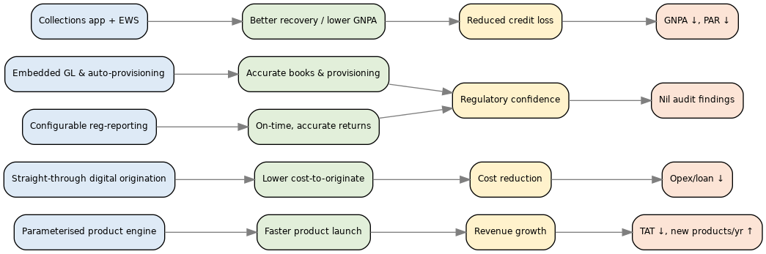
Figure 59.1 — Benefits dependency network: enablers → capabilities → benefits → KPIs.
Benefit | KPI | Illustrative target
Faster product launch | New products / variants per year | From weeks to days per product
Lower cost-to-originate | Opex per loan originated | Reduce by target %
Straight-through origination | % digital / STP applications | Increase STP share
Accurate books | GL auto-reconciliation break rate | Near-zero unexplained breaks
Regulatory confidence | On-time, accurate returns | Nil late/rejected submissions
Lower credit loss | GNPA % and PAR>90 | Downward trend vs baseline
Better collections | Collection efficiency | Sustained improvement

Each benefit is owned, baselined before go-live, and tracked post-implementation in a benefits-realisation review.

60. Accessibility & Localization
- Borrower-facing web/app targets WCAG 2.1 AA (perceivable, operable, understandable, robust); accessibility is tested, not assumed.
- Multilingual support: the Key Fact Statement, sanction letter and key notices are available in the borrower’s chosen language, satisfying the RBI requirement that terms be in a language the borrower understands (§17.1, §35).
- Vernacular content is data-driven (template + language pack), so new languages are added by configuration, not code.
- Inclusive design for low-literacy and assisted (branch/field) journeys, including the field PWA (§1.1).

61. Legal, Procurement & Vendor Governance
Area | Requirement
SaaS / licensing terms | Clear scope, SLAs, data-ownership, liability and IP terms (if COTS, §52)
Data Processing Agreement (DPA) | DPDP-compliant processor terms, purpose limitation, sub-processor control (§35)
Source-code / data escrow | Escrow for a COTS/hosted solution to mitigate vendor-continuity risk
Exit management | Documented exit plan, data return/deletion, transition assistance
Right to audit | Retained over vendors, LSPs and recovery agencies (§21, §36)
Cyber insurance | Coverage aligned to breach-liability exposure (§34)
Regulatory outsourcing | RBI outsourcing-directions compliance; the NBFC remains responsible

62. Quality Assurance, Methodology & Basis of Preparation
- Methodology: this specification was developed by consolidating the functional/regulatory requirements of an Indian NBFC multi-product lending operation and mapping them to a target architecture, with worked, numerically-verified calculations and industry-standard framework alignment (§46).
- Quality assurance: content was internally reviewed for internal consistency and cross-reference integrity; the calculation engine (§24, §32, §45) is backed by golden test vectors (§45.10) that a build team can execute directly.
- Independence & limitations: regulatory names, thresholds, formats and rates cited are per the extant RBI Master Directions and statutes as of this revision and are subject to periodic change; they must be re-validated by the NBFC’s Compliance and Legal functions before go-live. Illustrative financials and scores (§51, §52) are planning placeholders, not a costing or recommendation of any named vendor.
- This document is a functional and architectural specification, not legal, tax, accounting or investment advice; the NBFC remains responsible for regulatory compliance.

63. Appendix A — API Specification (OpenAPI 3.1 extract)
A machine-readable contract anchors the API-first design (Sections 15, 22, 40). Extract for a core endpoint; the full spec is version-controlled and generates client SDKs and mock servers.
openapi: 3.1.0
info: { title: LMS API, version: "1.0.0" }
servers: [{ url: https://api.lms.example.in/v1 }]
paths:
/loan-accounts/{id}/disburse:
post:
summary: Disburse a sanctioned loan (idempotent)
parameters:
- { name: id, in: path, required: true, schema: { type: string } }
- { name: Idempotency-Key, in: header, required: true, schema: { type: string } }
requestBody:
required: true
content:
application/json:
schema: { $ref: "#/components/schemas/DisburseRequest" }
responses:
"200": { description: Disbursed, content: { application/json:
{ schema: { $ref: "#/components/schemas/DisburseResponse" } } } }
"409": { description: Idempotency conflict }
"422": { description: Business rule violation, content: { application/json:
{ schema: { $ref: "#/components/schemas/Error" } } } }
security: [ { oauth2: [disburse] } ]
components:
schemas:
DisburseRequest:
type: object
required: [disbursementAmount, disbursementMode, beneficiaryAccount, valueDate]
properties:
disbursementAmount: { type: string, description: "DECIMAL minor-units as string" }
disbursementMode: { type: string, enum: [FULL, STAGED] }
beneficiaryAccount:
type: object
properties: { accountNumber: {type: string}, ifsc: {type: string} }
valueDate: { type: string, format: date }
Error:
type: object
properties:
code: {type: string}; message: {type: string}; traceId: {type: string}
securitySchemes:
oauth2: { type: oauth2, flows: { clientCredentials: { tokenUrl: /oauth/token, scopes: {} } } }

64. Appendix B — Core Data Model DDL (extract)
Illustrative PostgreSQL DDL for two core tables, realising the conventions in Section 39 (DECIMAL money, tenant partitioning, audit columns, idempotency).
CREATE TABLE loan_account (
loan_account_id UUID PRIMARY KEY,
tenant_id UUID NOT NULL,
party_id UUID NOT NULL REFERENCES party(party_id),
product_code TEXT NOT NULL REFERENCES product_master(product_code),
application_id UUID REFERENCES application(application_id),
config_version INT NOT NULL, -- booked-under product config (bi-temporal)
sanctioned_amt DECIMAL(18,4) NOT NULL,
roi DECIMAL(9,6) NOT NULL,
status TEXT NOT NULL, -- see Section 25.2 enum
dpd_bucket SMALLINT DEFAULT 0,
valid_from TIMESTAMPTZ NOT NULL DEFAULT now(),
created_at TIMESTAMPTZ NOT NULL DEFAULT now(),
created_by TEXT NOT NULL,
row_version INT NOT NULL DEFAULT 1
) PARTITION BY LIST (tenant_id);
CREATE INDEX ix_loan_status ON loan_account (status, dpd_bucket);
CREATE TABLE txn_ledger (
txn_id UUID PRIMARY KEY,
tenant_id UUID NOT NULL,
loan_account_id UUID REFERENCES loan_account(loan_account_id),
debit_gl UUID NOT NULL REFERENCES gl_account(gl_account_id),
credit_gl UUID NOT NULL REFERENCES gl_account(gl_account_id),
amount DECIMAL(18,4) NOT NULL CHECK (amount > 0),
value_date DATE NOT NULL,
posting_date TIMESTAMPTZ NOT NULL DEFAULT now(),
event_id TEXT NOT NULL,
CONSTRAINT uq_event UNIQUE (event_id) -- idempotent posting (Section 28.4)
) PARTITION BY RANGE (posting_date);

65. Appendix C — STRIDE Threat Model (extract)
Threat (STRIDE) | Example against the LMS | Mitigation
Spoofing | Impersonating a borrower or officer | MFA/OIDC, mTLS, device binding (§34)
Tampering | Altering a ledger entry or a disbursement amount | Append-only ledger, balanced-posting checks, integrity hashing (§28, §34)
Repudiation | Denying an approval or transaction | Immutable audit trail, e-sign, signed API requests (§14, §40)
Information disclosure | PII/account-data leak | Field encryption/tokenisation, DLP, least privilege (§34.2)
Denial of service | Flooding disbursement/collection APIs | Rate limiting, WAF, autoscaling, circuit breakers (§38)
Elevation of privilege | Officer gains admin/config rights | RBAC + SoD, PAM, maker-checker on config (§14, §34)

66. Appendix D — Model Risk Governance
The scorecards (Section 5), ECL model (Section 30), pricing model (Section 5.4) and any AI/algorithmic decisioning (Section 17.3) are models that require governance, in line with sound model-risk practice.
Control | Requirement
Model inventory | Register of all decisioning/valuation models with owner and version
Development standards | Documented data, assumptions, methodology; reproducible
Independent validation | Pre-deployment and periodic validation by a party independent of development
Performance monitoring | Ongoing back-testing, drift/stability monitoring, recalibration triggers
Explainability & fairness | Feature logging for adverse-decision explanation (§17.3); bias testing
Change control & versioning | Effective-dated model versions (§39.2); maker-checker on promotion
Board/committee oversight | Model-risk reporting to the risk committee

67. Appendix E — Data Governance & Data-Quality Framework
Element | Detail
Ownership & stewardship | Named data owners/stewards per domain (customer, loan, collateral, GL, reporting)
Golden record / MDM | Single customer master via de-dupe on PAN/Aadhaar-hash (§2, §11); one source of truth
Data-quality rules | Completeness, validity (§25.1 regex), consistency, uniqueness, timeliness — measured and scored
DQ at migration & runtime | Pre-submission DQ engine for bureau files (§10.5); migration DQ scorecards (§23.1)
Lineage | Traceability from source field → reporting mart → regulatory return (§9.3)
Reference data & codes | Centrally governed code sets (product, NIC, purpose, GL) with versioning
Privacy by design | Classification, minimisation, retention and consent (§35)

68. Appendix F — Sample MIS Dashboard & Report Catalogue
An illustrative portfolio dashboard demonstrating the MIS layer (Section 13). Layout and metrics are indicative; the report builder lets Finance/Compliance self-serve over the reporting mart.
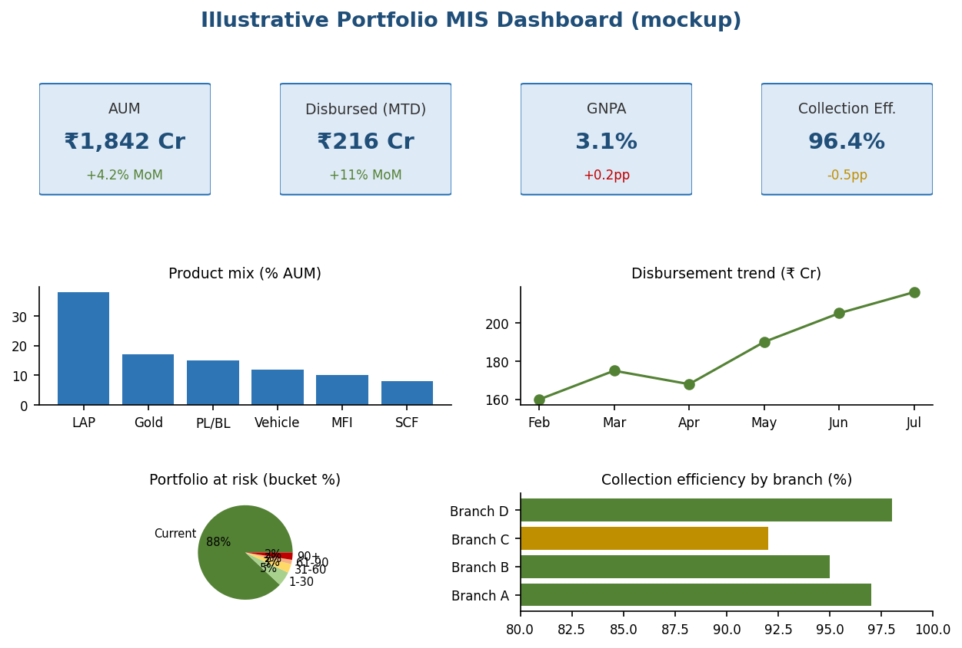
Figure 68.1 — Illustrative portfolio MIS dashboard (mockup): KPI tiles, product mix, disbursement trend, PAR buckets, branch collection efficiency.
Standard reports include the Portfolio Dashboard, Delinquency/PAR, Collection Efficiency, NPA & Provisioning, Product Profitability, and the Regulatory/Bureau submission trackers (Section 13), each drillable and exportable.

69. Financial Ratios & Regulatory Computation Engine
The platform must compute the prudential and performance ratios an NBFC (and, where the same codebase serves one, an Urban Cooperative Bank) reports and monitors. Each ratio below is given with its formula, a worked illustrative example (₹ crore), the applicable threshold, and the source module that supplies the inputs. All figures are illustrative; thresholds are per the extant RBI norms and must be confirmed by Compliance. These ratios feed the RBI returns (Section 9) and the MIS dashboards (Section 13).

69.1 Capital Adequacy
CRAR (Capital to Risk-weighted Assets Ratio) = (Tier I + Tier II capital) / RWA × 100
Tier I ratio = Tier I capital / RWA × 100
Net Owned Fund (NOF) = Owned Fund − investments in group/subsidiary companies (per RBI formula)

Example: Tier I ₹150 cr + Tier II ₹50 cr = capital funds ₹200 cr; RWA ₹1000 cr → CRAR = 20.0%, Tier I ratio = 15.0%. Tier II is capped at 100% of Tier I. Upper-Layer NBFCs must additionally maintain CET1 capital; UCBs follow a separate tiered CRAR regime (Section 69.8).

69.2 Risk-Weighted Assets (RWA)
RWA = Σ (Exposure_i × Risk_Weight_i) for on-balance-sheet assets
+ Σ (Credit_Equivalent_of_off-balance_item × Risk_Weight)
Risk weights are prescribed by asset class (e.g., different weights for cash, government securities,
secured retail, unsecured, capital-market/CRE exposures) per RBI norms.

Example: ₹600 cr of exposures at 100% + ₹400 cr at 50% → RWA = 600 + 200 = ₹800 cr. Risk weights are held in a configurable table (versioned per Section 39.2) so RBI revisions do not require a code change.

69.3 Leverage
Leverage Ratio (NBFC) = Total Outside Liabilities / Owned Fund

Example: TOL ₹900 cr / Owned Fund ₹200 cr = 4.5× (within the ceiling of 7 applicable to the relevant NBFC category). The Basel-style leverage view (Tier I / total exposure) is computed in parallel for Upper-Layer monitoring.

69.4 Asset Quality
GNPA % = Gross NPA / Gross Advances × 100
Net NPA % = (Gross NPA − Provisions held) / (Gross Advances − Provisions held) × 100
Provision Coverage Ratio (PCR) = Provisions held on NPA / Gross NPA × 100

Example: Gross advances ₹1050 cr, Gross NPA ₹35 cr, provisions ₹14 cr → GNPA 3.33%, Net NPA 2.03%, PCR 40%. Sourced from the NPA engine (Section 9.4) and provisioning/ECL (Section 30).

69.5 Profitability & Efficiency
Ratio | Formula | Illustrative
Net Interest Margin (NIM) | Net Interest Income / Avg interest-earning assets | 8.18%
Return on Assets (RoA) | Net profit after tax / Avg total assets | 2.61%
Return on Equity (RoE) | Net profit after tax / Avg net worth | 15.0%
Cost of Funds | Interest expense / Avg borrowings | from GL (Section 8)
Yield on Advances | Interest income / Avg advances | from GL (Section 8)
Cost-to-Income | Operating expenses / Net total income | from GL (Section 8)

69.6 Liquidity & ALM
Liquidity Coverage Ratio (LCR) = High-Quality Liquid Assets / Net cash outflows over 30 days × 100
Structural liquidity / ALM gap = Inflows − Outflows in each maturity bucket (cumulative)

Example: HQLA ₹120 cr / 30-day net outflows ₹100 cr = LCR 120% (≥ 100% where applicable). ALM buckets are built from the repayment/borrowing schedules and feed the ALM returns (Section 9.2).

69.7 Exposure & Concentration Norms
Single- and group-borrower ceilings are expressed as a percentage of Tier I capital (large-exposure framework). Example on Tier I ₹150 cr: single-borrower cap ~₹37.5 cr (25%), group cap ~₹60.0 cr (40%). The engine checks every sanction against the live utilisation of these limits and flags breaches (Sections 5, 9.2 CRILC).

69.8 Entity-Wise Threshold Matrix
Entity | Min CRAR | Tier I / CET1 | Notes
NBFC (Base/Middle/Upper Layer) | 15% | Tier I ≥ 10% | Upper Layer also maintains CET1 (RBI-prescribed); leverage ceiling applies
NBFC-Deposit-taking | 15% | Tier I ≥ 10% | Additional deposit-side prudential norms (Section 9.2)
UCB — Tier 1 | 9% | As per UCB norms | Deposits up to ₹100 cr
UCB — Tier 2/3/4 | 12% (phased to Mar 2026) | As per UCB norms | Higher-deposit UCBs; separate RBI UCB framework

Because a single codebase may serve an NBFC or a UCB, the capital-adequacy engine reads the entity type and its tier from configuration and applies the correct minimums, risk weights and provisioning rates — none hard-coded.

69.9 Computation Source & Cadence
- Inputs are drawn from the embedded GL (Section 8), the loan/borrowing sub-ledgers (Section 6), and the NPA/provisioning engine (Section 9.4); no ratio is keyed manually.
- Ratios are recomputed at day-end and month-end (Section 29.2) and are traceable to the GL for audit (Section 41.3); each flows into the relevant RBI return (Section 9.2) and the MIS dashboards (Section 13).

70. Accounting Standards Applicability & Enhanced Accounting
Which accounting framework applies depends on the entity. Middle-Layer and Upper-Layer NBFCs (and other NBFCs above the net-worth thresholds) prepare accounts under Indian Accounting Standards (Ind AS); smaller NBFCs use Accounting Standards (AS / Indian GAAP); Urban Cooperative Banks follow the banking accounting norms prescribed by RBI (Ind AS has been deferred for banks). The embedded GL (Section 8) therefore drives its statement formats, income-recognition and provisioning rules from configuration, so the same platform can serve either an Ind AS NBFC or a UCB.

70.1 Applicability Matrix
Entity | Framework | Key standards / basis | Provisioning
NBFC, net worth ≥ ₹500 cr (Phase I) | Ind AS | Ind AS 109/115/116/24/12 | ECL + IRAC floor (Section 30)
NBFC listed or net worth ₹250–500 cr (Phase II) | Ind AS | As above | ECL + IRAC floor
Middle-Layer / Upper-Layer NBFC | Ind AS (typically) | As above; UL also CET1 (Section 69) | ECL + IRAC floor
NBFC below thresholds, unlisted | AS (Indian GAAP) | AS 1–29 + RBI directions | IRAC provisioning
Urban Cooperative Bank | Banking norms (AS-based) | Banking Regulation Act 3rd Schedule formats; RBI UCB directions | IRAC provisioning; UCB CRAR (Section 69.8)

70.2 Ind AS the Platform Must Support
Standard | What it drives in the LMS
Ind AS 109 — Financial Instruments | Classification/measurement (amortised cost/FVOCI/FVTPL), EIR-based income, ECL staging (Section 30), de-recognition on assignment (Section 18)
Ind AS 115 — Revenue | Timing of fee income not part of EIR (e.g., certain servicing fees) vs. EIR-amortised fees (Section 8.2)
Ind AS 116 — Leases | The NBFC’s own lease right-of-use assets; interacts with finance-lease income on the Equipment/Leasing product (Section 3.14)
Ind AS 24 — Related Party | Related-party disclosures in the notes (Section 8.5)
Ind AS 12 — Income Taxes | Deferred tax on ECL/provision timing differences
Ind AS 32/107 — Presentation & Disclosure | Financial-instrument presentation and risk disclosures

70.3 IRAC vs Ind AS Interplay (Prudential Floor)
- Ind AS entities compute impairment as ECL (Section 30) but must also compute IRAC provisioning (Section 9.4); where IRAC exceeds ECL, the shortfall is appropriated to a non-distributable Impairment Reserve.
- Interest on NPAs is recognised on realisation under both regimes (Section 33); the GL keeps the memorandum Interest Suspense to satisfy this.

70.4 UCB Accounting Specifics
- Statements follow the Third Schedule (Form A balance sheet, Form B profit & loss) of the Banking Regulation Act, 1949, not Schedule III.
- Income recognition, asset classification and provisioning follow RBI’s IRAC norms for UCBs; statutory reserves, CRR/SLR maintenance, and profit appropriation (statutory/other reserves) are handled per cooperative-banking rules.
- The COA-to-statement mapping table (Section 8.1) carries an entity-type dimension so the correct statutory format is generated per tenant.

70.5 Additional Accounting Depth
- Effective Interest Rate (EIR): fees and transaction costs directly attributable to origination are amortised over the expected life using EIR (Section 24.10), not recognised upfront.
- Securitisation / assignment: gain or loss on de-recognition is computed on true-sale and posted to the GL (Section 18.2); retained interest and servicing assets are tracked.
- Government grants / interest subvention: subvention is accounted separately from borrower interest and matched to the period it relates to (Section 45.7).
- Deferred tax: timing differences arising from ECL/provisions and EIR are recognised (Ind AS 12); UCBs follow AS 22.
- Investments and any derivatives are measured per the applicable framework; fair-value movements post to P&L or OCI as classified.

71. Finance & Accounting Primer for Developers
This section is written for engineers who do not have a finance background. It explains — in plain language — the concepts the code must implement, so the team understands the domain, spots errors, and builds correctly. It complements the formal calculation engine (Section 45) and accounting rules (Sections 8, 33, 70).

71.1 Core Loan Vocabulary (plain language)
Term | What it means for the code
Principal | The money lent. The borrower repays this over time; “outstanding principal” is what is still owed.
Interest | The lender’s charge for the money, accruing over time on the outstanding principal.
Rate | Interest expressed per year (e.g., 14% p.a.). Convert to per-day or per-month before computing.
Tenure | How long the loan runs (months). Drives the number of instalments.
EMI | A fixed monthly payment covering part interest + part principal; interest share falls over time, principal share rises.
Moratorium | A pause before repayment starts; interest may still accrue (Section 32.1).
Disbursement | Paying the loan out to the borrower — money leaves the lender.
Repayment | Money coming back from the borrower — reduces outstanding.
Foreclosure/prepayment | Paying the loan off early; may attract a charge (Section 24.9).
NPA / DPD | A loan overdue past a threshold (90+ days) becomes a Non-Performing Asset; DPD = days past due.

71.2 How Interest Really Works
- Accrual vs. cash: interest is earned every day it is owed (accrual), even if the borrower pays monthly. The system accrues daily and recognises income daily, not only when cash arrives.
- Reducing balance vs. flat: reducing-balance interest is charged only on what is still owed (falls over time); flat interest is charged on the original amount throughout (costs more — Section 45.3.2).
- This is why the order of events and the exact day count matter to the paisa (Section 45.2).

71.3 Double-Entry Accounting for Programmers
Accounting records every money movement twice — a debit on one account and an equal credit on another — so the books always balance. Think of it as a rule the code must enforce: for every transaction, sum(debits) must equal sum(credits). A “ledger” (GL account) is just a running total for one category (e.g., “Bank”, “Loan Principal Outstanding”, “Interest Income”). The “trial balance” is the check that all ledgers together net to zero.
Business event | Plain-language money movement | Journal entry (Dr / Cr)
Disbursement | Lender pays out cash; borrower now owes principal | Dr Loan Principal (asset ↑) / Cr Bank (cash ↓)
EMI received | Cash comes in; part repays principal, part is income | Dr Bank / Cr Loan Principal, Cr Interest Income
Interest accrual (daily/period-end) | Income earned but not yet received | Dr Interest Receivable / Cr Interest Income
Loan turns NPA | Stop counting unrealised interest as income | Reverse income; move to Interest Suspense (Section 33)
Provision for expected loss | Set aside for possible non-repayment | Dr Provision Expense / Cr Provision (allowance)

71.4 Ten Rules a Developer Must Never Break
- Never store money as float/double — use DECIMAL or integer paise (Section 28.1).
- Round only at defined boundaries; the last EMI absorbs the residual (Section 28.2).
- Use one day-count convention per product consistently (Section 45.2).
- Separate value-date (when it counts) from system-date (when it was entered).
- Make money-moving APIs idempotent — a retry must not pay or charge twice (Section 40.1).
- The ledger is append-only — correct by posting a reversal, never UPDATE/DELETE a posted entry (Section 28.3).
- Every journal voucher must balance (Σ debits = Σ credits) before it can persist.
- Use IST consistently; day-boundary bugs corrupt daily interest.
- Penal charges are a flat/percentage fee, never compounded into interest (Section 24.7).
- Every computed balance must reconcile to the GL — if it doesn’t tie, stop (Section 41.3).

72. Loan Product Build Pack (Developer-Ready)
This section makes the loan products in Section 3 directly buildable. It sets out the config-driven form approach, a complete common field library reused across products, the data-type-to-UI-control mapping, and a per-product build checklist — so a developer can start building without needing to infer the form structure. The exhaustive, machine-readable field list for every product is provided as the companion Field-Catalog spreadsheet; this section is the human-readable guide to it.

72.1 Build Philosophy
- One form engine renders every product; the fields are data, not code. A product = a Product-Master row (parameters) + a field schema (common library + product delta) + a document checklist + a workflow + an interest/charge/penalty method (Section 45).
- Adding or changing a product is a configuration change, not a release (Sections 3, 39.2).
- Each field in the schema declares: name, data type, mandatory rule (with condition per Section 43.3), validation (Section 25.1), and UI control (Section 72.3).

72.2 Common Field Library (reused by all products)
These field groups are built once and referenced by every product; only the product-specific delta (collateral, product parameters) is added on top.
Group | Representative fields | Data type | Mand. | Validation / UI
Identity / KYC | Name, DOB, Gender, PAN, Aadhaar (masked), CKYC no., PEP flag, photo, signature | Text/Date/File | Yes | Regex §25.1; UI: input/date/upload
Contact | Mobile, Email, alternate contact | Text/Email | Yes/Cond | OTP verify; email format
Address | Current & permanent (Line1/2, city, district, state, PIN), residence type, years | Address block | Yes | PIN regex; composite UI
Employment / Income (individual) | Employer, designation, DOJ, gross/net salary, salary mode | Text/Currency/Date | Yes | Currency mask; FOIR input
Business / Entity | Constitution, GSTIN, Udyam, vintage, turnover, net profit, LEI | Text/Currency | Yes/Cond | GSTIN/LEI regex §25.1
Bank | Account no., IFSC, account type, name-match score | Text | Yes | IFSC regex; penny-drop
Consent block | Bureau, AA, GSTN, DPDP, LSP, e-sign (§43.1) | e-consent | Yes/Cond | Consent entity §35
References | 2 references: name, relationship, contact | Repeatable grid | Yes | Repeater UI
Nominee | Name, relationship, share % | Text/Number | Cond | For deposit/insurance-linked

72.3 Data-Type → UI Control Mapping
Data type | UI control | Notes
Text / Alphanumeric | Text input | With inline regex validation
Dropdown | Select / combobox | Options from reference/code table
Date | Date picker | Min/max per policy (e.g., age check)
Currency | Masked numeric | DECIMAL; thousands grouping; no float
Number | Numeric input | Min/max range (§25.3)
Boolean | Toggle / checkbox | —
File upload | File uploader | Type/size limits; OCR-assist
Address block | Composite group | Reuses common address component
Repeatable grid | Table / repeater | Add/remove rows (directors, references, ornaments)
Reference | Lookup / autocomplete | Links to Party/Product/Vendor master
e-Sign | Signature widget | Aadhaar e-Sign / DSC

72.4 Per-Product Build Checklist
For each product the developer assembles: (1) Product-Master parameters (Section 3), (2) common library groups used, (3) the product delta fields, (4) interest/charge/penalty method (Section 45), (5) collateral module, (6) document checklist, (7) workflow/DOA, (8) KFS fields (Section 17.1). Three worked examples:
Element | LAP (3.3) | Gold (3.4) | Personal (3.5)
Applicant types | Individual/Entity + co-applicant | Individual | Individual
Interest method | Reducing EMI (§45.3.5) | Bullet SI / monthly / EMI (§45.3.1) | Amortised EMI
Collateral module | Property (title, valuation, CERSAI) | Gold ornament packet | None (unsecured)
Key delta fields | Property, EC, mortgage type, valuation | Ornament grid, purity, vault, CCTV | FOIR, references, e-NACH
Docs | Title deed, legal opinion, valuation, EC | Appraisal cert, photos | Payslips/ITR, bank statement
Penalty | Penal on overdue EMI | Penal + auction | Penal + bounce
KFS | APR incl. fees, cooling-off | APR, auction terms | APR, cooling-off

72.5 Validation & Business Rules
- Field formats: use the regex library (Section 25.1) plus the min/max ranges (Section 25.3).
- Conditional fields carry a machine-evaluable trigger (Section 43.3); the engine renders/requires them deterministically.
- State transitions follow the application/loan state machines (Section 25.2, diagrams §44.8–44.9).

72.6 Companion Field-Catalog Spreadsheet
The complete, machine-readable field list for every product — field name, group, data type, mandatory rule, validation/regex, UI control, and source section — is delivered as the Field-Catalog spreadsheet accompanying this document. Developers should treat that spreadsheet as the authoritative field source and this section as its guide.

72.7 Definition of Ready (per product)
- Product-Master parameters signed off (limits, tenure, LTV, rate grid, fees).
- Field schema finalised (common library + delta) with validations and UI controls.
- Interest/charge/penalty method selected and unit-tested against the golden vectors (Section 45.10).
- Document checklist, workflow/DOA, and KFS template configured.
- Regulatory obligations for the product confirmed (Section 49).

Part III — Developer Build Kit (Sections 73–85) turns the specification into concrete build assets: screens, wireframes, permissions, validations, state tables, business rules, calculation pseudocode, code lists, events, configuration, print templates, tests and accessibility criteria. It is written so a web-development team can scaffold and start coding directly.

73. Screen Inventory & Navigation Map
The application is organised into modules, each a set of screens. Internal users share one workbench; borrowers use a separate self-service portal. The map below shows the primary navigation; the inventory lists every screen with its purpose and the roles that use it (Section 1.4).
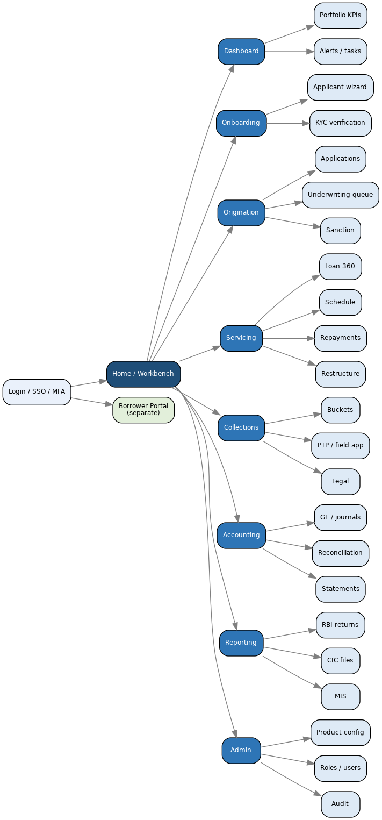
Figure 73.1 — Primary navigation map (internal workbench + borrower portal).
Screen | Module | Purpose | Primary roles
Workbench / Dashboard | Home | Portfolio KPIs, alerts, my-tasks | All internal
Applicant Onboarding Wizard | Onboarding | Stepwise KYC/income/consent capture | Sales/RO, Credit
Applications List & Detail | Origination | Create/track applications | Sales/RO, Credit
Underwriting Queue | Origination | Bureau, rules, deviations, recommend | Credit/Underwriter
Sanction & DOA | Origination | Approve within delegated authority | Credit Approver
Disbursement | Origination | Post-sanction docs, disburse | Ops/Disbursement
Loan Servicing 360 | Servicing | Account summary, schedule, transactions, actions | Ops, Servicing
Collections Workbench | Collections | Buckets, PTP, field app, legal | Collections
GL / Journals / Reconciliation | Accounting | Ledgers, entries, BRS, statements | Finance
Reporting Console | Reporting | RBI returns, CIC files, MIS | Compliance, Finance
Admin — Product Config | Admin | Products, fields, rates, workflows | Super Admin
Admin — Roles/Users/Audit | Admin | RBAC, users, audit trail | Super Admin, Auditor
Borrower Self-Service Portal | Portal | Statements, pay EMI, requests, documents | Borrower

74. Key Wireframes
Low-fidelity wireframes for the highest-traffic screens — indicative layout and controls, not final visual design. They pair with the field catalog (companion spreadsheet) and the UI-control mapping (Section 72.3).
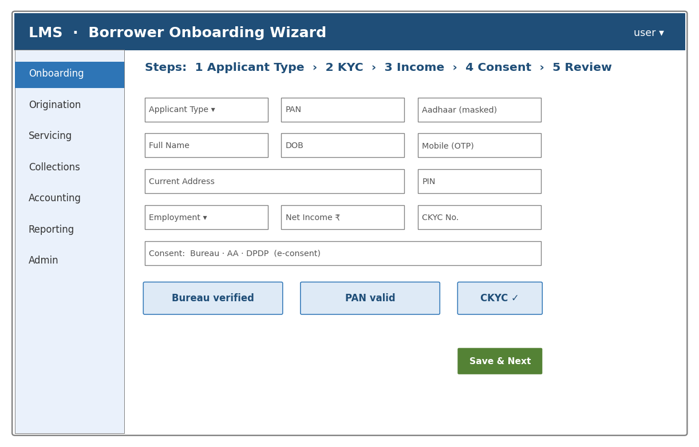
Figure 74.1 — Borrower onboarding wizard (stepper; validated fields; consent; live verification cards).
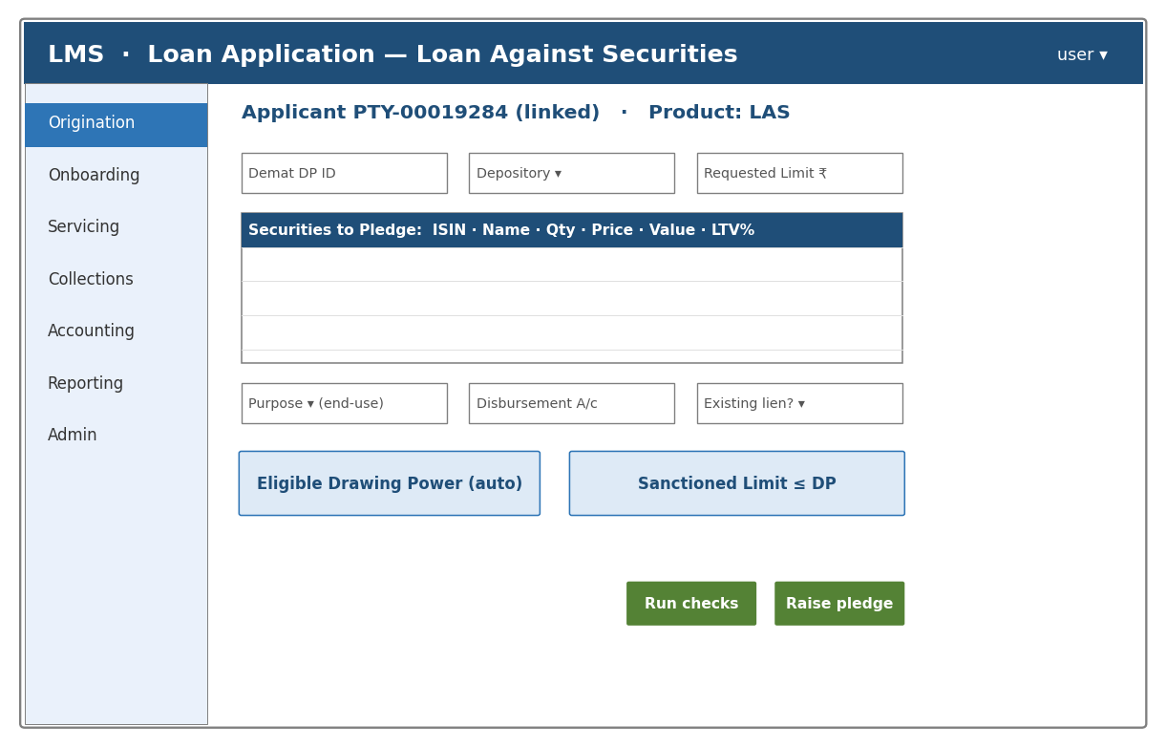
Figure 74.2 — LAS application (securities grid, auto drawing-power, sanctioned-limit ≤ DP, raise-pledge action).
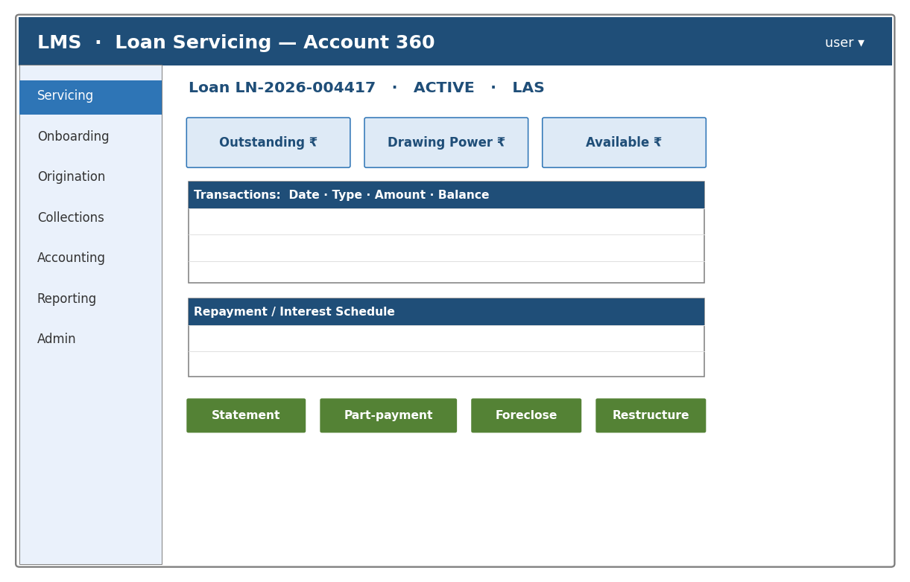
Figure 74.3 — Loan servicing 360 (balances, transactions, schedule, servicing actions).
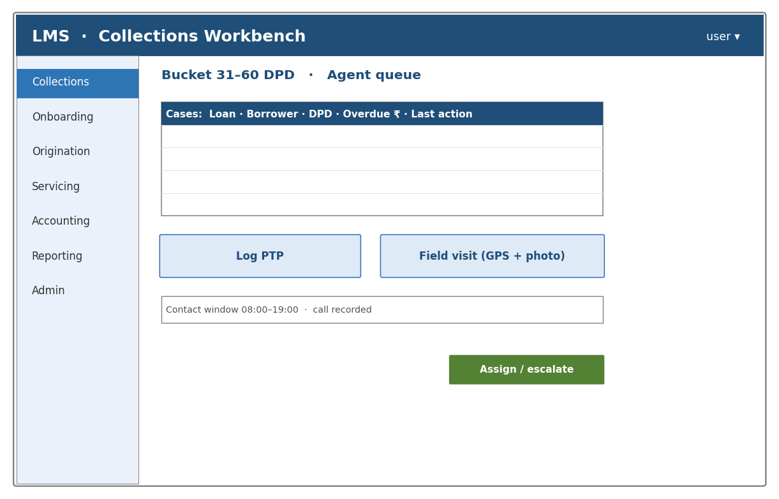
Figure 74.4 — Collections workbench (case queue, PTP, field visit, contact-window guardrail).

75. RBAC Permission Matrix
Authorization is role × resource × action, scoped further by branch/region (Section 1.4). V = view, C = create/edit, A = approve, — = no access. Sample extract:
Resource / Action | Sales/RO | Credit | Approver | Ops | Collections | Finance | Compliance | Admin
Applications | C | V | V | V | — | — | V | C
Underwriting decision | — | C | V | — | — | — | V | C
Sanction (within DOA) | — | — | A | — | — | — | — | C
Disbursement | — | — | — | A | — | V | V | C
Repayments / servicing | — | — | — | C | V | V | — | C
Collections actions | — | — | — | — | C | — | V | C
GL / journal entry | — | — | — | — | — | C/A | V | C
Regulatory returns | — | — | — | — | — | V | A | C
Product configuration | — | — | — | — | — | — | V | A
User / role management | — | — | — | — | — | — | — | A

Maker-checker (segregation of duties, Section 14) applies to disbursement, GL adjustments, regulatory submission and configuration: the maker (C) and checker (A) must be different users.

76. Validation & Error-Message Catalog
Every field/rule failure returns a stable code and a user-facing message with an i18n key (supporting the vernacular requirement, Section 60). Backend and frontend share this catalog. Extract:
Code | Field / rule | Message (English) | i18n key | HTTP
VAL_PAN | PAN format | Enter a valid PAN (AAAAA9999A). | err.pan.format | 422
VAL_AADHAAR | Aadhaar | Enter a valid 12-digit Aadhaar. | err.aadhaar.format | 422
VAL_IFSC | IFSC | Enter a valid IFSC. | err.ifsc.format | 422
VAL_MOBILE_OTP | Mobile OTP | Mobile number not verified. | err.mobile.otp | 422
BR_FOIR | FOIR cap | Obligations exceed the permitted FOIR. | err.foir.exceeded | 422
BR_LTV | LTV cap | Requested amount exceeds the LTV limit. | err.ltv.exceeded | 422
BR_DP | Drawing power | Requested limit exceeds drawing power. | err.dp.exceeded | 422
BR_DOA | Delegated authority | Amount is beyond your approval authority. | err.doa.exceeded | 403
BR_COND_PENDING | Sanction condition | Disbursement blocked: pending conditions. | err.condition.pending | 422
IDEMPOTENT_CONFLICT | Idempotency | Duplicate request with a different body. | err.idempotency.conflict | 409
RATE_LIMIT | Throttling | Too many requests; retry later. | err.rate.limited | 429

77. Entity State-Transition Tables
The state machines in Section 25.2 and diagrams §44.8–44.9, expressed as implementable transition tables. Each row: current state, event, guard (precondition), next state, side-effects. Illegal transitions are rejected.

77.1 Application
From | Event | Guard | To | Side-effects
DRAFT | submit | required fields valid | SUBMITTED | create application record
SUBMITTED | requestDocs | — | DOCS_PENDING | generate checklist
DOCS_PENDING | docsComplete | all mandatory docs | UNDER_APPRAISAL | trigger bureau pull
UNDER_APPRAISAL | approve | rules pass / deviations approved | APPROVED | record decision
UNDER_APPRAISAL | reject | — | REJECTED | notify borrower
APPROVED | sanction | within DOA | SANCTIONED | generate sanction letter, KFS
SANCTIONED | execute | agreement e-signed | AGREEMENT_PENDING | e-sign/e-stamp
AGREEMENT_PENDING | disburse | conditions cleared | DISBURSED | create loan account, GL posting

77.2 Loan Account
From | Event | Guard | To | Side-effects
ACTIVE | dpd≥1 | missed due date | OVERDUE_1 | start penal accrual, collections case
OVERDUE_1..3 | payment | cleared arrears | ACTIVE | close case
OVERDUE_3 | dpd>90 | — | NPA_SUBSTANDARD | reverse unrealised interest (§33), provision
NPA_* | restructure | approved | RESTRUCTURED | regenerate schedule (§32.2), flag
ACTIVE | foreclose | payoff received | FORECLOSED | NOC, release collateral
ACTIVE | maturity | balance = 0 | CLOSED | NOC
NPA_* | writeOff | approved | WRITTEN_OFF | utilise provision, memorandum register

78. Business-Rule Catalog
Rules the engine enforces, with a stable ID for traceability (Section 48). Thresholds are product-configured (Section 3).
Rule ID | Rule | Trigger | Error / action
BR-001 | Requested amount ≤ eligible amount (LTV/DP/income) | Application submit | Block; BR_LTV/BR_DP/BR_FOIR
BR-002 | FOIR ≤ product cap | Underwriting | Block or route to deviation
BR-003 | Bureau score ≥ minimum (or deviation) | Underwriting | Route to deviation approver
BR-004 | Sanction within delegated authority | Sanction | Block; escalate tier (BR_DOA)
BR-005 | All mandatory sanction conditions cleared | Disburse | Block (BR_COND_PENDING)
BR-006 | Every disbursement/repayment is idempotent | Money API | Replay stored result (409 on conflict)
BR-007 | Penal charge = fee, non-compounding | Overdue | Post to penal-charge ledger only (§24.7)
BR-008 | NPA at 90+ DPD; income on realisation | Day-end classification | Reverse interest (§33), provision
BR-009 | LAS: 50% LTV maintained at all times | Daily revaluation | Margin call; cure 7 working days (§86)
BR-010 | KFS with APR shown before acceptance | Sanction | Block acceptance without KFS (§17.1)

79. Calculation Pseudocode & Reference Snippets
Language-agnostic reference logic for the core computations (Section 45), so developers implement them identically. Money is DECIMAL; round only at boundaries (Section 28).

79.1 EMI & Amortisation Schedule
function emi(P, annualRatePct, n):
r = (annualRatePct / 12) / 100
if r == 0: return P / n
return P * r * (1+r)^n / ((1+r)^n - 1)
function schedule(P, annualRatePct, n):
r = (annualRatePct/12)/100
emiAmt = round2(emi(P, annualRatePct, n))
bal = P; rows = []
for i in 1..n:
interest = round2(bal * r)
principal = emiAmt - interest
if i == n: principal = bal; emiAmt = principal + interest # last EMI absorbs residual
bal = bal - principal
rows.add({i, emiAmt, principal, interest, balance: max(bal,0)})
return rows

79.2 Daily Interest Accrual (reducing/daily-rest)
function dailyAccrual(outstanding, annualRatePct, dayCountBasis):
dailyRate = (annualRatePct/100) / dayCountBasis # 365 or 360 per product
return round4(outstanding * dailyRate) # accrue at 4dp, post monthly

79.3 APR / EIR (iterative IRR)
function irrMonthly(cashflows): # cashflows[0] = -(net disbursed), then +EMIs
lo = -0.95; hi = 2.0
repeat 200 times:
mid = (lo+hi)/2
if npv(cashflows, mid) > 0: lo = mid else: hi = mid
return (lo+hi)/2
function aprPct(cashflows): return ((1 + irrMonthly(cashflows))^12 - 1) * 100

79.4 Provisioning (IRAC) & higher-of-ECL
provision = 0
for bucket in [STANDARD, SUBSTANDARD, DOUBTFUL, LOSS]:
provision += outstanding[bucket] * ratePct[bucket] / 100 # rates from config (§9.4)
finalImpairment = max(provision, eclLifetimeOr12m) # Ind AS 109 floor (§30)

80. Master Code Lists / Enumerations
Canonical code sets used across the platform. The complete, machine-readable list is delivered as the Code-List companion spreadsheet; key sets are shown here.
Code set | Values (illustrative)
Application status | DRAFT, SUBMITTED, DOCS_PENDING, UNDER_APPRAISAL, APPROVED, SANCTIONED, AGREEMENT_PENDING, DISBURSED, REJECTED, WITHDRAWN, CANCELLED
Loan status | ACTIVE, OVERDUE_1, OVERDUE_2, OVERDUE_3, NPA_SUBSTANDARD, NPA_DOUBTFUL, NPA_LOSS, RESTRUCTURED, WRITTEN_OFF, SETTLED, FORECLOSED, CLOSED
Collateral status | PENDING_VERIFICATION, VERIFIED, PLEDGED/REGISTERED, ACTIVE, PARTIALLY_RELEASED, RELEASED, INVOKED, AUCTIONED, REPOSSESSED
Document status | PENDING_UPLOAD, UPLOADED, UNDER_REVIEW, VERIFIED, REJECTED, EXPIRED
Product code | LAS, SCL, LAP, GL, PL, BL-UNSEC, VL, TW, SCF, MFI, FACT, TREDS, … (Section 3)
Purpose code | BUSINESS, WORKING_CAPITAL, PERSONAL, MEDICAL, EDUCATION, DEBT_CONSOLIDATION, …
Channel | BRANCH, DSA, DIGITAL, LSP, CAMPAIGN
Repayment mode | NACH, UPI, IMPS, NEFT, RTGS, CASH, CHEQUE
GL nature | ASSET, LIABILITY, EQUITY, INCOME, EXPENSE
Return code | NBS-1, NBS-2, NBS-7, ALM, CRILC, CIMS, SAC, … (Section 9.2)
NACH return reason | INSUFFICIENT_FUNDS, ACCOUNT_CLOSED, MANDATE_CANCELLED, SIGNATURE_MISMATCH, …
Rejection reason | LOW_SCORE, HIGH_FOIR, NEGATIVE_LIST, INCOMPLETE_DOCS, POLICY_DEVIATION

81. Domain Event & Webhook Catalog
The event-driven parts (accrual, disbursement, reporting) publish domain events (Section 38 outbox pattern). Partners receive HMAC-signed, idempotent webhooks with retry and dead-lettering.
Event | Trigger | Key payload | Consumers
application.created | New application | applicationId, partyId, productCode | LOS, analytics
bureau.pulled | Bureau response | applicationId, score, flags | Underwriting
loan.disbursed | Disbursement posted | loanAccountId, amount, glRef | GL, portal, partner
repayment.posted | Repayment received | loanAccountId, amount, split | GL, portal
repayment.failed | NACH/UPI return | loanAccountId, returnCode | Collections
loan.npa | Classified NPA | loanAccountId, class | Provisioning, reporting
margincall.raised | LAS DP shortfall | loanAccountId, shortfall, cureBy | Portal, collections
return.submitted | RBI/CIC submission | returnCode, period, ackRef | Compliance

Webhook contract: POST to the partner URL with an X-Signature (HMAC-SHA256) header; 2xx = delivered; non-2xx retried with backoff up to a cap, then dead-lettered with alerting.

82. Configuration, Environment, Repo Structure & Batch Jobs

82.1 Configuration / Environment Catalog
Setting | Example / default | Notes
API rate limit | 600 req/min per client | 429 with Retry-After (Section 40.2)
Default page size / max | 25 / 100 | Cursor pagination
External call timeout | 5–15 s per integration | Per Section 38.2
Retry policy | 3 attempts, exp backoff + jitter | Idempotent calls only
Session / token TTL | 15 min access, refresh rotation | OIDC (Section 34.2)
Feature flags | per-product, per-tenant | Staged rollout (Section 42.1)
Day-count / rounding | per product (Section 45.2 / 28.2) | Never global-hardcode

82.2 Suggested Repository Structure (bounded contexts)
/customer -- party, KYC, consent
/product -- product master, config engine, form schema
/origination -- LOS, underwriting, bureau, sanction
/servicing -- calc engine, schedules, repayments, restructure
/collections -- buckets, PTP, field app, legal
/accounting -- GL, journals, reconciliation, statements
/reporting -- RBI returns, CIC files, MIS, data mart
/collateral -- pledge/mortgage/lien, valuation, revaluation
/platform -- auth/RBAC, audit, notifications, integration adapters, api-gateway
/shared -- money(DECIMAL), enums, validation, event-bus contracts

82.3 Batch-Job Catalog
Job | Schedule | Inputs → Outputs | Idempotent?
Interest accrual (EOD) | 22:00 daily | txns → accrual entries | Yes (checkpointed)
DPD / NPA classification | post-accrual | accrual, dues → status | Yes
LAS drawing-power revaluation | pre-market daily | price feed → DP, margin calls | Yes
Provisioning & ECL | month-end | classification → provisions | Yes
CIC file generation | monthly by 5th | accounts → bureau files | Yes
RBI return generation | per due date | mart → returns | Yes
Bank reconciliation | daily 11:00 | statement → matched/exceptions | Yes

83. Document / Print Templates (merge fields)
System-generated documents (Section 20) are versioned templates merged with live data. Key merge fields per template:
Template | Trigger | Key merge fields
Key Fact Statement (KFS) | Pre-sanction | borrower, product, APR, itemised charges, cooling-off, grievance officer
Sanction Letter | Post-approval | sanctioned amount, ROI, tenure, conditions, validity
Loan Agreement | Execution | parties, terms, product clauses, schedule, penal terms
Repayment Schedule | Post-disbursement | installment no, due date, EMI, principal, interest, balance
Statement of Account | On demand | transactions, outstanding, interest/charges
NOC / Closure | On closure | loan id, closure date, collateral release

84. Test Scenarios (Given-When-Then) & Seed Data
Acceptance scenarios in Given-When-Then, executable as automated tests and mapped to the golden vectors (Section 45.10). Seed/fixture datasets ship with the build.
Scenario: Disbursement posts a balanced GL entry
Given a sanctioned LAP loan of 20,00,000 with cleared conditions
When Ops disburses with a unique Idempotency-Key
Then a loan account is created, EMI = 22,731.94,
And a journal voucher is posted where sum(debits) == sum(credits)
And a retry with the same key does NOT post twice
Scenario: NACH bounce rolls the loan into collections
Given an ACTIVE loan with an EMI due today
When the NACH presentation returns INSUFFICIENT_FUNDS
Then a non-compounding penal charge is applied
And the loan moves to OVERDUE_1 and a collections case is created
Scenario: LAS margin call on price fall
Given an LAS loan utilising 2,00,000 against pledged shares
When daily revaluation drops drawing power below utilisation
Then a margin call is raised with a 7-working-day cure period
And on non-cure the pledge is invoked and securities liquidated

85. Accessibility (WCAG 2.1 AA) Acceptance Checklist
- Perceivable: text alternatives for images/icons; sufficient colour contrast (≥ 4.5:1); content reflows; no information by colour alone.
- Operable: full keyboard navigation; visible focus; no keyboard traps; adequate time limits with extensions.
- Understandable: labels and instructions on inputs; inline, specific error messages (Section 76); consistent navigation; vernacular language support (Section 60).
- Robust: valid, semantic HTML with ARIA where needed; tested with a screen reader; forms announce validation state.
- Verified by an accessibility audit before go-live (Section 41.4), not assumed.

Part IV — Comprehensive Product Blueprint (Section 86) takes one product, Loan Against Securities, to full build depth: every variant, regulatory rule, form field, pledge step, computation, scenario and edge case. It is the template for elaborating any other product to the same depth (Section 86.17).

86. Loan Against Securities (LAS) — Comprehensive Product Blueprint
LAS is an overdraft/term facility secured by a pledge or lien over the borrower’s financial securities. This blueprint expands the summary in Section 3.1 into a build-ready specification. It draws on the calculation engine (Section 45), pledge integrations (Section 12), and the margin-call flow (Figure 44.7).

86.1 Product Overview & Variants
Variant | Description | Interest / structure
LAS — Overdraft (revolving) | Pre-set limit; draw/repay freely; interest only on utilised | Daily reducing on utilised (§24.6)
LAS — Term Loan | Fixed drawdown against pledge | Reducing EMI or bullet
Loan against Mutual Funds | Lien on MF units via RTA (CAMS/KFintech) | Overdraft, daily interest
Loan against Bonds / ETFs / SGB | Pledge of debt/gold instruments | Overdraft/term
Loan against Insurance Policy | Assignment of traditional policy surrender value | Term (§3.20 cousin)
ESOP Financing | Funding ESOP exercise against resulting shares | Term; special controls
IPO Financing / Margin (if offered) | Short-tenor funding to subscribe/hold | Capped per RBI (§86.2)

86.2 Regulatory Framework
- LTV: for loans against listed shares an NBFC (asset size ≥ ₹100 cr) must maintain a 50% LTV at all times; a shortfall from price movement must be cured within 7 working days, failing which securities are liquidated.
- Eligible collateral: only Group-I securities are accepted as collateral for loans above ₹5 lakh.
- Reporting: NBFCs with asset size above ₹100 cr report shares pledged in their favour to the stock exchanges.
- Pledge mechanism: under the SEBI margin-pledge framework the securities remain in the borrower’s demat account with a lien marked in the NBFC’s favour, authorised by the borrower via depository OTP (no power of attorney).
- IPO financing, where offered, is capped per borrower per the RBI ceiling; end-use for LAS is monitored and must not breach securities-market or anti-money-laundering restrictions.
- All thresholds are configurable and must be confirmed against the extant RBI/SEBI directions before go-live (Section 62).

86.3 Eligible-Securities & Haircut Master
A central, versioned master (Section 39.2) defines what can be pledged and at what value. It is maintained by Risk, not per loan.
Attribute | Detail
Approved list (ISIN) | Group-I / approved scrips, index-eligible; F&O eligibility flag
Per-ISIN LTV / haircut | e.g., equity 50%, debt MF higher; volatility-linked haircut
Concentration limits | Max % of a single scrip/group in one loan and across the book
Exclusions | Promoter/locked-in/pledged-elsewhere, illiquid, ESOP-restricted, suspended, in derivatives-ban
Price source | Exchange close / NAV; staleness rule if no price
Review | Daily refresh; scrip added/removed by Risk with effective-dating

86.4 Borrower Types & Eligibility
Type | Notes
Individual / Joint | Age and income checks; joint demat holders all consent
HUF | Karta operates; demat in HUF name
NRI | Permitted subject to FEMA/repatriation and end-use restrictions; NRE/NRO handling
Entity (company/LLP/partnership) | Board/partner authorisation; UBO; corporate demat
Not eligible | Minors (except through guardian per policy); securities the borrower does not fully own

86.5 Application Form — Complete Field Set
The LAS application captures full borrower information in addition to the pledge details. Fields below are in addition to the common Identity/KYC, Address and Consent blocks (Section 72.2).
Field | Data Type | Mandatory | Notes / Validation
Applicant KYC Reference | Reference | Yes | Linked Section 2 record (name, DOB, PAN, Aadhaar, CKYC, photo, signature)
Constitution / Applicant Type | Dropdown | Yes | Individual/Joint/HUF/NRI/Entity (§86.4)
Residential / FEMA Status | Dropdown | Yes | Resident/NRI; drives eligibility & account type
Occupation / Source of Funds | Dropdown/Text | Yes | AML source-of-funds; PEP overlay (§2.11)
Annual Income / Net Worth | Currency | Yes | Financial profile; supports limit & suitability
Existing Loan Obligations | Repeatable grid | Yes | For total-indebtedness/FOIR view
Demat Account Number & DP ID | Text | Yes | 16-digit BO ID; must belong to applicant
Depository | Dropdown | Yes | NSDL / CDSL
Broker / DP Name | Text | Yes | Depository Participant
Securities to be Pledged | Repeatable grid | Yes | ISIN, Security Name, Qty, Last Price, Value, applied LTV/haircut, F&O flag
Requested Limit | Currency | Yes | System caps at eligible Drawing Power
Facility Type | Dropdown | Yes | Overdraft (revolving) / Term
Purpose of Loan / End-Use | Dropdown+Text | Yes | End-use declaration; restricted uses blocked (§86.2)
Existing Lien on These Securities | Boolean | Yes | Cross-checked with depository/RTA
Disbursement / Interest-Debit Bank A/c | Text | Yes | Penny-drop + name-match; NRE/NRO if NRI
Nominee Details | Text | Conditional | Name, relationship, share
References | Repeatable grid | Conditional | Per product policy
Consents | e-consent | Yes | Bureau, DPDP, pledge-authorisation, standing instruction (§43.1)
e-Sign / Agreement Acceptance | Digital signature | Yes | Aadhaar e-Sign / DSC

86.6 Pledge Lifecycle
- Raise pledge: system initiates a pledge request to the depository (NSDL SPEED-e / CDSL EASIEST) or a lien request to the RTA (CAMS/KFintech) for mutual funds, or an assignment for insurance policies.
- Borrower authorisation: the borrower authorises via depository OTP; no power of attorney is used (SEBI margin-pledge framework).
- Confirmation: on depository/RTA confirmation the pledge/lien is recorded, the security is marked, and the limit is set live.
- Substitution: the borrower may swap pledged securities subject to maintaining drawing power (release one, pledge another).
- Release: on full repayment (or partial, pro-rata) the pledge/lien is released and the security freed for the borrower.

86.7 Drawing-Power Computation & Daily Revaluation
DrawingPower = Σ over pledged ISINs [ Quantity_i × Price_i × LTV_i ] (LTV from the master, §86.3)
Sanctioned Limit = min( Requested Limit , DrawingPower )
Available = min( Sanctioned Limit , DrawingPower ) − Utilised
-- revalued every day from the price/NAV feed before market open (§29.2)

Example: 1,000 shares of Stock A at ₹1,500 = ₹1,500,000; at 50% LTV the drawing power is ₹750,000. If the borrower has drawn ₹700,000, the account is within limit. Interest accrues daily only on the ₹700,000 utilised (Section 24.6).

86.8 Margin-Call Logic & Liquidation
When daily revaluation causes utilisation to exceed drawing power, a margin call is raised. Example: Stock A falls 20% to ₹1,200,000 value; drawing power becomes ₹600,000, below the ₹700,000 utilised — a shortfall of ₹100,000.
- Cure options within 7 working days: (a) repay the shortfall (cash top-up ₹100,000 brings utilisation back within DP), or (b) pledge additional securities of about ₹200,000 value to restore DP, or (c) part-substitute.
- Notice & timer: a margin-call notice is issued (SMS/email/portal) with the cure deadline; a timer tracks the 7-working-day window.
- Invocation on non-cure: the NBFC invokes the pledge and liquidates sufficient securities; a sell-down waterfall picks the most liquid/least-concentrated first; proceeds reduce the outstanding.
- Illiquidity handling: if a scrip is in lower circuit, suspended or illiquid, liquidation is deferred and the shortfall is pursued through the remaining securities and recovery process; the event is logged.
- Surplus/shortfall: any sale surplus is returned to the borrower; a residual shortfall becomes a recovery claim (Sections 7, 8.2).

86.9 Corporate Actions on Pledged Securities
Corporate action | System handling
Dividend / interest | Typically to borrower; monitor if agreement assigns it; no DP change
Bonus / stock split | Quantity increases at proportionally lower price — recompute DP; keep pledge on new units
Rights issue | Borrower decides; new shares pledged only if applied and lien-marked
Merger / demerger | Map ISIN to resultant security; re-mark pledge; revalue
Buyback | Reduces quantity; adjust pledge and DP; handle proceeds
Delisting / suspension | Security becomes ineligible — exclude from DP; margin call if it causes shortfall
Removal from approved list | Excluded at next revaluation; borrower notified to substitute

86.10 Interest, Charges & Accounting
- Interest: computed daily on the utilised balance (Section 24.6), debited monthly to the loan account; no compounding of penal charges.
- Charges: processing fee, annual renewal/maintenance on the limit, depository pledge/lien charges (pass-through), and, where applicable, foreclosure — each taxable with GST (Section 31).
- Accounting: disbursement/drawdown Dr Loan O/s / Cr Bank; daily accrual Dr Interest Receivable / Cr Interest Income; on invocation Dr Bank (sale proceeds) / Cr Loan O/s, surplus to a borrower-payable, shortfall to recovery (Section 8.2).

86.11 Scenarios & Edge Cases
Scenario | Expected handling
Sharp price crash | Daily revaluation → margin call → cure/invoke (§86.8)
Lower circuit / cannot sell | Defer liquidation; pursue other securities/recovery; log
Scrip suspended / delisted | Exclude from DP; margin call; substitute
Scrip removed from approved list | Exclude at next revaluation; notify to substitute
Partial redemption | Release securities pro-rata to repayment; recompute DP
Substitution of securities | Release one, pledge another; DP must remain sufficient
Limit enhancement / reduction | Re-underwrite / adjust; re-mark pledge as needed
Renewal (annual) | Review, revalue, re-sanction; roll the facility
Corporate action mid-loan | Per §86.9; re-mark and revalue
Joint holders | All demat holders authorise the pledge (OTP each)
Borrower death | Freeze; nominee/legal-heir process; settle from securities
NRI repatriation | Enforce FEMA end-use/account rules
Dispute on invocation | Hold, escalate to legal (§7.2); preserve audit trail
ESOP financing | Special controls on lock-in and exercise proceeds
Concentration breach | Reject/haircut per single-scrip and group caps (§86.14)

86.12 State Machine
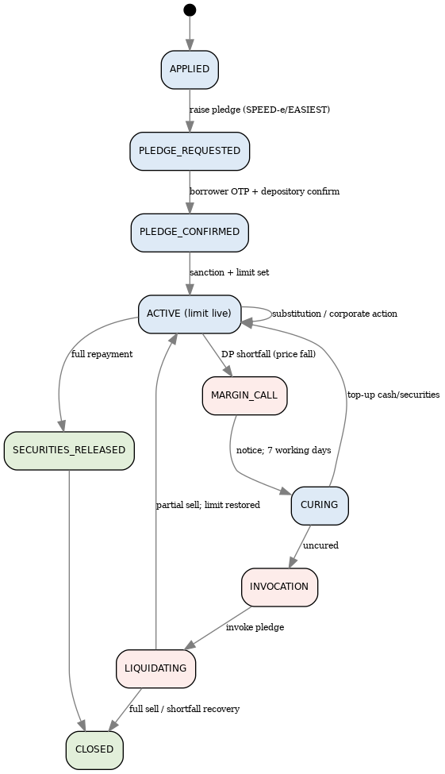
Figure 86.1 — LAS account & pledge lifecycle, including margin-call, cure, invocation and release.

86.13 Integrations
System | Purpose
Depository (NSDL SPEED-e / CDSL EASIEST) | Pledge creation, confirmation, invocation, release
RTA (CAMS / KFintech) | Lien marking/release for mutual-fund units
Insurer | Assignment/reassignment for policy-backed loans
Price / NAV feed | Daily revaluation of pledged securities
Stock exchange reporting | Report shares pledged in the NBFC’s favour (§86.2)
Bank / penny-drop | Disbursement & interest-debit account verification
CKYC / bureau | Onboarding and underwriting (Sections 5, 10)

86.14 Risk Controls
- Concentration: single-scrip and single-group caps per loan and across the portfolio; promoter/insider holdings excluded.
- Volatility: volatility-linked haircuts; tighter LTV for higher-beta or F&O-ban scrips.
- Eligibility: only approved Group-I securities above the ₹5-lakh threshold; illiquid/locked-in excluded (§86.3).
- End-use: monitored; restricted market/AML uses blocked; large-exposure and LEI checks (Sections 37, 43.2).

86.15 Documents Generated
Sanction letter, LAS/overdraft agreement, demand promissory note (where used), pledge/lien confirmation, standing-instruction/e-mandate, Key Fact Statement, statement of account, and the release/NOC on closure — each a versioned template (Section 83) merged with live data.

86.16 Field Catalog
The complete LAS field list — every field in Section 86.5 plus the pledge, revaluation and servicing fields — is included in the companion Field-Catalog spreadsheet, alongside the other products, as the authoritative machine-readable source for developers.

86.17 Applying This Blueprint to Other Products
This structure — overview & variants, regulatory framework, collateral/eligibility master, borrower types, complete application form, security/collateral lifecycle, computation, margin/servicing logic, corporate/asset events, accounting, scenarios & edge cases, state machine, integrations, risk controls and documents — is the template for elaborating any product in Section 3 to the same depth. Priority candidates to expand next in this style: Loan Against Property (title/valuation/CERSAI lifecycle), Gold Loan (appraisal/vault/auction), and Supply Chain Finance (anchor programme/invoice lifecycle). Each reuses the common field library (Section 72.2) and differs mainly in its collateral module, computation and regulatory overlay.

Part V — Comprehensive Product Blueprints (Section 87) elaborates every remaining product in Section 3 to build depth, following the LAS template (Section 86). Each carries product-specific regulatory notes, a complete field set (additional to the common library, Section 72.2), computation/servicing logic, and a scenario/edge-case catalogue. Field lists here also flow into the companion Field-Catalog spreadsheet.

87. Comprehensive Product Blueprints
These blueprints make each product directly buildable. They reuse the common field library (Section 72.2), the calculation methods (Section 45), the state machines (Section 25.2) and the integrations (Section 12); only the collateral module, computation and regulatory overlay differ per product.

87.1 Loan Against Property (LAP) [LAP]
A secured term loan against a registered or equitable mortgage of residential, commercial or industrial property or land; enforceable under SARFAESI.
Regulatory, eligibility & policy:
- LTV by property type per NHB/RBI norms (higher for residential, lower for commercial/industrial/land); tenure typically up to ~15 years.
- Mortgage registered or equitable; the security interest is registered on CERSAI within the prescribed timeline.
- Title search & legal opinion from an empanelled advocate; valuation (fair market, realisable, distress) by an empanelled valuer.
- End-use monitored (business/working-capital/personal/debt-consolidation); property insurance with the lender as loss payee.
Application & collateral fields (product-specific; additional to the common library, Section 72.2):
Field | Data Type | Mandatory | Notes / Validation
Property Address & Survey/Plot | Address/Text | Yes | Full identification
Property Type | Dropdown | Yes | Residential/Commercial/Industrial/Land
Ownership Type | Dropdown | Yes | Freehold/Leasehold (residual lease caps tenure)
Property Age / Built-up / Carpet Area | Number | Yes | Sq.ft.
Existing Encumbrance | Boolean/Text | Yes | Details of any existing charge
Property Owner | Dropdown | Yes | Applicant/Co-applicant/Third-party mortgagor
Title Deed & Chain of Title | File | Yes | —
Title Search & Legal Opinion | File/Status | Yes | Empanelled advocate
Valuation Report | Sub-form | Yes | Valuer, FMV, realisable, distress
Encumbrance Certificate (EC) | File | Yes | 13/30-year period
CERSAI Registration No. | Text | Yes | Security-interest registration
Mortgage Type Executed | Dropdown | Yes | Registered/Equitable
Property Insurance | File | Yes | Lender as loss payee
Stage-wise Disbursement Schedule | Repeatable grid | Conditional | Under-construction/renovation

Computation & servicing:
Reducing-balance EMI (Section 45.3.5); sanctioned amount capped at LTV × property value; staged disbursement for under-construction tied to construction milestones with broken-period interest on each tranche (Section 24.3).
Key scenarios & edge cases:
Scenario | Expected handling
Title defect / chain break | Reject or cure before disbursal
Valuation shortfall | Reduce sanction to the LTV cap
Third-party mortgagor | Mortgagor KYC + consent + guarantee
Existing charge on property | NOC / pari-passu / reject
Under-construction delay | Hold the next tranche
Property insurance lapse | Force-place cover; penal charge
Default | SARFAESI: 13(2) demand → possession → sale
Short residual lease | Cap tenure within residual period

Documents & integrations: Sanction letter, LAP agreement, mortgage deed, KFS, valuation & legal reports, insurance; integrations — CERSAI, empanelled valuer/advocate, property registry where available.

87.2 Gold Loan [GL]
A short-tenure loan against pledge of gold ornaments/coins, appraised in-branch and held in the vault.
Regulatory, eligibility & policy:
- LTV within the RBI-prescribed ceiling on loan value per gram; a per-gram rate table by purity is updated to the prevailing gold price.
- Only gold jewellery/specified coins accepted; purity/assay verification; custody in a CCTV-monitored strong-room.
- Auction on default follows prescribed notice, reserve-price and transparency norms; surplus refunded, shortfall recovered.
Application & collateral fields (product-specific; additional to the common library, Section 72.2):
Field | Data Type | Mandatory | Notes / Validation
Ornament Details Grid | Repeatable grid | Yes | Item, gross wt, net wt (ex-stones/wax), purity/karat, pieces
Appraiser Name & Certification | Reference | Yes | Empanelled in-house/external
Purity Test Method & Result | Dropdown/Text | Yes | Touchstone/XRF/acid
Appraised Value per Item / Total | Currency | Yes | System-computed from purity rate table
Photograph of Ornaments | File | Yes | —
Packet / Pledge Card Number | System | Yes | Unique per packet
Vault / Strong-room Location & Rack | Text | Yes | Physical custody tracking
CCTV Reference | Text | Yes | Timestamp / camera at appraisal
Insurance of Pledged Ornaments | File | Yes | Vault cover
Interest Scheme | Dropdown | Yes | Monthly servicing / bullet
Auction Clause Acknowledgement | e-sign | Yes | At agreement stage

Computation & servicing:
Bullet simple interest (Section 45.3.1) or monthly interest servicing; LTV = loan ÷ appraised value ≤ cap; daily gold-price monitoring for high-LTV accounts; proportionate interest recomputation on part-redemption (Section 24.11).
Key scenarios & edge cases:
Scenario | Expected handling
Spurious / low-purity gold | Reject at appraisal
Gold price crash | LTV breach → top-up / part-repay / auction
Non-redemption at maturity | Notice → auction
Part-release of ornaments | Proportionate repayment; re-appraise remainder
Re-pledge / top-up | Revalue at current rate
Auction surplus / shortfall | Refund surplus / recover shortfall
Vault theft / loss | Insurance claim; borrower made whole per policy

Documents & integrations: Pledge agreement, packet card, appraisal certificate, auction notice, KFS; integrations — gold-price feed, empanelled appraiser, insurer.

87.3 Vehicle / Two-Wheeler Loan [VL / TW]
Financing of new and used cars and two-wheelers, secured by hypothecation of the vehicle.
Regulatory, eligibility & policy:
- LTV by vehicle type/age; hypothecation endorsed at the RTO and verified via Vahan; comprehensive insurance with the lender as loss payee.
- Dealer/DSA sourcing via an empanelled master; independent valuation for used vehicles.
Application & collateral fields (product-specific; additional to the common library, Section 72.2):
Field | Data Type | Mandatory | Notes / Validation
Vehicle Type/Make/Model/Variant | Dropdown/Text | Yes | —
New / Used Flag | Boolean | Yes | Drives LTV & valuation
Ex-showroom / On-road Price | Currency | Yes | —
Dealer Name & Code | Reference | Yes | Empanelled
Invoice Number & Date | Text/Date | Yes | —
Down Payment | Currency | Yes | —
Chassis / Engine Number | Text | Yes | —
Registration Number | Text | Conditional | Post-RTO registration
RC Copy | File | Yes | —
Insurance Policy & Validity | Text/Date | Yes | Lender as loss payee
Hypothecation Endorsement (Vahan) | Status | Yes | Pending/Confirmed
Used-Vehicle Valuation | File | Conditional | Pre-owned

Computation & servicing:
Reducing-balance EMI, frequently advance EMI (Section 45.3.10); financed amount = on-road price less down payment within LTV; hypothecation charge marked; insurance-renewal and end-of-term tracking.
Key scenarios & edge cases:
Scenario | Expected handling
RTO hypothecation delay | Track to confirmation before/at disbursal per policy
Insurance lapse | Force-place cover; penal charge
Default | Repossession: notice → yard → sale (Section 7)
Used-vehicle valuation shortfall | Reduce LTV/sanction
Dealer subvention (no-cost EMI) | Per Section 45.7
Total loss / theft | Insurance settlement applied to the loan

Documents & integrations: Sanction, hypothecation agreement, RC, insurance, KFS; integrations — Vahan/MoRTH, insurer, dealer master.

87.4 Commercial Vehicle & Construction Equipment (CV/CE) [CVCE]
Financing of trucks, buses, tippers and earth-moving/construction equipment, including fleet-financing structures — higher ticket than passenger vehicles.
Regulatory, eligibility & policy:
- Hypothecation on commercial registries; permit/route documentation for transport vehicles; fleet facility limits for multi-unit operators.
- Underwriting on route/trip economics or fleet cash flow rather than salary.
Application & collateral fields (product-specific; additional to the common library, Section 72.2):
Field | Data Type | Mandatory | Notes / Validation
Vehicle/Equipment Category | Multi-select | Yes | Truck/Bus/Tipper/Excavator/Loader/Crane
Make/Model & Chassis/Serial No. | Text | Yes | —
New / Used Flag & Valuation | Boolean/File | Yes/Cond | —
Permit / Route Details | Text | Conditional | Transport permits
Fleet Size (multi-unit) | Number | Conditional | Fleet facility
Operator Vintage / Existing Fleet | Text | Yes | Experience & existing units
Hypothecation Endorsement | Status | Yes | Commercial registry
Comprehensive + Third-Party Insurance | File | Yes | —

Computation & servicing:
Reducing-balance EMI; fleet facilities apply multi-unit limits; income assessed on route/trip economics or consolidated fleet cash flow; used-equipment valuation for pre-owned.
Key scenarios & edge cases:
Scenario | Expected handling
Multi-unit fleet application | Fleet limit; unit-wise hypothecation
Permit expiry | Flag; recovery/early-warning
Route/economics deterioration | Early-warning (Section 37)
Default | Repossession & sale
Used-equipment valuation | Independent valuation; LTV adjust

Documents & integrations: Sanction, hypothecation agreement, permits, insurance, KFS; integrations — registry, insurer, valuer.

87.5 Tractor & Farm Equipment Loan [TRACTOR]
Rural/agri financing for tractors, harvesters and farm implements, with repayment aligned to crop/harvest cash-flow cycles.
Regulatory, eligibility & policy:
- LTV by equipment age; seasonal/half-yearly repayment options aligned to Rabi/Kharif in addition to monthly EMI; frequently subsidy-linked.
- Land-holding verification (survey/Khasra) and crop pattern support eligibility.
Application & collateral fields (product-specific; additional to the common library, Section 72.2):
Field | Data Type | Mandatory | Notes / Validation
Equipment Category | Multi-select | Yes | Tractor/Harvester/Rotavator/Irrigation
Land Holding Details | Text/Number | Yes | Survey/Khasra no., area owned/leased, crop pattern
Equipment Make/Model & Dealer | Text/Reference | Yes | —
Repayment Frequency | Dropdown | Yes | Monthly / Half-yearly / Seasonal
Hypothecation of Equipment | Status | Yes | —
Insurance | File | Yes | —
Subsidy Reference | Text | Conditional | Where scheme-linked (Section 3.9)

Computation & servicing:
Reducing-balance with seasonal instalments aligned to harvest inflows; LTV by equipment age; subsidy tracked to claim status where applicable.
Key scenarios & edge cases:
Scenario | Expected handling
Crop failure / poor monsoon | Restructure / moratorium (Section 32)
Seasonal cash-flow mismatch | Seasonal repayment schedule
Land-record verification | Confirm ownership/lease before sanction
Subsidy claim | Track with nodal agency (Section 3.9)
Default | Repossession in rural context; recovery

Documents & integrations: Sanction, hypothecation agreement, land records, insurance, KFS; integrations — subsidy nodal agency, dealer, insurer.

87.6 Electric Vehicle (EV) Financing [EV]
A variant of vehicle finance for electric vehicles, with battery-ownership and charging-infrastructure considerations.
Regulatory, eligibility & policy:
- Battery ownership model determines collateral (battery included vs Battery-as-a-Service excluded); optional green/EV rate concession; FAME/state-subsidy linkage.
- Hypothecation of the vehicle (and battery, if owned).
Application & collateral fields (product-specific; additional to the common library, Section 72.2):
Field | Data Type | Mandatory | Notes / Validation
EV Category | Multi-select | Yes | e-2W / e-3W / Passenger / Commercial EV
Battery Ownership Model | Dropdown | Yes | Included / Battery-as-a-Service
Vehicle & Battery Details | Text | Yes | Capacity, warranty, charging type
Battery Warranty / Health Certificate | File | Yes | —
Charging Infrastructure Access | Text | No | Home/public arrangement
Subsidy Reference | Text | Conditional | FAME/state scheme
Hypothecation (vehicle + battery if owned) | Status | Yes | —

Computation & servicing:
Reducing-balance EMI; collateral value net of any BaaS battery; residual-value sensitivity factored into LTV; green concession applied per policy (Section 45.7 mechanics).
Key scenarios & edge cases:
Scenario | Expected handling
Battery degradation / replacement | Health cert at origination; residual-value policy
BaaS subscription default | Battery excluded from collateral; coordinate with provider
Resale-value uncertainty | Conservative LTV
Subsidy claim | Track FAME/state subsidy
Charging dependency | Informational; no hard block

Documents & integrations: Sanction, hypothecation agreement, battery warranty, insurance, KFS; integrations — Vahan, subsidy portal, insurer.

87.7 Affordable Housing Loan [AHL]
Home purchase/construction/extension loans for EWS/LIG/MIG borrowers, often linked to PMAY credit-linked subsidy, usually written by an NBFC’s Housing Finance arm.
Regulatory, eligibility & policy:
- Income-segment bands (EWS/LIG/MIG) per scheme/internal policy; LTV by property-value slab per NHB/RBI housing norms.
- PMAY-CLSS subsidy tracked where applicable (Section 3.9); property mortgage per the LAP collateral pattern.
Application & collateral fields (product-specific; additional to the common library, Section 72.2):
Field | Data Type | Mandatory | Notes / Validation
Property Purpose | Dropdown | Yes | Purchase/Self-Construction/Extension/Improvement
Income Segment Declared | Dropdown | Yes | EWS/LIG/MIG-I/MIG-II
Property Details & Cost | Address/Currency | Yes | —
PMAY-CLSS Linkage | Boolean | Conditional | Subsidy eligibility
Mortgage of Property | Reference | Yes | Per LAP collateral (title/valuation/CERSAI)
Stage-wise Disbursement | Repeatable grid | Conditional | Under-construction
Subsidy Claim Status | Status | Conditional | Nodal-agency tracking

Computation & servicing:
Reducing-balance EMI; LTV by property-value slab; subsidy (if claimed) applied to reduce principal/EMI; staged disbursement for under-construction.
Key scenarios & edge cases:
Scenario | Expected handling
Subsidy eligibility/claim | Verify segment; track claim to nodal agency
Income-segment verification | Document-based confirmation
Under-construction delay | Hold next tranche
Title defect | Cure before disbursal
Resale before subsidy lock-in | Handle per scheme conditions

Documents & integrations: Sanction, agreement, mortgage deed, KFS, valuation/legal, insurance; integrations — PMAY nodal agency, CERSAI, valuer.

87.8 Reverse Mortgage Loan [RML]
RBI’s reverse-mortgage scheme for senior citizens: the lender pays the borrower a lump sum or periodic annuity against home equity with no EMI; the loan plus accrued interest is recovered from the sale of the property after the borrower’s death or permanent vacation.
Regulatory, eligibility & policy:
- Minimum borrower age (typically 60; co-borrower spouse 58); payout modes (lump sum/annuity/line of credit); LTV by age band; maximum tenure capped or tied to life expectancy.
- No transfer of ownership during the borrower’s lifetime/occupation; legal heirs’ acknowledgement of terms is captured.
Application & collateral fields (product-specific; additional to the common library, Section 72.2):
Field | Data Type | Mandatory | Notes / Validation
Borrower (and Spouse) KYC — age-verified | Reference | Yes | DOB drives eligibility
Property Details & Valuation | Address/Currency | Yes | Self-occupied residential, clear title
Payout Mode Selected | Dropdown | Yes | Lump sum/Annuity/Line of credit
Legal Heirs Acknowledgement | Document/e-sign | Yes | Disclosure of terms
Mortgage of Property | Reference | Yes | No ownership transfer during occupancy
Periodic Property Revaluation | Report | Yes | —
Recovery on Death/Vacation | Workflow | Yes | Sale process, settlement with heirs

Computation & servicing:
Negative amortisation — the outstanding (payouts + accrued interest) grows over time; periodic revaluation monitors coverage; on death/vacation the property is sold and any residual settled with heirs.
Key scenarios & edge cases:
Scenario | Expected handling
Borrower death / permanent vacation | Trigger recovery workflow; settle with heirs
Heirs wish to retain property | Allow settlement of dues to redeem
Property value decline | Monitor; lender bears no-negative-equity per scheme
Longevity beyond tenure | Handle per scheme (payouts may cease, interest accrues)
Spouse continuation | Surviving spouse continues per joint terms

Documents & integrations: Sanction, reverse-mortgage agreement, mortgage deed, heirs’ acknowledgement, KFS; integrations — valuer, CERSAI.

87.9 Lease Rental Discounting (LRD) [LRD]
A term loan to a commercial property owner secured by assignment/escrow of future rentals from a leased property rather than the property’s sale value alone.
Regulatory, eligibility & policy:
- Eligible property/tenant categories with tenant credit-rating thresholds; loan capped as a multiple of discounted future rentals.
- Loan tenure capped within the residual lease period (with renewal assumptions per policy); rentals routed through a lender-controlled escrow.
Application & collateral fields (product-specific; additional to the common library, Section 72.2):
Field | Data Type | Mandatory | Notes / Validation
Property Details | Address/Text | Yes | —
Lease Agreement Details | Text/File | Yes | Tenant, start/end date, rental, escalation clause
Tenant Credit Profile | Reference | Yes | Bureau/financial check on the tenant
Rental Escrow Account | Reference | Yes | Tenant pays rent into a controlled escrow
Assignment of Lease Rentals | Document | Yes | Registered/notarised as applicable
Property Mortgage | Reference | Yes | Per LAP collateral fields
Requested Amount & Tenure | Currency/Number | Yes | Within residual lease

Computation & servicing:
Loan sized as a multiple of discounted future rentals; instalments serviced from the escrowed rentals; tenure ≤ residual lease; coverage (rental ÷ instalment) monitored.
Key scenarios & edge cases:
Scenario | Expected handling
Tenant vacates / defaults | Coverage breach → early-warning; re-lease/top-up
Lease non-renewal | Tenure/coverage re-assessed at renewal
Rental revision | Re-compute coverage
Escrow diversion | Enforce escrow mandate; legal action
Property sale | Prepayment/assignment handling

Documents & integrations: Sanction, LRD agreement, assignment deed, escrow mandate, mortgage, KFS; integrations — escrow bank, valuer, CERSAI.

87.10 Loan Against FD / Insurance Policy / Mutual Funds [LAFD]
An overdraft/term loan against lien-marked bank Fixed Deposits, insurance policy surrender value, or mutual-fund units — a lower-risk cousin of LAS, often with minimal underwriting since the collateral is highly liquid.
Regulatory, eligibility & policy:
- LTV by collateral type (e.g., FD 90–95%, insurance surrender-value-based, MF per the LAS table); lien marked with the issuer (bank/insurer/AMC).
- For FD-backed loans, interest is typically 1–2% above the FD rate.
Application & collateral fields (product-specific; additional to the common library, Section 72.2):
Field | Data Type | Mandatory | Notes / Validation
Collateral Reference | Text | Yes | FD receipt no. / policy no. / folio no., issuer, value
Collateral Type | Dropdown | Yes | Bank FD / Insurance / Mutual Fund
Lien Marking with Issuer | Status | Yes | Bank/Insurer/AMC confirmation
Surrender Value Certificate (Insurance) | Document | Conditional | —
Requested Loan Amount | Currency | Yes | Within LTV cap
Auto-Foreclosure on Maturity Mismatch | Rule | Conditional | If FD matures before loan closure

Computation & servicing:
Interest 1–2% above FD rate (FD-backed) or daily reducing (others); drawing power = collateral value × LTV; for MF/insurance, periodic revaluation and margin logic similar to LAS (Section 86.7–86.8).
Key scenarios & edge cases:
Scenario | Expected handling
FD matures before loan | Renew lien or close loan per rule
Insurance policy lapse/surrender | Re-assess collateral; margin call
MF NAV fall | Margin call (LAS-style)
Premature FD closure request | Blocked while lien active
Joint FD holders | All holders consent to lien

Documents & integrations: Sanction, agreement, lien-confirmation, KFS; integrations — bank/AMC/insurer for lien marking, NAV feed.

87.11 Unsecured Personal / Business Loan [PL / BL-UNSEC]
A collateral-free term loan with risk-based pricing, underwritten on income, obligations and bureau profile.
Regulatory, eligibility & policy:
- Maximum ticket per internal risk policy; risk-based pricing slabs by bureau score/grade; FOIR discipline.
- Thin-file/new-to-credit applicants may be assessed with alternative data (Section 3.33).
Application & collateral fields (product-specific; additional to the common library, Section 72.2):
Field | Data Type | Mandatory | Notes / Validation
Loan Amount Requested | Currency | Yes | Within unsecured cap
Purpose | Dropdown | Yes | Personal: medical/travel/wedding/education/debt-consolidation; Business: WC/expansion/equipment
Employment / Business Reference | Reference | Yes | Section 2 income record
Existing Loan Obligations | Repeatable grid | Yes | For FOIR
References | Repeatable grid (2) | Yes | Name, relationship, contact
e-NACH Mandate | e-Mandate | Yes | Auto-debit
FOIR (computed) | System | Yes | Obligations ÷ income
Bureau Score & Risk Grade | System | Yes | At underwriting
Approved Rate (by grade) | Percentage | Yes | Risk-based

Computation & servicing:
Amortised EMI (Section 45.3.5); rate by risk grade; FOIR ≤ product cap; no collateral, so bureau/behaviour drive risk.
Key scenarios & edge cases:
Scenario | Expected handling
High FOIR | Reduce amount or reject (BR-002)
Thin file | Alternative-data underwriting (Section 3.33)
Early / first-payment default | EWS flag (Section 37)
NACH bounce | Penal + collections (Section 45.6)
Top-up / balance transfer | Sections 43.4–43.5

Documents & integrations: Sanction, loan agreement, e-NACH, KFS; integrations — bureau, e-NACH, alt-data engines.

87.12 Smart Credit Line (SCL) [SCL]
A pre-approved or API-underwritten revolving credit line with instant digital drawdown; interest is charged only on the utilised amount.
Regulatory, eligibility & policy:
- Full digital-lending compliance (KFS/APR/cooling-off/LSP, Section 17); credit-line limit slabs by segment/risk grade; defined billing cycle and minimum amount due.
- AI/ML dynamic limit adjustment within Board-approved bounds; limit increases require borrower consent (Section 36).
Application & collateral fields (product-specific; additional to the common library, Section 72.2):
Field | Data Type | Mandatory | Notes / Validation
Requested Limit | Currency | Yes | —
Eligibility Inputs | System | Yes | Bureau score, income/turnover, obligations
e-Mandate for Auto-Debit | e-NACH ref | Yes | —
Preferred Withdrawal Mode | Dropdown | Yes | App/UPI/Virtual Card/Net-Banking
Convert-to-EMI Option | Boolean/Rules | Yes | Convert a drawdown to fixed-tenure EMI
Approved / Available / Utilised | Currency | Yes | Real-time
Draw-down Record | Repeatable grid | Yes | Date, amount, purpose, EMI-conversion tenure
Statement Cycle / MAD & Due Date | Date/Currency | Yes | —

Computation & servicing:
Daily reducing interest on the utilised balance (Section 24.6); optional drawdown-to-EMI conversion; periodic behavioural re-scoring adjusts the available limit within bounds (Section 3.33).
Key scenarios & edge cases:
Scenario | Expected handling
Behavioural limit reduction | Auto-reduce within bounds; notify
Over-utilisation | Block drawdown beyond available; penal on overshoot
Minimum-amount-due default | Roll to DPD; collections
Dynamic limit increase | Only with explicit consent (Section 36)
Dormancy / renewal | Annual review; re-KYC if due

Documents & integrations: Sanction, credit-line agreement, KFS, e-mandate; integrations — bureau, UPI/card rails, e-NACH.

87.13 Buy Now Pay Later (BNPL) — Consumer & B2B [BNPL]
Short-tenure digital credit at checkout: the lender settles the merchant upfront and the borrower repays in instalments or at a single future date. The B2B variant extends this as a digital trade-credit line for business buyers.
Regulatory, eligibility & policy:
- Fully subject to digital-lending compliance (KFS, cooling-off, LSP tagging, Section 17); pre-approved, often algorithmic limits; merchant settlement T+1/T+2 net of fees.
Application & collateral fields (product-specific; additional to the common library, Section 72.2):
Field | Data Type | Mandatory | Notes / Validation
Borrower KYC Reference | Reference | Yes | Lightweight e-KYC (consumer) / entity KYC (B2B)
Merchant / Platform Reference | Reference | Yes | —
Checkout Transaction Reference | Text | Yes | Order ID, cart value
Repayment Option Selected | Dropdown | Yes | Pay-in-full-next-cycle / split 3–4 / EMI
Merchant Settlement | Currency/Date | Yes | T+1/T+2, net of MDR
Auto-Debit / Repayment Collection | e-Mandate | Yes | UPI Autopay / e-NACH
Late-Fee Application | Rules | Yes | Per Section 24.7

Computation & servicing:
Pay-in-full-next-cycle, split into 3–4 instalments, or EMI conversion; economics via interest and/or merchant discount; late fee non-compounding (Section 24.7).
Key scenarios & edge cases:
Scenario | Expected handling
Return / refund | Reverse/adjust the credit; recompute
Dispute / chargeback | Hold; investigate; adjust
First-payment default | EWS; collections
Limit misuse / velocity fraud | Device/velocity checks (Section 37)
B2B trade credit | Entity KYC; buyer credit limit

Documents & integrations: KFS, BNPL/trade-credit agreement, e-mandate; integrations — merchant/platform, UPI Autopay/e-NACH, bureau.

87.14 Consumer Durable / Point-of-Sale (POS) Loan [CDPOS]
Small-ticket, short-tenure financing for electronics/appliances/furniture originated at the retail point of sale, including No-Cost EMI and School-Fee financing sub-variants.
Regulatory, eligibility & policy:
- Empanelled merchant/retail-partner master; ticket band typically ₹5,000–₹3,00,000 over 3–24 months; digital-lending compliance applies.
Application & collateral fields (product-specific; additional to the common library, Section 72.2):
Field | Data Type | Mandatory | Notes / Validation
Applicant KYC Reference | Reference | Yes | Lightweight e-KYC given small ticket
Sub-Variant | Dropdown | Yes | Consumer Durable / No-Cost EMI / School Fee
Merchant / Institution Reference | Reference | Yes | Retailer or educational institution
Item / Invoice Details | Text/Currency | Yes | Description, amount, invoice number
Requested Tenure | Number | Yes | Months
Merchant Subvention (No-Cost EMI) | Currency | Conditional | Interest borne by merchant (Section 45.7)
Instant Approval/Disbursal at POS | Workflow | Yes | Real-time decisioning at checkout

Computation & servicing:
Amortised EMI, or No-Cost EMI where the merchant subvention funds the interest (Section 45.7); real-time decisioning integrated at checkout (Section 12).
Key scenarios & edge cases:
Scenario | Expected handling
No-cost subvention reconciliation | Separate merchant-funded interest from 0% borrower rate
Item return | Reverse/adjust
Instant-decision fraud | Device/velocity checks
Merchant settlement | Reconcile daily
School-fee cycle | Align tenure to term/semester

Documents & integrations: KFS, POS agreement, e-mandate; integrations — merchant/checkout, rails, bureau.

87.15 GST-Invoice-Based Unsecured Business Loan [GSTBL]
An unsecured MSME loan underwritten primarily from GST return history (GSTR-1/3B turnover trends) rather than traditional financial statements — fast turnaround.
Regulatory, eligibility & policy:
- Minimum GST filing vintage; loan sized as a multiple of average monthly GST-reported turnover; eligible filing frequency (monthly / QRMP).
- GSTN data pulled with borrower consent (Section 35).
Application & collateral fields (product-specific; additional to the common library, Section 72.2):
Field | Data Type | Mandatory | Notes / Validation
Applicant (Business) KYC Reference | Reference | Yes | Section 2.3–2.8
GSTIN & GST Portal Consent | Text/e-consent | Yes | Consent to pull GSTR-1/3B
Requested Loan Amount | Currency | Yes | Within turnover multiple
GST Turnover Analytics | System | Yes | Average monthly turnover, trend, volatility
Ongoing GST Filing Monitoring | Status | Yes | Lapse triggers an early-warning flag

Computation & servicing:
Loan = multiple × average monthly GST turnover; amortised EMI; continuous monitoring of filing regularity and turnover trend (Section 37).
Key scenarios & edge cases:
Scenario | Expected handling
GST filing lapse | Early-warning; review
Turnover drop | Early-warning; limit review
GSTIN cancellation | Freeze; recovery
Seasonal turnover | Smooth via trailing average
Fake-invoice fraud | EWS/RFA (Section 37)

Documents & integrations: Sanction, agreement, KFS; integrations — GSTN, Account Aggregator, bureau.

87.16 Gig-Worker / Platform-Income Loan [GIGL]
Small-ticket personal/working-capital loans underwritten primarily on verified earnings from a gig/platform job via API-based income verification rather than payslips.
Regulatory, eligibility & policy:
- Empanelled platforms with an income-verification API; verification via platform earnings API or bank-statement analysis of payouts; loan-to-average-earnings multiple.
Application & collateral fields (product-specific; additional to the common library, Section 72.2):
Field | Data Type | Mandatory | Notes / Validation
Applicant KYC Reference | Reference | Yes | Section 2.1/2.3
Platform Worker ID & Consent | Text/e-consent | Yes | Consent to pull earnings data
Requested Loan Amount | Currency | Yes | Within earnings multiple
Verified Average Earnings | System | Yes | From platform API / payout analysis
Ongoing Earnings Monitoring | Status | Yes | Material drop triggers early-warning

Computation & servicing:
Loan sized as a multiple of average monthly platform earnings; small-ticket EMI; continuous earnings monitoring feeds early-warning (Section 37).
Key scenarios & edge cases:
Scenario | Expected handling
Earnings drop / deactivation | Early-warning; collections
Multi-platform income | Aggregate verified sources
Thin credit file | Alt-data underwriting
Seasonal gig income | Trailing-average smoothing
Default | Small-ticket collections

Documents & integrations: Sanction, agreement, KFS, e-mandate; integrations — platform earnings API, Account Aggregator, bureau.

87.17 Working Capital Demand Loan / Cash Credit / Overdraft (WCDL/CC/OD) [WCDL_CC]
A traditional working-capital facility against a Drawing Power computed from periodic stock and book-debt statements — distinct from the digital Smart Credit Line in relying on physical/scanned statements and periodic stock audits.
Regulatory, eligibility & policy:
- Drawing-Power formula, e.g., (Stock × margin) + (Book Debts within 90 days × margin) − Sundry Creditors; configurable per policy.
- Stock-statement frequency (monthly/quarterly) and stock-audit frequency (half-yearly/annual by an empanelled auditor).
Application & collateral fields (product-specific; additional to the common library, Section 72.2):
Field | Data Type | Mandatory | Notes / Validation
Applicant (Business) KYC Reference | Reference | Yes | Section 2.3–2.8
Facility Type | Dropdown | Yes | Cash Credit / Overdraft / WCDL
Requested Limit | Currency | Yes | —
Latest Stock & Book-Debt Statement | File/Grid | Yes | Itemised stock; receivables ageing
Sundry Creditors Statement | File/Grid | Yes | For DP netting
Monthly Drawing Power (computed) | System | Yes | Caps utilisable limit
Stock Audit Report | File | Yes | Physical verification
Renewal / Review Date | Date | Yes | Annual facility review

Computation & servicing:
Daily interest on the utilised balance within Drawing Power; DP recomputed each period from fresh statements and caps the limit; annual review/renewal (Section 3.25).
Key scenarios & edge cases:
Scenario | Expected handling
DP shortfall | Reduce available limit; margin call
Stock-statement delay | Penal / DP freeze per policy
Adverse stock audit | Review; possible limit cut
Overdrawn account | Penal on overdrawn amount
Fund diversion | Early-warning / RFA (Section 37)
Renewal | Re-assess DP and limit

Documents & integrations: Sanction, facility agreement, hypothecation of stock/book-debts, KFS; integrations — stock auditor, Account Aggregator, CERSAI (charge on current assets).

87.18 Supply Chain Finance / Invoice Discounting [SCF / ID]
Working-capital financing to vendors/dealers of an anchor corporate, against confirmed invoices or purchase orders.
Regulatory, eligibility & policy:
- Anchor corporate onboarded with a program limit; program type (dealer/vendor/invoice discounting); recourse terms defined.
- GST e-invoice IRN validated against the GSTN Invoice Registration Portal; buyer must digitally confirm the invoice before disbursal.
Application & collateral fields (product-specific; additional to the common library, Section 72.2):
Field | Data Type | Mandatory | Notes / Validation
Borrower (Vendor/Dealer) KYC Reference | Reference | Yes | Entity form (Section 2)
Anchor Corporate Name & GSTIN | Reference/Text | Yes | —
Relationship with Anchor | Dropdown | Yes | Vendor/Dealer/Distributor
Trade History with Anchor | Text/Number | Yes | Years, average monthly trade
Invoice / PO Details Grid | Repeatable grid | Yes | No., date, amount, due date, buyer confirmation, IRN
Requested Limit | Currency | Yes | Within anchor program limit
Anchor Confirmation Workflow | Status | Yes | Buyer confirms before disbursal
Collection from Anchor/Buyer | Currency/Date | Yes | —

Computation & servicing:
Front-end discount or reducing interest on the drawn amount; anchor/buyer confirmation gates disbursal; collections routed from the buyer at invoice maturity (Section 3.7).
Key scenarios & edge cases:
Scenario | Expected handling
Buyer non-payment | Recourse to seller / non-recourse loss per terms
Disputed invoice | Hold; resolve before advance
IRN mismatch | Reject invoice
Anchor program-limit breach | Block further financing
Dilution / returns | Adjust advance
Single-buyer concentration | Cap exposure

Documents & integrations: Sanction, SCF agreement, anchor tie-up, KFS; integrations — GSTN IRP, anchor ERP/portal, TReDS (if routed), rails.

87.19 Factoring (Recourse & Non-Recourse) — NBFC-Factor [FACT]
Purchase of a seller’s trade receivables at a discount, governed by the Factoring Regulation Act, 2011 (as amended 2021); requires NBFC-Factor registration and filing of each assignment with the Central Registry within the prescribed timeline.
Regulatory, eligibility & policy:
- Recourse type (recourse/non-recourse); advance rate typically 75–90% of invoice, balance on collection less charges.
- Whitelisted buyer/debtor master with buyer-wise credit limits; disclosed vs undisclosed factoring; CERSAI assignment filing within the statutory timeline.
Application & collateral fields (product-specific; additional to the common library, Section 72.2):
Field | Data Type | Mandatory | Notes / Validation
Seller (Borrower) KYC Reference | Reference | Yes | Entity form (Section 2.4–2.8)
Buyer / Debtor Details | Reference/Text | Yes | Name, GSTIN, credit limit against this buyer
Invoice(s) to be Factored | Repeatable grid | Yes | No., date, amount, due date, IRN
Trade History with Buyer | Text/Number | Yes | Vintage, average billing
Requested Facility Limit | Currency | Yes | —
Assignment Filing Reference (Central Registry) | System | Yes | Within statutory timeline
Buyer Acceptance (if disclosed) | Status | Conditional | —
Recourse Invocation | Workflow | Conditional | Demand to seller on buyer default

Computation & servicing:
Advance = advance-rate × invoice value; discount/factoring charge on the advance until collection; on buyer default, recourse to the seller (recourse type) or financier bears the loss (non-recourse).
Key scenarios & edge cases:
Scenario | Expected handling
Buyer default | Recourse to seller / non-recourse loss
Disputed / diluted invoice | Hold; adjust
Undisclosed factoring | Collection handling without buyer notice
Buyer credit-limit breach | Block further purchases
Late CERSAI filing | Compliance breach; remediate
Receivables fraud | EWS/RFA (Section 37)

Documents & integrations: Factoring agreement, assignment, KFS; integrations — CERSAI Central Registry, GSTN IRP, bureau.

87.20 TReDS-Based Invoice Financing [TREDS]
The NBFC participates as a Financier bidding on an RBI-licensed TReDS platform to discount MSME sellers’ invoices via reverse auction — always without recourse; the platform files the assignment with the Central Registry.
Regulatory, eligibility & policy:
- TReDS platform(s) onboarded (RXIL / M1xchange / Invoicemart / other licensed); auto-bid discount bands by buyer rating/exposure; buyer-concentration limit across all TReDS invoices.
Application & collateral fields (product-specific; additional to the common library, Section 72.2):
Field | Data Type | Mandatory | Notes / Validation
Financier Onboarding Reference | Reference | Yes | NBFC credential on the platform (not per-borrower)
Invoice Batch Reference (platform API) | System | Yes | No., seller, buyer, amount, tenor
Winning Bid Discount Rate | Percentage | Yes | From the reverse auction
Disbursal to Seller | Currency/Date | Yes | Net of discount, on settlement
Collection from Buyer on Maturity | Currency/Date | Yes | —
Platform Settlement Reconciliation | Report | Yes | Daily vs each platform’s settlement file

Computation & servicing:
Front-end discount at the winning bid rate; automated bidding by buyer rating/exposure; daily reconciliation against each platform’s settlement file (Section 3.11).
Key scenarios & edge cases:
Scenario | Expected handling
Buyer default on maturity | Platform settlement mechanics; loss (no recourse)
Bid-strategy calibration | Tune auto-bid bands
Settlement break | Reconcile; escalate to platform
Buyer-concentration breach | Cap exposure
Multi-platform operations | Consolidate exposure view

Documents & integrations: Platform agreements, KFS n/a per-borrower; integrations — TReDS platform APIs, rails, Central Registry (via platform).

87.21 Bill / Cheque Discounting [BILLDISC]
Short-tenure discounting of usance bills of exchange or post-dated cheques, where the underlying instrument itself is negotiated (distinct from invoice-level TReDS/Factoring).
Regulatory, eligibility & policy:
- Instrument type (usance bill / post-dated cheque / demand promissory note); maximum usance period typically 30–120 days.
- Cheque dishonour triggers a Section 138 Negotiable Instruments Act workflow (Section 7.2).
Application & collateral fields (product-specific; additional to the common library, Section 72.2):
Field | Data Type | Mandatory | Notes / Validation
Drawer / Payee KYC Reference | Reference | Yes | —
Instrument Details | Repeatable grid | Yes | No., amount, due date, drawee bank/party
Requested Discounting Limit | Currency | Yes | —
Presentation & Realisation Status | Status | Yes | Presented/Realised/Dishonoured
Dishonour Handling | Workflow | Conditional | Section 138 legal workflow

Computation & servicing:
Front-end discount for the usance period; realisation on the due date; dishonour routes to the Section 138 legal workflow (Section 7.2).
Key scenarios & edge cases:
Scenario | Expected handling
Cheque dishonour | Section 138 notice & prosecution
Accommodation bills | Fraud detection (Section 37)
Drawee default | Recovery from drawer/endorser
Re-presentation | Per policy before legal action
Kite-flying pattern | Early-warning

Documents & integrations: Discounting agreement, DPN, KFS; integrations — presenting bank, legal (Section 138).

87.22 Warehouse Receipt / Commodity Financing [WHR]
Loans against Negotiable Warehouse Receipts (NWRs) issued by WDRA-accredited warehouses, primarily for agri-commodities and MSME inventory.
Regulatory, eligibility & policy:
- Eligible commodities with price-volatility haircuts; accredited warehouse/collateral-manager master; tenure tied to the commodity’s storage/marketing cycle (typically 6–12 months).
- Electronic lien marked on the e-NWR via the depository/registry.
Application & collateral fields (product-specific; additional to the common library, Section 72.2):
Field | Data Type | Mandatory | Notes / Validation
Depositor (Borrower) KYC Reference | Reference | Yes | Farmer/Trader/Processor/MSME
Negotiable Warehouse Receipt (NWR) Number | Text | Yes | e-NWR from WDRA repository
Commodity, Quantity & Quality Grade | Text/Number | Yes | —
Requested Loan Amount | Currency | Yes | Within commodity LTV/haircut
NWR Lien Marking | Status | Yes | Electronic lien on the e-NWR
Periodic Stock/Quality Revaluation | Report | Yes | Price-linked margin call
Warehouse / Collateral-Manager Certification | Document | Yes | —
Release on Redemption | Workflow | Yes | Lien released on full repayment

Computation & servicing:
LTV by commodity-wise haircut; periodic (or price-triggered) revaluation with a margin-call mechanism similar to LAS (Section 86.7–86.8); NWR lien released on repayment enabling withdrawal/sale.
Key scenarios & edge cases:
Scenario | Expected handling
Commodity price crash | Margin call; top-up/liquidate
Quality deterioration / spoilage | Re-grade; margin call
Warehouse fraud / insolvency | Collateral-manager recourse; recovery
NWR forgery | Registry verification at origination
Redemption / withdrawal | Release lien; enable delivery

Documents & integrations: Sanction, pledge/lien agreement, NWR, KFS; integrations — WDRA/e-NWR registry, warehouse/collateral manager, commodity price feed.

87.23 Equipment / Machinery Finance & Leasing [EQUIP]
Financing for industrial machinery, medical, IT/office and construction equipment — as a loan (equipment hypothecated) or as a finance/operating lease (NBFC retains ownership).
Regulatory, eligibility & policy:
- Facility structure (loan / finance lease / operating lease / sale-and-leaseback); eligible categories; LTV or lease residual value; vendor/OEM tie-up master.
- Finance-lease income and the NBFC’s own lease accounting follow Ind AS 116 (Section 70).
Application & collateral fields (product-specific; additional to the common library, Section 72.2):
Field | Data Type | Mandatory | Notes / Validation
Equipment Details | Text | Yes | Make, model, serial/asset no., invoice value, vendor
New / Used Flag | Boolean | Yes | —
Facility Structure | Dropdown | Yes | Loan / Finance Lease / Operating Lease / Sale-and-Leaseback
Requested Amount & Tenure | Currency/Number | Yes | —
Hypothecation / Ownership Marking | Status | Yes | Hypothecated or lender-owned under lease
Equipment Insurance | File | Yes | —
Sale-and-Leaseback Valuation | File | Conditional | For SLB structures
Lease Residual / Buy-Back Option | Currency/Date | Conditional | Finance-lease end

Computation & servicing:
Reducing-balance EMI (loan) or a lease-rental schedule; finance-lease income recognised per Ind AS 116; residual value and buy-back handled at term end (Section 3.14).
Key scenarios & edge cases:
Scenario | Expected handling
Sale-and-leaseback | Valuation; ownership transfer; leaseback
Lease-end buy-back | Residual settlement / return
Equipment obsolescence | Residual-value policy
Repossession of leased asset | Lender-owned; recover asset
Lease classification | Finance vs operating (Ind AS 116)

Documents & integrations: Sanction, loan/lease agreement, insurance, KFS; integrations — vendor/OEM, insurer, CERSAI (hypothecation).

87.24 Microfinance — JLG / SHG Group Loan [MFI]
Collateral-free group-guaranteed loans to low-income households, disbursed to individual members within a Joint Liability Group or Self-Help Group, per RBI’s microfinance regulations.
Regulatory, eligibility & policy:
- Qualifying-asset criteria: household annual-income cap and a per-borrower total-indebtedness cap aggregated across all lenders via a bureau check.
- Loan limit per member within the indebtedness cap; interest per the Board-approved pricing policy filed with RBI; weekly/fortnightly/monthly repayment.
Application & collateral fields (product-specific; additional to the common library, Section 72.2):
Field | Data Type | Mandatory | Notes / Validation
Group Reference | Reference | Yes | Section 2.10 group record
Member Individual KYC Reference | Reference | Yes | —
Household Income Declaration | Currency/Grid | Yes | All household income for indebtedness check
Existing Microfinance Loans (Other Lenders) | System | Yes | Bureau MFI segment
Purpose (Income-Generating Activity) | Dropdown/Text | Yes | —
Group Guarantee Acceptance | e-sign | Yes | —
Center Meeting Attendance | Log | Yes | —
Group Credit-Life Insurance | Text | Yes | —
Post-Disbursement Utilisation Check | File/Text | Yes | Field verification

Computation & servicing:
Reducing balance at the chosen rest (weekly/fortnightly/monthly); indebtedness-cap check gates eligibility; joint group liability supports repayment (Section 3.8).
Key scenarios & edge cases:
Scenario | Expected handling
Member default | Group liability; peer pressure/field follow-up
Over-indebtedness | Bureau cap check blocks; reject
Center-meeting non-attendance | Follow-up; early-warning
Migration / absconding | Skip-trace; group recovery
Ghost borrowers | Field verification; fraud (Section 37)
Income-cap breach | Ineligible per qualifying-asset norms

Documents & integrations: Group agreement, member notes, credit-life policy, KFS; integrations — MFI bureau segment, insurer.

87.25 Education Loan (Domestic & Overseas) [EDU]
Secured or unsecured financing for tuition, living and ancillary costs, with a moratorium during study and repayment starting post-course (or after a grace period).
Regulatory, eligibility & policy:
- Course/geography eligibility (domestic/overseas; technical/medical/management/other); above a ticket threshold, collateral (property/FD) or a third-party guarantee is required.
- Moratorium = course duration + grace; simple interest may accrue or be serviced during the moratorium (Sections 3.21, 32.1).
Application & collateral fields (product-specific; additional to the common library, Section 72.2):
Field | Data Type | Mandatory | Notes / Validation
Student (Borrower) KYC Reference | Reference | Yes | —
Co-Borrower (Parent/Guardian) KYC | Reference | Yes | Mandatory co-borrower
Institution & Course Details | Text | Yes | Accreditation, admission/offer letter
Fee Structure & Cost of Attendance | Currency breakup | Yes | Tuition, hostel, travel, books, other
Requested Loan Amount | Currency | Yes | —
Collateral (if above threshold) | Reference | Conditional | Property/FD (Sections 3.3/3.20)
Third-Party Guarantee | Reference | Conditional | Section 2.9
Admission / Visa Proof (Overseas) | Document | Conditional | —
Moratorium Tracking | Date/Status | Yes | Course-completion triggers EMI start
Simple-Interest Servicing (Moratorium) | Currency | Conditional | If opted

Computation & servicing:
Moratorium with interest capitalisation or servicing (Section 32.1); step-up EMI post-moratorium (Section 45.3.8); collateral/guarantee for higher tickets.
Key scenarios & edge cases:
Scenario | Expected handling
Course non-completion | Restructure; repayment-start rule
Moratorium extension | Per policy; re-capitalise
Overseas visa rejection | Cancel/withdraw
Currency (overseas fees) | FX handling
Post-course employment | Repayment start; grace
Co-borrower default | Joint liability recovery

Documents & integrations: Sanction, education-loan agreement, collateral/guarantee docs, KFS; integrations — institution verification, collateral integrations, insurer.

87.26 Insurance Premium Financing [IPF]
A short-tenure loan to pay an insurance premium (commonly large corporate/group or high-value life policies) upfront, repaid in instalments over the policy period.
Regulatory, eligibility & policy:
- Eligible policy types (group health/life/corporate general); advance percentage of premium; tenure capped within the policy period.
Application & collateral fields (product-specific; additional to the common library, Section 72.2):
Field | Data Type | Mandatory | Notes / Validation
Policyholder KYC Reference | Reference | Yes | —
Policy Details | Text/Currency | Yes | Insurer, policy number, premium, period
Requested Loan Amount | Currency | Yes | Advance % of premium
Assignment of Policy | Document | Conditional | Where applicable
Cancellation / Refund Clause Handling | Rule | Yes | Refunded premium applied to loan

Computation & servicing:
Reducing-balance instalments within the policy period; on mid-term cancellation, the refunded premium is applied against the outstanding (Section 3.28).
Key scenarios & edge cases:
Scenario | Expected handling
Policy cancellation mid-term | Refund applied to loan
Premium revision | Adjust facility
Claim on financed policy | Coordinate with insurer
Insurer default | Recovery from policyholder
Non-payment | Recovery; possible policy lapse

Documents & integrations: Sanction, IPF agreement, policy assignment, KFS; integrations — insurer.

87.27 Merchant Cash Advance / Revenue-Based Financing (MCA/RBF) [MCA_RBF]
An advance repaid as a fixed percentage of the merchant/business’s future daily card, UPI or overall revenue settlements rather than a fixed EMI.
Regulatory, eligibility & policy:
- Revenue stream type (card/POS settlement, payment-gateway settlement, UPI collections); advance multiple (e.g., 1.1–1.5×); holdback percentage; minimum settlement threshold as an eligibility floor.
Application & collateral fields (product-specific; additional to the common library, Section 72.2):
Field | Data Type | Mandatory | Notes / Validation
Merchant / Business KYC Reference | Reference | Yes | —
Payment Aggregator / PG / POS Reference | Reference | Yes | Source of settlement data & auto-deduction
Historical Settlement Statements | File | Yes | Typically 6–12 months
Requested Advance Amount | Currency | Yes | Multiple of average monthly settlement
Daily Holdback Deduction | Currency | Yes | Auto-swept per holdback %
Total Repayable Tracking | Currency | Yes | Advance × multiple, reducing
Settlement-Shortfall Handling | Rules | Yes | Minimum-payment fallback

Computation & servicing:
Total repayable = advance × multiple; a holdback percentage of daily settlements is auto-deducted until repaid; a minimum-payment fallback applies if settlements fall below a floor (Section 3.24).
Key scenarios & edge cases:
Scenario | Expected handling
Settlement volume drop | Minimum-payment fallback; extend
Aggregator switch (bypass) | Detect; enforce; early-warning
Seasonal revenue | Holdback flexes with settlements
Early payoff | Discount per policy
Merchant closure | Recovery; guarantee if any

Documents & integrations: Advance agreement, holdback/settlement mandate, KFS; integrations — payment aggregator/PG/POS, rails.

87.28 Franchise Financing [FRAN]
Financing for franchisee setup costs (franchise fee, fit-out, initial inventory), underwritten partly on the franchisor brand’s track record in addition to the franchisee’s own profile.
Regulatory, eligibility & policy:
- Empanelled franchisor/brand master with standard unit-economics; eligible cost components (fee/fit-out/inventory/working capital); LTV of total project cost.
Application & collateral fields (product-specific; additional to the common library, Section 72.2):
Field | Data Type | Mandatory | Notes / Validation
Franchisee (Applicant) KYC Reference | Reference | Yes | —
Franchisor / Brand Reference | Reference | Yes | Empanelled brand
Franchise Agreement Details | Text/File | Yes | Territory, term, fee structure
Project Cost Breakup | Currency grid | Yes | Per eligible cost component
Stage-Wise Disbursement | Repeatable grid | Conditional | Tied to fit-out milestones

Computation & servicing:
Reducing-balance EMI; LTV of total project cost; staged disbursement tied to fit-out milestones (Section 3.30).
Key scenarios & edge cases:
Scenario | Expected handling
Franchise failure | Recovery; brand support if any
Franchisor termination | Early-warning; recovery
Cost overrun | Re-assess; borrower funds gap
Ramp-up delay | Moratorium/restructure
Brand withdrawal from market | Portfolio review

Documents & integrations: Sanction, agreement, franchise documents, KFS; integrations — franchisor, vendor.

87.29 Startup Venture Debt [VDEBT]
Debt financing for venture-backed startups, typically alongside or after an equity round, sometimes structured with warrants/equity kickers — underwritten on cap table, burn rate and investor quality rather than conventional collateral or profitability.
Regulatory, eligibility & policy:
- Eligible stage (seed/Series A/B+ per risk appetite); optional warrant/equity-kicker terms; covenant package (runway, burn rate, MIS reporting).
Application & collateral fields (product-specific; additional to the common library, Section 72.2):
Field | Data Type | Mandatory | Notes / Validation
Startup (Company) KYC Reference | Reference | Yes | Section 2.6
Cap Table & Latest Funding Round | File/Text | Yes | Investors, round size, valuation, date
Burn Rate & Runway | Currency/Number | Yes | Monthly burn, months of runway
Requested Facility Amount & Structure | Currency/Text | Yes | Term/revolving, with/without warrant coverage
Covenant Monitoring | Report | Yes | Periodic MIS/compliance certificate
Warrant Exercise Tracking | Reference | Conditional | —

Computation & servicing:
Term loan or revolving facility; covenant monitoring on runway/burn; warrant valuation where applicable; sizing driven by runway and investor quality (Section 3.31).
Key scenarios & edge cases:
Scenario | Expected handling
Down round / runway shortfall | Covenant breach; re-negotiate
Bridge to next round | Structure accordingly
Investor exit | Re-assess support
Warrant exercise | Track and value
Default (limited collateral) | Enforce covenants; recovery

Documents & integrations: Term sheet, venture-debt agreement, warrant instrument, covenants, KFS; integrations — cap-table/data-room, bureau (commercial).

87.30 Renewable Energy / Solar Loan [SOLAR]
Financing for rooftop solar installations (residential and commercial/industrial) and other small renewable-energy assets, often with government-subsidy linkage.
Regulatory, eligibility & policy:
- Segment (residential rooftop / C&I rooftop / solar water heater); subsidy linkage (e.g., PM Surya Ghar or successor schemes, Section 3.9); LTV of system cost.
Application & collateral fields (product-specific; additional to the common library, Section 72.2):
Field | Data Type | Mandatory | Notes / Validation
Applicant KYC Reference | Reference | Yes | Individual or business
System Specification | Text | Yes | Capacity (kW), vendor/EPC, system cost
Subsidy Application Reference | Text | Conditional | Where scheme-linked
Requested Loan Amount | Currency | Yes | Net of subsidy if claimed upfront
Hypothecation of Solar Equipment | Status | Yes | —
Net-Metering / Grid-Connection Certificate | Document | Conditional | Grid-connected systems

Computation & servicing:
Reducing-balance EMI; LTV of system cost net of subsidy; optional green concession; subsidy tracked to claim status (Section 3.9).
Key scenarios & edge cases:
Scenario | Expected handling
Subsidy delay / rejection | Adjust exposure; borrower funds gap
System underperformance | Warranty/EPC recourse
EPC default | Coordinate; protect borrower
Net-metering approval delay | Hold grid-linked benefits
Equipment warranty claim | Vendor/OEM process

Documents & integrations: Sanction, agreement, EPC/vendor docs, KFS; integrations — subsidy portal, EPC/vendor, DISCOM (net-metering).

Sections 88–98 (Version 5.0) close the functional and engineering gaps identified in the v4.0 architecture review: payment appropriation, write-off/OTS, field cash handling, deceased-borrower settlement, party master-data management, offline field-app synchronisation, the production event architecture, configuration governance, scorecard champion–challenger, archival/purge under the DPDP Act, and borrower-portal session security. Each section follows the money-precision standard of Section 28 and the audit requirements of Section 34.

88. Payment Appropriation, Excess Funds & Refunds
Every credit received against a loan account must be applied in a deterministic, disclosed, and configurable order. This section is the single reference for appropriation; the servicing engine (Section 6), the calculation engine (Section 45) and NPA income recognition (Section 33) consume it. The appropriation order is disclosed in the KFS (Section 17.1) per the RBI Fair Practices Code.

88.1 Appropriation Order (Standard Accounts)
The default order below is configurable per product in the Product Master and is versioned/effective-dated (Section 39.2); a loan always applies the order in force under its booked config_version.
Priority | Applied to | GL reference | Notes
1 | Statutory dues recoverable from borrower (e.g., unpaid stamp/GST on charges) | Charges receivable | Only where contractually recoverable
2 | Bounce/other event charges & fees (oldest first) | Fee income / receivable | Section 45.5 fee heads
3 | Penal charges (oldest first) | Penal charge receivable | Not capitalised — Section 24.7 / 45.6
4 | Overdue interest (oldest installment first) | Interest receivable | FIFO by due date
5 | Overdue principal (oldest installment first) | Loan principal | FIFO by due date
6 | Current-due interest, then current-due principal | As above | —
7 | Residual → excess/unapplied funds (88.3) | Excess-money sub-ledger | Never silently absorbed
- Partial payments: within each priority bucket, dues are settled oldest-first (FIFO by due date); DPD and bucket are recomputed immediately after posting (Section 9.4).
- NPA accounts: recoveries are appropriated per the Board-approved policy referenced in Section 33 (typically charges → interest suspense realisation → principal, or principal-first where policy dictates); the engine supports both orders as a product/policy parameter and the applied order is stored on each posting for audit.
- Restructured/OTS accounts: appropriation follows the settlement schedule terms (Sections 32.2, 89.4), overriding the standard order for scheduled settlement receipts.

88.2 Excess & Unapplied Funds
- Any residual after full appropriation is credited to a per-loan Excess Money sub-ledger (GL: Excess/Unapplied Funds — liability), never to income.
- Auto-disposition rules (product-configurable): (a) hold and auto-apply to the next installment on its due date; (b) treat as part-prepayment per Section 24.8 with borrower confirmation via portal/SMS; (c) auto-refund where the excess exceeds a threshold (default: > 1 EMI or > ₹5,000, whichever is lower) or the account is closed.
- An ageing report on unapplied funds runs monthly; balances older than 90 days trigger mandatory refund workflow; unclaimed balances follow the dormancy/escheat policy and remain on the balance sheet until settled.
- Payments that cannot be matched to a loan (wrong reference, unknown VPA) land in a Payment Suspense queue with a 48-hour match SLA and maker-checker manual matching; suspense ageing is a day-end exception report (Section 8.3).

88.3 Refund Workflow
- Refunds (excess money, foreclosure residual, charge reversal, insurance premium refund on cancellation) are maker-checker approved, paid only to the borrower’s registered/source bank account, and posted as: Dr. Excess/Charge account, Cr. Bank.
- TAT: 7 working days from trigger; foreclosure excess is auto-refunded before NOC issuance (Section 4 Closure stage blocks NOC while excess > 0).
- Every refund emits a refund.processed domain event (Section 94) and a borrower notification with reason code.

88.4 Worked Example (Golden Test Vector)
Due today: EMI ₹10,000 (interest ₹6,200 + principal ₹3,800), penal charge ₹250, bounce charge ₹590 (incl. GST). Payment received: ₹9,000. Application: bounce charge 590 → penal 250 → interest 6,200 → principal 1,960 (partial). Result: principal overdue ₹1,840; DPD continues on the unpaid principal portion; no amount is posted to excess. This vector is added to the Section 41.2 regression suite.

89. Write-Off, One-Time Settlement (OTS) & Post-Write-Off Recovery
Section 8.2 defines write-off postings; this section adds the workflow, states and controls. The Loan Account state machine (Sections 25.2, 44.8) gains the states WRITE_OFF_APPROVED, WRITTEN_OFF and OTS_IN_PROGRESS.

89.1 Write-Off Types
Type | Meaning | Books | Recovery right
Prudential / technical write-off | Loan written off in the books (usually fully provided) while recovery efforts continue | Loan removed from advances; tracked in a memorandum (shadow) sub-ledger | Retained — collections & legal continue (Sections 7, 36)
Actual / full write-off (waiver) | Claim against the borrower is extinguished (e.g., post-OTS shortfall, uneconomic recovery) | Loan removed; waiver documented | Extinguished — account closed

89.2 Approval Workflow & Controls
- Write-off proposals carry mandatory documentation: outstanding break-up, provision held, recovery actions taken, security status/realisation, and NPV justification.
- Approval per the DOA matrix, with Board/Committee approval above configured thresholds; maker (proposing officer) can never be the approver; all approvals logged to the immutable audit trail (Section 34).
- Accounting on write-off: Dr. Provision for NPA (and P&L for any unprovided residue), Cr. Loan Principal; unrealised interest already sits in Interest Suspense (Section 33).

89.3 Post-Write-Off Recovery
- Written-off accounts move to the memorandum ledger: zero gross advance, full dues tracked for recovery; portfolio reports show written-off pools separately (shadow AUM).
- Recoveries post as Dr. Bank, Cr. Bad Debts Recovered (P&L); appropriation of recovery follows the Board policy of Section 88.1.
- CIC reporting continues with status “Written Off” and, on settlement, “Post-write-off settled/closed” (Section 10.2); collections conduct rules (Section 36) apply unchanged to written-off accounts.

89.4 One-Time Settlement (OTS)
- Workflow: borrower/officer proposal → NPV comparison of the offer vs. expected recovery (security value, ageing, legal cost) → DOA/Committee approval → settlement letter with payment schedule → receipts tracked against the OTS schedule.
- On full OTS receipt: shortfall posted as sacrifice/write-off with approval reference; account closed; bureau updated with settled status and settlement amount; NOC issued per Section 4.
- Broken OTS (missed settlement installment beyond grace): OTS stands cancelled, original dues (less amounts received, re-appropriated per Section 88.1) are reinstated, and the account returns to its prior classification; all reinstatements are system-computed, not manual.
- Sacrifice/waiver amounts are reported in the MIS (Section 13) and feed the fraud/EWS checks of Section 37 where settlement patterns are anomalous.

90. Field Cash Collections & Receipt Management
Cash remains material for gold-loan, microfinance and rural collections. Uncontrolled receipt books are the single largest field-fraud vector in NBFCs; this section makes the receipt, the cash and the agent each independently reconcilable. It binds the field PWA (Sections 1.1, 93), Collections (Section 7), the GL (Section 8) and AML thresholds (Section 16).

90.1 Receipt Integrity
- Receipts are system-generated only — a server-issued, gap-free sequence per branch/agent; manual/physical receipt books are prohibited.
- Offline issuance draws from a pre-allocated receipt-number block assigned to a registered device (Section 93.1); blocks are small (default 20), expire in 72 hours, and unused numbers are reconciled on sync.
- On every receipt (online or on sync), the borrower receives an independent SMS/WhatsApp confirmation on the registered mobile with amount and receipt number — the borrower-side check that defeats fake receipts.
- Receipt cancellation requires maker-checker with reason code; a cancelled receipt number is never reused.

90.2 Agent Cash Limits & Deposition
Control | Default | Enforcement
Cash-in-hand cap per agent | ₹50,000 (configurable by role/geography) | Receipting blocked above cap
Deposition SLA | T+1 working day to branch/bank/CMS pickup | Auto-block + supervisor alert on breach
Deposit evidence | Deposit slip / CMS acknowledgement photo, OCR-matched to amount | Recon exception if mismatch
Per-receipt cash limit | Per AML policy; CTR aggregation beyond threshold (Section 16.2) | Hard stop above regulatory limit

90.3 Daily Cash Reconciliation
- Three-way daily reconciliation per agent: receipts issued vs. cash deposited vs. GL cash-in-transit; breaks land in an exception queue with branch-manager ownership and a 24-hour ageing SLA.
- Cash-in-transit is a distinct GL account: receipt posts Dr. Cash-in-Transit (agent) / Cr. Loan dues; deposition posts Dr. Bank / Cr. Cash-in-Transit — so un-deposited cash is always visible on the balance sheet by agent.
- Surprise-audit sampling: the system randomly flags agents/receipts for physical verification; sampling output feeds internal audit (Section 34).

90.4 Fraud Controls
- Duplicate-receipt and split-receipt detection (same borrower, same day, amounts summing to a round figure just below limits).
- Geo/time stamp captured at receipt issuance; visits and receipts cross-checked against the agent’s assigned worklist (Section 7).
- Borrower dispute channel (“paid but not credited”) on the self-service portal creates a high-priority case linked to the agent’s reconciliation history; patterns feed the EWS engine (Section 37.1).

91. Deceased-Borrower & Claim Settlement Workflow
On credible notice of a borrower’s death the account enters a protective state, collections conduct changes immediately, and — where credit-life insurance exists (Section 19) — the claim pipeline drives resolution. The Loan Account state machine gains the flag/state DECEASED_FLAGGED (compatible with any lifecycle state) and the resolution states CLAIM_IN_PROGRESS and SETTLED_BY_CLAIM.

91.1 Trigger & Immediate System Actions
- Triggers: family/branch intimation, returned-mail/field report, or insurer/registry notification; the flag requires a supporting document reference within 15 days (death certificate or field verification) or it lapses with audit trail.
- On flagging: all automated dunning and reminder communications are suppressed (Section 36); field collection tasks are converted to sensitive-handling tasks; penal charges freeze from date of death per Board policy; NACH presentation is paused where the deceased was the sole account holder.

91.2 Insurance Claim Path (where credit-life cover exists)
- Claim initiation within the insurer’s notification window, tracked as a case: intimation → document collection (death certificate, claim forms, assignment) → insurer decision → proceeds receipt.
- Claim proceeds are appropriated to the loan (order per Section 88.1); surplus over dues is paid to the nominee/legal heirs; shortfall follows 91.3.

91.3 Resolution Paths (no cover / shortfall)
Path | Description | Key controls
Heir continuation | Legal heir(s)/co-borrower assume the loan; KYC + credit assessment; novation documented | Fresh agreement/novation; bureau linkage updated
Foreclosure by estate | Estate/heirs foreclose; foreclosure charges waived per policy | Waiver per DOA; NOC to estate
Security realisation | Where secured and estate does not resolve within policy window, recovery follows Section 7 with mandatory senior-officer approval | Compassionate-handling checklist; legal review
Write-off | Uneconomic recovery per Section 89 | Standard write-off DOA
- Legal-heir verification: death certificate plus legal-heir/succession certificate (or indemnity-based settlement below a configured threshold per Board policy); all documents stored against the Party (Section 11).
- Co-borrower/guarantor accounts: liability continues; the system re-papers repayment mandates to the surviving obligor; bureau reporting reflects the deceased status on the individual and continuation on co-obligors.

92. Party Master-Data Management — Duplicate Detection, Merge & Survivorship
Section 5.2’s negative-list de-dupe prevents some duplicates at onboarding; this section governs the golden record when duplicates nonetheless arise (name variants, pre-PAN legacy records, migration artefacts). It protects single-borrower exposure aggregation (Section 69.7), bureau accuracy (Section 10) and consent integrity (Section 35).

92.1 Detection
- Deterministic keys: PAN, Aadhaar-hash, CKYC ID — an exact match on any is a hard duplicate (blocked at onboarding; flagged in batch).
- Probabilistic matching: normalised name + DOB + mobile/email + address hash produce a match score; scores above the review threshold enter the steward queue; matching rules and thresholds are configurable and versioned.
- A weekly batch sweep scans the full Party base (including migrated records, Section 23.1) and after every bulk import.

92.2 Merge Workflow & Survivorship
- Merge is maker-checker: a data steward proposes survivor + merge set; an approver confirms; the merge executes atomically and emits party.merged (Section 94).
- Survivorship rules (attribute-level): latest KYC-verified value wins; otherwise most recent source-system value; conflicts listed for steward decision. The full pre-merge state is snapshotted for reversal.
- The losing party_id is never deleted: it is marked MERGED with a merged_into reference (alias). All reads resolve aliases transparently; historical documents, communications and audit rows keep their original FK and remain retrievable.
- Unmerge: permitted within a configured window by restoring the snapshot; post-window unmerge is a governed data-correction procedure with compliance sign-off.

92.3 Downstream Effects
Domain | Effect of merge
Exposure & limits | Single-borrower/group exposure (Section 69.7) recomputed on the survivor immediately
Bureau reporting | Subsequent CIC files report the survivor’s identifiers; prior submissions corrected via the dispute/correction flow (Section 10.6)
Consents (Section 35) | Union of valid consents retained; narrowest purpose limitation applies on conflict
Underwriting | Open applications on the merged party are re-pointed and re-deduped before decision
Collections | Worklists and PTPs re-pointed; communication history unified

93. Field PWA — Offline Synchronisation & Device Security
Sections 1.1 and 7 promise offline-capable field capture; this section specifies it. The design principle: the device queues signed intents; the server remains the sole authority on money.

93.1 Offline Operation Scope
Allowed offline | Never offline
Visit logging, PTP capture, borrower notes | Disbursement or limit changes
Cash receipt issuance — only within a pre-allocated receipt block and cash cap (Section 90) | Waivers, charge reversals, settlement approvals
KYC document/photo capture, gold appraisal photos & weights | KYC verification decisions
Read-only worklist, schedules and dues (as of last sync) | Any GL posting (receipts sync as pending postings)

93.2 Sync Protocol
- Each offline action is an operation record: client-generated UUID (doubles as the idempotency key, Section 40.1), operation type, payload, device ID, geo/time stamp, and a device signature; operations queue locally and upload in order on connectivity.
- Server application rules: money operations (receipts) are validated against current account state and posted via the normal engine — the server result is authoritative and the device reconciles; notes/PTP use last-write-wins with full history retained.
- Duplicate suppression by operation UUID; out-of-order and replayed uploads are safe (at-least-once upload, exactly-once apply — same regime as Section 38).
- Sync SLA: a device holding unsynced money operations beyond 24 hours (configurable) is auto-blocked from further receipting and escalated to the supervisor; unsynced-operation count is a standing ops dashboard metric.

93.3 Conflict Examples
Scenario | Resolution
Receipt taken offline; account foreclosed online meanwhile | Receipt posts to excess funds (Section 88.2) and triggers refund workflow; agent notified
Two devices log PTP for the same account | Both retained in history; latest by server receipt time is the active PTP
Offline receipt exceeds dues after an online payment landed first | Residual auto-flows to excess funds per Section 88.1 priority 7
Receipt-block number used twice (device clone attempt) | Second use rejected; fraud alert (Section 37) and device quarantined

93.4 Device Security
- Device registration and binding (device ID + certificate) precede any field use; certificate pinning on all API calls; jailbreak/root detection blocks the app.
- Local store is encrypted (e.g., SQLCipher/WebCrypto-wrapped IndexedDB); it holds only the agent’s assigned worklist, never the broader book; biometric/PIN unlock with 5-minute idle lock.
- Remote wipe and instant de-registration on exit/loss; local data auto-purges after successful sync and at end-of-day.

94. Domain Event Architecture (extends Section 81)
Section 81 lists core events and the webhook contract; this section adds the production semantics: envelope, schema governance, ordering, delivery guarantees, retention and replay. The transactional outbox (Section 38.1) is the only publish path — no service writes to the event backbone directly alongside a DB commit.

94.1 Event Envelope (all events)
Field | Type | Notes
eventId | UUID | Globally unique; consumer idempotency key
eventType | string | Namespaced, e.g. loan.disbursed; catalogue in Section 81
schemaVersion | semver | Payload schema version
occurredAt / recordedAt | timestamptz | Business time vs. outbox time
tenantId | UUID | Section 15 isolation carried end-to-end
aggregateType / aggregateId | string / ID | e.g. LoanAccount / LN-2026-000123
sequenceNo | long | Monotonic per aggregate — gap detection
traceId | string | Joins API trace (Section 40.2) to async flow
payload | object | Versioned business data; PII minimised per Section 35

94.2 Schema Governance
- All event schemas live in a schema registry; changes must be backward-compatible within a major version (add-only); breaking changes publish a new major version alongside the old for a deprecation window.
- Producers own schemas; consumers pin to major versions; CI contract tests (Section 41.1) fail on incompatible change.

94.3 Ordering & Delivery
- Events are partitioned by aggregateId, guaranteeing per-aggregate order (a repayment.posted can never overtake its loan.disbursed); no global ordering is promised or needed.
- Delivery is at-least-once; every consumer is idempotent on eventId (same regime as Section 40.1); poison messages go to a DLQ with alerting and a documented reprocessing runbook.

94.4 Retention & Replay
- Financial events are retained in the event store for the same period as the underlying records (Section 35.2) — they are evidence, not plumbing.
- The reporting mart (Section 9.3) and read models must be rebuildable by replay from the event store; a quarterly replay drill into a staging mart validates this (Section 41.3).

94.5 Catalogue Additions
Section 81’s catalogue is extended with: application.rejected, sanction.approved, loan.restructured, loan.written_off, ots.approved, ots.settled, ots.broken, refund.processed, receipt.issued, receipt.cancelled, party.merged, consent.revoked, device.blocked, config.activated, scorecard.promoted — each following the 94.1 envelope.

95. Configuration Lifecycle Governance
The platform’s central principle — products, rules, rates and returns as configuration, not code (Sections 1.3, 82) — is only safe if configuration is governed like code. Without this section, config becomes an unaudited release channel.

95.1 Configuration States & Approval
State | Meaning | Gate to next state
DRAFT | Editable working copy; never visible to runtime | Author completes; validation passes
SANDBOX_TESTED | Executed against the sandbox tenant with seed + cloned masked data | Test evidence attached
PENDING_APPROVAL | Locked; diff vs. active version generated automatically | Maker-checker: approver ≠ author; DOA by config class
APPROVED / SCHEDULED | Effective-dated activation queued (Section 39.2) | Effective date reached
ACTIVE | In force for new business from effective date | Superseded or retired
RETIRED | No new use; historical loans still resolve their booked config_version | —
Config class | Examples | Approval authority
Regulatory-sensitive | Interest rate model & grids (§5.4), penal charges (§45.6), KFS templates (§17.1), provisioning parameters (§9.4/30) | Board/Committee resolution reference mandatory
Financial | Fee schedules, appropriation order (§88), GL posting rules (§8.2) | CFO/Head of Product per DOA
Operational | Form fields, checklists, worklist rules, notification templates | Module owner per DOA

95.2 Impact Simulation (What-If)
- Before approval, a mandatory simulation runs the proposed config against a masked portfolio snapshot and reports: accounts affected, EMI/charge delta distribution, KFS re-disclosure obligations triggered (Section 17.1), GL posting-rule differences, and regulatory-return field impacts.
- The simulation report is attached to the approval record — an approver never approves a diff blind.

95.3 Environment Promotion & Drift
- Config exports are signed, versioned artifacts promoted Dev → UAT → Prod through the same pipeline discipline as code (Section 42.1); direct production config edits are disabled except break-glass with dual control and post-facto review.
- Nightly drift detection diffs each environment against its expected artifact set; unexplained drift pages the platform owner.
- Per-tenant overlays are themselves versioned artifacts; a tenant’s effective config is always reproducible as (base version + overlay version).

95.4 Rollback & Traceability
- Any activation can be rolled back by re-activating the prior version effective-dated forward; loans keep their booked config_version (Section 39.2) so rollback never rewrites in-flight terms.
- config.activated events (Section 94.5) give a complete, queryable history of what was in force when — the first artefact requested in any regulatory inspection of system-driven charges.

96. Scorecard & Rules — Champion–Challenger, Shadow Deployment & Monitoring
Appendix D (Section 66) sets model-risk governance; this section adds the operating mechanism that lets Credit evolve scorecards (Section 5.2) safely and demonstrably — supporting the algorithmic-decisioning disclosure duties of Section 17.3.

96.1 Shadow Mode
- A challenger scorecard/rule-set executes on every live application in parallel with the champion; its decision, score and reason codes are logged but never enforced.
- The comparison dashboard shows swap-set analysis (approve→decline and decline→approve populations), score-band migration and decision-agreement rate; shadow runs for a minimum sample size before any promotion case is accepted.

96.2 Champion–Challenger Split
- Optionally, an approved percentage of traffic (default ≤ 10%) is decided by the challenger; allocation is random within segment, logged per application, and requires Credit-head approval plus model-governance sign-off (Section 66).
- Guardrails: a challenger can never relax regulatory or Board-policy constraints (e.g., microfinance indebtedness caps, LTV ceilings in Section 25.3, negative-list checks) — these execute outside the experiment as invariant rules.

96.3 Ongoing Monitoring & Recalibration Triggers
Metric | Purpose | Default trigger
PSI / CSI | Population & characteristic stability vs. development sample | PSI > 0.25 → recalibration review
Gini / KS | Discriminatory power on booked outcomes | Drop > 10% from baseline
Vintage default curves by score band | Rank-ordering validation | Band inversion for 2 consecutive vintages
Override rate | Manual deviations vs. scorecard (Section 5.2) | > 15% sustained → policy review

96.4 Promotion & Reproducibility
- Promotion follows a checklist: shadow evidence, swap-set impact, fair-treatment review, model-governance approval, and a rollback plan; promotion emits scorecard.promoted (Section 94.5).
- Scorecards are versioned in a registry; every decision stores inputs, score, version and reason codes so any historical decision is exactly reproducible (Sections 17.3, 66).

97. Data Archival, Retrieval & DPDP Purge Certification
Section 35.2 fixes retention periods and Section 39.4 mentions partition archival; this section specifies the mechanism — how data moves through storage tiers, how it comes back for a regulator or court, and how erasure is proven under the DPDP Act.

97.1 Storage Tiers
Tier | Contents | Store | Access
Hot | Live accounts + 24 months of closed accounts | OLTP (Section 27.1) | Milliseconds, full application access
Warm | Closed accounts beyond hot window; full detail | Reporting mart / replica | Query access; read-only
Cold | Beyond warm window until retention expiry | Columnar files (e.g., Parquet) + schema snapshot on WORM object storage | Restore-based; 97.2 SLA
- Archival runs as an idempotent monthly batch (Section 82.3 catalogue addition); every archived partition carries a manifest (row counts, checksums, schema version) verified on write and on any restore.

97.2 Retrieval
- SLAs: warm ≤ 48 hours, cold ≤ 7 working days, for regulator, court, internal-audit or borrower (DPDP access-request) needs.
- Cold restores go to an isolated restore sandbox — never back into production tables; access is time-boxed and logged with a chain-of-custody record (who requested, legal basis, what was restored, when destroyed).

97.3 Purge & DPDP Erasure Certification
- The Section 35.2 schedule drives automated purge jobs; a purge is blocked by any active legal hold, ongoing dispute, or statutory retention override (RBI/PMLA periods prevail over erasure requests — the borrower is informed of the deferral basis).
- Encrypted PII supports cryptographic erasure (key destruction) where physical deletion is impractical (e.g., WORM archives); key-destruction events are themselves logged and certified.
- Every purge produces a purge certificate: scope, record-count manifest hash, schedule/authority reference, execution timestamp, operator and approver — retained as compliance evidence.

97.4 Backup Alignment
- Backups age out on a schedule consistent with retention: purged data must not outlive policy inside backups; backup encryption keys rotate, and restore tests (Section 42) verify that purged records do not resurrect.

98. Borrower-Portal Session Security & Account-Takeover Controls
Section 34 secures the platform; this section hardens the public-facing surface — the borrower portal/app (Section 1.2 Layer 1) — against credential abuse and account takeover (ATO). Fraud signals from this section feed the EWS engine (Section 37.1).

98.1 Session Policy
Control | Default | Notes
Idle timeout | 10 minutes | Sliding; re-auth on expiry
Absolute session lifetime | 24 hours | Refresh-token rotation per Section 82.1
Concurrent sessions | 2 devices | Oldest evicted with notification
Step-up authentication | OTP re-challenge | For: bank/beneficiary change, contact-detail change, foreclosure/statement-to-new-email requests
New-device login | OTP + push/SMS notification to registered contacts | Device fingerprint stored; borrower can revoke devices

98.2 Credential & Bot Defence
- Login rate-limiting per account and per IP with exponential lockout; CAPTCHA/bot-management challenge on anomaly; credentials screened against breached-password lists at set/change.
- Velocity and geo checks (impossible travel, TOR/proxy heuristics) score each session; high-risk sessions are limited to read-only until step-up succeeds.

98.3 Account-Takeover Response
- Mobile/email change requires dual verification (OTP on both old and new channel, or branch/VKYC where the old channel is lost) with a 24-hour cooling period during which payouts/mandate changes are blocked and the old channel is notified.
- Suspected ATO locks the portal account (never the loan servicing itself), notifies the borrower out-of-band, and requires verified re-KYC to unlock; every event is auditable and reported into fraud workflows (Section 37.2).
- All 98.x events (new device, step-up failure, channel change, lockout) emit domain events (Section 94) and appear in the borrower’s own activity log on the portal — transparency is itself a control.

