

Richard Berthold

5139 MCSD GPG512 SA Screenshots



Contents

Introduction 2

Screenshots 2

Code 2

Sound class 2

AudioManager script 3

Follow player script 5

EndTrigger script 5

Game Manager script 6

Score and health script 8

Player collision script 9

Player Movement script 10

Design 11

Menu 11

level 1 11

Level 2 12

Level 3 12

Game over screen when losing all three hearts 13

Level Complete screen when player has reached the end of the level 13

Conclusion 14

# Introduction

You have been tasked to create a Game that showcases your skills for a Game Development Company and have requested that the following be included in your Game:

* Must have Multiple levels/Rounds
* Must be a 3D Game
* Must have a Genre
* Must have a start Menu
* Game must have 1 Objective per level/Round
* Game Should end if Player health is 0 or if the Timer runs out
* Game must have a UI that shows the current objective
* No Payed/completed game assets may be used(Free Objects may be used but no completed Games may be used and/or altered)

# Screenshots

## Code

### Sound class

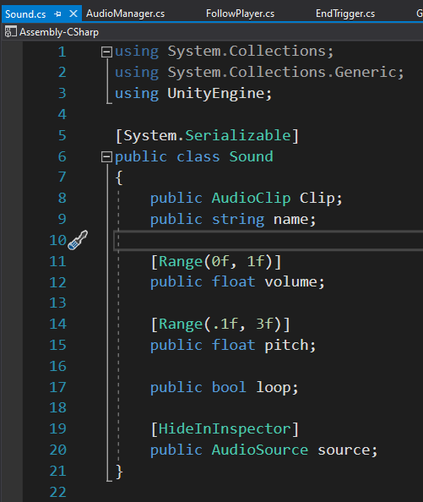

### AudioManager script

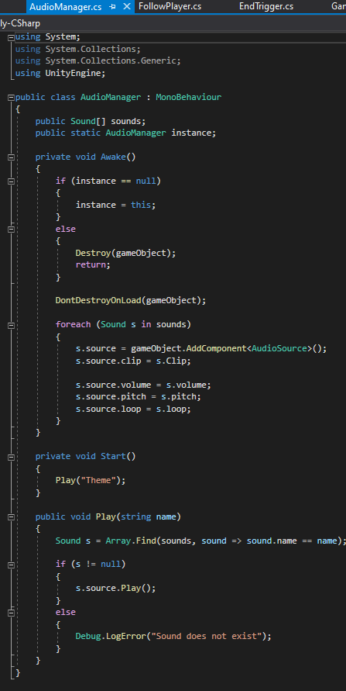

### Follow player script

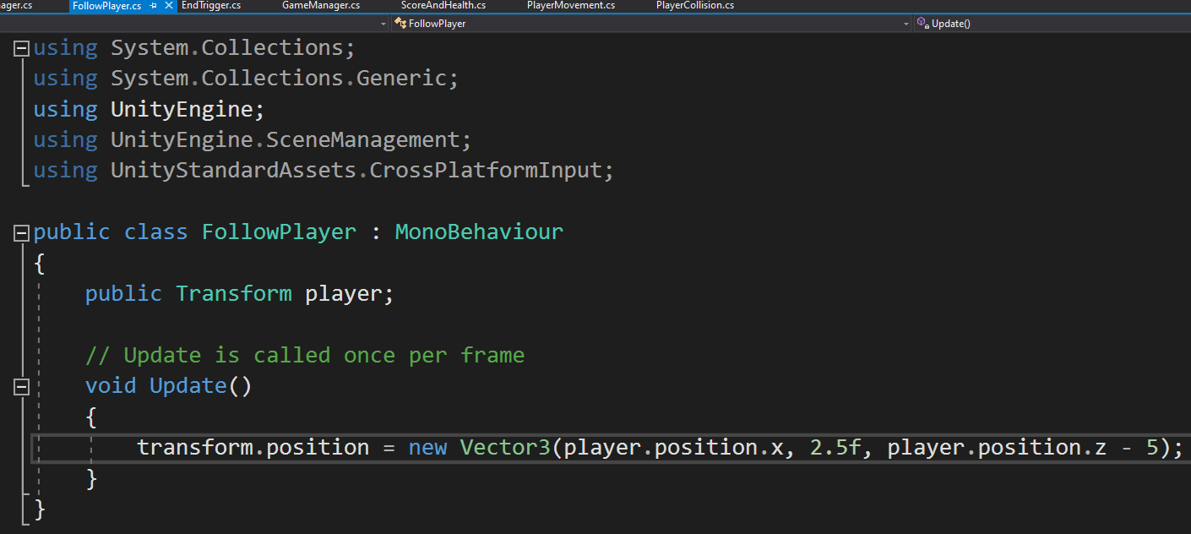

### EndTrigger script

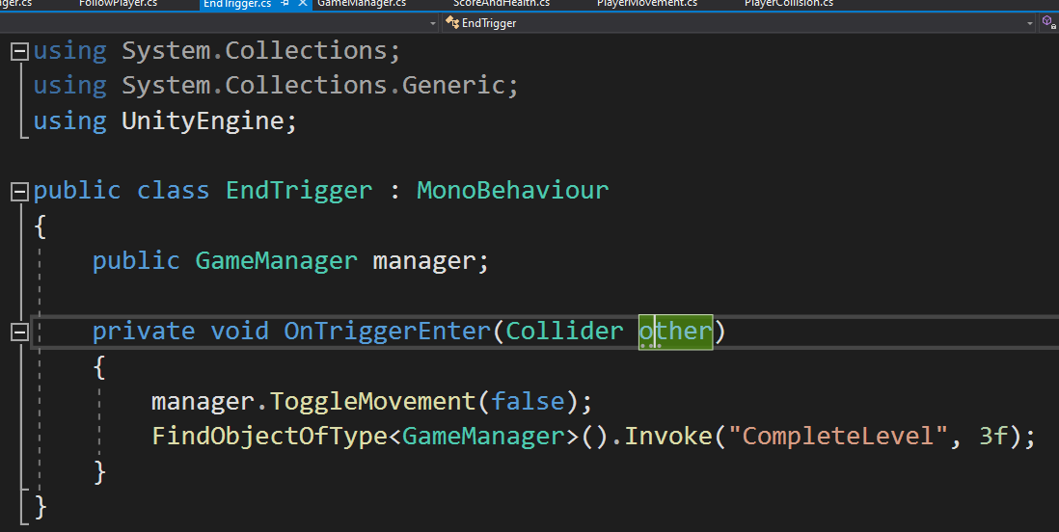

### Game Manager script

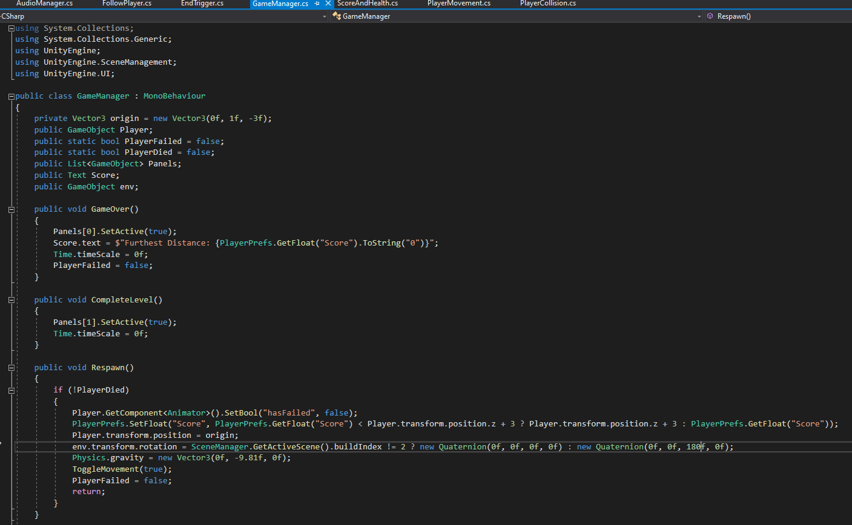

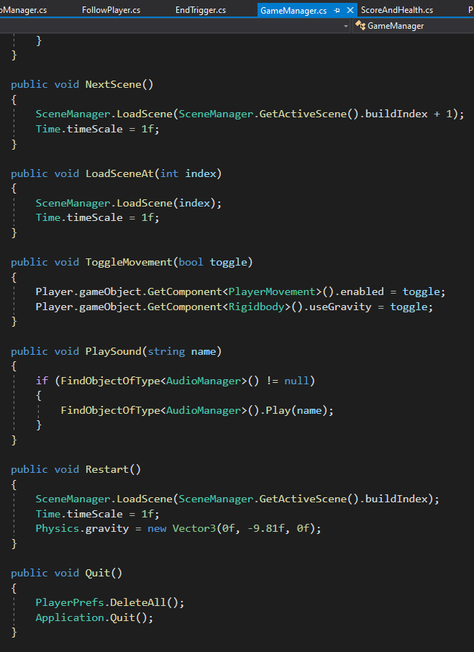

### Score and health script

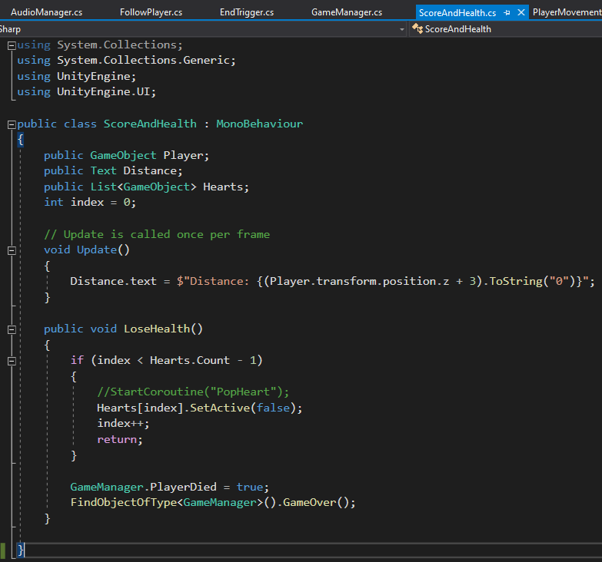

### Player collision script

### 

### Player Movement script

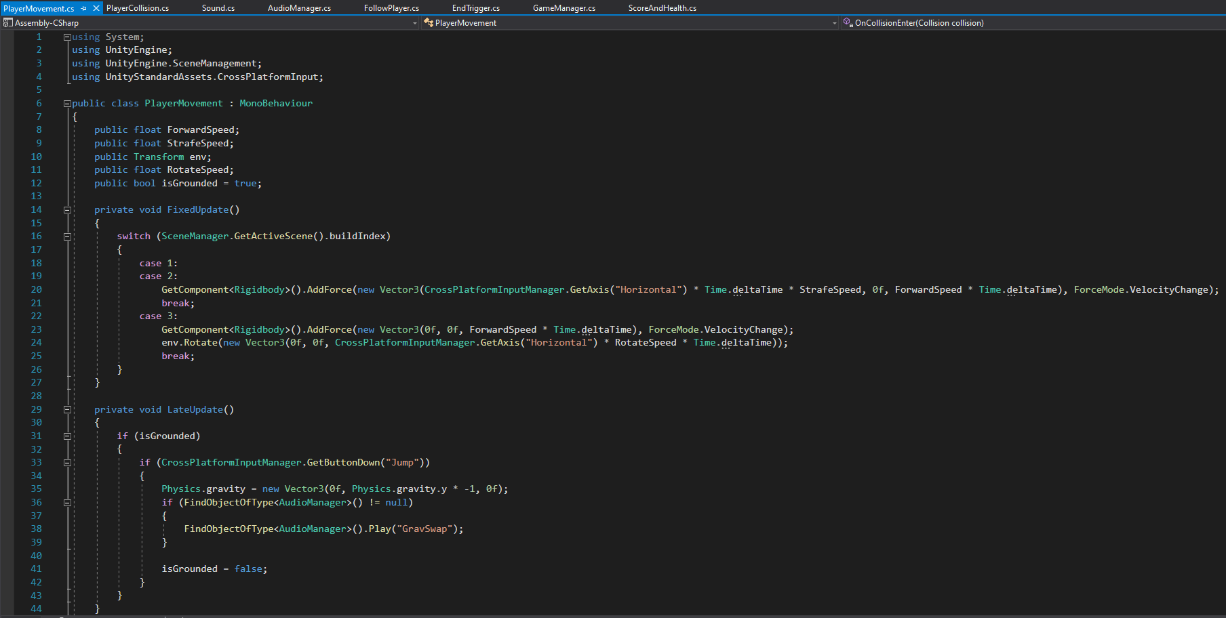

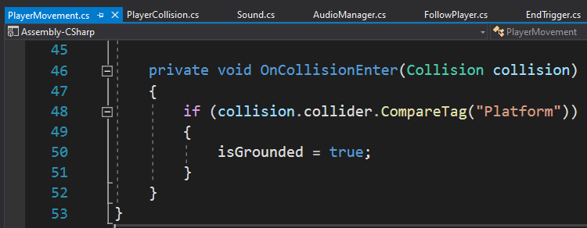

## Design

### Menu

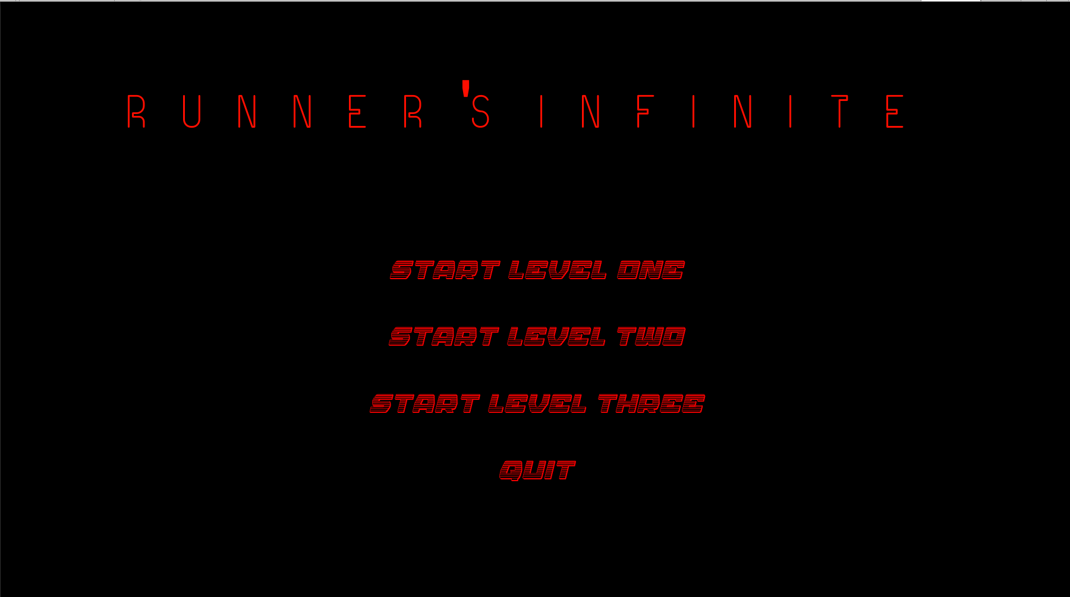

### level 1

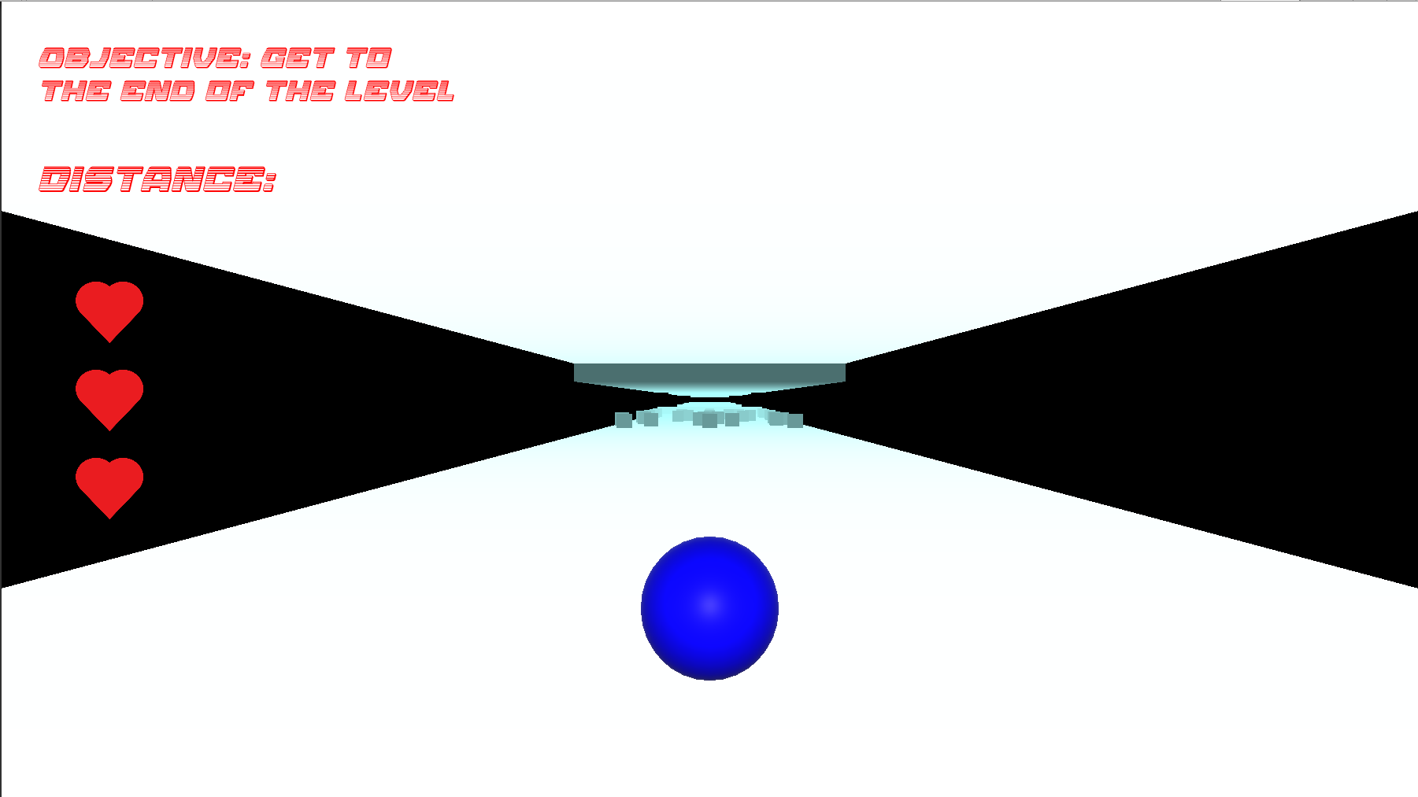

### Level 2

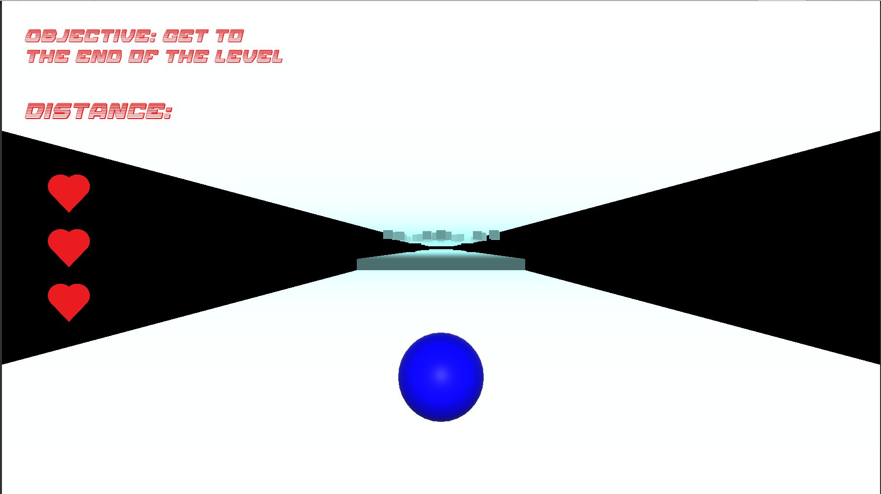

### Level 3

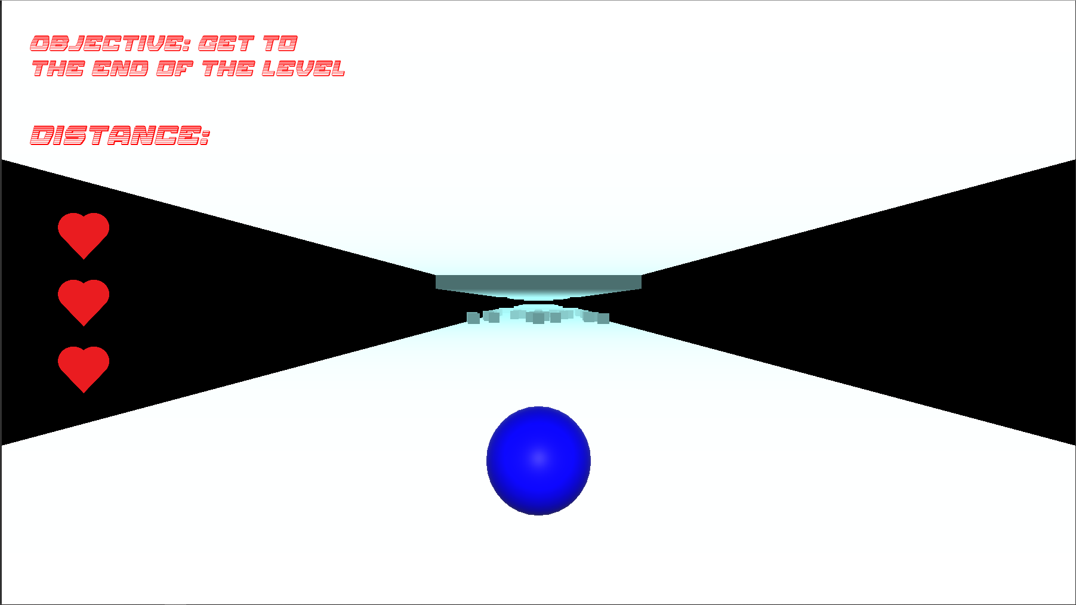

### Game over screen when losing all three hearts

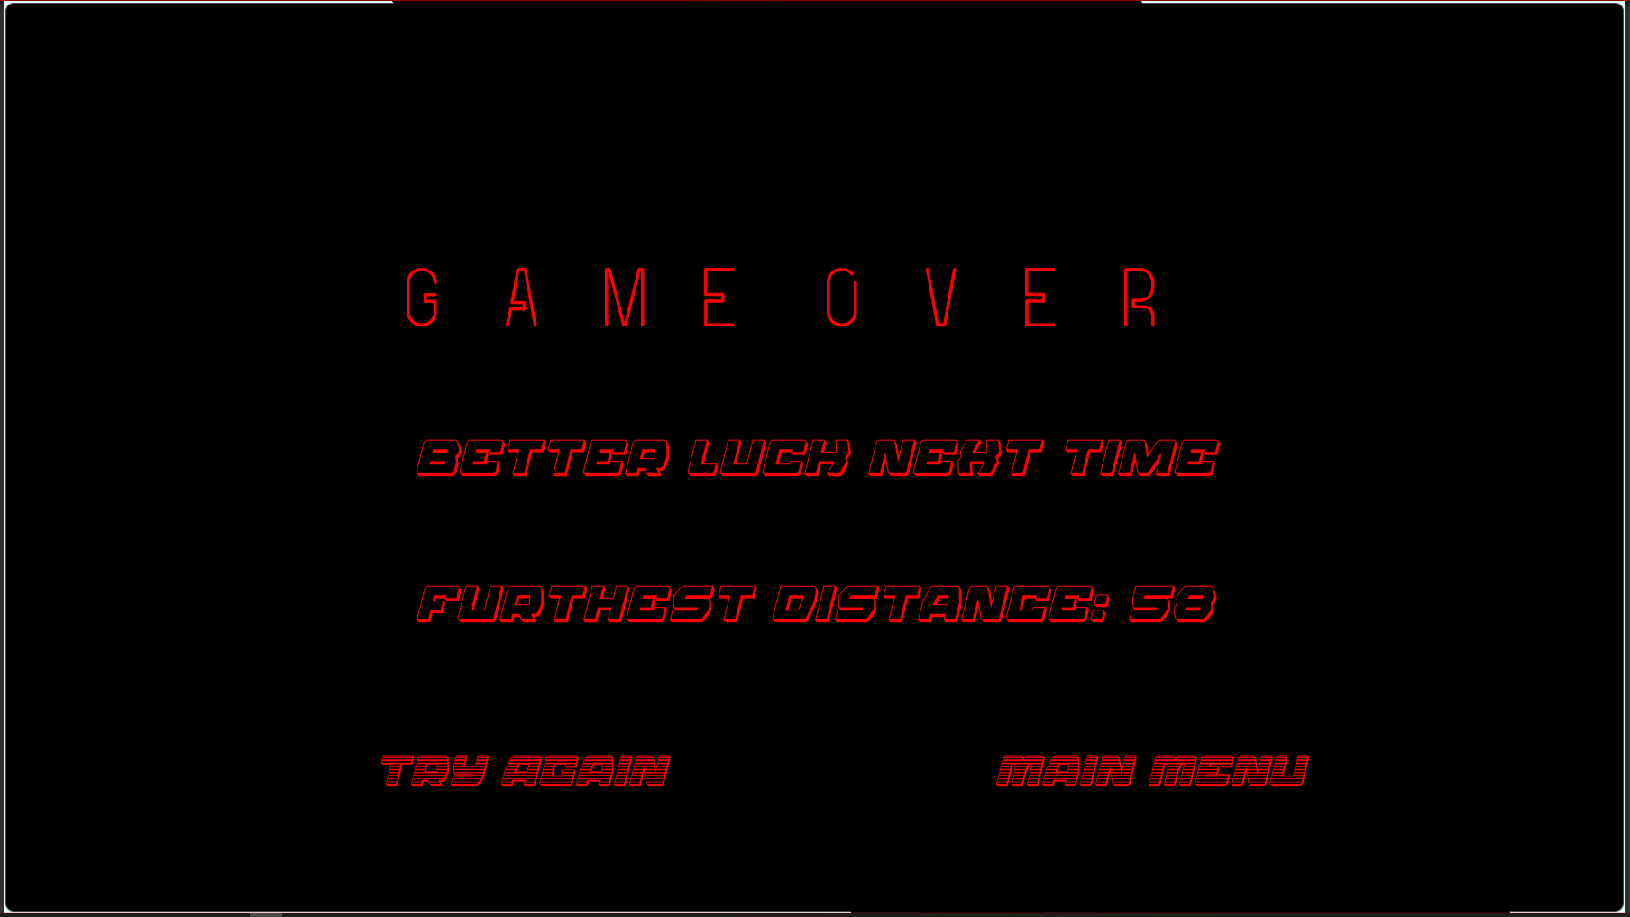

### Level Complete screen when player has reached the end of the level

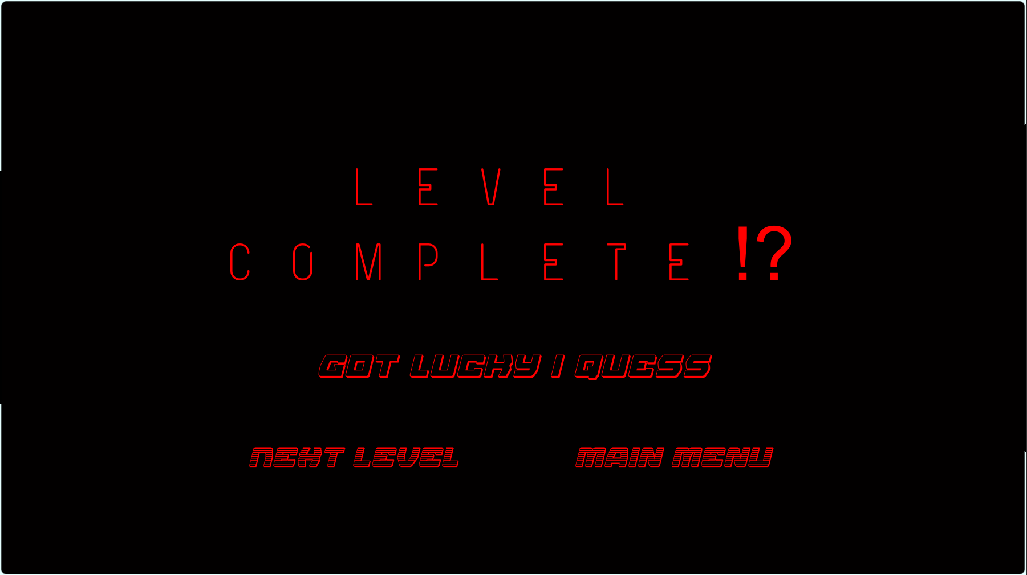

# Conclusion

* My game has multiple levels 1, 2 and 3
* My game is a 3d game
* My game has a genre (levelled runner)
* My game has a start menu
* My game has 1 objective per level
* The game ends when the player’s health reaches 0
* My game has an UI that displays the level objective
* No payed/completed assets where used in the game only unity’s primitive objects where used.