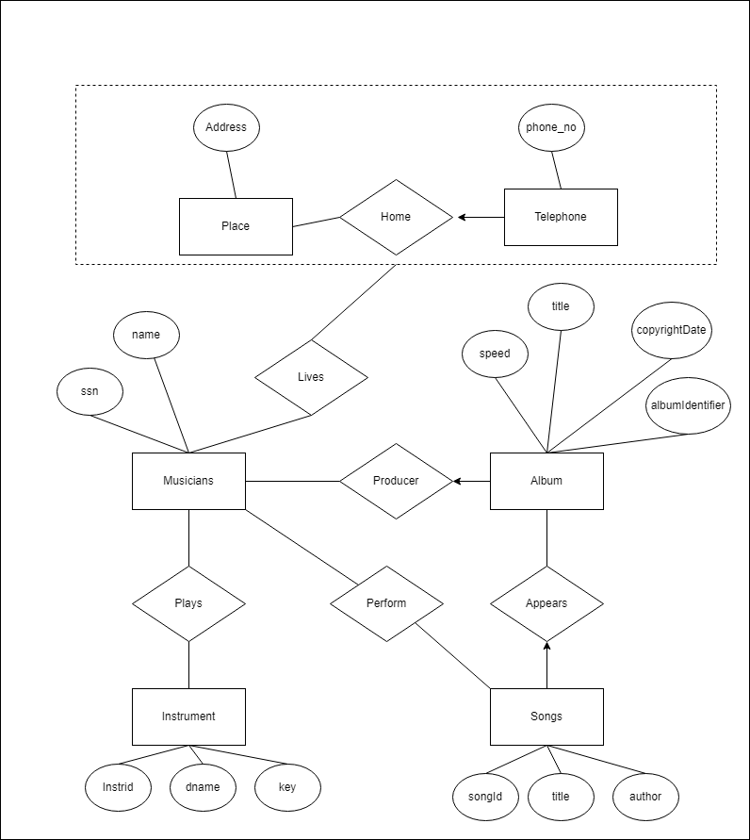

Assumptions: unique ID no and the album identifier are the same thing. Seemingly redundant.

Constraints that were unable to be expressed: I don’t believe there were any.