ASSIGNMENT 4

Ragunath Gunasekaran

2020-09-27

# Markdown Basics

## Favorite Foods

1. Pizza
2. Burger
3. Pad Thai

## Images

## Warning: package 'ggplot2' was built under R version 4.0.2

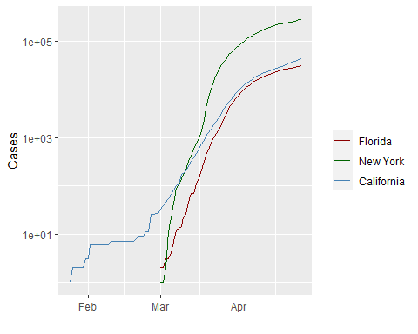

All Cases (Log Plot)

## Add a Quote

The best way to find yourself is to lose yourself in the service of others

## Add an Equation

$$P(A∣B)=P(B∣A)P(A)$$

## Add a Footnote

This is a footnote.[1]

## Add Citations

* R for Everyone (Lander 2014)
* Discovering Statistics Using R (Field, Miles, and Field 2012)

# Inline Code

## NY Times COVID-19 Data

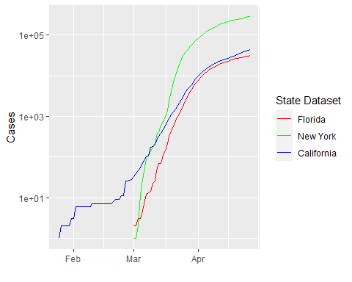

## R4DS Height vs Earnings

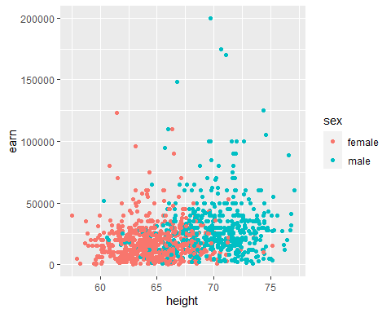

# Tables

## Knitr Table with Kable

One Ring to Rule Them All

|  |  |  |  |  |
| --- | --- | --- | --- | --- |
| name | race | in_fellowship | ring_bearer | age |
| Aragon | Men | TRUE | FALSE | 88 |
| Bilbo | Hobbit | FALSE | TRUE | 129 |
| Frodo | Hobbit | TRUE | TRUE | 51 |
| Galadriel | Elf | FALSE | FALSE | 7000 |
| Sam | Hobbit | TRUE | TRUE | 36 |
| Gandalf | Maia | TRUE | TRUE | 2019 |

## Pandoc Table

##   
##   
## +-----------+--------+----------------+-----------------+------+  
## | Name | Race | In Fellowship? | Is Ring Bearer? | age |  
## +===========+========+================+=================+======+  
## | Aragon | Men | Yes | No | 88 |  
## +-----------+--------+----------------+-----------------+------+  
## | Bilbo | Hobbit | No | Yes | 129 |  
## +-----------+--------+----------------+-----------------+------+  
## | Frodo | Hobbit | Yes | Yes | 51 |  
## +-----------+--------+----------------+-----------------+------+  
## | Galadriel | Elf | No | No | 7000 |  
## +-----------+--------+----------------+-----------------+------+  
## | Sam | Hobbit | Yes | Yes | 36 |  
## +-----------+--------+----------------+-----------------+------+  
## | Gandalf | Maia | Yes | Yes | 2019 |  
## +-----------+--------+----------------+-----------------+------+  
## | Legolas | Elf | Yes | No | 2931 |  
## +-----------+--------+----------------+-----------------+------+  
## | Sauron | Maia | No | Yes | 7052 |  
## +-----------+--------+----------------+-----------------+------+  
## | Gollum | Hobbit | No | Yes | 589 |  
## +-----------+--------+----------------+-----------------+------+

# References

1. Lander, J. P. 2014. R for Everyone: Advanced Analytics and Graphics. Addison-Wesley Data and Analytics Series. Addison-Wesley. <https://books.google.com/books?id=3eBVAgAAQBAJ>.
2. R Core Team. 2020. R: A Language and Environment for Statistical Computing. Vienna, Austria: R Foundation for Statistical Computing. <https://www.R-project.org/>.
3. Xie, Yihui. 2016. Bookdown: Authoring Books and Technical Documents with R Markdown. Boca Raton, Florida: Chapman; Hall/CRC. <https://github.com/rstudio/bookdown>.
4. <https://bookdown.org/yihui/rmarkdown-cookbook/>

1. This is a footnote in R Markdown