1. **Loading the data from .csv files to Dataset**

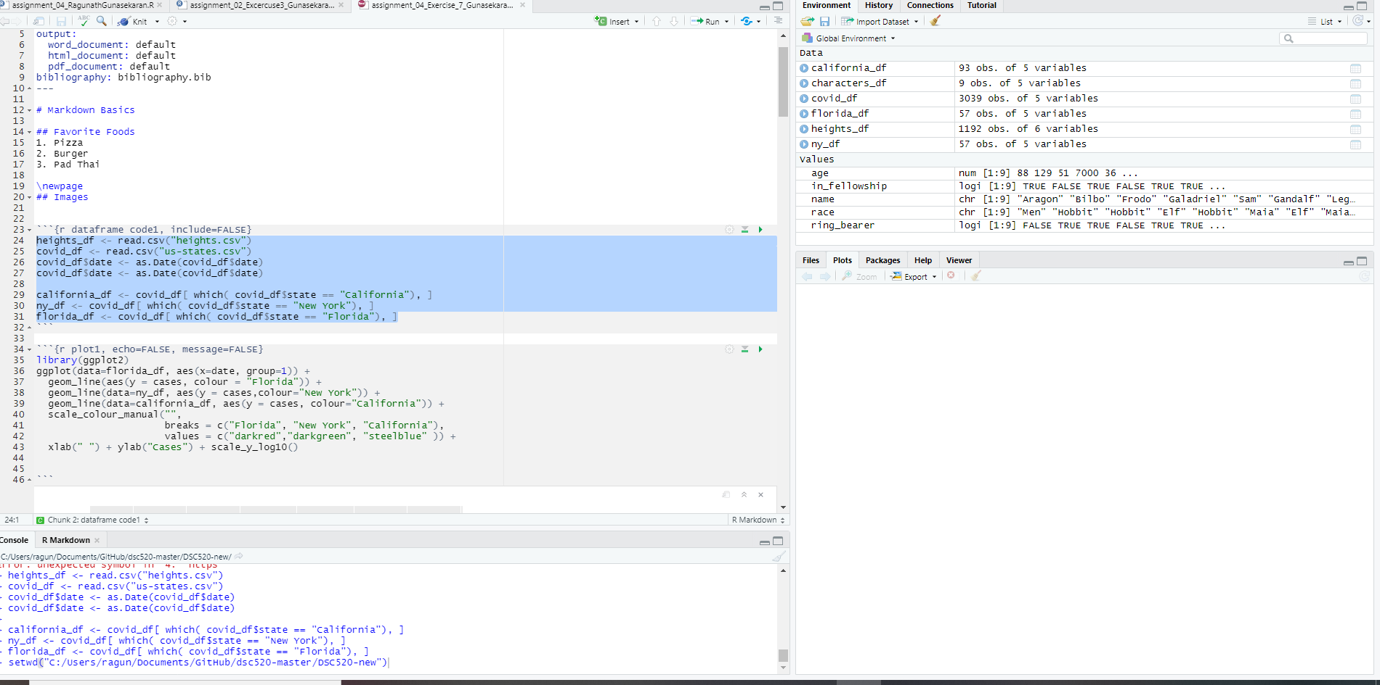

1. Generating the plot for all cases

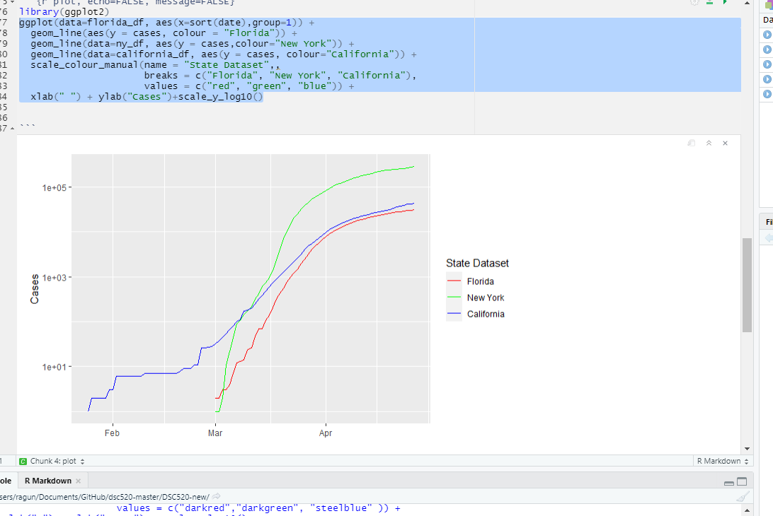

1. Generating plot for Height vs Earn

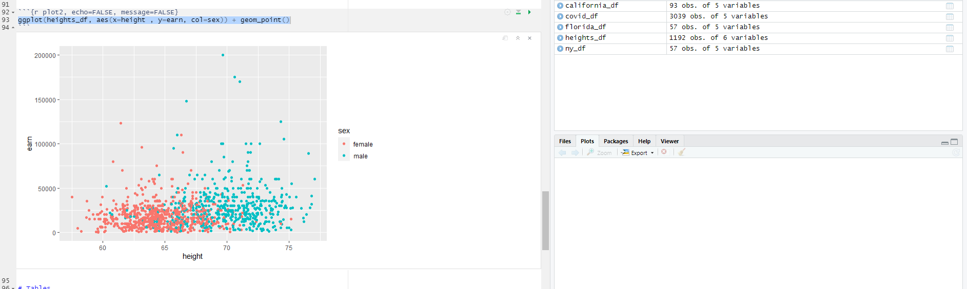

1. Generating table by using kable

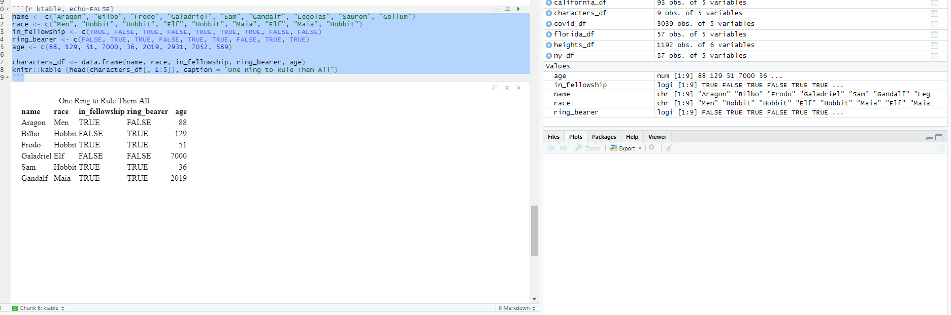

1. Generating table by using pandoc

