1. **Loading the data from .csv files to Dataset**

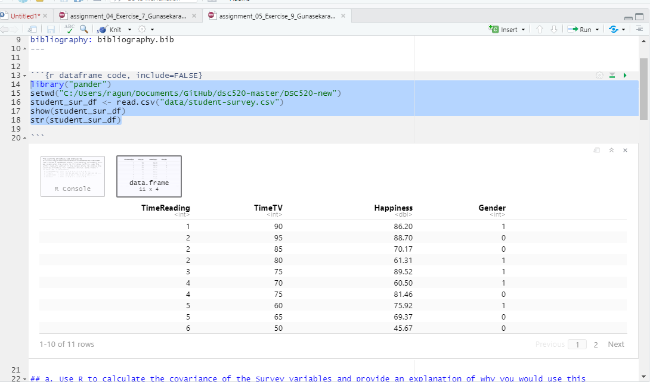

a. Use R to calculate the covariance of the Survey variables and provide an explanation of why you would use this calculation and what the results indicate.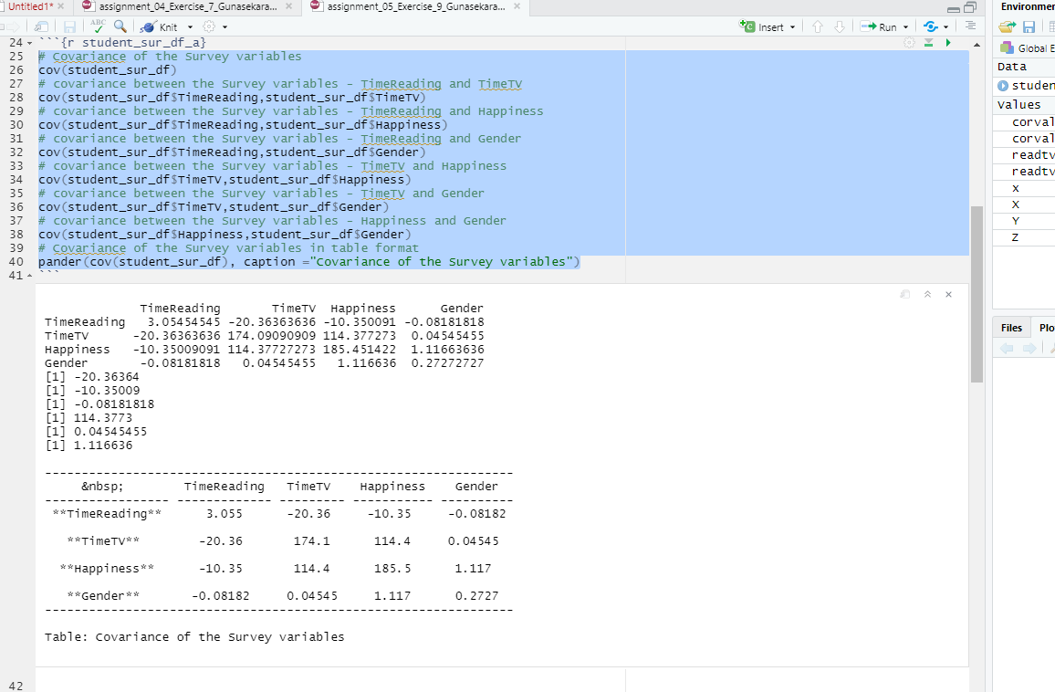

## b. Examine the Survey data variables. What measurement is being used for the variables? Explain what effect changing the measurement being used for the variables would have on the covariance calculation. Would this be a problem? Explain and provide a better alternative if needed.

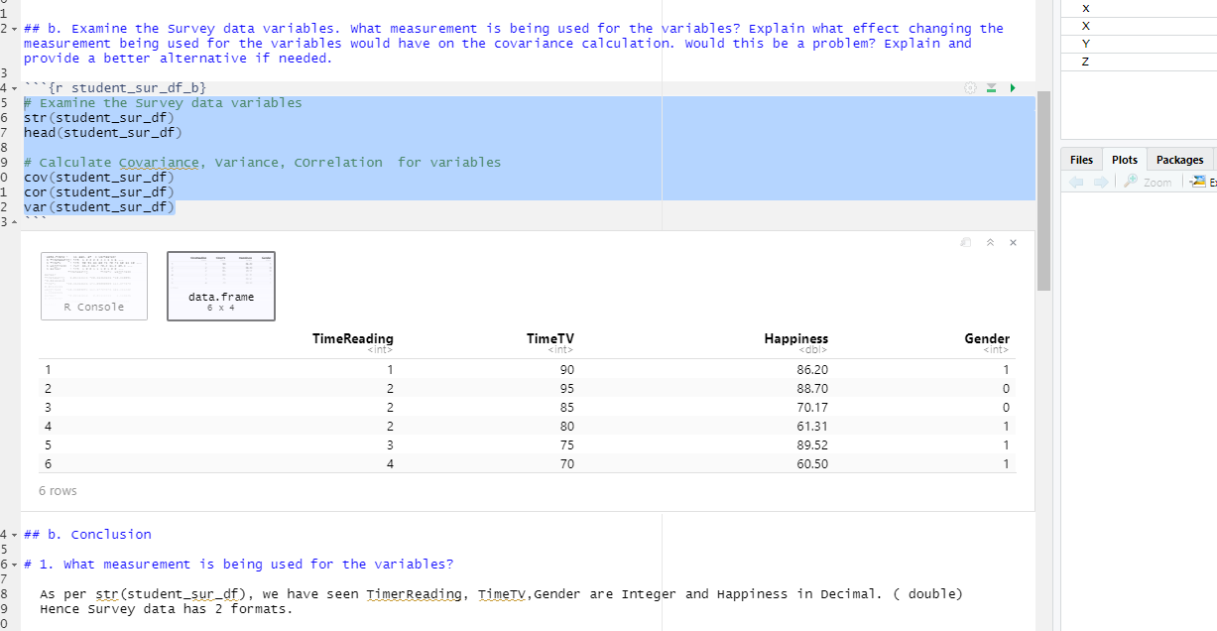

## Perform a correlation analysis of:

All variables

A single correlation between two a pair of the variables

Repeat your correlation test in step 2 but set the confidence interval at 99%

Describe what the calculations in the correlation matrix suggest about the relationship between the variables. Be specific with your explanation.

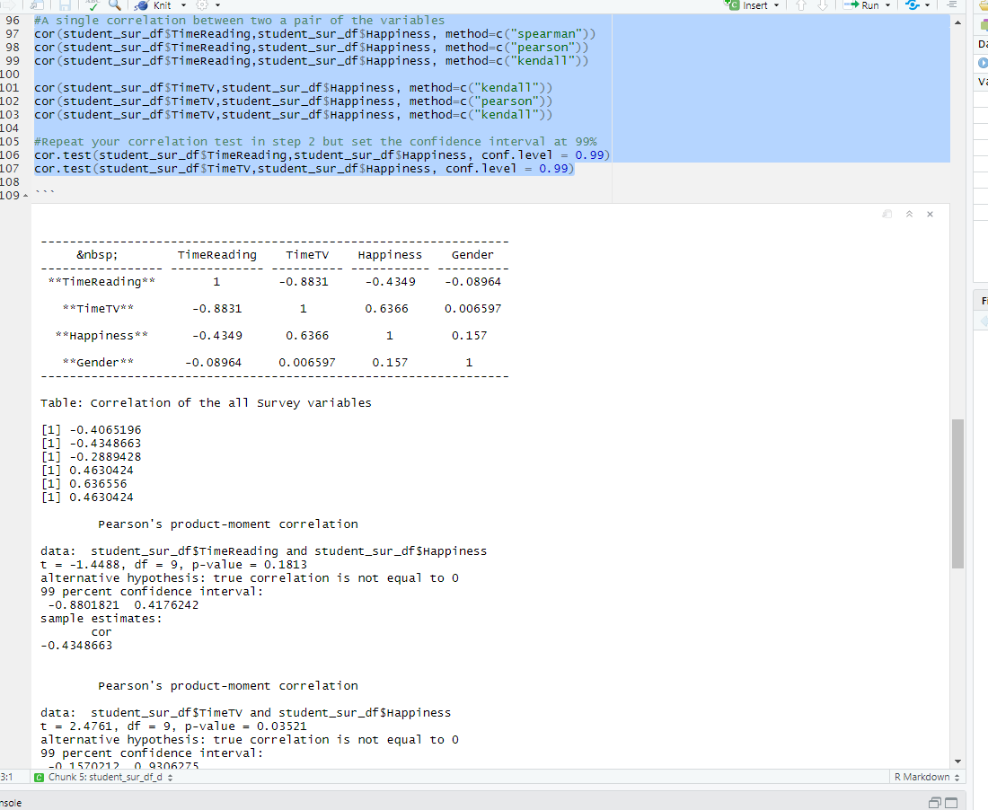

## f. Based on your analysis can you say that watching more TV caused students to read less? Explain.

