**Python**

Heat Map

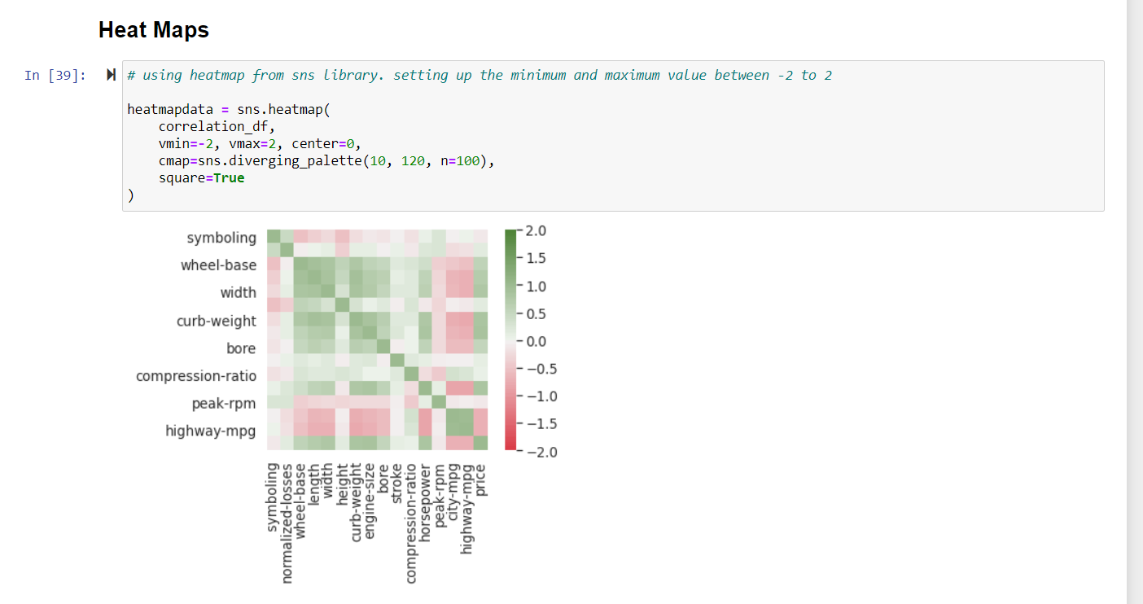

spatial chart

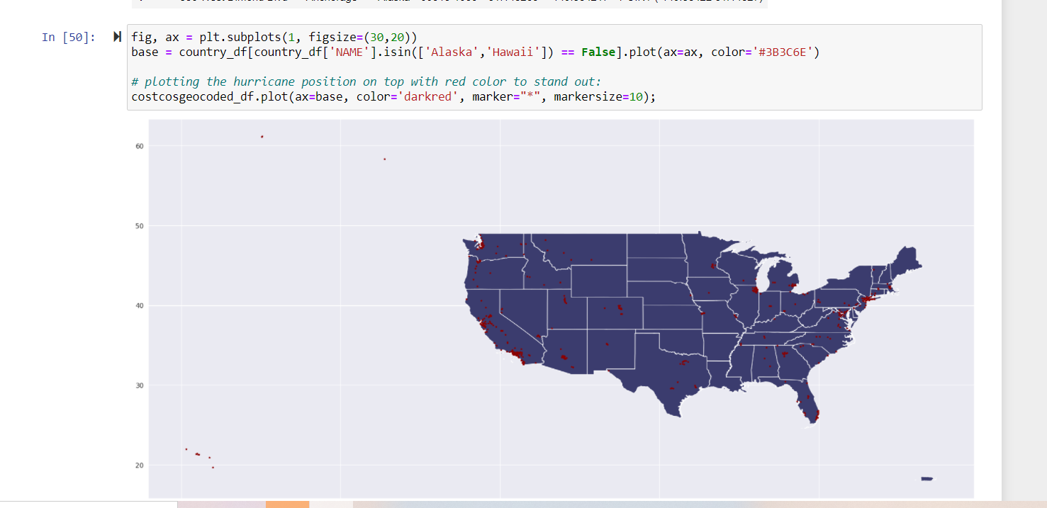

Contour Chart

Simple example

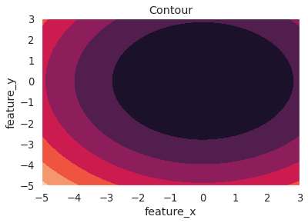

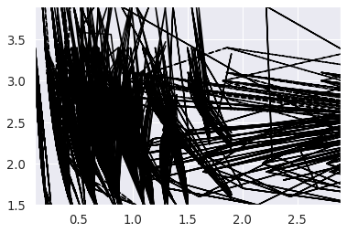

**R**

Heat Map by using cars data

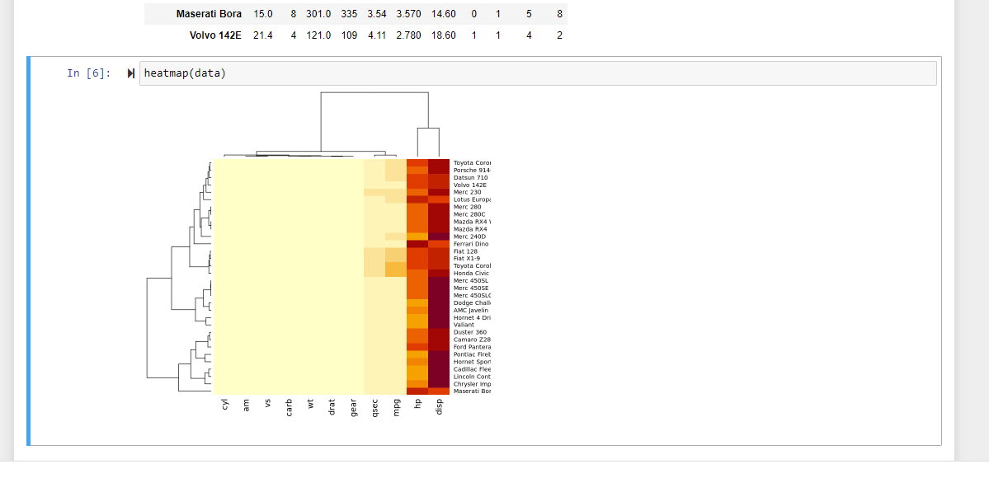

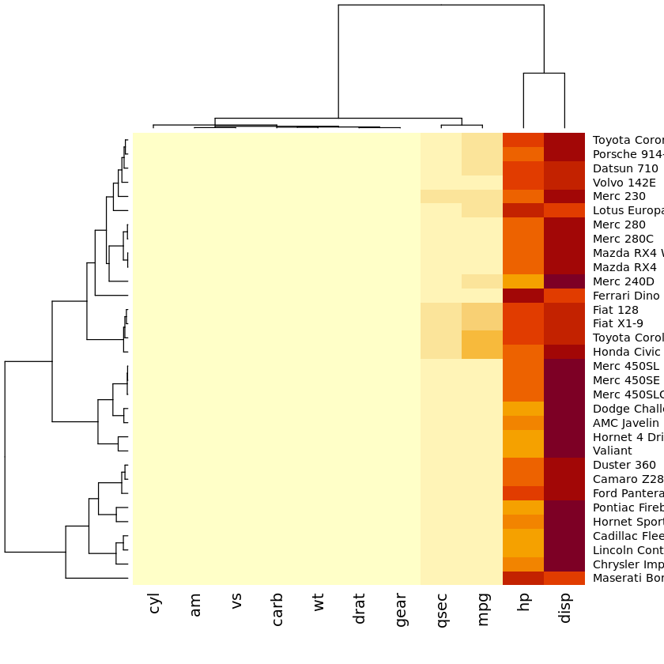

spatial chart – Aiports in World Map

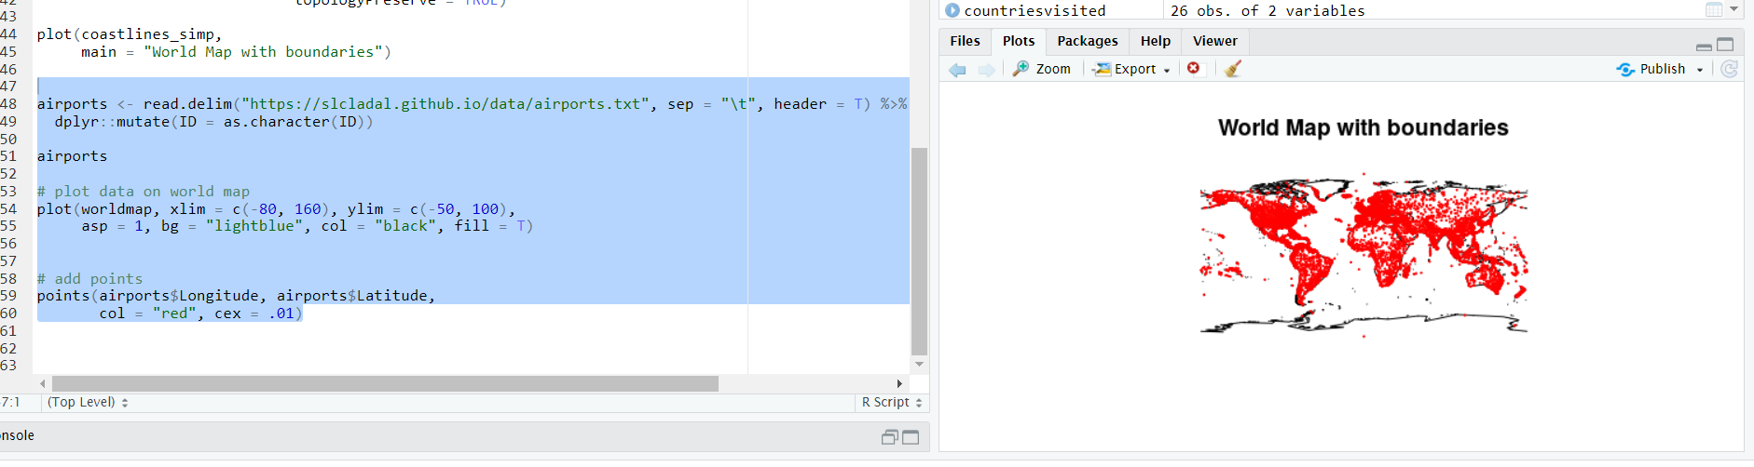

Contour Chart

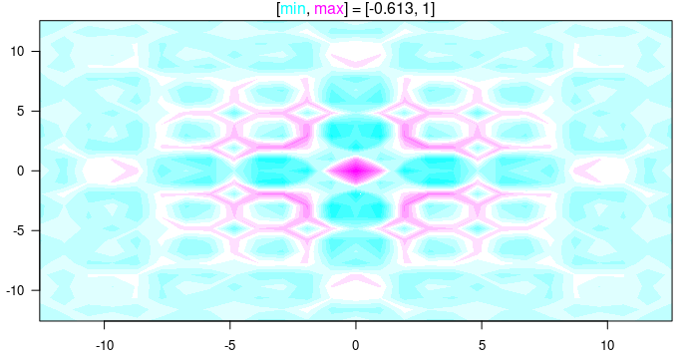

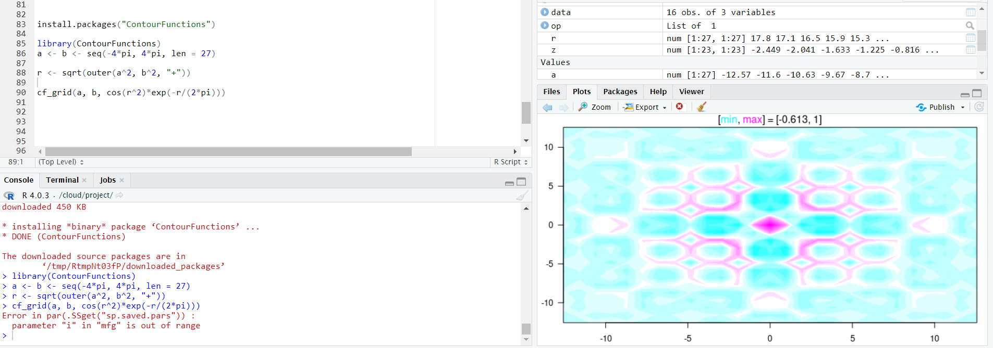

**Power BI**

Heat, Spatial and Funnel chart in Power BI Report

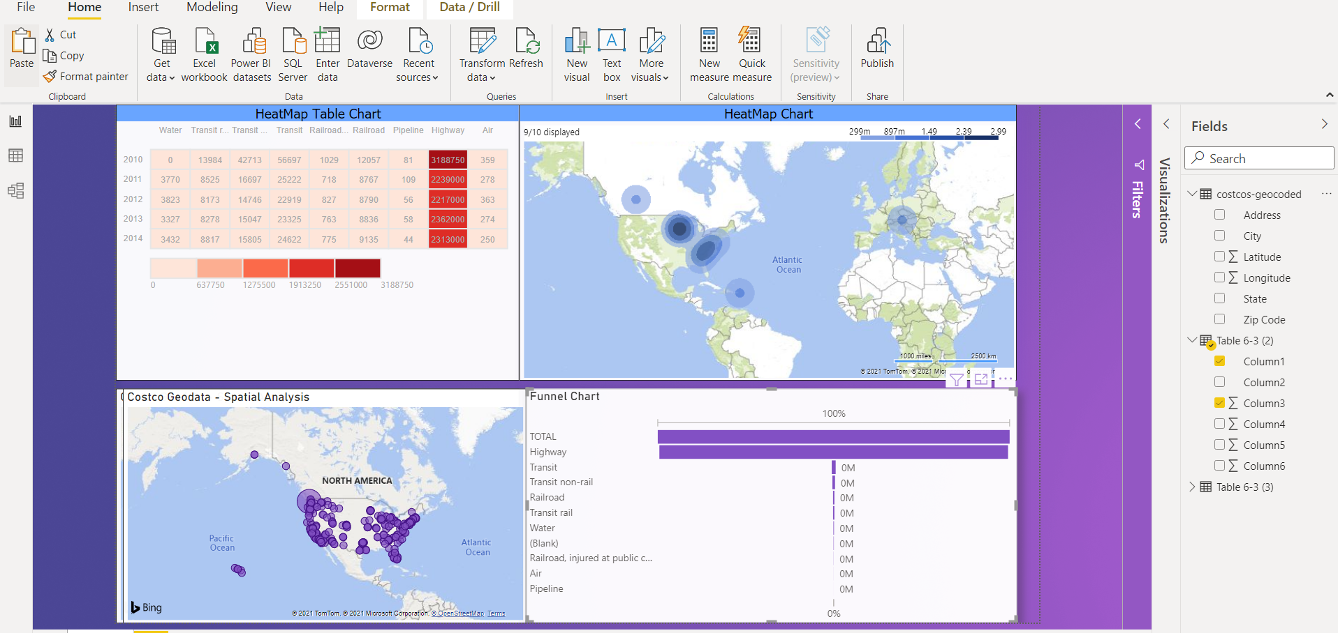

References

1. <https://www.rdocumentation.org/packages/graphics/versions/3.6.2/topics/contour>
2. <https://slcladal.github.io/maps.html>
3. <https://jcoliver.github.io/learn-r/006-heatmaps.html>