Assignment 8.2 : Introduction to machine Learning

Ragunath Gunasekaran

July 21 2020

## Footnote

This is a Footnote test.

## Citations

* R for Everyone
* Discovering Statistics Using R

## Plot the data from each dataset using a scatter plot

## Scatter plot of binary dataset

## Warning: package 'ggplot2' was built under R version 4.0.2

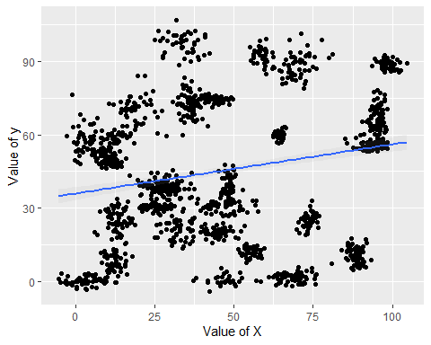

## Scatter plot of trinary dataset

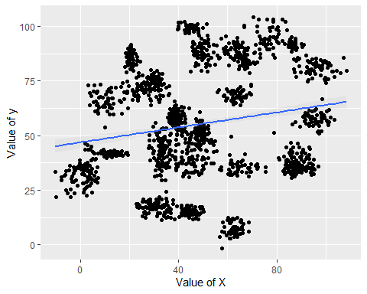

## k nearest neighbors algorithm categorizes

## Fiting a k nearest neighbors model for each dataset for k=3, k=5, k=10, k=15, k=20, and k=25. Compute the accuracy of the resulting models for each value of k. Plot the results in a graph where the x-axis is the different values of k and the y-axis is the accuracy of the model.

## [1] 1048

## [1] 450

## [1] 1048

## [1] 450

## 3 = 97.55556 5 = 97.33333 10 = 97.55556 15 = 97.55556 20 = 96.66667 25 = 96.44444

## [1] 1097

## [1] 471

## [1] 1097

## [1] 471

## 3 = 93.20594 5 = 92.14437 10 = 90.23355 15 = 89.17197 20 = 87.68577 25 = 86.83652

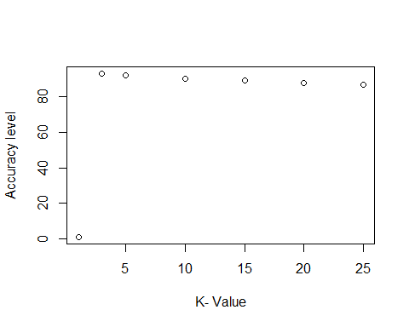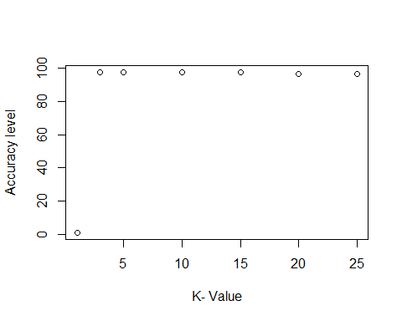

# References

1. Bernard Marr. (2016). Supervised V Unsupervised Machine Learning – What’s The Difference?
2. Bernard Marr. (2016). What Is The Difference Between Artificial Intelligence And Machine Learning?
3. Bernard Marr. (2016). What Is The Difference Between Deep Learning, Machine Learning and AI?