HW2

Github:

Q1: Alexnet performance for CIFAR10 dataset

Without Dropout

AlexNet is a pioneering convolutional neural network (CNN) that significantly influenced the field of deep learning, particularly in the area of computer vision. Developed by Alex Krizhevsky, Ilya Sutskever, and Geoffrey Hinton, it was introduced in the paper "ImageNet Classification with Deep Convolutional Neural Networks" and presented at the NIPS (now NeurIPS) conference in 2012.

Here we simplified the Alexnet to run on CIFAR10 dataset and get an accuracy of 73% which is not that great. This can be due to low no. of epochs, lack of tuning hyperparameters and oversimplicity of the model.

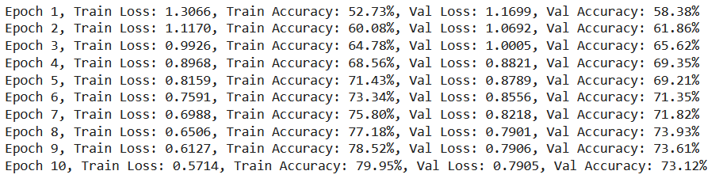

|  |
| --- |
| Fig. 1: Alexnet without dropout |

|  |
| --- |
| Fig. 2: Loss and accuracy |

Complexity comparison:

|  |
| --- |
| Total number of parameters: 56826698  Difference in parameters from original AlexNet: 5551646 |

|  |
| --- |
| Accuracy: 0.7312  Precision: 0.7431178631473572  Recall: 0.7312000000000001  F1 Score: 0.7333861919389613 |

With Dropout

|  |
| --- |
| Fig. 3: Alexnet with dropout |

|  |
| --- |
| Fig. 4: Losses |

Q2: ResNet18 performance for CIFAR10 dataset and comparison against ResNet11

**ResNet-18** is a convolutional neural network that is 18 layers deep. It's part of the ResNet (Residual Network) family introduced by Kaiming He, Xiangyu Zhang, Shaoqing Ren, and Jian Sun in their 2015 paper "Deep Residual Learning for Image Recognition." The ResNet models were designed to solve the problem of vanishing gradients, which was a significant issue for training very deep neural networks.

|  |
| --- |
| Fig. 5: ResNet18 accuracy and model complexity |

|  |
| --- |
| Fig. 6: Losses |

From the accuracy and loss calculation it’s obvious that ResNet18 performance is better than Alexnet for the same settings and dataset.

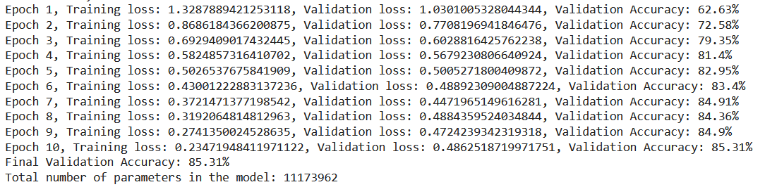**With dropout**

|  |  |
| --- | --- |
| Fig. 7: Accuracy and losses | |
| Fig. 8: Losses |

**ResNet11**

|  |
| --- |
| Fig. 9: performance |
| Fig. 10: losses without dropout |
| Fig. 11: With dropout |
| Fig. 12: losses with dropout |