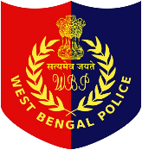WEST BENGAL POLICE RECRUITMENT BOARD

ARAKSHA BHAVAN (5TH FLOOR), 6TH CROSS ROAD,

BLOCK-DJ, SECTOR-II, SALT LAKE CITY, KOLKATA-700 091

**ADMIT CARD**

**PRELIMINARY WRITTEN TEST FOR THE POST OF CONSTABLES/LADY CONSTABLES IN WEST BENGAL POLICE - 2025**

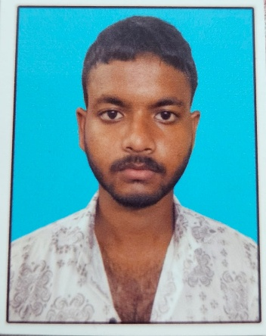

Preliminary Written Test Roll No. : 20548693

Application Serial No. : 400C7890

Name in Candidate : ANKUSH RAKSHIT

Father's/Mother's/ Husband's Name : UJJAL RAKSHIT

Address:

BARANILPUR UTTARPARA , P.O : SRIPALLI , P.S. : BURWAN SADAR , DIST :

PURBA BARDHAMAN , PIN : 713101

(PHOTOGRAPH & SIGNATURE AS UPLOADED)



Reporting time at the main entrance of the

Preliminary Written Test Venue: 09:30 AM.

Time of Last Entry in the Preliminary Written

Test Venue :- 11:30 AM

Date of Preliminary Written Test : 07.08.2025

Time of Preliminary Written Test : 12:00 Noon - 01:00 PM

Venue: Victoria Park Building, Plot No. 37/2, GN Block, Sector V,

Bidhannagar, Kolkata, West Bengal 700091

**IMPORTANT INSTRUCTIONS**

1. **Mandatory Documents**
   * Carry a printed copy of the e‑Admit Card and one original photo ID (e.g., Aadhaar, Voter ID, Passport, Driving License).
   * At least two recent passport-size photographs may also be required (for later stages/document verification).
2. **Admit Card Download Details**
   * Download from the official WB Police websites: wbpolice.gov.in or prb.wb.gov.in.
   * Use your 8-digit Application Serial Number and Date of Birth (DD/MM/YYYY) to log in.
   * Admit cards are not sent by post or SMS. You must download and print it yourself.
3. **Exam Day & Reporting**
   * Reach the exam venue 15–20 minutes before the reporting time stated on your Admit Card.
   * Report at the main entrance of the exam venue; mention on the card will specify the venue code/address, reporting time, and last entry time.
4. **Prohibited Items**
   * Items such as mobile phones, digital wristwatches, calculators, Bluetooth devices, or any other digital gadget—are strictly not allowed inside the exam hall.
   * No cheating materials or attempts to copy. Violators will be disqualified.
5. **Exam Format & Marking Scheme**
   * The Preliminary Written Test is OMR-based, consisting of MCQs.
   * Negative marking of ¼ mark for each wrong answer applies.
   * Paper is bilingual, in Bengali and Nepali (except the English section).
6. **Candidate Declaration & Signature**
   * Sign the Admit Card in the designated box (as uploaded during application).
   * Use a black ballpoint pen only for filling out responses on the OMR sheet.
7. **Preserve Admit Card Safely**
   * Retain the Admit Card throughout all stages of selection (PMT, PET, Final Written Test, Interview) as it will be required during document verification.
   * If any discrepancy is found in the details printed (e.g. personal information, exam center), contact WBPRB immediately for correction.

**Quick Checklist Before Exam Day**

| **Item** | **Status** |
| --- | --- |
| Printed e‑Admit Card | ☐ |
| Original Photo ID | ☐ |
| Black ballpoint pen | ☐ |
| Passport-size photo(s) | ☐ |
| Exam center route prepared | ☐ |

**Final Notes**

* No electronic items of any kind are allowed inside the venue—only water bottles and stationery (pen, pencil, eraser, etc.) permitted.
* Colored print of the Admit Card is preferable for clarity—black & white may be hard to read.
* Any form of canvassing or malpractice will lead to immediate cancellation of candidacy.

**THIS IS AN ORIGINAL DOCUMENT**