**Installation for Mac**

**A.** Installing Python and Pygame

1. Open up a **Terminal** window (Click on “Finder” then “Applications” and then open “Utilities.” Double-click on Terminal)
2. Type **gcc** into the command line and hit **Enter**
3. Your Mac will recognize that you don't have this command and offer to install it for you. Go ahead and do this. (If instead it says **error: no input files,**you already have an installation of gcc, so go on to the next step.)
4. Install XQuartz from:   
   [http://xquartz.macosforge.org](http://xquartz.macosforge.org/)
5. Download the **MacPygame** shell script file from the **Other** tab from the index Page.
6. In your Terminal type **cd ~/Downloads** then press ENTER.
   1. Type **chmod +x MacPygame.txt** then Press ENTER.
   2. Type **./MacPygame.txt** and press ENTER. The programs will begin to download.
   3. Enter your computer’s password whenever you are prompted to.
7. To insure Python and Pygame are installed, type **python3** into the Terminal.
   1. Type a simple **print(‘hello’)** statement into the Terminal and press ENTER.
   2. Then, type **import pygame** and press ENTER. If you do not receive an error, pygame is installed correctly.
   3. Type **Command + Z** to exit Python from your Terminal.

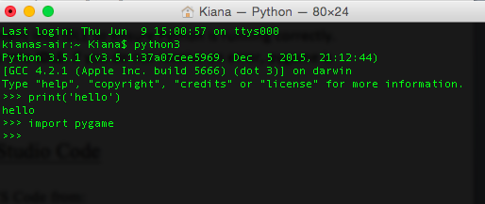

**B.** Installing Mac Visual Studio Code

1. Download Mac OS X of VS Code from:

<http://code.visualstudio.com/Download> and double-click it to install it.

1. Drag the Visual Studio Code.app to the Applications folder if you want to make it available in Launchpad 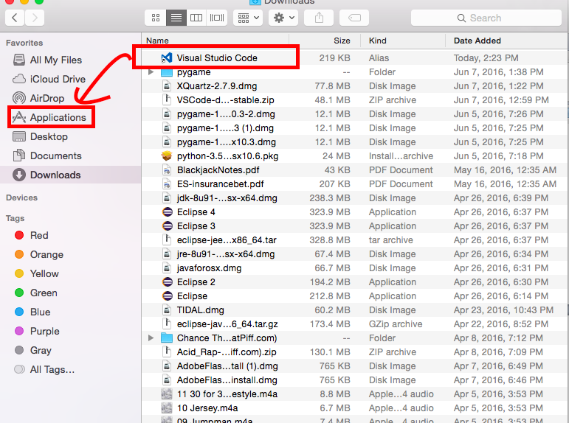
2. Launch VS Code and add it to your Dock by right clicking on the icon and choosing **Options, Keep in Dock**.
3. Open the **Command Palette** by pressing **Command + Shift + P**.
4. Type **shell command** to find the **Shell Command: Install 'code' command in PATH command**.

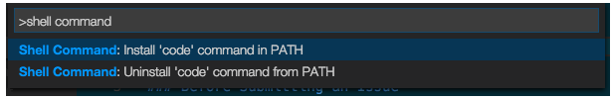

1. After executing the command, open a **Terminal** window (Click on “Finder” then “Applications” and then open “Utilities.” Double-click on Terminal) for the new PATH value to take effect. You will be able to simply type ‘**code .**’ in any folder to start editing files in that folder.

**C.** Configuring Visual Studio Code to work with Python

1. Launch VS Code
2. Open the **Command Palette** again (**Command + Shift + P**).
3. Type **ext install** and press ENTER; note the space after **install**. Type **python** and select the one circled below.

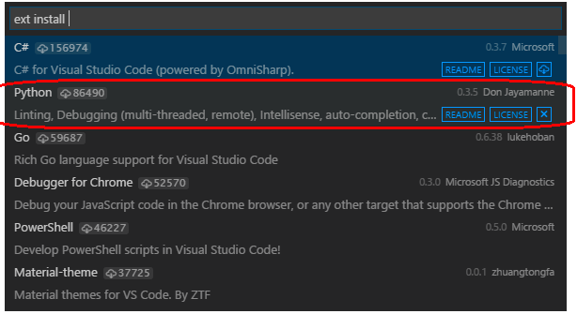

1. Open up a **Terminal** window, or restart it if you had one open.
   1. Type **which python3** into the Terminal.
   2. Copy the python path link.

The link should look something like:

**/Library/Frameworks/Python.framework/Versions/3.5/bin/python3**

**or**

**/usr/local/bin/python3**

1. Open the VS Code **Command Palette** again (**Command + Shift + P**), this time typing **User Settings**. A user setting file that overwrites the default one will open. Type the following into the file:

**{**

**“python.pythonPath”: “(python path copied link)”**

**}**

Then save the file.

1. In the **Explorer** on the left-hand side, create a **New Folder**; give it a name.
2. Open the **Command Palette** again (**Command + Shift + P**) and type **configure task** and press **Enter**. Select the **Others** tab shown below.

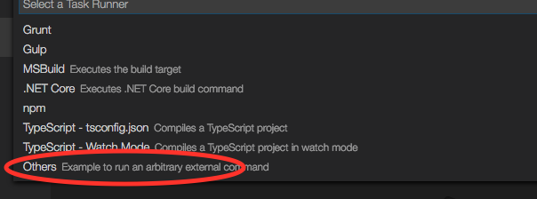

1. This will open a **tasks.json** file in the **.vscode** subfolder of your workspace (that is, the new folder you created above, where you will be entering your code). Replace the contents of **tasks.json** with the following code:

**{**

**“version”: “0.1.0”,**

**“command”: “python”,**

**“isShellCommand”: true,**

**“args”: [“${file}”],**

**“showOutput”: “always”**

**}**

Save the file.

1. At bottom right of your screen make sure the selected language is Python as shown below. If it is not, click on the current language and select Python to change it.

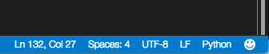

1. To run the Python program you are currently editing, use **Command + Shift + B**.